/*2.57题答案

*/

#include <stdio.h>

#include <stdlib.h>

typedef unsigned char *byte_pointer;

void show_short(short x);

void show_long(long x);

void show_double(double x);

void show_bytes(byte_pointer start,size_t len);

int main()

{

short a=821;

long b=1170300821;

double c=117030.0821;

printf("short a:%d\t",a);

show_short(a);

printf("long b:%ld\t",b);

show_long(b);

printf("double c:%lf\t",c);

show_double(c);

return 0;

}

void show_bytes(byte_pointer start,size_t len)

{

size_t i;

for(i=0; i<len; i++)

printf(" %.2x",start[i]);

printf("\n");

}

void show_short(short x)

{

show_bytes((byte_pointer)&x,sizeof(short));

}

void show_long(long x)

{

show_bytes((byte_pointer)&x,sizeof(long int));

}

void show_double(double x)

{

show_bytes((byte_pointer)&x, sizeof(double));

}

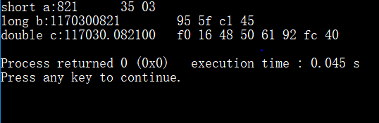

/*2.61题答案

*/

A :!(~x)

B :!x

C :!(~ (x | 0x00ffffff))

D :!(~ (x | 0xffffff00))

/*2.65题答案

*/

int odd_ones(unsigned x)

{

unsigned a;

a = x >> 16;

x = x^a;

a = x >> 8;

x = x^a;

a = x >> 4;

x = x^a;

a = x >> 2;

x = x^a;

a = x >> 1;

x = x^a;

x=x&1;

return x;

}

/*

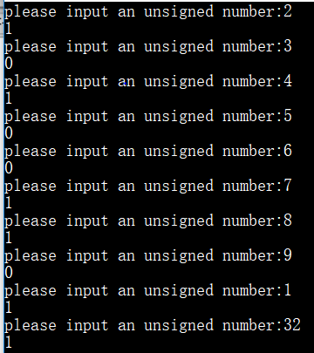

*/

/*2.69题答案

*/

unsigned rotate_left (unsigned x,int n)

{

int i;

unsigned y,z;

for(i=0;i<n;i++)

{

y=x;

z=x;

y=y<<1;

z=z>>31;

x=y+z;

}

return x;

}

/*

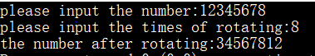

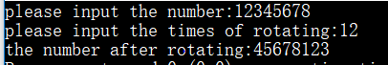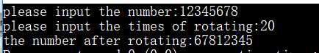

*/

/*2.73题答案

*/

int saturating_add(int x,int y)

{

int a,b,c,d;

a = sizeof(int) << 3;

b = x + y;

c = (( x ^ b) & (y ^ b)) >> ( a - 1);

d = x >> ( a - 1);

return (b | c) - ( (c & 1) << ( a - 1))^ (d & c);

}/*

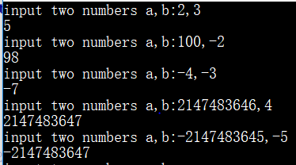

*/

/*2.77题答案

A: ,x+(x<<4)

B: x-(x<<3)

C: (x<<6)-(x<<2)

D: (x<<4)-(x<<7)

*/

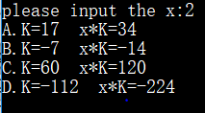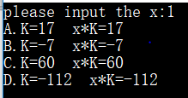

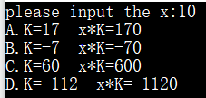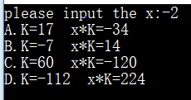

*/

/*2.81题答案

A：-1 << k；

B: ~(-1 << k) << j;

*/

/*2.85题答案

A: E = 2,  M = 1.1100...  f = 0.1100...

V = 2^2 * M  
表示：0  10...01  1100...

B:E = n, M = 1.111...(小数点后面n个1)， f = 0.111...（小数点后面n个1），

V = 2^E * M

0  n+(2^(k-1) – 1)  1111...

C:, E = (2^(k-1) – 1)-1, M = 1.00... f = 0.00...

V = 2^((2^(k-1) – 1) - 1)  
0  11...101  00...

*/

/*2.89题答案

A总成立。  
B 不总成立。 例如，当y=TMIN, x= TMAX  
C 总成立。  
D 不总成立。 因为浮点数不满足交换律。例如，x= TMAX，y= TMAX，z= TMAX  
E 不总成立。 例如，x = 1, z = 0

*/

/*2.93题答案

*/

float_bits float_absval(float_bits f)

{

float_bits sign = f >> 31;

float_bits exp = f >> 23 & 0xFF;

float_bits frac = f & 0x7FFFFF;

if ((exp == 0xFF) && (frac != 0))

{

return f;

}

else

{

sign = 0;

}

f = (sign << 31) | (exp << 23) | frac;

return f;

}

/*2.97题答案

*/

float_bits float_i2f(int i)

{

unsigned sign, exp, frac, bias,flag;

bias = 127;

frac = (unsigned)i;

if (i == 0)

return 0;

if (i == INT_MIN)

{

sign = 1;

exp = 31 + bias;

frac = 0;

return sign << 31 | exp << 23 | frac;

}

sign = i >> 31;

int j, k=i;

if (sign == 1) k = ~(i-1);

int first = 0;

for (j = 1; j <32; j++)

{

if ((k >> j) & 1)

{

first = j;

break;

}

}

exp = bias + first;

if (first < 23)

frac << (23 - first);

else

{

frac >> (first - 23);

flag = (1 << (first- 23)) - 1;

if( ((k&flag) > (1 << (first - 24))) || (((k&flag) == (1 << (first - 24))) && (frac & 1)))

frac++;

if (frac == (1 << 24))

exp++;

}

frac = frac & 0x7fffff;

return (sign << 31) | (exp << 23) | frac;

}

