SPORTIVA CM
PROJECT REQUIREMENTS & SPECIFICATIONS DOCUMENT
Implementation-grounded analysis and UML specification

Document field | Value
Version | 1.0
Date | 7 September 2026
Status | MVP / academic demonstration release
Technology | Python, Django, SQLite, HTML, CSS, JavaScript
Scope | Sports promotion, community, events, media, marketplace, sponsorships, and messaging

Prepared from the current SPORTIVA CM source code, migrations, templates, and project documentation.

Document Control and Executive Summary
SPORTIVA CM is a Django-based digital sports ecosystem designed to connect athletes, clubs, coaches, sponsors, organizers, sellers, and fans. It combines identity and profile management with event registration, achievement verification, a social media feed, a sports marketplace, sponsorship campaigns, and private chat.
The current release is an MVP suitable for demonstration, academic defense, and continued development. It provides a working modular foundation, but production deployment still requires hardened configuration, real payment services, stronger testing, and operational infrastructure.
Revision | Date | Description
1.0 | 2026-09-07 | Generated project requirements, analysis, specifications, and UML diagrams from the current implementation.

Table of Contents
In Microsoft Word, right-click the table of contents field below and choose “Update Field” to refresh page numbers after editing.

1. Project Context and Problem Analysis

1.1 Background
Sports stakeholders often operate across disconnected channels: social networks for announcements, messaging applications for coordination, spreadsheets for attendance, and informal contacts for sponsorship. This fragmentation reduces visibility, makes participation difficult to measure, and limits access to opportunities for athletes and organizations.

1.2 Problem statement
- Local athletes and clubs have limited professional digital visibility.
- Event discovery, registration, capacity management, and attendance records are fragmented.
- Sponsors have difficulty finding credible athletes, events, and funding opportunities.
- Sports media, marketplace activity, and community discussion are separated across different channels.
- Many sports communities need a Cameroon-focused platform that can also support international sports categories.

1.3 Proposed solution
SPORTIVA CM provides one role-aware web platform where users can create profiles, discover sports organizations and events, publish media, list equipment, communicate privately, and create or support sponsorship activity. The system uses Django modular applications and a responsive PWA-oriented interface.

1.4 Objectives
- Increase visibility of athletes, clubs, academies, and tournaments.
- Improve discovery and participation in sports events.
- Create a structured merit and achievement profile for athletes.
- Connect sponsors with athletes, organizations, events, and campaigns.
- Support community interaction through posts, likes, comments, follows, and chat.
- Create a foundation for future mobile, API, payment, and analytics capabilities.

2. Stakeholder and User Analysis
Role | Goals | Main capabilities
Athlete | Build credibility and find opportunities | Profile, exploits, endorsements, events, posts, sponsorships, chat
Organization / club / academy | Promote activities and manage events | Organization profile, event publishing, sponsorship proposals, discovery
Coach / trainer | Validate and support athlete development | Profiles, exploit verification, events, communication
Sponsor / business | Find and support sports opportunities | Sponsor profile, campaigns, pledges, proposals, contracts, chat
Fan / visitor | Discover and follow sports activity | Browse profiles, events, feed, marketplace, and campaigns
Seller | Promote sports products | Product listings, filtering, WhatsApp contact
Administrator / staff | Operate and govern the platform | Django admin, user management, verification, access control

Implementation note: the current User model combines club, academy, organization, and manager behavior under the ORGANIZATION role. If these stakeholders require separate permissions, the role model should be expanded in a future release.

3. System Scope and Boundaries

3.1 Included in the MVP
- Authentication and role-aware profiles.
- Organizations and sports directory.
- Events, RSVP/registration, capacity checks, payment status, and invoice PDF generation.
- Posts, shorts, likes, comments, and feed filtering.
- Sports products and seller contact.
- Sponsors, campaigns, pledges, proposals, and contracts.
- One-to-one messaging with attachments and unread tracking.
- PWA manifest, service worker, cached navigation, and offline fallback.
- Internationalization configuration for English, French, Spanish, German, Arabic, and Portuguese.

3.2 Excluded or simulated
- No real payment gateway or financial settlement is integrated.
- Marketplace checkout, orders, delivery, and inventory are not implemented.
- Offline writes and conflict-safe synchronization are not guaranteed.
- External live sports-news ingestion is not implemented as a production integration.
- Formal legal electronic signatures and contract audit trails are not implemented.
- Native mobile applications and a dedicated public mobile API are future work.

4. Functional Requirements Specification
ID | Requirement | Priority
FR-01 | The system shall allow a visitor to register with username, email, password, role, location, and sports information. | Must
FR-02 | The system shall authenticate users and provide protected session-based access. | Must
FR-03 | Users shall view and edit profile, avatar, biography, location, sports, and social links. | Must
FR-04 | Users shall browse, search, filter, sort, follow, and view community profiles. | Must
FR-05 | Athletes shall submit exploits with evidence; authorized roles shall verify or reject them. | Must
FR-06 | The system shall calculate a Sportiva Score and tier from verified exploits and activity. | Should
FR-07 | Organizations shall publish profiles and users shall filter organizations by sport and location. | Must
FR-08 | Authorized organizers shall create and publish events with venue, schedule, capacity, fee, and contact data. | Must
FR-09 | Users shall register for events; duplicate registrations and capacity overflow shall be rejected. | Must
FR-10 | The system shall track registration status/payment status and generate an invoice or entry-pass PDF. | Should
FR-11 | Users shall publish posts and interact through likes, comments, shorts, and feed filters. | Must
FR-12 | Sellers shall publish sports product listings with price, condition, media, location, and contact data. | Must
FR-13 | Users shall create sponsorship campaigns, pledges, proposals, and contracts. | Must
FR-14 | Users shall communicate through participant-restricted one-to-one conversations. | Must
FR-15 | The system shall provide a responsive interface, manifest, service worker, and offline fallback. | Should
FR-16 | Administrators shall manage data, verification, users, and custom tab access. | Must

4.1 Business rules
- A user cannot register for the same event more than once.
- An event cannot accept confirmed participants beyond max_participants.
- A user cannot create duplicate follow or like relationships.
- Only authorized verifiers can approve athlete exploits.
- Only conversation participants can access conversation messages.
- Accepted sponsorship proposals create active contract records in the current workflow.
- Pledge and sponsorship amounts are records only until payment integration is added.
- Protected mutations require authentication and server-side authorization.

5. Non-Functional Requirements
Category | Specification
Security | Use Django authentication, CSRF protection, password validation, clickjacking protection, and server-side authorization. Production must disable DEBUG, restrict hosts, use secure cookies/HTTPS, and protect uploads.
Performance | Use efficient filtered queries, pagination where needed, compressed/resized media, and safe static asset caching.
Availability | Provide cached navigation and offline fallback; define backups and recovery before production deployment.
Usability | Responsive layouts, clear validation feedback, accessible labels, role-aware navigation, and usable small-screen layouts.
Maintainability | Keep domain concerns in modular Django apps; manage schema changes through migrations; record dependencies and test critical workflows.
Internationalization | Use LocaleMiddleware and configured language choices; verify translation completeness and right-to-left behavior before release.
Privacy | Limit public exposure of personal data, protect private chat, validate uploads, and define retention rules for media and messages.

6. Technical Architecture and Analysis

6.1 Technology stack
Layer | Technology / implementation
Presentation | Django templates, HTML, CSS, JavaScript, Tailwind-oriented styling, local fonts, responsive layouts
Application | Python, Django views, forms, decorators, services, URL routing, Django messages
Persistence | Django ORM with SQLite development database and migrations
Media | Pillow-compatible image uploads and local media storage
API / filtering | Django REST Framework and django-filter dependencies
PWA | Web manifest, service worker, cached static assets and offline fallback
Integration | WhatsApp contact URLs; no payment provider or live-news provider in the MVP

6.2 Application modules
Module | Responsibility
core | Home dashboard, shared logic, sports news endpoint, offline page
accounts | Custom User, authentication, profiles, follows, exploits, endorsements, permissions
organizations | Sports categories, organization profiles, directory
events | Event categories, events, registrations, invoices, organizer workflows
media_feed | Posts, comments, likes, shorts, feed browsing
marketplace | Product categories, products, seller contact
sponsorships | Sponsor profiles, campaigns, pledges, proposals, contracts
chat | Conversations, messages, attachments, read state

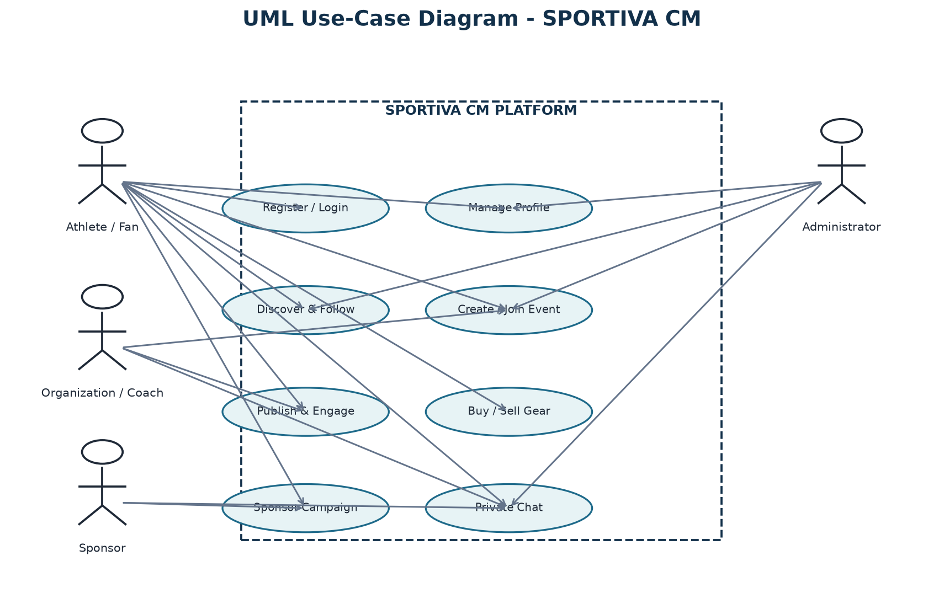
Figure 1. Use-case view of the SPORTIVA CM platform.
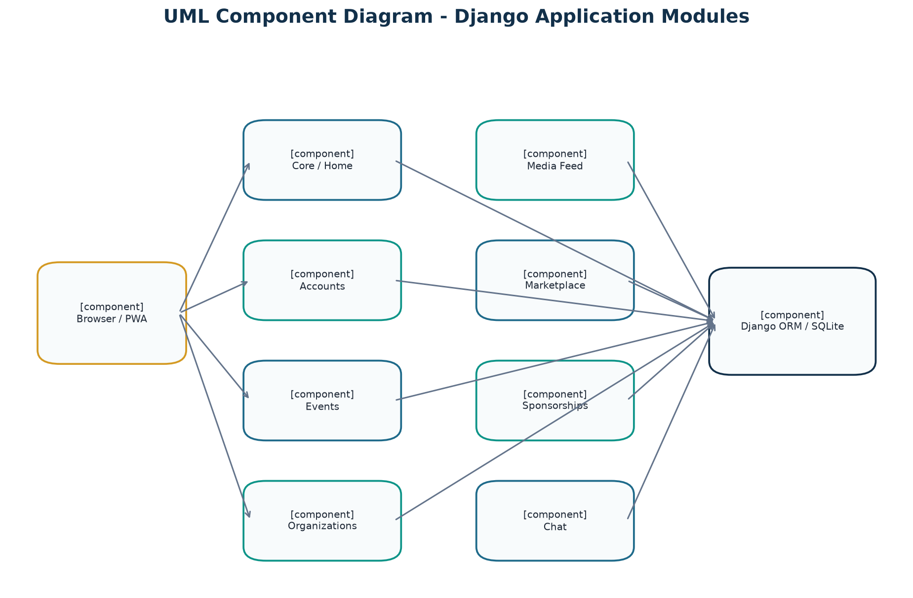
Figure 2. Component view of the modular Django architecture.
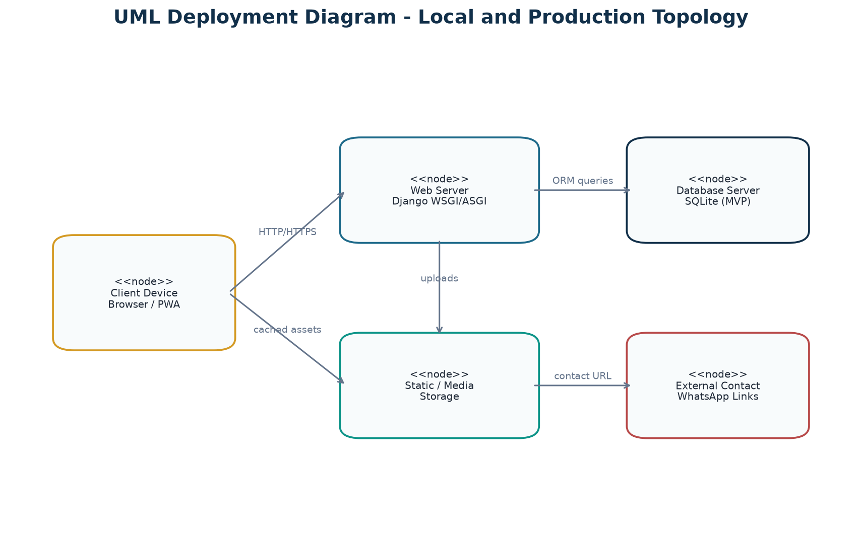
Figure 3. Deployment view for the current local MVP topology.

7. Data and Domain Analysis
The custom User entity is the central identity object. It participates in social relationships, event registration, content authorship, marketplace selling, sponsorship activity, and private messaging. Domain objects are separated into Django apps and connected through foreign keys, one-to-one relations, many-to-many relations, and unique constraints.
Entity | Key relationships and purpose
User | Central identity; owns profiles, posts, products, campaigns, proposals, and messages.
OrganizationProfile | Optional organization identity linked to a user; associated with events.
Event / EventRegistration | Event belongs to organizer, sport, category, and optionally organization; registrations link users to events uniquely.
Post / Comment / Like | Social content owned by users; comments and likes are dependent interactions.
Campaign / Pledge | Campaign belongs to creator and collects pledge records from sponsors.
SponsorshipRequest / Contract | Proposal workflow that can produce an active contract.
Conversation / ChatMessage | Private participant group and ordered messages with attachment/read state.
AthleteExploit / AthleteEndorsement | Achievement verification and community reputation signals.

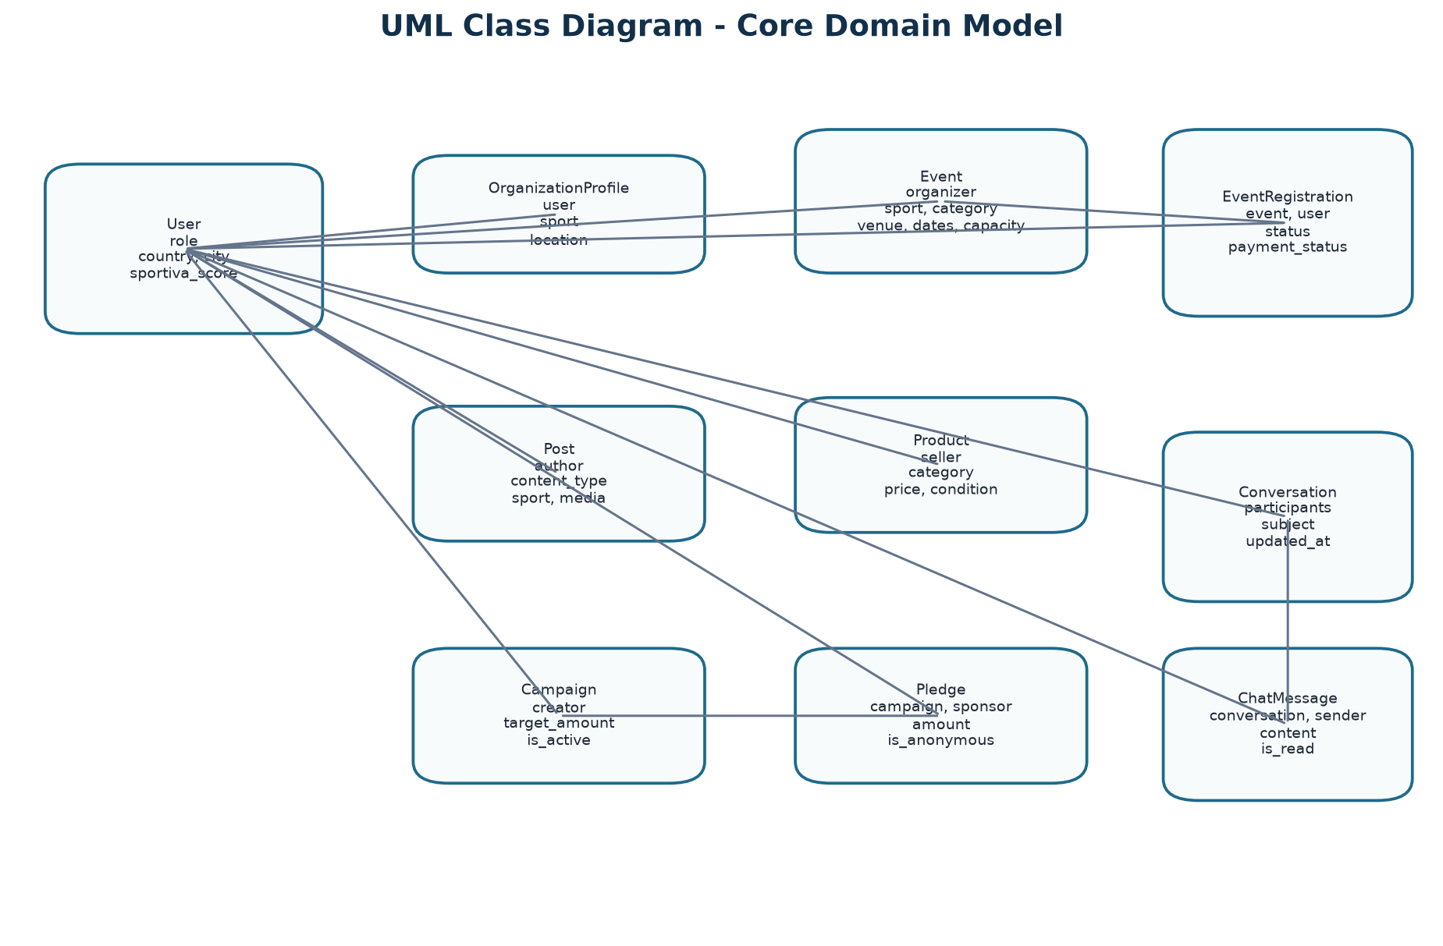
Figure 4. Core UML classes and principal associations.
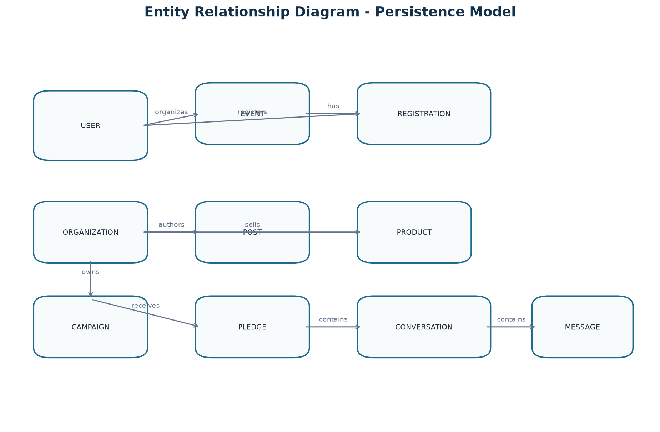
Figure 5. Entity relationship view of persistent platform records.

8. UML Behavioral Specifications

8.1 Event registration sequence
The browser requests event details, the view checks event availability and existing registrations, a valid registration is stored, and the invoice service generates a downloadable document. The current payment workflow records a status and does not connect to a payment gateway.
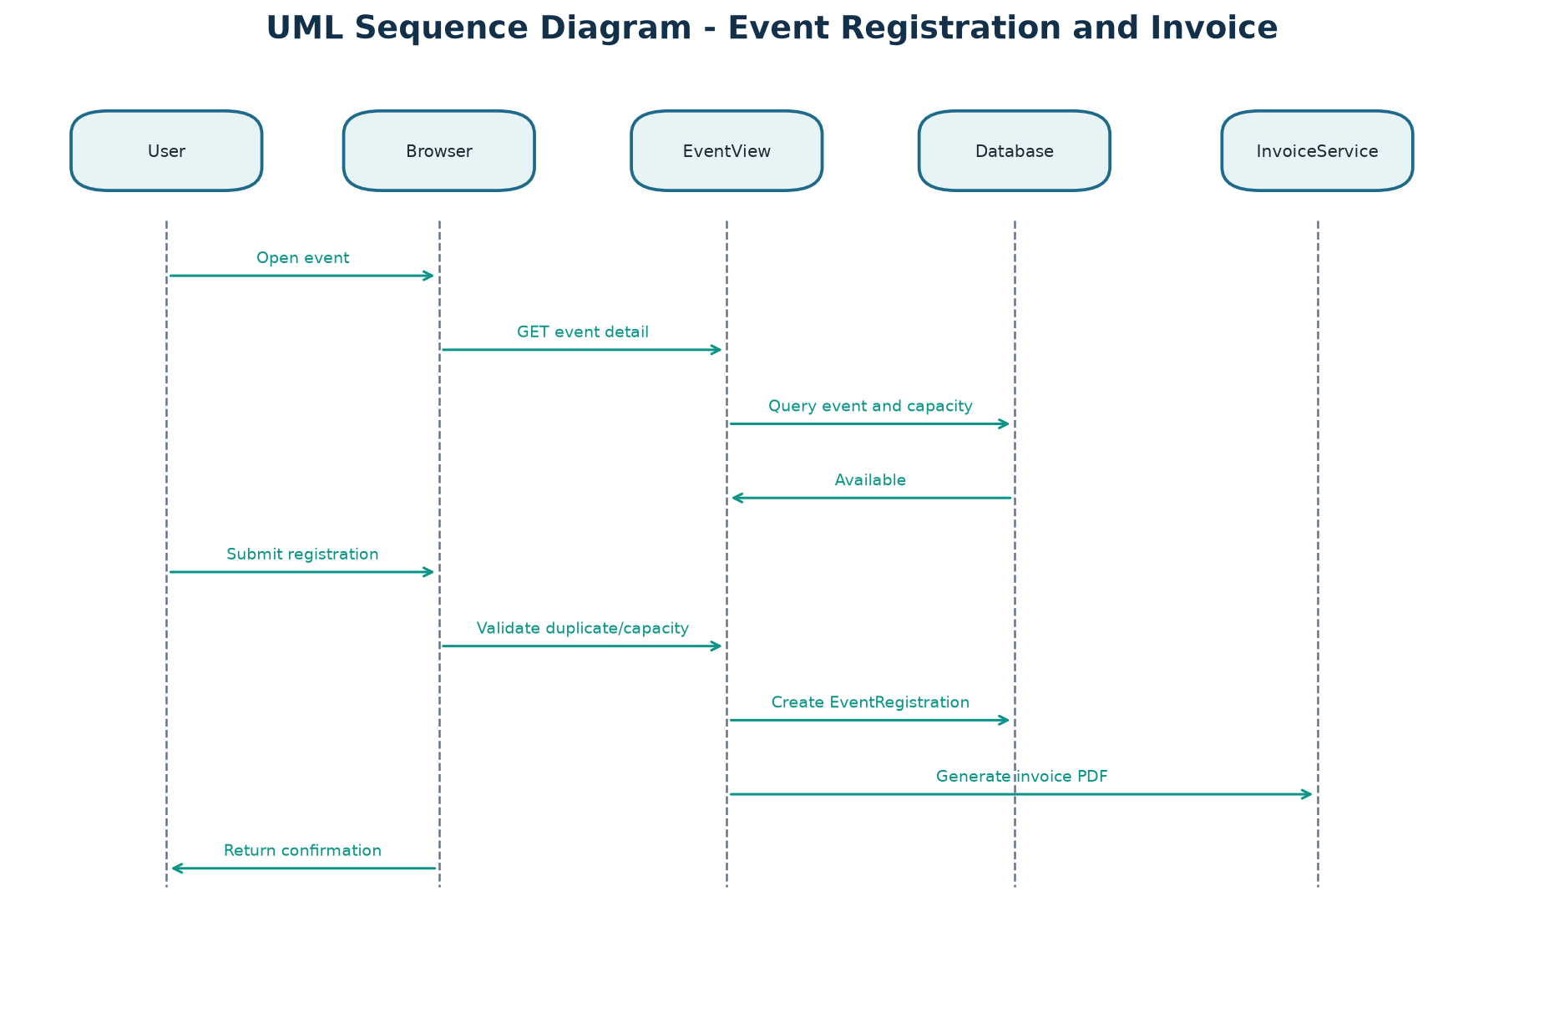
Figure 6. Sequence diagram for event registration and invoice generation.

8.2 Sponsorship proposal activity
A proposal is created, validated, reviewed by its recipient, and either declined with notification or accepted with contract creation. This represents the current application workflow and should be extended with audit history for production use.
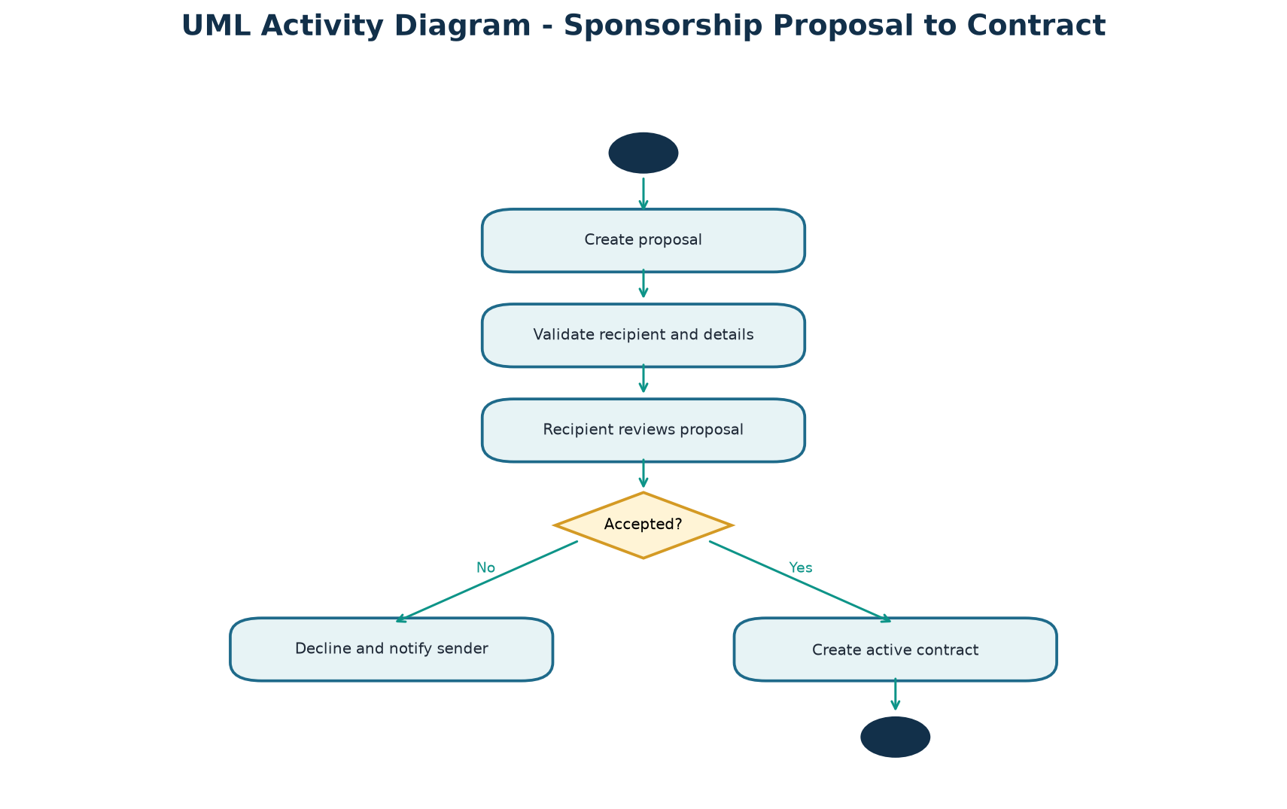
Figure 7. Activity diagram for sponsorship proposal handling.

8.3 Registration state machine
A registration moves from creation through validation to confirmation, cancellation, completion, or refund-related handling. The exact financial semantics depend on future payment integration.
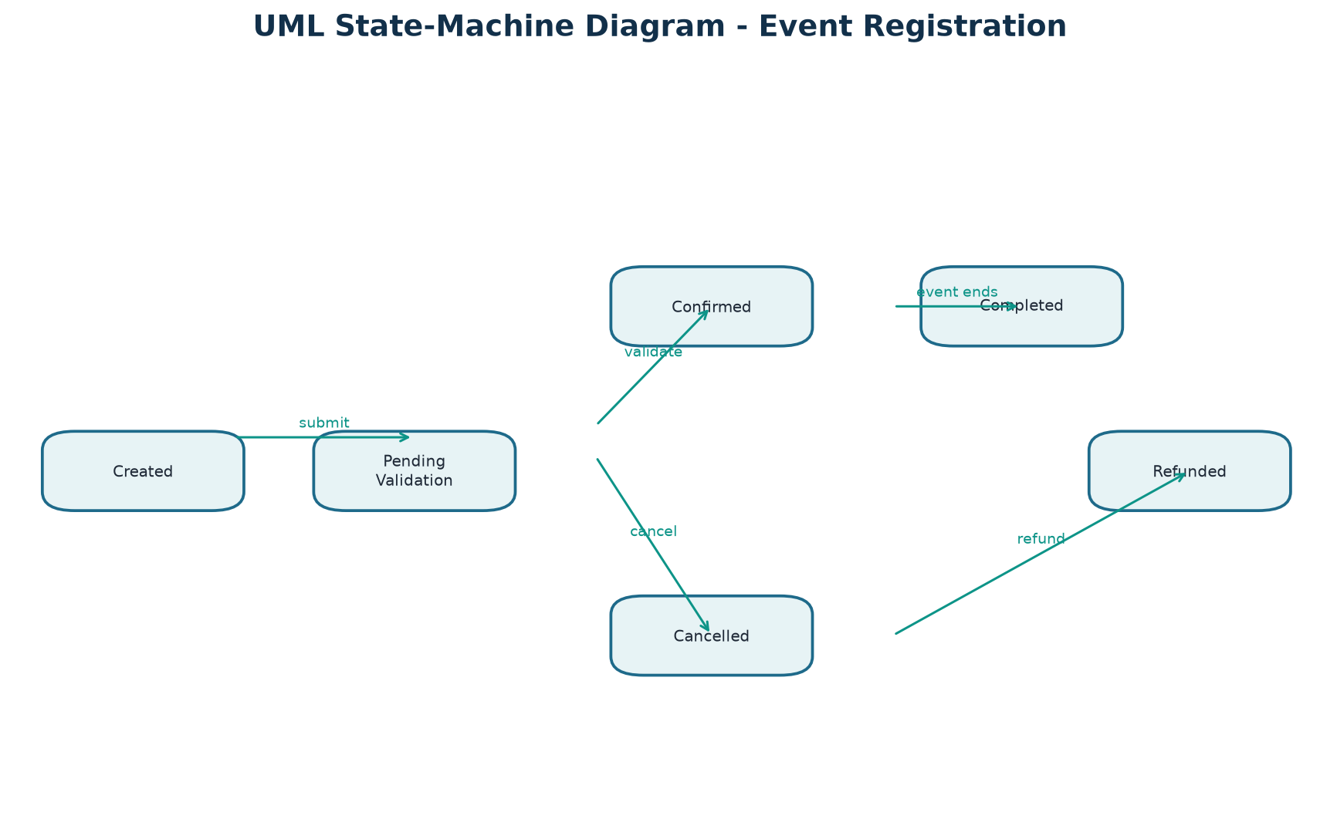
Figure 8. State-machine diagram for event registrations.
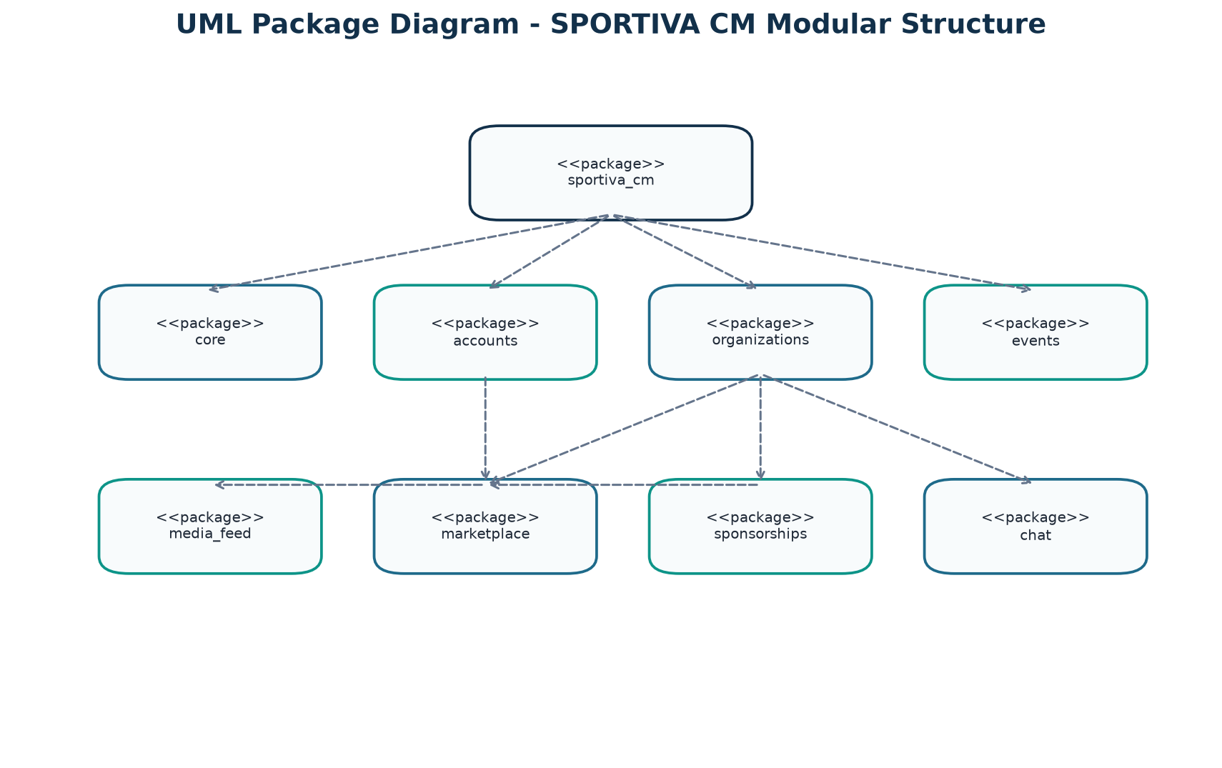
Figure 9. Package diagram showing Django application organization.

9. Interface and Route Specification
Area | Representative routes | Access
Home and PWA | /, /offline/, /sw.js, /manifest.json | Public
Accounts | /accounts/register/, /accounts/login/, /accounts/profile/ | Mixed / authenticated
Profiles | /profiles/, /accounts/profile/<username>/ | Public with protected mutations
Organizations | /organizations/ | Public with protected creation/editing
Events | /events/, /events/create/, /events/<id>/ | Public discovery; authenticated actions
Media | /media-feed/, /media-feed/create/, /media-feed/<id>/ | Public browsing; authenticated publishing
Marketplace | /marketplace/, /marketplace/sell/, /marketplace/<id>/ | Public browsing; authenticated selling
Sponsorships | /sponsorships/ and campaign/proposal routes | Authenticated workflows
Chat | /chat/, /chat/<conversation_id>/ | Authenticated participants only
API and admin | /api/sports-news/, /admin/ | Mixed / staff

10. Security, Privacy, and Operational Analysis

10.1 Implemented protections
- Django session authentication and custom user model.
- CSRF middleware and clickjacking protection.
- Django password validators for similarity, length, common passwords, and numeric-only passwords.
- Role-based tab access with staff and superuser override.
- Object-level checks for event registration, invoices, exploits, and chat participation.
- Unique constraints for event registrations, follows, and likes.
- Phone normalization before WhatsApp URL construction.

10.2 Production security gaps
- DEBUG currently defaults to True and ALLOWED_HOSTS defaults to wildcard behavior.
- A fallback development secret key exists and must be replaced through environment configuration.
- HTTPS, HSTS, secure cookies, CSP, rate limiting, upload scanning, and audit logging require production configuration.
- Local media storage and SQLite require replacement or hardening for scalable deployment.
- Email verification, password reset, moderation, abuse reports, and notification controls are not complete.

11. Installation, Deployment, and Maintenance

11.1 Local installation
The documented local workflow is: create a virtual environment, install Django/Pillow/form/API/filter dependencies, apply migrations, seed sample data, and run the development server.
python -m venv .venv
.venv\Scripts\activate
pip install django pillow django-crispy-forms crispy-tailwind djangorestframework django-filter
python manage.py migrate
python manage.py seed_data
python manage.py runserver

11.2 Production readiness requirements
- Use environment variables for SECRET_KEY, DEBUG, ALLOWED_HOSTS, database, email, and external services.
- Use PostgreSQL or another supported production database.
- Serve static files through a controlled web server/CDN and media through secure object storage.
- Configure HTTPS, secure cookies, HSTS, CSP, monitoring, backups, and log retention.
- Add dependency locking and continuous integration for migrations, checks, and tests.

12. Verification and Acceptance Criteria
ID | Acceptance criterion
AC-01 | A visitor can register, log in, view a profile, and update profile information.
AC-02 | An athlete can submit an exploit and an authorized verifier can approve or reject it.
AC-03 | An organizer can create an event and a user can register only once.
AC-04 | Capacity limits prevent additional confirmed registrations.
AC-05 | A registration can produce an invoice or entry-pass PDF.
AC-06 | A user can publish, like, comment on, and filter feed content.
AC-07 | A seller can publish a product and a visitor can contact the seller.
AC-08 | A campaign can receive a pledge record and display funding progress.
AC-09 | An accepted sponsorship proposal produces a contract record.
AC-10 | Only conversation participants can view private messages.
AC-11 | Previously visited pages can load through the offline cache and unavailable pages show the fallback.
AC-12 | Django checks and the automated test suite pass after dependencies are installed.

13. Testing Strategy
- Model tests: constraints, score calculations, relations, and status transitions.
- Form tests: required fields, invalid values, file handling, and validation feedback.
- View tests: authentication, authorization, redirects, filtering, and protected object access.
- Workflow tests: event registration, invoice generation, sponsorship proposal conversion, chat privacy, and feed interactions.
- Security tests: CSRF, upload restrictions, unauthorized access, and sensitive data exposure.
- PWA/browser tests: manifest, service-worker registration, cache behavior, and offline fallback.
- Usability tests: responsive layouts, language switching, keyboard navigation, and long translated strings.
Recommended commands: python manage.py check and python manage.py test. The current document describes the required test strategy; test execution should be recorded separately for each release.

14. Risks, Limitations, and Roadmap
Risk / limitation | Impact | Recommended response
Development security defaults | Potential exposure in public deployment | Harden settings and enforce environment configuration.
SQLite/local media | Limited concurrency, scaling, and resilience | Move to production database and managed media storage.
Simulated payments | No financial settlement or reconciliation | Integrate and audit a payment provider.
Cached-read offline mode | Users cannot reliably create data offline | Add a queued write/sync design with conflict handling.
Basic search and moderation | Lower discovery quality and governance | Add indexing, pagination, reporting, moderation, and audit tools.
Role overlap | Ambiguous permissions for managers and organizations | Define a permission matrix and separate roles where required.

15. Conclusion
SPORTIVA CM provides a coherent modular foundation for a sports promotion and community platform. Its strongest implemented capabilities are the domain separation across Django apps, role-aware user experience, event and sponsorship workflows, community interaction, and PWA-oriented access. The next engineering priority is production hardening: secure configuration, dependable payment and notification integrations, stronger automated verification, and scalable infrastructure.

Appendix A - Source and Evidence Basis
- README.md and SPORTIVA_USER_GUIDE.md for product goals and user workflows.
- sportiva_cm/settings.py and sportiva_cm/urls.py for configuration and route boundaries.
- accounts, organizations, events, media_feed, marketplace, sponsorships, chat, and core apps for implemented domain behavior.
- Django migrations for persisted schema history.
- Static manifest, service worker, templates, and JavaScript for PWA and interface behavior.
- The generated diagrams in DEFENSE/prsd_diagrams are aligned to the current implementation rather than legacy generic figures.

