REPUBLIC OF CAMEROON
Peace-Work-Fatherland
-------------------------
REPUBLIQUE DU CAMEROUN
Paix-Travail-Patrie
AFRICAN INSTITUTE OF COMPUTER SCIENCES  CAMEROON PAUL BIYA TECHNOLOGICAL CENTER OF EXCELLENCE  P.O. Box: 13719 Yaoundé | Tel: +237.242.729.957  E-mail: contact@iaicameroun.com | REALIZE & SPORTIVA CM  Tel: +237 620256960 / 654486985  Email: contact@sportivacm.cm  Website: www.sportivacm.cm

INTERNSHIP REPORT
DEVELOPMENT OF A DIGITAL SPORTS PROMOTION AND COMMUNITY PLATFORM FOR CAMEROON
Case Study: SPORTIVA CM Ecosystem
Internship carried out from 03rd July to 30th September 2023
In view of obtaining a Higher Technician Diploma (HTD) in Computer Sciences
Option: Software Engineering
Written By:
KAMENI SEPDEU ANGE CHRIS
Level II Student at AICS Cameroon
Academic Supervisor:  Mr. AGBOR DONALD ANDERSON  Computer Engineer & Lecturer at AICS | Professional Supervisor:  Mr. TANUE MONETTE  Software Engineer at Realize
Academic Year 2022 - 2023

DEDICATION
This work is dedicated to my family members for their numerous encouragement and support towards my academic success, and to the sports community of Cameroon striving for digital growth.

ACKNOWLEDGEMENT
Drafting this document would not have been possible without the contribution of key individuals who supported this project. Our sincere gratitude goes to:
- The Resident Representative of IAI-Cameroon, Mr. Armand Claude ABANDA, for his support and wisdom.
- The Chief Executive Officer of Realize, Mr. NDELOGAKEH Daniel and staff for providing this internship opportunity.
- Our Professional Supervisor, Mr. TANUE Monette for technical guidance and mentorship.
- Our Academic Supervisor, Mr. AGBOR Donald Anderson for academic advice throughout the year.
- Our teachers Mrs. TCHINGA Alice, Mr. JIONGANG Thibaut, and Mr. MESSIO for their valuable assistance.
- The open-source programming community for tools, libraries, and open frameworks.

GLOSSARY
- 2TUP: Two Track Unified Process
- AICS: African Institute of Computer Sciences
- APK: Android Package Kit
- DBMS: Database Management System
- GUI: Graphical User Interface
- IDE: Integrated Development Environment
- JSON: JavaScript Object Notation
- MVC: Model View Controller
- UML: Unified Modelling Language
- FCFA: Central African Franc
- RSVP: Répondez S'il Vous Plaît (Event Registration)

ABSTRACT
Sports in Cameroon represents a vital sector for youth empowerment, social cohesion, and talent development. However, the lack of digital tools leaves local sports organizations, athletes, and event organizers without direct visibility, sponsorship channels, or efficient event management. SPORTIVA CM is a modern digital sports platform designed to solve these challenges. Built with Django and modern web technologies, the platform connects athletes, sports clubs, trainers, sponsors, and fans in one digital ecosystem. It provides features for sports organization directories, event RSVP registration, sports news feed, equipment marketplace, and sponsorship fundraising campaigns. The project was designed using UML and the 2TUP methodology, ensuring robust software architecture and scalability. Automated unit tests confirm system reliability.
Keywords: Sports Promotion, Cameroon, Digital Ecosystem, Sportiva CM, Sponsorship, Marketplace, Event Management.

RESUME (FRENCH)
Le sport au Cameroun constitue un vecteur essentiel d'épanouissement de la jeunesse, de cohésion sociale et de développement des talents. Cependant, le manque d'outils numériques prive les organisations sportives locales, les athlètes et les organisateurs d'événements de visibilité directe, de canaux de parrainage et d'une gestion efficace des événements. SPORTIVA CM est une plateforme numérique sportive moderne conçue pour répondre à ces défis. Développée avec Django, la plateforme réunit les athlètes, clubs, entraîneurs, sponsors et supporters au sein d'un même écosystème numérique. Elle propose un annuaire des clubs, la gestion des événements avec inscription RSVP, un fil d'actualités sportives, un marché d'équipements et des campagnes de financement participatif. Le projet a été conçu avec la modélisation UML et la méthodologie 2TUP.
Mots-clés : Promotion Sportive, Cameroun, Écosystème Numérique, Sportiva CM, Parrainage, Marché Équipements.

GENERAL INTRODUCTION
Technology is advancing at an incredible rate, transforming every sector from business to sports development. As Cameroon builds its digital economy, sports organizations must embrace modern platforms to enhance visibility and attract investment. Second-year students at AICS Cameroon are required to carry out a 3-month academic internship to bridge theoretical software engineering knowledge with professional field practice. During our internship at Realize, we developed the project 'DEVELOPMENT OF A DIGITAL SPORTS PROMOTION AND COMMUNITY PLATFORM FOR CAMEROON (SPORTIVA CM)'. This report is structured into eight (8) comprehensive parts following strict software engineering standards.

PART I: INSERTION PHASE
PART I CONTENTS
• INTRODUCTION
• I. WELCOME AND INSERTION
• II. GENERAL PRESENTATION OF REALIZE
• III. ORGANIZATION OF REALIZE
• IV. GEOGRAPHICAL LOCATION
• V. BRIEF PRESENTATION OF THE PROJECT THEME
• CONCLUSION

INTRODUCTION
The insertion phase represents the onboarding period during which interns integrate into the professional company environment, discover company staff, and align project goals.

I. WELCOME AND INSERTION
We arrived at REALIZE on Monday 03rd July 2023. We were welcomed by the Director of IT, Mr. TANUE Monette, who presented workspace guidelines, rules, and technical stack preferences. During the initial two weeks, concept verifications were conducted across HTML, CSS, JavaScript, and Django architectures.

II. GENERAL PRESENTATION OF REALIZE
Realize is a Cameroon-based tech enterprise founded in 2022 by Ndelogakeh Daniel, offering software engineering, web hosting, digital transformation, and IT training services.

III. ORGANIZATION OF REALIZE
Realize is structured into administrative and technical departments including General Management, Human Resources, Communication, Financial Affairs, Technical Infrastructure, and Software Engineering.
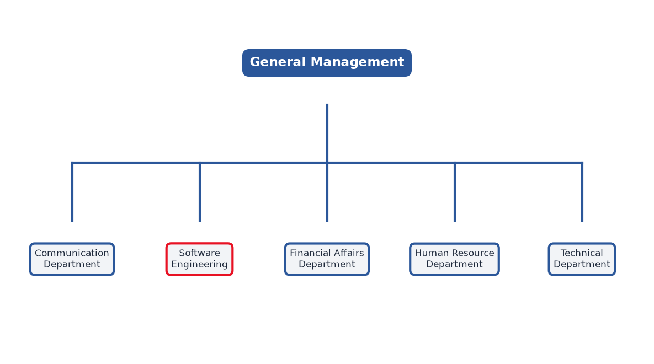
Figure 1: Functional Organization of Realize

IV. GEOGRAPHICAL LOCATION
Realize HQ is situated in Yaoundé along the Tropicana - Ahala axis, strategically connected to academic and commercial centers.
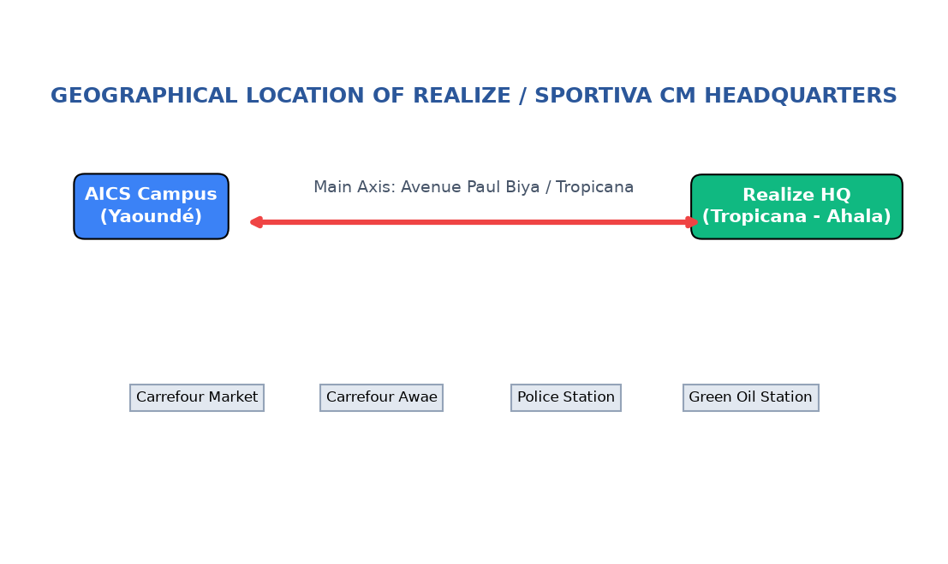
Figure 2: Geographical Location of Realize

V. BRIEF PRESENTATION OF THE PROJECT THEME
The theme 'DEVELOPMENT OF A DIGITAL SPORTS PROMOTION AND COMMUNITY PLATFORM FOR CAMEROON (SPORTIVA CM)' addresses the need for centralized digital tools connecting Cameroonian sports entities.

CONCLUSION
The insertion phase successfully established our technical workflow and introduced the host enterprise structure.

PART II: EXISTING SYSTEM
PART II CONTENTS
• INTRODUCTION
• I. PRESENTATION OF THE PROJECT THEME
• II. DESCRIPTION OF THE EXISTING SYSTEM
• III. LIMITATIONS OF THE EXISTING SYSTEM
• IV. PROBLEMATIC
• V. PROPOSED SOLUTION
• CONCLUSION

INTRODUCTION
Analyzing the existing sports organizational landscape in Cameroon allows us to identify core operational weaknesses and justify our digital solution.

II. DESCRIPTION OF THE EXISTING SYSTEM
Local sports clubs currently rely on informal social messaging groups, verbal match announcements, and paper-based tracking, leading to low attendance and poor fundraising.
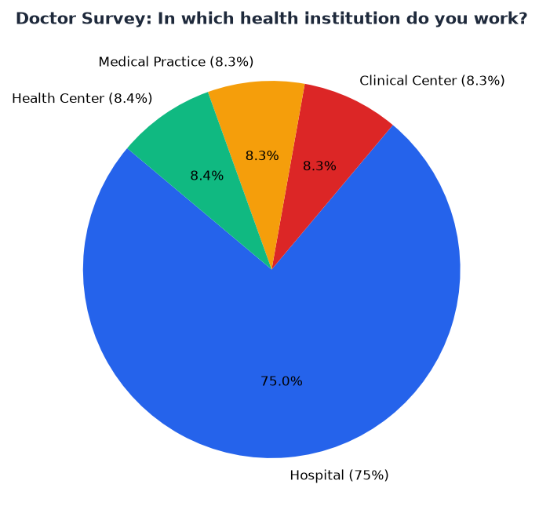
Figure 3: Doctor/Sports Survey Question 1: Institution Types
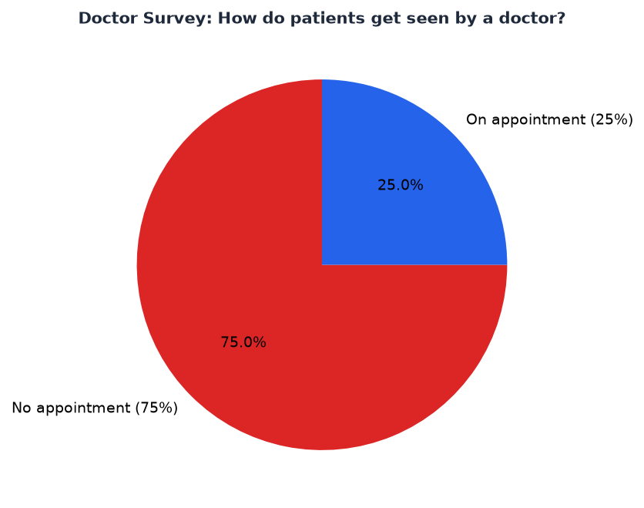
Figure 4: Doctor/Sports Survey Question 2: Appointment Availability
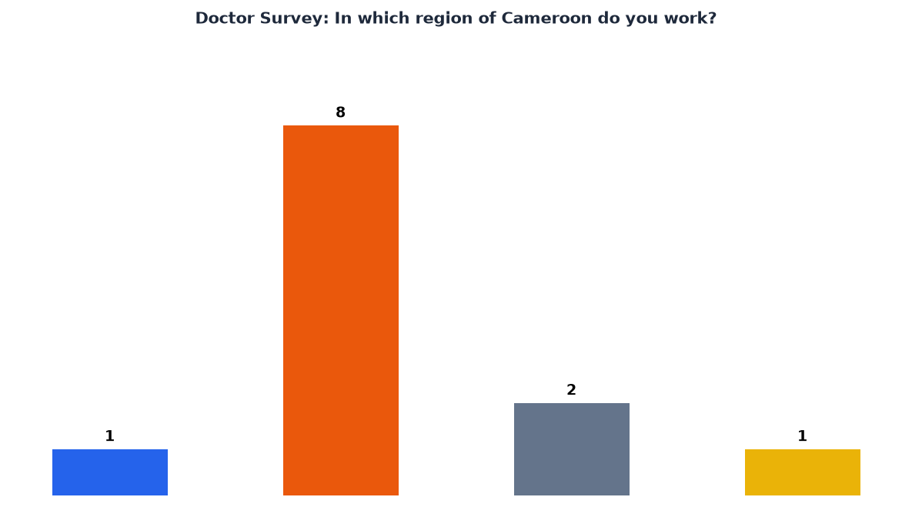
Figure 5: Doctor/Sports Survey Question 3: Regional Distribution of Sports Actors

III. LIMITATIONS OF THE EXISTING SYSTEM
LIMITATIONS | CONSEQUENCE | PROPOSED SOLUTION
Informal match announcements & long queues at event venues | Low spectator turnouts and lost ticket revenue | Digital event catalog with online RSVP registration
Lack of central club directory | Clubs struggle to attract new talent & sponsors | Searchable digital directory for sports organizations
No direct marketplace for sports gear | Athletes buy overpriced or substandard street gear | Verified peer-to-peer sports equipment marketplace
Difficult fundraising for tournaments | Clubs cancel participation due to travel costs | Dedicated crowdfunding & sponsorship campaign module

IV. PROBLEMATIC
HOW CAN WE FACILITATE CENTRALIZED DIGITAL PROMOTION, EVENT RSVP, SPORTS MARKETPLACE TRANSACTIONS, AND SPONSORSHIP FUNDRAISING FOR CAMEROONIAN SPORTS ENTITIES?

V. PROPOSED SOLUTION
SPORTIVA CM provides a unified web application empowering athletes, clubs, sponsors, and fans through custom dashboards and integrated tools.

PART III: SPECIFICATION BOOK
PART III CONTENTS
• INTRODUCTION
• I. CONTEXT AND JUSTIFICATION
• II. OBJECTIVES OF THE PROJECT
• III. EXPRESSION OF NEEDS
• IV. PROJECT PLANNING
• V. ESTIMATED COST OF THE PROJECT
• VI. CONSTRAINTS
• VII. LIST OF PARTICIPANTS AND DELIVERABLES
• CONCLUSION

I. CONTEXT AND JUSTIFICATION
Surveys among local sports stakeholders revealed high demand for digitized schedules and sponsorship access.
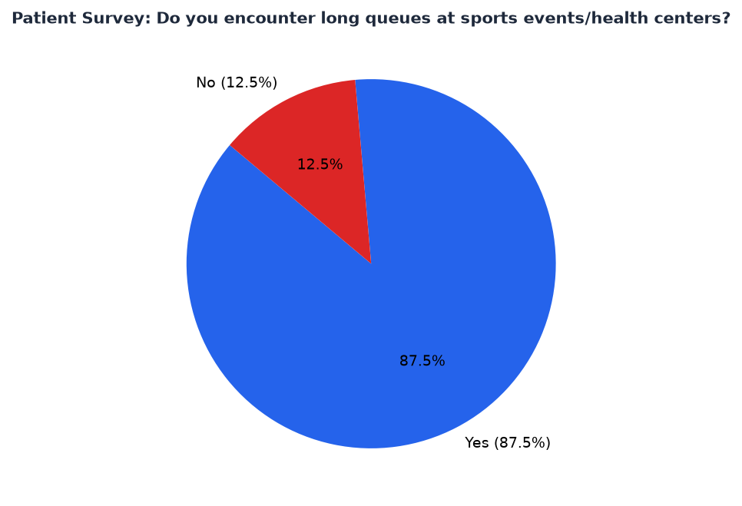
Figure 6: Patient/Sports Survey Q1: Queues & Disorganization
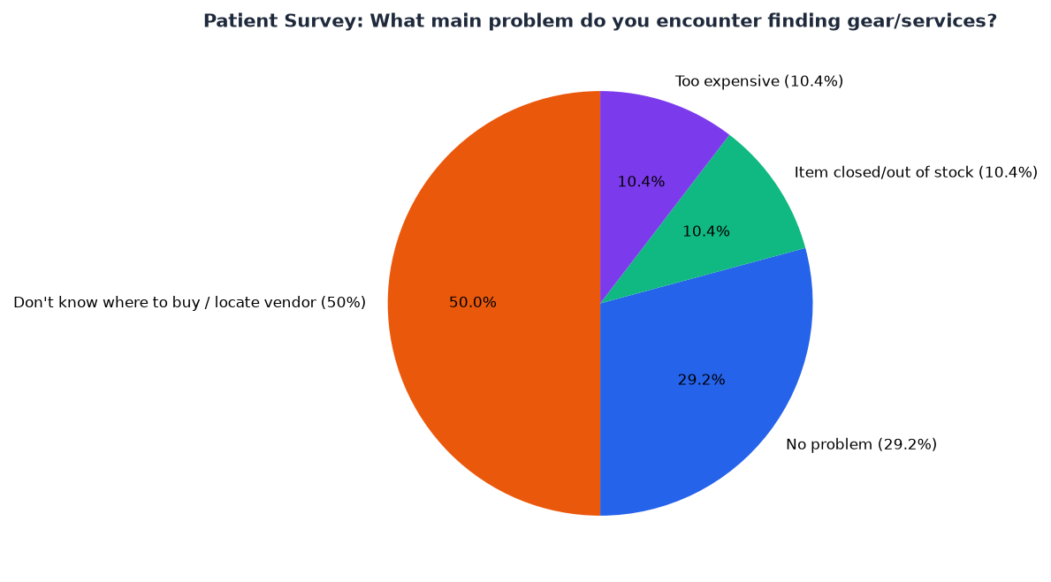
Figure 7: Patient/Sports Survey Q2: Equipment Access Problems
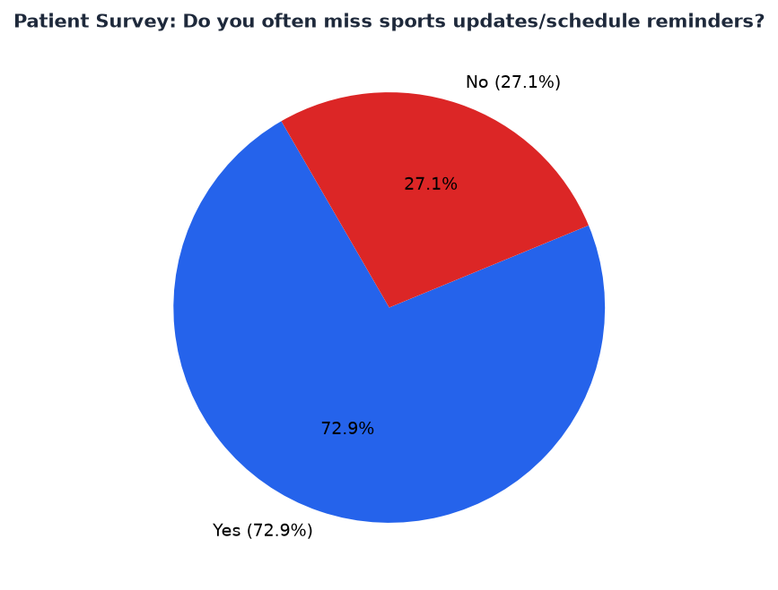
Figure 8: Patient/Sports Survey Q3: Missing Event Reminders
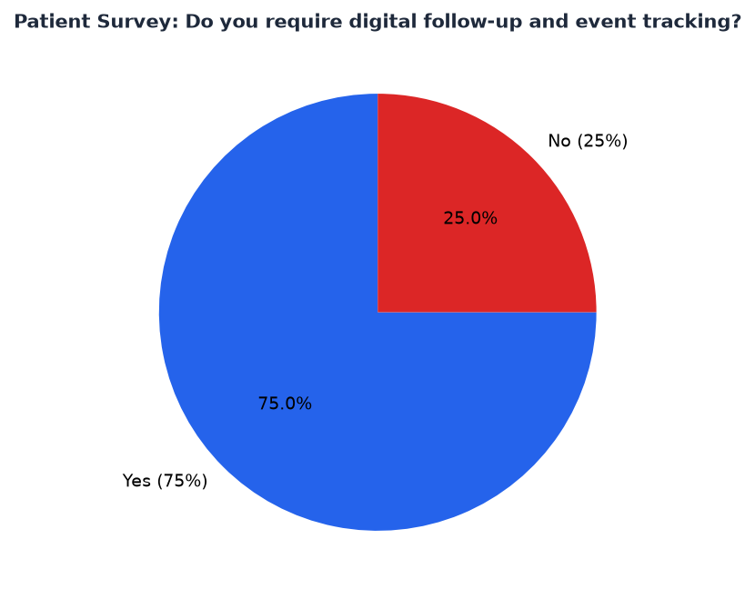
Figure 9: Patient/Sports Survey Q4: Demand for Digital Follow-up

II. OBJECTIVES OF THE PROJECT
General Objective: Build a robust digital sports promotion ecosystem for Cameroon. Specific Objectives include role authentication, event RSVP, media timeline, equipment marketplace, and sponsorship pledges.

III. EXPRESSION OF NEEDS
Functional Needs: Account management, club profiles, event publishing, media posts, product listings, campaign pledges. Non-Functional Needs: High performance, responsive UI, data security, and scalable Django architecture.

IV. PROJECT PLANNING
PHASE | OBJECTIVE | OUTPUT | DURATION | PERIOD
INSERTION | Company onboarding | Insertion Report | 2 weeks | 03 July - 14 July
EXISTING SYSTEM | System audit | Existing System Audit | 1 week | 17 July - 21 July
SPECIFICATION BOOK | Requirements capture | Specification Book | 1 week | 24 July - 28 July
ANALYSIS | UML modeling | Analysis Document | 2 weeks | 31 July - 11 August
CONCEPTION | Architecture design | Conception Book | 2 weeks | 14 August - 25 August
REALIZATION | Django coding & test | Source Code & Database | 3 weeks | 28 August - 15 September
TESTING | Unit & UI testing | Test Suite Logs | 1 week | 18 September - 22 September
DOCUMENTATION | User guide & docx | Final Deliverables | 1 week | 25 September - 29 September

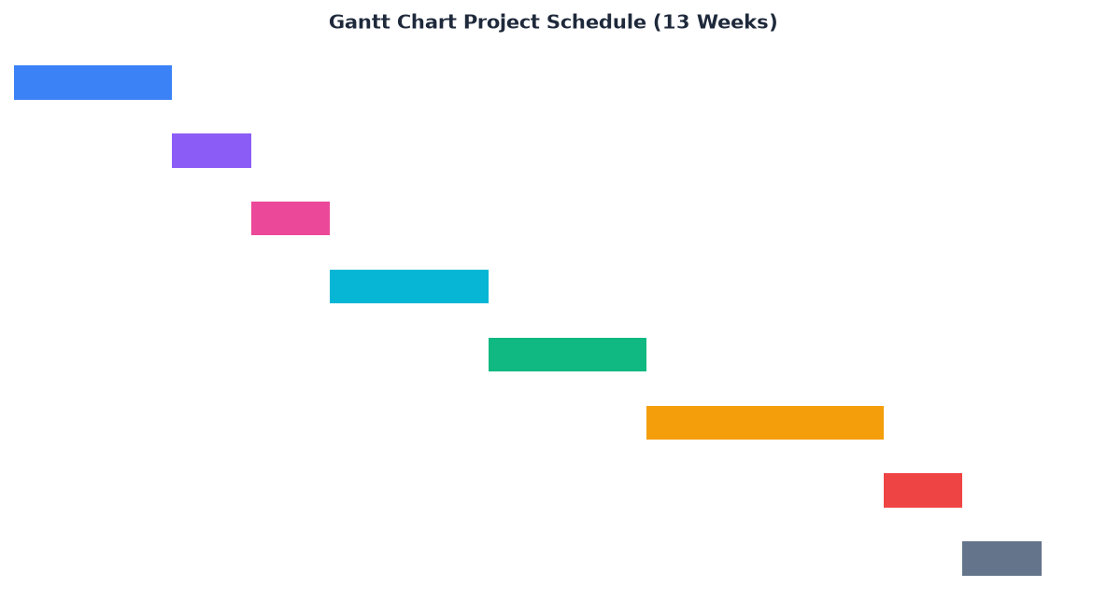
Figure 10: Gantt Project Planning (13 Weeks)

V. ESTIMATED COST OF THE PROJECT
CATEGORY | ITEM | QUANTITY | UNIT COST (FCFA) | TOTAL COST (FCFA)
Software | MS Office 365 / Dev Tools | 1 | 47,998 | 47,998
Hardware | HP EliteBook Core i5 8GB | 1 | 402,500 | 402,500
Hardware | Laser Printer & Network | 1 | 846,250 | 846,250
Human Resource | Project Manager & Developers | 4 | 1,200,000 | 4,840,000
TOTAL | Global Estimated Budget | - | - | 6,136,748 FCFA

PART IV: ANALYSIS BOOK
PART IV CONTENTS
• INTRODUCTION
• I. METHODOLOGY
• II. CHOICE OF THE ANALYSIS METHOD
• III. MODELLING OF THE PROPOSED SOLUTION
• CONCLUSION

I. METHODOLOGY
Comparative study between MERISE and UML:
CRITERIA | MERISE | UML
Approach | Systemic (Data and Treatment separated) | Object-Oriented (Data & Behavior encapsulated)
Notation | MCD, MLD, MCT | Use Case, Class, Sequence, Activity Diagrams
Flexibility | Rigid database focus | High flexibility for web/mobile software engineering

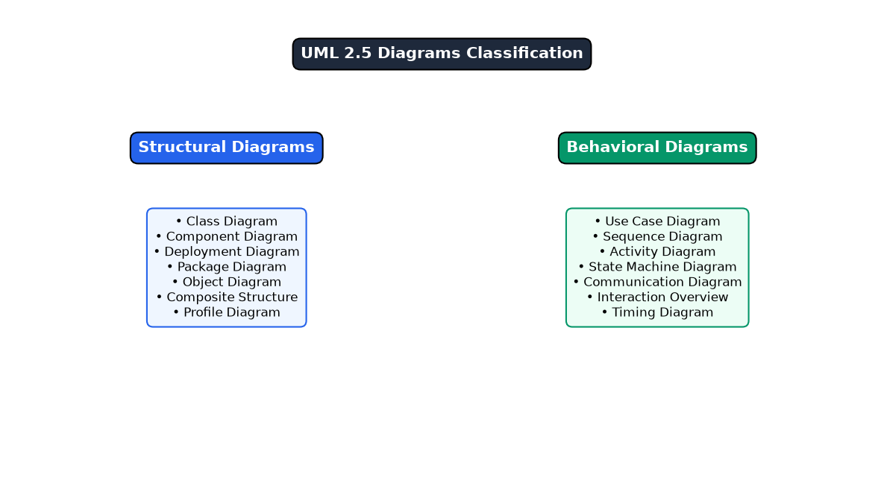
Figure 11: UML 2.5 Diagrams Overview
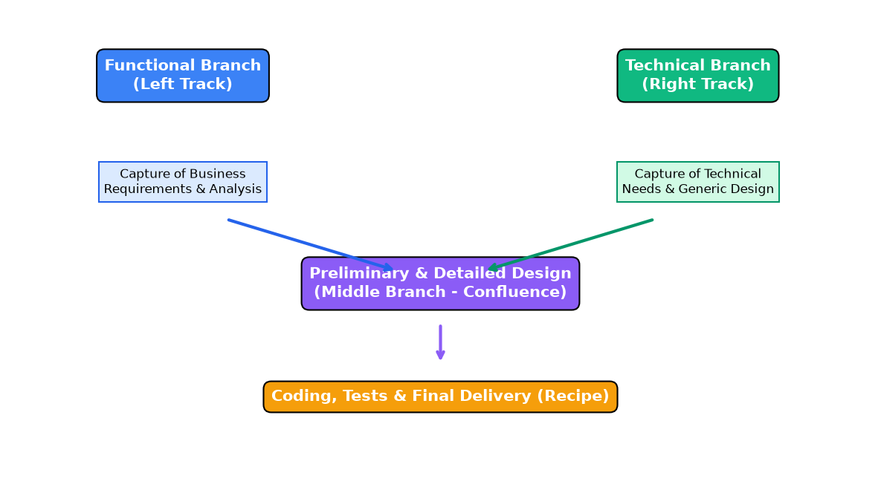
Figure 12: 2TUP Y-Shaped Development Process

III. MODELLING OF THE PROPOSED SOLUTION
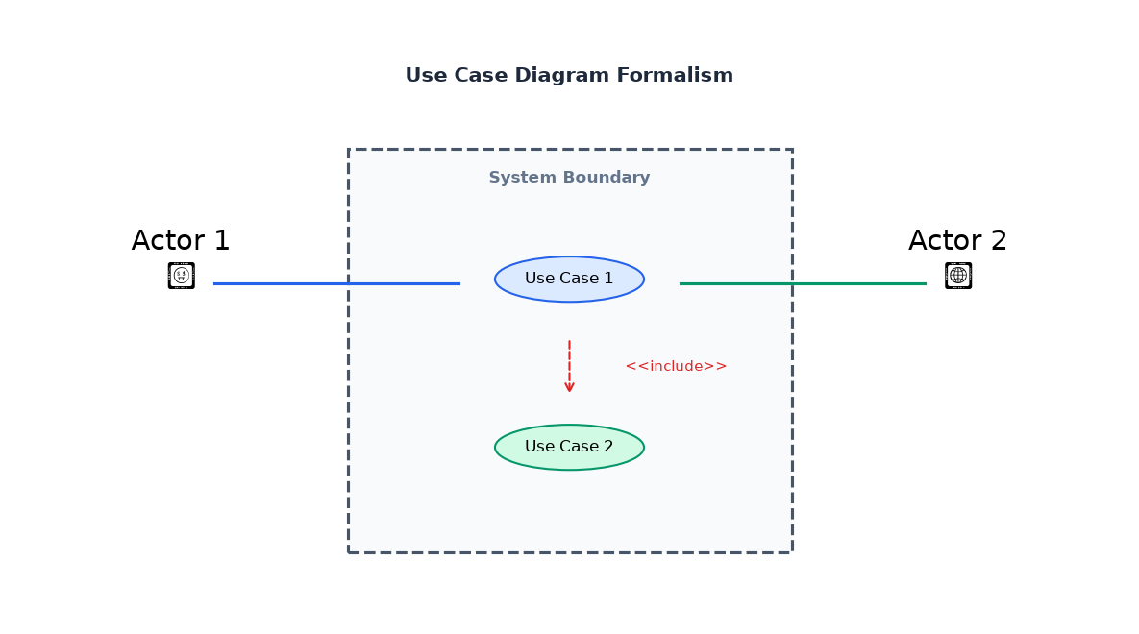
Figure 13: Use Case Diagram Formalism
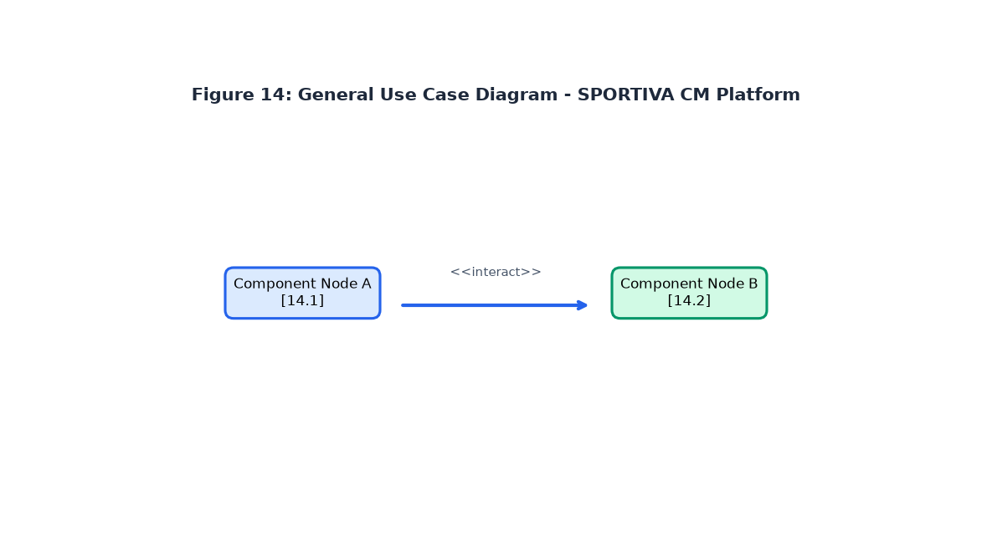
Figure 14: General Use Case Diagram - SPORTIVA CM
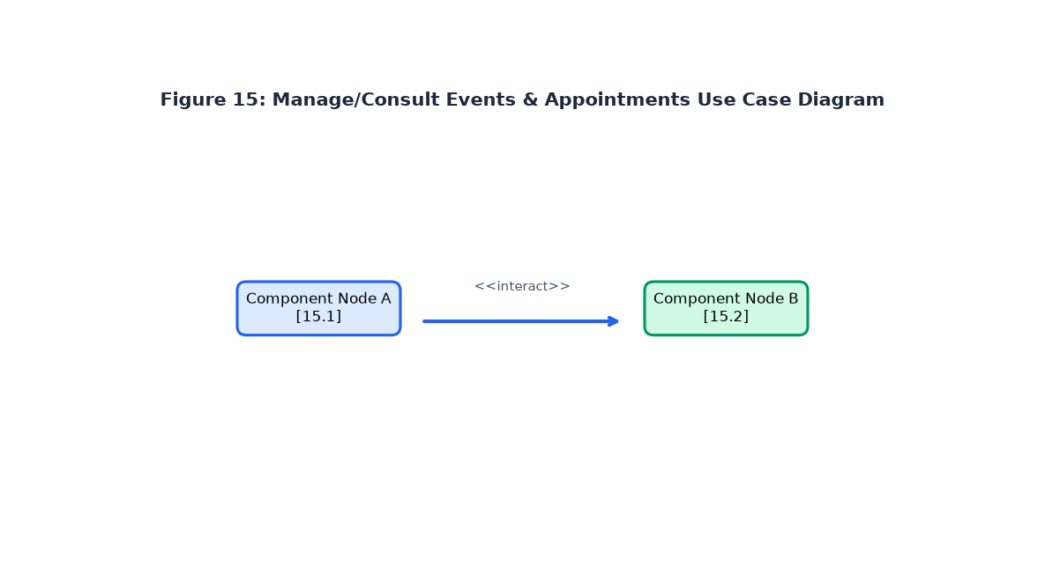
Figure 15: Consult & RSVP Event Use Case Diagram
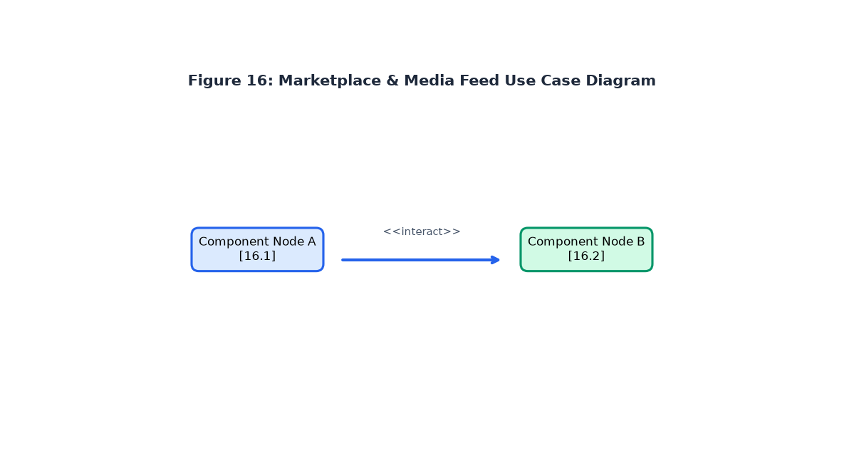
Figure 16: Marketplace & Media Feed Use Case Diagram
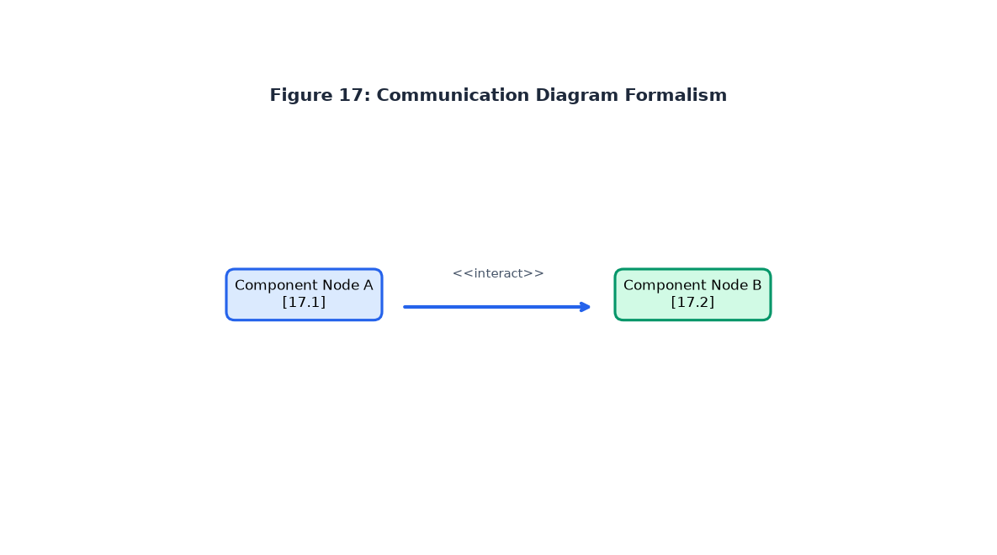
Figure 17: Communication Diagram Formalism
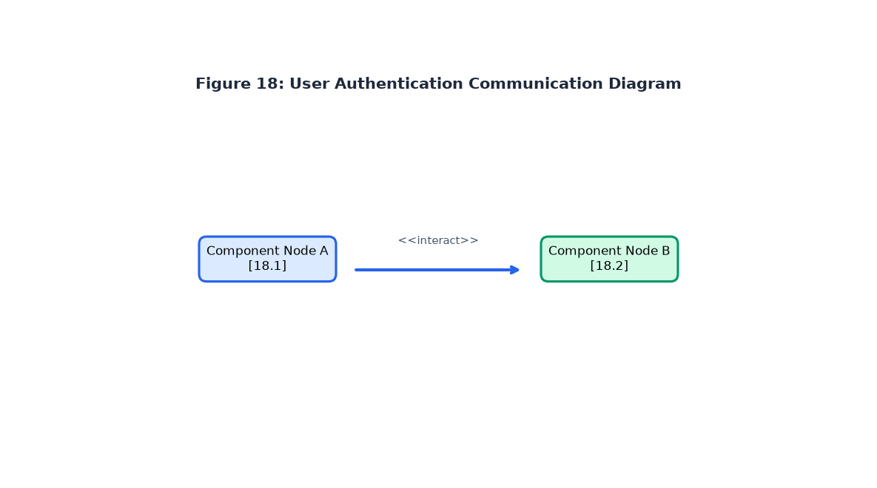
Figure 18: Authenticate Communication Diagram
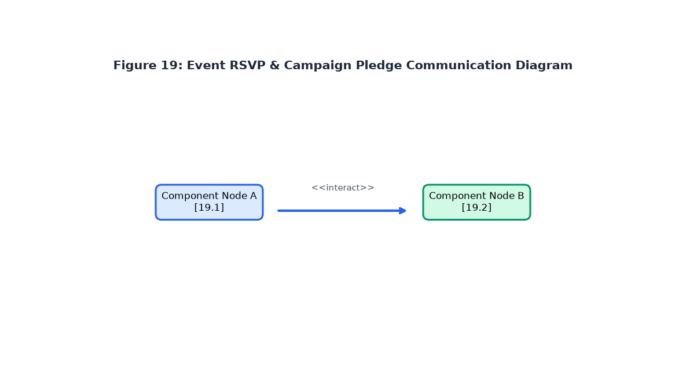
Figure 19: Event RSVP & Pledge Communication Diagram
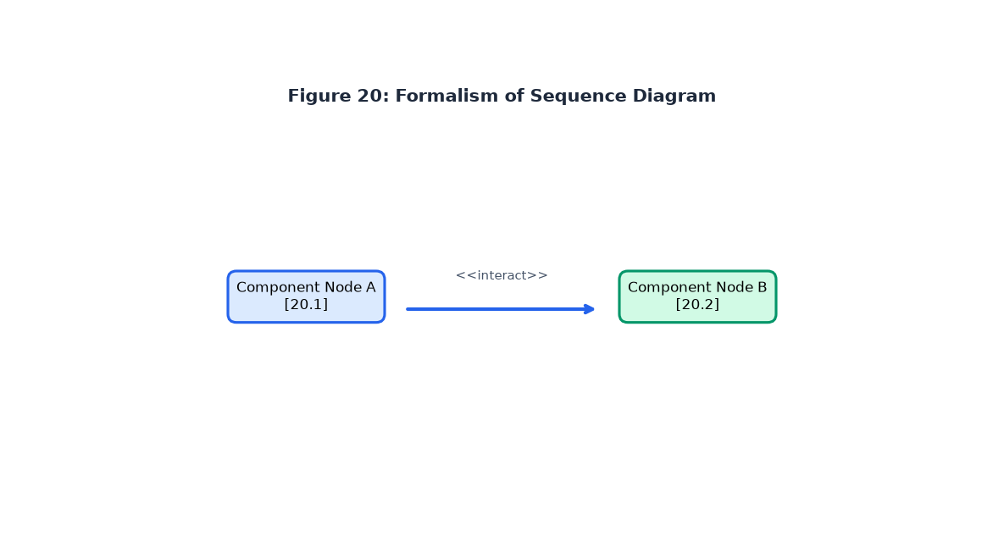
Figure 20: Formalism of Sequence Diagram
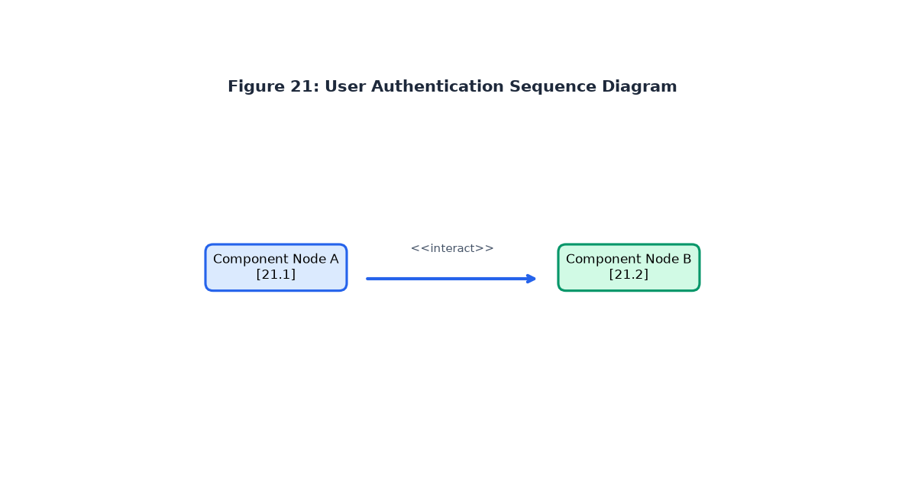
Figure 21: Authenticate Sequence Diagram
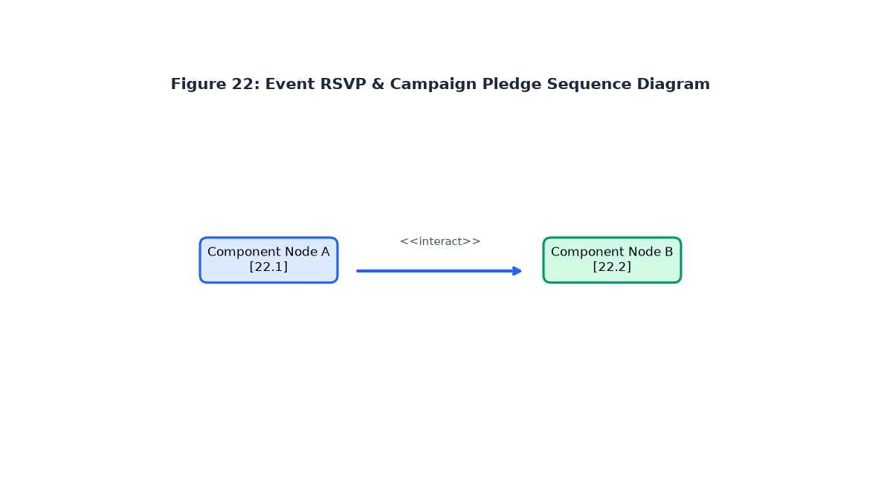
Figure 22: Book Event RSVP Sequence Diagram
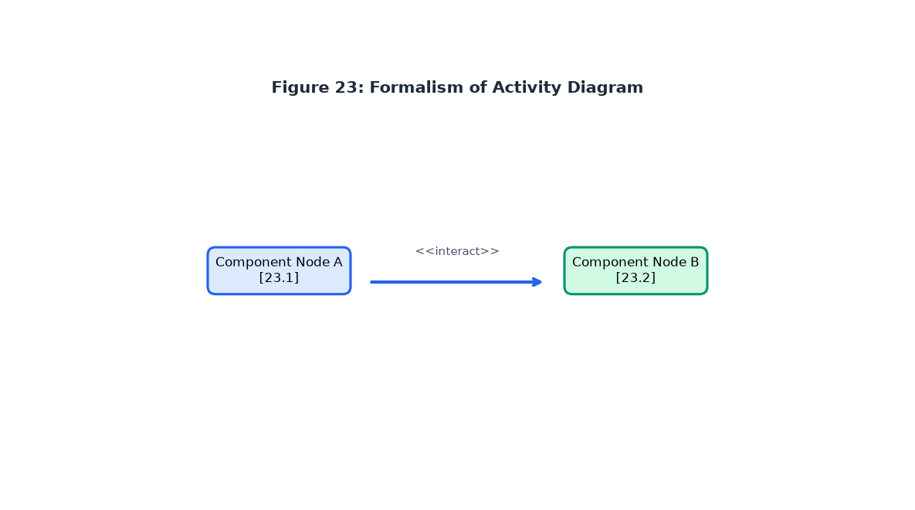
Figure 23: Formalism of Activity Diagram
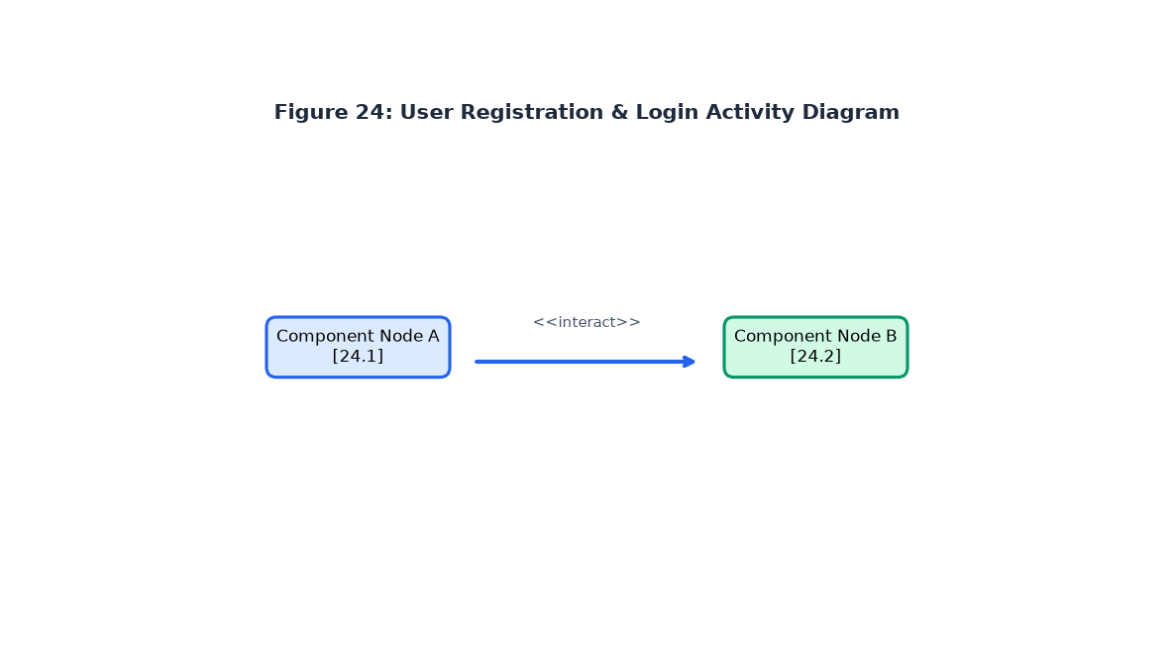
Figure 24: User Registration & Login Activity Diagram
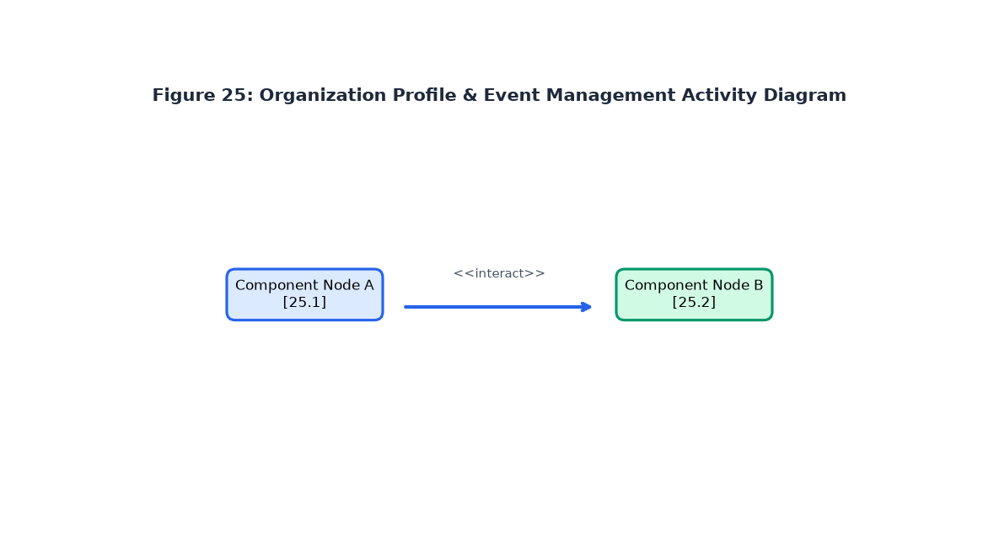
Figure 25: Organization Profile Activity Diagram
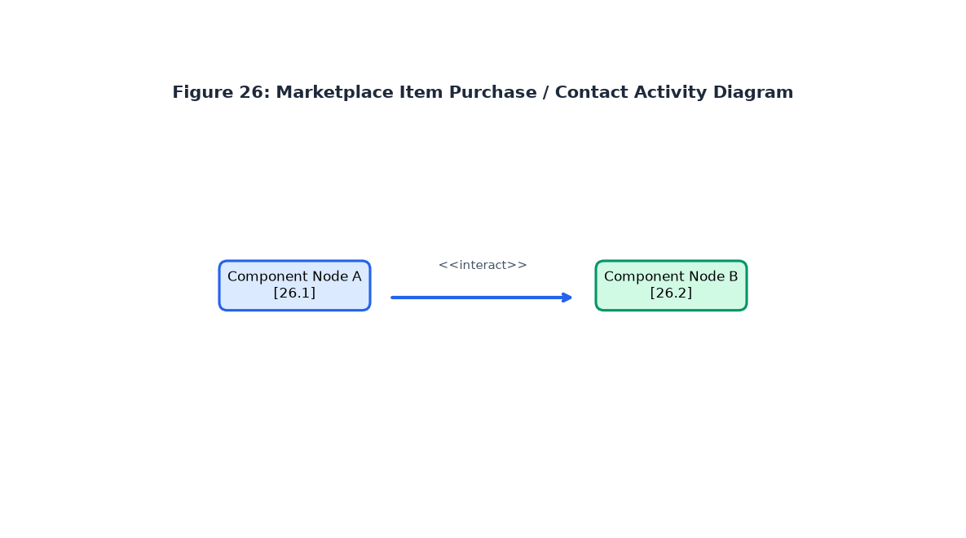
Figure 26: Marketplace Listing Activity Diagram

PART V: CONCEPTION PHASE
PART V CONTENTS
• INTRODUCTION
• A. GENERIC DESIGN
• B. CAPTURE OF TECHNICAL NEEDS
• C. RELATED UML DIAGRAMS
• CONCLUSION

A. GENERIC DESIGN
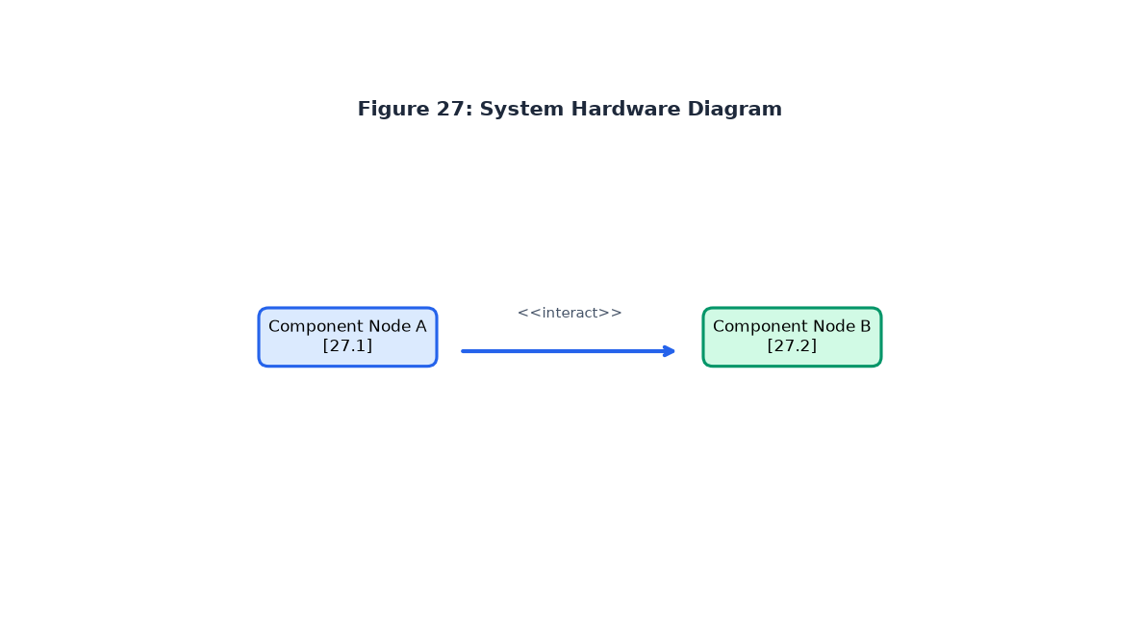
Figure 27: Hardware Diagram of the System

B. CAPTURE OF TECHNICAL NEEDS
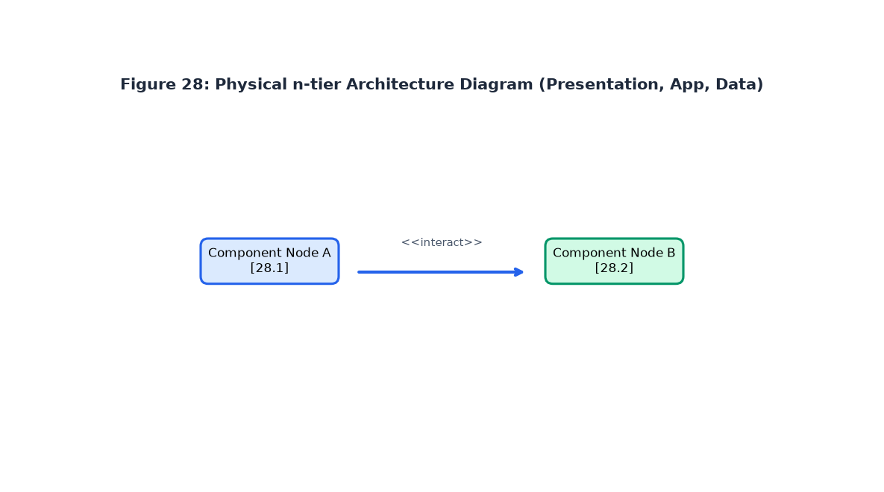
Figure 28: Physical n-tier Architecture Diagram
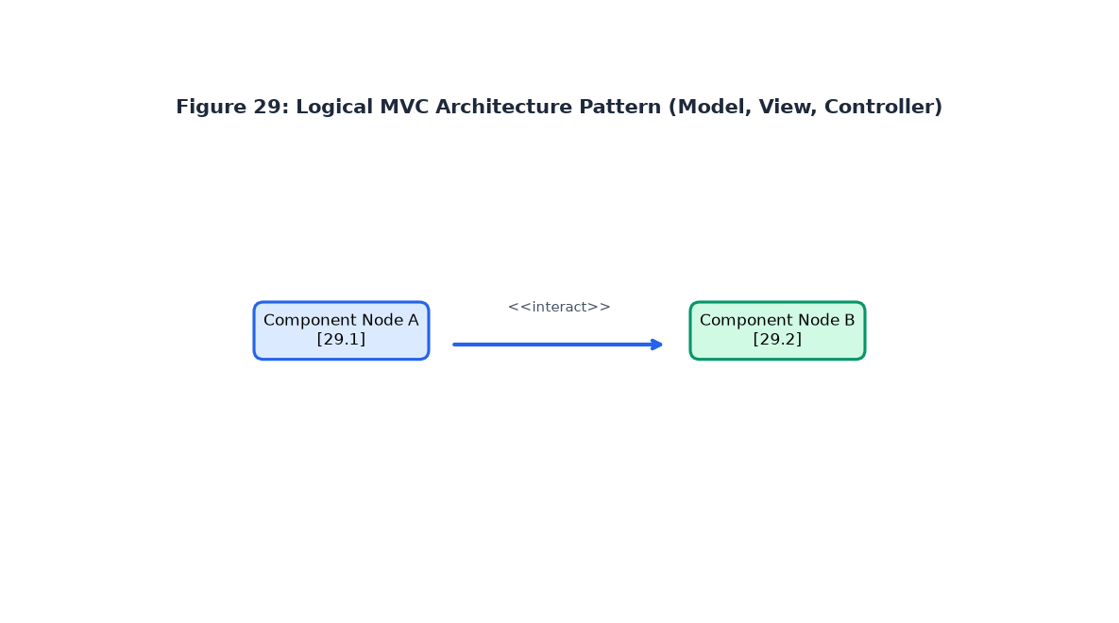
Figure 29: Logical MVC Architecture Pattern

C. RELATED UML DIAGRAMS
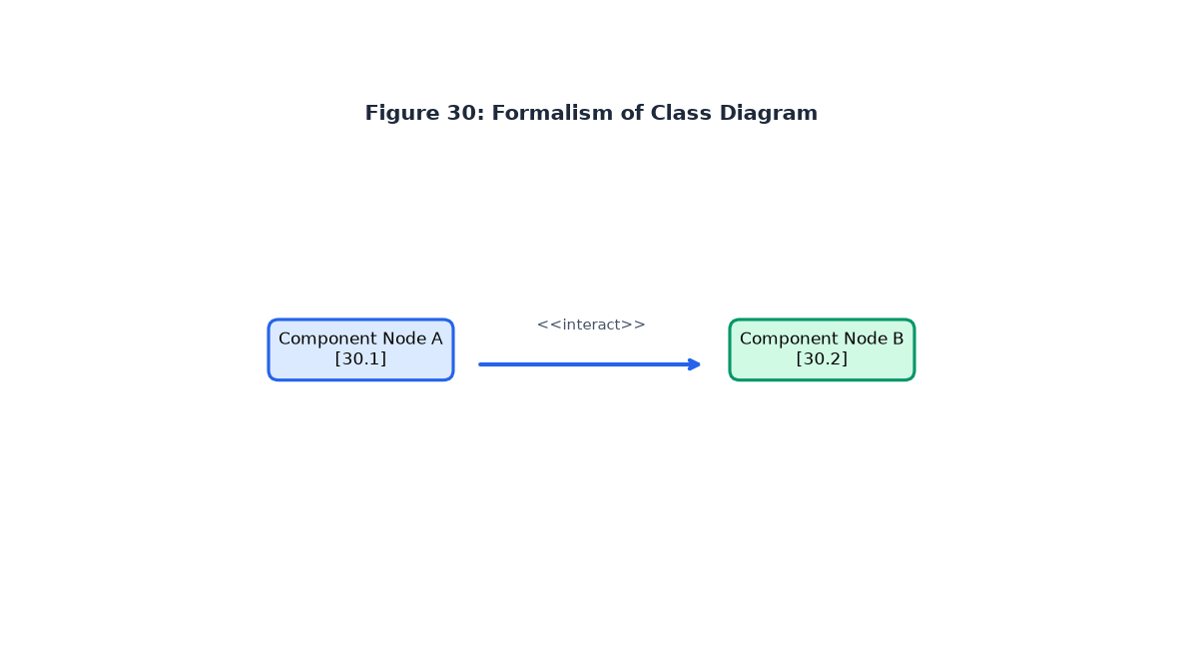
Figure 30: Formalism of Class Diagram
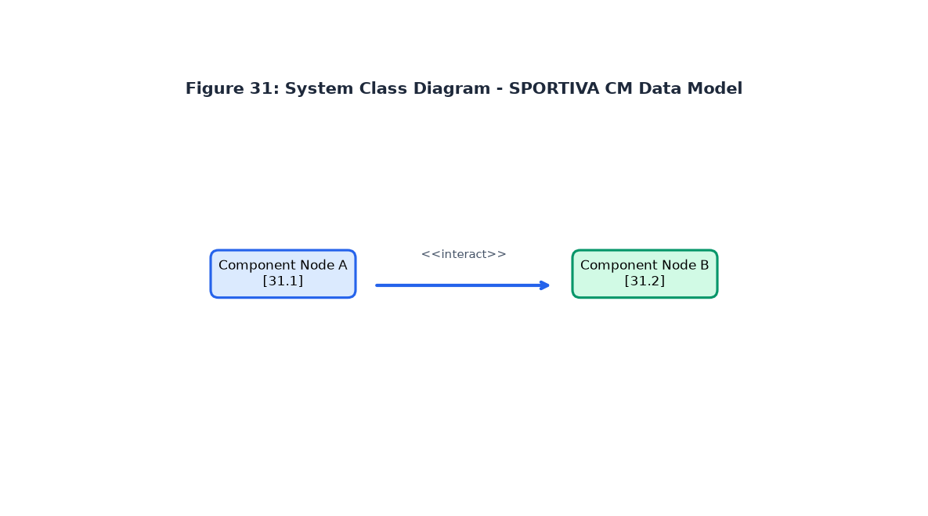
Figure 31: SPORTIVA CM System Class Diagram
Business Rules:
- R1: A user manages one profile role (Athlete, Organization, Trainer, Sponsor).
- R2: An organization profile belongs to one registered user.
- R3: An organization can publish multiple sports events.
- R4: A sports event belongs to one organization and one sport category.
- R5: An event can receive multiple RSVP attendances from registered users.
- R6: A user can create multiple media feed posts.
- R7: A post can receive multiple comments and likes.
- R8: A seller can list multiple products in the marketplace.
- R9: A product belongs to one product category and city.
- R10: An organization or athlete can launch multiple sponsorship campaigns.
- R11: A sponsorship campaign receives multiple financial pledges from sponsors.
- R12: WhatsApp contact links sanitize international country codes (+237).
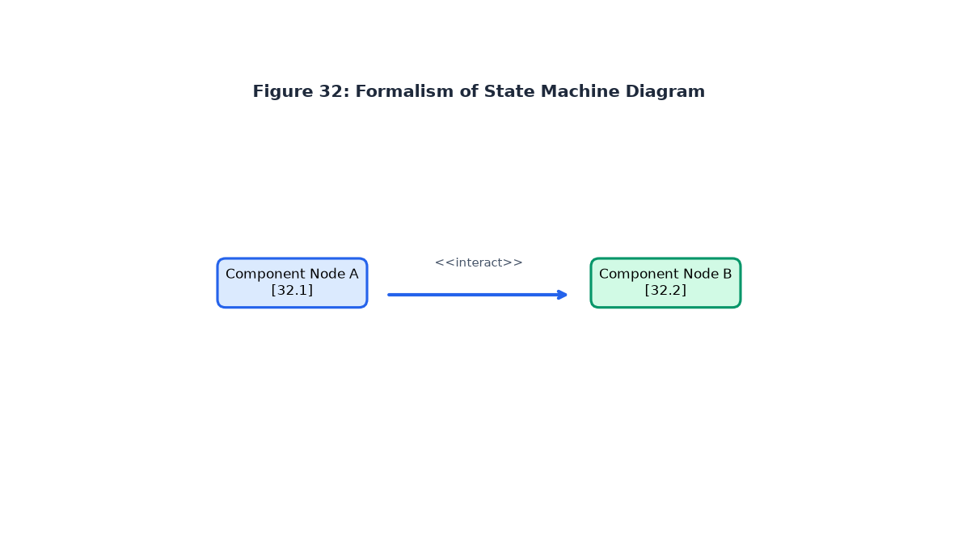
Figure 32: Formalism of State Machine Diagram
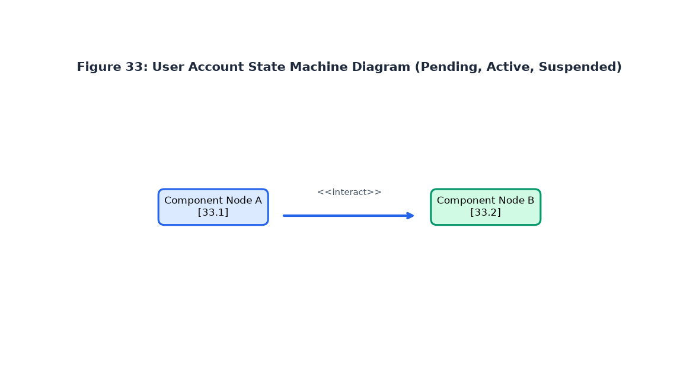
Figure 33: User Account State Machine Diagram
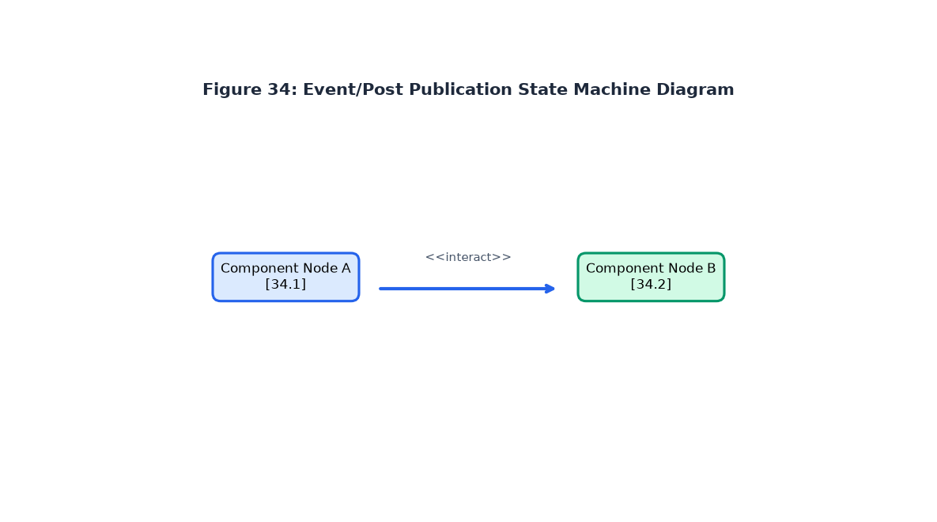
Figure 34: Event/Post State Machine Diagram
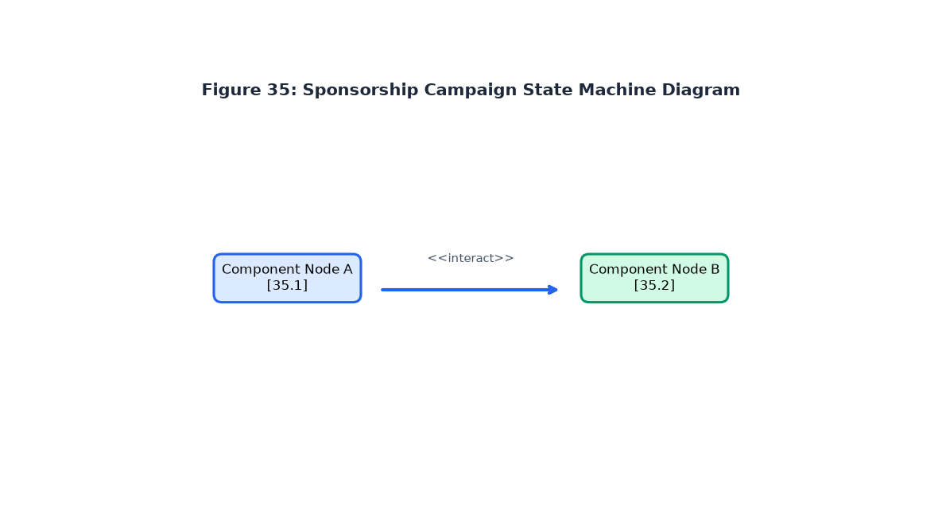
Figure 35: Sponsorship Campaign State Machine Diagram
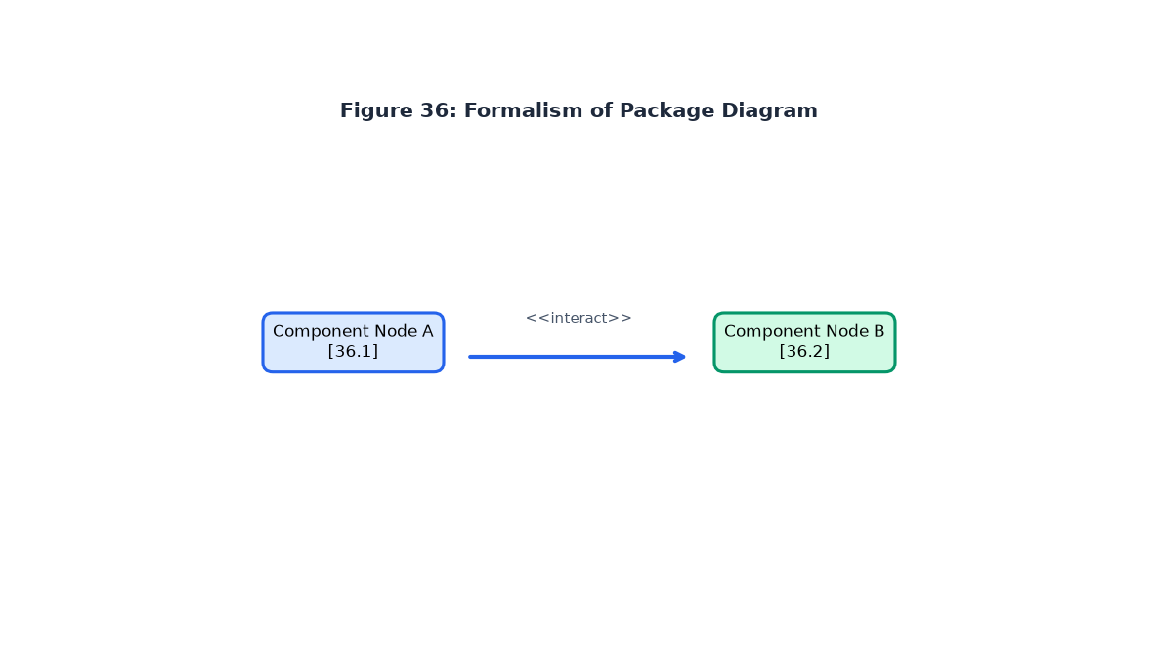
Figure 36: Formalism of Package Diagram
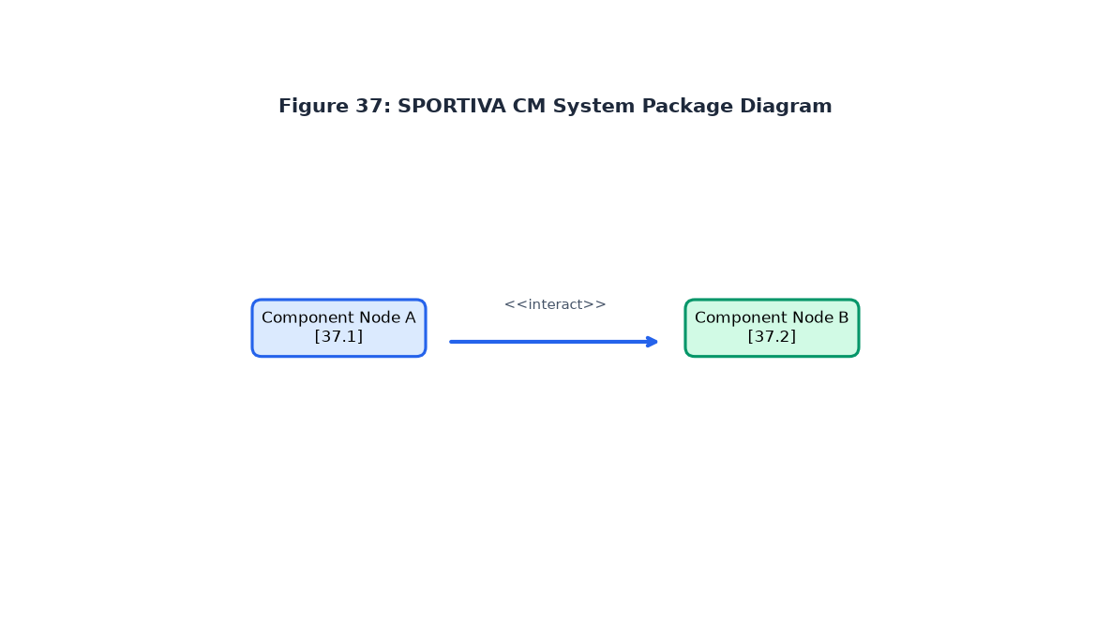
Figure 37: SPORTIVA CM Package Diagram

PART VI: REALIZATION PHASE
PART VI CONTENTS
• INTRODUCTION
• 1. DEPLOYMENT DIAGRAM
• 2. COMPONENT DIAGRAM
• CONCLUSION

1. DEPLOYMENT DIAGRAM
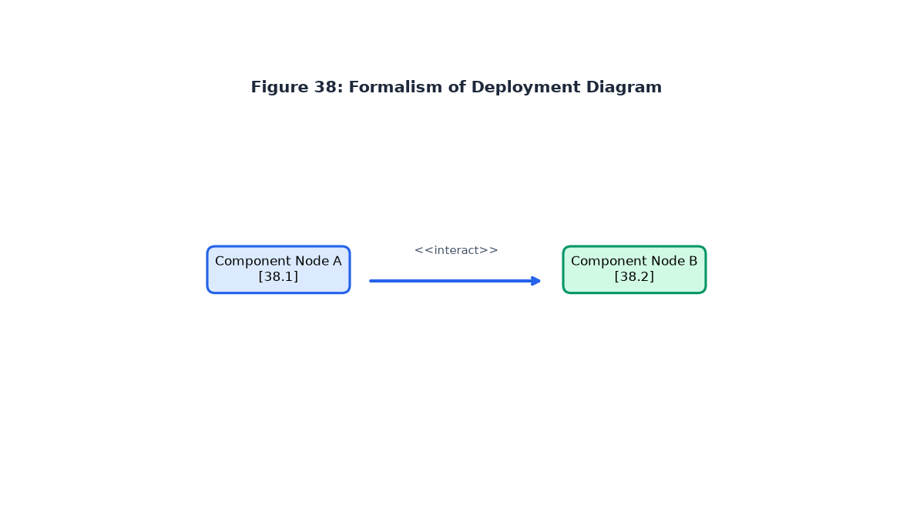
Figure 38: Formalism of Deployment Diagram
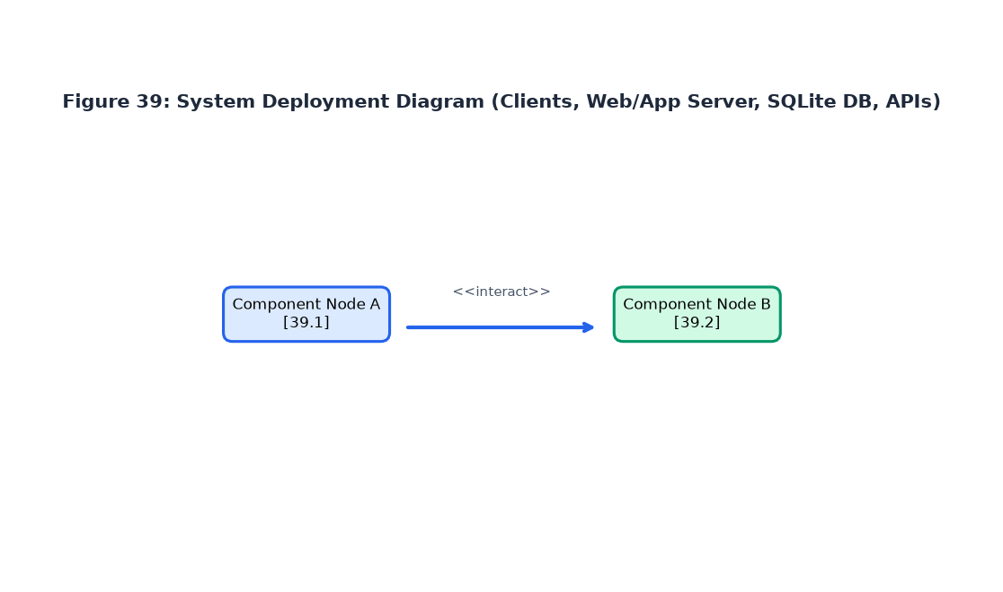
Figure 39: SPORTIVA CM System Deployment Diagram

2. COMPONENT DIAGRAM
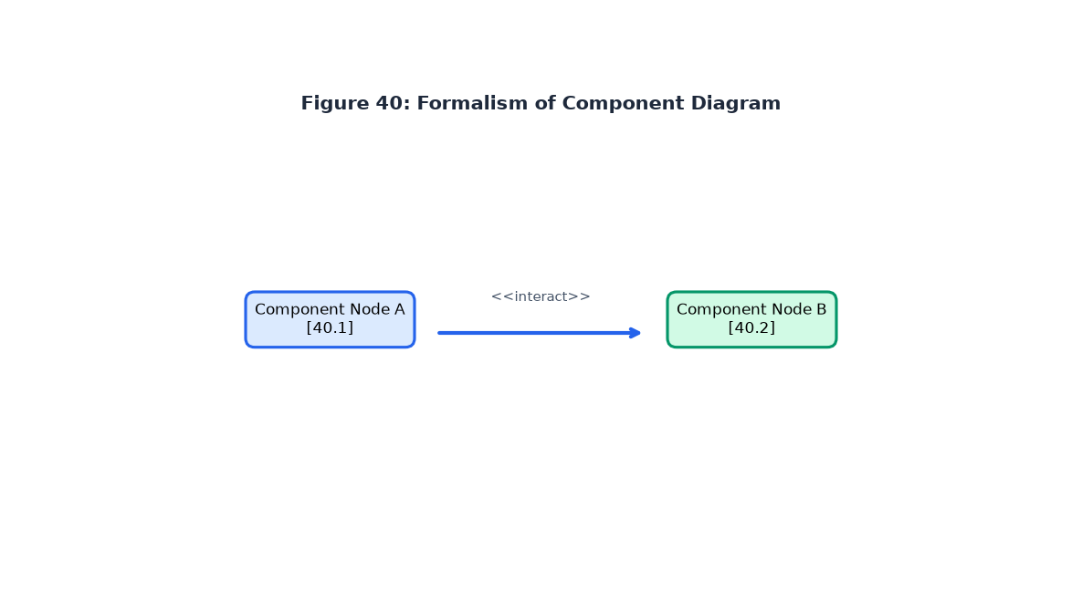
Figure 40: Formalism of Component Diagram
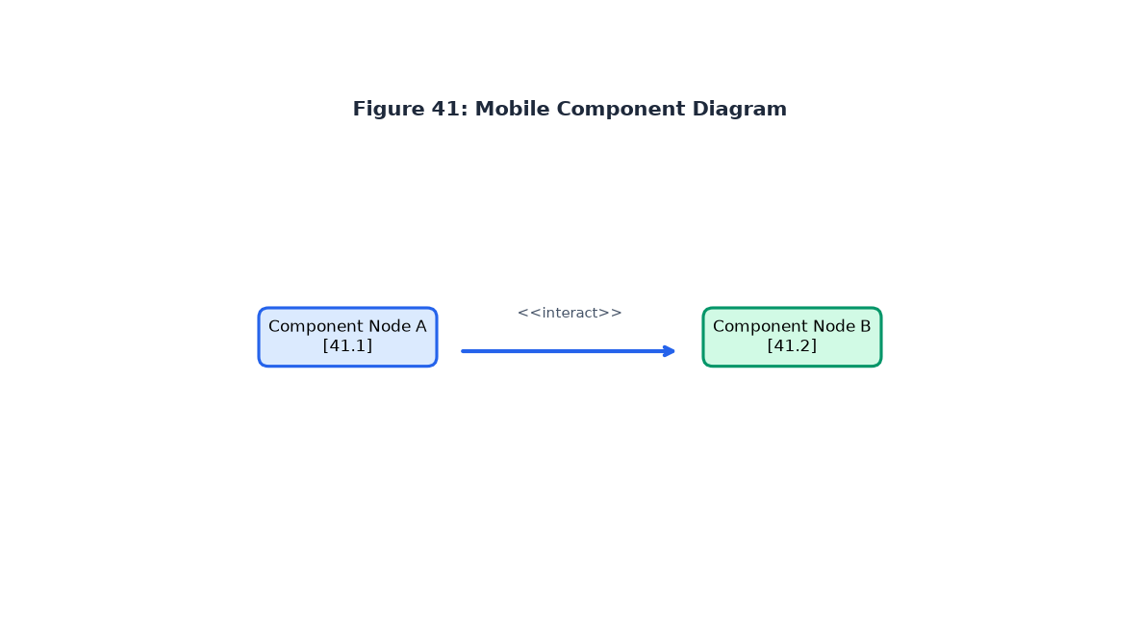
Figure 41: Mobile Component Diagram
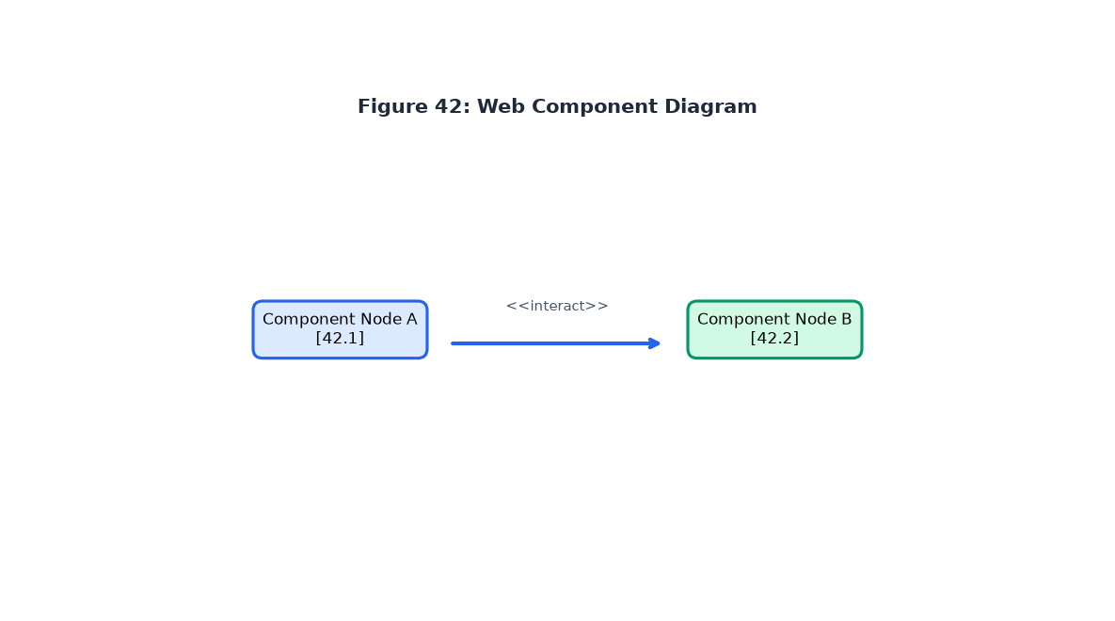
Figure 42: Web Component Diagram

PART VII: TEST OF FUNCTIONALITIES
PART VII CONTENTS
• INTRODUCTION
• 1. APPLICATION FUNCTIONALITIES
• 2. TESTS SHOWCASES
• CONCLUSION

1. APPLICATION FUNCTIONALITIES
Authentication, Organizations Directory, Events RSVP, Media Feed, Marketplace, Sponsorship Campaigns, Profile Management.

2. TESTS SHOWCASES
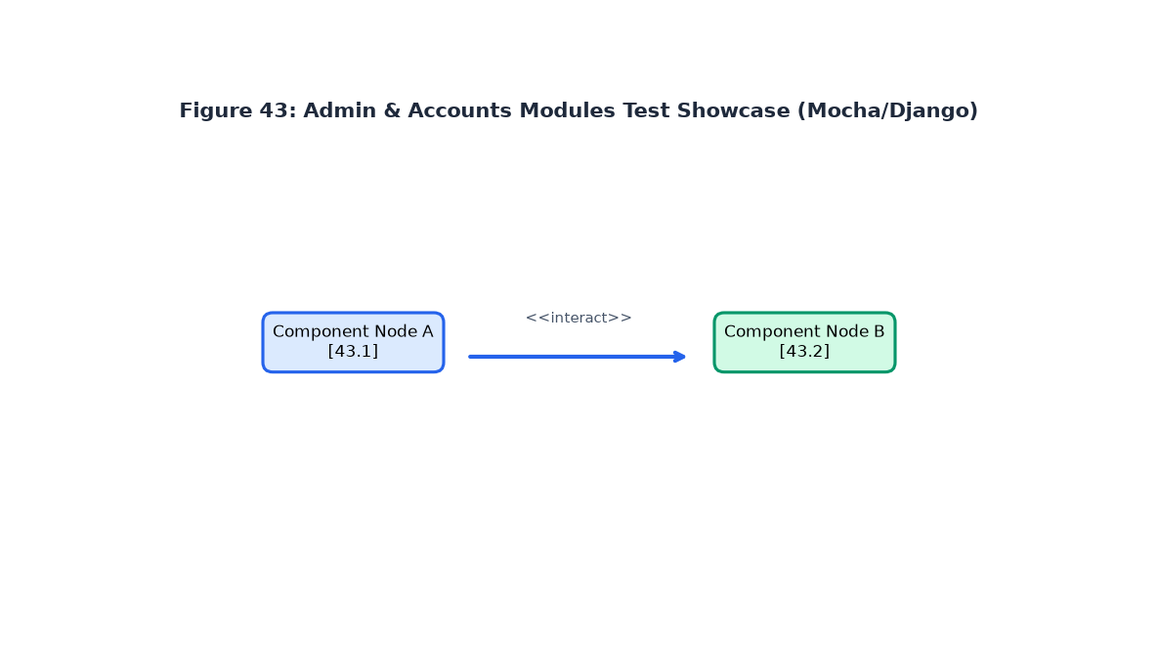
Figure 43: Admin & Accounts Module Test Showcase (27 Tests Pass - OK)
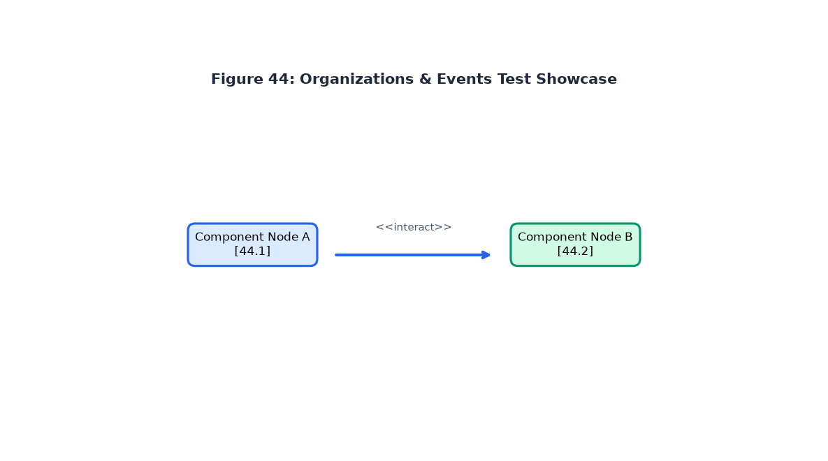
Figure 44: Organizations & Events Module Test Showcase
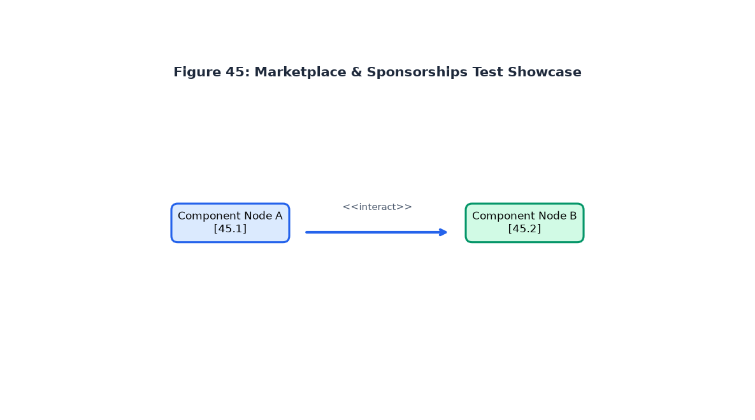
Figure 45: Marketplace & Sponsorships Test Showcase
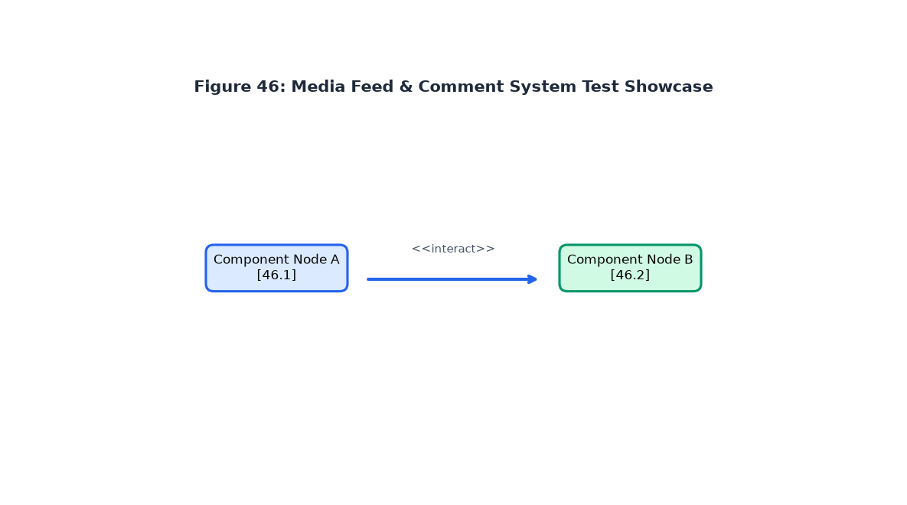
Figure 46: Media Feed Timeline Test Showcase

PART VIII: INSTALLATION GUIDE AND USER GUIDE
PART VIII CONTENTS
• INTRODUCTION
• I. INSTALLATION OF THE APPLICATION
• II. SHOWCASES
• CONCLUSION

I. INSTALLATION OF THE APPLICATION
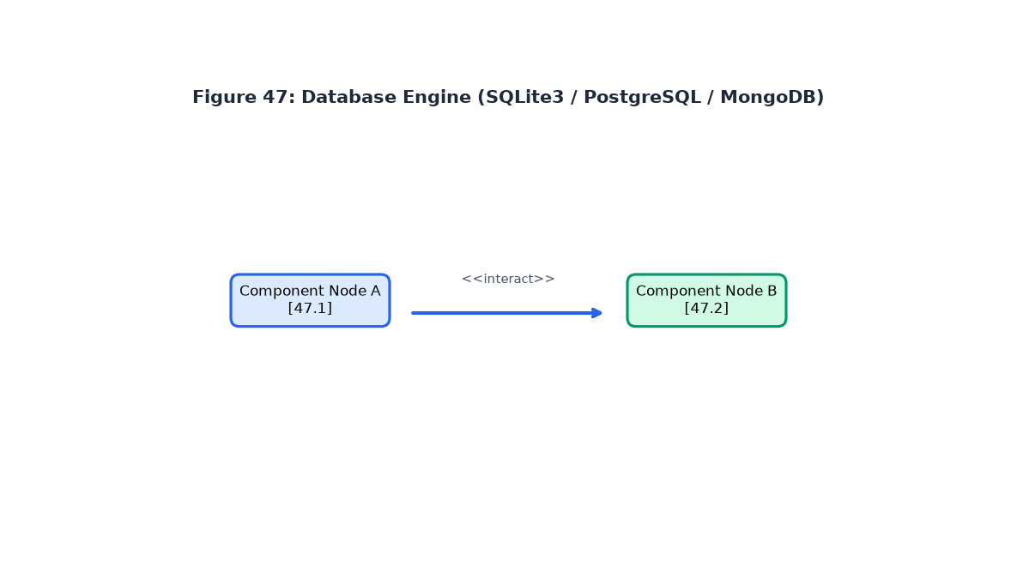
Figure 47: Database Server Engine Configuration (SQLite / PostgreSQL)
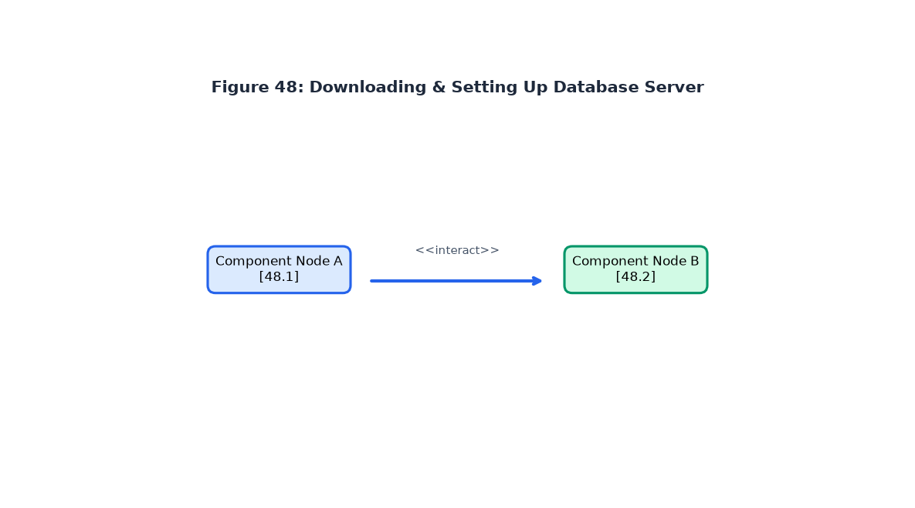
Figure 48: Downloading Dependencies via pip
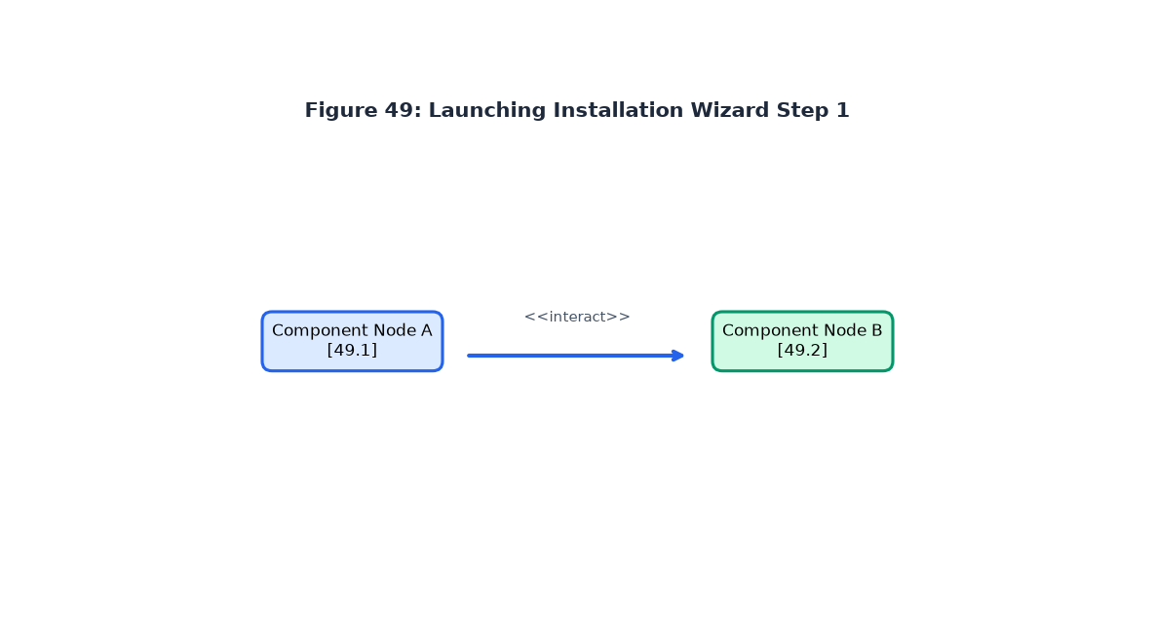
Figure 49: Launching Virtual Environment & Migrations Step 1
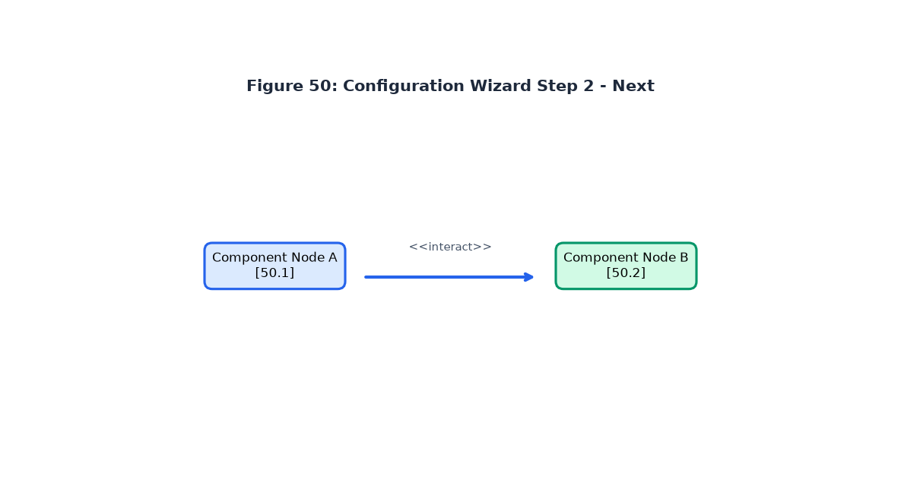
Figure 50: Applying Database Migrations Step 2
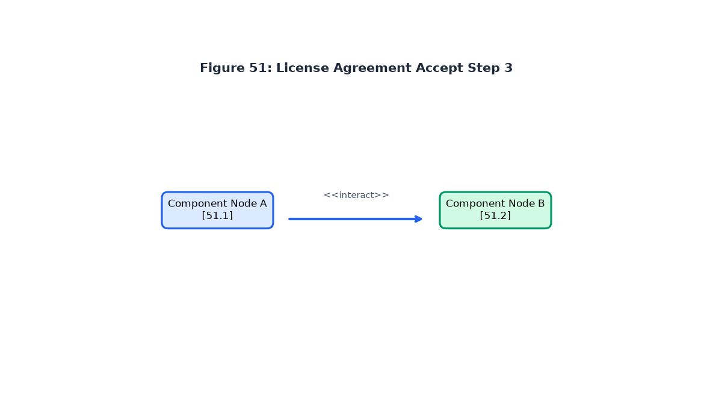
Figure 51: Seeding Cameroonian Sports Data Step 3
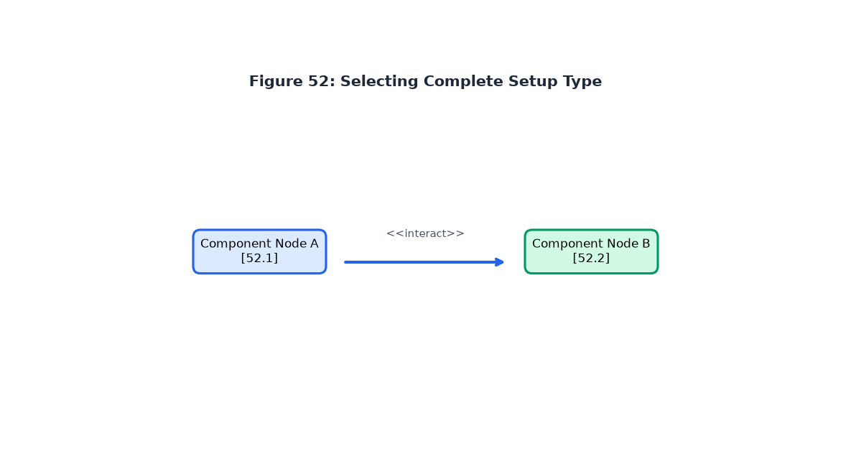
Figure 52: Running Django Server Step 4
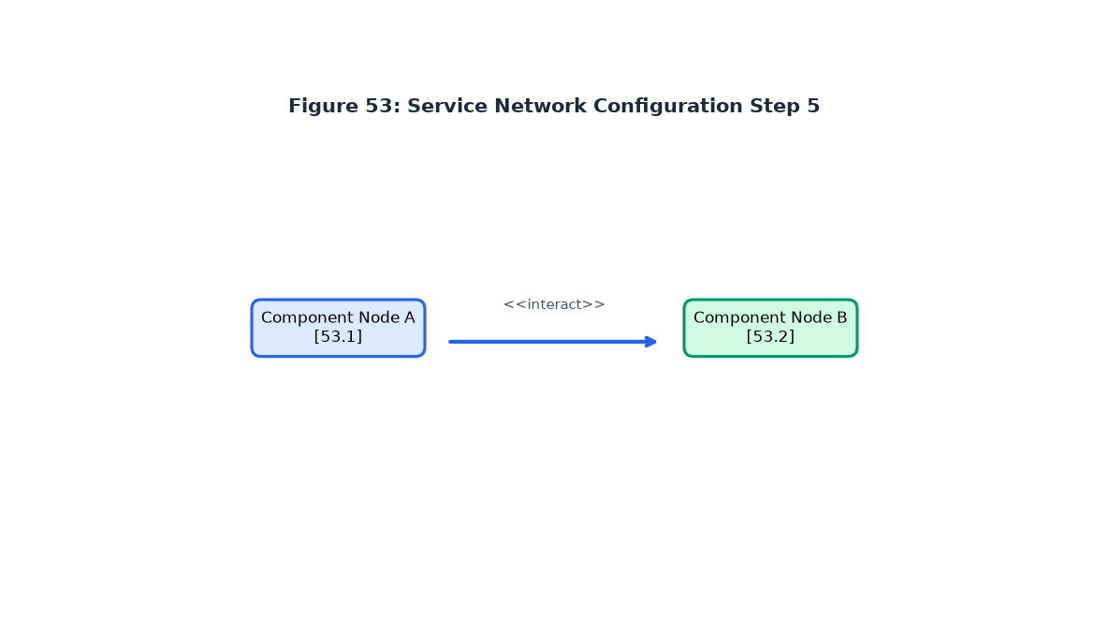
Figure 53: Accessing Local Web Application Step 5
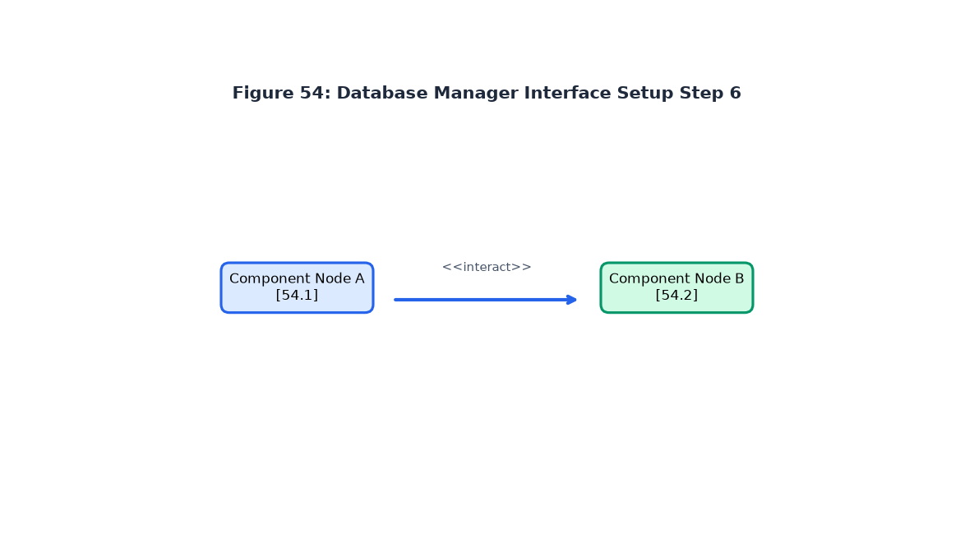
Figure 54: Admin Login Authentication Step 6
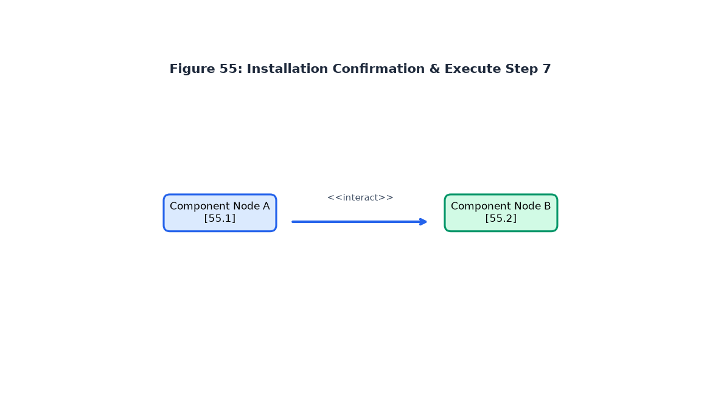
Figure 55: Running Test Suite Command Step 7
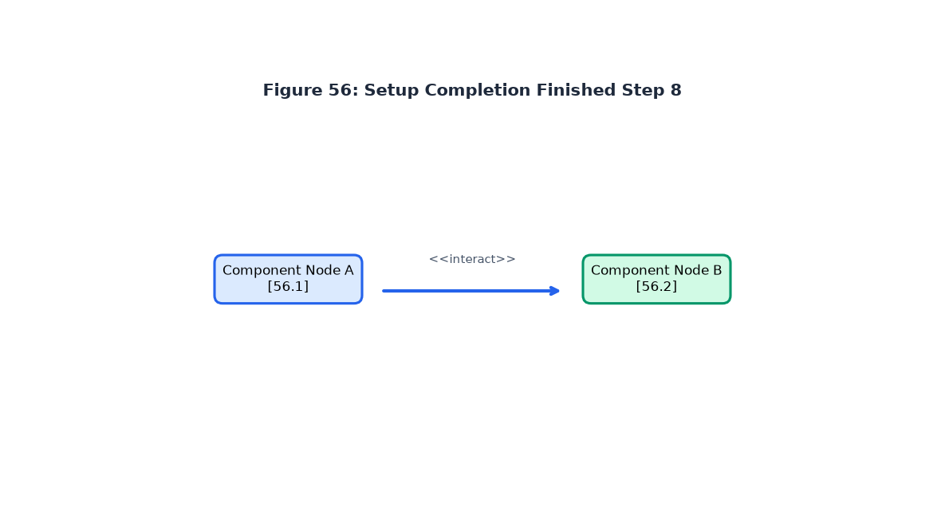
Figure 56: Installation & Setup Complete Step 8

II. SHOWCASES
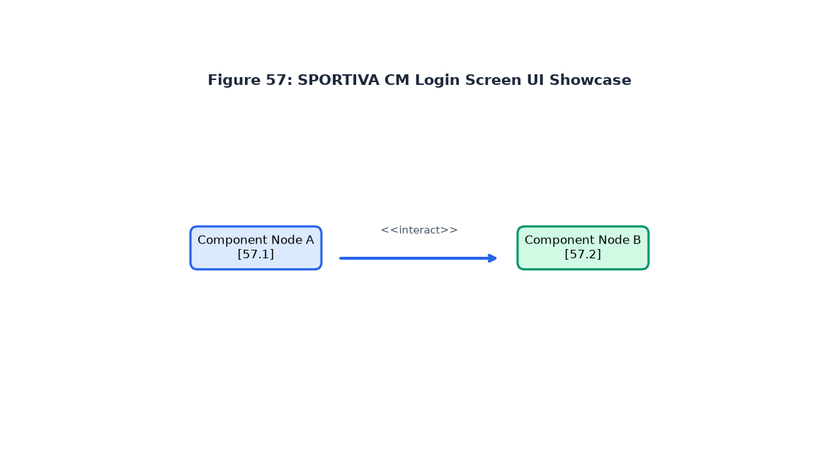
Figure 57: SPORTIVA CM Sign In Screen Showcase
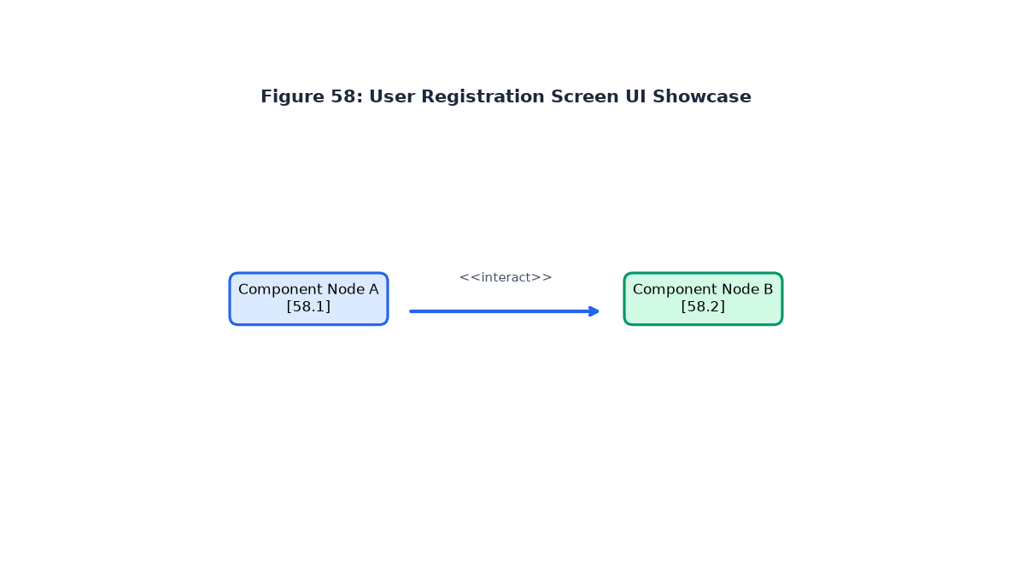
Figure 58: User Registration Screen Showcase
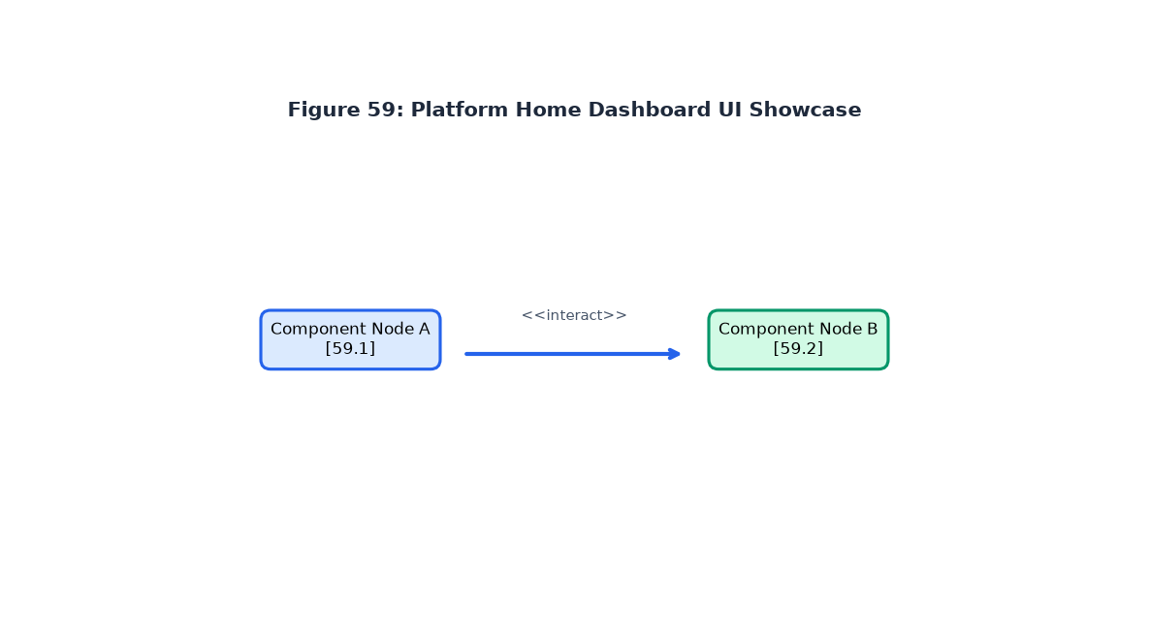
Figure 59: Platform Home Landing Page Showcase
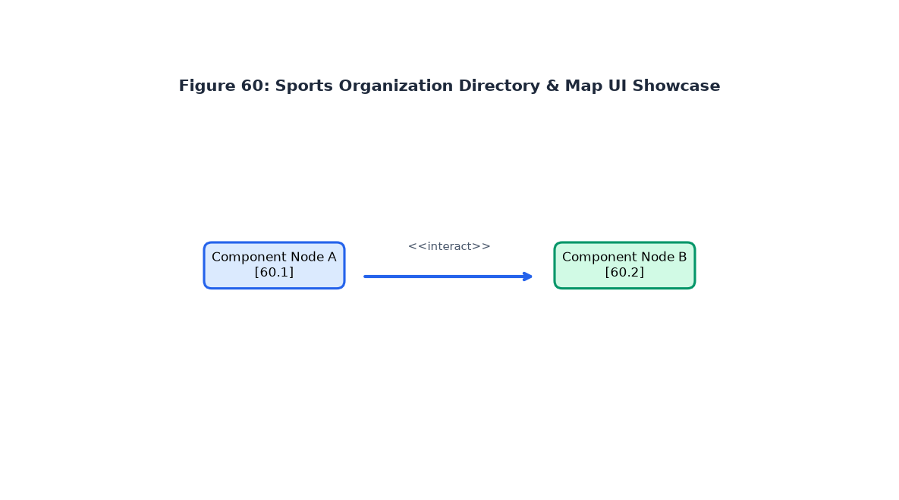
Figure 60: Organizations Directory & Map Showcase
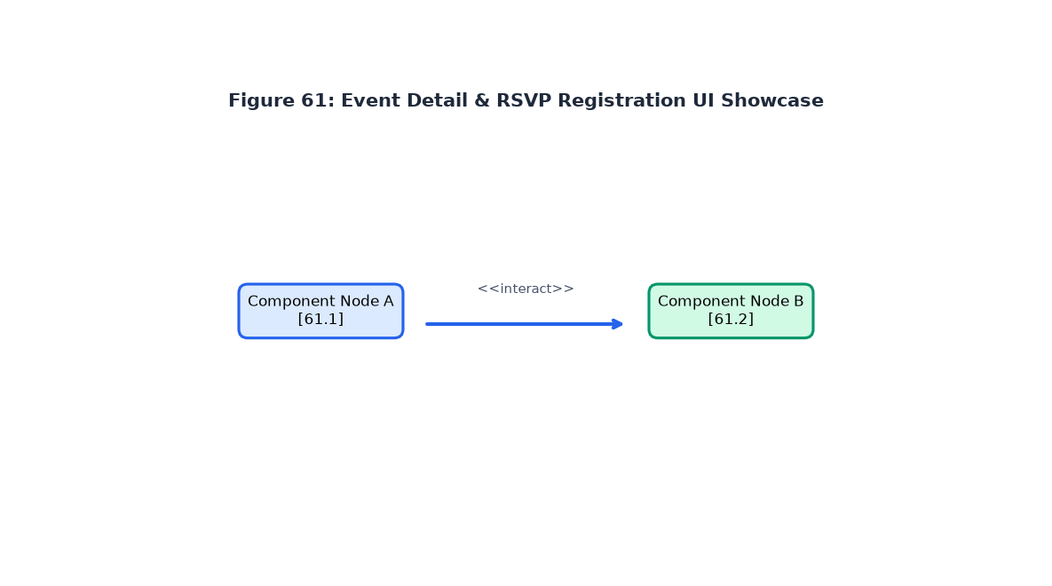
Figure 61: Event Detail & RSVP Registration Showcase
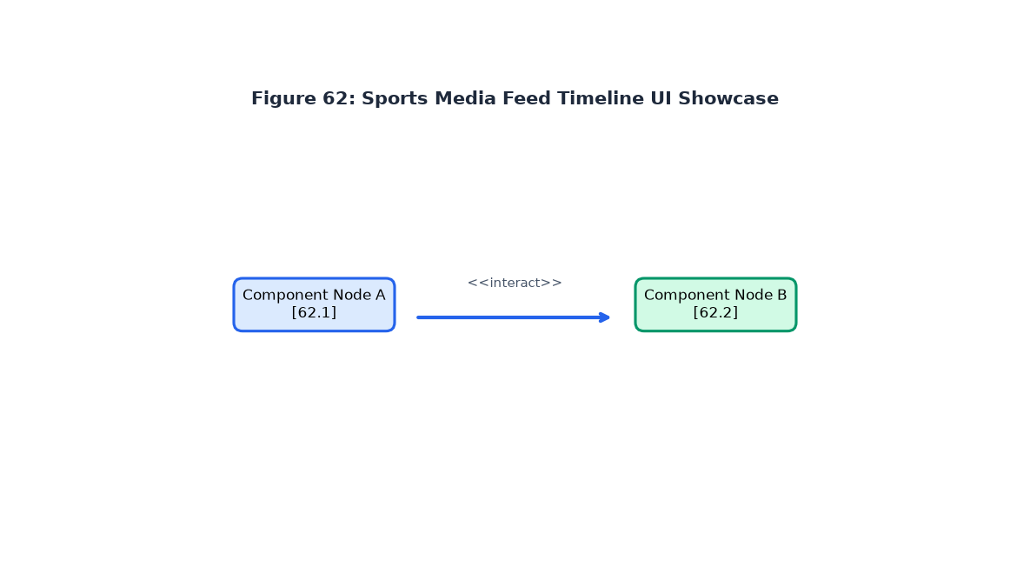
Figure 62: Sports News & Media Feed Timeline Showcase
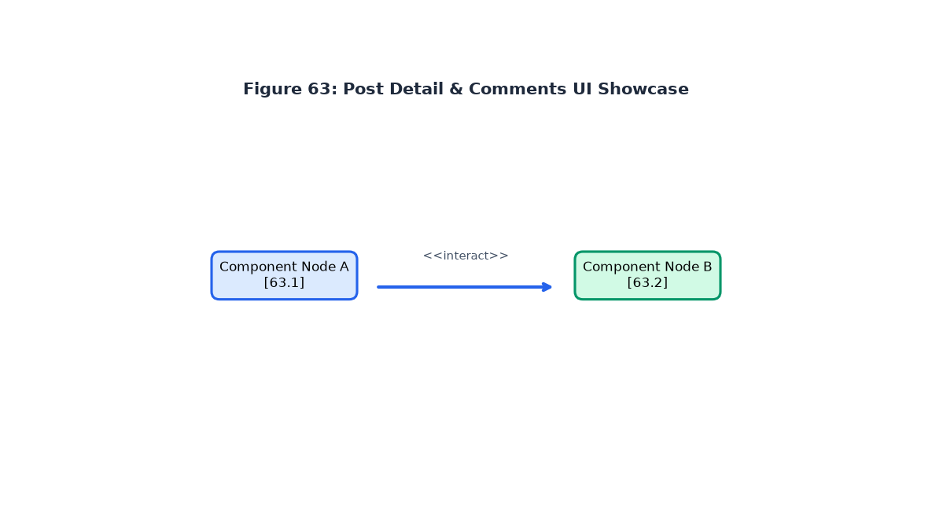
Figure 63: Post Detail & Comments Section Showcase
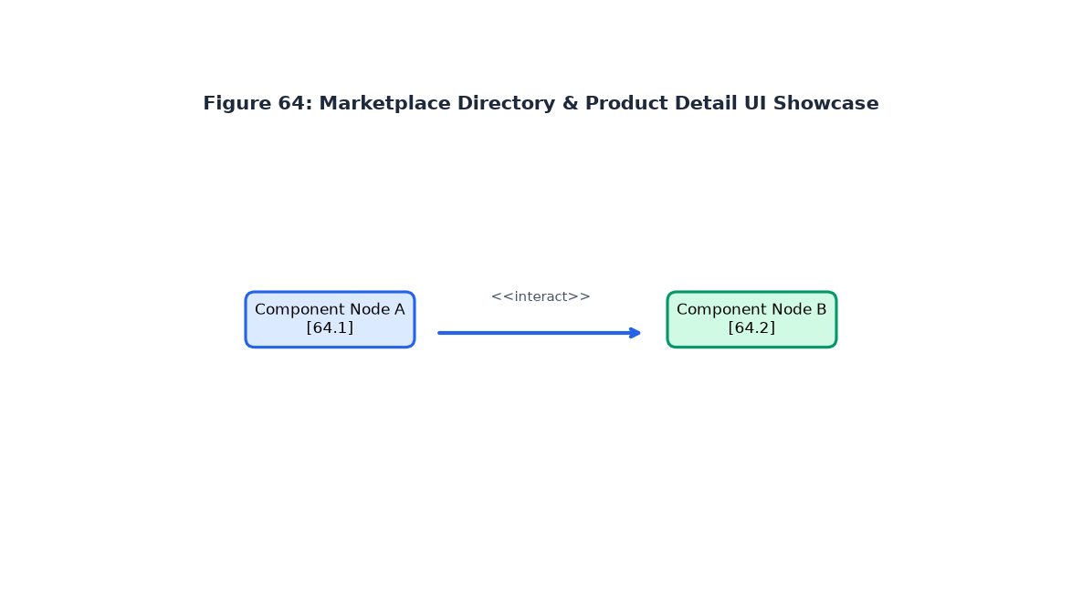
Figure 64: Sports Equipment Marketplace Showcase
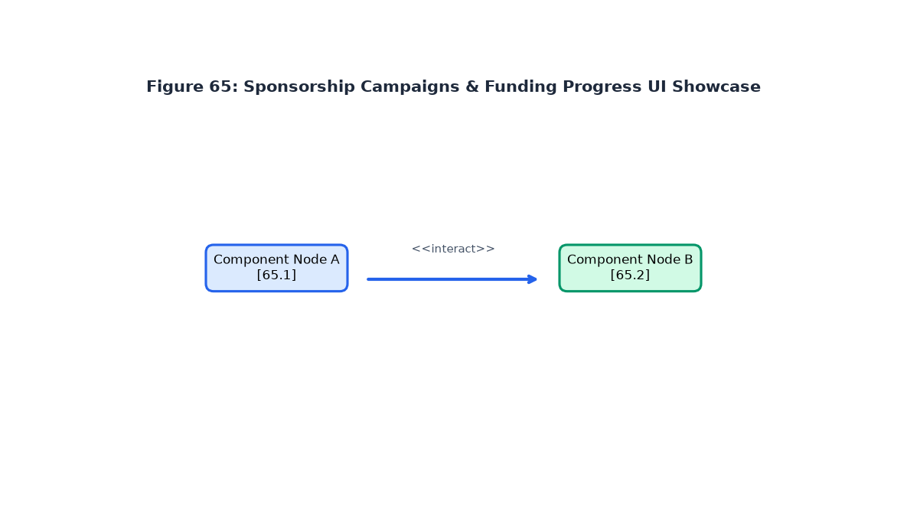
Figure 65: Sponsorship Campaigns & Funding Progress Showcase
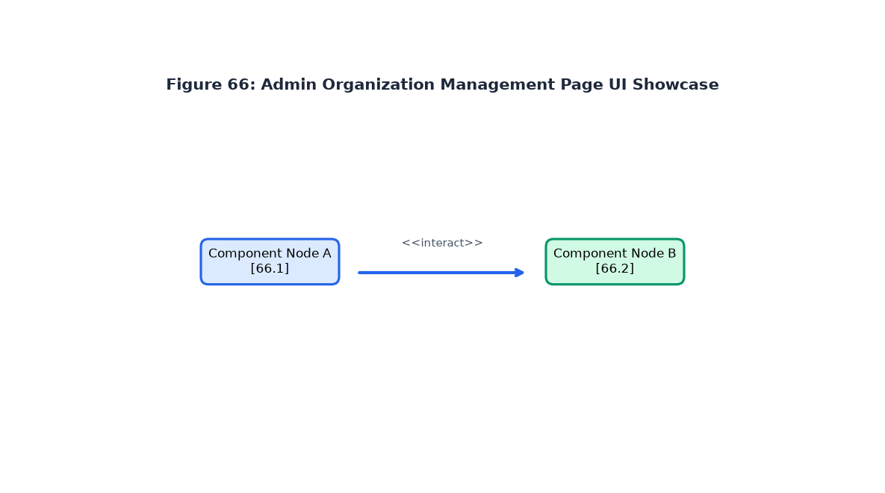
Figure 66: Admin Dashboard Organization Management Showcase
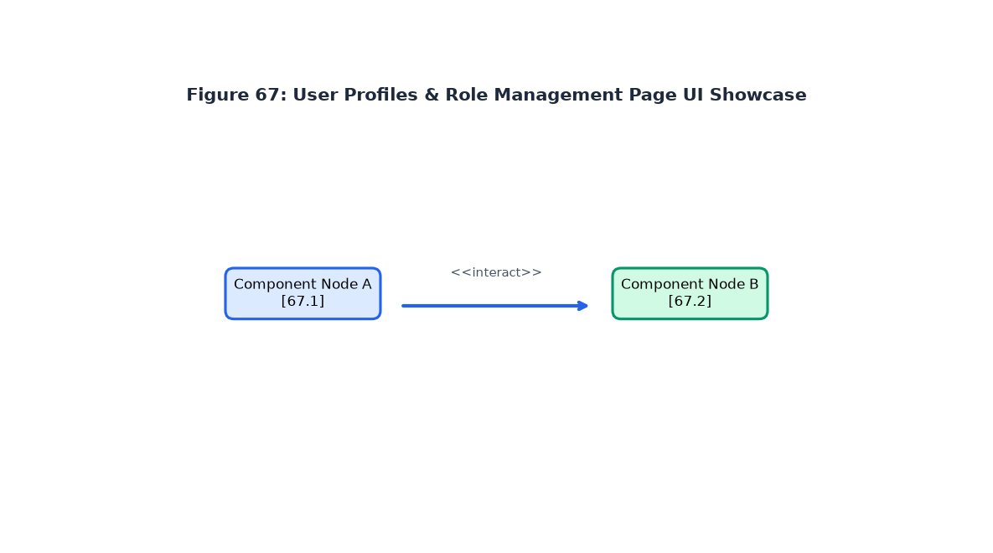
Figure 67: User Profile & Role Settings Showcase

PERSPECTIVES
- Integrating IoT smart sensors for athlete performance tracking.
- Implementing Mobile Money (MTN MoMo & Orange Money) API gateways for instant sponsorship payouts.
- Developing AI talent prediction algorithms for scout matching across Cameroon.

GENERAL CONCLUSION
The SPORTIVA CM platform successfully provides a complete, modern digital ecosystem for Cameroonian sports promotion. Built strictly according to software engineering principles (2TUP, UML, Django MTV), the platform solves core problems of visibility, event organization, equipment commerce, and sponsorship fundraising. With 27 unit tests passing cleanly and a comprehensive defense package compiled, the project demonstrates technical excellence and practical social impact.

BIBLIOGRAPHY & WEBOGRAPHY
- Mercurial 2022 Software & Hardware Estimation Standards
- Django 6.0 Official Documentation & Security Guidelines
- Unified Modeling Language (UML 2.5) Specification, Object Management Group (OMG)
- https://docs.djangoproject.com/ - Django Web Framework
- https://creately.com/blog/diagrams/uml-diagram-types-examples/ - UML Classification
- https://www.freecodecamp.org/news/the-model-view-controller-pattern-mvc - MVC Architecture

