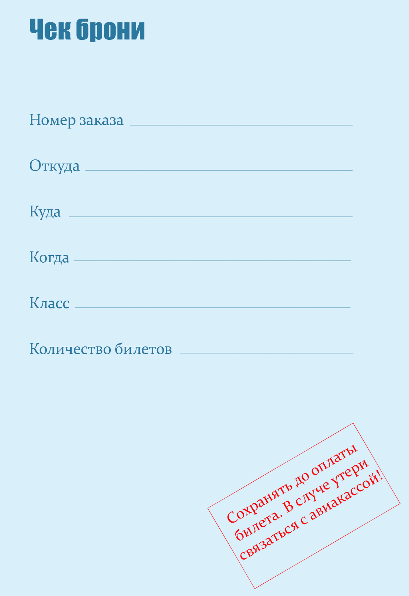

|  |  |  |  |  |
| --- | --- | --- | --- | --- |
| #{e} | | | #{order_number} | |
| #{e} | | #{from} | | |
| #{e} | #{where} | | | |
| #{e} | #{when} | | | |
| #{e} | #{class} | | | |
| #{e} | | | | #{count} |