1. **Heat the milk**

Gently heat the milk and salt in a medium saucepan over a low heat for about 10 mins, stirring often, until it reaches 93°C on a sugar thermometer. Alternatively, watch the mixture carefully: the milk should be consistently foaming and steaming but should not begin to boil and bubble, as this will scald it and affect the flavour.

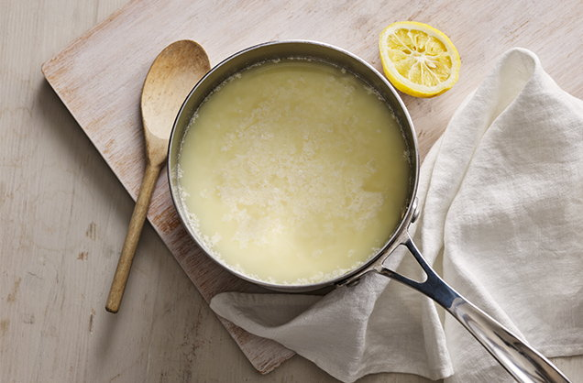

1. **Drain any excess whey**

Remove from the heat and stir in the lemon juice; the mixture should begin to look grainy. Cover the pan and set aside for 10 mins – curds of ricotta and a milky ‘whey’ should form. Line a sieve or colander with muslin and set over a bowl. Use a slotted spoon to carefully spoon the curds into the sieve; set aside for 45 mins to drain off any excess whey.

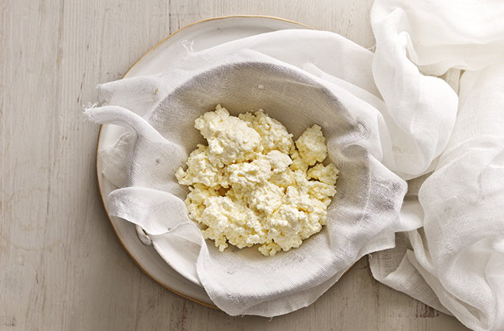

1. **Serve the ricotta**

The ricotta can now be eaten, plain or flavoured, or covered and chilled for up to 48 hrs. To flavour the cheese, try gently stirring through one of the combinations above. The 3 savoury ideas work well spread on hot toast and topped with sliced tomatoes, while the sweet option is lovely with fresh fruit and honey. Find more inspiration for using fresh ricotta [**here**](https://realfood.tesco.com/gallery/3-ways-to-use-ricotta.html).

**4 flavour ideas (optional)**

**1.**10g chopped thyme leaves and 1 tbsp finely grated lemon zest  
**2.**15g finely chopped flat-leaf parsley and 1 crushed garlic clove  
**3.**1 finely chopped red chilli and 30g chopped, stoned black olives  
**4.**A little vanilla extract or ground cinnamon