(車套1)

<https://www.gozilla.com.tw/products/pacman-cover-shop>

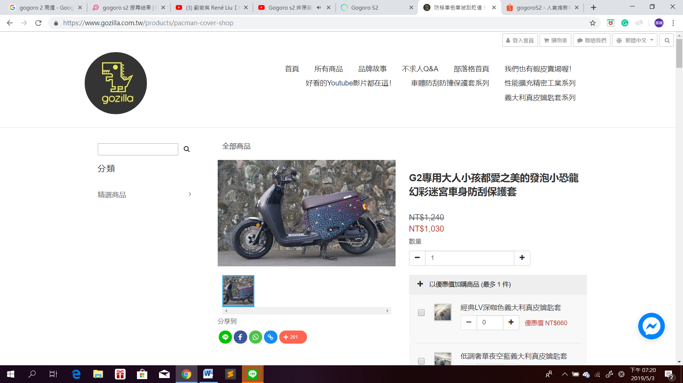

(車套2)

<https://shopee.tw/GOGORO-2%E3%80%8C%E5%B0%88%E7%94%A8%E6%AC%BE%E3%80%8D3D%E7%AB%8B%E9%AB%94%E6%84%9F%E5%89%AA%E8%A3%81%E9%98%B2%E5%88%AE%E5%A5%97-S-Performance%E7%8B%97%E8%A1%A3-%E9%98%B2%E5%88%AE%E5%A5%97-%E9%98%B2%E5%A1%B5%E5%A5%97-%E4%BF%9D%E8%AD%B7%E5%A5%97-%E4%BF%9D%E8%AD%B7%E8%B2%BC-%E8%BB%8A%E7%BD%A9-i.77088180.1892402045>

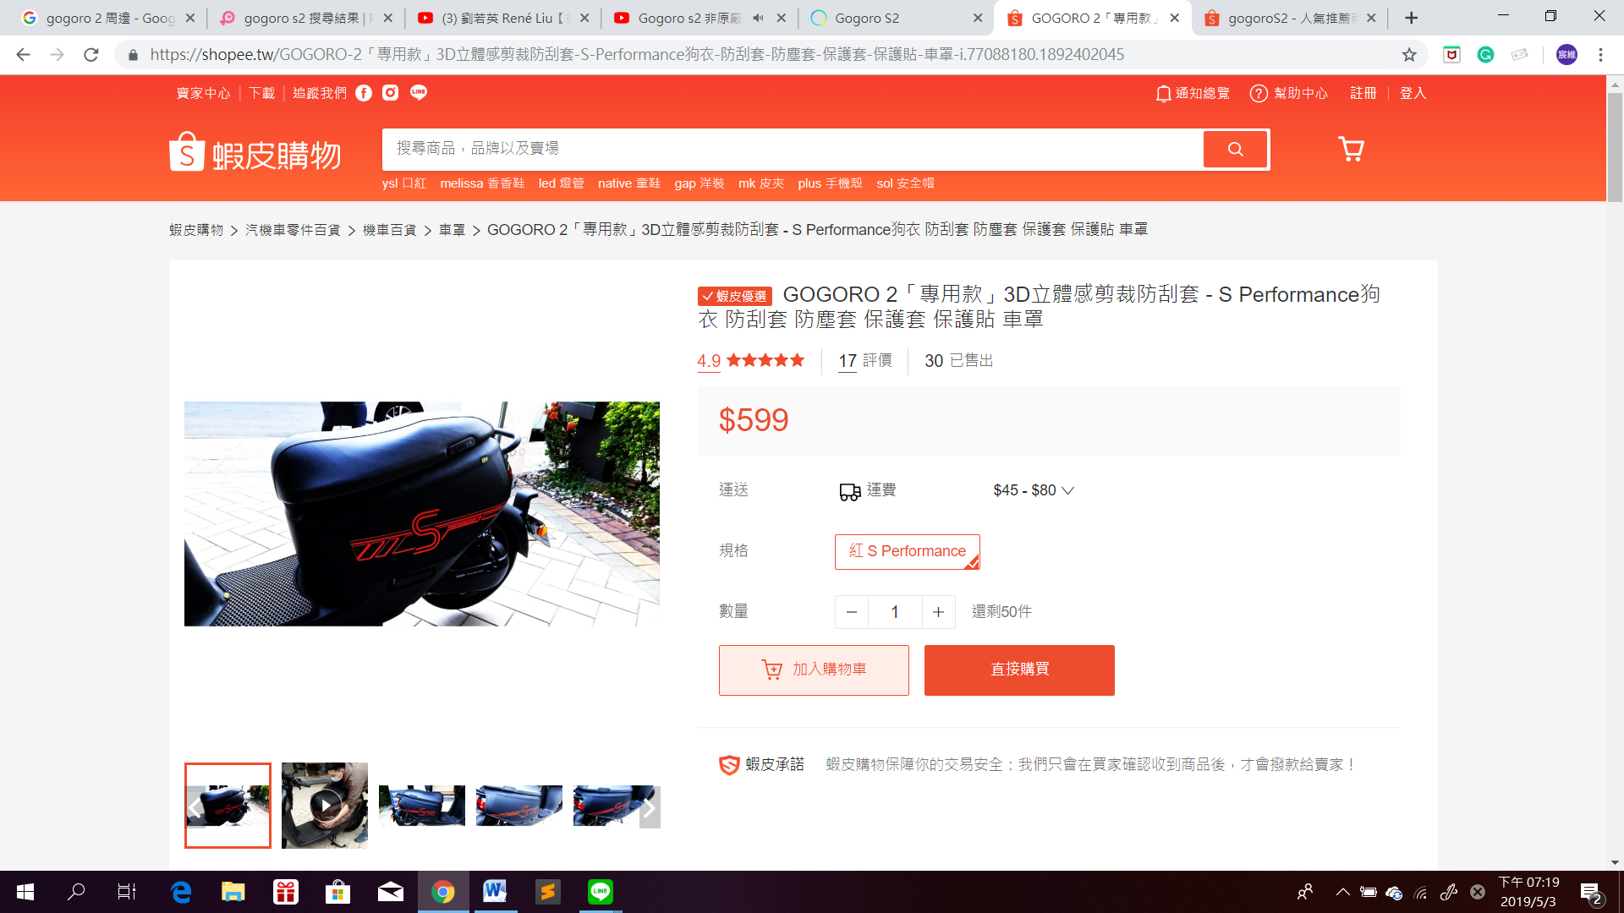

(手機架)

<https://www.gozilla.com.tw/products/phone-holder-black-shop>

<https://shopee.tw/%E6%96%B0%E5%8D%A1%E5%A4%A2-S%E9%9D%A2%E6%9D%BF%E9%A3%BE%E8%93%8B-%E5%89%8D%E6%9D%BF%E9%A3%BE%E8%93%8B-Gogoro2-Plus-Deluxe-Delight-GOGORO-%E5%89%8D%E6%93%8B%E6%9D%BF-i.27754820.2123492003>

<https://shopee.tw/%E7%B2%BE%E5%93%81%E5%90%8D%E7%A8%B1%EF%BC%9A%E9%9B%B7%E5%B0%84%E5%88%87%E5%89%B2-%E6%9D%90%E8%B3%AA%EF%BC%9A%E4%B8%8D%E9%8F%BD%E9%8B%BC-%E4%B8%8D%E9%8F%BD%E9%8B%BC%E5%8E%9A%E5%BA%A6%EF%BC%9A1.9mm-Gogoro-%E8%BB%8A%E7%89%8C%E6%9E%B6%E9%AB%98%E9%9B%84%E5%8F%AF%E9%9D%A2%E4%BA%A4%EF%BC%8C%E4%B8%8B%E6%A8%99%E5%89%8D%E8%AB%8B%E8%88%87%E8%B3%A3%E5%AE%B6%E7%A2%BA%E8%AA%8D%E5%95%86%E5%93%81%E5%BA%AB%E5%AD%98-i.29438252.1606278305>

<https://shopee.tw/%E3%80%90%E9%87%91%E5%89%9B%E5%AE%89%E5%85%A8%E5%B8%BD%E3%80%91Gogoro-%E7%B3%BB%E5%88%97%E7%9A%86%E9%81%A9%E7%94%A8-%E8%BB%8A%E7%89%8C%E9%A3%BE%E7%89%87-%E8%BB%8A%E7%89%8C-%E8%A3%9D%E9%A3%BE-%E8%BB%8A%E7%89%8C%E9%A3%BE%E7%89%87-%E7%99%BD%E9%90%B5-%E4%B8%8D%E9%8F%BD%E9%8B%BC-i.1505814.2173631305>

<https://shopee.tw/Gogoro-%E9%80%B1%E9%82%8A%E8%B2%BC%E7%B4%99-%E8%BB%8A%E5%B0%BElogo%E5%8F%8D%E5%85%89%E8%B2%BC-%E5%8F%8D%E5%85%89%E8%B2%BC-%E9%9B%BB%E6%B1%A0%E8%83%BD%E6%BA%90%E8%B2%BC-S2-%E5%BF%85%E8%B2%BC-gogoro2-%E4%B8%80%E4%BB%A3-%E4%BA%8C%E4%BB%A3-S-i.1503451.1281186146>