Section A
11.
A) Give his ankle a good rest.
B) Treat his injury immediately.
C) Continue .
D) Be careful when climbing steps.

12.
A) On a train.
B) On a plane.
C) In a theater.
D) In a restaurant.

13.
A) A tragic accident.
B) A fad occasion
C) Smith's unusual life story.
D) Smith's sleeping problem.

14.
A) Review the details of all her lessons.
B) Compare notes with his classmates.
C)Talk with her about his learning problems.
D) Focus on the main points of her lectures.

15.
A) The man blamed the woman for being careless.
B)The man misunderstood the woman's apology.
C) The woman offered to pay for the man's coffee.
D)The woman spilt coffee on the man's jacket.

16.
A) Extremely tedious.
B) Hard to understand.
C) Lacking a goot plot.
D) Not worth seeing twice.

17.
A) Attending every lecture.
B) Doing .
C) Reading very extensively.
D) Using test-taking strategies.

18.
A)The digital TV system will offer different programs.
B)He is eager to see what the new system is like.
C)He thinks it unrealistic to have 500 channels.
D)The new TV system may not provide anything better.

Question 19 to 22 are based on the passage you have just heard.

19.a)a notice by the electricity board. c)the description of a thief in disguise.
b)ads promoting electric appliances. d)a new policy on pensioners'welfare.

20.a)speaking with a proper accent. c)making friends with them
b)wearing an official uniform. d)showing them his ID.

21.a)to be on the alert when being followed.
b)not to leave senior citizens alone at home.
c)not to let anyone in without an appointment.
d)to watch out for those from the electricity board.

22.a)she was robbed near the parking lot.
b)all her money in the bank disappeared.
c)the pension she had just drawn was stolen.
d)she was knocked down in the post office.

Question 23 to 25 are based on the passage you have just heard.

23.a)marketing consultancy. c)luxury hotel management.
b)Professional accountancy. d)business conference organization

24.a)having a good knowledge of its customs.
b)knowing some key people in tourism.
c)having been to the country before.
d)being able to speak japanese.

25.a)it will bring her potential into full play.
b)it will involve lots of train travel.
c)it will enable her to improve her chinese.
d)it will give her more chances to visit japan.

Section B
Passage One

Question 26 to 28 are based on the passage you have just heard.

26.a) The lack of time c) The frustrations at work.
b) The quality of life. d) The pressure on working families.

27.a)They were just as busy as people of today.
b)They saw the importance of collective efforts.
c)They didn't complain as much as modern man.
d)They lived a hard life by hunting and gathering.

28.a)To look for creative ideas of awarding employees.
b)To explore strategies for costs.
c)To seek new approaches to dealing with complaints.
d)To find effective ways to give employees flexibility.

Passage Two

Question 29 to 31 are based on the passage you have just heard.

29.a)family violence. c)her father's disloyalty.
b)his children's efforts. d)his second wife's positive influence.

30.a)his advanced age. c) his improved financial condition.
b)his children's efforts. d)his second wife's positive influence.

31.a)love is blind. c)divorce often has .
b)love breeds love. d)happiness is hard to find in blended families.

Passage Three

Question 32 to 35 are based on the passage you have just heard.
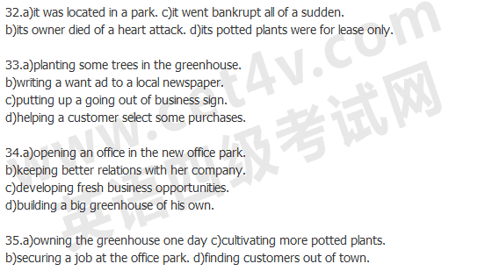

Section C

注意：此部分试题请在答题卡2上作答。
We're now witnessing the emergence of an advanced economy based on information and knowledge. Physical(36)___, raw materials, and capital are no longer the key(37) ____ in the creation of wealth. Now, the(38) ____ raw material in our economy is knowledge. Tomorrow's wealth depends on the development and exchange of knowledge. And(39) ___ entering the workforce offer their knowledge, not their muscles. Knowledge workers get paid for their education and their ability to learn. Knowledge workers(40)____ in mind work. They deal with symbols: words,(41) ___ and data.
