Section A
- M: Christmas is around the comer and I'm looking for a gift for my girlfriend. Any suggestions?
W: Well, you have to tell me something about your girlfriend first. Also, what's your budget?
Q: What does the woman want the man to do? B)。
2. M: What would you like for dessert? I think I'll have apple pie and ice cream.
W: The chocolate cake looks great, but I have to watch my weight. You go ahead and get yours.
Q: What would the woman most probably do? C) 。
3. W: Having visited so many countries, you must be able to speak several different languages!
M: I wish I could. But Japanese and of course English are the only languages I can speak.
Q: What do we learn from the conversation? A) 。
4. M: Prof. Smith asked me to go to his office after class. So it is impossible for me to make it to the bar at i0:00.
W: Then it seems well have to meet an hour later at the library.
Q: What will the man do first after class? C) 。
5. M: It's already 11:00 now. Do you mean I ought to wait until Prof. Bloom comes back from class?
W: Not really You can just leave a note. I'll give it to her later.
Q: What does the woman mean? D) 。
6. M: How's John now? Is he feeling any better?
W: Not yet. It still seems impossible to make him smile. Talking to him is really difficult and he gets upset easily over little things
Q: What do we learn about John from the conversation?
B). 7. M: Do we have to get the opera tickets in advance?
W: Certainly ! Tickets at the door are usually sold at a higher price.
Q: What does the woman imply? D) 。
8. M: The taxi driver must have been speeding.
W: Well,not really! He crashed into the tree because he was trying not to hit a box that had fallen off the truck ahead of him.
Q: What do we learn about the taxi driver? A) 。
Conversation One
W: Hey, Bob, guess what? I'm going to visit Quebec next summer. (9) I'm invited to go to a friend's wedding, but while I'm there, rd also like to do some sightseeing.
M: That's nice, Sherry. But do you mean the province of Quebec or Quebec City?
W: I mean the province. (9) My .friend's wedding is in Montreal, so I'm going there first. I'll stay for five days. Is Montreal the capital city.of the province?
M: Well, many people think so because it's the biggest city, but it's not the capital. Quebec City is. But Montreal is great. The St. Lawrence River nms right through the middle of the city. it's beautiful in summer.
W: Wow, and do you think I can get by in English? My French is OK, but not that good. I know most people there speak French, but can I also use English?
M: Well, people speak both French and English there, but you'll hear French most of the time and all the street signs are in French. In fact, Montreal is the third largest French-speaking city in the world.
10) So you'd better practice your French before you go.
W: (10) Good advice. What about Quebec City? I'll visit a friend from college who lives Cheer now. What's it like? M: ( 11 ) It's a beautiful city, very old. Many old buildings, have been niceely restored. Some of them were built in the 17th and 18th centuries. You'll love it there.
W: Fantastic. I can't want to go.
9. What's the woman's main purpose of visiting Quebec? D) 。
10. What does the man advise the woman to do before the trip? C) 。
11. What does the man say about Quebec City? B) 。
Conversation Two
M: Hi, Ms. Rowling. How old were you when you started to write? And what was your first book?
W: (12) I wrote my first finished story when I was about six. It was about a small animal, a rabbit, I mean, and.I've been writing ever since.
M: Why did you choose to be an author?
W: If someone asked me how to achieve happiness, step one would be finding out what you love doing most and step two would be finding someone to pay you to do it. (13) i consider myself very lucky indeed to be able to support myself by writing.
M.. Do you have any plans to write books for adults?
W.. My first two novels were for adults. I suppose I might write another one, but I never really imagine a target audience when I'm writing.
(14) The ideas come first, so it really depends on the idea that grabs me next.
M.. Where did the ideas for the Harry Potter books come from?
W: (15) I've no idea where the ideas came from and I hope I'll never find out. It would spoil my excitement if it turned out I just have a funny little wrinkle on the surface of my brain which makes me think about invisible train platforms.
M: How do you come up with the names of your characters?
W: I invented some of them, but I also collected strange names. I've gotten them from ancient saints, maps, dictionaries, plants, war memorials, and people I've met.
M: Oh, you are really resourceful.
12. What do we learn from the conversation about Ms. Rowling's fLrst book? A) 。13. Why does Ms. Rowling consider herself very lucky? D) 。
14. What dictates Ms. Rowling's writing? C)。
15. According to Ms. Rowling, where did she get the ideas for the Harry Potter books? A) 。
Section B
Passage One

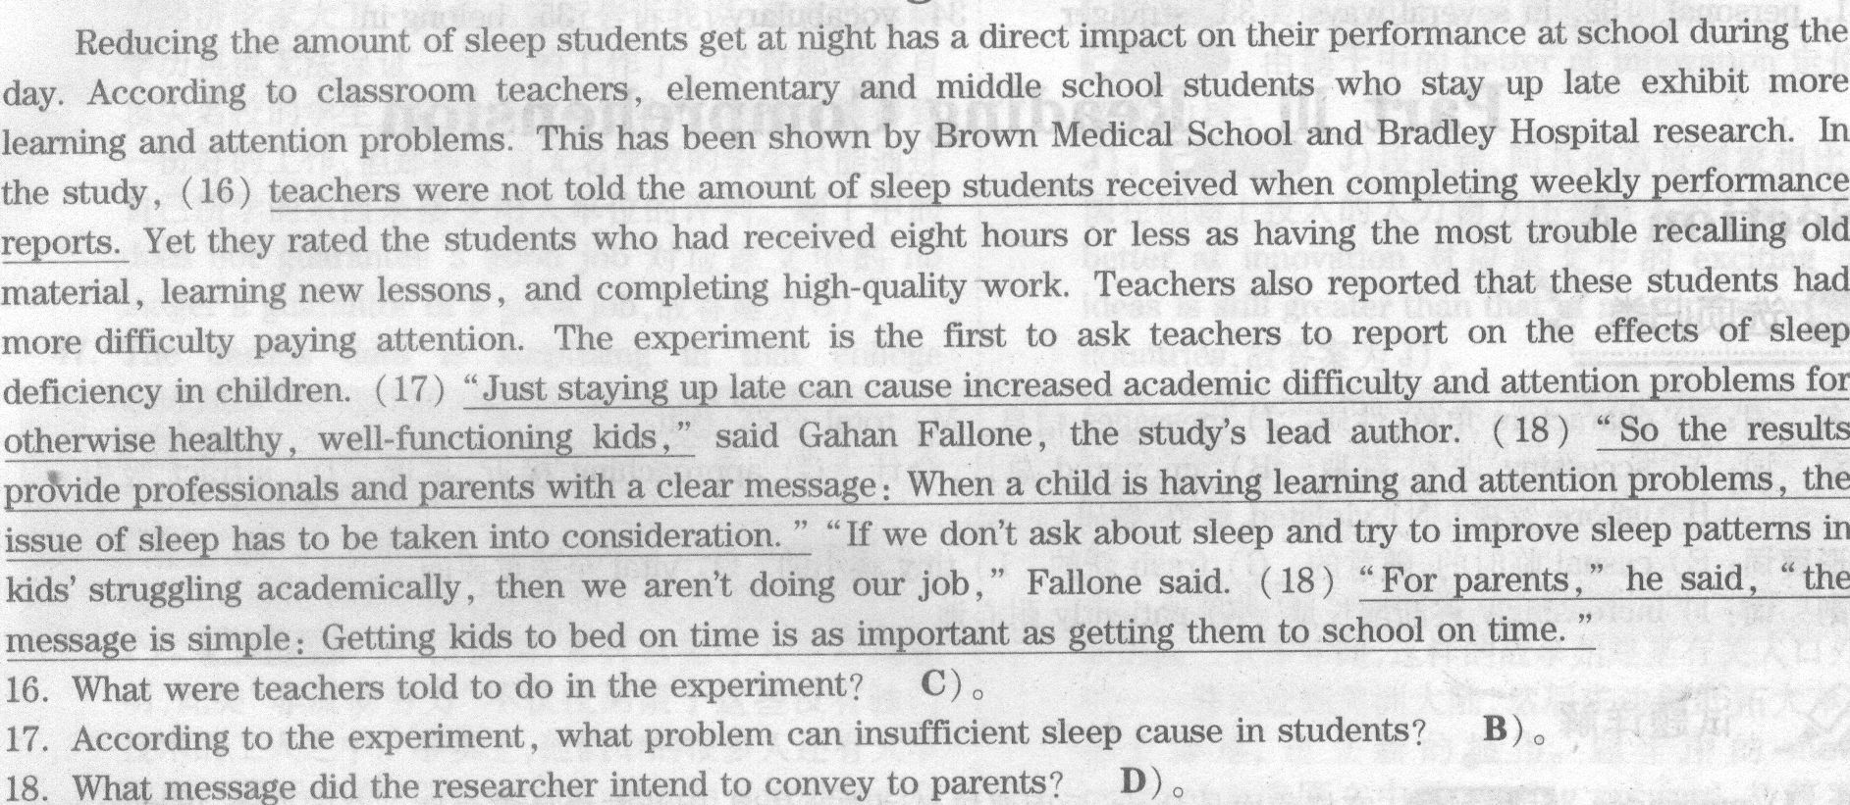
Passage Two
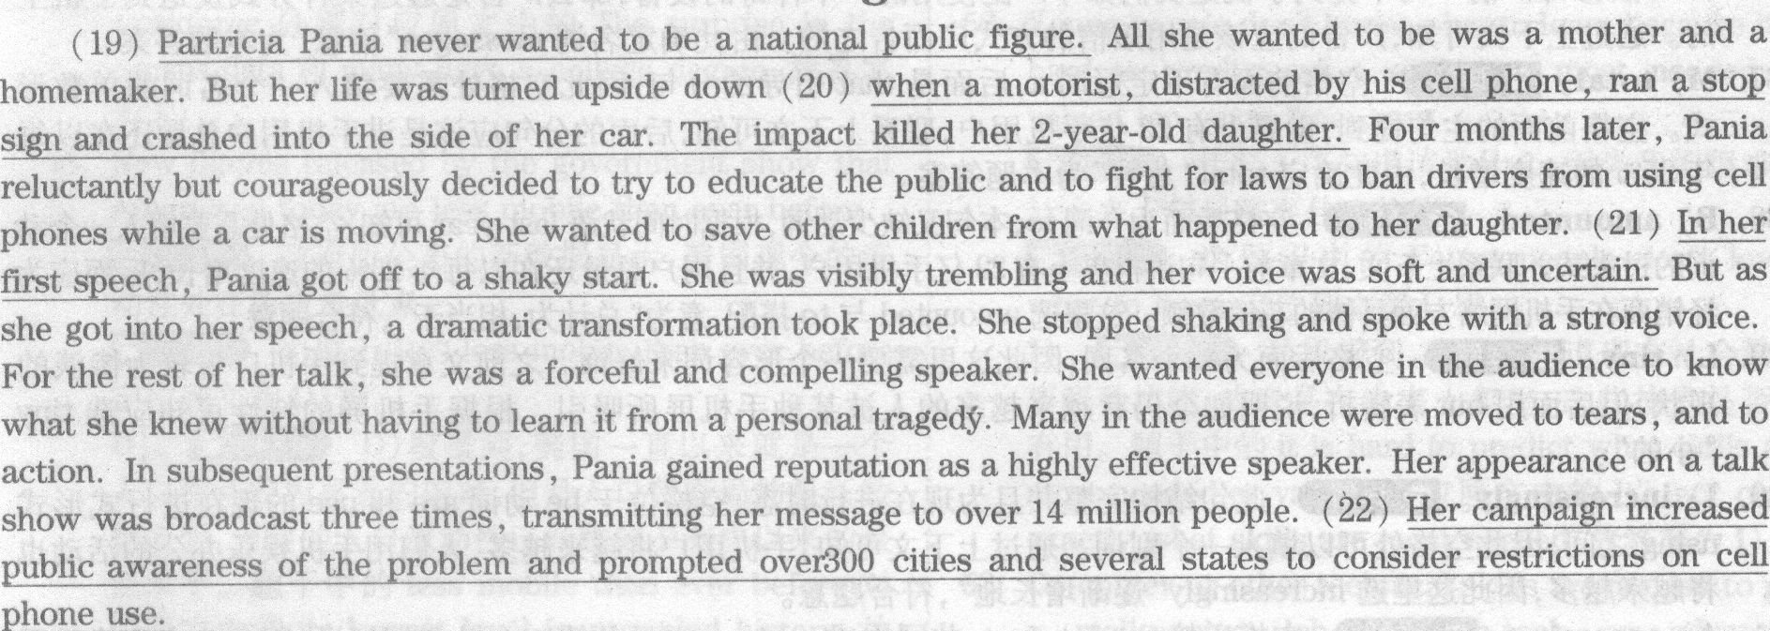
19. What was the significant change in Partricia Pania's life? C) 。
20. what had led to Pania's personal tragedy? D)。
21. How did Paula feel when she began her first speech? A) 。
22. What could be exoected as a result of Pania's efforts? B) 。
Passage Three
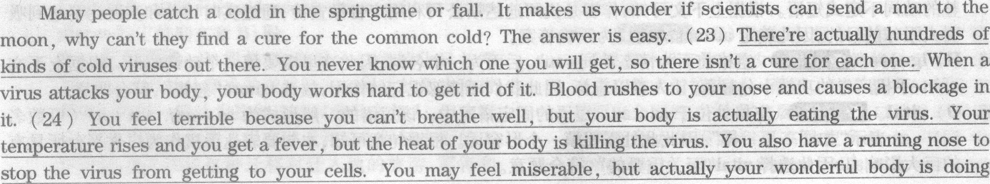
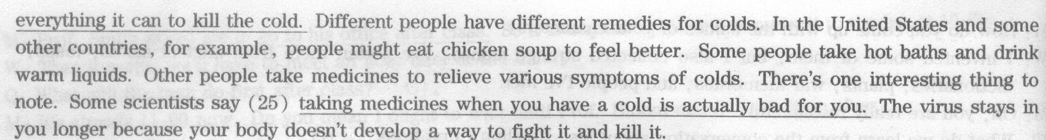
23. According to the passage, why haven't scientists found a cure for the common cold? B) 。
24. What does the speaker say about the symptoms of the common cold? D) o
25. What do some scientists say about taking medicines for the common cold, according to the passage? A) 。
Section C
You probably have noticed that people express similar ideas in different ways, depending on the situation they are in. This is very 26 All languages have two general levels of usage : a formal level and an informal level. English is no 27 . The difference in these two levels is the situation in which you use a 28 level. Formal language is the ldnd of language you find in textbooks, 29 , and in business letters. You would also use formal English in compositions and 30 that you write in school. Informal language is used in conversation with colleagues, family members and friends, and when we write 31 notes or letters to close friends.
Formal language is different from informal language 32 . First, formal language tends to be more polite. What we may find interesting is that it usually takes more words to be polite. For example, I might say to a friend or a family member, "Close the door, please. " but to a 33 , I probably would say,"Would you mind closing the door?"
Another difference between formal and informal language is some of the 34 There are bound to be some words and phrases that 35 formal language and others that are informal. Let's say that I really like soccer. If I'm talking to my friend, I might say "I'm just crazy about soccer !" But if I were talldng to my boss, I would probably say "I really enjoy soccer. "

26. natural
27. exception
28. particular
29. reference books
30. essays
31. peronal
32. in several ways
33. stranger
34. vocabulary
35. belong in

