1. W: I'd like to take a trip to Florida for my spring break. Can you give me any idea where, to go?
M: I could tell you about the places I visited, but I think you'd better look up a travel agency to help the arrangement.
W: What does the man suggest the woman do? C) 。
2. M: I'm reall,v tired of driving at night, even though the traffic seems fine.
W: I see. Let's stop for some food and then find a motel nearby, so we can start eaxiy tomorrow.
M: What do we learn about the speakers? A) 。
3. M: Jeff's got a lot of good ideas, Do you think he is willing to come to the meeting?
W: Oh, I think he'd be glad to come, but what's difficult is getting the guy to speak before a large crowd.
M: What does the woman imply about Jeff? C) 。
4. W: I hear you are leaving the company and going back to school this year.
M: Yes, I've enrolled in a graduate program in public admintistration.
W: what is the man going to do? B)。
5. W: Have you applied for the art director position?
M: No, I'd like to.But the Job starts on the first of May and I wouldn't be available until June.
W: What does the man mean? A) 。
6. W: Will my car be ready by the end of the. day?
M: It should be. I'll call if there are any problems. We are open until 6:00. W: What is probably the num's job? B) 。
7. W:I have a big paper due Monday, but i promise Laura we'd clean the apartment this weekend. What am I going to do?
M: Why don't you just see if Laura can wait for a week or two?
W: What does the man suggest the woman do? D) 。
8. W: Construction ,on the bridge has really slowed the traffic,
M: I know. Since they started working, the time it takes me to get to work has doubled. W: What are the speakers talking about? A)。
Conversation One
W: Sales department. Can I help you?
M: Oh, yes. I hope so. My name is Kings Bruce of GPF Ltd. (9) We need some supplies for our design office. W: I see. What sort of things are you looking for Mr. Kings Bruce?
M: Well, first of all, we need one complete new drawing board.
W. Well, in the standard range, we have the D044, and the D045 models. M: Oh, what's the difference between them?
W: Well, the D045 has itself mending system and it does cost slightly more as a result. M: So what is the total price?
W: For the D045, it is 387 pounds 50 pence. M: And does that include value added tax? W: Oh, yes,
M: Can you tell me how long it rakes to deliver?
W: I can't give a definite date now I'm afraid, because it depends on the other orders we have to get out. But it will certainly be within three weeks.
M: Ok, now we also want some drawing pens, ink and correction fluid, and some drawing paper.
W: (10) Ah, now the lady who deals with drawing office supplies isn't here this morning, I'm afraid. But I could ask her to give you a ring this .afternoon if you like.
M: Oh, yes. Thank you.
W: What is your telephone number?
M: It is Redding, (11) That is code 0734, 21653-51.
W: Ok, I will get Ms, Thomson to ring you this afternoon. Now would you like me to place an order for one D045 drawing board?
M: yes, please. You've been most helpful, Goodbye. W: Goodbye.
9. What's the man's purpose in making the telephone call? C) 。
10, Why can't the man order the other drawing office supplies right now? A) 。11, What's the man's telephone number? B) 。
Conversation Two
W: I'm so worried about Mark these days. ( 12 ) Ever since he moved into this apartment, he has. been losing weight. He really doesn't look well at all,
M: He should try to gain some weight. He is probably not eating enough. W: Well, anyway, how is Tim these days?
M: Tim? Oh, Tim has been worried, too.
( 13 ) He is really getting much too fat. He needs to lose about 75 pounds now.
W: That's a lot of weight to lose. What does Tim eat?
M: I really don't know. But I am sure he is eating too much cake and candy.
W: Well. did I tell you Mark doesn't eat any meat now? He only eats vegetables and fruit.
M: That's probably why he is so thin, Does he smoke?
W.. Does he smoke? About two packs of cigarettes a day. That's my son, a smoking vegetarian
M : Un, if he stops smoking, he would gain weight, I know he would. Tim put on a lot of weight, when he stopped smoldng.
W: Does Tim play any sports?
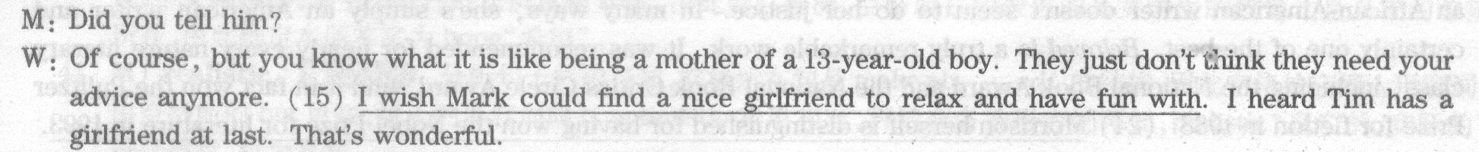
12. When did Mark start losing weight according to the woman? D) 。
13. Why is the man worried about Tim? A) 。
14. What did Mark and Tim have in common? D)。 15. What is the woman's wish for Mark? C) o
Section B
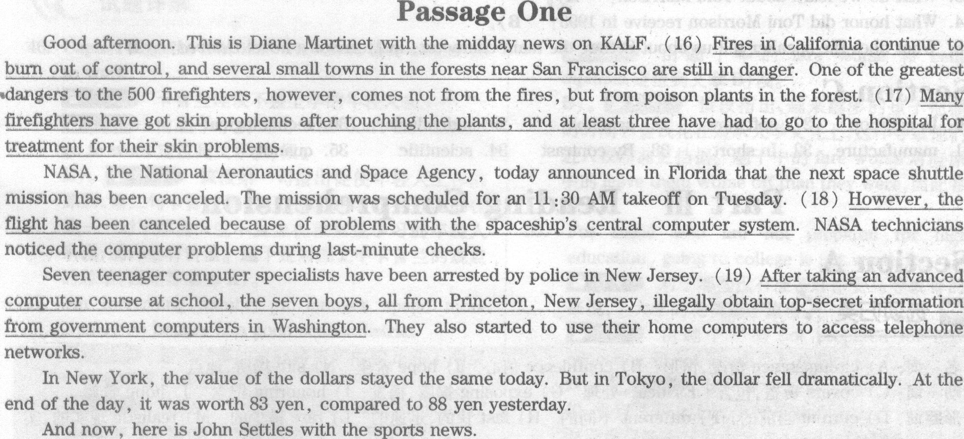
16. What does the midday news on KALF say about fires in California? .D) 。
17. What do we learn about many of the firefighters? B) 。
18. What do we learn from the news about the space shuttle mission? C)。
19. What do we learn about the seven boys in New Jersey? D) 。

Passage Two
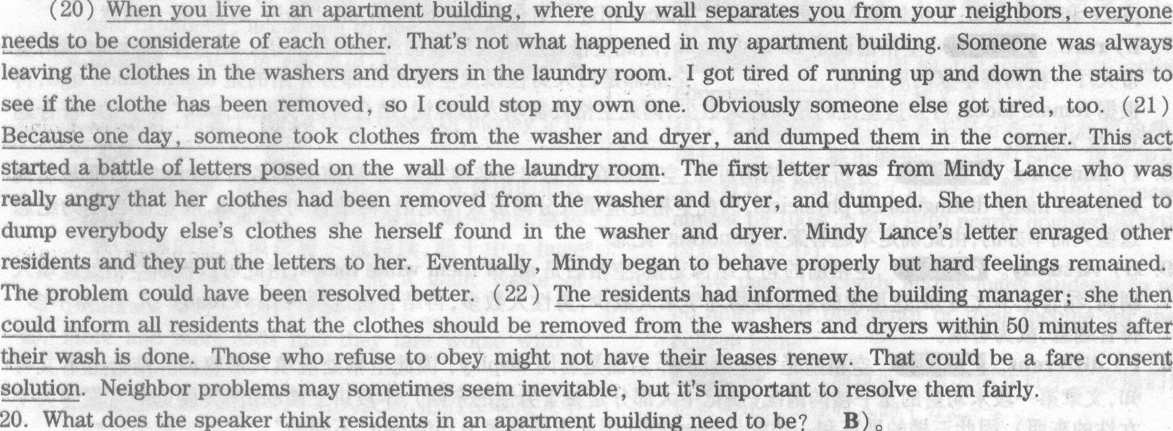
21. What started a battle of letters in the laundry room? A) 。
22. What does the speaker think might be a better way to resolve the problem? C)
Passage Three

23. What do we learn about Toni Morrison? A) 。
24. What honor did Toni Morrison receive in 1993? B) 。
25. What does the speaker tell us about Sethe, the main character, in Morrison's novel Beloved? D) 。
Section C
Directions: In this section, you will hear a passage three times. When the passage is read for the first time, you should listen carefully for its general idea. When the passage is read for the second time, you are required to fill in the blanks with the exact words you have just heard. Finally, when the passage is read for the third time, you should check what you have written.
Many college students today own personal computers that cost anywhere from $1,000 to perhaps $ 5,000 or more. 26 , it is not uncommon for them to purchase 27 costing another several hundred dollars, Twenty years ago, computers were 28 , but they were very large and extremely expensive. Few, if any, 29 purchased computers for home use..Over the years the price of the "guts" of a computer-its memory-has declined to less than a thousandth of the price per unit of memory that prevailed twenty years ago. This is the main reason why computers cost so much less today than they used to. Moreover, 30 improvements have made it possible to 31 memory circuitry that is small enou~ to fit into the portble personal computers that many of us own and use. 32 , as the price of computation has declined the average consumer and business have spent more on purchasing computers. 33 , improved agricultural technology, hybrid (杂交) seeds, 34 animal breeding, and so on have vastly increased the amount of output a typical farmer can produce. The prices of goods such as meats and grains have fallen sharply relative to the prices of most other goods and services. As agricultural prices have fallen, many households have decreased their total expenses on food. Even though the 35
of a product purchased generally increase when its price falls, total expenses on it may decline.

26. In addition
27. software
28. available
29. individuals
30. technological
31. manufacture
32. In short
33. By contrast
34. scientific
35. quantity

