2014年6月四级真题(第2套)
Part I Writing (30 minutes)
Directions: For this part, you are allowed 30 minutes to write a short essay on the following question.
You should write at least 120 words but no more than 180 words.
Suppose a foreign friend of yours is coming to visit your campus, what is the most interesting place you would like to take him/her to see and why?
注意：此部分试题请在答题卡1上作答。
Part II Listening Comprehension (30 minutes)
Section A
Directions: In this section, you will hear 8 short conversations and 2 long conversations. At the end of each conversation, one or more questions will be asked about what was said. Both the conversation and the questions will be spoken only once. After each question there will be a pause. During the pause, you must read the four choices marked A., B., C.and D., and decide which is the best answer. Then mark the corresponding letter on Answer Sheet Ｉ with a single line through the centre.
注意：此部分试题请在答题卡1上作答。
1. A.They came in five different colors.
B.They were good value for money.
C.They were a very good design.
D.They were s01d out very quickly.
2. A.Ask her roommate not to speak loudly on the phone.
B.Ask her roommate to make her phone calls outside.
C.Go and find a quieter place to review her lessons.
D.Report her problem to the dorm management.
3. A.The washing machine is totally beyond repair.
B.He will help Wendy prepare her annual report.
C.Wendy should give priority to writing her. report.
D.The washing machine should be checked annually.
4. A.The man fell down when removing the painting.
B.The wall will be decorated with a new painting.
C.The woman likes the painting on the wall.
D.The painting is now being reframed.
5. A.It must be missing. B.It was left in the room.
C.The man took it to the market. D.She placed it on the dressing table.
6. A.Go to a play.
B.Meet Janet.
C.Book some tickets.
D.Have a get-together.
7. A.One box of books is found missing.
B.Some of the boxes arrived too late.
C.Replacements have to be ordered.
D.Some of the books are damaged.
8. A.The man will pick up Professor Johnson at her office.
B.The man did not expect Iris paper to be graded too soon.
C.Professor Johnson has given the man a very high grade.
D.Professor Johnson will talk to each student in her office.
Questions 9 to 11 are based on the conversation you have just heard.
9. A.To buy a present for his friend who is getting married.
B.To find out the cost for a complete set of cookware.
C.To see what he could ask his friends to buy for him.
D.To make inquiries about the price of an electric cooker.
10. A.To teach him how to use the kitchenware.
B.To discuss cooking experiences with him.
C.To tell him how to prepare delicious dishes.
D.To recommend suitable kitchenware to him.
11. A.There are so many different sorts of knives.
B.Cooking devices are such practical presents.
C.A mixer can save so much time in making cakes.
D.Saucepans and frying pans are a must in the kitchen.
Questions 12 to 15 are based on the conversation you have just heard.
12. A.Some new problems in her work.
B.Cooperation with an international bank.
C.Her chance for promotion in the bank.
D.Her intention to leave her present job.
13. A.The World Bank.
B.Bank of Washington.
C.A U.S. finance corporation.
D.An investment bank in New York
14. A.Supervising financial transactions.
B.Taking charge of public relations.
C.Making loans to private companies in developing countries.
D.Offering service to international companies in the United States.
15. A.It is a first major step to realizing the woman's dream.
B.It is an honor for the woman and her present employer.
C.It is a loss for her current company.
D.It is really beyond his expectation.
Section B
Directions: In this section, you will hear 3 short passages. At the end of each passage, you will hear some questions. Both the passage and the questions will be spoken only once. After you hear a question, you must choose the best answer from the four choices marked A), B), C) and D). Then mark the corresponding letter on Answer Sheet 1 with a single line through
the centre.
注意：此部分试题请在答题卡1上作答。
Passage One
Questions 16 to 18 are based on the passage you have just heard.
16. A.Carry out a thorough checkup.
B.Try to keep the gas tank full.
C.Keep extra gas in reserve.
D.Fill up the water tank.
17. A.Attempting to leave your car to seek help.
B.Opening a window a bit to let in fresh air.
C.Running the engine every now and then.
D.Keeping the heater on for a long time.
18. A.It exhausts you physically.
B.It makes you fall asleep easily.
C.It causes you to lose body heat.
D.It consumes too much oxygen.
Passage Two
Questions 19 to 21 are based on the passage you have just heard.
19. A.They are very generous in giving gifts.
B.They refuse gifts when doing business.
C.They regard gifts as a token of friendship.
D.They give gifts only on special occasions.
20. A.They enjoy giving gifts to other people.
B.They spend a lot of time choosing gifts.
C.They have to follow many specific rules.
D.They pay attention to the quality of gifts.
21. A.Gift-giving plays an important role in human relationships.
B.We must be aware of cultural differences in giving gifts.
C.We must learn how to give gifts before going abroad.
D.Reading extensively makes one a better gift-giver.
Passage Three
Questions 22 to 25 are based on the passage you have just heard.
22. A.It reflects American people's view of French politics.
B.It is first published in Washington and then in Paris.
C.It explains American politics to the French public.
D.It is popular among French government officials.
23. A.Work on her column
B.Do housework at home.
C.Entertain her guests.
D.Go shopping downtown.
24. A.To report to her newspaper.
B.To refresh her French.
C.To visit her parents.
D.To meet her friends.
25. A.She might be recalled to France.
B.She might change her profession.
C.She might close her Monday column
D.She might be assigned to a new post.
Section C
Directions: In this section, you will hear a passage three times. When the passage is read for the first time, you should listen carefully for its general idea. When the passage is read for the second time, you are required to fill in the blanks with the exact words you have just hoard. Finally, when the passage is read for the third time, you should check what you have written.
注意：此部分试题请在答题卡1上作答。
According to American law, if someone is accused of a crime, he is considered (26)__________until the court proves the person is guilty.
To arrest a person, the police have to be reasonably sure that a crime has been (27)__________The police must give the suspect the reasons why they are arresting him and tell him his rights under the law. Then the police take the suspect to the police station, where the name of the person and the(28) __________ against him are formally listed.
The next step is for the suspect to go before a judge. The judge decides whether the suspect should be kept in jail or (29) __________ . If the suspect has no previous criminal record and the judge feels that he will return to court (30) __________run away, he can go free. Otherwise, the suspect must put up bail (保释金). At this time, too, the judge will (31)___________ a court lawyer to
defend the suspect if he can't afford one.
The suspect returns to court a week or two later. A lawyer from the district attorney's office Mpresents a case against the suspect. The attorney may present (32) __________ as well as witnesses.
The judge then decides whether there is enough reason to (33) __________ The American justice system is very complex and sometimes operates slowly. However, every step is(34) __________ to protect the rights of the people. These individual rights are the(35) __________ of the American government.
Part III Reading Comprehension(40 minutes)
Section A
Directions: In this section, there is a passage with ten blanks. You are required to select one word for each blank _from a list o.f choices given in a word bank following the passage. Read the passage through carefully before making your choices. Each choice in the bank is identified by a letter. Please mark the corresponding letter for each item on Answer Sheet 2 with a single line through the centre. You may not use any of the words in the bank more than once.
Questions 36 to 45 are based on the following passage.
Thefact is, the world has been finding less oil than it has been using for more than twenty years now. Not only has demand been36 , but the oil we have been finding is coming from places that are37to reach. At the same time, more of this newly38oil is of the type that requires a greater investment to39 . And because demand for this precious resource will grow, according to some, by over 40 percent by 2025, fueling the world's economic40will take a lot more energy from every possible source.
The energy industry needs to get more from existing fields while continuing to search for new41 . Automakers must continue to improve fuel efficiency and perfect hybrid (混合动力的) vehicles. Technological improvements are needed so that wind, solar and hydrogen can be more42 parts of the energy equation. Governments need to formulate energy policies that promote43and environmentally sound development. Consumers must be willing to pay for some of these solutions, while practicing conservation efforts of their own.
Inaction is not an44 . So let's work together to balance this equation. We are taking some of the45needed to get started, but we need your help to go the rest of the way.
注意：此部分试题请在答题卡2上作答。
A. consequently
B.cultivate
C.declining
D.derived
E. difficult
F. discovered
G. economically
H. exception
I. feasible
J. growth
K. optionL) refine
M. reserves
N.soaring
O. steps
Section B
Directions: In this section, you are going to read a passage with ten statements attached to it. Each statement contains information given in one of the paragraphs. Identify the paragraph from which the information is derived. You may choose a paragraph more than once. Each paragraph is marked with a letter. Answer the questions by marking the corresponding letter on Answer Sheet 2.
I Cry, Therefore I Am
A) In 2008, at a German zoo, a gorilla (大猩猩) named Gana gave birth to a male infant, who died after three months. Photographs of Gana, looking stricken and inconsolable (伤心欲绝的), attracted crowds to the zoo. Sad as the scene was, the humans, not Gana, were the only ones crying. The notion that animals can weep has no scientific basis. Years of observations by biologists Dian Fossey, who observed gorillas, and Jane Goodall, who worked with chimpanzees (黑猩猩), could not prove that animals cry tears from emotion.
B)It's true that many animals shed tears, especially in response to pain. Tears protect the eye by keeping it moist. But crying as an expression of feeling is tmique to humans and has played an essential role in human evolution and the development of human cultures.
C)Within two days an infant can imitate sad and happy faces. If an infant does not cry out, it is unlikely to get the attention it needs to survive. Around 34 months, the relationship between the human infant and its environment takes on a more organized commtmicative role, and tearful crying begins to serve interpersonal purposes: the search for comfort and pacification (抚慰). As we get older, crying becomes a tool of social interaction: grief and joy, shame and pride, fear and
manipulation.
D)Tears are as universal as laughter, and grief is more complex than joy. But although we all cry, we do so in different ways. Women cry more frequently and intensely than men, especially when exposed to emotional events. Like crying, depression is, around the world, more commonly seen in women than in men. One explanation might be that women, who despite decades of social advances still suffer from economic inequality, discrimination (歧视) and even violence, might have more to cry about. Men not only cry for shorter periods than women, but they also are less inclined to explain their tears, usually shed them more quietly, and tend more frequently to apologize when they cry openly. Men, like women, report crying at the death of a loved one and in response to a moving religions experience. They are more likely than women to cry when their core identities--as providers and protectors, as fathers and fighters--are questioned.
E) People who score on personality tests as more sympathetic cry more than those who are more rigid or have more self-control. Frequency of crying varies widely: some shed tears at any novel or movie, others only a handful of times in their lives. Crying in response to stress and conflict in the home, or after emotional trauma (创伤), lasts much longer than tears induced by everyday sadness--which in turn last longer than tears of delight and joy.
F) Sadness is our primary association with crying, but the fact is that people report feeling happier after crying. Surveys estimate that 85% of women and 73% of men report feeling better after shedding tears. Surprisingly, crying is more commonly associated with minor forms of depression than with major depression involving suicidal thoughts.
G) People widely report that crying relieves tension, restores emotional balance and provides "catharsis," a washing out of bad feelings. The term "catharsis" has religious implications of removing evil and sin; it's no surprise that religious ceremonies are, around the world, one of the main settings for the release of tears.
H) Crying is a nearly universal sign of grief, though some mourners report that, despite genuine sorrow, they cannot shed tears--sometimes even for years after their loved one has gone. Unlike today, when the privacy of grief is more respected, the public or ceremonial shedding of tears, at the graveside of a spouse or the funeral of a king or queen, was once considered socially or even politically essential.
I) Crying has also served other social purposes. Rousseau wrote in his Confessions that while he considered tears the most powerful expression of love, he also just liked to cry over nothing.
J) The association of tears with art has ancient roots. The classic Greek tragedies of the fifth century
B.C. were primarily celebrations of gods. Tragedies, like poetry and music, were staged religions events. Even then it was recognized that crying in response to drama brought pleasure.
K) I have argued that there are neurobiological (神经生物方面的 ) associations linking the arts and mood disorders. When I lecture on crying, I ask my audience to let me know, by a show of hands, which art forms most move them to tears. About 80% say music, followed closely by novels (74%), but then the figures fall sharply, to 43%, for poetry, and 10-22% for paintings, sculpture and architecture.
L) The physical act of crying is mainly one of breathing in air, which is why we choke up when we weep. This suggests to language scientists that emotional crying evolved before language, perhaps explaining why tears communicate states of mind and feelings that are often so difficult to express in words. Of course, from an evolutionary perspective, recognition of emotion (usually through facial gesture) was essential for survival.
M) The earliest humans arrived sevetal million years ago, but only 150,000 to 200,000 years ago, did cultures, language, religion and the arts arise. Along the way, tears became more than a biological necessity to lubricate (润滑) the eye and developed into a sign of intense emotion and a signal of social bonding. The development of self-consciousness and the notion of individual identity, or ego; storytelling about the origins of the world, the creation of humanity and life after death; and the
ability to feel others' sadness--all were critical parts of the neurobiological changes that made us human
N) More recently, we've learned from neuroscience that certain brain circuits (回路) are activated (激活), rapidly and unconsciously, when we see another in emotional distress. In short, our brain evolved circuits to allow us to experience sympathy, which in turn made civilization, and an ethics based on sympathy, possible. So the next time you reach a tissue box, or sob on a friend's shoulder, or shed tears at the movies, stop and reflect on why we cry and what it means to cry. Becanse ultimately, while we love to cry, we also cry to love.
注意：此部分试题请在答题卡2上作答。
46. Nowadays people respect the privacy of grief more than in the past.
47. Infants cry to attract attention for survival.
48. There is no scientific evidence as yet that animals can shed tears from emotion.
49. Tears can perform certain communicative functious which words cannot.
50. Our ability to experience sympathy is essential to the development of civilization.
51. People are more inclined to cry when suffering minor forms of depression.
52. Sometimes people cannot cry despite genuine grief.
53. In humans' long history, tears have developed an essential role in social relationships.
54. Men are less likely to give reasons for their tears.
55. Crying has long been associated with art.
Section C
Directions: There are 2 passages in this section. Each passage is followed by some questions or
unfinished statements. For each of them there are four choices marked A), B), C.and D).
You should decide on the best choice and mark the corresponding letter on Answer Sheet 2
with a single line through the centre.
Passage One
Questions 56 to 60 are based on the following passage.
Hospitals, hoping to curb medical error, have invested heavily to put computers, smartphones and other devices into the hands of medical staff for instant access to patient data, drug information and case studies.
But like many cures, this solution has come with an unintended side effect: doctors and nurses can be focused on the screen and not the patient, even during moments of critical care. A poll showed that half of medical technicians had admitted texting during a procedure.
This phenomenon has set off an intensifying discussion at hospitals and medical schools about a problem perhaps best described as "distracted doctoring." In response, some hospitals have begun limiting the use of electronic devices in critical settings, while schools have started reminding medical students to focus on patients instead of devices.
"You justify carrying devices around the hospital to do medical records, but you can surf the Internet or do Facebook, and sometimes Facebook is more tempting," said Dr. Peter Papadakos at the University of Rochester Medical Center.
"My gut feeling (本能的感觉is lives are in danger," said Dr. Papadakos. "We're not educating people about the problem, and it's getting worse."
A survey of 439 medical technicians found that 55 percent of technicians who monitor bypass machines acknowledged that they had talked on cellphones during heart surgery. Half said they had texted while in surgery. The study concluded, "Such distractions have the potential to be disastrous."
Medical professionals have always faced interruptions from cellphones, and multitasking is simply a fact of life for many medical jobs. What has changed, say doctors, especially younger ones, is that they face increasing pressure to interact with their devices.
The pressure stems from a mantra (信条) of modem medicine that patient care must be "data driven," and informed by the latest, instantly accessible information. By many accounts, the technology has helped reduce medical error by providing instant access to patient data or prescription details.
Dr. Peter Carmel, president of the American Medical Association, said technology "offers great potential in health care." but he added that doctors' first priority should be with the patient.
注意：此部分试题请在答题卡2上作答。
56. Why do hospitals equip their staff with computers, smartphones and other devices?
A.To reduce medical error.
B.To cope with emergencies.
C.To facilitate administration.
D.To simplify medical procedures.
57. What does the author refer to by "distracted doctoring"?
A.The disservice done by modem devices to doctors, nurses, as well as patients.
B.The tendency of medical institutions encouraging the use of modem devices.
C.The problem of devices preventing doctors from focusing on their patients.
D.The phenomenon of medical staff attending to personal affairs while working.
58. What does Dr. Peter Papadakos worry about?
A.Medical students are not adequately trained to use modem technology.
B.Doctor's interaction with their devices may endanger patients' lives.
C.Doctors are relying too heavily on modem electronic technology.
D.Pressures on the medical profession may become overwhelming.
59. Why do doctors feel increasing pressure to use modem devices?
A.Patients trust doctors who use modern technology.
B.Use of modem devices adds to hospitals' revenues.
C.Data is given too much importance in patient care.
D.Patients' data has to be revised from time to time.
60. What is Peter Carmel's advice to doctors?
A.They follow closely the advances in medical science.
B.They focus their attention on the patient's condition.
C.They observe hospital rules and regulations.
D.They make the best use of modem devices.
Passage Two
Questions 61 to 65 are based on the following passage.
I have closely watched my generation, known as The Millennials, for 29 years now. Joel Stein wrote an extensive piece on Millennials and he remains rather optimistic about our potential.
I hesitate to share his optimism because of a paradox (矛盾的现象) we seem to exhibit, namely, that there are more avenues for us to entertain ourselves than ever before, yet we are more bored than ever before.
Entertainment has never been more varied. We have more cable channels, television shows, and movies than ever before. Intemet providers allow instant viewing of almost any movie or television program ever created. Social drinking and partying are also widely available for Millennials. Every generation develops these habits at a certain age, but Millennials seem to be extending this phase of life as they postpone marriage.
Some of this is undoubtedly due to The Great Recession. Millennials are having a difficult time finding jobs; only 47 percent of 16-to-24-year-olds are employed, the smallest share since government started recording data in 1948.
But do Millennials respond to these economic troubles by doing whatever it takes to make ends meet? Hardly. In fact, of the four generations Pew Research has data for, the Millennial generation does not cite work ethic (勤奋工作) as distinctive of itself. Millennials want to save the world, but they sit and wait for that world-changing opportunity to be handed to them. Instead of working 2-3 jobs,
launching a business, or doing what it takes to succeed, they retreat. Millennials may be the first generation to have a lower standard of living than their parents, but with this response to adversity (逆境), perhaps deservingly so.
Much ink has been spilled in management books discussing how to get the most out of these youths in the workplace. Largely, they come to the same conclusion: Millennials are entitled, over-confident, and expect too much too quickly. We should not be surprised. Today's young adults were raised by parents who made sure to boost their self-esteem at every turn, telling them they could achieve whatever they set their minds to, and handing out prizes for the sixth place.
注意：此部分试题请在答题卡2上作答。
61. What does the author of the passage think of Millennials?
A.They show little interest in entertainment.
B.They are not confident about their ability.
C.They enjoy an easy life due to high technology.
D.They may not have bright prospects for success.
62. How do Millennials feel about their life?
A.They can hardly do anything about it.
B.There is little in it to get excited about.
C.It is not as good as their parents'
D.It is full of opportunities for success.
63. In what way are Millennials different from previous generations according to Pew Research?
A.They spend less time socializing.
B.They are indifferent to others.
C.They do not value hard work.
D.They are more independent.
64. What should Millennials do according to the author?
A.Remain optimistic in face of adversity.
B.Start a business as early as possible. C.Make full use of new opportunities.
D.Take action to change their situation.
65. Why are Millennials over-confident about themselves?
A.They have been spoiled by their parents.
B.They can always get whatever they expect.
C.They are misguided by management books.
D.They think they are young and energetic.
Part IV Translation (30 minutes)
Directions: For this part, you are allowed 30 minutes to translate a passage from Chinese into English.
You should write your answer on Answer Sheet 2.
中国教育工作者早就认识到读书对于国家的重要意义。有些教育工作者2003年就建议设立全民读书日。他们强调。人们应当读好书，尤其是经典著作。通过阅读，人们能更好地学会感恩、有责任心和与人合作，而教育的目的正是要培养这些基本素质。阅读对于中小学生尤为重要，假如他们没有在这个关键时期培养阅读的兴趣，以后要养成阅读的习惯就很难了。
注意：此部分试题请在答题卡2上作答。
2014年6月四级真题答案详解(第2套)
Part I Writing
The Must-visit Place in My Campus
写作指南
这是一篇介绍性说明文，考生可以结合实际情况，客观描述自己学校的著名景点，重点是陈述该景点值得介绍的原因。第一段可以开篇点题，第二段描述该景点的特色，第三段总结全文。文章的结构可安排如下：
第一段：开门见山地点明想带外国朋友游览的景点。
第二段：列举该景点值得游览的原因。注意该段落为主体部分，最好能罗列两个或更多具有说服力的优点予以说明。
第三段：言简意赅地复述前两段的内容，总结全文。注意，该总结段尽量不要简单重复第一、二段的表达，应尽量换种表达．以使全文的表达富有多样性。
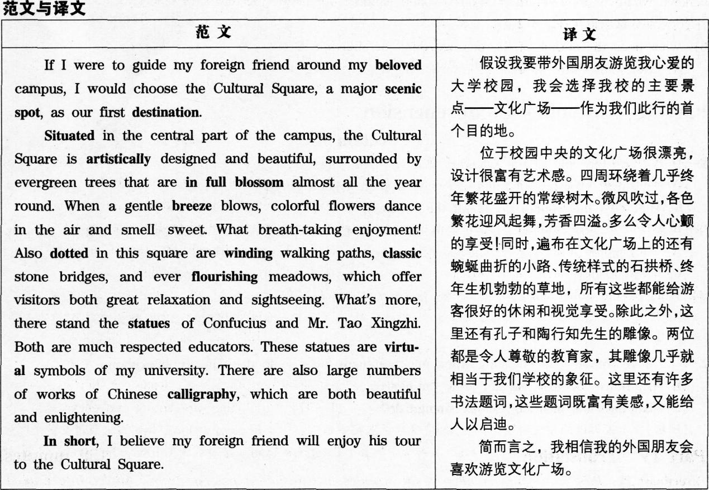
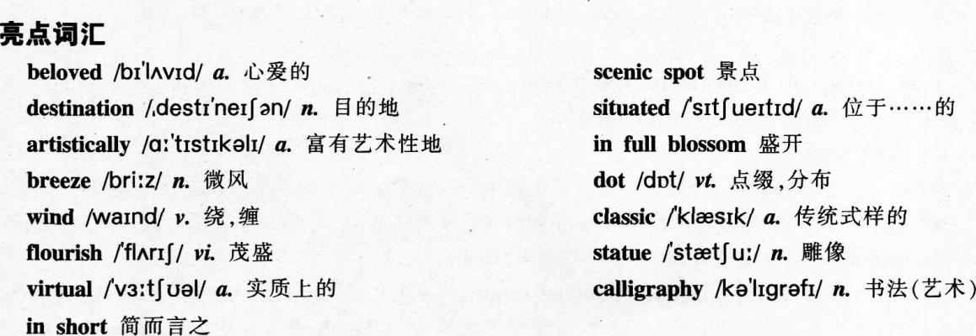
万能句型

1．If l were to guide…around…．l woulld choose…，a major scenic spotasour first destination．假设我要带……游览……，我会选择主要景点——…… ——作为我们此行的首个目的地。
2．Ifis coming to visit．…l will take…t0…first．假设……即将造访……．我会首先带……去……。
3 Tf T wprp tn name the first destination that…should pay a visit，1 would definitely come up with…如果要让我推荐……应该首先游览的目的地．我会毫无疑问地推荐……。
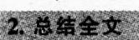
1．In short一．简而言之，……。
2．In conclusion…．总而言之，……。
3．All in all…总而言之…
写作模板
If l were to guide （某人） around （某地），1 would choose （某具体景点)，a major scenic spot，as our first destination．
Situated in （某方位)，（某具体景点） is artistically designed and beautiful，（列举第一个优点)．Also dotted in （某具体景点）are （列举第二个优点)．What’s more，(列举第三个优点)．There are also (列举第四个优点)．
In shortIbelieve (某人) will enjoy his]her tour to (某具体景点)．
Part Ⅱ Listening Comprehension
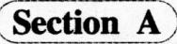
1. M: Did you buy any of the sweaters that were on sale?
W: Buy any? I got five of them. They were such a good bargain.
O: What does the woman say about the sweaters?
【B】【解析】男士询问女士是否买了在降价促销(on sale)的毛衣，女士回答说买了5件，认为它们是a good bargain。
bargain作名词时指廉价的商品，词组a good bargain则指“自己占便宜、划算的交易”，故B项“(毛衣)物有所值”正确。【点睛】①由D项中的sold out“售謦”可知，they指代某类商品。②录音是说女士买了5件毛衣，并非指毛衣有5种不同的颜色，A项排除。女士只强调了毛衣的便宜，C项“毛衣的设计很好”和D项“毛衣很快就卖完了”都是无中生有。
2. W: I have trouble concentrating when my roommate talks so loud on her mobile phone.
M: Why don't you just ask her to lower her voice?
O: What does the man surest the woman do?
【A】【解析】女士投诉她的室友讲电话声音太大，令她无法集中精神。男士用了why don’t you的句型建议女士叫她的室友小声点(10wer her voice)，A项中的not to speak loudly与对话中的lower her voice同义，故确定A项为答案。
【点睛】①四个选项均为祈使句，都与提建议相关，听音时特别留意与建议相关的内容。②B项“叫她的室友到外面讲电话”只是利用对话中的mobile phone作干扰。C项“出去找个安静点的地方复习功课”和D项“向宿管处报告”都是无中生有。
3. W: Wendy is in the basement, trying to fix the washing machine.
M: Shouldn't she be working on her annual report?
O: What does the man mean?
【C】【解析】女士说Wendy在地下室修理洗衣机，男士用了否定式的反问句说，“难道她不是应该在写年度报告吗?”，相当于she should be working on her annual report，男士的话暗示，Wendy这个时间应该首先完成报告，而不去修理洗衣机，C项“Wendy应优先写报告”正确。
【点睛】①选项出现两大关键词washing machine及annual report，听音时注意两者的有关信息。②A项“洗衣机已完全修不好”过度推断，男士只是强调Wendy应该先写报告，无法推断是Wendy是否能修好洗衣机。B项也是过度推断。男士的话并不能理解为他会帮Wendy写报告。D项只是拼凑了对话中的washing machine及annual作干扰，其内容没有实质根据。
4. W: What happened to the painting that used to be on the wall?
M: It fell down and the glass broke. I'm having it reframed.
O: What do we learn from the conversation?
【D】【解析】女士问墙上的画去哪了，男士回答说它掉下来，玻璃碎了，他正在帮画重新装画框(having it reframed)。
D项复现对话中的reframed，内容与对话相符。
【点睛】①四个选项中都出现the paintin9，两个选项含有wall，故推测对话与墙上的画有关。②掉到地上的是画，而不是男士．故A项“男士在拿走画时，摔到地上了”错误。由对话可推测，画被重新上框后会挂回去，而是不会更换新画．故B项“墙上会挂一幅新画”错误。女士只是好奇墙上的画不见了，但无法推知她是否喜欢该画，故C项女士喜欢墙上的画”错误。③refr是由frame“给……装上框架”派生出来的，前缀re一表示“重新，再次”，故此可推测reframe为“为……重新加上框”。
5. M: You must have left the camera in the market. It's a very expensive camera, you know.
W: But I tell you that I didn't take it I remember clearly that you put it on the dressing table.
Q: What does the woman say about the camera?
B]【解析】男士责怪女士在市场里丢了相机，但女士说她清楚记得她没有带相机出门，男士把相机放在梳妆台(dressing table)了，故可知．女士认为相机留在房间了，B项正确。
【点睛】①由选项中的missing，left等词可推测对话与丢失某物品有关。②女士认为相机在梳妆台没拿出来，并未丢失．A项“相机丢了”和C项“男士把相机带到市场”错误。把相机放在梳妆台的是男士，并非女士，故D项“她把相机放在梳妆台了”也错误。③本题的关键在于听到并知道dressing table的含义，就算不知道dressing table的具体含义．考生根据dressing与衣着、打扮有关，也可推测出答案。
6. W: There is a good comedy on at the Theatre Royal next Saturday. ff you like, I can book four seats for us.
M: All right. I'll ask Janet if she is free then. I'll let you know tomorrow.
Q: What does the woman suggest they do next Saturday?
【A】【解析】女士提到下周六在皇家剧院(TheatreRoyal有一出不错的喜剧(comedy)上演，并说可以预订四张票，故女士是建议去看戏剧，A项中的play指“戏剧，话剧”，包括对话中的comedy，故为正确答案。
【点睛】①对话中的Theatre‘‘剧院”一词也提示A项正确。②B项“见Janet’’及C项“订票”都不是下周六要做的事，故排除这两项。D项get-together“聚会”范围过大，不如A项准确。
7. W: We've opened the first box. Look! Some of these books are soaked.
M: They should've used waterproof wrappings. What are we going to do about it? It's too late to order replacements.
O: What do we learn from the conversation?
【D】【解析】女士提到有些书遭到了浸泡(soaked)，D项中的damaged“受损”对应对话中的soaked，故D项为答案。
【点睛】①选项反复出现box，books及一些负面情况，故预测本题询问书本的寄送出现了什么问题。②A项中的missing“丢失了”没有根据。B项利用对话中的too late作干扰，对话是说现在订替换的书太迟了，而不是书到得太迟．对话明确提到“订替换的书太迟了”，所以就没有订的必要了，C项“必须订替代品”错误。
8. W: Professor Johnson said you can pick up your term paper at her office.
M: So she has graded it?
O: What can we infer from the conversation?
【B】【解析】女士告知男士，说他可以到Professor Johnson办公室拿回他的学期论文了，男士以惊讶的语气问“她已经打分了?”，表明男士没有想到Professor Johnson这么快就评好分了，B项正确。
【点睛】①有三个选项均与Professor Johnson的行为有关，预测本题询问Professor Johnson的相关行为。②男士可以pick up的是他的term paper，而不是Professor Johnson，故A项错误。C项“Professor Johnson给男士评了很高的分”过度推测，男士惊讶的是Professor Johnson的评分速度，与分数无关。D项只是简单拼凑了对话中的Professor Johnson和in her office．其内容无实质根据。
Now you'll hear the two long conversations.
Conversation One
W: Can I help you?
M: Well, I'm not sure. I hope so. You see, actually, [9]I'm getting married soon. And my friends want to buy me presents and things.
W: And you would like some things for the kitchen?
M: Yes, that's right. [9]I thought if I could fred out about kitchen things, they would be the best sort of presents.
W: Well, I suppose the first thing you need is a cooker. Do you want an electric one or a gas one?
M: Em. I think I'd probably prefer a gas one, but cookers are very expensive, aren't they? How much is this one?
W: It's one hundred and seventy-five pounds, including tax and delivery. It's a very good one though.
M: But it's a lot of money, isn't it? What sorts of things could I ask people to buy, you know, cheaper?
W: We]l, you need some pans, won't you? A set of saucepans, I suppose, and frying pans. [10]Do you like cooking?
M: Yes, I suppose so.
W: Well. [10]In that case, you might like a mixer. If you make cakes and things like that, it'll save you a lot of time. [10]And a blender too. That's good if you make soups and things.
M: Era. That's a thought.
W: Something else you might use is [ll]a set of these knives, you know, carving knives, bread knives,steak knives, fruit knives, potato peeling knives.
M: [ll]Heavens! I never knew there were so many sorts.
W: Oh, Yes. Come over here and I'll show you some more.
9．Why is the man in the kitchenware shop?
[C] 【解析】男士在对话的开头提到，他快要结婚了．而他的朋友准备买礼物给他。之后他又提到要看看有什么厨房用具是朋友可以买来送给他的，故C项“看看可以让他的朋友买什么给他’,正确。
【点睛】①纵观第9题至第11题的选项．可知本题的对话内容与厨房用具有关，场境很可能是在商场中。②本题四个选项均为动词不定式短语，预测本题询问做某事的目的。③A项“为他将要结婚的朋友买礼物”张冠李戴，是男士自己准备结婚，不是他的朋友。B项“为了找出一整套厨具的价格”和D项“为了询问电子炉具的价格”都不是男士的目的。
10．Wlly does the woman want to know whether the man likes cooking?
【D】【解析】对话中，女士在询问男士是否喜欢烹饪后．就向男士介绍了几款具体的厨具．如mixer,blender和knives，故可推测女士这样问的目的是为了更有针对性地向男士推荐厨房用具，故D项“向他推荐合适的厨具”正确。
【点睛】由对话内容可推测，女士的身份是一名售货员，男士是一位顾客，故A项“教他如何使用厨具”、B项“与他讨论烹饪经验”和C项“告诉他如何煮佳肴”都不合情理。
11．What does the man say he has never real-ized?
【A】【解析】在对话的末尾，女士向男士介绍了一套刀具．
其中列举了几种不同用途的刀．如carving knives雕花刀”、bread knives“面包刀”、steak knives“牛排刀”等等，男士用惊讶的语气说Heavens!“天啊!”，说他从不知道有这么多种刀，故男士之前并未意识到会有这么多种刀，A项正确。
【点睛】④本题除听清楚男士说话的内容外．听清楚他惊讶语气也很重要。②男士在整个对话中并没有选定礼物，故8项“厨具是非常实用的礼物”不正确。
C项“搅拌器在制作蛋糕时可以节省很多时间”和D项“平底锅和煎锅是厨房的必需品”只是利用对话出现的个别字眼，如nlixer，saucepans和frying pans制造干扰，其内容并没有原文根据。
Conversation Two
M: Good morning, Mrs. Thompson.
W: Oh, Mr. Minisuka. Please come in and sit down. [12]I want to talk to you about something that's
come up.
M: What'S up? Anyway, I'll be glad to help you with anything I can.
W: Some advice, Mr. Minisuka. [12]I've been offered a new job.
M: A new job?
W: As a matter of fact, it isn't the bank in New York.
M: Is the offer from another bank?
W: [13]It's from the International Bank for Reconstruction and Development in Washington.
M: [13]You mean the World Bank?
W: [13]That's right. And it's really very unexpected, I must say.
M: You've established a reputation in international banldng circles. May I ask what kind of position they've offered you?
W: A rather important one, as a matter of fact, [14]Deputy Director of the International Finance Corporation.
M: [14]Isn't that the part of the bank that makes loan to private companies in the developing countries?
W: [14]Yes, it is. It's a job that certainly offers a chance for public service.
M: [15]It seems to me that it's a real honor for you.
W: Yes, it is. But I've been with this bank for so many years, ever since I graduated from college in fact.
M: [15]But it's an honor for the bank, too, for the training and experience it's given you.
W: Yes, I suppose I could think of it that way.
M: [12]Then you've decided to accept the offer?
W: [12]Probably, yes, almost certainly. I'd like to think I can do some work that will contribute to international cooperation and understanding.
12．What does the woman want to discuss with the man?
[D] 【解析】对话的开头女士就跟男士说，她收到一份新工作的邀请(I've been offered a new job)，之后就一直讲述这份新工作的内容，对话的最后女士表示很有可能接受这份新工作，故可判断女士就是想和男士讨论辞职，另谋高就的问题，D项正确。
【点睛】①纵观第l3题至第15题的选项，发现多次出现bank,work，company等词，故对话应该与在银行工作或转换公司有关。②对话的大部分内容都是讲述新的工作的内容，与女士现有工作无关，故A项“她工作中的一些问题”和C项“她在所在银行的晋升”错误。8项“与国际银行的合作”只是拼凑了对话中的Cooperation和international bank，也不是女士谈话的目的。
13．Who offered the woman the new job?
【A】【解析】男士询问女士工作邀请是来自哪间银行的，女士回答是International Bank for Reconstruction and Development in Washington．男士问是不是就是World Bank，并得到女士的肯定回答，故女士的新工作就是来自World Bank的，A项
为答案。
【点睛】①四个选项均为银行或企业机构，听音时听到各选项的相关内容时，可用笔记下信息要点，以便之后与问题对照。②world Bank所在地是在Washington．但银行名称不是叫“华盛顿银行”，B项错误。C项中的finance corporation是女士要工作的部门．而不是其公司名称，C项错误。女士已明确说银行不在纽约，故D项也错误。
14．What will be the woman’s main responsibility as a Deputy Director?
【C】【解析】女士提到她的职位是International Finance Corporation的副总裁．男士问职责是不是向发展中国家的私人企业贷款(makes loan to private companies in the developing eountries)．女士给出了肯定回答，C项复现了对话原词，为本题答案。
【点睛】①四个选项均为动名词结构，内容都与工作职责有关，故推测本题问某人或某职位的工作职责。②其他三项都与女士的职责无关，也没有实质根据。A项“监管金融交易”，B项“负责公共关系”，D项“向美国的跨国公司提供服务”。
15．What does the man think of the job offer?
[B] 【解析】男士分两次提到，这份工作对于女士来说是荣幸(it’s a real honor for you)，同时也是女士现在所在银行的荣幸(it’s an honor for the bank．too)．B项概括了这两点，其中的her present employer“现在的雇主”指的就是女士现在工作的银行。
【点睛】①选项是对It价值的评价，听音时注意听清楚It的指代。②A项“这是实现女士梦想的重要一步”在对话中完全没有提到。C项“这是女士现在所在银行的损失”与对话中男士提到的honor相反。D项“这真的超出男士的预期”张冠李戴．对话中说超出预期的是女士(it’S really very unexpected)，而不是男士。
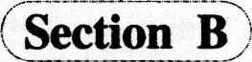
Passage One
Good transportation is very important in winter. [16]If you have a car, make sure it is ready for the cold weather. Keep the gas tank as nearly full as you can. This will keep water out of the tank and will be a reserve in case you get into trouble. If a storm traps you in your car, there are some steps you should take for your own safety. [17A]Do not attempt to walk to find help. You may quickly lose your way in blowing and snow. Your chances of being found are better if you stay in your car.
[17B]Keep a downwind window open slightly for fresh air. Freezing rain can seal off your car and lock you inside. [17C]Run the engine and heater once in a while. Keep the same downwind window open while the engine is running. Make sure that snow has not blocked the exhaust pipe. Clap your hands and move your arms and legs from time to time. Do not stay in one position too long. [18]But do not move too much. Exercise warms you up, but it also causes you to lose body heat. If more than one person is in the car, do not sleep at the same time. One person should always be awake. If you are alone, stay awake as long as you can Turn on the inside light at night. This will make your car more visible to rescue crews. Don't panic. Stay with your car.
16．What does the speaker say you should do in winter with your car?
【B】【解析】短文开头部分提到，在冬天，要确保你的汽车为寒冬作好准备，并建议要尽量让油箱充满汽油(Keep the gas tank as nearly full as you can)．B项几乎为原文复现，为本题答案。
【点睛】①纵观这三题的选项，均与car有关，故推断本文与汽车的保养或问题有关。②短文开头只是说要确保汽车做好应对寒冷天气的准备，接下来几句说的都是要给汽车油箱装满油，可见这里所谓“做好准备”主要是指给油箱装满油。而这不等于要为汽车做彻底的检查．故A项“进行彻底的检查”错误。文中提到加满油可以作为一种储备(will be a reserve)，并非C项说的“要留些额外的汽油作储备”。原文说的是keep water out of the tank“让水不要进入到油箱中”．而不是要填满水箱，D项也错误。
17．What should you avoid doing if a storm traps you in the car?
【A】【解析】录音提到，被风暴困住时的注意事项，其中提到不要走到车外求救(Do not attempt to walk to find help)．A项所述与此相符。
【点睛】①注意要听清问题问的是“要避免做的事”。四个选项的内容都在录音有提到．听音要在选项旁加上相应标注．记清哪些做法是对的，哪些是错的。②其他三项在录音中都有提到，都是应该要做的事。B项“开一点窗．让新鲜空气进入车内”，C项“时不时发动一下引擎”．D项“长时间开着暖气”(由于天气寒冷，开着暖气有助于人的身体保暖)。
18．Whv is too much exercise undesirable when you are trapped in a car by a winter storm?
【C】【解析】文中提到，不要做幅度太大的动作，因为会让你失去体热(causes you to lose body heat)，C项复现了原文原词，为正确答案。
【点睛】①四个选项均为It带来的负面影响，故推测本题询问不要做某事的原因。②其他三项均无原文根据。A项“这会耗尽你的体能”，B项“这会让你容易入睡”，D项“这会消耗太多的氧气”。
Passage Two
The topic of my talk today is gift giving. Everybody likes to receive gifts, right? So you may think that gift giving is a universal custom. But actually the rules of gift giving vary quite a lot. And not knowing them can result in great embarrassment. In North America the rules are fairly simple. If you're invited to someone's home for dinner, bring wine or flowers, or a small item from your country.
[19]Among friends, family and business associates, we generally don't give gifts on other occasions except on someone's birthday and Christmas. The Japanese, on the other hand, give gifts quite frequently, often to thank someone for their kindness. The tradition of gift giving in Japan is very ancient. [20]There are many detailed rules for everything, from the color of the wrapping paper to the time of the gift presentation ，And while Europeans don't generally exchange business gifts, they do follow some formal customs when visiting homes, such as bringing flowers. The type and color of flowers, however, can carry special meaning. Today we have seen some broad differences in gift giving.
I could go on with additional examples. But let's not miss the main point here. [21]If we are not aware of and sensitive to cultural differences, the possibilities from miscommunication and conflict are enormous. Whether we learn about these differences by reading a book or by living abroad, our goal must be to respect differences among people in order to get along successfully with our global neighbors.
19．What does the speaker say about gift giving of North Americans?
【D】【解析】录音的开头就介绍美国人的送礼习俗，其中提到在朋友、亲人和生意伙伴之间，除了生日和圣诞等特殊场合，一般不送礼(don’t give gifts…except on someone’S birthday and Christmas)， D项“他们只在特殊场合送礼”，是对录音内容的反话正说．表达内容一致。
【点睛】①第l9题至第21题的各选项均提到送礼(give gifts)．故推测短文的内容-9送礼的习俗或文化有关。②根据本题选项中9iving gifts，refuse guts等词可知。本题询问某类人的送礼收礼习俗。听问题时要注意听清是问North Americans。③A项中的generous“慷慨”没有根据。虽然北美人只在特殊场合送礼．但并不代表他们在谈生意时不会收礼，B项错误。C项“他们把礼物当成友谊的象征”也没有原文根据。
20．What do we learn about the Japanese concerning gift giving?
【C】【解析】录音提到，日本人送礼的频率更高，而且送礼有许多细节要注意，包括包装纸的颜色及送礼时间等．可见日本人有很多具体的送礼礼仪，C项正确。
【点睛】①本题的选项内容与上题类似，也是关于某类人的送礼习俗，听音时注意区分哪些选项是对应哪类人群的。做好相应笔记。注意听清本题问的是Japanese。②A项“他们很喜欢送礼给别人”偷换了概念．录音只是说他们的送礼频率较北美人高，而且他们送礼是有原因的(thank someone for their kindness)，并非随便就送礼，故A项错误。B项“他们花很多时间选礼物”及D项“他们很注重礼物的质量”都是主观臆断，并没有原文根据。
21．What point does the speaker make at the end of the talk?
[B]【解析】在录音的最后，说话者特别提到(not miss the main point)．如果我们不了解文化差异，在交流中就很可能产生误解甚至冲突，故说话者是在强调送礼时注意文化差异的重要性，B项正确。
【点睛】A项“送礼于人际关系起至关重要的作用”偏离主题．录音强调只是送礼习俗的差异，并非强调送礼本身的社交作用。C项“我们出国前必须学会如何送礼”缩小了原文的概念，我们要学会的是外国的送礼文化．并不单单是如何送礼。D项“广泛阅读可让人更好地送礼”利用录音最后的reading a book制造干扰，原文只是说可以通过书本来了解文化差异，与D项内容无关。
Passage Three
Claudette Rigol is a reporter for a French newspaper. Her assignment for the last five years has been Washington and American politics. She reports the current political news for her paper. In addition,she writes a column that is published every week. [22]The column explains American politics to her readers in France. They often find it very difficult to understand the United States and Americans.
Claudette lives in a small house in a fashionable section of Washington She entertains a great deal. Her guests are usually government officials, diplomats, lawyers and other newspaper people. When she isn't entertaining, she goes out to dinners and parties. In spite of her busy social life, Claudette works very hard. The parties are really work for her, because reporters frequently get new stories just by talking and listening to people. Claudette also has a small office in a building downtown. She goes there every morning to write up her stories and send them to Paris. [23]Her column is published every Monday, so she usually spends a large part of the weekend working on it at home. [24]Claudette spends a month in
France every year, so that she won't forget how to speak French. In spite of all her experience in Washington, Claudette may be transferred. This is an election year in the United States when the people elect a new president. [25]When the election is over, Claudette thinks that her newspaper in Paris may change her assignment.
22．What do we learn about the column Claudette writes?
[C] 【解析】原文提到Claudette的专栏是向她法国的读者解释美国的政治事务，C项复现了原文的explains American politics．而French public则对应录音中的her readers in France，故C项为 正确答案。
【点睛】①由选项中的published“出版”可知，It可能指代某本书刊或书刊上的内容．并且与政治事务相关。②Claudette的专栏介绍的是美国政务，而不是法国的。只是该专栏的读者群是法国，故A项“该专栏反映美国人对法国政务的见解”错误。Claudette是为一份法国报纸工作，只是工作地点在华盛顿而已，故她的专栏应该只会在法国出版．录音也没有提到专栏会在华盛顿出版，故B项“该专栏先在华盛顿出版．之后在巴黎出版”错误。D项“该专栏受到法国政府官员的欢迎”无中生有。
23．What does Claudette usually do on weekends?
[A]【解析】录音提到，Claudette的专栏在周一出版，所以她周末大部分时间都需要在家写专栏(spends alarge part of the weekend working on it)，A项正确。
【点睛】①四个选项均为动词原形短语，内容与平时的娱乐和工作相关。听音时应注意在听到与选项相关的内容时记下相关信息。本题要注意听清问题是问weekends。②B项“在家做家务”和D项“去市区购物”均没有在录音中提到。C项中的Entertain和guests有在录音中出现，但这并不是Claudette周末的活动。
24．Why does ClaudeUe spend a month in France every year?
[B] 【解析】录音提到Claudette每年会在法国住一段时间，SO that表目的，说这是为了让她不要忘记法语(SO that she won’t forget how to speak French)，B项中的refresh有“使想起，使记起”之意，与录音内容相符。
【点睛】①四个选项均为不定式短语，推测本题询问做某事的目的。②其他三项均没有在录音中提到，A项“向她的报纸作报告”，C项“探望她的父母”，D项“与朋友见面”。
25．What might happen to Claudette after this year’S American presidential election?
D【解析】录音最后提到，当总统大选结束后，Claudette认为巴黎的报社会更改她的工作任务(change her assignment)，D项中的new post指“新岗位”，该项说她会被委派新的工作岗位与录音所述一致， D项为答案。
【点睛】(D四个选项均与She的工作调动有关，听清时注意听清这方面的内容。②录音只是说改变她的工作任务．并没有明确指出新的工作任务是什么、她未来的工作地点在哪．A项“她会被召回法国”及C项“她的专栏将会结束”都是过度推断，更说不上“她会改变职业了”(D项)。
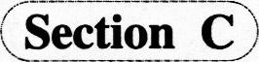
26．innocent
【解析】空格所在句为“sb．is considered+补语”的结构．空格处填入修饰主语he的补语成分。 innocent意为“清白的，无罪的”。注意该词前部有两个n。
27．committed
【解析】空格处填人的词与has been共同构成谓语。commit a crime是常用搭配，指“犯下罪行”。注意commit一词变成过去分词要双写t，再加-ed。
28．charges
【解析】由空格前的the可知，空格处应填人名词(词组)。charge在文中为法律术语，意为“指控，控罪”。
29．released
【解析】由空格前的or可知，空格处所填内容与前面的kept in jail并列，形式应为动词(词组)的过去分词，语义可能与kept in jail“入狱”相反。release在文中意为“释放”，注意不要忘了用过去分词released。
30．rather than
【解析】空格前后分别为动词原形短语return to court及mn away．故考虑空格处应为连词。rather than为表选择的连词，意为“(会腰)……，而不……”。
31．appoint
【解析】空格前为助动词will，空格后为名词a court lawyer。故空格处应填入动词(词组)原形，充当句子的谓语。appoint意为“指派，派遣”。
32．evidence
【解析】由空格后的as well as“和”可知，填入内容与witnesses“证人”并列，共同作present“提交，呈送”的宾语。evidence意为“证据”。
33．hold a trial
【解析】空格前是不定式小品词to，故填入内容应为动词(词组)原形。hold a trial意为“开庭审理， 进行审讯”。
34．designed
【解析】空格填入内容与is共同构成句子的谓语部分。词组be designed to do sth．意为“被设计成做某事”。
35．foundation
【解析】由空格前的the可知，空格处应填入名词(词组)。foundation意为“基础，根基”。
Part Ⅲ Readimg Comprehension
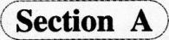
全文翻译
事实上，如今已有二十多年，全球找到的石油资源的数量比不上全球的石油使用量。不但需求量一直在飙升，而且找到的石油也都源自难以开采的地方。与此同时，越来越多这种新发现的石油需要更多投资去精炼。有人说，到2025年，这种珍贵资源的需求会增长40％以上，这意味着为了推动世界经济的增长，需要从一切可能的来源中获取更多的能源。
能源产业需要从现有的油田中开采更多能源，同时应继续寻找新的储备。汽车制造商必须继续提高燃油效率，并且完善混合动力汽车。技术改进是必须的，以便风能、太阳能和氢能可成为能量供求关系中更为可行的部分。各国政府需制定能源政策，以促进经济和环境健全发展。消费者必须愿意为这些解决方案买单，同时自己也应努力节约。
不作为不是一种选择。因此，让我们齐心协力平衡这种关系。我们正在采取一些马上行动所需要的措施，但在余下的路程中，我们需要您的帮助。
词性分析
名词：exception例外9rowth增长；增长量；发展；生长物option选择；选择权；选课reserves储备；保留，矜持；后备部队；自然保护区[复数]steps步，脚步；步骤，措施；台阶[复数]
动词：cultivate耕作(植物)，养殖(水产)；培养(爱好、习惯、人等)declinin9下降；衰退；谢绝，拒绝[现在分词或动名词] derived取得，得到；(from)起源[过去式或过去分词]discovered发现，发觉[过去式或过去分词][refine精炼，精制；使优美，使完善reserves保留；预订[第三人称单数]soaring猛增；高飞；(情绪、期望等)高涨；高耸[现在分词或动名词]steps跨步，行走；(on)踩，踏上[第三人称单数]
形容词：difficult困难的，艰难的；不易相处的 feasible可行的，可能的
副词：consequently所以，因此economically经济地，经济上；节约地，省俭地解题思路
36．[N]空格所在句是Not only开头的倒装句，主语是demand(需求)，谓语部分已有助动词has been，故应填入分词或形容词；由并列的后一句中的have been findin9可知是现在分词。上文提到如今已有二十多年，全球找到的石油资源的数量比不上全球的石油使用量，由此可推断石油的需求量是增加的，该段最后一句也提demand for this precious resource will grow(这种珍贵资源的需求会增长)，故选择与grow语义一致的soaring“猛增”。
37．[E]空格处在that引导的修饰places的定语从旬中，前面是are，后面是不定式结构to reach，故应填入形容词或分词。该段第2句是not only…but…(不仅……而且……)句式，由第1句中的less oil可知石油供应不足．故此处描述石油所在地点的词应该表消极意义，difficult“困难的”符合，表示石油来源地很难开采。
38．[F]空格前是副词newly，空格后是名词on，故应填入形容词或分词，与newiy一起修饰oil。上文修饰the oil的定语从旬使用了现在完成进行时have been finding，说明一直在找，由空格前的newly可知修饰oil的词应与“寻找”语义相关，过去分词discovered作定语表示“被发现的”，符合上下文语义。derived表示“取得”，而本句说这种石油需要更多投资，因此它们只是被发现，不是已经到手的“被取得”。
39．【L】空格前的requires…t0结构表明应填入动词原形，表目的。跟石油相关的原形动词是refine“精炼，精制”。表示新发现的石油需要更多投资去提炼。refine the on意为“炼油”。cultivate指“耕作(植物)，养殖(水产)；培养(爱好、习惯、人等)”，不符合此处语境。
40．【J】空格前是形容词economic，故应填入名词，作动名词fueling(力fl燃料，推动)的宾语。词库的名词中．与economic构成合理搭配的只有growth“增长”，句子表示“为了推动世界经济的增长，需要从一切可能的来源中获取更多的能源”。
41．瞰】空格前是形容词new，故应填入名词，充当search fbr的宾语。上文提到exiting fields(现有的油田)，因此此处寻找的是新的油田，该名词应能指代fields，且也是复数形式，故reserves“储备”正确。option“选择”是单数形式，且意义上指的是除油田以外的选择，与本句主语Theenergy industry(能源产业)不相关，故不对。
42．【l】此处应填入修饰名词parts的定语，与more一起构成比较级，可能是形容词或分词。上文提到perfect by brid vehicles(完善混合动力汽车)，本句描述的是风能、太阳能和氢能，这些相对于越来越难获取的石油来说，是天然的能源，因此是更加feasible“可行的”能源选择。
43．【G】此处应填入副词，与空格后的environmentally并列，修饰形容词sound(健全的)。备选项中只有conse．
quenfly“因此”和economically“经济上”两个副词，符合语境的是后者，句子表示“各国政府需制定能源政策，以促进经济和环境健全发展”。
44．【K】空格前的an提示此处应填入以元音字母开头的单数可数名词。句首的Inaction意为“不作为”．下文let’s work together表明我们不能不采取行动，故填入option“选择”，表示不作为不是一种“选择”。本句的action和not是双重否定，若填入exception“例外”则表示“行动是一种例外”，与下文逻辑相悖。
45．【0】空格前的some of the表明此处应填入可数名词复数，或不可数名词。上文说到work together．故此处是行动的一些措施，steps可表示“措施”，符合要求。take steps意为“采取措施”。
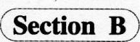
全文翻译期线点评
我哭故我在
A)2008年，在一家德国的动物园里，一只名叫加纳的大猩猩产下了一只雄性幼崽，但幼崽在出生3个月后就夭折了。照片里的加纳看起来萎靡不振、伤心欲绝，这吸引了不少游客前来。这一幕虽然令人伤感。但人类是唯一会哭泣的物种，而加纳不会。【48】动物会哭的观点并没有科学依据。观察大猩猩的生物学家迪安·弗塞和研究黑猩猩的珍·古德经过多年观察后。也无法证明动物会因为情感而哭泣流泪。
B)不可否认，很多动物会流眼泪，尤其是在疼痛时。眼泪能保持眼睛湿润从而起到保护作用。但哭泣作为人类特有的感情表达方式，在人类进化和人类文化发展中起到了至关重要的作用。
C)出生两天的婴儿就能模仿快乐和悲伤的表情，【47】如果一个婴儿不哭出来。他就很可能会因得不到足够的关注而活不下去。三、四个月大的婴儿就能和周围环境进行更有条理的交流。这时婴儿流泪哭泣起着人际沟通的目的：寻找安抚。再长大一点，哭泣变成了一种社交手段：用以表达悲伤和喜悦、羞愧和自豪、恐惧和对他人的操纵控制。
D)眼泪和笑容一样普遍，但悲伤却远比快乐复杂。我们虽然都会哭，但方式各异。女性比男性哭得更频繁、更剧烈。特别是遇到伤感的事情时。类似的，从世界范围来看，女性普遍要比男性更容易抑郁。对此现象有一个解释。认为尽管社会向前发展了几十年，但女性仍然饱受经济不平等、性别歧视甚至暴力的摧残，因此比起男性她们更有理由哭泣。【54】而男性相比女性，不但哭的时间更短，而且解释为何哭泣的可能性更低，他们大多数情况下都是默默流泪，并且往往会因当众哭泣而道歉。跟女性一样，男性会在某位深爱的人离世时哭泣，也会因某个感人的宗教活动而哭泣。当他们的核心身份(作为养家者和保护者，作为父亲和斗士)受到质疑时，男性比女性更容易哭泣。
E)相比那些原则性更强、更有自制力的人，性格测试结果为更富有同情心的人更容易哭。哭泣的次数差别很大：有些人一看小说或电影就会哭，有些人一生中哭泣的次数屈指可数。因为压力、家庭冲突或者感情创伤的哭泣，相比平日里因悲伤难过而哭泣，持续的时间要长得多，而后者持续的时间又比喜极而泣持续的时间要长。
Ｆ)哭泣让人首先联想到难过。但事实是，人们哭过之后会更快乐。调查表明，85％的女性和73％的男性在哭泣之后感觉更好。[51]令人惊讶的是。说到哭泣，人们普遍更容易联想到轻度抑郁。而不是那些有自杀想法的严重抑郁。
Ｇ)人们普遍反映哭泣能缓解紧张、平复情绪、“净化”心灵。“净化”一词具有宗教含义，表示“去除邪恶与罪过”。因此。宗教仪式是世上一个主要的流泪场景之一就不足为奇了。
H)【52】虽然有些哀悼者表示．尽管真的悲伤。但他们却哭不出来，有时甚至在挚爱离世多年后还哭不出来，但哭泣几乎是通用的悲伤符号。【46】人们现在更尊重悲伤这种隐私。但与之不同的是，以前人们认为，不论是从社会角度甚至是政治层面上看。在爱人的墓旁或是国王、女王的葬礼这样的场合当众哭泣流泪是非常必要的。
I)哭泣还有其他社交作用。罗素在《忏悔录》中写道，他认为最强烈的爱在眼泪里，但就算没事他也会哭。
J)【55】眼泪和艺术的联系渊源久远。公元前5世纪，希腊古典悲剧基本在赞颂众神。像诗歌和音乐一样，悲剧也将宗教活动搬上舞台。甚至在那时，人们就已认识到观看戏剧而流泪能带来愉悦感。
K)我曾指出，艺术和情绪失控之间有神经生物方面的联系。当我就哭泣做演讲时，我让观众举手告诉我哪一种艺术形式最能让他们感动流泪，80%的人说音乐，紧接着是74％的人说小说。接下来数据急剧下降。只有43％的人认为是诗歌，剩下的10％到22％的人则认为是绘画、雕塑和建筑。
L)哭泣从生理活动上看主要是吸入空气，这就是我们会在哭泣时呛到自己的原因。语言学家从中得到启示，认为带情绪的哭泣先于语言出现，【49】这也许解释了为什么眼泪能表达出语言难以描述的心境和感觉。当然，从进化的角度看，识别情绪(一般通过面部表情)对于生存来说至关重要。
M)人类最早出现在几百万年前。但直到l5万到20万年前才出现文化、语言、宗教和艺术。[53]期间，眼泪不仅仅是润滑眼睛的一种生理需要。也逐渐变成了对强烈感情的表达和社会联系的标志。自我意识、个人身份或自尊的发展。对于世界起源的各种说法，造人的传说和死后轮回，还有感受他人悲伤的能力，这些都是神经生物方面至关重要的变化，使得人之所以成为人。
N)最近，神经科学发现，当我们看到别人情绪低落时，我们大脑中某些回路就会在不知不觉中快速地被激活。简而言之，[50]历经进化，我们的大脑产生了让我们能够同情别人的回路，从而使得文明以及建立在同情心之上的道德观成为可能。因此，下次你要拿面纸擦眼泪，或在朋友肩膀上抽泣，或看电影流泪时，停下来反思一下为什么我们会哭泣，哭泣又意味着什么。因为终究说来，尽管我们爱哭泣，我们也以哭表达爱。
46．【H】【译文】现在，人们比过去更尊重“悲伤“这种隐私。
【定位解析】根据题目的关键词respect the privacy of grief可定位到H段第2句。题目只是将该句的被动语态改为了主动语态，意思没变。由此可判断本题信息来自于H段。
47．【C】【译文】婴儿哭泣是为了吸引关注以生存下去。
【定位解析】文章提到婴儿哭泣的只有C段。根据题目的关键信息Infants cry及attract attention for survival可定位到C段第2句。该句提到，如果一个婴儿不哭出来，他很可能会因得不到足够的关注而活不下去。意即，婴儿哭泣是为了吸引注意以生存下去。由此可判断本题信息来自于C段。
48[A]【译文】至今仍没有科学证据表明动物会因为情感而哭泣流泪。
【定位解析】原文提到动物哭泣的段落只有A段，结合题目的关键信息scientific evidence，animals及shed tears from emotion可定位到该段最后两句。该段倒数第2句提到，动物会哭的观点并没有科学依据。最后一句则说．两个科学家的多年观察无法证明动物会因为情感而哭泣流泪。题目概括了这两句的意思，故选A。
49．【L】【译文】眼泪能够起到某种语言无法发挥的交际功能。
【定位解析】根据题目的关键信息communicative functions及words可定位到L段第2句。该句中why引导的从句提到眼泪能表达出语言难以描述的心境和感觉，意即，眼泪能够起到某种语言无法发挥的交际功能，故选L。
【干扰排除】C段第3句也提到了流泪哭泣能起到人际交往的作用(serve interpersonal purposes)，但该句并没有提到“语言无法发挥的”这个关键信息，因此排除。
50．Ｎ]【译文】我们能够同情别人，这对于文明的发展至关重要。
【定位解析】根据题目的关键信息experience sympathy及development of civilization可定位到N段第2句。该句提到“历经进化，我们的大脑产生了让我们能够同情别人的回路，从而使得文明……”，题目信息与此相符。题目的essential to the development of civilization是对原文made civilization…possible的同义改写。故选N。
51．Ｆ]【译文】人们在遭受轻度抑郁的时候更可能哭。
【定位解析】文章提到depression“抑郁”这个话题的只有F段，结合题目的关键信息minor forms of de pression定位到该段最后一句。该句提到，说到哭泣，人们普遍更容易联想到轻微的抑郁，而不是一些重度的抑郁。意即，人们在遭受轻度抑郁的时候更可能哭。由此可判定题目信息来自于F段。
52．[H]【译文】有时候人们即使真的悲伤也无法哭泣。
【定位解析】根据题目关键信息cannot cry及despite genuine grief可定位到H段第l句。该句中though引导的从句提到，有些哀悼者表示，尽管真的难过，但他们却哭不出来，题目意思与此相符，故选H。
53．【M】【译文】在人类漫长的历史中，眼泪在社交关系中已经起到了重要作用。
【定位解析】由humans’long history可知本题谈及眼泪与人类历史进化的关系，相关内容在M段提及。题目中的In humans’long history对应该段第2句中的Along the way，而tears have developed…in social relationships则对应该句中的developed int0．。a signal of social bondin9，由此可判断题目信息来自于M段。
54．【D】【译文】男性给出哭泣理由的可能性更低。
【定位解析】根据题目的关键信息give reasons for their tears可定位到D段倒数第3句，题目是对该句 but后分句的同义改写：题目中的less likely t0及give reasons for their tears分别对应原文中的less inclined t0和explain their tears．由此可判断题目信息来自于D段。
55．【J】【译文】哭泣跟艺术的联系由来已久。
【定位解析】文中只有J段提到了“哭泣跟艺术的联系”这个话题。题目是对该段第l句的同义改写，题目中的 has long been对应原文中的has ancient roots。由此可判断题目信息来自于J段。
Section C
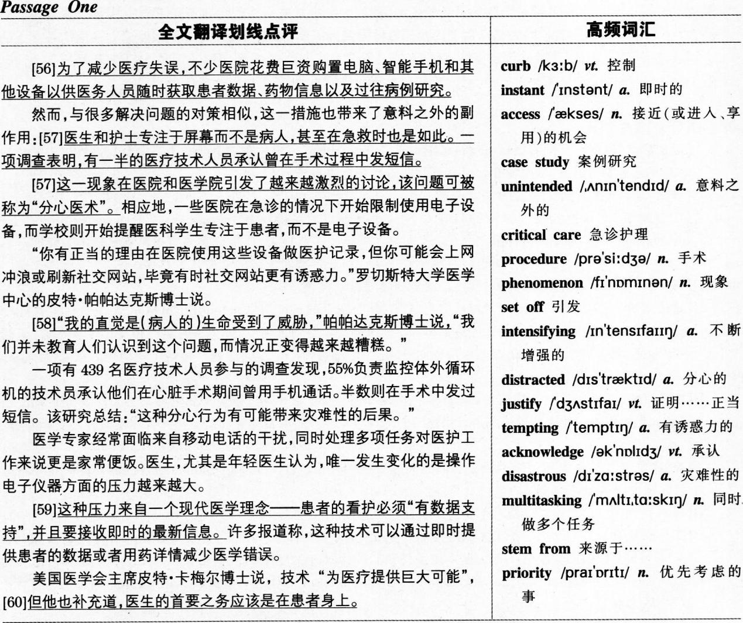
56[A]定位】根据题于中的computers，smartphones and other devices定位至全文首句。
【解析】题干所述的“医院给医护人员配备电脑、智能手机和其他设备”与首句的put…into the hands of medical staff同义．该旬中的状语hoping to curb medical error即为这样做的原因，A中的reduce“减少” 与文中的curb“控制”同义，故A为本题答案。
【点睛】本题只要确定文章首句与题干的所述一致，就能得出答案。其他三项8“为了应对紧急情况”、C“为了方便行政管理”及D“为了简化医护程序”均是凭空猜想，没有根据。
57．【C】【定位】题干中的disWacted doctorin9出现在第3段，解题需结合第2段内容。
【鹪析】由第3段首句可知，distracted doctorin9指代a problem，与该段段首的nIis phenomenon对应，而“这现象”回指第2段提到的现代设备带来的“副作用”：医护人员可以只关注屏幕，而非病人；导致医疗技术人员在手术中分心做其他事，C“仪器让医生不关注病人的问题”很好地概括了提到的“副作用”，同时这也与全文讨论的主题相符，故确定C为答案。【点睛】本文主要集中讨论现代设备使医护人员分心，从而对病人造成的伤害，并没有提到现代设备对医生和护士的伤害．故A“现代设备对医生、护士以及病人的伤害”不对；B“医疗机构鼓励使用现代设备”与第l段的内容对应，但这种做法本身没有问题．distracted doctorin9指代的是这种做法带来的问题，即side effect，故C比B更恰当；D中的attending to personal affairs“专注于个人私事”不对，本文讨论的是医生过分专注于“电子设备”，与“个人私事”无关．故D也不对。
58．【BI[定位】根据题干中的Dr．Peter Papadakos定位至第4、5段。
【解析】文中第4、6段提到了Dr．Peter Papadakos的观点，本题询问他担忧的事情。第5段提到了他直觉认 为“(病人的)生命受到威胁”(1ives are in daIlger)，而且情况变得越来越糟糕，B“医生对设备的使用可能会危及病人性命”与此相符，故B为答案。
【点睛】A是利用原文not educating people制造的干扰，文中说的是“我们对在看病时分心引发的问题教育不足”。
而非A所说的“对使用现代技术的教育不足”，故A不对；C“医生过分依赖现代电子技术”偏离了文章的主题，Dr．Peter Papadakos关心的是医生由于使用设备而分心。而非过分依赖设备，两者侧重点不同，故C也不对；第7段提到了与“压力”相关的内容。但该段只提到医生在使用设备上的压力越来越大，D将其范围扩大到了一切的pressure。故也不对。
59．【C】【定位】根据题干中的increasing pressure定位至倒数第2段第l句。
【解析】本题询问医生对于使用现代设备感到压力与日俱增的原因。倒数第2段第l句中的stems from“来源于”表明该句内容为本题的答案。文中提到现代医学信奉“对病人的护理必须‘以数据作为支持’(data driven)”，而且必须即时获得最新的数据，两者均强调了数据对医疗的重要性，故C“人们在病人护理中过分注重数据”为答案。
【点睛】虽然文中有提到现代设备的确能减少医疗失误，但无法推断出A“病人相信那些使用现代设备的医生”；而B“使用现代设备可增加医院的收益”及D“病人的数据需经常修改”均为主观猜测，无原文根据。
[B]【定位】根据题干中的Peter Carmel定位至最后一段。
【解析】本题询问Peter Cannel给医生的建议是什么，全文最后一句转折词but后的内容指出，医生的首要之务(priority)关注病人本身。priority一词指“优先处理的事，最重要的事情”，故确定8“他们应该将注意力集中在病人的情况上”为答案。
【点睛】虽然Peter Carmel也承认现代设备的好处(为医疗提供巨大可能)，但转折词but后的内容才是他的话的重点所在．由此可排除A“他们应紧随医疗科学的进步”和D“他们应最大程度地使用现代设备”；C“他们应遵守医院的规章制度”在文中并未提及，也排除。
难句归纳
1．Hospimls,hoping to curb medical error,have invested heavily to put computers，smartphones and other devices into the bands of medical staff for instant access to patient data。drug information and case studies．(第56题解题句)
【分析】本句的主干是Hospitals have invested，副词heavily修饰invested，说明医院投入的程度。hoping to curb medical elTor作状语．说明医院这样做是希望减少医疗失误。to put…into the hands of medical staff．．．为不定式短语作目的状语。说明医院大量投资的目的。
2．The pressure stems from a mantra(信条)of modem medicine that patient care must be“data driven，” and informed by the latest，instantly accessible informatiorL(第59题解题句)
【分析】本句的主干是，Thepressure stems from a mantra“压力来自一个信条”。that至句末为同位语从句，解释说明现代医学信条(a mantra of modem medicine)的具体内容。该同位语从句为被动语态，有两个并列的谓语,be drive ang(be)informed.

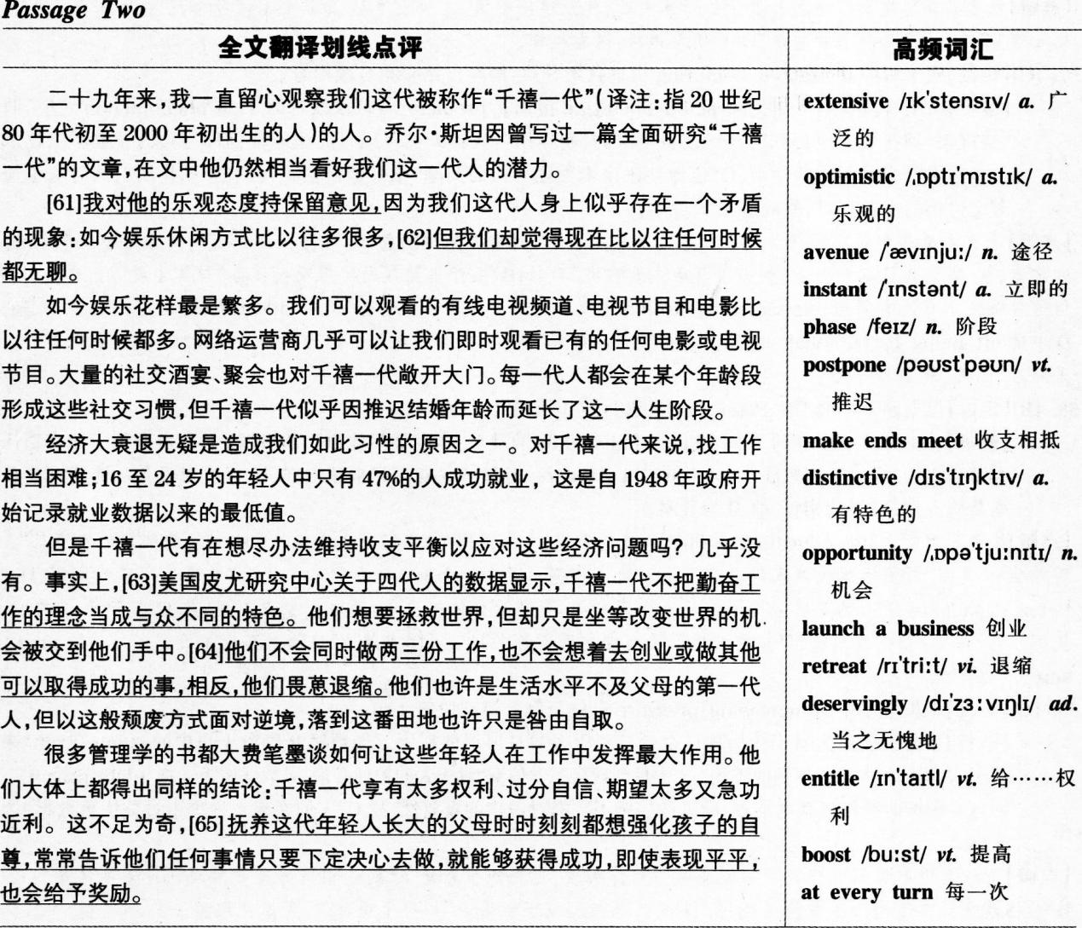
61．D]【定位】根据各选项内容，各自定位。
【解析】本题询问作者对千禧一代的看法，题干没有明显的定位词，故可将选项与文章内容一一对应，找出答案。第1段末提到，Joel Stain撰写文章表示对千禧一代的潜能持乐观态度(optimistic)，而第2段首句作者则说对这种乐观持保留态度(hesitate to share his optimism)，故作者并不看好千禧一代的未来，D“他们获得成功的希望不大”与上述内容相符，故D为答案。
【点睛】A“他们对娱乐活动几乎没兴趣”利用第2段末句中的we are more bored than ever before作干扰，千禧一代感到生活无聊乏味并非因为对娱乐活动没有兴趣，且由第3段最后一句可知，相反，他们在延长玩乐时间，故A不对；B“他们对自己的能力没有信心”，与最后一段第2句提到的千禧一代过分自信(over-confident)相矛盾，故 B不对；C“得益于高科技，他们生活舒适”，第3段的确提到高科技为千禧一代带来各类娱乐。但他们的生活并不舒适，他们就业率创新低(第4段)，且生活水平不如父辈(第5段末句)，故C也不对。
62．[B]【定位】根据各选项内容，各自定位。
【解析】第2段末尾提到的we are more bored than ever before“我们觉得现在比以往任何时候都无聊”表明千禧一代对生活失去了热情，觉得生活乏味无趣，B所说的“生活中没有什么值得兴奋”与此相符，故确定B为答案。
【点睛】A“他们几乎不能做任何事”利用第5段第2句中的Hardly作干扰，文中说的是千禧一代几乎不做任何事情来应对逆境，这与他们“是否有能力”去应对逆境语义不同，故A不对；C“他们的生活不如父辈”与第5段末句提到的“也许他们的生活水平不如父辈”对应，但这只是作者的观点，并非千禧一代自己的看法，故C不对；D“生活中充满成功的机遇”利用第5段中的opportunity一词制造干扰，文中提到千禧一代习惯于等待机会送上门．但并没有说明生活中“充满机会”，故D也不对。
63．【C】【定位】根据题干中的Pew Research定位至第5段第3句。
【解析】该句提到Pew Research的数据表明，千禧一代并不把“勤奋工作”当作是一个优点特色，由此可推知．他们并不看重“勤奋工作”这一做法，C所述与此相符，故为答案。
【点睛】本题只要紧紧抓住专有名词Pew Research准确定位后，即可得出答案。其他三项(A“他们花在社交上的时间更少”、B“他们对人冷漠”、D“他们更独立”)均无原文根据。
64．【D】【定位】定位至倒数第2段。
【解析】作者在倒数第2段提到了千禧一代面对经济困境的态度，提到了他们只会坐等机会上门，并且选择了退缩(retreat非去采取诸如做两三份工作、创业或通过其他可以成功的途径去改变逆境，并在末句说他们的生活水平不如父辈是咎由自取的(deservingly)。倒数第2段中Instead of后的内容才是作者提倡的，作者认为千禧一代应该积极采取行动改变逆境，故D为答案。
【点睛】A”面对逆境保持乐观”偏离重点，千禧一代的问题在于缺乏积极行动，而非持悲观态度，A不对；B“尽早创业，，中的Start a business与文中的launching a business对应，但这只是作者建议应该采取的措施之一，不具概括性。且作者也没有说要as early as possible，故8不对；C“充分利用新机遇”中的new opportunities没有原文根据。
65．【A】【定位】根据题干中的over-confident定位至最后一段。
【解析】最后一段第2句提到，管理学类的书都大致认为千禧一代是过分自信的(over-confident)，该段最后一句解释了造成这现象的原因，指出由于父母总是利用一切机会提高他们的自信(boost their self-esteem at every turn)，误导他们认为只要有决心凡事都能成功，并且对成绩平平的孩子也给予奖励。A“他们被父母宠坏了”很好地概括了上述内容，故为答案。
【点睛】8“他们总能获得他们期望的一切”说法过于绝对，且文中也没有提到他们想要什么就能得到什么，故B不对：由最后一句可知，误导千禧一代的是他们的父母，而非management books，故C“他们被管理类书籍误导”错误：D“他们认为自己年轻有活力”属于无中生有，没有原文根据。难句归纳
1．I hesitate to share his optimism because of a paradox(矛盾的现象)we seem to exhibit，namely，that there are more avenues for us to entertain ourselves than ever before，yet we are more bored than ever before．(第61题解题句)
【分析】本句主干为I hesitate to share his optimism“我对他的乐观持保留意见”。because of后接原因状语， We seem to exhibit为省略关系代词(that)的定语从句，修饰paradox；而that至句末则为同位语从句，解释说明该矛盾现象(par嫩)是什么。该同位语从句为yet连接的并列句，两分句间存在语义转折。
2．Today’S young adults were raised by parents who made sure to boost their serf-esteem at every turn, telling them they could achieve whatever they set their minds t0，and handing out prizes for the sixth place．(第65题解题句)
【分析】本句的主干为adults were raised by parents，为被动语态。wh0至句末为定语从句，修饰parents，说明这类父母的特点；该定语从句含有两个并列的现在分词短语作状语，telling them…and handing out…，补充说明父母如何强化孩子的自尊；前一个状语为tell sb．sth．"告诉某人某事”的结构，其中的sth．由从句thev could achieve whatever they set their minds to充当。

36. N 37. E 38. F 39. L 40. J 41. M 42. I 43. G 44. K 45. O
46. H 47. C 48. A 49. L 50. N 51. F 52. H 53. M 54. D 55. J
56. A 57. C 58. B 59. C 60. B 61. D 62. B 63. C 64. D 65. A

Part IV Translation
词汇难点
教育工作者：educator 认识到：realize；learn
重要意义：importance；significance 建议：suggest；propose
设立：set up 全民读书日：national reading day；national book day
强调：emphasize；highlight 经典著作：classics；classical works
感恩：(n)gratitude；appreciation／(a)grateful；thankful
培养：cultivate；foster 基本素质：basic qualityessential quality
关键时期：critical period；crucial time 培养……的兴趣：cultivate／develop an interest of．．．
养成……习惯：develop／acquire／form a habit of．．．
表达难点
1．第l句中的“早就认识到”暗含对现在的影响，故本句应该选用现在完成时。由下文可知，本句中的“读书”指“阅
读”，而并非“上学读书”，故不能译作studyattending school，该译作reading。“重要意义”不能按字面译作
important meanin9，此处实指“重要性”，故译作importance或significance即可。
2．第2句中的“建议设立全民读书日”可套用suggest doing sth．或suggest sth．的句式，也可处理为suggest+从句，
注意从句应用should+d0的虚拟语气。
3．第4句的两个分句由“而”连接，表的是顺承关系，故可处理为and连接的并列句。
4．第4句的前半句按中文直译为Through readin9，people CaIL…但此句强调的是阅读的作用，并非原主语“人
们”．且英文有使用抽象名词作主语的表达习惯，故本句可将状语“通过阅读”转换为动名词Readin9，作主语。“学
会感恩、有责任心和与人合作”可统一处理成名词，套用equip sb．with sth．的句型，整句译作Reading equips
people with gratitude，responsibility and cooperation；也可用参考译文中的方法，将三个宾语转译为形容词。
5．第4句中含“正是要……”，故可考虑套用it is…that的强调句型来译。
6．最后一句的后半句“假如……，……很难了”与前半句隐含因果关系，前半句是果，后半句是因，故可将前半句处理
为主名，后半名处理为原因状语从句．
参考译文
China's educators have long realized reading's importance to our nation. Some of them have suggest-
ed setting up a national reading day as early as 2003. They emphasized that people ought to read good
books, especially the classics. Reading enables people to be grateful, responsible and cooperative, and it
is these basic qualities that education intends to cultivate. Reading is especially important for primary
and middle school students, for, ff they don't develop an interest of reading during this critical period, it
will be difficult for them to acouire a reading habit later in life.
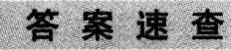
1. B 2. A 3. C4. D 5. B 6. A 7. D 8. B 9. C 10. D
11. A12. D13. A14. C15. B16. B17. A18. C19. D20. C
21. B22. C23. A 24. B25. D
26. innocent27. committed 28. charges 29. released30. rather than
31. appoint 32. evidence 33. hold a trial 34. designed 35. foundation

