2015年12月大学英语四级考试真题(第2套)
Part I Writing(30 minutes)
Directions: For this part, you are allowed 30 minutes to write an essay commenting on the saying"Learning is a daily experience and a lifetime mission. " You can cite examples to illustrate the importance of lifelong learning. You should write at least 120 words but no more than 180 words.
_____________________________________________________________________________________________________________________________________________________________________________________________________________________________________________

Part II Listening Comprehension ( 30 minutes )
听力音频地址：
http://wximg.233.com/attached/media/20160421/20160421173301_3840.mp3
Section A
Directions: In this section, you will hear 8 short conversations and 2 long conversations. At the end of each conversation, one or more questions will be asked about what was said. Both the conversation and the questions will be spoken only once. After each question there will bea pause. During the pause, you must read the four choices marked A), B), C. and D), and decide which is the best answer.Then mark the corresponding letter on Answer Sheet I with a single line through the centre.
1. A. The agenda for the board of directors' meeting.
B. The details of the meeting to be held next week.
C. The reason for the man's absence from the meeting.
D. The time for the man's visit to the woman's company.
- A. At a travel agency.
B. At a department store.
C. In a library.
D. In a post office.
- A. He cannot hear the woman's call.
B. He cannot get through to New York.
C. He cannot recall the phone number.
D. He cannot find a public phone nearby.
- A. Watch a movie with the woman.
B. Revise his thesis in the office.
C. Do some shopping with Jane.
D. Discuss his thesis with Prof. Hudson.
5. A. He just cannot work properly without a watch.
B. He has no idea where he can buy a gold watch.
C. He still does not know where he left his watch.
D. He is not sure what went wrong with his watch.
- A. He forgot all about what he said.
B. He slipped and hurt his head.
C. He was sorry for being off sick last week.
D. He thought the woman's car had been sold.
- A. She should try to catch an earlier bus.
B. She is absent from his class too often.
C. She is always making excuses for being late.
D. She should come up with a better excuse.
- A. He is going to help the woman out.
B. He has to move out of the building soon.
C. He is on his way to see a real estate agent.
D. He will stay with the woman's brother.
Questions 9 to 11 are based on the conversation you have just heard.
- A. From the wanted cohunn.
B. From some of her friends.
C. From a telephone directory.
D. From a television commercial.
- A. She received full-time education abroad.
B. She graduated from an open university.
C. She fmished her secondary school.
D. She studied in a vocational college.
- A. She is a shorthand-typist.
B. She works as a tour guide.
C. She is a policewoman.
D. She teaches an evening class.
Questions 12 to 15 are based on the conversation you have just heard.
- A. It provides him with career opportunities.
B. It helps enlarge his customer network.
C. It has been off and on for ten years.
D. It was interrupted for four years.
- A. Individualized service.
B. Traditional setting.
C. Home-made beer.
D. Social games.
- A. The quality of beer.
B. The atmosphere.
C. The owner's attitude.
D. The right location.
- A. It is a rather tough job.
B. It is a profitable business.
C. It helps old people kill time.
D. It makes retirees feel useful.
Section B
Directions: In this section, you will hear 3 short passages. At the end of each passage, you will hear some questions. Both the passage and the questions will be spoken only once. After youhear a question, you must choose the best answer from the four choices marked A , B ,C. and D. Then mark the corresponding letter on Answer Sheet 1 with a single line through the centre.
Passage One
Questions 16 to 18 are based on the passage you have just heard.
- A. It is becoming increasingly popular.
B. It helps the user to escape reality.
C. It gives rise to serious social instability.
D. It hurts a person and those around them.
- A. They use drugs just for fun.
B. They take drugs to get high.
C. They use drugs as medicine.
D. They keep drug use a secret.
18. A. It is quite common in entertainment circles.
B. It is the cause of various social problems.
C. It is hard to get rid of.
D. It is fatal to the user.
Passage Two
Questions 19 to 22 are based on the passage you have just heard.
- A. Taking up exercises after recovery.
B. Producing tasty healthy frozen food.
C. Finding new ways to cure heart disease.
D. Going on a diet upon leaving the hospital.
- A. Itwas carefully tested with consumers.
B. It was promoted by health organizations.
C. It was disapproved by many diet experts.
D. It was highly expected by the general public.
- A. Competitive price.
B. Low expectations.
C. Vigorous promotion.
D. Unique ingredients.
22. A. It was suggested by the firm's vice-president.
B. It matches the food's dark green packaging.
C. It has a positive implication for consumers.
D. It tricks the elders into impulse purchasing.
Passage Three
Questions 23 to 25 are based on the passage you have just heard.
- A. It is practiced in most of the states.
B. It will be abolished sooner or later.
C. It has drawn a lot of criticism from overseas.
D. It has to be approved by the Supreme Court.
24. A. Whether the practice should be allowed to continue in future.
B. Whether there should be a minimum age limit for execution.
C. What type of criminals should receive it.
D. What effect it might have on youngsters.
25. A. The court sentenced him to life in prison for killing two friends.
B. The governor changed his death sentence to life in prison.
C. He was the first minor to be executed in South Carolina.
D. He was sentenced to death for a crime he committed as a minor.
Section C
Directions: In this section, you will hear a passage three times. When the passage is read for the first time, you should listen carefully for its general idea. When the passage is read for the second time, you are required to fill in the blanks with, the exact words you have just heard. Finally, when the passage is read for the third time, you should check what you have written.Some people borrow money and "forget" to pay it back.
Large loans are seldom the issue; they are usually treated as business26, with the terms spelled out on paper. But many women suffer27over problems like Carol's "My friend Ginny is always28cash," she says. "I hate to recall how often I've ' loaned' her a dollar or two for a drink or a movie. Each loan is so small I'd feel really cheap making a big deal out of it; still, I do29the fact that she never pays me back. "Carol admits to being "too30or something" to demand repayment, but she has resolved tostop lending money to Ginny. "The last time she asked for five dollars to pay for her dry cleaning, I just told her I couldn't31it. "Another woman suggests a bolder32. "When somebody refuses to repay a loan, I33byrequesting one myself," she says. "'I left home without my wallet,' I'll say. 'Can you lend meenough to cover lunch?' Then, when the money is safely in hand, I am struck by a sudden34Why, this is exactly the amount I loaned you last week ! How35! Now you won't have to repay me'" She says it works like a charm.

Part III Reading Comprehension(40 minutes)
Section A
Directions: In this section, there is a passage with ten blanks. You are required to select one word for each blank from a list of choices given in a word bank following the passage. Read the passage through carefully before making your choices.Each choice in the bank isidentified by a letter. Please mark the corresponding letter for each item on Answer Sheet 2 with a single line through the centre. You may not use any of the words in the bank more than once. Questions 36 to 45 are based on the following passage.
For many Americans,2013 ended with an unusually bitter cold spell.Late November and December36early snow and bone-chilling temperatures in much of the country, part of a year when, for the first time in two37, record-cold days will likely turn out to have oumumbered record-warm ones. But the U. S. was the exception: November was the warmest ever38, and current data indicates that 2013 is likely to have been the fourth hottest year on record. Enjoy the snow now, because39are good that 2014 will be even hotter, perhaps the hottest year since records have been kept. That's because, scientists are predicting,2014 will be an El Nifio Year. El Nino, Spanish for "the child",40when surface ocean waters in the southern Pacific become abnormally warm. So large is the Pacific, covering 30% of the planet's surface, that the41energy generated by its warming is enough to touch off a series of weather changes around the world. El Ninos are42with abnormally dry conditions in Southeast Asia and Australia. They can lead to extreme rain in parts of North and South America, even as southern Africa43dry weather. Marine life may be affected too: E1 Ninos can44the rising of the cold, nutrient-rich ( 营养丰富的） water that supports large fish45, and the unusually warm ocean temperatures can destroy coral ( 珊瑚).
A. Additional I. logically
B. Associated J. occurs
C. bore K. populations
D. Chances L. realize
E. Communicated M. reduce
F. Decades N. Saw
G. experiences O. Specific
H. globally
Section B
Directions: In this section, you are going to read a passage with ten statements attached to it. Eachstatement contains information given in one of the paragraphs. Identify the paragraphfrom which the information is derived. You may choose a paragraph more than once.Each paragraph is marked with a letter.Answer the questions by marking the corresponding letter on Answer Sheet 2. How to Eat Well
A. Why do so many Americans eat tons of processed food, the stuff that is correctly called junk (垃圾. and should really carry warning labels?
B. It's not because fresh ingredients are hard to come by. Supermarkets offer more variety than ever, and there are over four times as many farmers' markets in the U. S. as there were 20 years ago. nor is it for lack of available information. There are plenty of recipes (食谱), how-to videos and cooking classes available to anyone who has a computer, smartphone or television. If anything, the information is overwhelming.
C. And yet we aren't cooking. If you eat three meals a day and behave like most Americans, you probably get at least a third of your dally calories (卡路里. outside the home. Nearly two-thirds of us grab fast food once a week, and we get almost 25% of our dally calories from snacks. So we're eating out or taking in, and we don't sit down－or we do, but we hurry.
D. Shouldn't preparing－and consuming－food be a source of comfort, pride, health, weli－being, relaxation, sociability? Something that connects us to other humans? Why would we want to outsource(外包. this basic task, especially when outsourcing it is so harmful?
E. When I talk about cooking, I'm not talking about creating elaborate dinner parties or three－day science projects. I'm talking about simple, easy, everyday meals. My mission is to encourage green hands and those lacking time or money to feed themselves. That means we need modest, realistic expectations, and we need to teach people to cook food that's good enough to share with family and friends.
F. Perhaps a return to real cooking needn't be far off. A recent Harris poll revealed that 79% of Americans say they enjoy cooking and 30% "love it" ; 14% admit to not enjoying kitchen work and just 7% won't go near the stove at all. But this doesn't necessarily translate to real cooking, and the result of this survey shouldn't surprise anyone: 52% of those 65 or older cook at home five or more times per week; only a third of young people do.
G. Back in the 1950s most of us grew up in households where Morn cooked virtually every night. The intention to put a home-cooked meal on the table was pretty much universal. Most people couldn't afford to do otherwise.
H. Although frozen dinners were invented in the '40s, their popularity didn't boom until televisions became popular a decade or so later. Since then, packaged, pre-prepared meals have been what's for dinner. The microwave and fast-food chains were the biggest catalysts ( 催化剂), but the big food companies--which want to sell anything except the raw ingredients that go into cooking－made the home cook an endangered species.
I. Still, I fmd it strange that only a third of young people report preparing meals at home regularly. Isn't this the same crowd that rails against processed junk and champions craft cooking? And isn't this the generation who say they're concerned about their health and the well－being of the planet? If these are truly the values of many young people, then their behavior doesn't match their beliefs.
J. There have been haft－hearted but well-publicized efforts by some food companies to reduce calories in their processed foods, but the Standard American Diet is still the polar opposite of the healthy,mostly plant－based diet that just about every expert says we should be eating. Considering that the government's standards are not nearly ambitious enough, the picture is clear: bynot cooking athome, we're not eating the right things, and the consequences are hard to overstate.
K. To help quantify (量化). the costs of a poor diet, I recently tried to estimate this impact in terms of a most famous food, the burger (汉堡包). I concluded that the profit from burgers is more than offset (抵消） by the damage they cause in health problems and environmental harm.
L. Cooldng real food is the best defense－not to mention that any meal you're likely to eat at home contains about 200 fewer calories than one you would eat in a restaurant.
M. To those Americans for whom money is a concern, my advice is simple: Buy what you can afford,and cook it yourself. The common prescription is to primarily shop the grocery store, since that's where fresh produce, meat and seafood, and dairy are. And to save money and still eat well you don't need local, organic ingredients; all you need is real food. I'm not saying local food isn't better; it is. But there is plenty of decent food in the grocery stores.
N. The other sections you should get to know are the frozen foods and the canned goods. Frozen produce is still produce; canned tomatoes are still tomatoes. Just make sure you're getting real food without tons of added salt or sugar. Ask yourself, would Grandma consider this food? Does it look like something that might occur in nature? It's pretty much common sense: you want to buy food,not unidentifiable foodlike objects.
O. You don't have to hit the grocery store daily, nor do you need an abundance of skill. Since fewer than haft of Americans say they cook at an intermediate level and only 20% describe their cooldng skills as advanced, the crisis is one of confidence. And the only remedy for that is practice. There's nothing mysterious about cooking the evening meal. You just have to do a little thinking ahead and redefine what qualifies as dinner. Like any skill, cooking gets easier as you do it more; every time you cook, you advance your level of skills. Someday you won't even need recipes. My advice is that you not pay attention to the number of steps and ingredients, because they can be deceiving.
P. Time, I realize, is the biggest obstacle to cooking for most people. You must adjust your priorities
to find time to cook. For instance, you can move a TV to the kitchen and watch your favorite shows while you're standing at the sink. No one is asking you to give up activities you like, but if you're watching food shows on TV, try cooking instead.
46. Cooking benefits people in many ways and enables them to connect with one another.
47. Abundant information about cooking is available either online or on TV.
48. Young people do less cooking at home than the elderly these days.
49. Cooking skills can be improved with practice.
50. In the mid-20th century, most families ate dinner at home instead of eating out.
51. Even those short of time or money should be encouraged to cook for themselves and their family.
52. Eating food not cooked by ourselves can cause serious consequences.
53. To eat well and still save money, people should buy fresh food and cook it themselves.
54. We get a fairly large portion of calories from fast food and snacks.
55. The popularity of TV led to the popularity of frozen food.
Section C
Directions: There are 2 passages in this section. Each passage is followed by some questions or unfinished statements. For each of them there are four choices marked A), B), C. and
D ). You should decide on the best choice and mark the corresponding letter on Answer
Sheet 2 with a single line through the centre.
Passage One Questions 56 to 60 are based on the following passage.
The wallet is heading for extinction. As a day-to-day essential, it will die off with the generation who read print newspapers. The kind of shopping－where you hand over notes and count out change in return－now happens only in the most minor of our retail encounters, like buying a bar of chocolate or a pint of milk from a comer shop. At the shops where you spend any real money, that money is increasingly abstracted. And this is more and more true, the higher up the scale you go. At the most cutting-edge retail stores－Victoria Beckham on Dover Street, for instance－you don't go and stand at any kind of cash register when you decide to pay. The staff are equipped with iPads to take your payment while you relax on a sofa.
Which is nothing more or less than excellent service, if you have the money. But across society, the abstraction of the idea of cash makes me uneasy. Maybe I'm just old－fashioned. But earning money isn't quick or easy for most of us. Isn't it a bit weird that spending it should happen in haft a blink (眨眼). of an eye? Doesn't a wallet－that time－honoured Friday－night feeling of pleasing, promisingfatness－represent something that matters?
But I'll leave the economics to the experts. What bothers me about the death of the wallet is thechange it represents in our physical environment. Everything about the look and feel of a wallet－theway the fastenings and materials wear and tear and loosen with age, the plastic and paper and gold andsilver, and handwritten phone numbers and printed cinema tickets－is the very opposite of what ourworld is becoming. The opposite of a wallet is a smartphone or an iPad..The rounded edges, coolglass, smooth and unknowable as a pebble (鹅卵石). Instead of digging through pieces of paper andpeering into corners, we move our fingers left and right. No more counting out coins. Show yourwallet, if you still have one. It may not be here much longer.
56. What is happening to the wallet?
A. It is disappearing.
B. It is being fattened.
C. It is becoming costly.
D. It is changing in style.
57. How are business transactions done in big modern stores?
A. Individually.
B. Electronically.
C. In the abstract.
D. Via a cash register.
58. What makes the author feel uncomfortable nowadays?
A. Saving money is becoming a thing of the past.
B. The pleasing Friday－night feeling is fading.
C. Earning money is getting more difficult.
D. Spending money is so fast and easy.
59. Why does the author choose to write about what's happening to the wallet?
A. It represents a change in the modern world.
B. It has something to do with everybody's life.
C. It marks the end of a time－honoured tradition.
D. It is the concern of contemporary economists.
60. What can we infer from the passage about the author?
A. He is resistant to social changes.
B. He is against technological progress.
C. He feels reluctant to part with the traditional wallet.
D. He feels insecure in the ever－changing modern world.
Passage Two
Questions 61 to 65 are based on the following passage.
Everybody sleeps, but what people stay up late to catch－or wake up early in order not to miss－varies by culture. From data collected, it seems the things that cause us to lose the most sleep, on average, are sporting events, time changes, and holidays.
Around the world, people changed sleep patterns thanks to the start or end of daylight savings time. Russians, for example, began to wake up about a half-hour later each day after President Vladimir Putin shifted the country permanently to "winter time" starting on October 26.Russia's other late nights and early mornings generally correspond to public holidays. On New Year's Eve, Russians have the world's latest bedtime, hitting the hay at around 3:30 am. Russians also get up an hour later on International Women's Day, the day for treating and celebrating female relatives. Similarly, Americans' late nights, late mornings, and longest sleeps fall on three－day weekends. Canada got the least sleep of the year the night it beat Sweden in the Olympic hockey (冰球. final.The World Cup is also chiefly responsible for sleep deprivation (剥夺). The worst night for sleep in the U. K. was the night of the England-Italy match on June 14. Brits stayed up a half－hour later to watch it, and then they woke up earlier than usual the next morning thanks to summer nights, the phenomenon in which the sun barely sets in northern countries in the summertime. That was nothing, though, compared to Germans, Italians, and the French, who stayed up around an hour and a haft later on various days throughout the summer to watch the Cup.
It should be made clear that not everyone has a device to record their sleep patterns; in some of these nations, it's likely that only the richest people do. And people who elect to track their sleep may try to get more sleep than the average person. Even if that's the case, though, the above findings are still striking. If the most health-conscious among us have such deep swings in our shut-eye levels throughout the year, how much sleeg are the rest of us losing?
61. What does the author say about people's sleeping habits?
A. They are culture－related.
B. They affect people's health.
C. They change with the seasons.
D. They vary from person to person.
62, What do we learn about the Russians regarding sleep?
- They don't fall asleep until very late.
B. They don't sleep much on weekends.
C. They get less sleep on public holidays.
D. They sleep longer than people elsewhere.
63. what is the major cause for Europeans' loss of sleep?
A. The daylight savings time.
B. The colorful night life.
C. The World Cup.
D. The summertime.
64. what is the most probable reason for some rich people to use a device to record their sleeppatterns?
- They have trouble falling asleep.
B. They want to get sufficient sleep.
C. They are involved in a sleep research.
D. They want to go to bed on regular hours.
65. what does the author imply in the last paragraph?
A. Sleeplessness does harm to people's health.
B. Few people really know the importance of sleep.
C. It is important to study our sleep patterns.
D. Average people probably sleep less than the rich.

Part TV Translation( 30 minutes )
Directions: For this part, you are allowed 30 minutes to translate a passage from Chinese into English. You should write your answer on Answer Sheet 2.
云南省的丽江古镇是中国著名的旅游目的地之一。那里的生活节奏比大多数中国城市都要缓慢。丽江到处都是美丽的自然风光，众多的少数民族同胞提供了各式各样、丰富多彩的文化让游客体验。历史上，丽江还以“爱之城”而闻名。当地人中流传着许多关于因爱而生、为爱而死的故事。如今，在中外游客眼中，这个古镇被视为爱情和浪漫的天堂。

2015年12月大学英语四级考试真题答案与详解
(第2套)
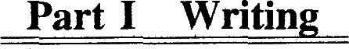

这是一篇四级考试中常见的议论文。此次话题lifelong learning(终身学习)在考生日常生活中是比较常见的，因此写起来难度不大。考生应该将重点放在第二段阐释终身学习的重要性上。尤其可以结合当今信息时代涌现的一些新事物、新现象，比如从近几年出现的网店、打车软件等展开讨论，从而使论证有理有据，避免空洞说理。

一、引出话题：终身学习很重要(the importance of lifelong learning)
二、论证重要性：在信息时代，必须通过不断学习，紧跟时代步伐(keep pace with the times through ceaselessleaning)
两个例让：
l．使用打车软件(a Taxi App)的出租车司机比不用软件的司机挣得多
2．一个开网店的家庭主妇甚至比白领职员挣得多(out．e锄a white．collar worker)
三、深化主题、总结全文：活到老、学到老；只有不断学习，才能在迅速发展的社会中实现自身潜能(achieve ourpotential)，生活得更好(1ive a better life)

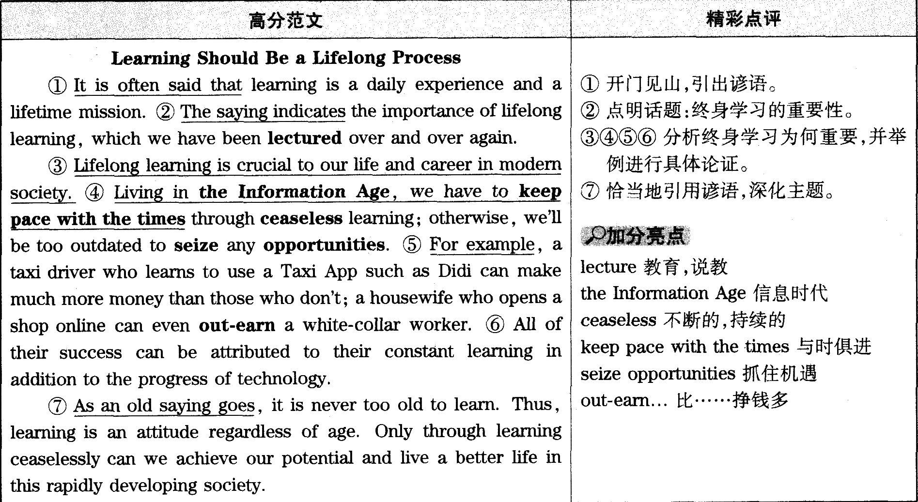
俗话说得好：活到老，学到老。因此，学习是一种态度，无关乎年龄。只有通过不断学习，我们才能在当今迅速发展的社会中发挥自身潜能，生活得更好。

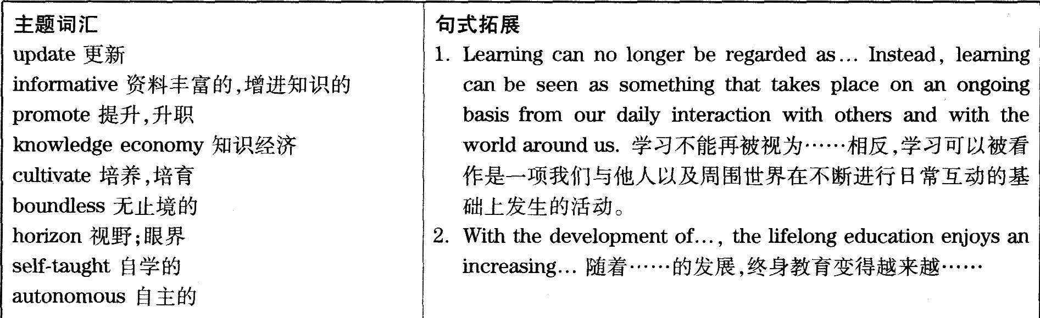

1．W：HeH0．Mr．Harrison，thanks for callin9．Now,when would it be good for you to visit our company?
M：Well．In fact．I Can come almost any tiine next month．And probably toward the end of a week would be best for me．
Q：What are the speakers talking about?
D. 未听先知：四个选项均为描述事实状况的短语，结合选项中多次出现的meeting一词，以及details，next week和the man's visit等，可以推断，对话内容与男士的出访和会面有关，而且此次会面尚未达成。
详解：女士询问男士什么时候方便到她所在的公司参观，男士说下个月几乎任何时间都行，可能接近周末的时间最好。由此可知，两人在谈论男士参观女士所在公司的时间，故答案为D.
2．W：Can you help me find a book on South America?
M：What specifically would you like to know about?We catalogue Our books in many different ways．
Q：Where does the conversation most probably take place?
C. 未听先知：四个选项均为表示场所的短语，可以推测本题考查地点，听对话时注意捕捉提示对话发生场所的关键词。详解：女士请男士帮助她寻找一本关于南美洲的书，男士反问女士具体想要哪方面的书籍，因为他们
通过多种不同的方式对书籍进行归类。由此可知，对话发生在图书馆，故答案为C.
3．M：I'm trying to make a call to New York and haven't been able to get through Can you heIp me?
W：Sure．Try my phone．
Q：What is the man’s problem?
B. 未听先知：四个选项均以he cannot开头，可以推断对话中男士一定是遇到了某种问题，结合选项中出现的call，get through，phone number和public phone等词，可以进一步确定男士遇到的问题与电话有关。
详解：男士说他在尝试打电话到纽约，但一直没打通，询问女士能否帮助他，女士很爽快地答应，并让男士试试她的手机。由此可知，男士没办法打电话到纽约，故答案为B.
4．M：I have to go to Prof．Hudson's office—to discuss my the siser．If tiIne allows，I'd like to go to the movies with you when I come back．
W：I don’t think I earl make it．I'm going shopping with Jane right now．
Q：What is the man going to do first?
D. 未听先知：四个选项均为表示行为的动词短语，可以推断本题考查的内容与行为动作有关。结合选项中出现的with the woman和his thesis等词，可以进一步判定本题考查的是男士的行为动作，因此男士的话为听音重点。
详解：男士说他必须去哈德森教授的办公室讨论他的论文，如果时间允许的话，他希望回来后能和女士一起去看电影，而女士却说她不一定能赶得及，因为她现在要和简去购物。由此可知，男士首先要做的事情是与哈德森教授讨论他的论文，故答案为D.
5．W：Why are you So upset and worried?
M：I've been racking my brains all morning,trying to recall where I put my gold watch．But it has been in vain
Q：What do we learn about the man?
C. 未听先知：四个选项的主语均为he，结合选项中多次出现的watch可以推断本题考查内容与男士的手表相关，听录音时注意与手表相关的内容。
详解：女士问男士为什么那么心烦和焦虑，男士说他整个上午一直在回忆，试图回想起来他把金表放到哪儿了，但一直都是徒劳。由此可知，男士仍然不知道他把金表放在哪儿了，故答案为C.
6．W：I thought you said you were going to call me last week about the car I'm sellin9．
M：Oh，I'm sorry．It completely slipped my mind．
Q：What does the man mean?
A. 未听先知：四个选项的主语均为he，结合选项中出现的forgot，slipped and hurt，sorry和sold等词，可以初步推断与男士相关的事实并不是特别好的事实，因此听录音时要注意捕捉与男士相关的信息。
详解：女士说她记得男士说过上周会给她打电话，与她讨论一下她要卖的那辆车，男士听到女士的话后，马上表示道歉，因为这件事completely slipped my mind，本题的关键在于理解短语slip one’s mind
的含义，即“忘记”。也就是说，男士把这件事忘得一干二净，故答案为A.
7．W：I tried to catch the bus but couldn’t make it．So I'm late for class．
M：A nother excuse．Are you ready for what you'll say tomorrow?
Q：What does the man imply about the woman?
c. 未听先知：四个选项均以she开头，结合选项中出现的absent，class，excuses和being late等词，可以推断女士上课出勤情况不好，对话内容应该围绕女士上课出勤情况展开。
详解：女士说她努力赶汽车，但没有赶上，所以上课才会迟到，男士却说又一个借口，并问她是不是连明天要说什么都准备好了。由此可知，男士认为女士总是在为她的迟到找借口，故答案为C.
8．M：The apartment building I live in is going to be torn down before the end of this month．一I don’t know what to do．
W：Well，my brother is a real estate agent．He Can help you out，I think．
Q：What do we learn about the man?
B. 未听先知：四个选项均以he开头，结合选项中出现的move out of，buildin9，real estate agent和stay with等词，可以推断对话内容与男士的住房情况有关。
详解：男士说他住的那栋公寓楼月底前就要拆除了，他对此一筹莫展，女士告诉男士，她弟弟是房地产经纪人，应该能够为男士提供帮助。由此可知，男士必须在短期内搬离现在的住所，故答案为B.
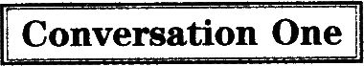
M：Ace Employment Agency．Good mornin9．
W：Good mornin9．1 wonder if you Can help me．I'm looking for a job．
M：I’ll see what we can d0．Uh…Have you been to us before?
W：N0．(9)But you've managed to get jobs for some of my friends．So I thought，perhaps，you know…
M：Yes，I see．First of all，could you give me your full name?
W：Yes．of course．Susan Hollies．
M：Good．And could I have your phone number?
W：Yes．7788992．
M：Fine．And your date of birth，please?
W：Feb．erd，1980．
M：Thank you．Now education．Which school did you go to?
W：(10)1 went to a secondary school in South Town
M：And have you been to coHege?
W：N0．(10)11eft hill—time education when l was l8．
M：I see．Any qualifications?
W：Yes．I gained a shorthand and typing diploma at evening classes．
M：That’S good．Now．where are you working at the moment?
W：(11)Well,I've got a job as a shorthand-typist．But I'm not enjoying it very much and it doesn’t pay very well．
M：I see．Have you applied for any other jobs?
W：Yes．I thought I'd like to be a policewoman．But they turned me down because I Was too short．
M：whatwould you like to do now．then?
W：WeU，I think I'd like to work in a travel agency．
M：I see．I think the best thing is for me to see what we might find for you．And then…
未听先知：预览三道题各选项，由wanted column，she，tour guide和policewoman等，可以初步推测对话内容与女士的求职以及工作情况相关，再结合education，school和cortege等词，可以确定对话内容涉及女士的受教育情况等相关背景。
9．How did the woman get to know about the mall’s company?
B. 详解：男士问女士是否曾通过他所在的机构找过工作，女士表示没有，但这家职业介绍所曾帮助她的朋友们找到过工作，由此推断，她是从朋友处得知这家职业介绍所的信息的，故答案为B.
10．What formal education did the woman receive?
C. 详解：对话中男士问女士曾在哪所学校上学，女士说她在South Town上的中学，然后又说，她l8岁之后就没有再接受过全日制教育，由此可知，女士所接受的最高程度的正规教育就是中学，故答案为C.
11．What do we learn about the woinan’s occupation?
A. 详解：对话中男士询问女士目前在哪里工作，女士回答说自己现在的工作是一名速记打字员，故答案为A.
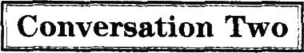
W：Steve，Can you tell me how long you’ve been a pub owner?
M：Well，four years，I suppose．(12)I've been involved with pubs off and on for ten years．I've sort of done hotel work and I've also run a restaurant pub．And now I've got what you call a good old．fashioned pub．
(13)That is,a public bar,with all the social games going with it,which is what we've always wanted to have,you know．
W：It sounds like you've always worked in pubs．but not always in this one．
M：N0。n0．1 worked in quite a variety of pubs．
W：What makes a good pub?I mean，you said，you know，it has got a good variety of things．
M：Well，(14)I think having the fight customers to start with,selling the right beer,keeping it good,and most of all,keeping a good attitude yourself,even though you probably feel very tired．But the idea is，if you generate from your side，it’s got to affect the other side，if you’re getting the right customers in．
W：Yeah I must say that’s one thing that has always struck me about being a pub owner．I mean．a lot ofpeople seem to think that it’s a nice job，you know．Everybody says，“0h，I'd love to retire and get a country pub．”(15)But it seems to me that it's actually very hard work．
未听详解：预览四道题各选项，由第12题中的career opportunities和第l5题中的toughjob，可以判断对话内容与某种工作有关，再结合第l4题中出现的beer，可以进一步确定对话中两人所谈论的工作场所提供啤酒，应该是酒吧或餐馆。
12．What does the man say about his involvement with pubs?
C. 详解，对话中女士问男士他成为酒吧老板有多长时间了，男士回答说已经四年了，不过他从事与酒吧相关的工作断断续续已经有十年，故答案为C.
13．What characterizes the old-fashioned pub．according to tlIe man?
D. 详解:对话中男士说他现在的酒吧是那种人们普遍认为的传统酒吧，这种酒吧的特点就是会有很多社交活动，故答案为D。
14．What does the man say is most important in making a good pub?
C. 详解:当女士问男士怎样才能成为好酒吧时，男士说，首先要有合适的顾客，售卖合适的啤酒，并且酒要好，最重要的是，即使感觉很疲惫，也依然要保持良好的态度，这样才能让酒吧更成功，故答案为C.
15．What does the woman think of running a country pub?
A. 详解:对话结尾时，女士说，很多人都认为经营酒吧是一份很好的工作，每个人都说想在退休以后，开一家乡村酒吧，但女士却认为经营酒吧实际上是一份相当辛苦的工作。选项A)中的tough是原文中hard的同义转述，故答案为A.

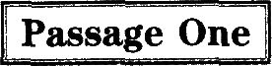
To help ourselves and others．it’s important to know something about drugs．A drug is a chemical substance．It Can bring about a physical，emotional，or mental change in people．Alcohol and tobacco are drugs．Caffeine，a substance found in coffee and some soft drinks，is also a drug．
(16)Drug abuse is the use of a drug,legal or illegal,that hurts a person or someone close to him．A druguser is the person who takes the dru9．There are many kinds of drug users．Experimental users may try drugsonce or twice．They want to see what the effects will be．(17)Recreational users take drugs to get high．Theyuse drugs with friends or at parties to get into the mood of things．Regular users take drugs all the time．Butthey are often able to keep up with the normal routine of work．Dependent users can’t relate to anything butdrugs．Their whole life centers around drugs．They feel extreme mental or physical pain without drugs．
It’s not always easy to tell that someone is using drugs．In the early stages，drug use is often hard to see．Sometimes．people like drugs or need drugs SO much；they Can’t do without them．They are dependent upon drugs．(18)Only a few kinds of drugs can cause physical dependence．But almost any drug,when it's misused,can make a person think he needs it all the time．By this time,it's too late and the person is hooked．
未听先知:预览三道题各选项，由第l7题各选项可以推断出短文与药物使用相关，再结合第l6题中的social instability．hurts a person以及第l8题中的social problems，fatal to the user等可以进一步判断，短文涉及药物滥用造成的危害。
16．What does the speaker say about drug abuse?
D. 详解:短文中提到，药物滥用是指合法或非法地使用药物，并对使用者本人或者与其亲近的人造成伤害，故答案为D.
17．What does the speaker say about recreational drug users?
B. 详解:短文中提到了不同类型的人使用药物的目的。其中提到，Recreational users take drugs to get high．即娱乐性毒品使用者吸毒是为了让自己兴奋，故答案为B.
18．What does the speaker say about drug dependence?
C。详解:短文最后一部分提到，虽然仅有很少几种药物会造成身体的依赖性，但若使用不当，几乎所有药物都会让人一直觉得他需要该药物，这时候已经晚了，因为他已经上瘾了。也就是说，药物依赖性很难根除，故答案为C.
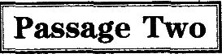
According to Charles Harper，Chairman of ConAgra，the Healthy Choice line of frozen dinners，began with his own heart attack．It has been brought on by years of eating anything he could get his hands on．(19)Ashe 1ay in the hospital recovering,Harper imagined the line of healthy frozen foods that tasted good．(20)The Healthy Choice product line was carefully tested with consumers before being introduced to the general public．ConAgra’s research and development staff spent a year working under the instruction“Whatever the cost，don’tsacrifice taste”．The first test market results surprised even the ConAgra team．The low sodiuIn，low fatfrozen dinners sold much better than expected．(21)According to the finn's vice-president of marketing andsales,"We benefited from low expectations．The products were much better than people thought they would be．’’This finding supported ConAgra's decision to position the product against other high-quality frozen dinners rather than as a diet or health food．The new product’s brand name and packaging were an important part of the development process．(22)The name Healthy Choice was chosen for the positive implication it held for consun2ers．Because Conigra felt the product would be an impulse purchase，it was important to make the item stand out in the freezer case．This was accomplished through the dark green packaging that not onlydiffered from the competitors’but also suggested freshness and richness in vitamins．
未听先知：预览四道题各选项，由第19题中的healthy frozen food，第20题中的diet experts，第21题中的competitive price．unique ingredients以及第22题中的food’s dark green packagin9可以判断，短文围绕某种食品展开，涉及该商品的多种特性。
19．What did Charles Harper think of while he was in hospital?
B)详解：短文中提到，当查尔斯·哈柏因为心脏病发作而躺在医院康复时，他想象着一排健康美味的冷冻食品，故答案为B.
20．What does the passage say about the Healthy Choice product line before it went to market?
A. 详解：短文中提到，在真正投放到市场面向大众之前，Healthy Choice系列的食品经过了消费者的认真测试，故答案为A.
21．What is said to contribute to ConAgra’s business success?
B. 详解：短文中提到，ConAgra公司负责市场营销的副总裁认为，他们从低期待值中受益，产品比人们想象的更出色，故答案为B.
22．What does the speaker say about the naule Healthy Choice?
C. 详解：短文中提到，选择使用Healthy Choice这个商品名称，是因为它能给消费者以正面暗示，故答案为C.
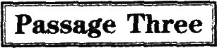
(23)In the United—States,36 states currently allow capital punishment for serious crimes such as murderAmericans have always argued about the death penalty．(24)Today,there is a serious question about this issue：Should there be a mage limit for executing criminals?In other words，is it right for convicted murderers who kill when they are minors that is．under the age of l8 to receive the death penalty?
In most other countries of the world，there is no capital punishment for minors．In the United States though，each state makes its own decision．Of the 36 states that allow the death penalty，30 permit the execution of minors．
In the state of South Carolina，a convicted murderer was given the death penalty for a Cyllne he committed while he was a minor．(25)In l977,when he was l7 years old,James Terry Roach and two friends cruelly murdered three people．Roach’s lawyer fought me decision to execute him．The young murderer remained on Death Row for ten years while his lawyer appealed to the governor．The lawyer argued that it is wrong to execute a person for a cme he committed while he was a nlinor．In the United States，the governor of a state has the power to change a sentence from the death penalty to life in prison．(25)Nonetheless,the governor of South Carolina refused to stop the execution．Roach was finally executed in l986．
未听先知：预览三道题各选项，由第24题中的criminals以及第25题各选项中出现的court，death sentence和executed等可以推断，短文与犯罪行为以及相关的死刑判决有关，再结合第23题.选项中的criticism和第24题四个选项所提到的问题，可以进一步判断短文涉及对死刑这一刑罚的争议。
23．What does the speaker say about the death penalty in the United States?
A. 详解：短文开头明确指出，在美国，目前有36个州允许对严重罪行执行死刑，比如谋杀。也就是说，美国大部分地区有死刑的存在，故答案为A.
24．Whatisthe focus of tlle debate around the death penalty?
B. 详解：短文提到，目前关于死刑存在一个重大问题：是否应该对被执行死刑的罪犯设置一个最低年龄限制，故答案为B.
25．What does the speaker say about James Terry Roach?
D. 详解:短文最后提到，l977年，詹姆斯·特里·罗奇当时l7岁，与两个朋友一起残忍地杀害了三个人，因此被判死刑。虽然他的律师提起上诉，但该州州长拒绝撤销死刑，最终他于l986年被执行死刑。由此可知，虽然罗奇在犯罪时仍是未成年人，但依然被执行了死刑。故答案为D.

26．transactions。详解:本句主语they为复数，因此空格处应该填入名词复数形式，作介词as的宾语。空格所在句分号前提到，大笔借款通常不是问题，而空格所在部分后半句中说条款都已经被白纸黑字地记录下来。由此可见，大笔借款被看作商业交易。结合录音填人transactions，意为“交易，业务”。
27．in silence。详解:本句主干结构完整，此处应该填人副词或副词短语，充当状语，修饰动词suffer。由该句之后卡萝尔对自己遭遇的描述可以看出，她的朋友金尼经常向她借钱，但从来没有还过，虽然数目不大，而卡萝尔也觉得不好意思，没有要求她还钱，也就是说，她对朋友的行为是默默地忍受：结合录音填入in silence，意为“默默地”。
28．short of。详解:此处填入的词或词组应该能够连接系动词is和空格后的名词cash，描述主语金尼与金钱之间的关系。空格所在句后一句中说，金尼经常向卡萝尔借上一两美元买饮料或者电影票，也就是说，金尼比较缺钱。结合录音填入short of，意为“缺少，缺乏”。
29．resent。详解:此处应该填入动词，作句子的谓语。空格所在句及其前两句都是在描述卡萝尔的朋友向她借钱不还，说明卡萝尔对朋友这样的行为表示反感。结合录音填人resent，意为“愤恨，怨恨，憎恶”。
30．embarrassed。详解:此处位于副词t00之后，应该填入形容词。由于朋友只是借上一两美元，如果要求还钱，让人感觉有点小题大做。因此，卡萝尔感觉不好意思让朋友还钱。结合录音填入embarrassed，意为“困窘的，尴尬的”。
31．spare。详解:空格前是情态动词的否定形式couldn't，因此，此处应该填入动词原形，与couldn’t起作从句的谓语。由于朋友总是借钱不还，而卡萝尔又不好意思向朋友要求还钱，时间长了，卡萝尔决定不再借钱给朋友，再结合本句句首的the last time可以判断，从这一次起，卡萝尔拒绝借钱给朋友。因此，她告诉朋友她没钱可借。结合录音填入spare，意为“提供(时间、钱等)；匀出，分出”。
32．response。详解:此处应该填入名词单数形式，与不定冠词a搭配，作句子的宾语。卡萝尔拒绝再借钱给朋友的方式是说她没钱可借，而另外一位女士的建议更为大胆，本句后面就给出了那位女士在朋友借钱时的反应。结合录音填人response，意为“反应，回答”。
33．turn the tables。详解:此处应该填入动词或动词短语，充当句子的谓语。这位女士的回答更为大胆，当有人借钱不还时，她不是被动忍受，而是扭转局面，主动出击，向朋友提出要求。结合录音填入turn the tables，意为“扭转局面，转败为胜”。
34．reization。详解:空格位于不定冠词a和形容词sudden之后，因此应该填入单数名词，作介词by的宾语。当把钱拿到手后，这位女士才表现出突然想起来的样子，说这和你上次借我的一样多呢!结合录音填人realization，意为“意识，领悟”。
35．convenient。详解:此处应该填入形容词或副词，与how一起构成感叹句。女士假装刚刚反应过来，并告诉对方，她这次借的和对方欠她的一样多，这样省得对方再还钱了，还真是省事呢!结合录音填入
convenient，意为“方便的，便利的”。


对于很多美国人来说，2013年以异乎寻常的寒冷结束。在美国的多数地区，11月底和12月(36)已有初雪，大部分地区的天气寒冷刺骨。这一年是(37)20年以来第一次有记录的寒冷天数可能超过有记录的温暖天数的年份。但是美国的情况是个例外：(38)全球范围内，ll月是有史以来最暖和的，而且现有数据表明，2013年有可能是记载中第四个最热的年份。
现在快享受降雪的乐趣吧，因为2014年很有(39)可能会更热，也许是有记录以来最热的年份。因为科学家预测，2014年是厄尔尼诺年。
厄尔尼诺在西班牙语中是“小孩”的意思，当南太平洋表层海水温度异常升高时就会(40)出现。太平洋如此广袤，覆盖了地球表面的30％，以至于由于温度升高带来的(41)额外能量足以引发全球一系列的天气变化。厄尔尼诺与东南亚和澳大利亚的极端干旱天气(42)有关，而且还会导致南北美洲部分地区的极端降雨，即便是在非洲南部(43)遭受干旱的时候。海洋生物也会受其影响：厄尔尼诺会(44)降低寒冷但营养丰富的海水的上升，这些海水供养着大量(45)鱼群。另外，异常温暖的海水温度还会破坏珊瑚。

名词：D)chances可能性；机会；F)decades十年；G)experiences经历；K)populations族群；人口数量；N)saw锯子动词：B)associated联系，交往；C)bore忍受；E)communicated交流，沟通；G)experiences遭受，经受；
J)occurs出现；发生；L)realize认识到；实现；M)reduce降低；缩小；N)saw见证，看见
形容词：A)additional额外的，附加的；B)associated相关的，有联系的；O)specific具体的；特定的副词：H)giohany全球地；I)logically合乎情理地，符合逻辑地

36．N.saw。详解：动词辨析题。本空位于两个名词之间，而且late November and December作句子的主语，因此应填入动词作谓语。此处意思是ll月底和12月已经有了初雪，应填入含有该层意思的动词。备选动词中，G.experiences和N.saw符合句意，但本段第一句用了一般过去时，此句承接第一句，因此也应该用一般过去时，故答案为N.saw。本题也可以先根据时态将选项范围缩小至B)associated、C.bore、E.communicated和N.saw，再根据句意排除B.、C.和E.
37．F.decades。详解：名词辨析题。本空位于数词之后，故应填入名词。此处意为：二以来第一次有记录的寒冷天数可能超过有记录的温暖天数。由句意可知本空应填人表示时间的名词，故答案为F.decades“十年”。two后面应填人复数名词，因此可将选项范围缩小至D.chances、F.decades、G.experiences和K.populations，再根据句意排除D.、G.和K.
38．H.globally。详解：副词辨析题。本句属于主系表结构，并不缺少主要成分，因此应填入副词作状语。本段第一、二句讲的是美国2013年ll月底和12月比往年冷，第三句开始转折，说美国是特例。本句进一步解释说11月是最暖和的，应该是将美国和全球其他国家对比得出的，因此答案为H)globally。备选副词I.logically不符合句意，因此排除。
39．D)chances。详解：名词辨析题。本空位于原因状语从句的系动词are之前，故应填入名词作主语。本句是对2014年天气的预测：2014年会更热，也许是有记录以来最热的年份。由perhaps可知本空应填入有“可能”含义的名词，故答案为D.chances。
40．J.occurs。详解：动词辨析题。分析句子结构可知，空格位于主语ElNifi0之后，应填入动词作谓语。本句解释什么是厄尔尼诺现象，句意为：当南太平洋表层海水温度异常升高时，厄尔尼诺就会一。因此本空应填入有“出现；发生”含义的词，故答案为J.occurs。本题也可以根据句子成分逐步分析，本句中，El Nifio是主语，Spanish for“the child”是其同位语，when引导时间状语从句。同位语是对其前面名词的进一步解释说明，去掉并不影响句子的结构，在分析时可以省略，因此可判断本句缺少谓语动词。另外，本段在介绍厄尔尼诺现象时，用的都是现在时，可以将选择范围缩小至动词G.experiences和J.Occurs，再根据句意排除G.
41．A.additional。详解:形容词辨析题。本空位于定冠词the和名词energy之间，因此应填入形容词作修饰语。句意为：由于温度升高带来的能量足以引发全球一系列的天气变化。温度升高必然会带来额外的能量，故答案为A.additional“额外的，附加的”。备选的形容词只有A.additional、B.associated和0.specific，可根据句意排除B和0。
42．B.associated。详解:动词辨析题。本空位于系动词are之后，应填入形容词或可作表语的分词、动词被动语态。本题前一句提到厄尔尼诺现象足以引发全球一系列的天气变化，本句对此举例说明，指出厄尔尼诺与东南亚和澳大利亚的极端干旱天气有关。因此应填入含有“相关的”含义的词，故答案为B.associated。符合条件的备选词中，A.additional、C.bore、E.communicated和O.specific均不能与with搭配，故排除。
43．G.experiences。详解:动词辨析题。本空位于两个名词(词组)之间，应填入动词作谓语。本句仍然在说明厄尔尼诺带来的天气变化，南北美洲部分地区极端降雨，即便是在非洲南部干旱的时候。由句意可知，本空应填入有“遭受”含义的动词，故答案为G.experiences。另外，本段在介绍厄尔尼诺现象，用的都是现在时，可以将选择范围缩小至动词G.experiences和J.occurs，而0ccurs已在上文用过，故排除。
44．M.reduce。详解:动词辨析题。本空位于情态动词Can之后，应填入动词原形。本句意为：厄尔尼诺会寒冷但营养丰富的海水的上升。根据本段第一句可知，厄尔尼诺发生意味着海水温度升高，自然不利于寒冷海水的上升，故答案为M.reduce。备选动词L.realize不符合句意，故排除。
45．K.populations。详解:名词辨析题。本空位于句末名词之后，应填入名词。that引导的定语从句的意思是：这些海水供养着大量的鱼。由句意可知，此处意为“鱼群”，故答案为K.populations。备选名词中D.chances、F.decades和G.experiences均在上题中已选，而N)saw显然与句意不符，因此均排除。

46. Cooking benefits people in many ways and enables them to connect with one another.
译文：烹饪在很多方面都使人受益，使他们能够彼此联系。
定位：由connect with one another定位到文章D.段画线处。
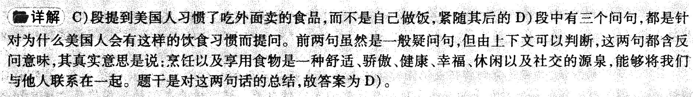
47. Abundant information about cooking is available either online or on TV.
译文：在网络或电视上，都可以获取大量关于烹饪的信息。
定位：由abundant information，online和TV定位到文章B.段画线处。
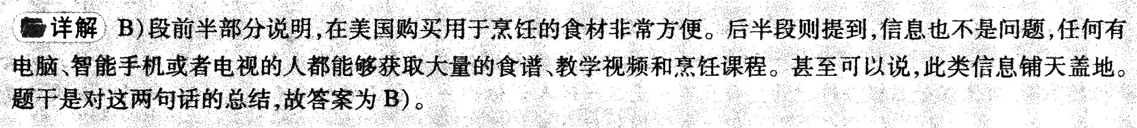
48. Young people do less cooking athome than the elderly thesedays.
译文：如今，与老年人相比，年轻人在家做饭比较少。
定位：由题干中的young people, less 和the elderly 定位到文章F)段画线除
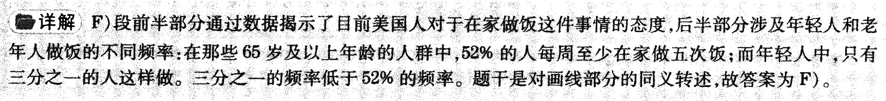
49. Cooking skills can be improved with practice.
译文：烹饪技巧能够通过练习得以提高。
定位：由题干中的improved和practice定位到文章段画线处。
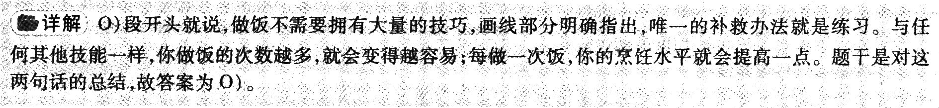
50. In the mid-20th century, most families atedinner at home instead of eating out.
译文：20世纪中期，大部分家庭都在家吃饭，而不是外出就餐。
定位：由题干中的mid-20th century和ate dilliler at home定位到文章G)段画线处。
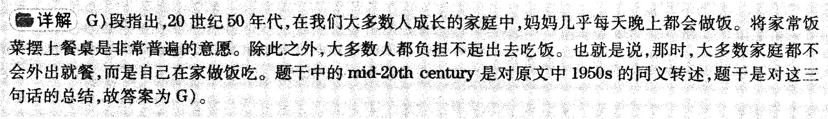
51. Even those short of time or money shouldbe encouraged to cook for themselves and their family.
译文：即使有些人不怎么有时间或钱，也应该鼓励他们为自己和家人做饭。
定位：由题干中的short of time ormoney，encouraged和cook for themselvesand theb．family定位到文章E.段画线处。
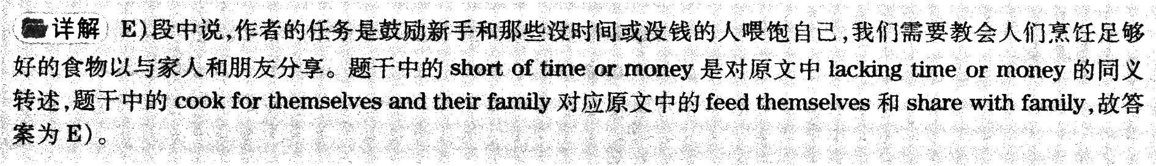
52. Eatingfoodnotcookedbyourselves can cause serious consequences.
译文：吃那些不是自己烹饪的食物会造成严重后果。
定位：由题干中的consequen ces定位到文章J.段画线处。
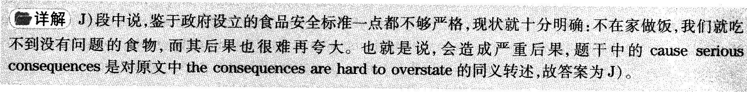
53. To eat well and still save money, people should buy fresh food and cook it themselves.
译文：想要既吃好又省钱，人们应该购买新鲜食品，自己烹饪。
定位: 由题干中的eat well and still save money和cook it themselves定位到文章M)段画线处。
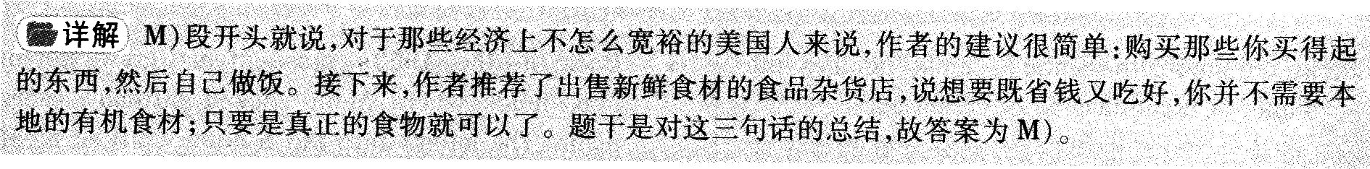
54. We get a fairly large portion of calories from fast food and snacks.
译文：我们相当大一部分的卡路里都来自于快餐和零食。
定位：由题干中的calories，fastfood和snacks定位到文章C)段画线处。
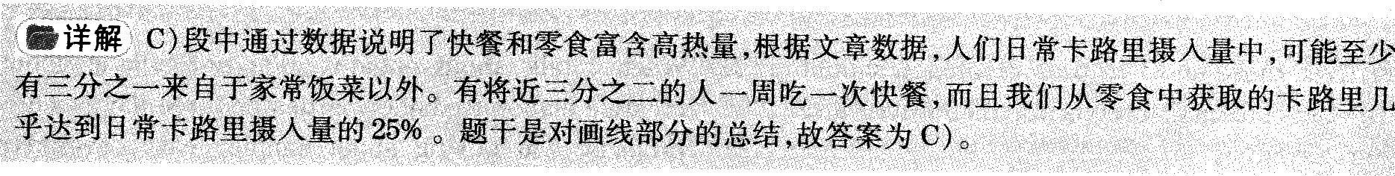
55. The popularity of TV led to thepopularity of frozen food.
译文：电视的普及使得冷冻食品流行开来。
定位：由题干中的popularity，TV和frozen food定位到文章H)段画线处。

56，A. 定位:由题干中的happening to the wallet定位至第一段第一句：The wallet is heading for extinction．
详解:事实细节题。第一段第一句开篇便点明钱包正走向灭绝。因此A.“它正在消失”符合文意，故为答案。
点睛:B.“它正在变厚”、C.“它正变得昂贵”和D.“它的样式正发生变化”在原文中均未提及，因此均排除。
57．B. 定位：由题干中的in big modern stores定位至第一段第六、七句：At the most cutting edge retail stores--Victoria Beckham Off Dover Street，for instance—_yoU don、go and stand at any kind of cash register when you decide to pay．the staff axe equipped with iPads to take your payment while you relax on a sofa．
详解：事实细节题。第一段第六句举例说明在最前沿的商店里人们如何付款。第七句提到，店员都配有平板电脑，顾客在沙发上休息时就可以付账。由此可知，在大型现代商店里，商业交易是通过电子设备完成的，故答案为B.
点睛：A.“单独地”在原文中并未提及，排除；C.“抽象地”，原文只是说货币的概念被抽象化，并没有说交易抽象地完成，因此排除；D.“通过收银台”，与本段第六句提到的“不需要站在任何收银台前”矛盾，因此排除。
58．D. 定位：由题干中的makes the author feel uncomfortable定位至第二段第二至五句：But across society，the abstraction of the idea of cash makes me uneasy．Maybe I'm just old fashioned．But earning money isn’t quick or easy for most of us．Isn’t it a bit weird that spending it should happen in haft a blink(眨眼)ofan eye?
详解：事实细节题。第二段介绍作者的看法。现金概念的抽象化使作者感到不安。究其原因是作者认为挣钱不容易，而花钱却在转瞬间，故答案为D.
点睛；A.“省钱成为了过去”和C.“挣钱变得更加困难”在原文中并未提及，因此排除；B)“周五晚上：人愉悦的感觉正在消退”，与原文不符，因此排除。
59．A. 定位：由题干中的why和what’s happening to the wallet定位至第三段第二句：What bothers me about the death of the wallet is the change it represents in our physical environment．
详解：事实细节题。what’s happening to the wallet指的是钱包正走向灭绝。第三段继续介绍作者对钱包即将灭绝的看法。第二旬提到，钱包的消失给我带来的困扰是关于它所代表的实体环境的改变。因此A.“它代表现代世界的一个改变”符合文意，故为答案。
点睛： B.“它与每个人的生活有关”和C.“它标志着一个历史悠久的传统的结束”都是原文流露的事实，并不是作者写作的原因，因此排除；D.“它是当代经济学家所关心的事”是对第三段第一旬But I’II leave the economics to the expels．的曲解，因此排除。
60．D. 定位：由题干定位至第二段第二句：But across society，the abstraction of the idea of cash makes me uneasy．以及第三段第二句：What bothers me about the death of the wallet is the change it represents in our physical environment．
详解：推理判断题。由定位句可以看出，作者对钱包走向灭绝感到不安和困惑，而钱包灭绝正是代表着社会的变化，因此D.“他在不断变化的现代世界中感到不安”符合文意，该选项中的insecure对应定位句中的uneasy和bother，故答案为D.
点睛：A.“他反对社会变革”和B.“他反对技术进步”在原文中均未提及，因此排除；C.“他不愿 意与传统的钱包告别”是对原文第三段最后两句Show your wallet，if you still have one．It may not be here much longer．的解释．过于片面，并不是文章中作者表达的主要意图，因此排除。

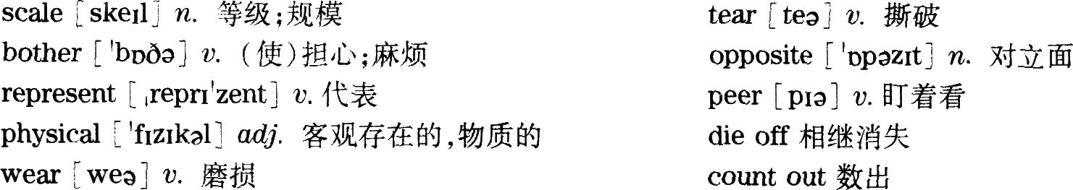

61．A. 定位：由题干中的sleeping habits定位到第一段：Everybody sleeps，but what people stay up late to Catch or wake up early in order not to miss--varies by culture．
详解：事实细节题。文章首段后半句指出，人们为了赶上什么而熬夜或者为了不错过什么而早起，却因文化的不同而存在差异。由此可见，人们的睡眠习惯与文化有关，故答案为A.
点腈:文章第一段提到人们的睡眠与文化有关，第二段又提到影响人们睡眠的几个主要因素：体育赛事、时间变更和假期，并未提到睡眠习惯与健康、季节以及个人之问的关系，故B)“它们影响人们的健康”、C.“它们随着季节而改变”和D.“它们因人而异”三项均可以排除。
62．C. 定位:由题干中的the Russians regarding sleep定位到第四段第一句：Russia’s other late nights and early mornings generally correspond to public holidays．
详解:推理判断题。文章第四段第一句指出，俄罗斯其他熬夜或早起的日子基本上与公共假期相一致。故本题答案为C.
点睛:A.“他们直到很晚才睡觉”，文章第三段提到俄罗斯改为冬令时后，俄罗斯人起床时间比以前晚了，并且第四段提到他们会在假期里早起或晚睡，A)项说法太绝对，故可以排除；B)“他们周末睡得不多”，文章第六段提到美国人会在三日周末熬夜、晚起以及睡得最长，B)项属于张冠李戴，故可以排除；D.“他们比其他地方的人睡的时间更长”，文章第三段提到俄罗斯改为冬令时后，俄罗斯人起床时间比以前晚了，但这推断不出“他们比其他地方的人睡的时间更长”，故可以排除。
63．C. 定位:由题干中的Europeans’loss of sleep定位到第八段：The World Cup is also chiefly responsible for sleep deprivation(剥夺)．The worst night for sleep in the U．K．was the night of the England Italy match．．．compared to Germans．Italians，and the French，who stayed up．．．to watch the Cup．
详解:推理判断题。文章第八段首句指出，世界杯也应承担剥夺人们睡眠的主要责任。最后两句用英国人、德国人、意大利人和法国人熬夜看世界杯的例子来论证。因此，欧洲人缺乏睡眠的主要原因是为了看世界杯，故本题答案为C.
点睛:文章第三段提到俄罗斯改为冬令时后，俄罗斯人起床时间比以前晚了，夏令时的结束对俄罗斯人的睡眠造成了影响，而非欧洲人，故可以排除A.“夏令时”；文章并未提到欧洲人的夜生活是否丰富，B.“丰富的夜生活”属于无中生有，故可以排除；文章第八段第三句提到．夏天北方国家太阳几乎不会落下，由此导致英国人比平时醒得早一些，但是第四句用though转折指出这与德国人、意大利人和法国人为了看世界杯熬夜相比根本不算什么，即夏天并非导致欧洲人缺少睡眠的主要原因，故可以排除D.“夏天”。
64．B. 定位:由题于中的a device to record their sleep patterns定位到最后一段第一、二句．Not everyone has a device to record their sleep patterns…only the richest people d0．And people who elect to track their sleep may try to get more sleep than the average person．
详解：事实细节题。文章最后一段前两句指出，并不是每个人都有设备记录自己的睡眠模式，在以上一些国家中，可能只有最富有的人才这样做；那些选择追踪自己睡眠的人也许是想要获得比普通人更多的睡眠。即富人记录自己睡眠模式最可能的原因是他们想要充足的睡眠，故本题答案为B.
点睛：A.“他们难以入睡”和C.“他们参与了一项关于睡眠的研究”，文章并未提及，故可以排除；
D.“他们想在固定的时间睡觉”，文章最后一段首句提到他们用设备记录A己的睡眠时间，并未提到他们是想要在固定的时间睡觉，故可以排除。
65．B. 定位：由题干定位到最后一段．people who elect to track their sleep may try to get more sleepthan the average person．If the most health·conscious among us have such deep swings in Our shuteye levels throughout the year，how much sleep are the rest of us losing?
详解：推理判断题。文章最后一段最后一句提到，这一整年里，如果我们中最具健康意识的人的睡眠时间都有这么大的浮动，那我们其余的人又失去了多少睡眠呢?换句话说，人们对睡眠不够重视，故本题答案为B. 点睛： A.“失眠对健康有害”，题干问的是作者在最后一段暗示了什么，A.并非作者暗示的内容，故可以排除；C.“研究我们的睡眠模式很重要”，文章并未提及这一点，故可以排除；D.“普通人可能比富人睡得少”，文章最后一段前两句提到了富人用设备记录自己的睡眠时间，可能是想要获得比普通人更多的睡眠．并没有提到普通人和富人之间谁睡眠时间更多的问题，故可以排除。

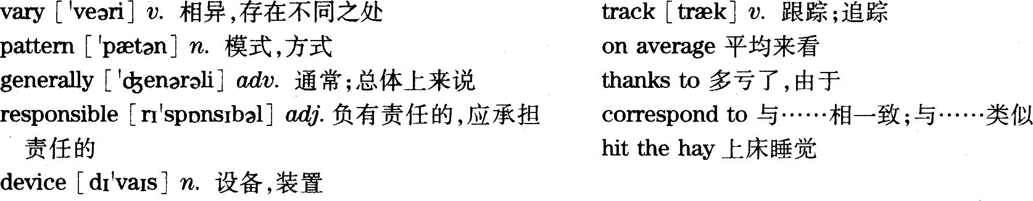

Lijiang, an ancient town in Yunnan Province, is one of the most famous tourist attractions in China. The life tempo there is slower than that of most Chinese cities. There is beautiful natural scenery everywhere in Lijiang, and many minorities provide tourists with various and colorful cultural experience. It has also been known as the "City of Love" in history. Numerous legends about people who were born for love and died for love circulate among the local folk. Nowadays, this ancient town is regarded as the paradise of love and romance in the eyes of both Chinese and foreign visitors.

1．翻译第一句时，首先要确定主语。一种译法是将“丽江”作为主语，将“云南省的古镇”译为“丽江”的同位语。另一种译法是直接将“云南省的丽江古镇”作为主语，即Lijiang ancient town ofYunnan Province。相比而言，第一种译法更地道、更简洁。此外，要注意汉语中的地名翻译成英语时，只有第一个字母大写，而且拼音之间没有空格。“旅游目的地”译为tourist attractions或travel destinations皆可。
2．翻译第二句时，需要用到形容词比较级结构，要注意than前后对比的内容是同样的，这里是丽江的生活节奏和大多数中国城市的生活节奏相比较，因此后面要用that指代life tempo，以避免重复，即译成that of most Chinese cities。“生活节奏”也可译为the pace of life。
3．翻译第三句时，可以同参考译文一样用and连接两个简单句，也可拆译为两个句子。“美丽的自然风光”也可译为natural beauties。“提供”译为provide，搭配有provide sb．with sth．和provide sth．for sb．。这里sb．是tourists，较简洁，因此选用第一种搭配，避免头重脚轻式的结构。“各式各样”除了用various之外，还可以用avariety of。
4．第四句较简单，“以……闻名”有多种译法，除了be known as之外，还有be famous for／be well．known for／berenowned for等。因为第一句用到了famous，所以最好选用be famous for以外的表达，以避免重复。
5．翻译第五句时，可将“关于因爱而生、为爱而死的故事”译为包含定语从句的结构，或者译为stories of peopleborn for love and dying for love，用born和dyin9两个分词作后置定语修饰people。“流传”除了用circulate之外，还可以译为be handed down。
6．翻译第六句时，可以同参考译文一样使用被动语态，也可以将both Chinese and foreign visitors译作主语，用主动语态。不过用被动语态为佳，这样更突出强调丽江古镇。“被视为”有多种译法，除了用be regarded as以外，还可以译为be deemed as／be seen as／be considered as／be treated as／be thought of as等。“中外游客”还可以译为tourists from both home and abroado
附：最全历年英语四六级真题答案及下载大汇总！
http://www.233.com/cet4/zhuanti/linianzhenti/

