**2014年12月四级真题(第3套)**

Part I Writing (30 minutes.

Directions: For this part, you are allowed 30 minutes to write a short essay about a classmate of yours who has influenced you most in college. You should state the reasons and write at least 120 words but no more. than 180 words.

注意：此部分试题请在答题卡1上作答。

Part II Listening Comprehension (30 minutes)

Section A

Directions: In this section, you will hear 8 short conversations and 2 long conversations. At the end of each conversation, one or more questions will be asked about what was said. Both the conversation and the questions will be spoken only once. After each question there will be a pause. During the pause, you must read the four choices marked A., B., C. and D., and decide which is the best answer. Then mark the corresponding letter on Answer Sheet 1 with a single line through the centre.

注意：此部分试题请在答题卡1上作答。

1. A. Give his ankle a good rest.

B. Treat his injury immediately.

C. Continue his regular activities.

D. Be careful when climbing steps.

2. A. On a train.

B. On a plane.

C. In a theater.

D. In a restaurant.

3. A. A tragic accident.

B. A sad occasion.

C. Smith's unusual life story.

D. Smith's sleeping problem.

4. A. Review the details of all her lessons. 、

B. Compare notes with his classmates.

C. Talk with her about his learning problems,

D. Focus on the main points of her lectures.

5. A. The man blamed the woman for being careless.

B. The man misunderstood the woman's apology.

C. The woman offered to pay for the man's coffee.

D. The woman spilt coffee on the man's jacket.

6. A. Extremely tedious.

B. Hard to understand.

C. Lacking a good plot.

D. Not worth seeing twice.

7. A. Attending every lecture.

B. Doing lots of homework.

C. Reading very exteusively.

D. Using test-taking strategies.

8. A. The digital TV system will offer different programs.

B. He is eager to see what the new system is like.

C. He thinks it unrealistic to have 500 channels.

D. The new TV system may not provide anything better.

Questions 9 to 12 are based on the conversation you have just heard.

9. A. A notice by the electricity board.

B. Ads promoting electric appliances.

C. The description of a thief in disguise.

D. A new policy on pensioners' welfare.

10. A. Speaking with a proper accent.

B. Wearing an official uniform.

C. Making friends with them.

D. Showing them his ID.

11. A. To be on the alert when being followed.

B. Not to leave senior citizens alone at home.

C. Not to let anyone in without an appointment.

D. To watch out for those from the electricity board.

12. A. She was robbed near the parking lot.

B. All her money in the bank disappeared.

C. The pension she had just drawn was stolen.

D. She was knocked down in the post office.

Questions 13 to 15 are based on the conversation you have just heard.

13. A. Marketing consultancy.

B. Professional accountancy.

C. Luxury hotel management.

D. Business conference organization.

14. A. Having a good knowledge of its customs.

B. Knowing some key people in tourism.

C. Having been to the country before.

D. Being able to speak Japanese.

15. A. It will bring her potential into full play.

B. It will involve lots of train travel.

C. It will enable her to improve her Chinese.

D. It will give her more chances to visit Japan.

Section B

Directions: In this section, you will hear 3 short passages. At the end of each passage, you will hear some questions. Both the passage and the questions will be spoken only once. After you hear a question, you must choose the best answer from the four choices marked A., B., C. and D.

Then mark the corresponding letter on Answer Sheet 1 with a single line through the centre.

注意：此部分试题请在答题卡1上作答。

Passage One

Questions l6 t018 are based on the passage you have just heard．

16．A. The lack of time．

B.The quality of life．

C.The frustrations at work．

D.The pressure on worldng families．

17．A.They were just as busy as people of today．

B.They saw the importance of conecfive efforts．

C.They didn’t complain as much as modem mail．

D.They lived a hard life by hunting and gatherin9．

18．A. To look for creative ideas of awarding employees．

B.To explore strategies for lowering production costs．

C.To seek new approaches to dealing with complaints．

D.To fmd effective ways to give employees flexibility．

Passage Two

Questions l9 t021 are based on the passage you have just heard．

19．A.Family violence．

B.The Great Depression．

C.Her fathers disloyalty．

D.Her mother’S bad temper．

20．A.His advanced age． C.His improved financial condition．

B.His children’S efforts． D.His second wife’s positive influence．

21．ALove is blind． B.Love breeds love．

C.Divorce often has disastrous consequences．

D.Happiness is hard to fmd in blended families．

Passage Three

Questions 22 to 25 are based on the passage you have just heard.

22. A. It was located in a park.

B. Its owner died of a heart attack.

C. It went bankrupt all of a sudden.

D. Its potted plants were for lease only.

23. A. Planting some trees in the greenhouse.

B. Writing a want ad to a local newspaper.

C. Putting up a Going Out of Business sign.

D. Helping a customer select some purchases.

24. A. Opening an office in the new office park.

B. Keeping better relations with her company.

C. Developing fresh business opportunities.

D. Building a big greenhouse of his own.

25. A. Owning the greenhouse one day.

B. Securing a job at the office park.

C. Cultivating more potted plants.

D. Finding customers out of town.

Section C

Directions: In this section, you will hear a passage three times. When the passage is read for the first time, you should listen carefully for its general idea. V/hen the passage is read for the second time, you are required to fill in the blanks with the exact words you have just heard. Finally, when the passage is read for the third time, you should check what you have written.

注意：此部分试题请在答题卡1上作答。

We're now witnessing the emergence of an advanced economy based on information and knowledge.Physical labor, raw materials, and capital are no longer the key (26. __________in the creation of wealth. Now, the (27. __________raw material in our economy is knowledge. Tomorrow's wealth depends on the development and exchange of knowledge. And (28. __________entering the workforce offer their knowledge, not their muscles. Knowledge workers get paid for their education and their ability to learn. Knowledge workers(29. __________ mind work. They deal with symbols: words, figures, and data.

What does all this mean for you? As a future knowledge worker, you can expect to be(30. __________ , processing, as well as exchanging information. (31. __________three out of four jobs involve some form of mind work, and that number will increase sharply in the future. Management and employees alike will be malting decisions in such areas as (32. __________ development, quality control, and customer satisfaction.

In the new world of work, you can look forward to being in constant training to acquire new skills that will help you (33. __________ improved technologies and procedures. You can also expect to be taking greater control Of your career. Gone are the nine-to-five jobs, lifetime security, predictable promotions, and even the (34. __________ workplace, as you are familiar with. Don'texpect the companies will (35. __________ a clearly-defined career path. And don't wait for,someone to "empower" you. You have to empower yourseff.

Part III Reading Comprehension (40 minutes.

Section A

Directions: In this section, there is a passage with ten blanks. You are required to select one word for each blank from a list of choices given in a word bank following the passage. Read the passage through carefully before making your choices. Each choice in the bank is identified by a letter. Please mark the corresponding letter for each item on Answer Sheet 2 with a single line through the centre. You may not use any of the words in the bank more than once. Questions 36to 45 are based on the following passage.

One principle of taxation, called the benefits principle, states that people should pay taxes based on the benefits they receive from government services. This principle tries to make public goods similar to 36 goods. It seems reasonable that a person who often goes to the movies pays more in 37 for movie tickets than a person who rarely goes. And 38 , a person who gets great benefit from a public good should pay more for it than a person who gets little benefit.

The gasoline tax, for instance, is sometimes 39 using the benefits principle. In some states, 40 from the gasoline tax are used to build and maintain roads. Because those who buy gasoline are the same people who use the roads, the gasoline tax might be viewed as a 41 way to pay for this government service.

The benefits principle can also be used to argue that wealthy citizens should pay higher taxes than poorer ones, 42 because the wealthy benefit more from public services. Consider, for example, the benefits of police protection from 43 . Citizens with much to protect get greater benefit from police than those with less to protect. Therefore, according to the benefits principle, the wealthy should 44 more than the poor to the cost of 45 the police force. The same argument can be used for many other public services, such as fire protection, national defense, and the court system.

注意：此部分试题请在答题卡2上作答。

A. adapt

B. contribute

C. exerting

D. expenses

E. fair

F. justified

G. maintaining

H. private

I. provided

J. revenues

K. similarly

L. simply

M. theft

N. total

O. wealth

Section B

Directions: In this section, you are going to read a passage with ten statements attached to it. Each statement contains information given in one of the paragraphs. Identify the paragraph from which the information is derived. You may choose a paragraph more than once. Each paragraph is marked with a letter. Answer the questions by marking the coresponding letter on Answer Sheet 2.

Grow up Colored

[A] You wouldn't know Piedmont anymore―my Piedmont, I mean—the town in West Virginia where I learned to be a colored boy.

[B] The 1950s in Piedmont was a time to remember, or at least to me. People were always proud to be from Piedmont—lying at the foot of a mountain, on the banks of the mighty Potomac. We knew God gave America no more beautiful location. I never knew colored people anywhere who were crazier about mountains and water, flowers and trees, fishing and hunting. For as long as anyone could remember, we could outhunt, outshoot, and outswim the white boys in the valley.

[C] The social structure of Piedmont was something we knew like the back of our hands. It was animmigrant town; white Piedmont was Italian and Irish, with a handful of wealthy WASPs (盎格鲁撒克逊裔的白人新教徒. on East Hampshire Street, and "ethnic" neighborhoods of working-class peopleeverywhere else, colored and white.

[D] For as long as anyone can remember, Piedmont's character has been completely bound up with the Westvaco paper mill: its prosperous past and doubtful future. At first glance, the town is a typical dying mill center. Many once beautiful buildings stand empty, evidencing a bygone time of spirit and pride. The big houses on East Hampshire Street are no longer proud, as they were when I was a kid.

[E] Like the Italians and the Irish, most of the colored people migrated to Piedmont at the turn of the 20th century to work at the paper mill, which opened in 1888. All the colored men at the paper mill worked on "the platform"—loading paper into trucks until the craft unions were finally integrated in 1968. Loading is what Daddy did every working day of his life. That's what almost every colored grown-up I knew did.

[F] Colored people lived in three neighborhoods that were clearly separated. Welcome to the ColoredZone, a large stretched banner could have said. And it felt good in there, like walking around your house in bare feet and underwear, or snoring (打鼾. right out loud on the couch in front of the TV—enveloped by the comforts of home, the warmth of those you love.

[G] Of course, the colored world was not so much a neighborhood as a condition of existence. And though our own world was seemingly self-contained, it impacted on the white world of Piedmont in almost every direction. Certainly, the borders of our world seemed to be impacted on when some white man or woman showed up where he or she did not belong, such as at the black Legion Hail. Our space was violated when one of them showed up at a dance or a party. The rhythms would be off. The music would sound not quite right. Everybody would leave early.

[HI Before 1955, most white people were just shadowy presences in our world, vague figures of power like remote bosses at the mill or clerks at the bank. There were exceptions, of course, the white people who would come into our world in routine, everyday ways we all understood. Mr. Mail Man, Mr. Insurance Man, Mr. White-and-Chocolate Milk Man, Mr. Landlord Man, Mr. Police Man: we called white people by their trade, like characters in a mystery play. Mr. Insurance Man would come by every other week to collect payments on college or death policies, sometimes 50 cents or less.

[I] "It's no disgrace to be colored," the black entertainer Bert Williams famously observed early in the century, "but it is awfully inconvenient." For most of my childhood, we couldn't eat in restaurants or sleep in hotels, we couldn't use certain bathrooms or try on clothes in stores. Mama insisted that we dress up when we went to shop. She was carefully dressed when she went to clothing stores, and wore white pads called shields under her arms so her dress or blouse would show no sweat. "We'd like to try this on," she'd say carefully, uttering her words precisely and properly. "We don't buy clothes we can't try on," she'd say when they declined, and we'd walk out in Mama's dignified (有尊严的) manner. She preferred to shop where we had an account and where everyone knew who she was.

[J] At the Cut-Rate Drug Store, no one colored was allowed to sit down at the counter or tables, with one exception: my father. I don't know for certain why Carl Dadisman, the owner, wouldn't stop Daddy from sitting down. But I believe it was in part because Daddy was so light-colored, and in part because, during his shift at the phone company, he picked up orders for food and coffee for the operators. Colored people were supposed to stand at the counter, get their food to go, and leave. Even when Young Doc Bess would set up the basketball team with free Cokes after one of many victories, the colored players had to stand around and drink out of paper cups while the white players and cheerleaders sat down in comfortable chairs and drank out of glasses.

[K] I couldn't have been much older than five or six as I sat with my father at the Cut-Rate one afternoon, enjoying ice cream. Mr. Wilson, a stony-faced Irishman, walked by. "Hello, Mr. Wilson," my father said.

"Hello, George."

[L] I was genuinely puzzled. Mr. Wilson must have confused my father with somebody else, but who? There weren't any Georges among the colored people in Piedmont. "Why don't you tell him your name, Daddy?" I asked loudly. "Your name isn't George."

"He knows my name, boy," my father said after a long pause. "He calls all colored people George."

[M] I knew we wouldn't talk about it again; even at that age, I was given to understand that there were some subjects it didn't do to worry to death about. Now that I have children, I realize that what distressed my father wasn't so much the Mr. Wilsons of the world as the painful obligation to explain the racial facts of life to someone who hadn't quite learned them yet. Maybe Mr. Wilson couldn't hurt my father by calling him George; but I hurt him by asking to know why.

注意：此部分试题请在答题卡2上作答。

46. The author felt as a boy that his life in a separated neighborhood was casual and cozy.

47. There is every sign of decline at the paper mill now.

48. One reason the author's father could sit and eat at the drug store was that he didn't look that dark.

49. Piedmont was a town of immigrants from different parts of the world.

50. In spite of the awful inconveniences caused by racial prejudice, the author's family managed to live a life of dignity.

51. The author later realized he had caused great distress to his father by asking why he was wrongly addressed.

52. The author took pride in being from Piedmont because of its natural beauty.

53. Colored people called white people by the business they did.

54. Colored people who lived in Piedmont did heavy manual jobs at the paper mill.

55. The colored people felt uneasy at the presence of the whites in their neighborhoods.

Section C

Directions: There are 2 passages in this section. Each passage is followed by some questions or unfinished statements. For each of them there are four choices marked A）, B）, C） and D）.You should decide on the best choice and mark the corresponding letter on Answer Sheet 2 with a single line through the centre.

Passage One

Questions 56 to 60 are based on the following passage.

Children are a delight. They are our future. But sadly, hiring someone to take care of them while you go to work is getting more expensive by the year.

Earlier this month, it was reported that the cost of enrolling an infant or small kid at a childcare center rose 3% in 2012, faster than the overall cost of living. There are now large strips of the country where daycare for an infant costs more than a tenth of the average married couple's income.

This is not necessarily a new trend, but it is a somewhat puzzling one. The price of professional childcare has been rising since the 1980s. Yet during that time, pay for professional childcare workers has stood still. Actually caregivers make less today, in real terms, than they did in 1990. Considering that labor costs are responsible for up to 80% of a daycare center's expenses, one would expect flat wages to have meant flat prices.

So who's to blame for higher childcare costs?

Childcare is a carefully regulated industry. States lay down rules about how many children each employee is allowed to watch over, the space care centers need per child, and other minute details. And the stricter the regulations, the higher the costs. If it has to hire a caregiver for every two children, it can't really achieve any economies of scale on labor to save money when other expenses go up. In Massachusetts, where childcare centers must hire one teacher for every three infants, the price of care averaged more than $16,000 per year. In Mississippi, where centers must hire oneteacher for every five infants, the price of care averaged less than $5,000.

Unfortunately, I don't have all the daycare-center regulations handy. But I wouldn't be surprised if as the rules have become more elaborate, prices have risen. The tradeoff (交换) might be worth it in some cases; after all, the health and safety of children should probably come before cheap service. But certainly, it doesn't seem to be an accident that some of the cheapest daycare available is in the least regulated South.

注意：此部分试题请在答题卡2上作答。

56. What problem do parents of small kids have to face?

A. The ever-rising childcare prices.

B. The budgeting of family expenses.

C. The balance between work and family.

D. The selection of a good daycare center.

57. What does the author feel puzzled about?

A. Why the prices of childcare vary greatly from state to state.

B. Why increased childcare prices have not led to better service.

C. Why childcare workers' pay has not increased with the rising childcare costs.

D. Why there is a severe shortage of childcare professionals in a number of states.

58. What prevents childcare centers from saving money?

A. Steady increase in labor costs.

B. Strict government regulations.

C. Lack of support from the state.

D. High administrative expenses.

59. Why is the average cost of childcare in Mississippi much lower than in Massachusetts?

A. The overall quality of service is not as good.

B. Payments for caregivers there are not as high.

C. Living expenses there are comparatively low.

D. Each teacher is allowed to care for more kids.

60. What is the author's view on daycare service?

A. Caregivers should receive regular professional training.

B. Less elaborate rules about childcare might lower costs.

C. It is crucial to strike a balance between quality and costs.

D. It is better for different states to learn from each other.

Passage Two

Questions 61 to 65 are based on the following passage.

Alex Pang's amusing new book The Distraction Addiction addresses those of us who feel panic without a cellphone or computer. And that, he claims, is pretty much all of us. When we're not online, where we spend four months annually, we're engaged in the stressful work of trying to get online.

The Distraction Addiction is not framed as a self-help book. It's a thoughtful examination of the dangers of our computing overdose and a historical overview of how technological advances change consciousness. A "professional futurist", Pang urges an approach which he calls "contemplative (沉思的) computing." He asks that you pay full attention to "how your mind and body interact with computers and how your attention and creativity are influenced by technology."

Pang's first job is to free you from the common misconception that doing two things at once allows you to get more done. What is commonly called multitasking is, in fact, switch-tasking, and its harmful effects on productivity are well documented. Pang doesn't advocate returning to a pre-Internet world. Instead, he asks you to "take a more ecological (生态的) view of your relationships with technologies and

look for ways devices or media may be making specific tasks easier or faster but at the same time making your work and life harder."

The Distraction Addiction is particularly fascinating on how technologies have changed certain fields of labor-often for the worse. For architects, computer-aided design has become essential but in some ways has cheapened the design process. As one architect puts it, "Architecture is first and foremost about thinking.., and drawing is a more productive way of thinking" than computer-aided design.

Somewhat less amusing are Pang's solutions for kicking the Internet habit. He recommends the usual behavior-modification approaches, familiar to anyone who has completed a not smoking program. Keep logs to study your online profile and decide what you can knock out, download a program like Freedom that locks you out of your browser, or take a "digital Sabbath (安息日 )": "Unless you're a reporter or

emergency-department doctor, you'll discover that your world doesn't fall apart when you go offline."

注意：此部分试题请在答题卡2上作答.

61. Alex Pang's new book is aimed for readers who

A. find their work online too stressful

B. go online mainly for entertainment

C. are fearful about using the cellphone or computer

D. can hardly tear themselves away from the Internet

62. What does Alex Pang try to do in his new book?

A. Offer advice on how to use the Interuet effectively.

B. Warn people of the possible dangers of Internet use.

C. Predict the trend of future technological development.

D. Examine the influence of technology on the human mind.

63. What is the common view on multitasking?

A. It enables people to work more effectively.

B. It is in a way quite similar to switch-tasking.

C. It makes people's work and life even harder.

D. It distracts people's attention from useful work.

64. What does the author think of computer-aided design?

A. It considerably cuts down the cost of building design.

B. It somewhat restrains architects' productive thinking.

C. It is indispensable in architects' work process.

D. It can free architects from laborious drawing.

65. What is Alex Pang's recommendation for Internet users?

A. They use the Internet as little as possible.

B. They keep a record of their computer use time.

C. They exercise self-control over their time online.

D. They entertain themselves online on off-days only.

Part IV Translation (30 minutes)

Directions: For this part, you are allowed 30 minutes to translate a passage from Chinese into English. You-should write your answer on Answer Sheet 2.

越来越多的中国年轻人正对旅游产生兴趣，这是近年来的新趋势。年轻游客数量的不断增加，可以归因于他们

迅速提高的收入和探索外部世界的好奇心。随着旅行多了，年轻人在大城市和著名景点花的时间少了，他们反而更

为偏远的地方所吸引。有些人甚至选择长途背包旅行。最近调查显示，很多年轻人想要通过旅行体验不同的文化、丰

富知识、拓宽视野。

2014年12月四级真题答案详解(第3套)

Part I Writing

A Classmate of Mine Who Has Influenced Me Most in College

写作指南

本年度的作文文体比较自由，不再局限于议论文。要求考生描述对自己影响最大的一位大学同学，并列举该大

学同学对自己影响最大的原因。根据题目要求。文章的结构可安排如下：

开头部分：简单介绍对自己影响最大的一位大学同学。指出其优点，如能极好地保持生活、娱乐和学习三者之间

的平衡。

中间部分：具体列举该大学同学对自己影响最大的原因，最好列举2—3个具体原因，以使文章内容充实。

结尾部分：表明自己的态度，总结全文。

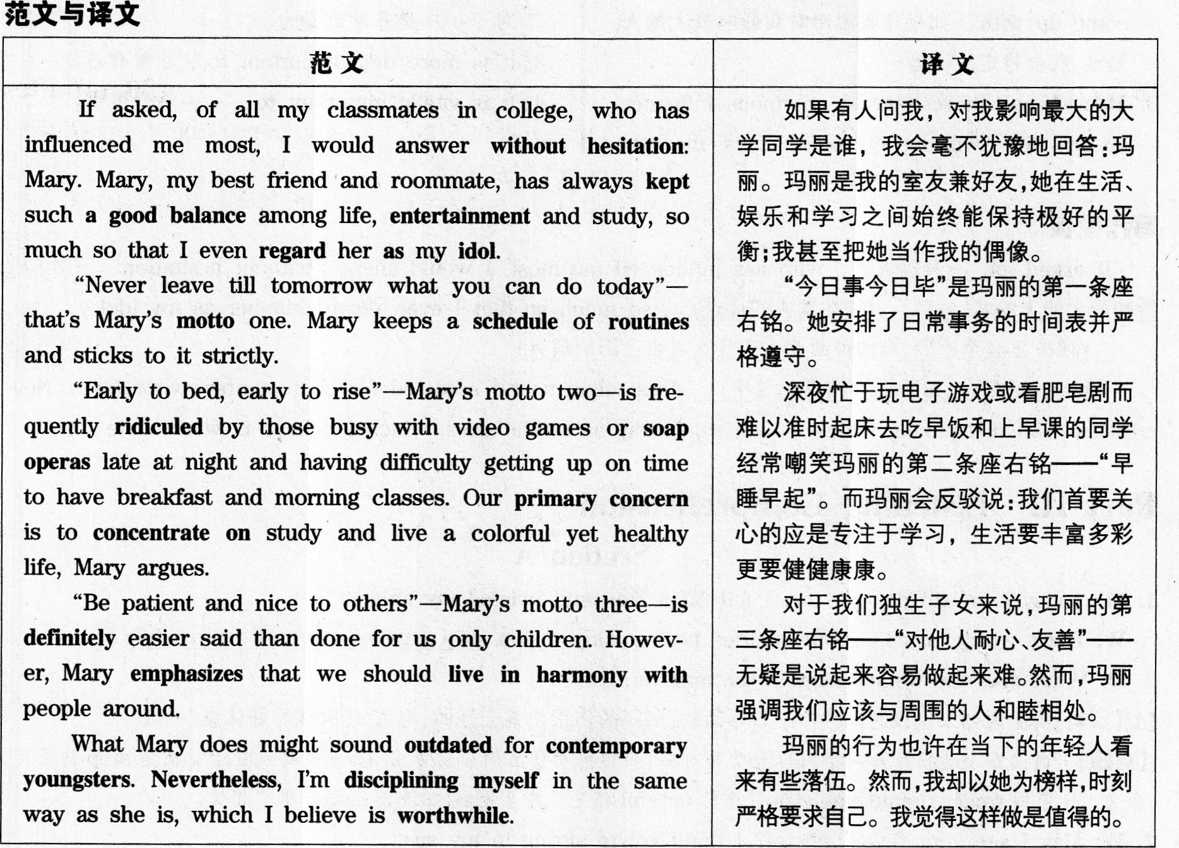

亮点词汇

without hesitation 毫不犹豫 keep a balance 保持平衡

entertainment/ *ˌentəˈteinmənt* /n. 娱乐 regard...as... 将……视为……

idol / *ˈaidəl* n. 偶像 motto / *ˈmtəu* /n. 座右铭

schedule / *ˈʃedju: l* ,*ˈskɛdʒul* /n. 时刻表 routine / *ru:ˈti:n*/n. 例行事务

ridicule/ *ˈrɪdɪˌkju:l* vt. 嘲笑 soap opera 肥皂剧

primary / *ˈpraiməri*/ a. 首要的 concern/ *kənˈsə:n* /n. 关切的事

concentrate on 全神贯注于 definitely/ *ˈdefɪnətli* /ad. 明确的

emphasize / *ˈemfəsaiz* / *vt*.强调 live in harmony with... 与……和睦相处

outdated / *aʊtˈdeɪtɪd* /a. 过时的 contemporary / *kənˈtempərəri* /a. 当代的

youngster / *ˈjʌŋstə* / n.年轻人 nevertheless/ *ˌnevəðəˈles* / 然而

discipline oneff 严格要求自己 worthwile/*ˌwə:θˈwail* / a. 值得做的

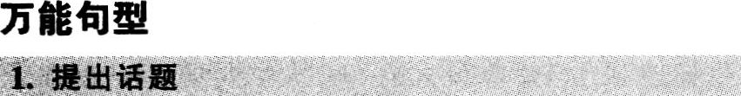

1. If asked, of all.., who has influenced me most, would answer without hesitation: ... 如果有人问我，对我影响最大的……是谁，我会毫不犹豫的回答：……

2. If I were to name the one that has exerted the most influence on me, I would definitely come up with 如果让我说出对我影响最大的人是谁，我会肯定地说是……

3. Many people have exerted enormous influence on my life. Without question, …is the one live has influenced me most. 许多人对我的生活产生了巨大影响。毫无疑问的，……是对我影响最大的人。



1. Our prin~ary concern is to... 我们首要关心的应是……

2. It is of great importance for.., to... ……对于……是非常重要的.

3. It is more than important to... 非常必要…

4. It is vitally important to... ……十分重要.

写作模板

If asked, of (某类人) , who has influenced me most, I would answer without hesitation: (对自己影响最大的人的名字) . （简述此人优点） so that I even regard him/her as my idol.

(列举2-3个原因，具体说明此人为什么对自己影响最大)

What (对自己影响最大的人的名字) does might sound outdated for contemporary youngsters. Nevertheless, I'm disciplining myself in the same way as he/she does, which I believe is worthwhile.

Part III Listening Comprehension

(Secdtiom A)

1. M: Today is a bad day for me. I fell off a step and twisted my ankle.

W: Don't worry, usually ankle injuries heal quickly ff you stop regular activities for a while.

Q: What does the woman suggest the man do?

【A】【解析】女士说如果这段时间你停下日常活动，脚踝的伤很快就会好的，与A“让脚踝好好休息”一致。

【点睛】①通读四个选项可知对话内容与受伤有关，要留意受伤后的应对方法。②解题要点在于听清楚stop的否定含义。B中的treat…immediately和D中的carefifl都是无中生有；C的意思正好与原文相反。

2. W: May I see your ticket, please? I think you're sitting in my seat.

M: Oh, you're right. My seat is in the balcony. I'm terribly sorry.

Q: Where does the conversation most probably take place?

【C】【解析】关键词是ticket和balcony。balcony此处的意思是“戏院等的楼厅或包厢”，故答案为C。

【点睛】①预读选项可知本题提问对话地点，听音时要抓听特殊场景词汇。②在听力材料中，多义词balcony的常用意义是“包厢，(戏院)楼厅”而不是“阳台”，往往与“剧院”场景有关。

3. W: Did you hear Jay Smith died in his sleep last night?

M: Yes, it's very sad. Please let everybody know that whoever wants to may attend the funeral.

Q: What are the speakers talking about?

[B][解析]抓听到关键词 died,sad,funeral 即可选出答案B.

【点睛】话题往往由第一个人提出，重要信息往往多次出现，捕捉到任何一处均可解决问题。其实答案中的sad一词

也是听到的，使得本题难度大大降低，即使不懂funeral是“葬礼”的意思也问题不大。‘‘睡眠中去世’’不是‘‘惨剧”．不

可选A。

4. M: Have you taken Professor Yang's exam before? I'm kind of nervous.

W: Yes. Just concentrate on the important ideas she's talked about in class and ignore the details.

Q: How does the woman suggest the man prepare for Professor Yang's exam?

D】【解析】女士说抓住要点，忽略细节，正好是D的意思：focus与concentrate同义，main points与impol与nt ideas同义。

【点睛】①预读选项可知话题与学习有关。四个选项均用了动词原形短语形式，可推断考建议、要求等。②A与事实相反，B、C均未提及。

5. W: I'm so sorry sir, and youll let me pay to have your jacket cleaned, won't you?

M: That's all fight It could happen to anyone. And I'm sure that coffee doesn't leave lasting marks on clothing.

Q: What can we infer from the conversation?

【D】【解析】女士提出出钱负责洗净男士的夹克衫，男士说这种事情谁都会碰到的，而且衣服上的咖啡渍不会洗不掉的。可见当时的场景是女士把咖啡泼撒在男士身上了，选D。

【点睛】①预读选项可推断对话话题涉及女士向男士赔礼道歉。②推断题要抓听关键信息。A、B无依据：女士说出钱洗男士的夹克衫．而C镨在说女士出钱给男士买咖啡．

6. W: Have you seen the movie The Departed? The plot was so complicated that I really got lost.

M: Yeah, I felt the same, but after I saw it a second time, I could put all the pieces together.

Q: How did the two speakers find the movie?

【B】【解析】本题关键在于听懂女士说电影情节复杂，她看不懂，然后男士说他有同感。因此选B。

【点睛】①预读选项可推断本题提问某人对某事物(由plot一词猜测可能是电影)的看法如何有关。②A中tedious没有依据；C是利用原词plot进行干扰；根据转折词之后的信息可排除D。

7. M: I'm really surprised you got an A on the test; you didn't seem to have done a lot of reading.

W: Now you know why I never missed a lecture.

Q: What contributes to the woman's high score?

【A】【解析】男士说很惊讶女士考试得分为A，因为她似乎不怎么看书，女士回答说因为她“从不落下一节课”。因此选A。

【点睛】①预读选项可知本题提问与学习、考试有关。②A正与考点构成同义表达。问题中的contribute t0表示“导致，造成”，也要听懂。

8. W: Have you heard about the new digital television system? It lets people get about 500 channels.

M: Yeah But I doubt they'll have anything different from what we watch now.

Q: What does the man mean?

【D】【解析】男士说他认为新的数字电视系统所提供的东西与他们现在观看的内容不会有什么区别，D与此一致。

【点睛】doibt“不相信”表示对后面所跟内容的否定，而且由转折词But也能听出不赞成的意思，可首先排除B.A的内容与男士的话正好矛盾。新的数字电视系统确定可以提供500个频道，这并非unrealistic,故C也不妥。

Now you'll hear the two long conversations.

Conversation One

W: Gosh! Have you seen this, Richard?

M: Seen what?.

W: In the paper. It says, there is a man going around [9]pretending he's from the electricity board. He's been calling at people's homes, saying he's come to check that all their appliances are safe. Then he gets around them to make him a cup of tea, and [9]while they are out of the room he steals their money, handbag, whatever and makes off with it.

M: But you know, Jane, it's partly their own fault; you should never let anyone like that in unless ou're expecting them.

W: It's all very well to say that. But someone comes to the door, and says electricity or gas and you utomatically think they are OK [10]especially if they flash a card to you.

M: Does this man have an ID then?

W: Yes, that's just it. It seems he used to work for the electricity board at one time. [ll]According to the aper the police are warning people especially pensioners not to admit anyone unless they have an ppointment. It's a bit sad. [12]One old lady told them she'd just been to the post office to draw her pension when he called. She said he must have followed her home. [12]He stole the whole lot.

M: But what does he look like? Surely they must have a description.

W: Oh, yes, they have. Let's see, in his thirties, tall, bushy dark hair, slight northern accent, sounds a bit lide you actually.

9. What does the woman want the man to read n the newspaper?

【C】【解析】女士用了好几句话描述报纸上登载的内容．特别是注意她提到的一些要点“该男子假装来自电力部门；借故把主人从房间支走之后，趁机盗走财物，然后逃之天天”。由此断定这是一段关于乔装改扮的窃贼的描述。答案为C。

【点睛】名词选项，问对话主题。抓听到关键词pre．

Tending steal money等，就不难选出答案。

10. How did the man mentioned in the newspaper ry to win further trust from the victims?

【D】【解析】女士说很难防备此类窃贼，特别是当他们向你出示证件的时候。故答案为D“出示身份证”。

【点睛】动词现在分词选项，要注意对话中提到的相关动作。B、C毫无依据；A是利用对话结尾处accent进行原词干扰。

11. What is the warning from the police?

【C】【解析】警方警告人们，特别是领养老金的人．不要让任何人人室，除非有预约。故选C。

【点睛】动词不定式选项，多问表示目的的动作。若因内容多未能回忆出警察所说的具体内容，可根据通篇对话的主旨答题。A、B与对话主旨不相关；D则是误导，对话针对的是假冒电力公司的人，而非真正的电力公司的人。

12. What does the woman speaker tell us about the old lady?

【C】【解析】浏览选项可知，本题询问的是某位女士的遭

遇，因此当听到对话中提到一位老太太时，很自然

就对应到本题中去，不难选出正确答案C。

【点睛】对话讲匪徒乔装入室盗窃，A、B、D所述地点

均不在家中，故均可轻松排除。若仅凭听到的只言片

语作答．则易误选。

Conversation Two

M: Miss Jones, could you tell me more about [13]your first job with hotel marketing concepts?

W: Yes, certainly. [13]I was a marketing consultant responsible for marketing 10 UK hotels. They were all uxury hotels in a leisure sector, all of a very high standard.

M: Which markets were you responsible for?

W: For Europe and Japan.

M: I see from your resume that you speak Japanese. Have you ever been to Japan?

W: Yes, I have, I spent a month in Japan in 2006. I met all the key people in the tourist industry, the ig tour operators and the tourist organizations. [14]As I speak Japanese I had a very big advantage.

M: Yes, of course. Have you had any contact with Japan in your present job?

W: Yes, I've had a lot. Cruises have become very popular with the Japanese both for holidays and for business conferences. In fact, the market for all types of luxury holidays for the Japanese has increased a lot recently.

M: Really, I'm interested to hear more about that, but first tell me, have you ever traveled on a luxury train, the Orient Express, for example?

W: No, I haven't. But I've traveled on the Glacier Express ~o Switzerland and I traveled across China by train about 8 years ago. [15]I love train travel. That's why I'm very interested in this job.

13. What did the woman do in her first job?

【A】【解析】对话开篇女士就说自己第一份工作是做营销咨询师，负责为l0家英国宾馆做市场营销．所以答案为A。

【点睛】选项均是行业、职务名称，可知本题将问及有关工作性质。要注意对话开头处对相关人员的介绍。B未提及；C错在management；D与女士不相干。

14. What gave the woman an advantage during her business trip in Japan?

【D】【解析】对话中女士明确提到了自己会讲日语．并说这是个很大的优势，所以答案为D。

【点睛】根据选项可预测问题为某人的能力或经历方面的优势。预测准了问题的话，本题非常容易答对。A未提及；B、C是利用对话中的信息制造的干扰项。

15. Why is the woman applying for the new job?

【B】【解析】在对话最后两句中，女士很清楚地提到了自己应聘这份‘工作的原因，即B。

【点睛】①预读选项可知本题提问与It对女士的影响或对女士的吸引有关。②答案是听到的原词。其余选项均未提及。

Passage One

Time

I think a lot about time and not just because it's the name of the news organization I work for. Like most working people, [16]I find time, or the lack of it, a never-ending frustration and an unwinnable battle. My every day is a race against the clock that I never ever seem to win. This is hardly a lonesome complaint. According to the families and work institutes, national study of the changing workforce,55 percent of employees say they don't have enough time for themselves,63 percent don't have enough time for their spouses or partners, and 67 percent don't have enough time for their children. [17]It's also not a new complaint. I bet our ancestors returned home from hunting wild animals and gathering nuts and'complained about how little time they had to paint battle scenes on their cave walls. The difference is that the boss of animal hunting and the head of nut gathering probably told them to shut up or no survival for you. Today's workers are still demanding control over their time. The difference is today's bosses are listening. I've been reading a report issued today called "When Work Works" produced jointly by three organizations. [18]They set up to find and award the employers who employ the most creative and most effective ways to give their workers fl~ihility. I found this report worth reading and suggest every boss should read it for ideas.

16. What is the speaker complaining about?

【A】【解析】文章开篇就提到，时间的缺乏给人挫败感。而且全文都在围绕这一主题而展开。所以选A。

【点睛】短文听力的开头很重要，本文高频关键词为time。凭四个选项的中心词即可准确答题。

17. What does the speaker say about our ancestors?

【A】【解析】文中提到，我们的祖先打猎采集野果归来．抱怨说他们没有时间在洞穴的墙壁上画下打猎的场面。所以选A。

【点睛】本文主题“忙”有助于确定答案。B未提及：C正好与文意相反；D中的hard在文中没有评价。

18. Why does the speaker suggest all bosses read the report by the three organizations?

【D】【解析】文章最后两句提到一个报告，说雇主要采用最有创新和最有效的办法来给员工提供灵活的制度，并建议每位老板阅读，关键词都体现在D中．所以D为答案。

【点睛】短文听力的结尾经常成为考点，要密切关注。A为原词的错误匹配，具有一定的干扰性，但原文find的宾语不是creative ideas，而是employers。

Passage Two

[21]"Loving a child is a circular business. The more you give, the more you get, the more you want to give," Penelope Leachwon said. What she said proves to be true of my blended family. I was born in 1931. As the youngest of six children, I learned to share my parents' love. [19]Raising six children during the difficult times of the Great Depression took its toll on my parents' relationship and resulted in their divorce when I was 18 years old. Daddy never had very close relationships with his children and drifted even farther away from us after the divorce. Several years later, a wonderful woman came into his life and they were married. She had two sons, one of them still at home. Under her influence, we became a blended family and a good relationship developed between the two families. She always treated us as ff we were her own children. [20]It was because of our other mother, Daddy's second wife, that he became closer to his own children. They shared over 25 years together before our father passed away. At the time of his death, the question came up of my mother, Daddy's first wife, attending his funeral. I will never forget the unconditional love shown by my step mother. When I asked her if she would object to mother attending Daddy's funeral, without giving it a second thought, she immediately replied, "Of course not, honey. She is the mother of my children."

19. According to the speaker, what contributed to her parents' divorce?

[B]【儿解析】文章前半部分提到，在经济大萧条的困难时期抚养六个孩子对父母的关系造成了重大伤害，导致父母离婚，所以选B。

【点睛】名词选项，A、C、D均与家庭不和有关，B则涉及社会大背景．也对家庭有影响。据此可大致推断出本题提问的内容。即使听不懂短语take one’s toll“造成重大损失或伤害”的意思，根据句中另外一个谓语resulted in(their divorce)也可以得出答案。

20. What brought the father closer to his own children?

[D]【解析】文章提到，正是因为父亲第二任妻子的影响，

父亲才变得和自己的孩子亲近起来，所以选D。

【点睛】选项与某男士有关，问题应当涉及男士的变化之类。答案直接来自于文中的强调句。

21. What message does the speaker want to convey in this talk?

[B]【解析】文章开门见山，非常明确地提出了积极意义的主题“爱是循环的。付出越多，回报越多”。毫无疑问．答案是意义积极、含关键词love的B。

【点睛】文章的主旨大意通常出现在开头或结尾，本题再次说明了听懂短文听力的开头和结尾的重要性。

Passage Three

In February last year, my wife lost her job. Just as suddenly, [22]the owner of the greenhouse where I worked as manager died of a heart attack. His family announced that they were going to close the business because no one in the family wanted to run it. Things looked pretty gloomy. My wife and I read the want-ads each day. [23]Then one morning, as I was hanging a Going Out of Business sign at the greenhouse, the door opened and in walked a customer. She was an office manager whose company had just moved into the new office park on the edge of town. She was looking for potted plants to place in the reception areas in offices. "I don't know anything about plants," she said, "I am sure in a few weeks, they'll all be dead." While I was helping her select her purchases, my mind was racing. [24]Perhaps as many as a dozen firms that recently opened offices in the new office park and there were several hundred more acres with construction under way. That afternoon, I drove up to the office park. By 6 o'clock that evening, I had signed contracts with 7 companies to rent plants from me and pay me a fee to maintain them. Within a week, I had worked out an agreement to lease the greenhouse from the owner's family. Business is now increasing rapidly. [25]And one day we hope to be the proud owners of the greenhouse.

22. What do we learn about the greenhouse?

m】【解析】文章第2句给出了B中的信息，故选B。

【点睛】选项主语是it，内容涉及其位置、所有人、植物．甚至会“破产”，从后面的各题选项来看，推测it指greenhouse。根据短文听力“听到什么选什么”的规律作答。文章只是说温室老板死于心脏病。其家人宣布将关门停业，并没有说突然破产，所以C错。

23. What was the speaker doing when a customer walked in one morning?

【C】【解析】文中明确提到客人进店时说话人正在挂一块“停业”的牌子，所以选C。

【点睛】浏览选项可预测，题目询问某人在做什么。C中的putting up与文中的hangin9同义．a Going Out of Business sign是听到的原词。同时含有“同义替换”和“听到原词”的选项一定是答案。

24. What did the speaker think of when serving the office manager?

【C】【解析】文中提到有很多新开的公司，并且还有很多

在建，说明商机无限，故选C。

【点睛】本题答案没有在文中明确说明。需要概括上下文的语义得出。

25. What was the speaker's hope for the future?

【A】【解析】文章尾句说到终有一天他们希望能自豪地成为温室的老板，所以答案选A。

【点睛】①预读选项可知都是关于某种期许．可推断提问可能与将来的打算或向往有关。②短文听力的结尾往往是考点所在。

Section C

26．ingredients

【解析】空格处填入句子的表语，说明主语Physical labor,raw materials，and capital“体力劳动、原材料和资本”的情况。ingredient在句中意为“元素，因素”。

27．vital

【解析】空格前是定冠词the，空格后是名词词组raw material“原材料”，故考虑空格处应该填入修饰raw material的定语。vital意为“至关重要的”。

28．individuals

【解析】空格所在句缺少主语，句子的谓语为0ffer，提示此空格应填入名词复数。individual意为“个体”。

29．engage in

【解析】空格所在句缺少连接主语Knowledgeworkers“知识工作者”和宾语mind work“脑力劳动”的谓语。动词词组engage in意为“从事”。

30．generating

【解析】由空格后的as well as可知，空格处应填入与processing及exchanging并列的现在分词。generate意为“产生，创造”。

31.Currently

【解析】空格位于句首，所在句子的主干成分完整．故考虑应填人作状语的副词(词组)。currently意为“目前，现在”，注意首字母要大写。

32．product

【解析】空格处应填入名词(词组)，与空格后的development“开发”一起构成和quality control“质量控制”及customer satisfaction“顾客满意度”并列的名词短语。product意为“产品”．Product development意为“产品开发”。

33．keep up with

【解析】空格位于help sb．(to)do sth．结构中，应填入动词(词组)的原形或不定式形式。keep up with意为“跟上，与……同步”。

34．conventional

【解析】空格处应填入workplace“工作地点”的修饰成分。conventional意为“传统的，常规的”。

35．provide you with

【解析】空格位于助动词will后，空格后为名词词组a clearly-defined career path“明确的职业发展之路”，故空格处应填人动词(词组)的原形。provide sb．with sth．意为“为某人提供某物”。

Part Ⅲ Reading Comprehension

Section A

全文翻译

受益原则是税收的一大原则，该原则说明人们应该根据从政府服务中受益的多寡来纳税，以让公共财产与私人

财产类似。经常去看电影的人在电影票上的总花费比很少去的人多，这似乎是合理的。同样，从公共福利中获得了巨

大利益的人应该比几乎没获利的人纳更多的税。

例如。使用受益原则征收汽油税有时是合理的。某些州用汽油税的税收来建造和维护道路。买汽油的人也是使

用道路的人，因此汽油税可以视为支付该项政府服务的公平方式。

受益原则也可用来论证有钱人应该比穷人纳税更多，仅仅因为富人从公共服务中受益更多。比如，想想警察防

盗的利益。大量财产需要保护的公民比少量财产需要保护的人从警方处获益更多。因此，根据受益原则，在维持警察

机构的花费上，富人应比穷人付出更多。同理，这一论据也适用于其他许多公共服务，如消防、国防和法院系统。

词性分析

名 词：expenses花费；开支[复数]fair集市；商品交易会private士兵，列兵revenues(大宗)收入，收益；税收[复数]theft偷窃，失窃total总数，总计wealth财富，财产

动 词：adapt使适应，适合；改编contribute捐款，作出贡献；(to)有助于；投稿exertin9用(力)，尽(力)；运用，发挥，施加[现在分词或动名词]justified证明……正当(或有理)；为……辩护[过去式或过去分词]maintaining维持：维修；坚持，主张；赡养[现在分词或动名词]provided供给，提供[过去式或过去分词]otal合计；总数达

形容词：fair公平的；尚可的；金发的；晴朗的justified有正当理由的，合理的private私人的；秘密的，私下的：私立的total全部的；完全的

副词：fair公正地similarly相似地，类似地simply简单地；简直；仅仅；朴素地

解题思路

36．【H】空格前的similar t0“与……类似的”表明此处应填入修饰名词goods的词。上一句提到受益原则说明人们应该根据从政府服务中受益的多寡来纳税，本句把public goods“公共财产”与另一类别的财产类比。根据形容词public“公共的”选择反义的private“私有的”。

37．【N】空格前的介词in表明此处应填入名词或动名词。本句说经常去电影院的人在电影票上的花费比很少去的人多。total“总量”与in搭配，表示“整个地，合计”，符合此处语义逻辑。

38．【K】空格位于并列连词And之后，且有逗号与句子主语隔开，故应填入副词作状语。本句与上一句结构类似，都用more…than比较结构说明获益多的人需要多纳税，故选择副词similarly“类似地”，句子表示从公共财产中获得巨大利益的人应该要比没怎么获利的人纳更多税。

39．【F】本句的主语是the gasoline tax“汽油税”，空格前是is和副词sometimes，空格后的using the benefits Drinciple"使用受益原则，，是状语，故空格应填人名词、形容词或分词，充当句子表语或谓语。上文用看电影的类比解释了税收中受益原则的合理性(reasonable)。本句的举例则是受益原则运用到汽油税的征收上，justiffed“有正当理由的，有合理解释的”符合上下文语义，与上一段的reasonable“合理的”呼应。fair通常指游戏或竞赛“公平的”，或某种方式、情形是“合理可接受的”，此处形容汽油税，不如justified贴切。

40．【J】此处需填入名词，作句子主语。由空格后的from the gasoline tax“来源于汽油税”，可判断revenues“收益；税收，，正确，句子表示有些州把来自汽油税的税收用于建造和维护道路。expenses“花费，开支”不会跟介词from搭配使用，故排除。

41．【E】空格前是不定冠词a，故此处应填人修饰名词way的词，且为辅音开头，可以是形容词或分词。上文说到买汽油的人也是使用道路的人，因此汽油税是支付政府服务的“公平或合理”的方式，故填入fair“公平的”。justifled“合理的”通常不修饰way。

42．【L】空格位于表原因的连词because之前，故应填入副词。上一句提到受益原则也可用来证明有钱人应该比穷人纳更多税，本句说因为富人从公共服务中受益更多。原因简单明了，因此选simply“仅仅”。

43．【M】空格前是介词from，故应填入名词或动名词。protect…from表示“使……免于，防止”，根据pohce，可选择与之语义相关的theft“盗窃”。

44．【8】空格前should表明此处应入动词原形，与后文的介词t0搭配。根据受益原则，受益更多，付出也更多。因此选择contribute“贡献”。adapt“使适应，改编”也能与t0搭配，但“富人适应花费”不合逻辑。

45．【G】空格前是介词of，空格后是名词短语the pofice force“警察部门”，故此处应填入与之搭配的动名词。上文说大量财产需要保护的公民比少量财产需要保护的人从警方处受益更多，接着本句用Therefore“因此’’开头，故本句应该指他们付给警察机构的要更多，填入mamtamLn9“维持”，句意为“富人为维持警察的开支付出更多”。而exertin9，填入文中意为“运用”警察机构，这是一种“花费”，不是cost“成本”。

Section B

全文翻译划线点评

有色人成长记

【A】你可能再也不认识皮德蒙特(Piedmont)了——我是指我成长时的皮德蒙特——它是西弗吉尼亚州的一个小镇，我在那里学会了做一名有色的男孩。

【B】在皮德蒙特，20世纪50年代是一个值得纪念的时代。至少对于我来说如此。【52】人们一直以自己为皮德蒙特人而感到自豪。皮德蒙特依山傍水．面前就是浩瀚的波托马可河。美国再也没有比这更美丽的地方了。我从不知道哪里还有对山山水水、花草树木、钓鱼打猎更加着迷的有色人。在每个人的记忆里，我们在打猎、射击和游泳方面都胜过山谷中的白人男孩。

【C】我们对皮德蒙特的社会结构了如指掌。【49】这是一个移民小镇：皮德蒙特白人主要是意大利裔和爱尔兰裔。汉普郡东大街有少数有钱的盎格鲁撒克逊裔白人新教徒，其他地方都是工人阶层的“种族”社区。白人和非白人都有。

【D】从人们能记起的久远以来，皮德蒙特的特征一直与维斯瓦克造纸厂紧密相联：【47】其繁荣的过去和不确定的未来。乍一看。这个小镇是典型的“垂死”工厂中心。许多见证了往昔豪迈时光的美丽建筑今却空空屹立着。我孩提时代那些令人为之骄傲的汉普郡东街上的大房子也风光不再了。

【E】像意大利人和爱尔兰人一样，大多数有色人在20世纪之交就移民到了皮德蒙特，并在1888年开业的纸厂工作。【54】纸厂中所有的有色人都在“平台”上工作——把纸装进卡车，直到1968年手工艺联盟最终被合并。装载是爸爸每天的工作，那也是几乎所有我认识的有色成年人的工作。

【F】有色人居住在分隔明显的三个街区。也许该挂上写着“欢迎光临有色人社区”的大幅。【46】在那呈感觉很好，比女啁以光着脚、只穿内衣裤在自家房子周围随处走。或者在电视机前的沙发椅上大声打呼噜——被家的舒适和那些你爱的人的温暖所包围。

【G】当然，有色人的世界尚不足以形成一个独自存在的社区。虽然我们自己的世界似乎是独立的。但几乎在所有方面都影响了皮埃蒙特的白人世界。当然，一些白种男人或女人出现在不属于他或她的地方时，比如黑人退伍军人大厅，我们的世界的边界也似乎受到了影响。【55】当其中一个白人出现在舞会或晚会时，我们的空间被侵犯了。原有旋律会中断，音乐听起来会不太合适。每个人都会早早离开。

【H】在1955年之前，大部分白人在我们的世界里只是虚幻的存在，都是些有权有势的模糊形象，像工厂里高高在上的老板或银行职员。当然也有例外——每天按我们都了解的惯例进入我们世界的白人。邮递员先生，保险员先生，纯牛奶和巧克力牛奶先生，房东先生和警察先生：【53】我们根据其职业称呼这些白人，他们就像神秘剧中的人物。保险员先生会每隔一周来收大学保单或死亡保单的钱，有时50美分或更少。

【I】【50】“身为有色人种并不是耻辱。但很不方便。”这是本世纪初的黑人艺人伯特·威廉姆斯的名言。在我大部分的童年时光里，我们都不能去餐厅吃饭或入住酒店。不能使用某些浴室或在商店里试穿衣服。我们去购物时。妈妈坚持让我们要衣着光鲜。她去服装店前也会精心打扮一番，腋下会垫块被称为“防护盾”的白色衬垫，这样她的裙子或衬衣上就看不出有汗。“我们想试试这个。”她小心地说，用词准确、得体。当被绝时，她会说：“我们不买不能试穿的衣服。”接着，【50】我们就用妈妈这种有尊严的方式走出商店。她喜欢在有我们账户的商店购物，那里每个人都认识她。

【J】【48】在cut-Rate杂货店，有色人都不允许坐在柜台或桌旁，只有一个例外：我的父亲。我不知道为什么店主卡尔‘达迪斯曼不阻止爸爸坐下。【48】但我相信部分原因是爸爸的肤色较浅。还有部分原因是因为他在电话公司代班期间，负责给接线员订食物和咖啡。有色人应该站在柜台边，拿-J'夕b带食物就离开。扬格·道·贝斯的篮球队连连得胜，在某场胜利后得到了免费可乐赞助，即使这样，有色球员也只能站在旁边用纸杯喝，而白人运动员和拉拉队员则坐在舒适的椅子上，用玻璃杯喝可乐。

【K】我当时应该不过五六岁，有一天下午，我跟父亲坐在Cut-Rate店里吃着冰淇淋。板着脸的爱尔兰人威尔逊先生走了过来。“你好，威尔逊先生，”我父亲说。“你好，乔治。”

【L】这真把我弄糊涂了。威尔逊先生一定把我父亲和其他人弄混了，但是是谁呢?皮德蒙特没有一个叫乔治的有色人。“爸爸，为什么不告诉他你的名字?”我大声地问。“你的名字不是乔治。”“他知道我的名字，孩子，”父亲顿了很久说，“他把每个有色人都唤作乔治。”

【M】我知道我们不会再谈论这个话题了；即便在那个年纪，我已经懂得了有一些东西不要过于苦恼。现在我有了孩子，我意识到让父亲困扰的与其说是世上的“威尔逊先生们”，【51】还不如说是有义务把人生中有关种族的真相痛苦地解释给还不知道的人听。威尔逊先生叫我父亲乔治，这也许不会伤害他；【51】但我询问原因却伤害了他。

46．【F】【译文】作者还是小男孩时，感觉在分隔的社区生活随意舒适。

【定位解析】根据题目中的separated neighborhood定位到F段。该段首句用定语从句that were clearly separated说明有色人生活的街区分隔明显，与题目中的in a separated neighborhood对应。第3句说在那里生活感觉很好(felt good)，接着说可以赤脚和只穿内衣裤在家周围走，这对应题目中的casual“随意的”；破折号后面的enveloped by the comforts和the warmth对应题目的cozy“舒适的”。据此可判断本题选F。

47．【D】【译文】现在种种迹象表明造纸厂的衰落。

【定位解析】本题与造纸厂有关，可根据paper mill查找到D段和E段。D段第l句冒号后的内容说明造纸厂有prosperous past“繁荣的过去”和doubtful future“不确定的未来”。第2句用dying“垂死的”形容这个工厂．这些都说明造纸厂衰落了，对应本题的sign of decline“衰落的迹象”。故判断本题信息来自D段。

【干扰排除】E段描述的是纸厂的有色人所从事的具体工作，并没有描述纸厂的衰落，故排除。

48．【J】【译文】作者的父亲可以在杂货店坐下来吃东西的一个原因是他看起来没有那么黑。

【定位解析】根据author’S father和sit and eat at the drug store锁定答案至J、K两段。J段第l句提到在Cut-Rate杂货店．作者的父亲是唯一能在柜台或桌旁坐下来的有色人。第3句他推测了两个原因。其中之一是父亲的肤色较浅(1ight-colored)，对应本题的didn’t look that dark。由此可知，本题是对J段前3句的概括总结，故选J。

【干扰排除】K段提到作者与父亲坐在Cut-Rate杂货店吃冰淇淋时碰到了Mr．Wilson，没有分析他们可以坐下来吃东西的原因，故排除。

49．【C】【译文】皮德蒙特是一个移民小镇，居民来自世界各地。

【定位解析】本题与皮德蒙特的居民来源有关，文章有多段都提到了Piedmont“皮德蒙特”，故不能用这个词定位。可根据a town of immigrants查找到C段第2句，该句指出皮德蒙特是一个移民小镇(an immigrant town)．这对应题目中的a town of immigrants；第2句分号后的内容说明了皮德蒙特的不同移民人群，对应本题的from different parts of the world，故选C。

50．【I】【译文】尽管种族偏见引起了很大的不便，但作者的家人设法过上有尊严的生活。

【定位解析】根据awful inconveniences可定位至l段第l句。该句引用黑人艺人Bert Williams的话，说明身为有色人种不是耻辱(disgrace)，但很不方便(awfully inconvenient)这对应本题的前半句。接着作者用与母亲的购物经历进行说明，倒数第2句提到，他们在试衣服遭拒后，用妈妈那种有尊严的(dignified)方式走出了商店，这与题目中的managed to five a life of dignity相符。由此可判断本题信息来自1段。

51．【M】【译文】作者后来意识到，他询问父亲被错误称呼的原因时，给父亲造成了很大的痛苦。

【定位解析】本题与作者父亲被错误称呼一事有关，根据题目中的caused great distress查找到M段第2句。该句用not SO much…as“与其……不如”结构指出了令父亲困扰的(what distressed my father)是有义务向一个什么也不懂的人解释有关种族问题的真相。最后一句进一步解释他的问题伤害了父亲(hurt him by asking to know why)。据此可判断本题信息来自M段。

52．【8】【译文】作者因为皮德蒙特的自然美景而为自己是皮德蒙特入感到自豪。

【定位解析】根据题目中的took pride in being from Piedmont以及natural beauty可查找到8段第2句。该句提到人们以自己是皮德蒙特人而骄傲(proud to be from Piedmont)，破折号后指出原因是皮德蒙特依山傍水，美国没有比这更美丽的地方(no more beautiful locafion)，这跟题目中的namral beauty对应。据此可判断选B.

53．【H】【译文】有色人根据白人所从事的职业称呼他们。

【定位解析】本题与白人的称呼有关，根据called white people查找到H段。该段倒数第2句提到．We called white people by their trade“我们根据其职业称呼这些白人”，这与题目中的called white people by the business they did相符，故选H。

54．【E】【译文】住在皮德蒙特的有色人在造纸厂从事繁重的体力劳动。

【定位解析】本题与有色人在造纸厂的工作有关，根据题目中的paper mill和jobs可锁定答案至E段。该段与造纸厂的具体工作有关。第2句说，纸厂的有色人都在“平台”上工作，也就是装纸入车。本题用heavy manual jobs对此内容进行了概括，故答案为E。

55．【G】【译文】白人出现在有色人的街区时，有色人会感到不自在。

【定位解析】本题与有色人生活的街区有关，根据neighborhoods将范围缩小至F段和G段。其中G段最后三句提到，如果有白人出现在舞会或晚会时，有色人感到其空间被侵犯了，原有音乐旋律会中断，人们会早早离开。题目中的felt uneasy“感到不自在”是对上述一系列反应的概括，故本题选G。

【干扰排除】F段也出现了neighborhoods，但只描述了有色人是怎么在其所在社区生活，没有出现关键信息the whites。

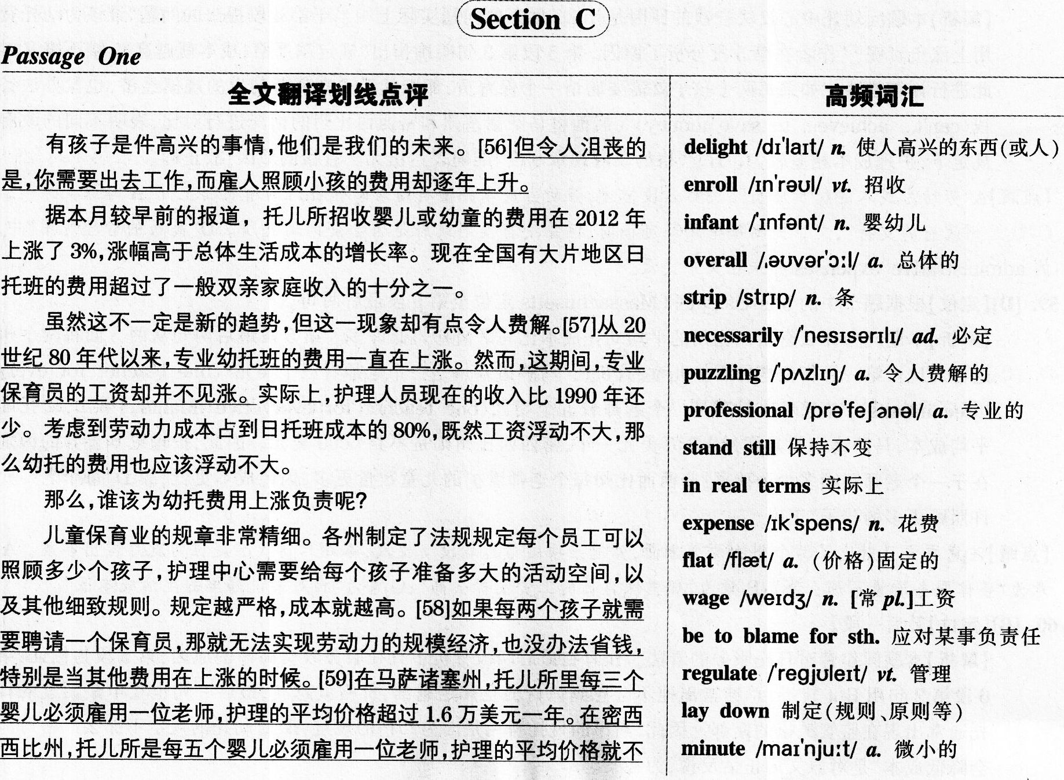

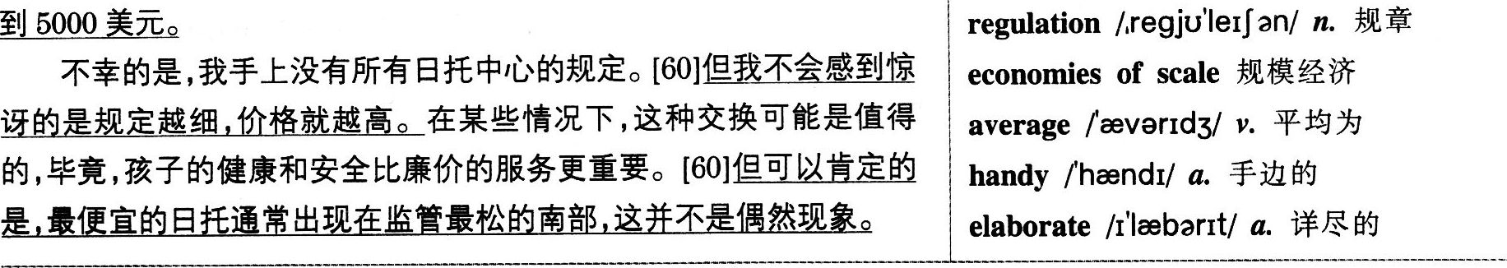

56．【A】【定位】根据题干中的problem，parents of small kids定位至第l段最后一句。

【解析】本题问有小孩的家长必须面临什么问题。第I段末句指出“令人沮丧的是(sadly)，你需要出去工作，而雇人照顾小孩的费用却逐年上升(getting more expensive by the year)”。题于中的problem对应了原文中的sadly。故家长面临的问题就是育儿费用的上升，A“日益高涨的幼托费用”是原文的同义表述。

【点睛】8“家庭费用预算”，第2段末句提到日托班的费用超过家庭收入的十分之一，但并没有提到家庭针对这情况作出具体预算，B实际上没有原文根据。C“工作和家庭的平衡”，原文提及因为家长需要出去2r_作，所以必须请人照顾小孩。最后谈到费用高的问题，没有讨论如何平衡工作与家庭的关系。D“选择好的日托机构”偏离重点，家长的问题是日托机构费用高，而非烦恼如何选择好的日托机构。

57．【C】【定位】根据题干中的puzzled定位至第3段。

【解析】本题问作者对什么感到疑惑不解。题干中的puzzled与第3段首句的puzzlin9对应，第2、3句指出疑惑的内容，其大意是专业幼托班的费用一直在上涨(has been rising)，而保育员的工资却并不见涨(stood still)，而这是不合情理的，因为劳动力成本占了日托中心80％的开支，按正常情况，保育员的工资应该会随着日托费用的上升而增加，所以C“为什么保育员的收入没有随着幼托费用上涨而增加”为答案。

【点睛】A“为什么幼托费用每个州差别这么大”，作者对这一个问题在第5段做了详尽的描述和分析，可见他对此很清楚．并没有感到疑惑不解。B“为什么幼托费用上涨却没有带来更好的服务”，全文讨论的重点是幼托费用高的问题．没有提及服务质量。D“为什么在很多州严重缺乏专业保育员”无中生有，全文未提及缺少保育员的问题。

58．【8】【定位】根据题干中的saving money定位至第5段。

【解析】本题问幼托中心没法省钱的原因是什么。题干的问题实际上相当于第4段提出的问题“谁该为幼托费用上涨负责呢?”作者在第5段分析了原因。第5段第3句明确指出“规定越严格，成本就越高”。接下来又对此进行详细描述，“如果每两个孩子就需要聘请一个保育员，那么就无法实现劳动力的规模经济，也没办法省钱(can，t…achieve…to save money)”，后面将马萨诸塞州和密西西比州的情况进行对比，表明不同的政府规定下．护理成本相差较大。B“严格的政府规章制度”准确表达出无法省钱的原因，故正确。

【点睛】A“劳动力成本的稳步增长”，按第3段描述，劳动力成本并没有随着幼托费用的增长而上升，A与原文矛盾。C“缺乏州政府的支持”，文章提到每个州规定不同，但并没有提到政府是否会资助幼托所。D“高昂的管理费用”中的administrative expenses并未在文中提及。

59．【D】【定位】根据题干中的Mississippi和Massachusetts定位至第5段最后两句。

【解析】本题问为什么密西西比州的平均幼托成本比马萨诸塞州低许多。第5段最后两句从两方面将两个州进行对比：第一，每位老师看护儿童的数量，马萨诸塞州是一个老师看三个婴儿(one teacher for every three infants)．密西西比州则是一个老师看五个婴儿(one teacher for every five infants)；第二，幼托的平均成本．马萨诸塞州是超过1．6万美元一年，密西西比州则是不到5000美元。因此，护理成本差异的区别在于一个老师照顾多少个孩子，密西西比州每个老师看护的儿童数量更多，因此成本更低，故D“每个老师允许照顾更多的孩子”正确。

【点睛】注意原文只对比了两个州的两个方面，其他三项的信息均没有提及，本题只需找准定位句就可得出答案。A意为“整体服务质量不那么高”；B意为“那里保育员的S-资没那么高”；C意为“相对来说那里的生活成本低”。

60．【B】【定位】最后一段。

【解析】本题问作者对日托服务的看法。作者在最后两段分析了日托服务收费高昂的原因，第5段为例证，第6段第2句用But转折，总结指出他不会感到惊讶的是规定越细，价格就越高，最后一句也重申最便宜的日托通常出现在监管最松的南部。因此，高昂的日托费用是因为严格的规定，B“对幼托的规定不那么严格可能会降低成本”是对原文的正话反说，为答案。

【点睛】①A “保育员应该定期接受专业培训”，作者在全文未提及保育员培训的问题。C“保持质量和成本的平衡是至关重要的”，最后一段提到，用‘‘精细的规定”(从而保证孩子的健康和安全)交换高价“有时候是值得的”，但文中没说如何在tt质量’’和‘‘成本’’之间取得平衡，也没说取得这种平衡是否很重要。D“各个州最好相互学习”，虽然第5段提到了马萨诸塞州和密西西比州的不同情况，但这只是为了说明日托成本高的原因，并未说明哪个州的日托教育更好．故不存在各个州相互学习的说法。②本题是态度观点题，表转折对比的逻辑关系词后的内容，往往体现态度，阅读时需要多注意这些词，如：but，however，although，while等。

难句归纳 ’

1．Ⅱit has to hire a caregiver for every two children，it can’t really achieve any economies of scale on labor to save money when other expenses go up．(第58题解题句)

【分析】本句为主从复合句。逗号前的内容为If引导的条件状语从句，every two children表示“每两个孩子”。主句的主干是it can，t achieve any economies of scale，后面接不定式to save money表示“实现劳动力的规模经济”的目的，即“为了节省开支”；主句还含有时间状语从句when other expenses go up。

2．In Massachusetts．where childcare centers must hire one teacher for every three infants，the price of care averaged more than$16，000 per year．(第59题解题句)

【分析】本句为主从复合句。句首的In Massachusetts为地点状语，其后有一个where引导的非限定性定语从句，对其进行修饰，说明该州的一些情况。主句的谓语是averaged，该词在句中作动词，表示“平均值为”。

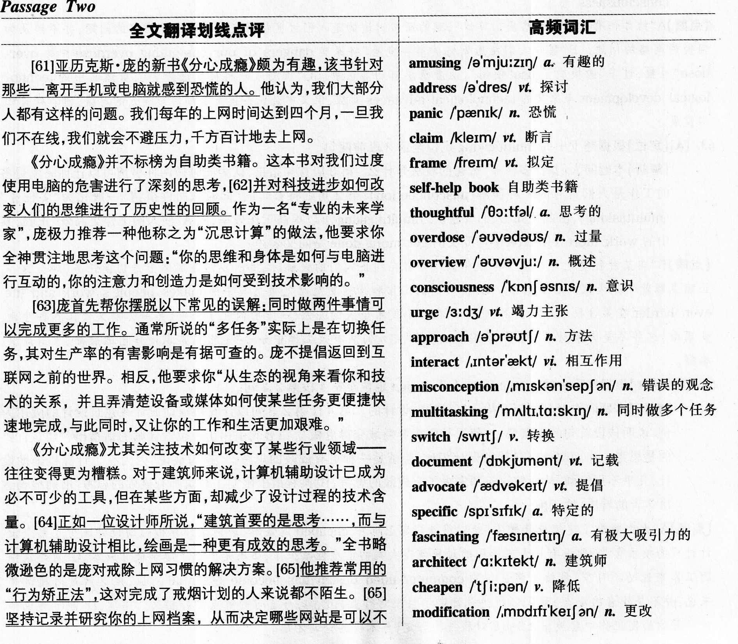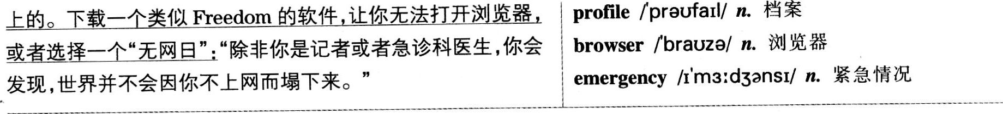

61．【D】【定位】根据题干中的Alex Pan9’s new book和aimed for定位至第l段第l句。

【解析】本题问庞的新书针对的是哪些读者群。第l段开头就介绍，亚历克斯·庞的新书《分心成瘾》针对的是那些一离开手机或电脑就感到恐慌的人(those of us who feel panic without a cellphone or computer)。由该段第3句中的oaline可知，第l句中的cellphone or computer实际上是“网络”的代名词，因此，D“几乎无法离开网络”正确。

【点睛IA“发现他们上网工作压力太大”利用第1段末句提到的stressful work制造干扰，该句说的是没有网络会给人造成压力．而不是在网络上工作压力大。8“上网主要是为了娱乐”，该书只是针对离不开网络的人群，并没有提及这些人上网的目的是什么，无法从原文推断出B的内容。C“害怕使用手机或电脑”与原文首句的feel panic without a cellphone or computer“没有手机或电脑就感到恐慌”相反。

62．【D】【定位】第2段。

【解析】本题问庞的新书的写作目的。第2段第2句提到该书的两方面内容：第一，对我们过度使用电脑的危害(dangers of our computing overdose)进行了深刻的思考；第二，对科技进步如何改变人们的思维(how techn0109ical advances change consciousness)进行了历史性的回顾。D“研究科技对人们的思维的影响”与第二点对应，选项中的technology对应原文的technological advances，而human mind则对应原文的consciousness“意识”。

【点睛】A “给如何有效使用网络提出建议”，庞的新书讨论的是人们过度使用电脑以及戒掉网络的问题，并不涉及如何使用网络的问题。B“警告人们使用网络的潜在危险”将原文dangers of our computing overdose中的overdose"过量，过多，，偷换成了use“使用”，两者意思有明显区别。C“预测未来科技发展趋势”，虽然其中的technological development与原文的technological advances对应，但文中是说科技发展如何影响人的思维，而非科技如何发展。

63．【A】【定位】根据题干中的multitaskin9定位至第3段前两句。

【解析】本题问人们对“多任务”普遍的看法是什么。第3段首句指出，认为同时做两件事情可以让你完成更多的工作是人们常有的一种误解(misconception)，第2句则将首句的“同时做两件事情”一般化为“多任务”(mllltitaSldng)，由此可知，人们普遍认为multitaskin9可以提高工作效率，故A“使人们工作更高效”正确，其中的work more effectively与原文的9et more done是同义表述。

【点睛】B“在某种程度上与切换任务很相似”，作者在纠正人们的误解时，提出多任务实际上是切换任务，那么这一正确见解就不是大家的普遍看法。C“使人们的工作和生活更艰难”，虽然其中的makes people’s work and life even harder在第3段末尾有提到，但那是在讨论技术与人的关系，一方面简化了任务，另一方面又使工作和生活变艰难，这并不是大家对多任务的普遍看法。D“使人们从有效工作中分心”是根据常识而作出的臆断，没有原文根据。

64．【B】【定位】根据题干中的computer-aided design定位至第4段第2、3句。

【解析】本题问作者是如何看待计算机辅助设计的。第4段第2,3句以计算机辅助设计在建筑设计的应用为例．说明该段首句的观点“科技使得某些行业领域变得更糟”。第3句引用了一位设计师的话指出，“建筑首要的是思考……而与计算机辅助设计相比，绘画是一种更有成效的思考。”换句话说，因为有了计算机辅助设计．几乎不用绘画，从而使建筑师失去了有成效的思考。B“某程度上限制了建筑师有成效的思考”准确地表达出作者的看法，故正确。

【点睛】A“大大减少了建筑设计成本’’是对第4段第2句中cheapen的误解，该词指计算机辅助设计减少了整个设计过程的技术含量，即没有了人工绘图的过程使得人类的创造性减少了，而不是降低了建筑设计成本。C“对建筑师的工作来说必不可少，，虽然与第2句的computer-aided design has become essential对应，但这只是对建筑师来说．并不是作者的观点，而且C所述是肯定了科技对行业的影响，与首句的观点刚好相反。同理，D“能把建筑师从辛苦的绘图工作中解放出来”也是对科技的肯定，与本段的论调矛盾。

65．【C】【定位】根据题干中的recommendation定位至第4段最后两句。

【解析】本题问庞对网络使用者的建议是什么。第4段结尾处提到庞对戒除上网习惯的建议是“行为矫正法”(behavior-modification)，具体措施包括记录并研究上网档案，戒掉某些网站，下载相关软件让你打不开浏览器，选择“无网日”等，这些行为都是在控制上网时间。C“他们需要自我控制上网时间”概括了上述措施，其中的self-control“自我控制”与原文的behavior-modification意思相近。

【点睛】A“他们尽可能少地使用网络”，庞并没有强调越少使用网络越好，只是需要控制时间。B“他们需要记录使用电脑的时间”，原文提及记录的不是上网的时间，而是上网的习惯，从而戒掉不好的上网习惯。D“他们只在休息的时候上网娱乐”，庞未提及休息的时候上网及娱乐等内容。

难句归纳

1.It’S a thoughtful examination of the dangers of our computing overdose and a historical overview of how technological advances change consciousness．(第62题解题句)

【分析】本句为复合句。主句主干是主系表结构，其中表语由两个并列的名词词组充当．其中心词分别是examination和overview。介词短语of the dangers…overdose作后置定语，修饰examination。overview后的 of how…consciousness也是后置定语，对其进行修饰。0f后的how引导从句，作介词0f的宾语。

2.Instead，he asks you t0“take a more ecological(生态的)view of your relationships with technologies and hmk for ways devices or media may be making specific tasks easier or faster but at the same time making your work and life harder．”(第3段最后一句)

【分析】本句为复合句。主句主干为he asks you t0“take a．view and(to)look for ways”，谓语部分为ask

sb．to do sth．结构，其中to take a view与㈤look for ways是两个并列结构。ways后面至句末是省略了引导词that的定语从句，修饰ways，该定语从句的主干是devices or media may be making…but making．．．。

Part IV Translation

词汇难点

越来越多的：increasin9；ever-increasing；more and more

旅游(n./v)：travel；tour；journey

产生兴趣：get／become interested in；develop an interest in

趋势：trend；tendency

归因于：attribute t0；ascribe to

探索：explore

好奇心：curiosity

景点：tourist attraction；scenic spot；tourist site

偏远的：remote；faraway

长途旅行：make a long journey／trip

背包：backpack

体验文化：experience／explore culture

丰富知识：enrich／eularge one’S knowledge

拓宽视野：broaden one’S horizon；widen one's vision

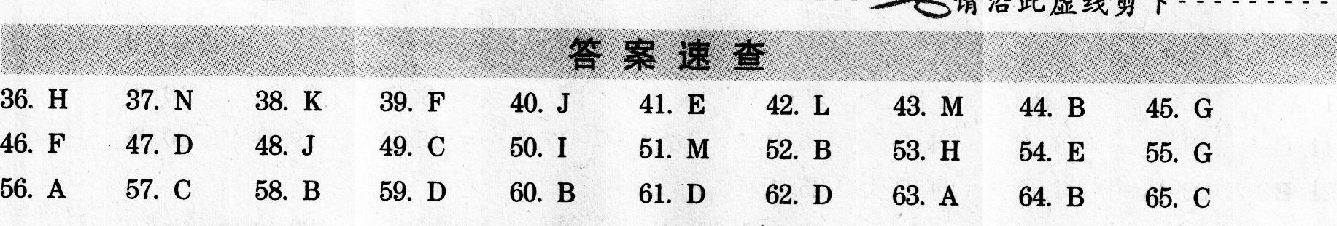

表达难点

1．第l句包含两个独立的分句，第二个分句的主语“这’’指代的正是第一个分句的内容，故可将第二个分句处理为which引导的非限制性定语从句。

2.第l句中的“年轻人……产生兴趣’’不可直译为young people arouse the interest of．．．，因为arouse意为“引起，致使”，常见用法为sth．arouse the interest of sb．“某事物引起某人的兴趣”，一般不用人作主语。“对……产生兴趣”可表达为develop an interest in…或become／get interested in…。

3.第2句的谓语动词是“归因于”，可用attribute／ascribe t0来翻译，但注意该短语的用法是attribute A to B,意为“造成A的原因是B”，而在本句中，A是指“游客数量的增加”，B是指“迅速提高的收入和好奇心”，故attribute to套入本句要么增添主语we，译成we can attribute the increasing number of．．．t0…income and curiosity；要么处理成被动语态，译作the increasing number of．一can be attributed t0…income and curiositv。

4.第3句中的“随着旅行多了”实际上指“随着旅行的经验或次数多了”，翻译时可将这层意思补全，表达为with more travel experience或with more opportunities to travel。

5.第3句的两个分句“年轻人……时间少了”和“他们反而更为偏远的地方所吸引’’较长，各自的内容均完整，可考虑将其分译成两句。两句间表对比，可用instead连接。

6.第4句的主语“有些人”具体是指“某些年轻的旅行者”，翻译时可将其译出，比笼统地译成some people更佳，“背包旅行”可译为a backpacking journey／trip，或可按其具体含义译成a walking journey with little monev and a light backpack。

7-最后一句中的“最近调查显示”可处理成状语According to a recent survey，也可以处理成句子的主句A recent survey shows／suggests．．．。

参考译文

More and more Chinese youths are developing an interest in traveling, which has been a new trend in recent years. The increasing number of young tourists can be attributed to their fast-growing income and their curiosity to explore the outside world. With more travel experience, young people tend to spend less time in big cities and well-known tourist sites. Instead, they find remote areas more appealing. Some young tourists even choose to make a long backpacking journey. According to a recent survey, many young people intend to experience different cultures, enrich their knowledge and broaden their horizon through traveling around.



1．A 2．C 3．B 4．D 5．D 6．B 7．A 8．D 9．C l0．D

11．C l2．C l3．A l4．D l5．B l6．A l7．A l8．D l9．B 20．D

21．B 22．B 23．C 24．C 25．A

26．ingredients 27．vital 28．individuals 29．engage in 30．generating

31．Currently 32．product 33．Keep up with 34．conventional 35．provide you with