A user manual of the “GISnetwork3D”- An R-based QGIS tool for 3D spatial network analysis
Table of Contents
1 Introduction 2
2 Set-up 2
2.1 Install RStudio and QGIS 2
2.2 Install required packages in RStudio 2
2.3 Install "Processing R Provider" in QGIS 2
2.4 Install "GISnetwork3D" in QGIS 4
3 Demonstration of using "GISnetwork3D" in QGIS 4
3.1 Data 6
3.1.1 Boundary of the study area 6
3.1.2 Building data 6
3.1.3 3D pedestrian network 6
3.1.4 Location of primary school 6
3.1.5 Digital terrain model (DTM) 6
3.2 Data preprocessing 7
3.2.1 Defining Z value of residential building and primary school 7
3.2.2 Topology correction of the pedestrian network data 7
3.2.2.1 Component identification 7
3.2.2.2 Snapping disconnected segments 8
3.2.2.3 Create the pedestrian network by extracting the edges and vertices 9
3.2.2.4 Identify the nearest network vertices for residential buildings and primary schools 10
3.3 Analysis 10
3.3.1 Analysis: Origin-Destination matrix and summary 10
3.3.1.1 Create OD matrix 11
3.3.2 Analysis: Deriving the shortest path for each O-D pair 12
3.3.2.1 Summary of paths 13
3.3.3 Analysis: Deriving service area 13
3.4 Function documentation 14
3.4.1 A brief summary of the functionalities 14
3.4.2 build3DNET - Build network for 3D line vector 15
3.4.3 findVertices3D - Find the nearest network vertex for each input point 15
3.4.4 Identify_components - Identify the components of the network 15
3.4.5 ODmatrix3D - Create OD matrix 16
3.4.6 reverseLine_by_condition - Reverse line by condition 16
3.4.7 ServiceArea3D - Create 3D service area 17
3.4.8 Shortest_3Dpath_oneToMany - Create paths from one origin to one or more destination(s) 17
3.4.9 Shortest_3Dpaths_for_pairs - Create one or more paths for each pair of origin and destination 18
3.4.10 snapNET3D - Connect disconnected line within a distance threshod 18

Introduction
The "GISnetwork3D" is an R package supporting 3D spatial network analysis capable of reading, pre-processing, and analyzing 3D spatial data. This user manual provides an overview of the setup and functionality of using this package in QGIS in a GUI manner.

Set-up

Install RStudio and QGIS
Running the "GISnetwork3D" on QGIS requires the installation of R, RStudio, and QGIS.
R & RStudio: https://posit.co/download/rstudio-desktop/
QGIS: https://qgis.org/en/site/
Please click the links above and follow the instructions to download R, Rstudio, and QGIS.

Install required packages in RStudio
The "GISnetwork3D" requires several R packages installed. Please run the codes below to install them first in R studio.
install.packages("sf")
install.packages("igraph")
install.packages("dplyr")
install.packages("purrr")
install.packages("furrr")
install.packages("qgisprocess")
Then, the "GISnetwork3D" package can be installed manually from the R project. Please open the R project called " GISnetwork3D.Rproj" which is located in workspace> rPackage > GISnetwork3D.
Then, on the top bar, please click "Build" and then "Install Package". The package will then be installed automatically.

Install "Processing R Provider" in QGIS
The running of R code in QGIS requires the "Processing R Provider" Plugin in QGIS. This Plugin serves as a bridge between R and QGIS. Please follow the procedures below for installation.
- Open the QGIS.
- On the top bar, click "Plugins" > "Manage and Install Plugins…"
- Then, search the PlugIn name "Processing R Provider" in the search box.
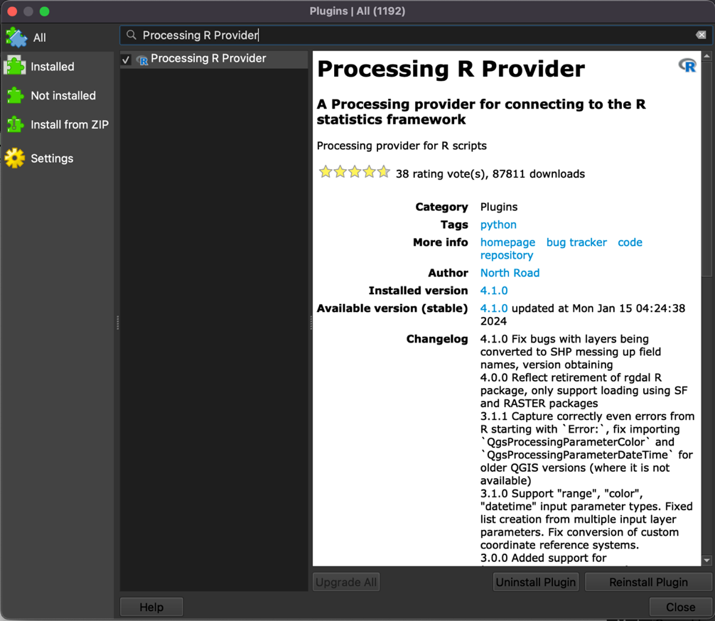
- Click "Install Plugin"
- In the "Processing Toolbox", please click "Options".
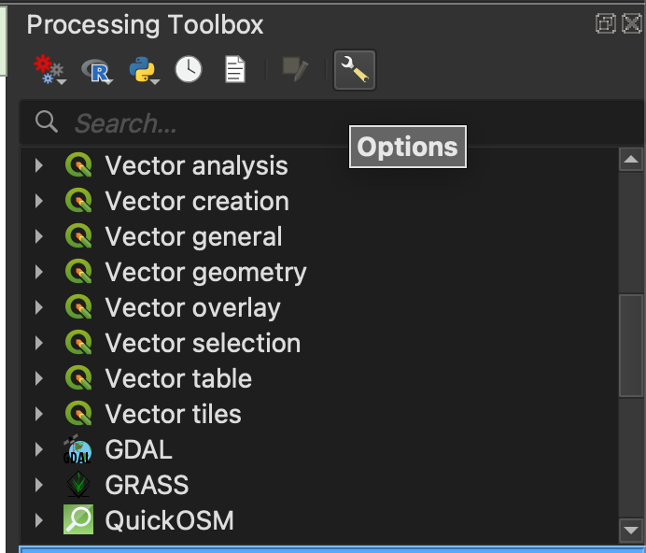
- Expands the "Providers" and "R". Make sure that the directory of the "R folder" is correctly linked to R.
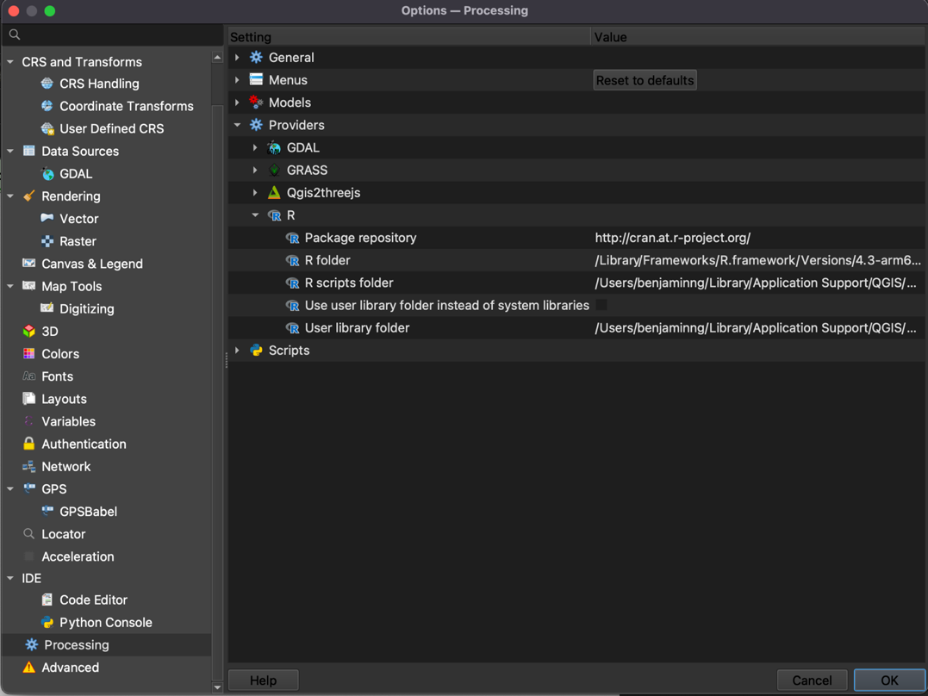
- More details concerning the installation can be found on the URL (https://north-road.github.io/qgis-processing-r/

Install "GISnetwork3D" in QGIS
The final step is to install the "GISnetwork3D" in QGIS.
- Go to the "R script folder" according to the directory specified in the "Options > Providers > R" as shown in the above image.
- Then, go to "workspace > rQGISpackage" and drag and drop the "GISnetwork3D" folder into that "R script folder". Then, the installation is completed. "GISnetwork3D" folder is in the downloaded folder of this project, of which the directory is "Workspace/QGISpackage/GISnetwork3D".
- Relaunch the QGIS. If the package is installed properly, all of the functions should be shown in the "Processing toolbox".
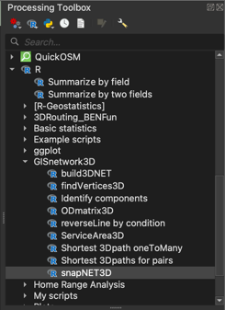

Demonstration of using "GISnetwork3D" in QGIS
The reproducible workflow of using this tool is available in "workspace > QGISexample". The "data" folder embeds all data required. Then, the "QGISexaple.qgz" is a QGIS project for running the demonstration.
This user manual provides a step-by-step demonstration of assessing the spatial accessibility to primary schools in a small community in Hong Kong, China, using this package. This demonstration selected a small community in the Eastern District on Hong Kong Island as a study area and used the "GISnetwork3D" package to model the spatial accessibility to primary schools from residential buildings.
We will use 3D building data, a Digital Terrain Model (DTM), the location of the primary school, 3D pedestrian network, and they were preprocessed in advance. Please note that the data is for demonstration only and is not intended for formal investigation!
- Click the "QGISexample.qgz".
- On the top bar, click "Processing > Graphical Modeler…"
- In the Graphical Modeler, click the "Open model" icon and then import the model "Model01_dataPreprocessing.model3", which is inside the "QGISexample" folder.
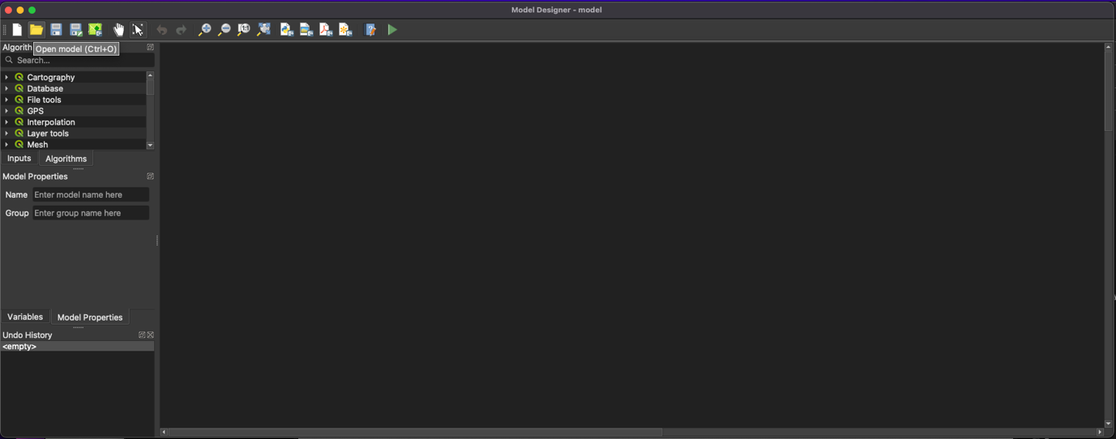
- The workflow for data preprocessing will then be loaded. This workflow recorded the process of using the "GISnetwork3D" for data preprocessing.
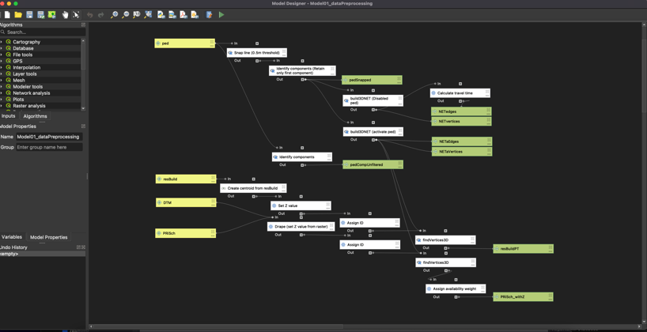
- Run the workflow by clicking 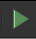. Please check if the inputs of the data match the name of the required input before running. Then, outputs from the workflows will be generated automatically.
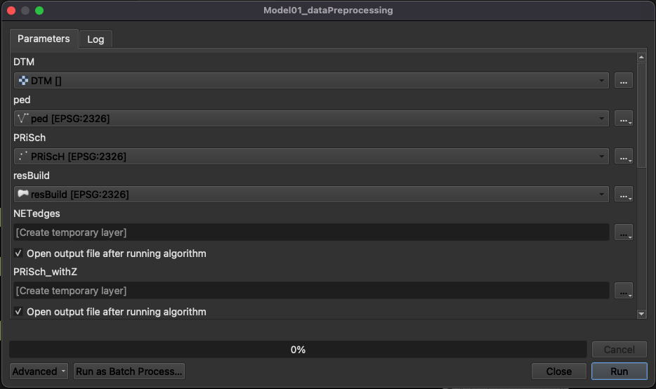
- Next, import another workflow model "Model02_Analysis.model3". This workflow demonstrates how to use this tool to conduct an analysis of accessibility.
- Run the analysis workflow, and the results will be automatically generated. You can inspect the results accordingly.

Data

Boundary of the study area
We have two boundaries. First, the studyArea is the boundary of the study area of which the buildings (or the demands) are located.
Second, the studyAreaBuf is the boundary of the 2000m buffer of the study area. This buffer area accounts for the cross-boundary movement of the demand near the fringe of the study area. All data, except for the buildings, were delineated by this boundary. The raw data were retrieved from the District Council Constituency Areas (DCCA) census map, downloaded from an open data portal by the Hong Kong government (https://www.csdi.gov.hk/).

Building data
We have two building data. First is the resBuild. This includes residential buildings. Second, it is otherBuild. This includes buildings other than residential buildings, such as podium structures.
The raw data were retrieved from the iB1000 dataset, downloaded from an open data portal managed by the Hong Kong government (https://www.csdi.gov.hk/). The landuse of buildings is defined by the Land Utilization map 2022, downloaded from the CSDI portal (https://portal.csdi.gov.hk/geoportal/#metadataInfoPanel).
The building data are in polygon format. Though this data contains the third dimension (z value), the z value is 0 for all polygons. The true z value is recorded in the attribute table with the field name called "BASELEVEL".

3D pedestrian network
This 3D pedestrian data recorded pedestrian paths in the study area in 3D. This dataset does not simply drape the network on the earth's terrain and record its surface height. This dataset records the actual location of each path. Therefore, this dataset also includes underground, footbridge, and paths inside some major shopping malls. The raw data were downloaded from an open data portal managed by the Hong Kong government (https://www.csdi.gov.hk/).

Location of primary school
The primary school's location within the study area's buffer was retrieved from the iGeoCom dataset from the open data portal managed by the Hong Kong government (https://www.csdi.gov.hk/). This data records the 2D coordinates of the points of interest. Therefore, we will need to estimate the z value from the digital terrain model (DTM).

Digital terrain model (DTM)
This data recorded the terrain of Hong Kong with 5m resolution in raster format. This raw dataset was obtained from the Hong Kong government (https://www.csdi.gov.hk/).

Data preprocessing

Defining Z value of residential building and primary school
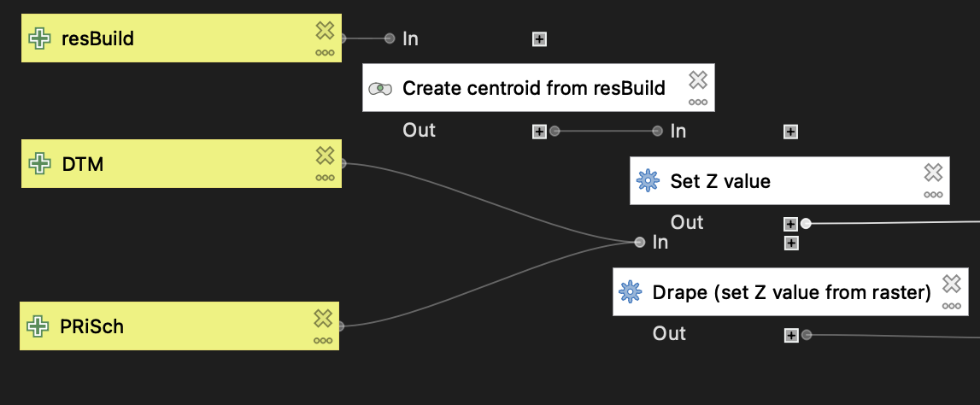
In this study, the spatial accessibility measures the access to primary school from resBuild. We will convert the resBuild to centroid point for each polygon and then use this centroid as the origin for the spatial accessibility analysis. We will create a 3D centroid point layer.
We first used the function- "Centroids" to convert the resBuild from polygon to point, and then assigned a Z value to them using its base height specified in its field "BASELEVEL" by using the "Set Z value" function.

Besides, the primary school data lack the Z value. Therefore, we extracted the Z value from the DTM and converted the PRiScH to 3D point features by using the function " Drape (set Z value from raster)".

Topology correction of the pedestrian network data
This section will show how to use the "GISnetwork3D" to correct some geometry errors of the input 3D line layer.
First, we will demonstrate the component identification. Second, we will demonstrate how to connect the disconnected network nodes.

Component identification
In a network, each component represents a group of connected network nodes. Each component is isolated, meaning components A and B are not connected.
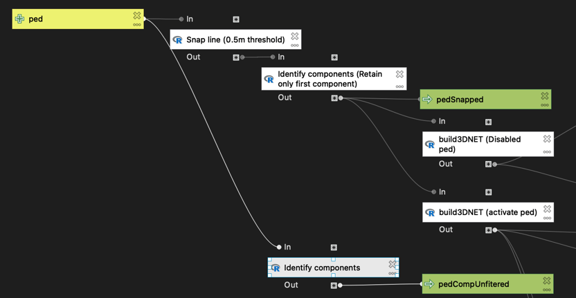
We used the "Identify components" function from the "GISnetwork3D" package to identify components for the ped layer.
The input is the 3D line feature, and the output "pedCompUnfiltered" is the input plus an additional field of "component". The component is a numeric vector. Each unique value represents the identifier of each isolated group of line segments.
We can map the component to inspect what happened. We can define a group as the main component (mainComp). mainComp = 1 if the line is within the main component and 0 otherwise. From the map, we can see that some components are isolated, which can be related to the clipping of the network by the buffer of the study area and also because of digitization errors, such as overshoot and undershoot.
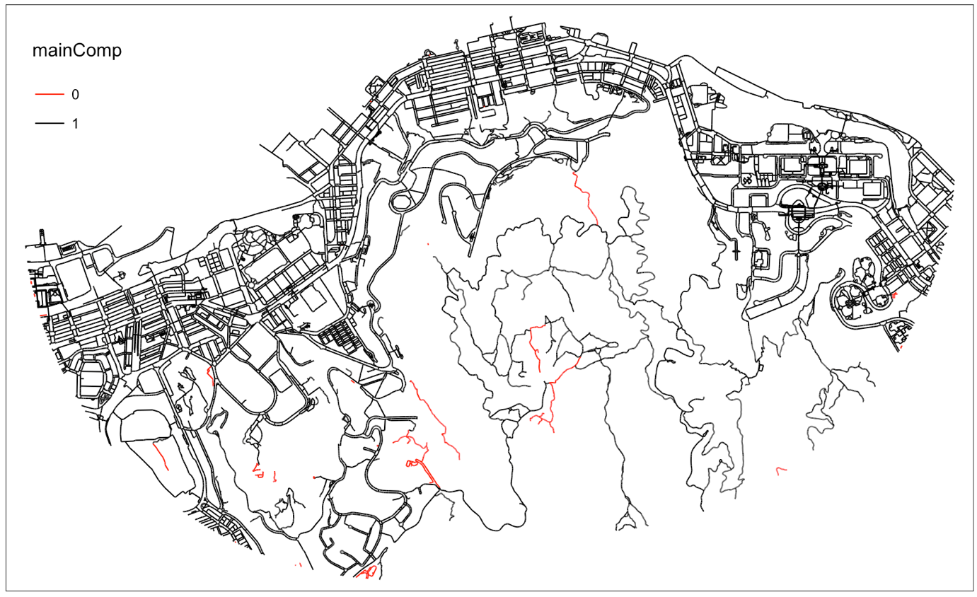

Snapping disconnected segments
Inaccurate routing results may emerge if the lines supposed to connect are disconnected. We can define a distance threshold. Then, a 3D line is created to connect two disconnected vertices within this threshold.
We can use the "snapNET3D" function from the "GISnetwork3D" package to do this task.
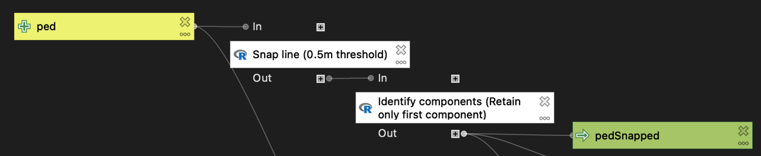
We used the function "snapNET3D" (in the box "Snap line (0.5m threshold)") to snap disconnected vertices within the threshold value of 0.5m.
We used the "Identify components" function to identify the component and filter out all components> 1 by defining the argument "filter = 1".
The output "pedSnapped" is a 3D line layer having all vertices separated within 0.5m connected and containing only the main component.
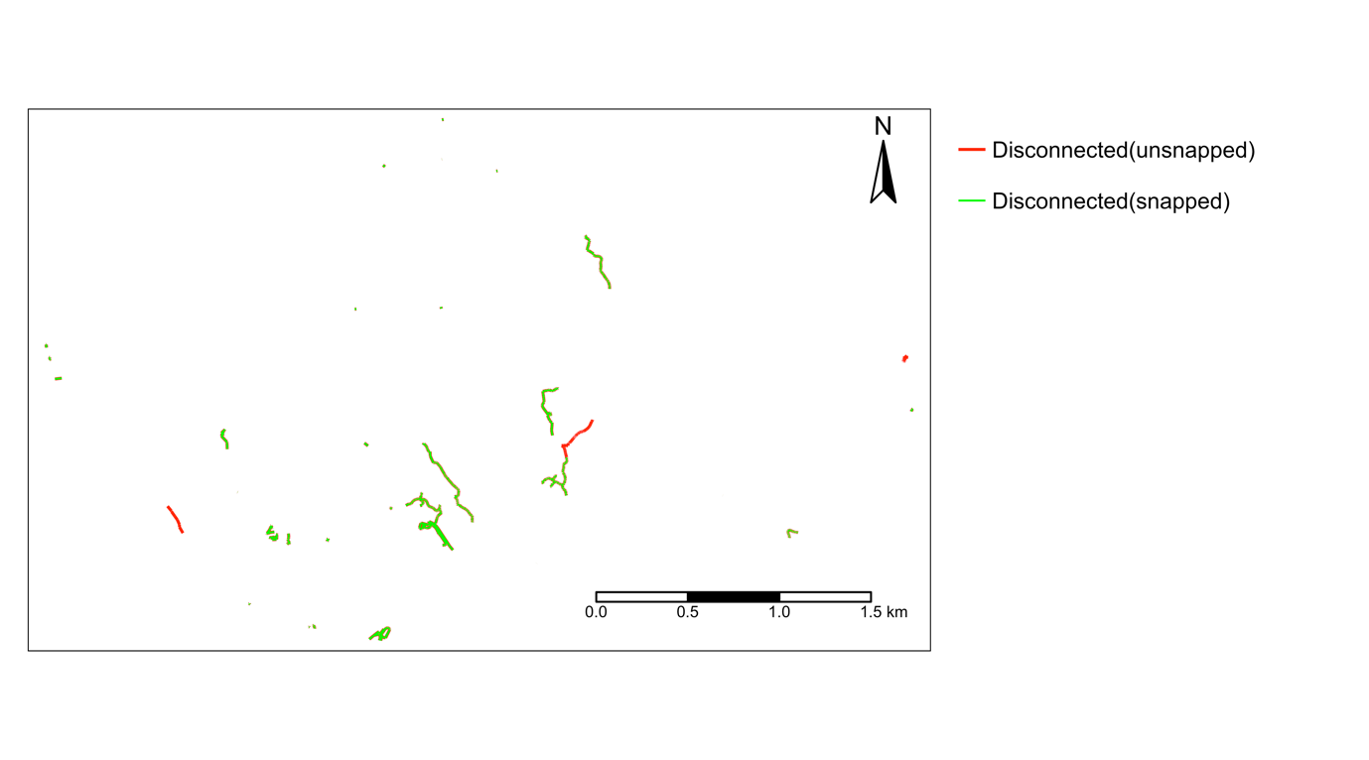
The map above shows the disconnected lines between unsnapped and snapped networks. We can see that the snapped network has fewer disconnected lines.

Create the pedestrian network by extracting the edges and vertices
In network analysis, we need to have the information of the edges and nodes/vertices. Each edge connects two nodes. Edges record the weight/cost. The edges and vertices layers are the prerequisites for constructing the graph for routing and network analysis.
Here, we created two sets of networks. One is a usual network, and the other is an anisotropic network.
We can use the "build3DNET" function from the "GISnetwork3D" package for this task.
The "build3DNET" will produce edges and vertice layers. By default, the argument "ped" is FALSE. This means the network built has the direction of each edge based on the digitization direction. In later routing, you can still use directional or bi-directional routing. If "ped" is TRUE, a pedestrian network is created. This acknowledges the usual bidirectional nature of the pedestrian route and the direction-dependent weight, known as anisotropic movement. By enabling this argument, the output network will calculate the walking duration for each line segment, which depends on direction. Each line segment has two travel times depending on the direction. The calculation is based on Tobler's hiking function. Besides, If a column "directCond" is presented in the attribute table of the input line, directed edges will be filtered before producing a bi-directional network when the ped argument is TRUE. Only 1 and 0 are accepted for the directCond. 1 indicates that the edge is directed according to its digitization direction. 0 indicates that it is bi-directed, and bi-directed walking speed and travel time were calculated for these edges. This can account for some portion of pedestrian paths that are not bi-direction while others are bi-direction with directional-dependent weight. We did not consider both directional and bi-directional pedestrian networks in this demonstration. Further information can be found in the package documentation.
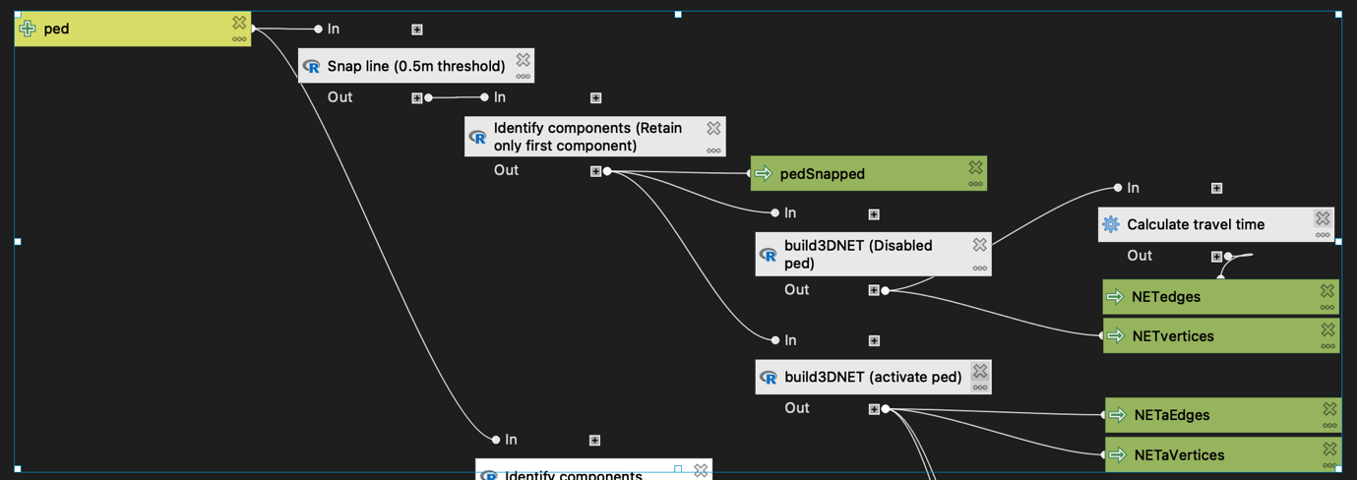
Here, we used the "build3DNET" function to create two sets of networks, one having the "ped" argument enabled (NETaEdges and NETaVertices) and one with a disabled "ped" argument (NETedges and NETvertices).

For better comparison, we need to calculate the travel time for the bi-directional pedestrian network (NETedges) (in the box "Calculate travel time"). As it does not consider the direction, the slope will become useless. Therefore, we assume 0 degrees of slope and use the 3D length to calculate the travel time.

Identify the nearest network vertices for residential buildings and primary schools
The "findVertices3D" function from the "GISnetwork3D" package helps find the nearest network vertices for each input 3D point layer. The input is two 3D point layers; one is the point of interest, and the other is the vertices layer from the "build3DNET" function.
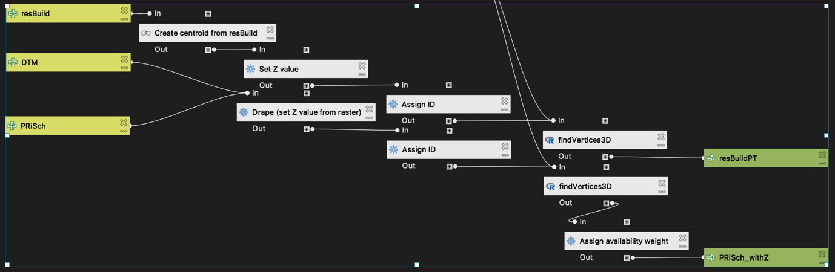
After converting the resBuild and PRiSch to point layers, we need to give each POI a unique ID in ascending chronological order (Box: Assign ID – using the function "Field calculator").

Then, we applied the function "findVertices3D" to find the nearest network vertices for each POI. For the primary school POI, we also assign an availability weight (a new field "avaiW" is created using the "Field calculator" with all POI having a weight 1) for later analysis.

Two outputs were defined, "resBuildPT" and "PriSch_withZ" and are used for later origin-destination analysis.

Analysis

Analysis: Origin-Destination matrix and summary
This section shows how to use the "GISnetwork3D" to calculate the least-cost travel between each origin and each destination. Origin-Destination Matrix (ODM) is a data matrix recording the cost of travel between each origin and each destination. Each row represents each origin, and each column represents each destination. Please import the "Model02_Analysis" into the Model Designer for the analysis workflow.

Create OD matrix
We will calculate the OD matrix and its summary for each residential building and each primary school for both isotropic and anisotropic routing using the "ODmatrix3D" function from the "GISnetwork3D" package.
Here, we will create three scenarios. First, the travel time between each O-D based on an undirected movement and assumes a 0-degree slope. Second is the travel time from each residential building to each school. Third is the travel time from each school to each residential building. This directional movement is defined by the argument "mode" as "in" or "out" - by default, it is "all", assuming bi-directional.
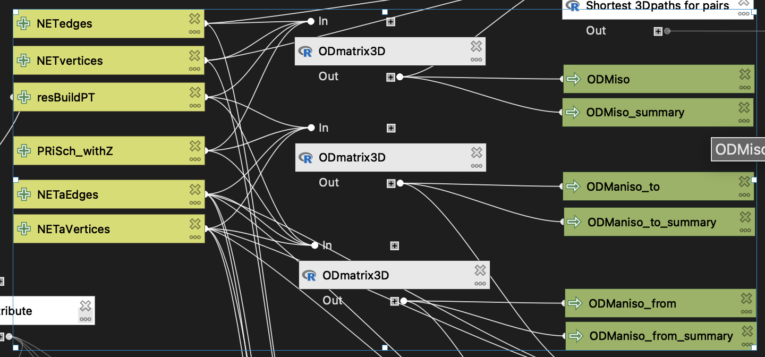
The "ODmatrix3D" function requires the (1) network edges, (2) network vertices, (3) directed networking or not, (4) origin point, (5) destination point, (6) fields defining ID and vertex ID for both origin and destination, (7) modeling mode (in = toward origin from destination; out = from the origin toward the destination; all = no direction), (8) weight – the travel impedance for each edge, (9) threshold cost for counting availability, (10) field from the destination point defining the availability weight for the destination (e.g., 2 means the destination is counted twice for availability metric).
In this demonstration, we defined the threshold as 600s (about 10 minutes walk), and avaiW as 1 for all destinations. The NETedges and NETvertices were used to calculate the isotropic ODM. Then, the NETaEdges and NETaVertices were used to model the anisotropic ODM (one was from the origin, and one was toward the origin).

This function created two outputs: one is ODM as a table, and one is the summary of the ODM for each origin in point layer format. The summary includes the minimum cost, mean cost, median cost, and availability for each origin to many destinations. The availability is calculated by the sum of "avaiW" of each destination for each origin within a "threshold" search. avaiW is the weight for each destination. For instance, one means that the destination is counted as 1. The threshold is the cost <= which the destination is counted as available within a certain level of cost.
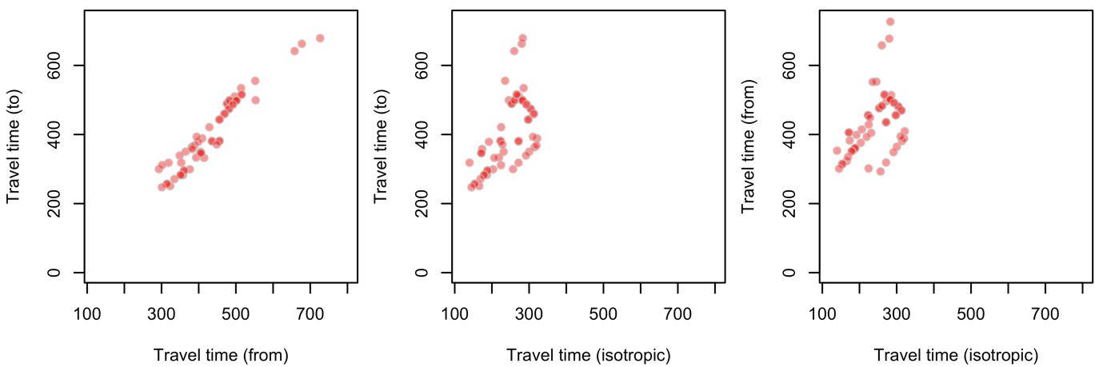
Here, we ploted three scatter plots to compare travel time for the three scenarios mentioned above. We can see the variation in travel time between scenarios. Besides, we can also see that isotropic routing tends to have lower values than anisotropic routing. We can also see the variability in travel time between travel from and to residential buildings.

Analysis: Deriving the shortest path for each O-D pair
In the previous section, we summarized the ODM. The ODM summary recorded each origin's destination with the least-cost travel time. We can use this O-D pair and derive the path in the 3D line feature using the "Shortest 3Dpaths for pairs" function from the "GISnetwork3D" package.
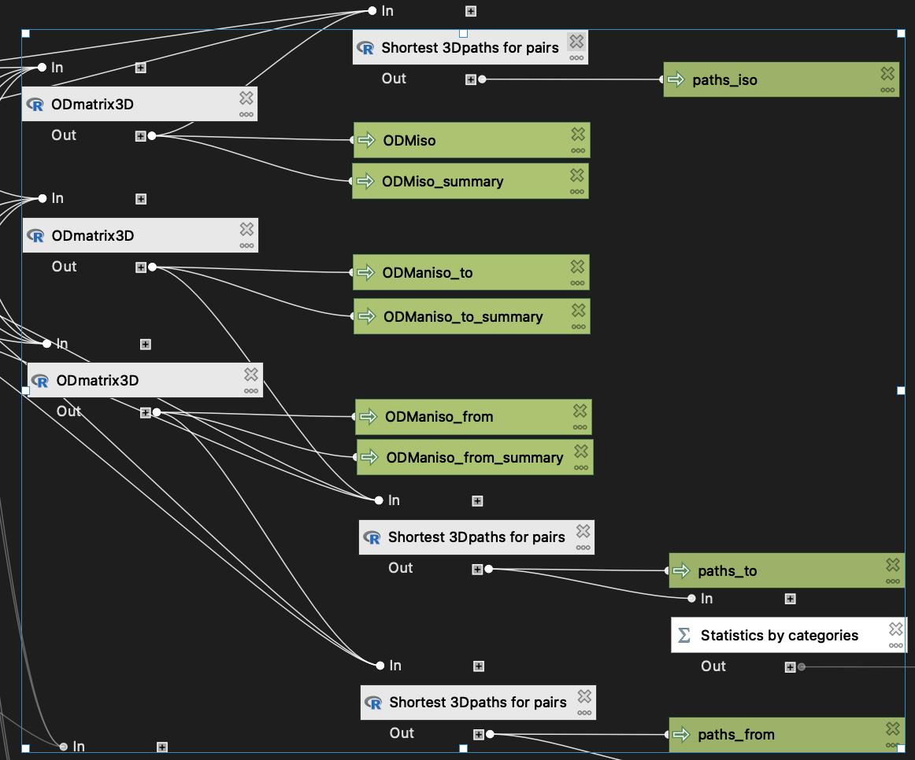
The summary of ODM generated previously identified the least-cost destination for each origin, and we used this O-D pair to derive the route linking them together following the least-cost principle. The paths_iso, paths_to, and paths_from are the generated O-D routes for isotropic, toward-the-origin, and from-the-origin scenarios.

Summary of paths
We can summarize the exported path. For instance, we can calculate the mean walking pace or summarize environmental variables along the way. Here, we calculated the average walk pace.
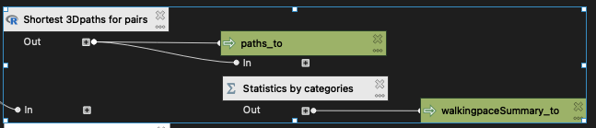
We used paths_to as an example.
We calculated the summary statistics of the walking pace by each oID (ID for each origin) to derive the attribute of each O-D route.
We can see that some routes have a faster pace while some have a slower.
Min. 1st Qu. Median Mean 3rd Qu. Max.
0.8075 0.8445 0.8702 1.1374 1.1583 4.4840
The "Shortest 3Dpath oneToMany" function from the "GISnetowrkGIS" is similar to the "Shortest 3Dpaths for pairs" while the former supports one-to-one and one-to-many routing.

Analysis: Deriving service area
This section demonstrates how to use the "ServiceArea3D" function from the "GISnetwork3D" package to explore the reachable areas by an origin point.
We will create a service area for a sampled building using both isotropic and anisotropic methods.
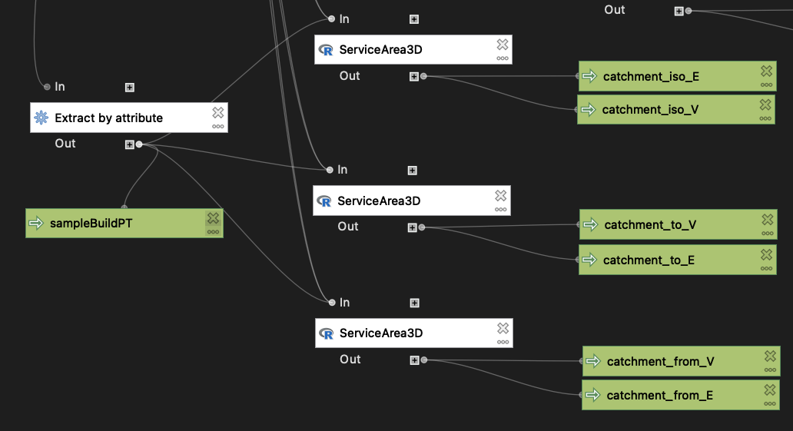
We first created a sampled building for deriving the service area (Box: Extract by attribute).

Then we used the "ServiceArea3D" function to create the catchment/ service areas for isotropic, from-origin, and toward-origin scenarios. This function requires the (1) network edges, (2) network vertices, (3) argument whether the network is directed, (4) the origin point, (5) fields defining the ID and vertice ID of origin, (6) mode of travel (in, out, all), (7) weight – the travel impedance for each edge, (8) the search threshold – the 2D distance for first filtering out distant vertices, (9) cost threshold- Defining the size of catchment.

The output consists of a line layer showing the reachable edges and a table listing all reachable vertices. This function first calculates the cost between the origin and all network vertices (within the search threshold), and then subsets all vertices within reachable cost, and then extracts the edges containing these vertices.
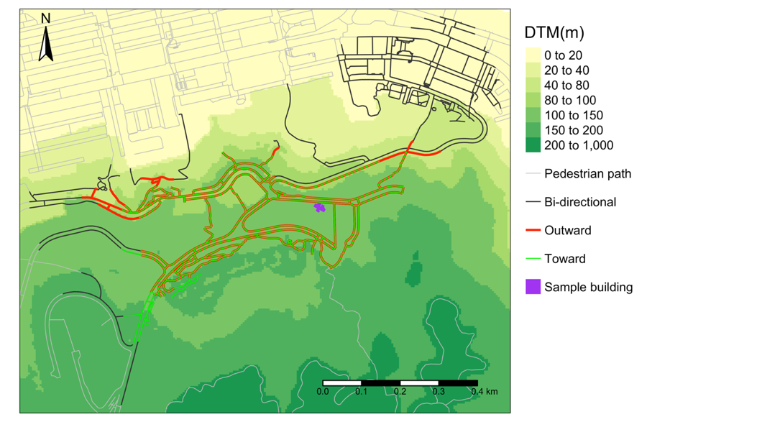
From the result, we can see that the elevation increases southward. The walking pace is faster for going downhill than going uphill. Therefore, the outward catchment extends northward while the inward catchment retreats southward. The isotropic travel (assuming 0 slopes) gets the greatest areal footprint.

Function documentation

A brief summary of the functionalities
Functionality | Function | Brief details
Geometry & topology correction/ modification | snapNET3D | - Connect disconnected line vertices situated within a predefined 3D distance  - Addressing overshoot/ undershoot problems
 | reverseLine_by_condition | - Reverse all or indexed line segments  - Correct the conflict of direction between true and digitizing direction
Network creation | Build3DNET | - Decompose a 3D line layer into two layers: edges and vertices  - Support the creation of anisotropic (bi-directional routing with direction-dependent weight)/ partial anisotropic (some paths are directed while some are bi-directional with anisotropic weights) network
 | findVertices3D | - Identify the nearest network vertices for the input 3D point  - A prerequisite of routing as it identifies the entry point to the network for each POI
Analysis | ODmatrix3D | - Calculate the travel cost between each origin and each destination  - Support anisotropic/ partial anisotropic routing
 | Shortest_3Dpaths_for_pairs | - Extract the path in a 3D line layer for each origin-destination pair  - Support anisotropic/ partial anisotropic routing
 | Shortest_3D path_oneToMany | - Extract the path in a 3D line layer from one origin to one or more destinations  - Support anisotropic/ partial anisotropic routing
 | ServiceArea3D | - Identify edges and vertices within reach for a 3D point  - Support anisotropic/ partial anisotropic routing
Utility | Identify_components | - Classify line segments into components.  - Each component is an isolated set of lines

build3DNET - Build network for 3D line vector
This function produces the edges and vertices of the input line feature. Each edge is only connected by two vertices as this function first explodes the line feature. The edges record the from and to vertices, of which the index is the vID recorded in the vertices layer. The digitization direction determines the from and to vertices. A unique ID is generated for each edge segment (eID) and each vertex (vID). If the ped is TRUE, the produced edges will record the slopes and the walking time for both directions. The walking time is based on Tobler's hiking function.

Input parameters
  - line
A 3D line layer
  - ped
Boolean-Indicate whether the network is built as a pedestrian network. If TRUE, this function will create a network that supports bi-directional routing with slope/directional dependent walking time(s) for each edge.

Outputs
  - edges
Edges of the network as a 3D line layer
  - vertices
Vertices of the network as a 3D point layer

findVertices3D - Find the nearest network vertex for each input point
This function finds the nearest vertex from the vertices layer, produced from the function build3DNET, for each input pt. The input pt must have the z value. The output has the original pt with the vID of the nearest network vertex.

Input parameters
  - pt
A 3D point layer
  - vertices
The vertices of a network produced from the function - build3DNET

Outputs
  - ptWithV
A 3D point layer, same as the input pt, but with an additional field of vID recording the unique ID of the nearest network vertex.

Identify_components - Identify the components of the network
This function identifies the component to which each edge belongs for the input line layer. This function first converts the input line layer into network data using the build3DNET function, and it is then converted to igraph using the GISigraph function to identify the component of edges. Please be cautious that the output layer is an exploded version of the line, meaning each line segment only has two connected vertices.

Input parameters
  - line
A 3D line layer
  - filter
A number indicating the component index within which the line segments are to be retained. Default is -999, which indicates that no filtering is performed.

Outputs
  - lineComp
A 3D line layer with an additional field called component, denoting the component for each line segment

ODmatrix3D - Create OD matrix
This function produce an OD matrix that calculate the cost of the least-cost paths between each origin and destination.

Input parameters
  - NETedges
Edges produced from the function build3DNET
  - NETvertices
Vertices produced from the function build3DNET
  - directed
Boolean. If TRUE, a directed graph is produced for network analysis.
  - origin
A 3D point layer of the origin for the network analysis.
  - des
A 3D point layer of the destination for the network analysis.
  - oID
A numeric vector of the ID of the origin location(s)
  - oV
A numeric vector of the vertex ID of the origin location(s)
  - dID
A numeric vector of the ID of the destination location(s)
  - dV
A numeric vector of the vertex ID of the destination location(s)
  - weight
A field from the NETedges recording the weight or cost for each edge for the least-cost routing.
  - mode
The direction of routing. all is undirected, in is toward the origin, and out is from the origin.
  - avaiW
A numeric vector defining the weight for each destination for calculating the availability within a threshold travel cost from each origin location. Weight of one for a destination refers to counting a destination as one if it is within the catchment of the origin within a cost budget.

Outputs
  - ODM
A table recording the least travel cost between each origin and each destination. Rows represent origins and column represent destination.
ODMsummary
Summary of the ODM. It includes the minimum cost, mean cost, median cost, and availability for each origin to many destinations.

reverseLine_by_condition - Reverse line by condition
This function reverses the direction of each line for the sf line features.

Input parameters
  - line
A line layer
  - condition
A field name from the input line layer to specify the line segment requiring reversion. Value of 1 - requiring reversion. 0 - not requiring reversion. All line segments are reversed if the condition is not specified by default.

Outputs
  - revLine
Output line layer having specified lines reversed

ServiceArea3D - Create 3D service area
This function identifies vertices reachable within a cost threshold from an origin vertex and also all edges linking to these vertices. Therefore, the output is a list of (1) sf point showing the reachable vertices, and (2) the edges within threshold cost from each origin location.

Input parameters
  - NETedges
Edges produced from the function build3DNET
  - NETvertices
Vertices produced from the function build3DNET
  - directed
Boolean. If TRUE, a directed graph is produced for network analysis.
  - origin
The point of which the service area is to be derived for.
  - oID
A field from the origin point showing the IDs of the origin locations.
  - oV
A field from the origin point showing the vertices IDs of the origin locations
  - mode
The direction of routing. all is undirected, in is toward the origin, and out is from the origin.
weight
A field from the NETedges recording the weight or cost for each edge for the least-cost routing.
  - search
A number indicating the size of straight-line radius used to first identify possible reachable vertices. This is expressed as 2D distance.
  - costThreshold
The catchment size expressed as the maximum 3D network cost.

Outputs
  - edgesReached
3D line layer of the edges within reach of the origin
  - ListWithinV
A table indexing the network vertices within reach of the origin

Shortest_3Dpath_oneToMany - Create paths from one origin to one or more destination(s)
Create paths from one origin to one or more destination(s).

Input parameters
  - NETedges
Edges produced from the function build3DNET
  - NETvertices
Vertices produced from the function build3DNET
  - directed
Boolean. If TRUE, a directed graph is produced for network analysis.
  - origin
An origin location in point layer.
  - oV
A field from the origin point showing the vertices IDs of the origin locations
  - des
The destination location(s) in point layer.
  - dV
A field from the destination point showing the vertices ID(s)
  - mode
The direction of routing. all is undirected, in is toward the origin, and out is from the origin.
  - weight
A field from the NETedges recording the weight or cost for each edge for the least-cost routing.

Outputs
  - paths
A 3D line layer of the O-D(s) least-cost paths

Shortest_3Dpaths_for_pairs - Create one or more paths for each pair of origin and destination
Create one or more paths for each pair of origin and destination.

Input parameters
  - NETedges
Edges produced from the function build3DNET
  - NETvertices
Vertices produced from the function build3DNET
  - directed
Boolean. If TRUE, a directed graph is produced for network analysis.
  - ODMsummary
An origin point layer with the field of oID, oV, dID, and dV, recording the origin ID, origin vertices ID, destination ID, and destination vertices ID. This can be the ODMsummary output from the ODmatrix3D function.
  - weight
A field from the NETedges recording the weight or cost for each edge for the least-cost routing.
  - mode
The direction of routing. all is undirected, in is toward the origin, and out is from the origin.

Outputs
  - paths
A 3D line layer of the O-D least-cost paths

snapNET3D - Connect disconnected line within a distance threshod
This function connects the disconnected lines that are separated from each other within a predefined distance in 3D. Please note that the output layer is an exploded version of the line. Each line segment only has two connected vertices.

Input parameters
  - line
A 3D line layer

Outputs
  - snapped
A 3D line layer with additional snapping line features tagged as 1 in the additional field called snap.

