**War of Ships**

**V. 2**

**CSC 17A 43950**

**Nornubari Kanabolo**

**06/10/2015**

**Introduction**

In this game there is a naval war taking place between the British Empire (User) and Germany (Enemy) in 1839. They are fighting over control of the section of the Mediterranean Sea that has a less treacherous and more lucrative trade route, which can maximize only one of the country’s wealth. The program is similar to Battleship, and allows the user to decide the size of the board and how many ships should be used. The battleship game is an object oriented program. It uses two class objects one derived from the other and a template. In the main file it has five functions to perform different tasks. First the program ask the user for three inputs: the number of rows in the board, the number of columns and the number of ships. Then the program initializes a class object from the User class to store those values. The User class is a derived class form the base class Board. After storing the user inputs in the Board class the program runs an exception to check for errors in the inputs. Then the program prints a reference board using the user inputs and calls the functions getUser from the User class to get the positions in the board to place the ships, it places an “O” in those places. It does the same with the enemy board calling the getEnemy function but the positions are randomly selected.

The program then runs a while loop. Inside the loop a new player and enemy board is printed. The player board displays the ships and the enemy board is blind. Coordinates are requested to launch attack into the board, the player enters inputs for the rows and the columns. Then the program uses those numbers in the enemy array to check if there are any ships in that position. If there is a ship that spot is marked with the “#” symbol and a one is added to a counter called userPoints, the program keeps track of the number of ships destroyed. If the attacked space is blank an “X” is placed in that position. The game then ends and displays the winner of the war.

**Summary**

Lines of code: 309

Comment Lines: 41

White spaces: 37

This project used most of the concepts and constructs we learned in this course. It uses a series of for loops, while, if-else-if statements and do while loops to control the moves, points, constructors, destructors, accessors, and mutators and winner of the game. The game uses classes and headers for the board and players which had the components for the size of the board and the user and enemy ships, respectively. It also used functions with pass by references and dynamically allocated arrays to keep displaying the position of the two fleets’ ships during the war. It was difficult to figure out how to exactly nest some of the for loops since each one has a specific placement on the board.

**Pseudo Code**

**Game board and user input functions**

***Call begin function***

***Get board row and column size and number of ships from user***

***Print empty game board***

***Initialize i***

***For i<a.columns display empty space***

***Initialize i***

***Initialize j***

***For i<a.rows display empty space***

***i++***

***For j<a.columns display border section***

***j++***

***Initialize i***

***For i<a.columns display end of border section***

***i++***

***Dynamically allocate memory for arrays of the players***

***Call Player structure***

***Declare **arr***

***Initialize variables***

***Set random number seed***

***Set spots where each ship will be blank***

***Do***

***Input tRow***

***while(tRow <= 0 ||tRow > b.rows)***

***Check if position is valid***

***Input tCol***

***while(tRow <= 0 ||tRow > b.columns)***

***check if position is valid***

***Initialize i***

***For i < b.ships***

***Do***

***Set random positions for enemy***

***while(valLoc == false)***

***Validate positions***

***Return arr***

|  |  |  |  |
| --- | --- | --- | --- |
| Type | Variable Name | Description | Location |
| int | rows | Number of rows on board | In Gameboard header file |
|  | columns | Number of columns on board | In Gameboard header file |
|  | ships | Number of ships on board | In Gameboard header file |
|  | setRows | Mutator to transform rows | In Gameboard header file |
|  | setCols | Mutator to transform columns | In Gameboard header file |
|  | setShips | Mutator to transform ships | In Gameboard header file |
|  | tempRow | temporary value for the row | In User.cpp |
|  | tempCol | temporary value for the column | In User.cpp |
|  | usrRow | player rows | Main function |
|  | usrColumn | player columns | Main function |
|  | enmyRow | enemy rows | Main function |
|  | enmyCol | enemy rows | Main function |
|  | usrPnts | counter for each ship destroyed by user | Main function |
|  | enmyPnts | counter for each ship destroyed by enemy | Main function |
| char | start | Blank space | In prntBrd function |
|  | usrBoard | Array with all the player tokens | In User header file |
|  | enmyBoard | Array with all the enemy’s tokens | In User header file |
|  | invisBrd | Invisible board for the enemy | Main function |
| bool | validLoc | check for valid input | Main function |

|  |  |  |
| --- | --- | --- |
| Chapter | Constructs/Syntax | Location |
| 2 | Equality and relational operators  (&&, ||, ==,>=,>,<=,<,-,+) | Comparing positions of ships |
|  | bool | Check validity of positions |
|  | If | Where ship positions are compared to board positions |
|  | If else | Where ship positions are compared to board positions |
|  | While | Checks if points exceed the number of ships |
|  | Do-while | Checks if points are in boundaries of number of ships |
|  | for | Prints out boards, ships, and their positions |
| 7 | Array | Board and player ships arrays |
| 11 | Dynamic array | References the array of each player |
|  | Class | Gameboard, User, and Victor header  Gameboard, User, and Victor souce files |

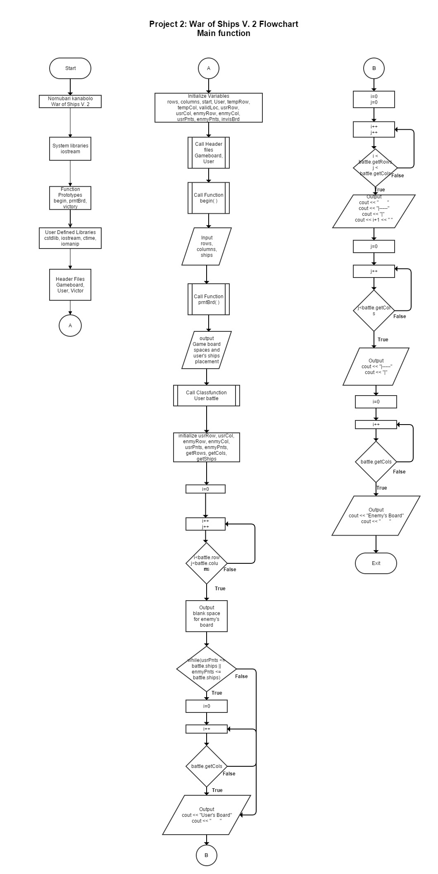

**Example Code**

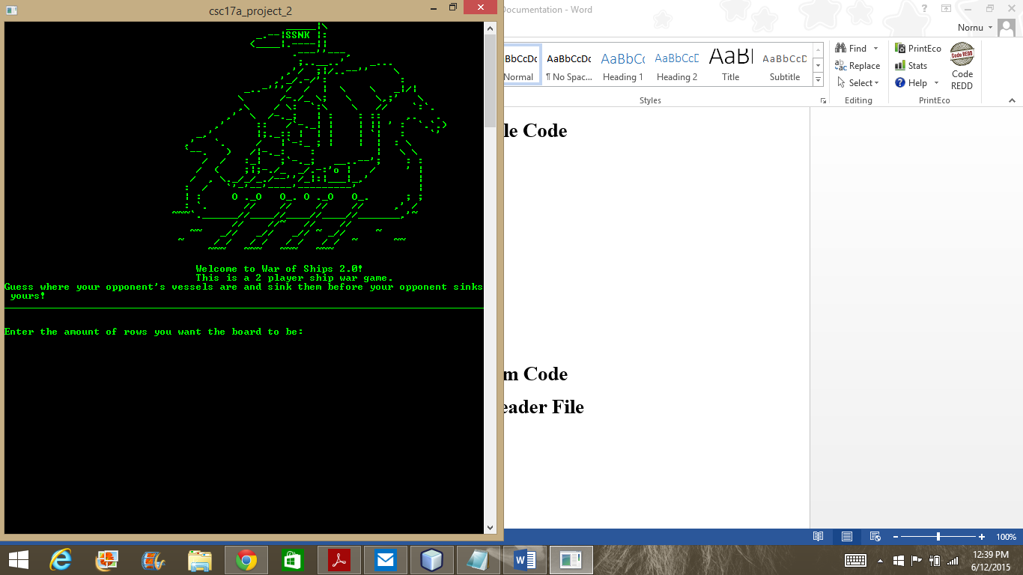

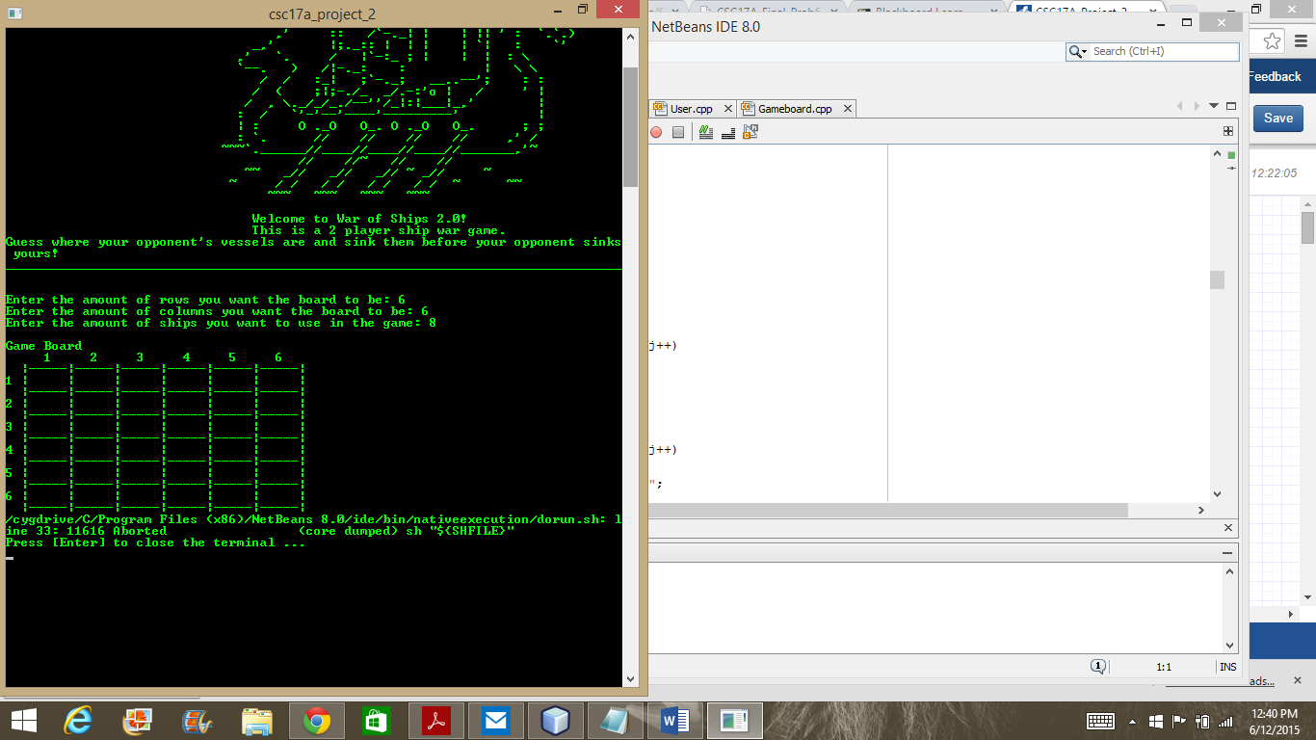

Was unable to get my code to work, but my code seems to be right. I could not find the problem.

**Program Code**

**Gameboard Header File**

|  |
| --- |
|  |
| #ifndef BOARD_H |
|  | #define BOARD_H |
|  | #include <cstdlib> |
|  | #include <iostream> |
|  | #include <iomanip> |
|  | #include <ctime> |
|  |  |
|  | struct Board |
|  | { |
|  | int rows; //The number of rows in the board |
|  | int columns; //The number of columns in the board |
|  | int ships; //The number of ships in the board |
|  | }; |
|  |  |
|  | #endif /* BOARD_H */ |
|  |  |

**Players Header File**

|  |
| --- |
| #ifndef PLAYERS_H |
|  | #define PLAYERS_H |
|  | #include <cstdlib> |
|  | #include <iostream> |
|  | #include <iomanip> |
|  | #include <ctime> |
|  |  |
|  | struct Players |
|  | { |
|  | char playrBd; //Array with all the player tokens |
|  | char enemyBd; //Array with all the enemy tokens |
|  | }; |
|  |  |
|  | #endif /* PLAYERS_H */ |

**Main**

|  |
| --- |
| /* |
|  | * File: main.cpp |
|  | * Author: Nornubari Kanabolo |
|  | * Project 1 - War of Ships |
|  | */ |
|  |  |
|  | //User Defined Libraries |
|  | #include <cstdlib> |
|  | #include <iostream> |
|  | #include <iomanip> |
|  | #include <ctime> |
|  | #include "Board.h" |
|  | #include "Players.h" |
|  |  |
|  | using namespace std; |
|  |  |
|  | //Function Prototypes |
|  |  |
|  | //Prints the beginning to the game |
|  | void begin(); |
|  | //Prints the starting board |
|  | void prntBrd(Board); |
|  | //Gets the ships position in the board |
|  | Players **usrInp(Board); |
|  | //Where the war is |
|  | void war(Board, Players**); |
|  |  |
|  | //Execution Begins Here |
|  |  |
|  | int main(int argc, char** argv) { |
|  | //Declare structures |
|  | struct Board game; //Structure that holds the board dimensions |
|  | struct Players **boards; //Structure that composes the players boards |
|  |  |
|  | //Call beginning function |
|  | begin(); |
|  |  |
|  | //Getting input to make the board |
|  | cout << endl << "Enter the number of rows you want the board to be: "; |
|  | cin >> game.rows; |
|  | cout << endl << "Enter the number of columns you want the board to be: "; |
|  | cin >> game.columns; |
|  | cout << endl << "Enter the number of ships you want to use in the game: "; |
|  | cin >> game.ships; |
|  |  |
|  | //Calls the function that prints the board |
|  | prntBrd(game); |
|  |  |
|  | //Allocate new array for resizing board |
|  | boards = new Players*[game.rows]; |
|  | for(int i = 0; i < game.rows; ++i) |
|  | boards[i] = new Players[game.columns]; |
|  |  |
|  | //Retrieve the user's input |
|  | boards = usrInp(game); |
|  |  |
|  | //Calling the war function |
|  | war(game, boards); |
|  |  |
|  | return 0; |
|  | } |
|  |  |
|  | void begin() |
|  | { |
|  | //Output the introduction |
|  | cout << endl << endl; |
|  | cout << right << setw(30) << "Welcome to War of Ships!" << endl ; |
|  | cout << endl << "This is a 2 player ship war game.\n"; |
|  | cout << "Guess where your opponent's vessels are and sink them before your opponent sinks yours!\n"; |
|  | cout << endl; |
|  | } |
|  |  |
|  |  |
|  | void prntBrd(Board a) |
|  | { |
|  | //Prints the empty board |
|  | //Declare variables |
|  | char test = ' '; |
|  |  |
|  | cout << endl << " User's Board" << endl; |
|  | for(int i = 0; i < a.columns; i++) |
|  | { |
|  | cout << " " << i+1; |
|  | } |
|  | cout << endl; |
|  | for(int i = 0; i < a.rows; i++) |
|  | { |
|  | cout << " "; |
|  | for(int j = 0; j < a.columns; j++) |
|  | { |
|  | cout << "|-----"; |
|  | } |
|  | cout << "|" << endl; |
|  | cout << i+1 << " "; |
|  | for(int j = 0; j < a.columns; j++) |
|  | { |
|  | cout << "| " << test << " "; |
|  | } |
|  | cout << "|" << endl; |
|  | } |
|  | cout << " "; |
|  | for(int j = 0; j < a.columns; j++) |
|  | { |
|  | cout << "|-----"; |
|  | } |
|  | cout << "|" << endl; |
|  |  |
|  | } |
|  |  |
|  | Players **usrInp(Board b) |
|  | { |
|  | //Declare and allocate dynamic array |
|  | Players **arr; |
|  | arr = new Players*[b.rows]; |
|  | for(int i = 0; i < b.rows; ++i) |
|  | arr[i] = new Players[b.columns]; |
|  |  |
|  | int tRow = 0; //temporary value for the row |
|  | int tCol = 0; //temporary value for the column |
|  | bool valLoc = true;//check for valid input |
|  |  |
|  | srand(time(0)); |
|  |  |
|  | //Set array spaces to blank spaces |
|  | for(int i = 0; i < b.rows; i++) |
|  | { |
|  | for(int j = 0; j < b.columns; j++) |
|  | { |
|  | arr[i][j].playrBd = ' '; |
|  | arr[i][j].enemyBd = ' '; |
|  | } |
|  | } |
|  |  |
|  | //Get locations for user's ships |
|  | cout << "Put your "<< b.ships << " ships in the board" << endl; |
|  |  |
|  | for(int i = 0; i < b.ships; i++) |
|  | { |
|  | do |
|  | { |
|  | cout << endl << "Ship " << i+1 << endl; |
|  | cout << "Row: "; |
|  | cin >> tRow; |
|  | while(tRow <= 0 ||tRow > b.rows) |
|  | { |
|  | cout << endl << "Invalid input!" << endl; |
|  | cout << "Row: "; |
|  | cin >> tRow; |
|  | } |
|  | cout << "Column: "; |
|  | cin >> tCol; |
|  | while(tCol <= 0 ||tCol > b.columns) |
|  | { |
|  | cout << endl << "Invalid input!" << endl; |
|  | cout << "Row: "; |
|  | cin >> tCol; |
|  | } |
|  |  |
|  | //Check if position is valid |
|  | if(arr[tRow-1][tCol-1].playrBd == 'O') |
|  | { |
|  | valLoc = false; |
|  | cout << endl << "You already have a ship there" << endl; |
|  | } |
|  | else |
|  | { |
|  | arr[tRow-1][tCol-1].playrBd = 'O'; |
|  | } |
|  | }while(valLoc == false); |
|  | } |
|  |  |
|  | //Enemy randomly selects ship position |
|  | for(int i = 0; i < b.ships; i++) |
|  | { |
|  | do |
|  | { |
|  | tRow = (rand() % b.rows); |
|  | tCol = (rand() % b.columns); |
|  |  |
|  | if(arr[tRow][tCol].enemyBd == 'O') |
|  | { |
|  | valLoc = false; |
|  | } |
|  | else |
|  | { |
|  | arr[tRow][tCol].enemyBd = 'O'; |
|  | } |
|  | }while(valLoc == false); |
|  | } |
|  |  |
|  |  |
|  | return arr;//Return array with position of ship |
|  | } |
|  |  |
|  | //Function where all moves and calculations take place |
|  | void war(Board g, Players **b) |
|  | { |
|  | //Declare variables |
|  | int plyrRow = 0; //Initialize player rows |
|  | int plyrCol = 0; //Initialize player columns |
|  |  |
|  | int enmyRow = 0; //Initialize enemy rows |
|  | int enmyCol = 0; //Initialize enemy columns |
|  |  |
|  | int playrPts = 0; //Initialize counter for each ship destroyed by user |
|  | int enmyPts = 0; //Initialize counter for each ship destroyed by enemy |
|  | char enmyBlk[g.rows][g.columns];//Blank board for the enemy |
|  |  |
|  | //Setting enmyBlk array with blank spaces |
|  | for(int i = 0; i < g.rows; i++) |
|  | { |
|  | for(int j = 0; j < g.columns; j++) |
|  | { |
|  | enmyBlk[i][j] = ' '; |
|  | } |
|  | } |
|  |  |
|  | //Loop to make the moves |
|  | while(playrPts <= g.ships || enmyPts <= g.ships) |
|  | { |
|  | cout << endl << " User's Board" << endl; |
|  | for(int i = 0; i < g.columns; i++) |
|  | { |
|  | cout << " " << i+1; |
|  | } |
|  | cout << endl; |
|  | for(int i = 0; i < g.rows; i++) |
|  | { |
|  | cout << " "; |
|  | for(int j = 0; j < g.columns; j++) |
|  | { |
|  | cout << "|-----"; |
|  | } |
|  | cout << "|" << endl; |
|  | cout << i+1 << " "; |
|  | for(int j = 0; j < g.columns; j++) |
|  | { |
|  | cout << "| " << b[i][j].playrBd << " "; |
|  | } |
|  | cout << "|" << endl; |
|  | } |
|  | cout << " "; |
|  | for(int j = 0; j < g.columns; j++) |
|  | { |
|  | cout << "|-----"; |
|  | } |
|  | cout << "|" << endl << endl; |
|  |  |
|  | cout << " Enemy's Board" << endl; |
|  | for(int i = 0; i < g.columns; i++) |
|  | { |
|  | cout << " " << i+1; |
|  | } |
|  | cout << endl; |
|  | for(int i = 0; i < g.rows; i++) |
|  | { |
|  | cout << " "; |
|  | for(int j = 0; j < g.columns; j++) |
|  | { |
|  | cout << "|-----"; |
|  | } |
|  | cout << "|" << endl; |
|  | cout << i+1 << " "; |
|  | for(int j = 0; j < g.columns; j++) |
|  | { |
|  | cout << "| " << enmyBlk[i][j] << " "; |
|  | } |
|  | cout << "|" << endl; |
|  | } |
|  | cout << " "; |
|  | for(int j = 0; j < g.columns; j++) |
|  | { |
|  | cout << "|-----"; |
|  | } |
|  | cout << "|" << endl; |
|  |  |
|  | //Check for the winner |
|  | if(playrPts == g.ships) |
|  | { |
|  | cout << endl << "You have won the war! The enemy fleet is vanquished!" << endl; |
|  | break; |
|  | } |
|  | else if(enmyPts == g.ships) |
|  | { |
|  | cout << endl << "You have been defeated by the enemy. Your fleet has been decimated" << endl; |
|  | break; |
|  | } |
|  |  |
|  | //Get coordinates to attack the enemy |
|  | cout << endl << "Where do you wish to launch an attack, Captain?" << endl; |
|  | cout << "Row: "; |
|  | cin >> plyrRow; |
|  | while(plyrRow <= 0 ||plyrRow > g.rows) |
|  | { |
|  | cout << endl << "Invalid input. Try again" << endl; |
|  | cout << "Row: "; |
|  | cin >> plyrRow; |
|  | } |
|  | cout << "Column: "; |
|  | cin >> plyrCol; |
|  |  |
|  | //Confirm user's move |
|  | while(plyrCol <= 0 || plyrCol > g.columns) |
|  | { |
|  | cout << endl << "Invalid input. Try again" << endl; |
|  | cout << "Column: "; |
|  | cin >> plyrCol; |
|  | } |
|  |  |
|  | if(b[plyrRow-1][plyrCol-1].enemyBd == ' ') |
|  | { |
|  | b[plyrRow-1][plyrCol-1].enemyBd = 'X'; |
|  | enmyBlk[plyrRow-1][plyrCol-1] = 'X'; |
|  | cout << endl << "You missed the enemy"; |
|  | } |
|  | else if(b[plyrRow-1][plyrCol-1].enemyBd == 'O') |
|  | { |
|  | b[plyrRow-1][plyrCol-1].enemyBd = '+'; |
|  | enmyBlk[plyrRow-1][plyrCol-1] = '+'; |
|  | cout << endl << "You took out one of the enemy ships!"; |
|  | playrPts++; |
|  | } |
|  | else if(b[plyrRow-1][plyrCol-1].enemyBd == 'X' || |
|  | b[plyrRow-1][plyrCol-1].enemyBd == '+') |
|  | { |
|  | cout << endl << "That spot has already been attacked. That was a waste of a turn"; |
|  | } |
|  |  |
|  | //Confirm enemy's move |
|  | enmyRow = (rand() % g.rows); |
|  | enmyCol = (rand() % g.columns); |
|  |  |
|  | if(b[enmyRow][enmyCol].playrBd == 'O') |
|  | { |
|  | b[enmyRow][enmyCol].playrBd = '+'; |
|  | cout << endl << "Noooo! You've been hit!"; |
|  | enmyPts++; |
|  | } |
|  | else if(b[enmyRow][enmyCol].playrBd == ' ') |
|  | { |
|  | b[enmyRow][enmyCol].playrBd = 'X'; |
|  | } |
|  | else if(b[enmyRow][enmyCol].enemyBd == 'X' || |
|  | b[enmyRow][enmyCol].enemyBd == '+') |
|  | { |
|  | cout << endl << "The enemy missed you"; |
|  | } |
|  | } |
|  | } |