**Gremlin v. Wizard: The Rematch**

**CSC 5 46024**

**Nornubari Kanabolo**

**07/21/2014**

**Introduction**

In this game the wizard wants revenge on the gremlin for defeating him years ago. He travels the mountains searching for the gremlin and finally finds him at the peak of Mount Kilimanjaro. The wizard challenges him to battle to settle the score once and for all. However, the gremlin has grown more powerful than their last meeting and the wizard does not know if he can defeat him or not. The program decides whether or not the wizard(user) or gremlin attacks first. The user enters an option of what he wants to do and the program makes the gremlin retaliate and administer damage to the user. The user options are:

1 – Strong Attack

2 – Magic Attack

3 – Defensive Move

This continues until either the wizard or gremlin’s health hits 0.

**Summary**

Lines of code: 171

Comment Lines: 22

White spaces: 15

This project used most of the concepts and constructs we learned so far in the course. It uses a series of if, if-else, switch, while, and do while loops to control who goes first, what happens when a command is made, and how the gremlin or user wins the battle. It was difficult to figure out where exactly to put the proper while, if else, and do-while statements and why they would go there.

**Pseudo Code**

***Initialize***

***If the user starts***

***Then the user chooses a move he wants to execute***

***Both the user and gremlin’s health are greater than 0***

***If the ghurt is less than 0***

***Then the gremlin takes no damage***

***If ghurt is greater than 0 then the user did damage to the gremlin***

***If ghp is less than 0***

***User wins***

***If hurt is less than 0***

***User takes no damage***

***If hurt is greater than 0 then gremlin did damage to user***

***If hp is less than 1***

***Gremlin wins***

***Else gremlin starts***

***If hurt is less than 0***

***User takes no damage***

***If hurt is greater than 0 then gremlin did damage to user***

***If hp is less than 1***

***Gremlin wins***

***If user still alive***

***Then the user chooses a move he wants to execute***

***If the ghurt is less than 0***

***Then the gremlin takes no damage***

***If ghurt is greater than 0 then the user did damage to the gremlin***

***If ghp is less than 0***

***User wins***

|  |  |  |  |
| --- | --- | --- | --- |
| Type | Variable Name | Description | Location |
| int | hp | User health points | If statement where calculation of damage to user is done |
|  | ghp | Gremlin health points | If statement where calculation of damage to gremlin is done |
|  | atk | User attack power | User menu choices of attack |
|  | gatk | Gremlin attack power | Gremlin menu choices of attack |
|  | mag | User magic power | User menu choices of attack |
|  | gmag | Gremlin magic power | Gremlin menu choices of attack |
|  | def | User defense power | User menu choices of attack |
|  | gdef | Gremlin defense power | Gremlin menu choices of attack |
|  | hurt | User damage taken | If statement where amount of damage taken by user is calculated |
|  | ghurt | Gremlin damage taken | If statement where amount of damage taken by gremlin is calculated |
|  | choice | Move execution choice | Menu choices for user and gremlin |
|  | Start | Determines who makes the first move | The first if statement of program |

|  |  |  |
| --- | --- | --- |
| Chapter | Constructs/Syntax | Location |
| 2 | Equality and relational operators  (==,>=,>,<=,<,-,+) | Where health, damage given, and taken are compared or calculation |
|  | If | Where the damage to user and gremlin are determined |
|  | If else | If the user starts the program or the monster does |
|  | While | While either the user or gremlins health points is greater than 0 or less than 1 |
|  | Do-while | Executes the menu at least once before checking if health for either is diminished |
| 3 | Switch | The menu options for the user and gremlin |

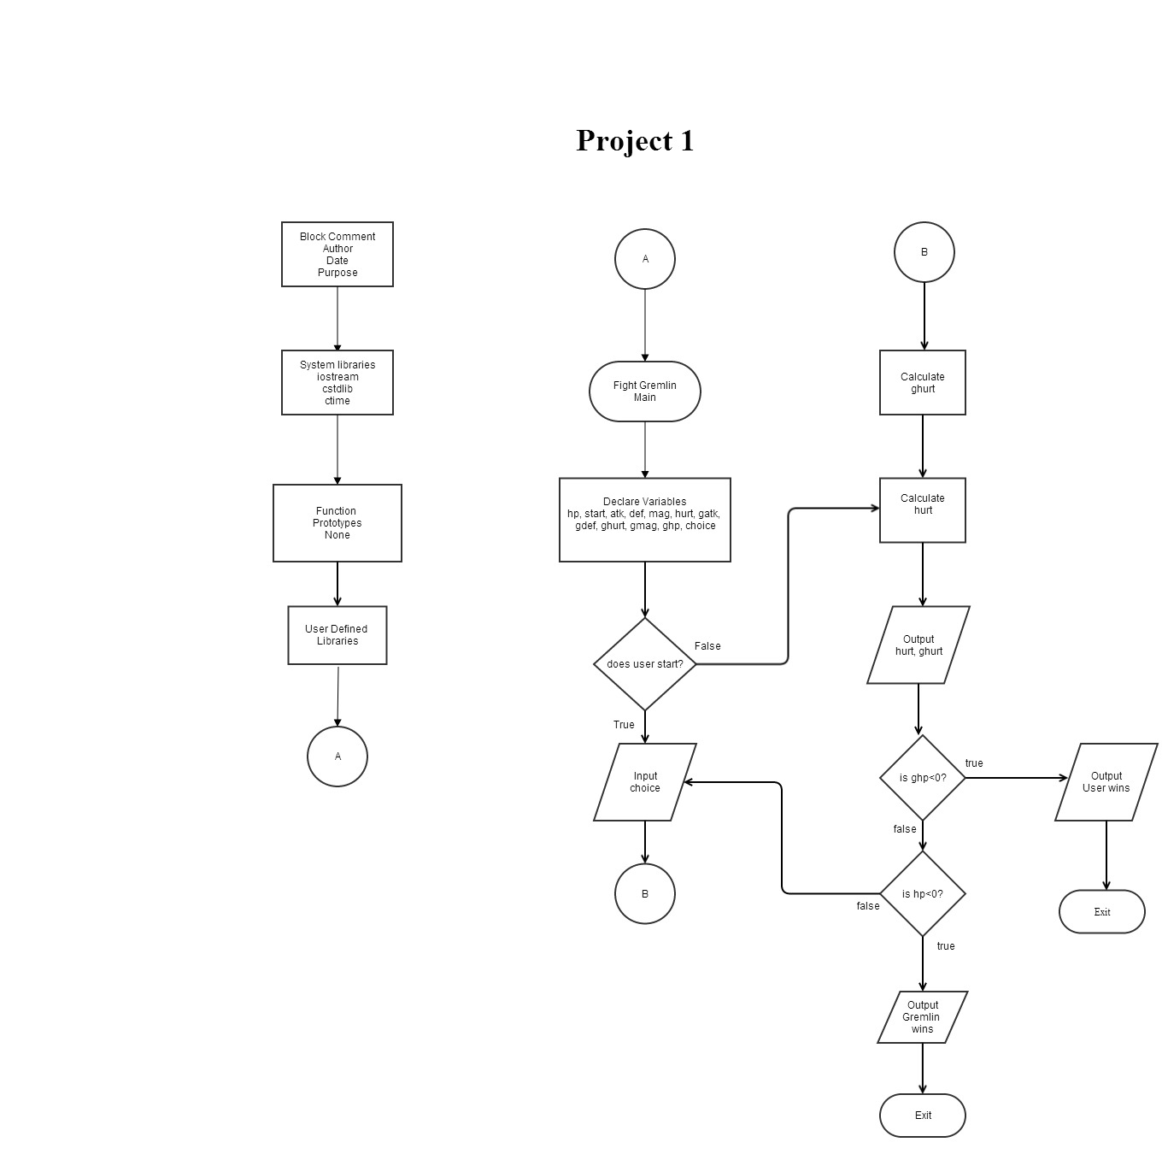

**Program Code**

*/\**

*\* File: main.cpp*

*\* Author: Nornubari Kanabolo*

*\* CSC 5 Project 1*

*\*/*

**#include <iostream>**

**#include <ctime>**

**#include <cstdlib>**

**using** **namespace** std;

**int** **main**(**int** argc, **char\*\*** argv){

*//Declare variables*

**int** choice;

**int** hp, start, atk, def, mag, hurt, gatk, gdef, ghurt, gmag, ghp;

    atk **=** 12;*//user attack*

    def **=** 18;*//user defense*

    mag **=** 7;*//user magic*

    gatk **=** 14;*//gremlin attack*

    gdef **=** 18;*//gremlin defense*

    gmag **=** 7;*//gremlin magic*

*//Random seed that determines who starts*

    start **=** rand()**%**2**+**1;

    hp **=** rand()**%**60**+**100;*//health points user starts with*

    ghp **=** rand()**%**40**+**100;*//health points gremlin starts with*

*//User starts*

**if** (start **==** 1)

    {

        cout**<<**"You attack first and swiftly!";

        cout**<<**endl;

*//User Menu*

**while** (hp **>** 0 **||** ghp **>** 0) {

        cout**<<**"Choose what move you want to execute"**<<**endl;

        cout**<<**"1 - Strong Attack"**<<**endl;

        cout**<<**"2 - Magic Attack"**<<**endl;

        cout**<<**"3 - Defensive Move"**<<**endl;

**do**

        {

            cin**>>**choice;

        }**while**(choice**>**3 **||** choice**<**1);

**switch** (choice)

        {

**case** 1**:**

            atk **=** rand()**%**20**+**10;

            def **=** rand()**%**10**+**10;

            mag **=** rand()**%**5;

**break**;

**case** 2**:**

            atk **=** rand()**%**5**+**10;

            def **=** rand()**%**10**+**10;

            mag **=** rand()**%**15;

**break**;

**case** 3**:**

            atk **=** rand()**%**10**+**10;

            def **=** rand()**%**20**+**10;

            mag **=** rand()**%**5;

**break**;

         }

*//Gremlin Menu decides which move it executes*

        choice **=** rand()**%**3;

**switch** (choice)

        {

**case** 1**:**

            gatk **=** rand()**%**20**+**10;

            gdef **=** rand()**%**10**+**10;

            gmag **=** rand()**%**5;

**break**;

**case** 2**:**

            gatk **=** rand()**%**5**+**10;

            gdef **=** rand()**%**10**+**10;

            gmag **=** rand()**%**15;

**break**;

**case** 3**:**

            gatk **=** rand()**%**10**+**10;

            gdef **=** rand()**%**20**+**10;

            gmag **=** rand()**%**5;

**break**;

        }

*//Damage to gremlin*

        ghurt **=** (atk **-** gmag) **-** (gdef**/**atk);

**if** (ghurt **<** 0)

        {

            ghurt **=** 0;

        }

        ghp **=** ghp **-** ghurt;

        cout**<<**"You did "**<<**ghurt**<<**" damage to the gremlin!";

        cout**<<**endl;

*//If user defeats gremlin*

**if** (ghp **<** 1)

        {

            cout**<<**"You destroyed the gremlin! You are victorious with "**<<**hp**<<**" hp to spare.";

            cout**<<**endl;

**return** 0;

        }

        cout**<<**"The gremlin now has "**<<**ghp**<<**" hp left.";

        cout**<<**endl;

        hurt **=** (gatk **-** mag) **-** (def**/**gatk);

**if** (hurt **<** 0)

        {

            hurt **=** 0;

        }

        hp **=** hp **-** hurt;

        cout**<<**"The gremlin administered to you "**<<**hurt**<<**" damage.";

        cout**<<**endl;

*//If gremlin defeats user*

**if** (hp **<** 1)

        {

            cout**<<**"You have been defeated. The gremlin lives with "**<<**ghp**<<**" hp remaining.";

            cout**<<**endl;

**return** 0;

        }

        cout**<<**"You now have "**<<**hp**<<**" hp left.\n"**<<**endl;

        }

        }

*//The gremlin starts*

**else**

    {

        cout**<<**"Gremlin attacked first!"**<<**endl;

**while** (hp **>** 0 **||** ghp **>** 0) {

        choice **=** rand()**%**3;

**switch** (choice)

        {

**case** 1**:**

            gatk **=** rand()**%**20**+**10;

            gdef **=** rand()**%**10**+**10;

            gmag **=** rand()**%**5;

**break**;

**case** 2**:**

            gatk **=** rand()**%**5**+**10;

            gdef **=** rand()**%**10**+**10;

            gmag **=** rand()**%**15;

**break**;

**case** 3**:**

            gatk **=** rand()**%**10**+**10;

            gdef **=** rand()**%**20**+**10;

            gmag **=** rand()**%**5;

**break**;

        }

*//Gremlin does damage to user*

        hurt **=** (gatk **-** mag) **-** (def**/**gatk);

**if** (hurt **<** 0)

        {

            hurt **=** 0;

        }

        hp **=** hp **-** hurt;

        cout**<<**"The gremlin hit you for "**<<**hurt**<<**" damage.";

        cout**<<**endl;

*//If the gremlin kills the user*

**if** (hp **<** 1)

        {

            cout**<<**"You were killed. The gremlin still has "**<<**ghp**<<**" hp left.";

            cout**<<**endl;

**return** 0;

        }

        cout**<<**"You now have "**<<**hp**<<**" hp left.";

        cout**<<**endl;

*//Next move for user if not killed*

        cout**<<**"Choose what move you want to execute"**<<**endl;

        cout**<<**"1 - Strong Attack"**<<**endl;

        cout**<<**"2 - Magic Attack"**<<**endl;

        cout**<<**"3 - Defensive Move"**<<**endl;

**do**{cin**>>**choice;}**while**(choice**>**3 **||** choice**<**1);

**switch** (choice)

        {

**case** 1**:**

            atk **=** rand()**%**20**+**10;

            def **=** rand()**%**10**+**10;

            mag **=** rand()**%**5;

**break**;

**case** 2**:**

            atk **=** rand()**%**5**+**10;

            def **=** rand()**%**10**+**10;

            mag **=** rand()**%**15;

**break**;

**case** 3**:**

            atk **=** rand()**%**10**+**10;

            def **=** rand()**%**20**+**10;

            mag **=** rand()**%**5;

**break**;

        }

*//User hurts gremlin*

        ghurt **=** (atk **-** gmag) **-** (gdef**/**atk);

**if** (ghurt **<** 0)

        {

            ghurt **=** 0;

        }

        ghp **=** ghp **-** ghurt;

        cout**<<**"You did "**<<**ghurt**<<**" damage to the gremlin!";

        cout**<<**endl;

*//User wins*

**if** (ghp **<** 1)

        {

            cout**<<**"You destroyed the gremlin! You are victorious with "**<<**hp**<<**" hp remaining!";

            cout**<<**endl;

**return** 0;

        }

        cout**<<**"The gremlin now has "**<<**ghp**<<**" hp left."**<<**endl;

        cout**<<**endl;

        }

      }

}