**Gremlin v. Wizard: The Rematch**

**Part 2**

**CSC 5 46024**

**Nornubari Kanabolo**

**07/30/2014**

**Introduction**

In this game the wizard wants revenge on the gremlin for defeating him years ago. He travels the mountains searching for the gremlin and finally finds him at the peak of Mountain of Mordor. The wizard challenges him to battle to settle the score once and for all. However, the gremlin has grown more powerful than their last meeting and the wizard does not know if he can defeat him or not. The program decides whether or not the wizard(user) or gremlin attacks first. The user enters an option of what he wants to do and the program makes the gremlin retaliate and administer damage to the user. The user options are:

1 – Strong Attack

2 – Magic Attack

3 – Defensive Move

This continues until either the wizard or gremlin’s health hits 0. There are 4 functions that keep the score of the wizard and gremlin, project the map of the encounter on the screen, and repeat the program so the score accumulates.

**Summary**

Lines of code: 234

Comment Lines: 34

White spaces: 29

This project used most of the concepts and constructs we learned so far in the course. It uses a series of if, if-else, switch, while, and do while loops to control who goes first, what happens when a command is made, and how the gremlin or user wins the battle. It also used functions with a one dimensional array to display the map of battle. It was difficult to figure out where exactly to put the proper while, if else, and do-while statements and why they would go there. The array was difficult to code because I originally did not know how to display ASCII characters.

**Pseudo Code**

***Display map***

***Do***

***Initialize***

***If the user starts***

***Then the user chooses a move he wants to execute***

***Both the user and gremlin’s health are greater than 0***

***If the ghurt is less than 0***

***Then the gremlin takes no damage***

***If ghurt is greater than 0 then the user did damage to the gremlin***

***If ghp is less than 0***

***User wins***

***Output 1 point for user***

***If hurt is less than 0***

***User takes no damage***

***If hurt is greater than 0 then gremlin did damage to user***

***If hp is less than 1***

***Gremlin wins***

***Output 1 point for gremlin***

***Else gremlin starts***

***If hurt is less than 0***

***User takes no damage***

***If hurt is greater than 0 then gremlin did damage to user***

***If hp is less than 1***

***Gremlin wins***

***Output 1 point for gremlin***

***If user still alive***

***Then the user chooses a move he wants to execute***

***If the ghurt is less than 0***

***Then the gremlin takes no damage***

***If ghurt is greater than 0 then the user did damage to the gremlin***

***If ghp is less than 0***

***User wins***

***Output 1 point for user***

***While the program repeats***

|  |  |  |  |
| --- | --- | --- | --- |
| Type | Variable Name | Description | Location |
| int | hp | User health points | If statement where calculation of damage to user is done |
|  | ghp | Gremlin health points | If statement where calculation of damage to gremlin is done |
|  | atk | User attack power | User menu choices of attack |
|  | gatk | Gremlin attack power | Gremlin menu choices of attack |
|  | mag | User magic power | User menu choices of attack |
|  | gmag | Gremlin magic power | Gremlin menu choices of attack |
|  | def | User defense power | User menu choices of attack |
|  | gdef | Gremlin defense power | Gremlin menu choices of attack |
|  | hurt | User damage taken | If statement where amount of damage taken by user is calculated |
|  | ghurt | Gremlin damage taken | If statement where amount of damage taken by gremlin is calculated |
|  | choice | Move execution choice | Menu choices for user and gremlin |
|  | Start | Determines who makes the first move | The first if statement of program |
|  | usr_score | Reference value for user score | Function prototypes |
|  | comp_score | Reference value for gremlin | Function prototypes |
|  | value_usr | Reference value for user counter | Function prototypes |
|  | value_comp | Reference value for gremlin counter | Function prototypes |
|  | usr_point | User score value | Variable declaration and function calls after user win |
|  | comp_point | Gremlin score value | Variable declaration and function calls after gremlin win |
|  | value_point | Counter value | Variable declaration and function calls after user or gremlin win |

|  |  |  |
| --- | --- | --- |
| Chapter | Constructs/Syntax | Location |
| 2 | Equality and relational operators  (==,>=,>,<=,<,-,+) | Where health, damage given, and taken are compared or calculation |
|  | If | Where the damage to user and gremlin are determined |
|  | If else | If the user starts the program or the monster does |
|  | While | While either the user or gremlins health points is greater than 0 or less than 1 |
|  | Do-while | Executes the menu at least once before checking if health for either is diminished |
|  | for | Loop to output the map |
| 3 | Switch | The menu options for the user and gremlin |
| 7 | Array | Displaying the map array at the start of the game |

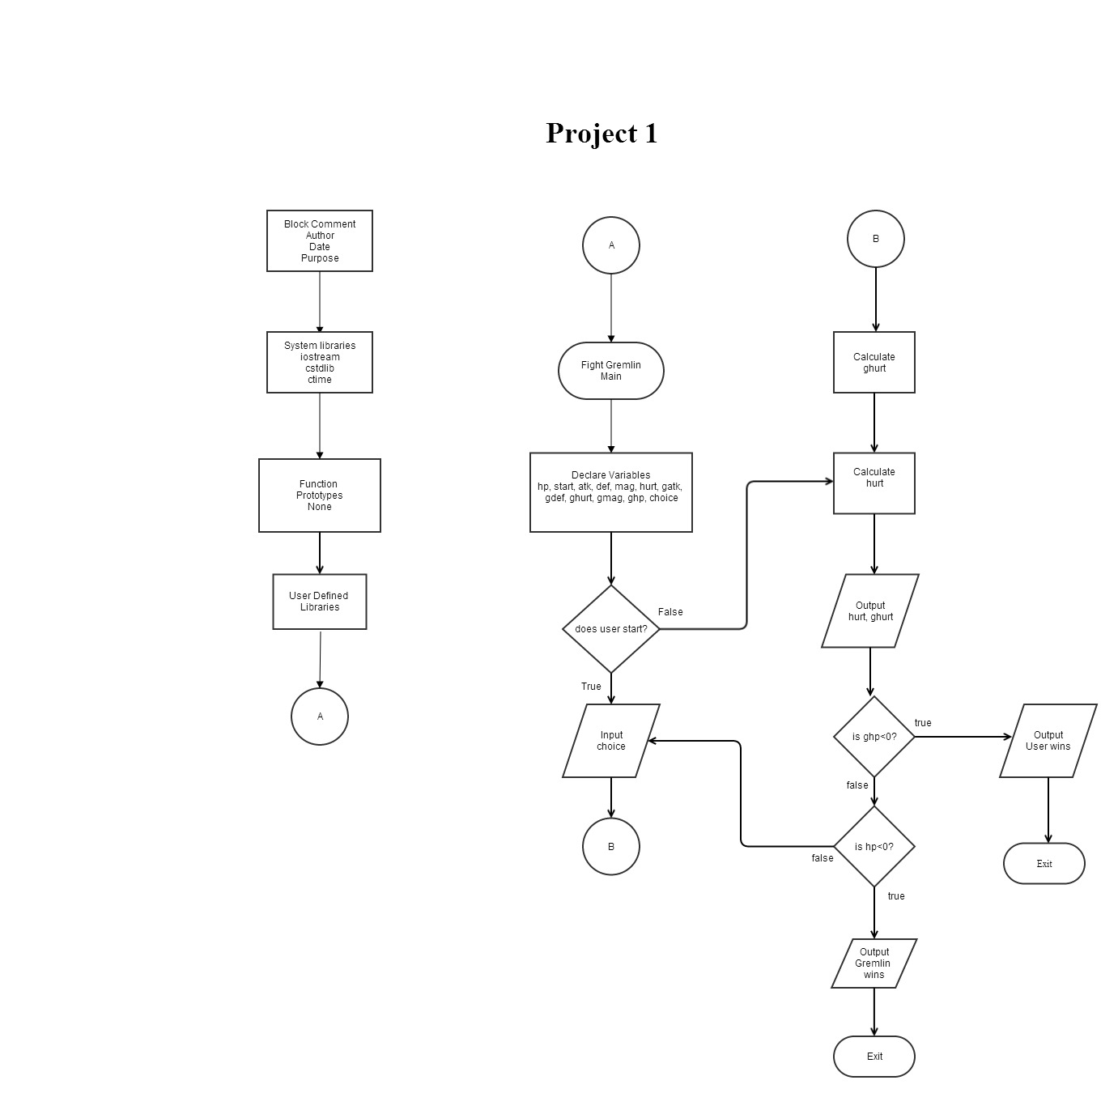

**Program Code**

*/\**

*\* File: main.cpp*

*\* Author: Nornubari Kanabolo*

*\* CSC 5 Project 1*

*\*/*

**#include <iostream>**

**#include <ctime>**

**#include <cstdlib>**

**using** **namespace** std;

**int** **main**(**int** argc, **char\*\*** argv){

*//Declare variables*

**int** choice;

**int** hp, start, atk, def, mag, hurt, gatk, gdef, ghurt, gmag, ghp;

    atk **=** 12;*//user attack*

    def **=** 18;*//user defense*

    mag **=** 7;*//user magic*

    gatk **=** 14;*//gremlin attack*

    gdef **=** 18;*//gremlin defense*

    gmag **=** 7;*//gremlin magic*

*//Random seed that determines who starts*

    start **=** rand()**%**2**+**1;

    hp **=** rand()**%**60**+**100;*//health points user starts with*

    ghp **=** rand()**%**40**+**100;*//health points gremlin starts with*

*//User starts*

**if** (start **==** 1)

    {

        cout**<<**"You attack first and swiftly!";

        cout**<<**endl;

*//User Menu*

**while** (hp **>** 0 **||** ghp **>** 0) {

        cout**<<**"Choose what move you want to execute"**<<**endl;

        cout**<<**"1 - Strong Attack"**<<**endl;

        cout**<<**"2 - Magic Attack"**<<**endl;

        cout**<<**"3 - Defensive Move"**<<**endl;

**do**

        {

            cin**>>**choice;

        }**while**(choice**>**3 **||** choice**<**1);

**switch** (choice)

        {

**case** 1**:**

            atk **=** rand()**%**20**+**10;

            def **=** rand()**%**10**+**10;

            mag **=** rand()**%**5;

**break**;

**case** 2**:**

            atk **=** rand()**%**5**+**10;

            def **=** rand()**%**10**+**10;

            mag **=** rand()**%**15;

**break**;

**case** 3**:**

            atk **=** rand()**%**10**+**10;

            def **=** rand()**%**20**+**10;

            mag **=** rand()**%**5;

**break**;

         }

*//Gremlin Menu decides which move it executes*

        choice **=** rand()**%**3;

**switch** (choice)

        {

**case** 1**:**

            gatk **=** rand()**%**20**+**10;

            gdef **=** rand()**%**10**+**10;

            gmag **=** rand()**%**5;

**break**;

**case** 2**:**

            gatk **=** rand()**%**5**+**10;

            gdef **=** rand()**%**10**+**10;

            gmag **=** rand()**%**15;

**break**;

**case** 3**:**

            gatk **=** rand()**%**10**+**10;

            gdef **=** rand()**%**20**+**10;

            gmag **=** rand()**%**5;

**break**;

        }

*//Damage to gremlin*

        ghurt **=** (atk **-** gmag) **-** (gdef**/**atk);

**if** (ghurt **<** 0)

        {

            ghurt **=** 0;

        }

        ghp **=** ghp **-** ghurt;

        cout**<<**"You did "**<<**ghurt**<<**" damage to the gremlin!";

        cout**<<**endl;

*//If user defeats gremlin*

**if** (ghp **<** 1)

        {

            cout**<<**"You destroyed the gremlin! You are victorious with "**<<**hp**<<**" hp to spare.";

            cout**<<**endl;

**return** 0;

        }

        cout**<<**"The gremlin now has "**<<**ghp**<<**" hp left.";

        cout**<<**endl;

        hurt **=** (gatk **-** mag) **-** (def**/**gatk);

**if** (hurt **<** 0)

        {

            hurt **=** 0;

        }

        hp **=** hp **-** hurt;

        cout**<<**"The gremlin administered to you "**<<**hurt**<<**" damage.";

        cout**<<**endl;

*//If gremlin defeats user*

**if** (hp **<** 1)

        {

            cout**<<**"You have been defeated. The gremlin lives with "**<<**ghp**<<**" hp remaining.";

            cout**<<**endl;

**return** 0;

        }

        cout**<<**"You now have "**<<**hp**<<**" hp left.\n"**<<**endl;

        }

        }

*//The gremlin starts*

**else**

    {

        cout**<<**"Gremlin attacked first!"**<<**endl;

**while** (hp **>** 0 **||** ghp **>** 0) {

        choice **=** rand()**%**3;

**switch** (choice)

        {

**case** 1**:**

            gatk **=** rand()**%**20**+**10;

            gdef **=** rand()**%**10**+**10;

            gmag **=** rand()**%**5;

**break**;

**case** 2**:**

            gatk **=** rand()**%**5**+**10;

            gdef **=** rand()**%**10**+**10;

            gmag **=** rand()**%**15;

**break**;

**case** 3**:**

            gatk **=** rand()**%**10**+**10;

            gdef **=** rand()**%**20**+**10;

            gmag **=** rand()**%**5;

**break**;

        }

*//Gremlin does damage to user*

        hurt **=** (gatk **-** mag) **-** (def**/**gatk);

**if** (hurt **<** 0)

        {

            hurt **=** 0;

        }

        hp **=** hp **-** hurt;

        cout**<<**"The gremlin hit you for "**<<**hurt**<<**" damage.";

        cout**<<**endl;

*//If the gremlin kills the user*

**if** (hp **<** 1)

        {

            cout**<<**"You were killed. The gremlin still has "**<<**ghp**<<**" hp left.";

            cout**<<**endl;

**return** 0;

        }

        cout**<<**"You now have "**<<**hp**<<**" hp left.";

        cout**<<**endl;

*//Next move for user if not killed*

        cout**<<**"Choose what move you want to execute"**<<**endl;

        cout**<<**"1 - Strong Attack"**<<**endl;

        cout**<<**"2 - Magic Attack"**<<**endl;

        cout**<<**"3 - Defensive Move"**<<**endl;

**do**{cin**>>**choice;}**while**(choice**>**3 **||** choice**<**1);

**switch** (choice)

        {

**case** 1**:**

            atk **=** rand()**%**20**+**10;

            def **=** rand()**%**10**+**10;

            mag **=** rand()**%**5;

**break**;

**case** 2**:**

            atk **=** rand()**%**5**+**10;

            def **=** rand()**%**10**+**10;

            mag **=** rand()**%**15;

**break**;

**case** 3**:**

            atk **=** rand()**%**10**+**10;

            def **=** rand()**%**20**+**10;

            mag **=** rand()**%**5;

**break**;

        }

*//User hurts gremlin*

        ghurt **=** (atk **-** gmag) **-** (gdef**/**atk);

**if** (ghurt **<** 0)

        {

            ghurt **=** 0;

        }

        ghp **=** ghp **-** ghurt;

        cout**<<**"You did "**<<**ghurt**<<**" damage to the gremlin!";

        cout**<<**endl;

*//User wins*

**if** (ghp **<** 1)

        {

            cout**<<**"You destroyed the gremlin! You are victorious with "**<<**hp**<<**" hp remaining!";

            cout**<<**endl;

**return** 0;

        }

        cout**<<**"The gremlin now has "**<<**ghp**<<**" hp left."**<<**endl;

        cout**<<**endl;

        }

      }

}