**SIMULATION OF CRYPTOCURRENCY SYSTEM USING BLOCKCHAIN**

An internship report submitted in partial fulfillment of the requirements for the award of the degree of

**Bachelor of Technology**

in

**Department of Computer Science and Engineering**

By

**JEROME B(CS22b1019)**

**SANDEEP U(CS22B1050)**

**N KATHIRAVAN (CS22B1036)**



**DEPARTMENT OF**

**COMPUTER SCIENCE AND ENGINEERING**

**NATIONAL INSTITUTE OF TECHNOLOGY PUDUCHERRY**

**KARAIKAL – 609 609**

**November 2023**

**BONAFIDE CERTIFICATE**

This is to certify that the internship report entitled "Simulation of Cryptocurrency system using Blockchain" has been submitted by JEROME.B, SANDEEP.U and N.KATHIRAVAN bearing the register numbers CS22B1019, CS22B1050 and CS22B1036 respectively. He has successfully completed the internship at NIT PUDUCHERRY under the supervision/guidance of Dr. Sanjay S Bankapur, Assistant Professor, affiliated with NIT PUDUCHERRY, during the period from 24/07/2023 to 07/11/2023.

The internship report is accepted as a partial fulfillment of the requirements for the award of the degree of Bachelor of Technology in the Department of Computer Science and Engineering at the National Institute of Technology, Puducherry, Karaikal, during the academic year 2025-26.

**Dr. Sanjay S Bankapur**

Internship Supervisor

Assistant Professor

NIT Puducherry.

**Dr. V Vani Dr. M Venkatesan**

Internship Coordinator Head of the Department Assistant Professor Assistant Professor

Department of CSE Department of CSE

NITPY, Karaikal NITPY, Karaikal

**ABSTRACT**

Blockchain technology has ushered in a transformative era, significantly impacting multiple industries. It explores the profound influence of blockchain on finance, healthcare, supply chain management, and more, establishing itself as a disruptive force.

This report also dives deep and gives a solution for creating a cryptocurrency wallet and its requirements. This report also deals with the future works to be made to make the market expansion of the wallet. It deals with tools regarding blockchain and testing of the wallet simulated. It consists of various architectures involved in the creation of the wallet and also explains the implementation in detail. It also makes a few points about the statistics involved in cryptocurrency in the real world. Beginning with the fundamentals, this report traces blockchain's journey to its present state. It elaborates on the core principles, consensus mechanisms, and the ascendancy of smart contracts.

Real-world case studies in finance, government, healthcare, and logistics illuminate the benefits of transparency, security, and efficiency. Simultaneously, it navigates the challenges and regulatory nuances confronting organizations adopting blockchain solutions.

**MOTIVATION**

Blockchain internship is embarking on a journey of innovation and transformation. The future of blockchain is very bright due to the digitalization of banking, as security is a big concern in dealing with money the concept of blockchain would be a boon to the use of cryptocurrency. It is a chance to make a difference and explore the unexplored and be a part of the next generation of digital pioneers. The concepts of blockchain are also going to play a major role in the future of many fields like medicine and healthcare, banking systems, car odometer tampering, the food industry, digital voting, and legal documentation.

A Blockchain internship allows us to be a part of the digital gold rush and make a contribution to the evolution of this transformative technology. Moreover, a blockchain internship provides a realm of opportunities and allows us to play pivotal roles and reshape many industries. In recent times the boom of cryptocurrencies like Ethereum, Bitcoin, Solana, etc.

**WORK DONE/Methodology**

**Decentralization vs Centralization:**

In the field of cryptocurrency, the fundamental choice between decentralization and centralization will determine the nature of digital currency. In a centralized structure, power is concentrated in a central entity, allowing a select few to manage, control, and monitor the entire network.

This approach is the exact opposite of decentralization, in which no one individual or organization holds power; instead, the network operates as a distributed, autonomous system. The path chosen for this cryptocurrency was decentralization, a better decision to avoid the concentration of control in the hands of a few traditional banking institutions.

**Proof-of-Work VS Proof-of-Stake:**

Another important decision in creating this cryptocurrency lies in the choice of the consensus mechanism, which determines how transactions are verified and are added to the blockchain. PoW, a respected pioneer, always ensures rock-solid security but at the cost of longer verification times.

On the other hand, PoS, which is increasingly popular, boasts efficiency with faster verification, but faces security issues when user participation is limited.

PoW provides an impenetrable shield from the earliest stages, protecting the network from potential threats. As the number of users increases, the transition to PoS becomes efficiency in danger with cryptocurrency expansion.

**Architecture:**

1. Blockchain:
   * Manages blockchain using PoW, Sustains data in interconnected blocks.
2. Blockchain Account:
   * Represents user accounts with keys.
   * Monitors account balances.
3. Cryptocurrency Wallet:
   * Graphical interface for user actions.
   * Enables secure key generation, transactions, and balance checks.
4. Server:
   * Listens for connections, maintains data consistency.

Data Management:

1. Blockchain Data (blockchain.json):
   * JSON format for local and server storage.
2. User Account Data (accounts.json):
   * JSON format for user info.

Interactions:

1. Users engage with the Cryptocurrency Wallet.
2. Wallet syncs data with the server after transactions.



**RESULT Analysis**

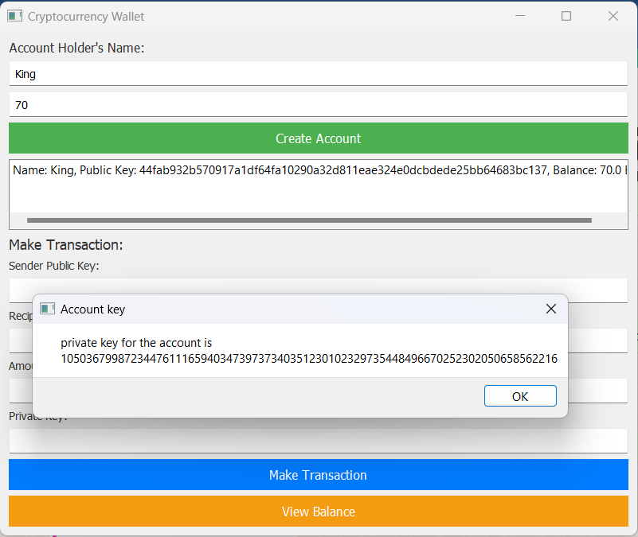

This is the Cryptocurrency wallet created separately for the crytocoin created. It stores the accounts that were created in a separate JSON file named “accounts.json” and the blockchain is stored in a different JSON file named “blockchain_data.json”. When the first account is created, along with the account `Genesis` block is created in blockchain_data.json file. When a transaction takes place, the changes is displayed in blockchain_data.json file by creation of new block. And the balances of the accounts involved in the transaction are also modified automatically.

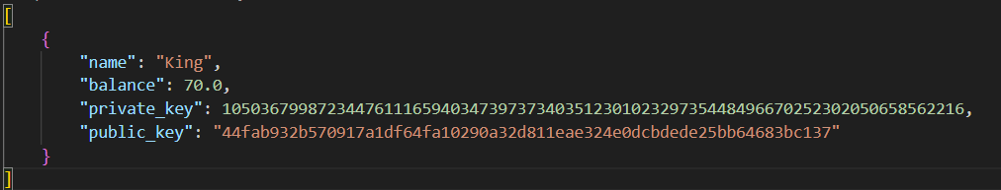



**Outcome of the internship**

* Creating a server-client model of the network using Socket programming.
* Obtained a good understanding of Knowledge regarding object-oriented programming in Python.
* Learning Database management using JSON interchangeable file format.
* To obtain Knowledge of Blocks and Hashing.
* Knowledge of the history of Blockchain.
* Implementation of Graphical user Interface using PYQT5.