Evidence-Based Fake News Detection with Calibrated Scoring
Mugilan K S
Undergraduate Student, B.E. Computer Science and Engineering
Department of Computer Science and Engineering, Kongu Engineering College
Perundurai, Erode, Tamil Nadu
mugilanks.23cse@kongu.edu
Nandha Kumar S
Undergraduate Student, B.E. Computer Science and Engineering
Department of Computer Science and Engineering, Kongu Engineering College
Perundurai, Erode, Tamil Nadu
nandhakumars.23cse@kongu.edu
Nandhini A
Undergraduate Student, B.E. Computer Science and Engineering
Department of Computer Science and Engineering, Kongu Engineering College
Perundurai, Erode, Tamil Nadu
nandhinia.23cse@kongu.edu
Kannukkiniyal M (Corresponding Author)
Assistant Professor
Department of Computer Science and Engineering, Kongu Engineering College
Perundurai, Erode, Tamil Nadu
kannukkiniyal.cse@kongu.edu
Evidence-Based Fake News Detection with Calibrated Scoring
Abstract
Most automated fake news detectors judge an article by the way it is written, yet writing style is the one thing a fabricator fully controls. This paper presents a checking system that weighs evidence the author cannot control. A reader submits a link, pasted text, a screenshot or a video; the system works out what the message asserts, in English, Tamil or Hindi, and checks each claim against independent news coverage, rulings published by fact-checkers, the current week’s reporting on its subject and encyclopedia entries for false premises. Writing signals are converted into likelihood ratios estimated from labelled data, but they are allowed to count only against a story. A fixed, ordered set of rules then gives a verdict, names the rule that decided it, and abstains when the evidence is insufficient. On 120 held-out ISOT articles the system matched a hand-weighted baseline within one article while reducing calibration error on its accusations from 0.267 to 0.152, and it rated none of six carefully written fabrications as credible, against four for the baseline. On 200 claims ruled on by professional fact-checkers, sealed before development and never tuned on, it gave the fact-checker’s verdict or an acceptable one for 141, withheld a verdict for 47 and erred on 12. For platforms and newsrooms, an auditable verdict that can say “cannot verify” proves more useful than a confident score.
Keywords: Fake news detection; Evidence-based verification; Calibration; Abstention; Fact-checking
1. Introduction
Misinformation now ranks among the most serious short-term risks facing societies; the World Economic Forum (2026) placed misinformation and disinformation second among global risks over a two-year horizon. For organisations the problem is concrete. A fabricated circular on a bank’s letterhead, a forged government notice or a cloned news site can travel through messaging groups faster than any correction, and the cost of a wrong response falls on the organisation whose name was borrowed.
Automated detection has largely been treated as text classification: a model reads an article and labels it fake or real from its wording. Reported scores on public datasets are high, but much of that accuracy comes from properties of the corpus rather than from the truth of the stories. Verma (2026) showed that on the widely used ISOT corpus a classifier given only the subject field of each article, with the text discarded, reaches an F1 score of 1.000. Large language models sharpen the weakness. Chen and Shu (2024) found that misinformation written by such models is harder for people and detectors to spot than human-written misinformation with the same meaning, because the surface cues that classifiers rely on are exactly what a fluent model produces on request.
We start from a different premise: a piece of evidence should count in favour of a story only if its author could not have produced it. Clean prose, a neutral tone and quoted sources cost a careful fabricator nothing, so their absence may raise suspicion but their presence should never establish credibility. Independent reporting, a fact-checker’s ruling, an encyclopedia entry and the publisher’s verifiable identity lie outside the author’s reach, and they may count in either direction (Figure 1).
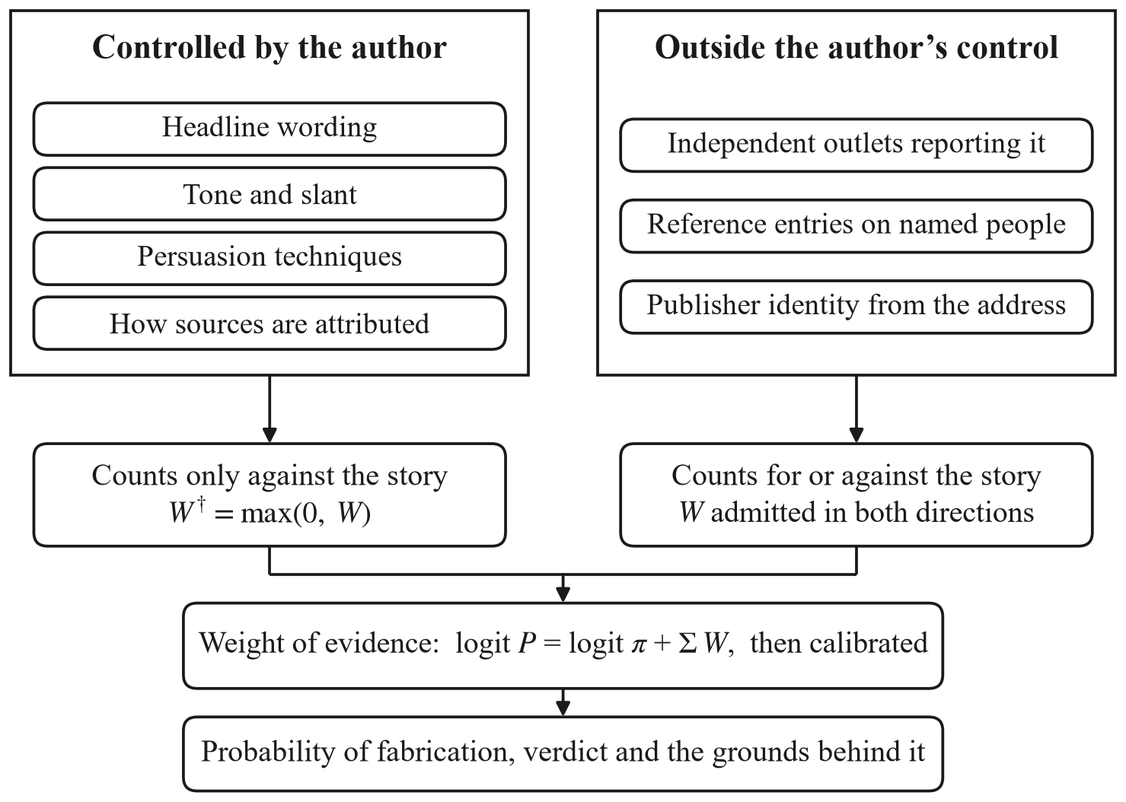
Figure 1. Evidence the author controls counts only against a story; evidence outside it counts either way
The resulting system is built on the MERN stack and deployed as a public web application. It makes three contributions. First, it applies this one-sided rule inside a weight-of-evidence model whose weights are likelihood ratios estimated from data and calibrated against held-out outcomes. Second, it separates a check that found nothing from one that could not run, and abstains rather than guess when the evidence is insufficient. Third, it is evaluated on claims chosen by others: rulings published by 29 professional fact-checking desks, with the test portion sealed before development began.
2. Related Work
Braun et al. (2025) present DEFAME, the system closest to ours and the base for this work. DEFAME plans a fact-check in six stages, calls web search, image search, reverse image search and geolocation tools, and returns a verdict with a written justification. It reports accuracies of 70.5% on AVeriTeC, 83.9% on VERITE and 69.7% on ClaimReview2024+, a set of claims made after its model’s training cut-off. Three of its documented limits shaped our design. It relies on the search engine’s own trustworthiness signals rather than weighing sources, it returns a categorical verdict without a probability, and it depends on GPT-4o at about four minutes and USD 0.13 per claim. Our system weighs sources explicitly, attaches a calibrated probability to every verdict and runs on free model tiers, with a median of 9.3 seconds per claim on our sealed test.
Several recent systems use language models as advisers rather than judges. Hu et al. (2024) found that a large model reasoning about an article detects fake news less accurately than a small fine-tuned classifier, but that its rationales improve the classifier when supplied as features. Wang et al. (2024) draw competing evidence for and against a claim, have a language model explain each side, and decide between them in a separate inference step. Both remain anchored to the text of the article. Work on automated fact-checking (Guo et al., 2022) and the AVeriTeC benchmark (Schlichtkrull et al., 2023) instead place retrieved evidence at the centre, which is the position we take, and we follow AVeriTeC in allowing a “not enough evidence” outcome.
Two further strands inform the scoring. Source reputation can be measured: Lin et al. (2023) showed that independent sets of news-domain quality ratings agree closely, which justifies using published ratings as a prior. Calibration and abstention come from machine learning more broadly. Minderer et al. (2021) found that calibration differs markedly between model families, so a stated confidence must be measured before it is trusted; Silva Filho et al. (2023) survey the methods for correcting it, and Hendrickx et al. (2024) review classifiers that may decline to predict. The persuasion-technique taxonomy of Da San Martino et al. (2020) supplies the vocabulary for one of our writing checks.
3. Proposed System
3.1 Reading the Message
A reader may submit an article link, pasted text, a screenshot or a video link (Figure 2). Links are read from the publisher’s page, screenshots through optical character recognition and videos through their caption tracks. People rarely paste a tidy claim: they ask whether something is true, pass on what they heard, forward warnings in capitals, mock a claim, or write Tamil in English letters. A single model call at temperature zero therefore reads the message first. It returns the language, the kind of message and its tone, and up to three claims, each rewritten as a neutral English sentence with its time frame and search terms. A question is checked as the claim it asks about, a hedge as the claim passed on, and sarcasm as the claim being mocked. Input with nothing checkable in it, such as an opinion, a forecast or a call to action, is refused with the reason. Before this step existed, pattern rules alone decided what could be checked. They looked for capitalised names, and so refused every question and every message in Tamil or Hindi.
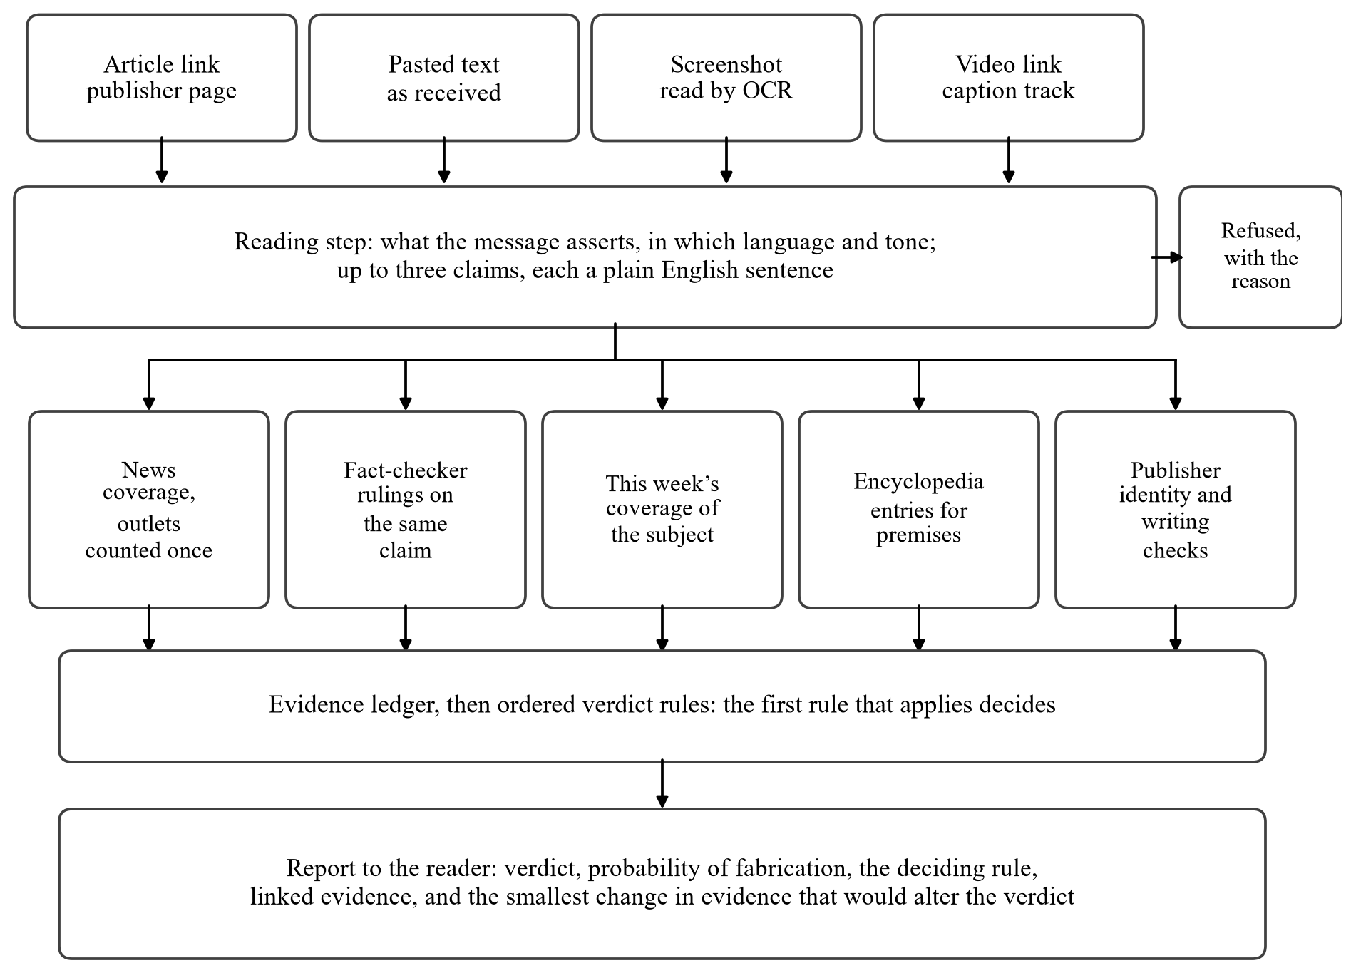
Figure 2. Processing pipeline of the proposed system
3.2 Evidence Channels
Each claim is checked through five channels that run in parallel.
News coverage. The claim is searched in Google News as a sentence, as a headline and by keyword. A second model call reads each headline and decides whether it concerns the same event and whether it supports or contradicts the claim, quoting the words that state the reported fact. The results are then reduced to the sources behind them: outlets under one owner count once, and copies of a single wire-agency story count once.
Fact-checker rulings. Viral rumours are seldom reported as news, so a news search can only fail to find them. Fact-checking desks publish their rulings with ClaimReview markup, which Google indexes. Each candidate ruling is shown to a model that must decide whether it examined the same assertion, so a ruling on a similar but different claim does not count.
This week’s coverage. An invented event about a heavily covered subject leaves a trace in the rest of the week’s news. On the day a message claimed that the Prime Minister had resigned, outlets were reporting him opening projects in Chennai. Headlines from the past seven days that could not be true if the claim were are marked, with the words that show it.
Encyclopedia entries. A story built on a false premise describes something no outlet reports. The people and organisations it names are looked up in Wikipedia, and a conflict counts only if the model quotes the entry and the quotation is actually found in it.
Publisher and writing. The publisher is identified from the web address rather than the name on the page, so a page calling itself “BBC News” at bbc-breaking-news.xyz does not inherit the BBC’s record. Four writing checks look for clickbait, slant, persuasion techniques and missing attribution, and each must quote the words it reacts to.
Every channel records whether it actually ran. A search that failed because of a rate limit or a timeout is reported as unavailable and adds nothing, so an outage is never presented to the reader as an absence of coverage. Our first version made exactly that mistake, telling readers that no outlet carried a wire story that five major outlets were reporting at the time.
3.3 Weight of Evidence
Each observation o is converted into a likelihood ratio and expressed in decibans (Equation 1). The ratios are estimated from labelled articles by grouping observations into bands and counting, with a Jeffreys prior, and each estimate is shrunk to the conservative end of its 95% interval, so a band with few articles behind it contributes nothing. The log-odds that a story is fabricated are the prior log-odds plus the sum of the weights (Equation 2). The prior π is set by the publisher’s record, from 0.02 for an outlet with a strong record to 0.35 for a social-media post; these priors are our own choice rather than measurements, and every report says so.
W(o) = 10 log₁₀ [ P(o | fabricated) / P(o | genuine) ] (1)
logit P(fabricated | O) = logit π + Σ_{o ∈ O} W(o) (2)
W†(o) = max(0, W(o)), for every o the author controls (3)
For observations the author controls, only the part that counts against the story is kept (Equation 3). On a corpus of crude fakes, fluent writing does predict a genuine article, and an unconstrained model learns to reward it; a careful fabricator writes fluently on purpose, so that lesson fails exactly when it matters. The four writing checks read the same prose and are correlated, with a mean pairwise correlation of 0.55, so their combined weight is scaled by the effective number of independent checks, 1.52 of 4, and capped at 8 decibans. The summed log-odds are finally calibrated with isotonic regression on held-out data. The clamp of Equation 3 is applied again after calibration, because the first fitted map had quietly restored the weight the clamp removes.
3.4 Verdict Rules and Abstention
The probability and the verdict answer different questions: the probability is a graded belief, while the verdict states what has been established. The verdict comes from an ordered list of eighteen rules over the evidence; the first rule that applies decides, and its name and its record on labelled messages are shown to the reader. A fact-checker’s ruling of false on the same claim, or two independent outlets contradicting it, makes a story FAKE. A confirmed claim carrying a contradicted one is PARTLY FALSE, two independent outlets confirming every claim make it REAL, and a claim presented as new but confirmed only by coverage weeks old is old news. When nothing settles the claim, the verdict is CANNOT VERIFY even if the probability is low, because most stories are genuine and a low prior is not a confirmation. Since the rules are fixed, the system can also say what would change a verdict. It reruns them with each line of evidence removed or with hypothetical evidence added, and reports the smallest change that alters the outcome.
3.5 Implementation
The application uses MongoDB, Express, React and Node.js. Every model call passes through one gateway that routes each task to the provider that measured best on it: Google Gemini for the judgements, NVIDIA NIM as the fallback, and a local Llama 3.1 8B model for eight writing and search tasks where a GPU is available. A multilingual MiniLM pair model of 118 million parameters, fine-tuned by the authors and exported as a 42 MB quantised file, matches claims to fact-checks and to earlier checks, and vetoes contradictions that a fallback model reports but the encyclopedia entry does not state. Every check is stored with the exact inputs the rules read, so any verdict can be reproduced from its record, and the backend has 519 automated tests that run without network access.
4. Evaluation Design
Held-out ISOT articles. After length filtering, ISOT holds 21,379 genuine and 21,915 fabricated articles. We used 239 articles whose writing checks had all come from the language model, split by a hash of the article identifier into 119 for estimating the ratios and 120 for testing. Sources were hidden and agency prefixes removed, since every genuine ISOT article comes from Reuters. Historical articles have no live coverage, so this test measures only the writing half of the model. The baseline is our earlier hand-weighted sum applied to the same check outputs.
Adversarial set. Ten items written by the authors: five fabrications in plain newsroom style with named sources and no clickbait, one high-impact fabrication with manipulation signals, two genuine reports, a satirical piece and an opinion column.
Plain-model benchmark. 22 claims about October 2026, from wrong figures to true reports, were put both to the full system and to the same hosted model, Gemini 3.1 Flash-Lite, asked with the date and nothing else to read.
Fact-checked rulings. 320 claims on which 29 fact-checking desks, among them FACTLY, NewsMobile, AFP Fact Check, The Quint, BOOM and Full Fact, published rulings between October 2024 and October 2026; 211 were rated false, 90 misleading and 19 true. A false rating expects FAKE and accepts PARTLY FALSE or MISLEADING, a misleading rating expects MISLEADING and accepts the other two, and a true rating expects REAL. The labelling desk’s own ruling is hidden during a run. The set was split once, before any result was seen: rulings 1–120 for development, and rulings 121–320 sealed, run whole once per release candidate, reported only as totals and never inspected.
5. Results
5.1 Held-Out Articles and Adversarial Items
Table 1 compares the two scoring rules on the 120 held-out articles. Accuracy is the same within one article: 114 correct for the proposed rule (95.0%, 95% interval 89.5–97.7%) and 115 for the baseline (95.8%, 90.6–98.2%). The difference lies in the accusations. Expected calibration error (ECE) on stories called fabricated fell from 0.267 to 0.152, a reduction of 43%, with precision unchanged at about 0.97. The proposed rule ranks slightly worse, with an ROC-AUC of 0.951 against 0.978, which is the cost of Equation 3: on ISOT the only evidence that could clear an article is its style, and the rule refuses to use it. Removing the clamp raised ROC-AUC to 0.983 but also raised the ECE on accusations to 0.191, so we kept the clamp. On the adversarial set the baseline rated four of the six deceptive items as credible; the proposed rule rated none as credible and condemned neither genuine report.
Table 1. Held-out comparison of the two scoring rules (120 ISOT articles)
Rule | Accuracy | ROC-AUC | ECE | ECE on accusations | Precision on accusations | Brier
Hand-weighted baseline | 0.958 | 0.978 | 0.237 | 0.267 | 0.968 | 0.101
Proposed rule | 0.950 | 0.951 | 0.246 | 0.152 | 0.967 | 0.117

5.2 Current Claims Against a Plain Language Model
On the 22 current claims the system answered all 22 correctly and the plain model 15. The plain model’s correct answers are weaker than they appear: it called 4 of the 9 true reports fake, among them the Reserve Bank’s rate rise and India’s 85-medal total at the Asian Games, so its “fake” on a false claim reflects a habit rather than a finding, and it cites nothing a reader could check.
5.3 Fact-Checked Rulings
Table 2 gives the results. The first release candidate gave the desk’s verdict for 97 of the 200 sealed rulings, an acceptable verdict for 34, no verdict for 52 and a wrong one for 17. Its wrong calls on claims rated true prompted one further round of corrections, made only on development rulings and on a second development pool of 160 rulings from outside India. In that round we found that our reader of desk ratings had taken ratings written as sentences, such as “That’s not correct”, as true; a script that reads only the ratings, without the system’s answers, corrected four sealed labels from true to false. The first candidate’s totals stand on the old labels and cannot be rescored, since a sealed run keeps totals only, so part of the later fall in wrong verdicts may be due to the labels rather than the code. The final code gave the desk’s verdict for 102, an acceptable one for 39, none for 47 and a wrong one for 12, at a median of 9.3 seconds per claim.
Table 2. Outcomes on claims ruled on by fact-checkers
Rulings and code | Claims | Desk’s verdict | Acceptable | No verdict | Wrong
Development 1–120, final code | 120 | 57 | 27 | 33 | 3
Sealed 121–320, first candidate | 200 | 97 | 34 | 52 | 17
Sealed 121–320, final code | 200 | 102 | 39 | 47 | 12
of which rated false | 130 | 98 | 4 | 26 | 2
of which rated misleading | 57 | 1 | 35 | 14 | 7
of which rated true | 13 | 3 | 0 | 7 | 3

The system fails far more often by withholding a verdict than by giving a wrong one. Of 130 claims rated false, 102 were called fake, partly false or misleading and 2 were called real. Claims rated true are the weak point, with 3 of 13 confirmed. In development such failures came from events reported by too few outlets, rankings that no headline states, and counts accumulated over different dates. The result also depends on the hosted model: on rulings 1–60, switching Gemini off raised the number of claims left without a verdict from 21 to 37, while wrong verdicts stayed at 2.
5.4 Explanations and Claim Memory
Because rules decide the verdict, every explanation can be tested. A separate script recomputed each statement the explainer makes on 94 stored checks, 380 scenario ledgers and 2,000 random ones, and all 33,429 statements agreed. Across 20,000 further random ledgers, adding a fact-checker’s false rating, an encyclopedia contradiction or two more contradicting outlets never made a verdict milder, and adding confirming evidence never made it harsher. On 46 held-out claim pairs the claim memory filed 44 correctly and merged no two different claims.
6. Discussion
6.1 Implications for Practice
For platforms and messaging services, a verdict that comes with its reason and a willingness to say “cannot verify” is more useful than a confident score. An unexplained label invites distrust the first time it is wrong, whereas a verdict traced to named outlets and a stated rule can be checked and appealed. For organisations whose name carries weight, such as banks, government departments and newsrooms, reading identity from the web address stops lookalike sites from borrowing their record. In our tests five lookalikes of the BBC, Reuters and the Associated Press each inherited the real outlet’s rating when the publisher was taken from the page, and none did when it was taken from the address. For regulators, every verdict can be traced to a rule, the outlets involved and the quoted text. The system reads Tamil and Hindi as readily as English, which matters where misinformation travels in regional languages, and it runs on free model tiers. In this way the work supports Sustainable Development Goal 16, target 16.10, on public access to information.
6.2 Limitations
The likelihood ratios come from 239 articles, so some bands are too thin to estimate, and the publisher priors are set by hand. The adversarial set and the plain-model benchmark are small and were written by the authors. The rulings set is labelled by the desks, but only 19 of its 320 claims are rated true, too few to measure that class closely. Verdicts depend on Google News, the fact-check index, Wikipedia and a hosted model whose free daily quota, once spent, leaves slower and more cautious fallbacks. Stance is judged from headlines rather than full articles, which is the main reason true claims go unconfirmed. Manipulated images and synthetic video are not analysed directly. Finally, we did not run DEFAME on our data, so the comparison in Section 2 is one of design, not a benchmark result.
7. Conclusion
We built and deployed a fake news checker that weighs evidence by who controls it. Writing signals may count only against a story, while support must come from independent outlets, fact-checkers, reference entries and a publisher identified by its address. Every weight is a likelihood ratio estimated from data, and the combined score is calibrated. On held-out ISOT articles the system matched a hand-weighted baseline’s accuracy while cutting calibration error on its accusations by 43%, and it rated none of six careful fabrications as credible. On 200 sealed claims ruled on by professional fact-checkers it gave the desk’s or an acceptable verdict for 141 and a wrong verdict for 12. Future work will address the claims it leaves unanswered, true ones especially, by reading article bodies rather than headlines; it will also enlarge the estimation corpus so that the priors can be measured, and move the remaining judgements onto models the authors run themselves.
References
Braun, T., Rothermel, M., Rohrbach, M., & Rohrbach, A. (2025). DEFAME: Dynamic evidence-based fact-checking with multimodal experts. In Proceedings of the 42nd International Conference on Machine Learning (Vol. 267). PMLR. https://arxiv.org/abs/2412.10510
Chen, C., & Shu, K. (2024). Can LLM-generated misinformation be detected? In Proceedings of the Twelfth International Conference on Learning Representations. https://arxiv.org/abs/2309.13788
Da San Martino, G., Barrón-Cedeño, A., Wachsmuth, H., Petrov, R., & Nakov, P. (2020). SemEval-2020 Task 11: Detection of propaganda techniques in news articles. In Proceedings of the Fourteenth Workshop on Semantic Evaluation (pp. 1377–1414). https://doi.org/10.18653/v1/2020.semeval-1.186
Guo, Z., Schlichtkrull, M., & Vlachos, A. (2022). A survey on automated fact-checking. Transactions of the Association for Computational Linguistics, 10, 178–206. https://doi.org/10.1162/tacl_a_00454
Hendrickx, K., Perini, L., Van der Plas, D., Meert, W., & Davis, J. (2024). Machine learning with a reject option: A survey. Machine Learning, 113, 3073–3110. https://arxiv.org/abs/2107.11277
Hu, B., Sheng, Q., Cao, J., Shi, Y., Li, Y., Wang, D., & Qi, P. (2024). Bad actor, good advisor: Exploring the role of large language models in fake news detection. Proceedings of the AAAI Conference on Artificial Intelligence, 38(20), 22105–22113. https://doi.org/10.1609/aaai.v38i20.30214
Lin, H., Lasser, J., Lewandowsky, S., Cole, R., Gully, A., Rand, D. G., & Pennycook, G. (2023). High level of correspondence across different news domain quality rating sets. PNAS Nexus, 2(9), pgad286. https://doi.org/10.1093/pnasnexus/pgad286
Minderer, M., Djolonga, J., Romijnders, R., Hubis, F., Zhai, X., Houlsby, N., Tran, D., & Lucic, M. (2021). Revisiting the calibration of modern neural networks. In Advances in Neural Information Processing Systems (Vol. 34). https://arxiv.org/abs/2106.07998
Schlichtkrull, M., Guo, Z., & Vlachos, A. (2023). AVeriTeC: A dataset for real-world claim verification with evidence from the web. In Advances in Neural Information Processing Systems (Vol. 36, Datasets and Benchmarks Track). https://arxiv.org/abs/2305.13117
Silva Filho, T., Song, H., Perello-Nieto, M., Santos-Rodriguez, R., Kull, M., & Flach, P. (2023). Classifier calibration: A survey on how to assess and improve predicted class probabilities. Machine Learning, 112(9), 3211–3260. https://doi.org/10.1007/s10994-023-06336-7
Verma, Y. (2026). What does 99% accuracy measure? A reproducible audit of shortcut learning in a widely used fake news corpus (arXiv:2609.25006). arXiv. https://arxiv.org/abs/2609.25006
Wang, B., Ma, J., Lin, H., Yang, Z., Yang, R., Tian, Y., & Chang, Y. (2024). Explainable fake news detection with large language model via defense among competing wisdom. In Proceedings of the ACM Web Conference 2024 (pp. 2452–2463). https://doi.org/10.1145/3589334.3645471
World Economic Forum. (2026). Global risks report 2026. https://www.weforum.org/publications/global-risks-report-2026/

