CHAPTER 1
INTRODUCTION

MERN Stack

MERN Stack is a popular full-stack JavaScript technology stack used for developing modern web applications. MERN stands for MongoDB, Express.js, React, and Node.js. It provides technologies for developing the frontend, backend, and database of a web application.

1.2 Importance of MERN Stack

MERN Stack simplifies web application development by using JavaScript across different layers of the application. It helps developers build applications faster, reduce development complexity, and create dynamic and scalable web applications. It is widely used for developing interactive and responsive applications.

1.3 Basic Terminologies
- MongoDB: A NoSQL database used to store and manage application data in document format.
- Express.js: A lightweight web framework for Node.js used to develop backend applications and APIs.
- React: A JavaScript library used to create dynamic and interactive user interfaces.
- Node.js: A JavaScript runtime environment used to execute JavaScript on the server side.
1.4 Components of MERN Stack

1.4.1 MongoDB
MongoDB is a NoSQL database that stores data in flexible document-based formats. It is used to store and retrieve application data efficiently.
1.4.2 Express.js
Express.js is a backend framework built on Node.js. It is used to create server-side applications, handle HTTP requests, and develop REST APIs.
1.4.3 React
React is a JavaScript library used to develop interactive and reusable user interface components. It supports component-based development and helps create dynamic web pages.
1.4.4 Node.js
Node.js is a JavaScript runtime environment that allows JavaScript code to run on the server. It is commonly used with Express.js to build backend services.
1.5 Operations in MERN Stack
Common operations include:
- Create: Adding new data to the application.
- Read: Retrieving stored data.
- Update: Modifying existing data.
- Delete: Removing data from the database.
- API Communication: Transferring data between frontend and backend.
1.6 Need for MERN Stack
MERN Stack provides:
- Full-stack development using JavaScript
- Faster and easier development
- Efficient database management
- Dynamic and interactive user interfaces
- Reusable React components
- Scalable backend applications
- Easy communication between frontend and backend
1.7 Applications of MERN Stack
MERN Stack is used in:
- E-commerce applications
- Online food ordering systems
- Social media applications
- Content management systems
- Booking and reservation systems
- Real-time web applications
- Business and management applications

CHAPTER 2

METHODOLOGY
2.1 Objective
The main objective of QuizNest – Online Quiz System is to develop a secure, user-friendly, and efficient web application for conducting and managing online quizzes using the MERN Stack. The system aims to automate quiz evaluation and make student and quiz management easier.
The specific objectives of the system are:
- To develop a full-stack web application using MongoDB, Express.js, React.js, and Node.js.
- To provide secure student registration and login using JWT authentication and bcryptjs.
- To provide separate functionalities for students and administrators.
- To allow students to browse, search, filter, and attempt quizzes based on category and difficulty level.
- To provide an interactive quiz interface with question navigation and progress tracking.
- To automatically evaluate answers and generate scores and percentages.
- To display quiz results and performance including correct and wrong answers.
- To maintain quiz attempt history for students.
- To allow administrators to create, edit, and delete quizzes and questions.
2.2 Problem Statement
Traditional quiz systems often require manual question preparation, answer evaluation, score calculation, and result management. These processes take time and may lead to errors. Students may face difficulties in accessing quizzes, viewing results, reviewing answers, and tracking their previous performance. Administrators may also find it difficult to manage quizzes, questions, student details, and results manually. Security issues such as unauthorized access and early exposure of correct answers may also occur. Therefore, there is a need for a simple, secure, and reliable online quiz system that provides quiz participation, automatic evaluation, performance tracking, and easy administration in one platform.

2.3 Project description
The QuizNest – Online Quiz System is a MERN stack-based web application that provides separate functionalities for Students and Administrators to make online quiz participation, evaluation, and management simple and efficient.

Student Functionalities
- User Registration and Login: Students can create an account and log in securely to access the quiz system.
- Quiz Browsing: Students can view the available quizzes and explore quizzes based on different categories and difficulty levels.
- Quiz Search and Filter: Students can search for quizzes and filter them according to category and difficulty level.
- Quiz Attempt: Students can attend quizzes through an interactive interface and answer questions one by one.
- Question Navigation: Students can navigate between questions and keep track of their progress while attempting a quiz.
- Quiz Submission: Students can submit their answers after completing the quiz.
- Automatic Evaluation: The system automatically evaluates the submitted answers and calculates the student's score and percentage.
- Quiz Results: Students can view their scores, percentages, correct answers, wrong answers, and overall performance after submission.
- Answer Review: Students can review their submitted answers and understand which answers were correct or incorrect.
- Attempt History: Students can view their previous quiz attempts and performance records for future reference.
- Performance Statistics: Students can track their quiz performance and understand their overall progress.

Admin Functionalities
- Admin Dashboard: The administrator can view important information such as registered students, available quizzes, questions, and quiz results.
- Quiz Management: Administrators can create, edit, and delete quizzes according to the requirements.
- Question Management: Administrators can add, edit, and delete questions associated with quizzes.
- Category and Difficulty Management: Administrators can organize quizzes based on categories and difficulty levels.
- Student Management: Administrators can view and manage registered student records.
- Result Management: Administrators can view students' quiz results and performance records.
- Quiz Monitoring: Administrators can manage available quizzes and maintain quiz-related information through the dashboard.
- Role-Based Access: The system provides separate functionalities for students and administrators so that restricted administrative features can only be accessed by administrators.
- Secure Quiz Evaluation: Correct answers are evaluated on the backend after submission to prevent students from accessing the answers during the quiz.

CHAPTER 3

RESULTS AND DISCUSSION

3.1 Screenshots
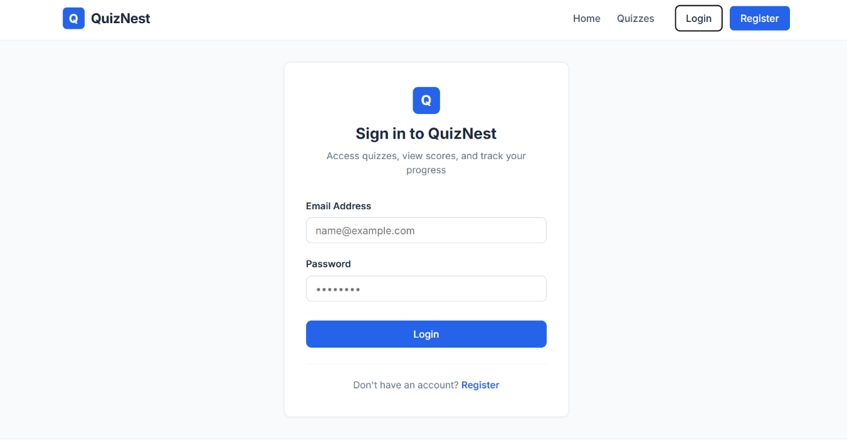
Figure 3.1 Student Login Page
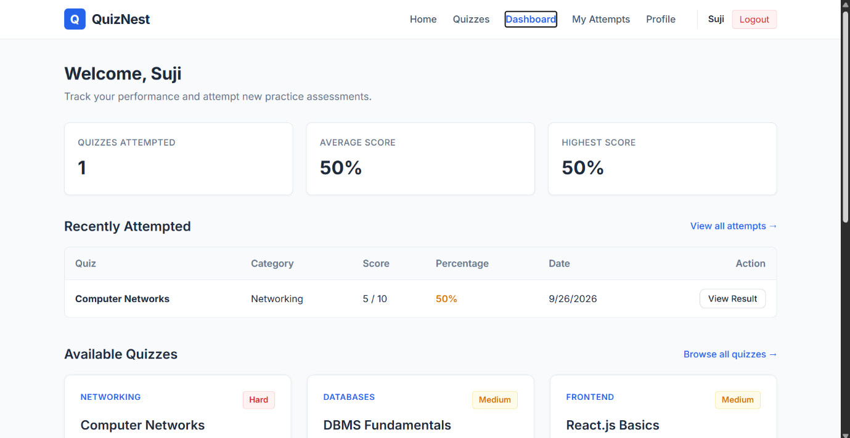
Figure 3.2 Student Dashboard

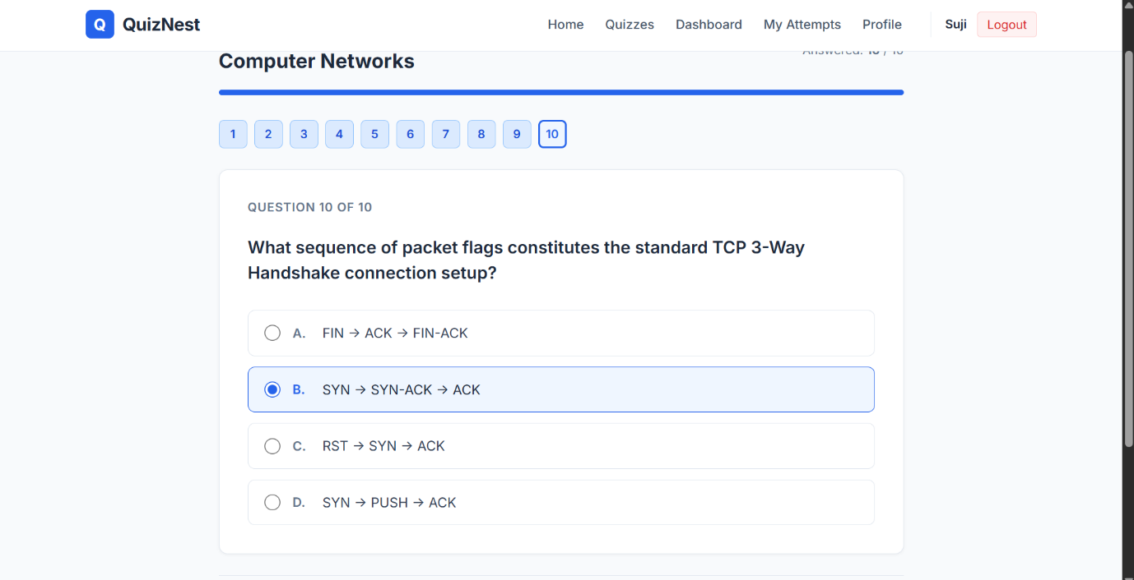
Figure 3.3 Quiz Attempt Interface

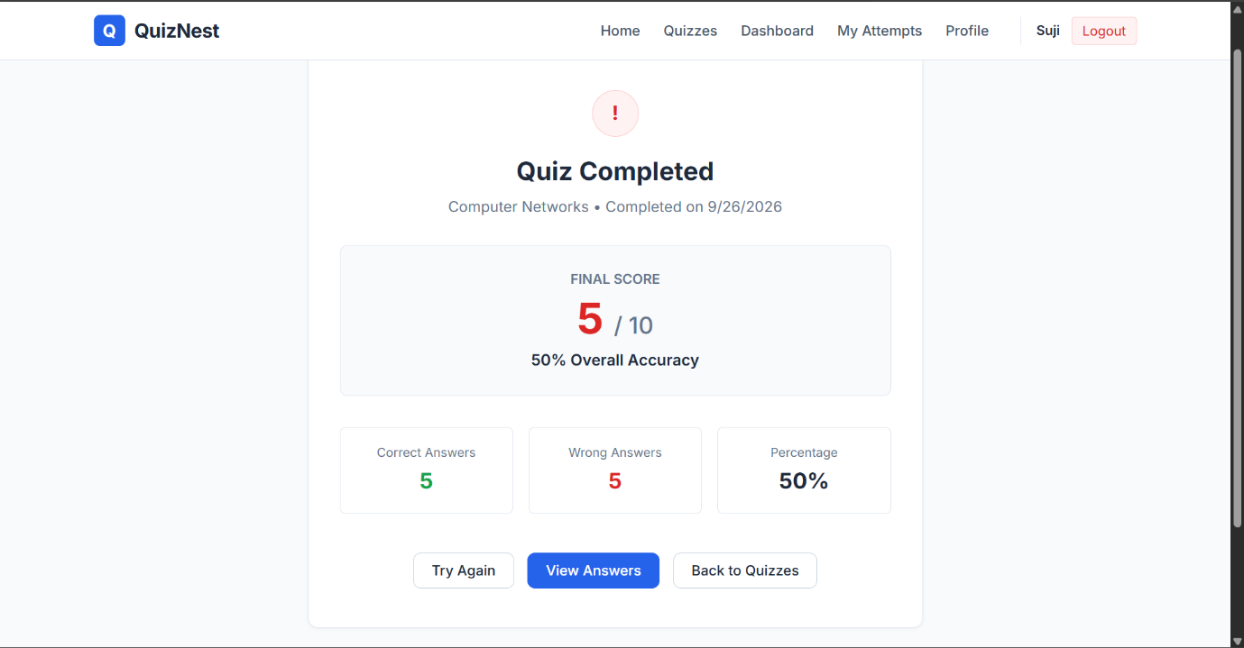
Figure 3.4 Quiz Result Page

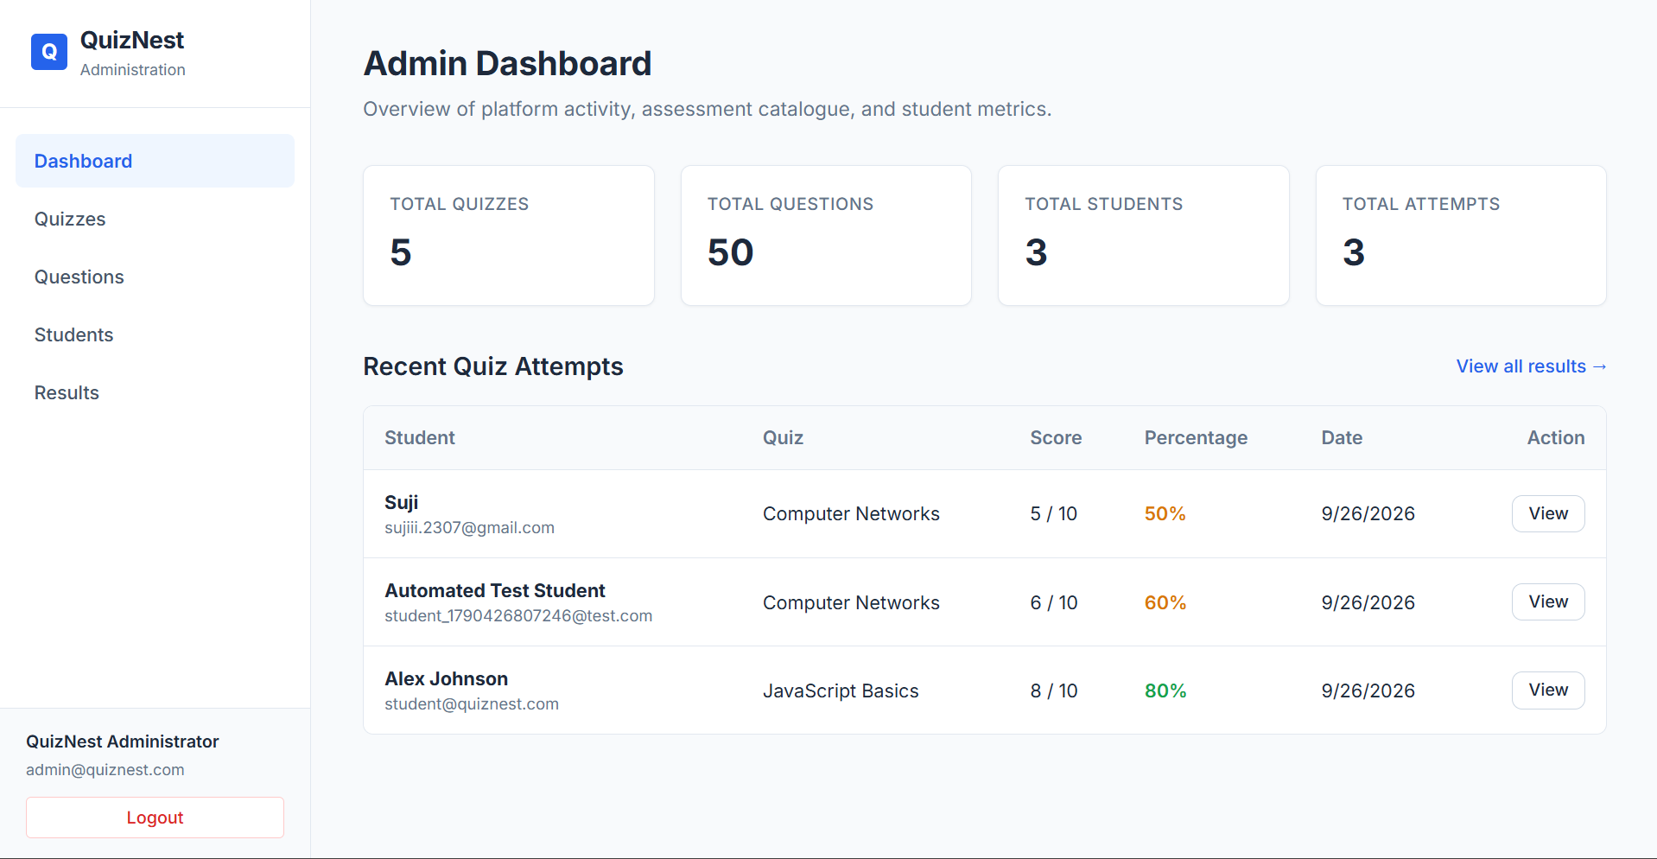
Figure 3.5 Admin Dashboard

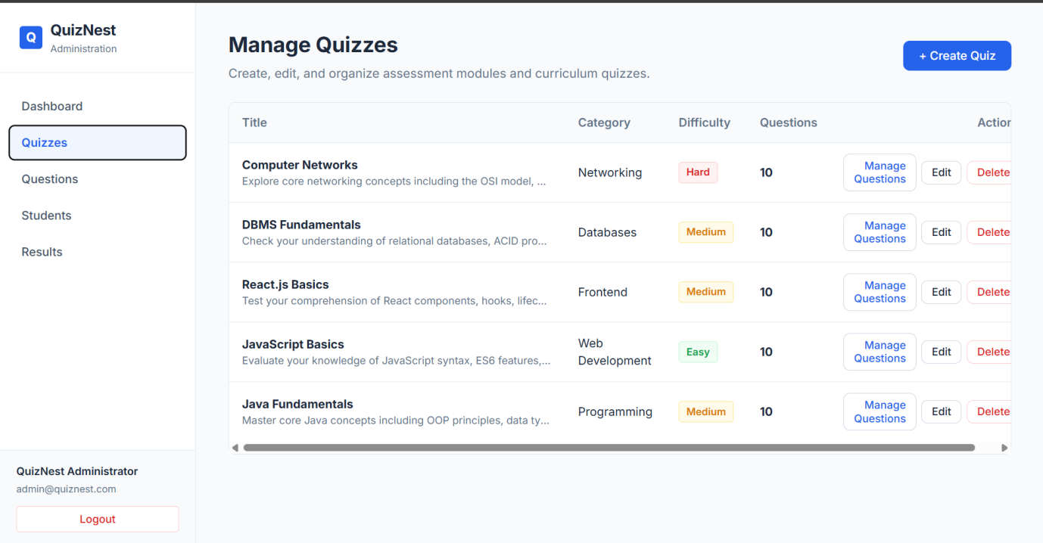
Figure 3.6 Quiz Management

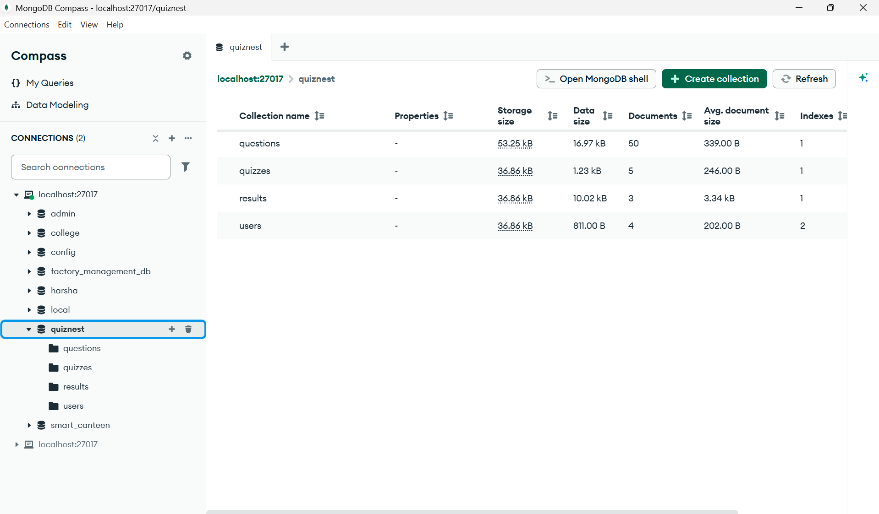
Figure 3.7 MongoDB QuizNest Database Collections

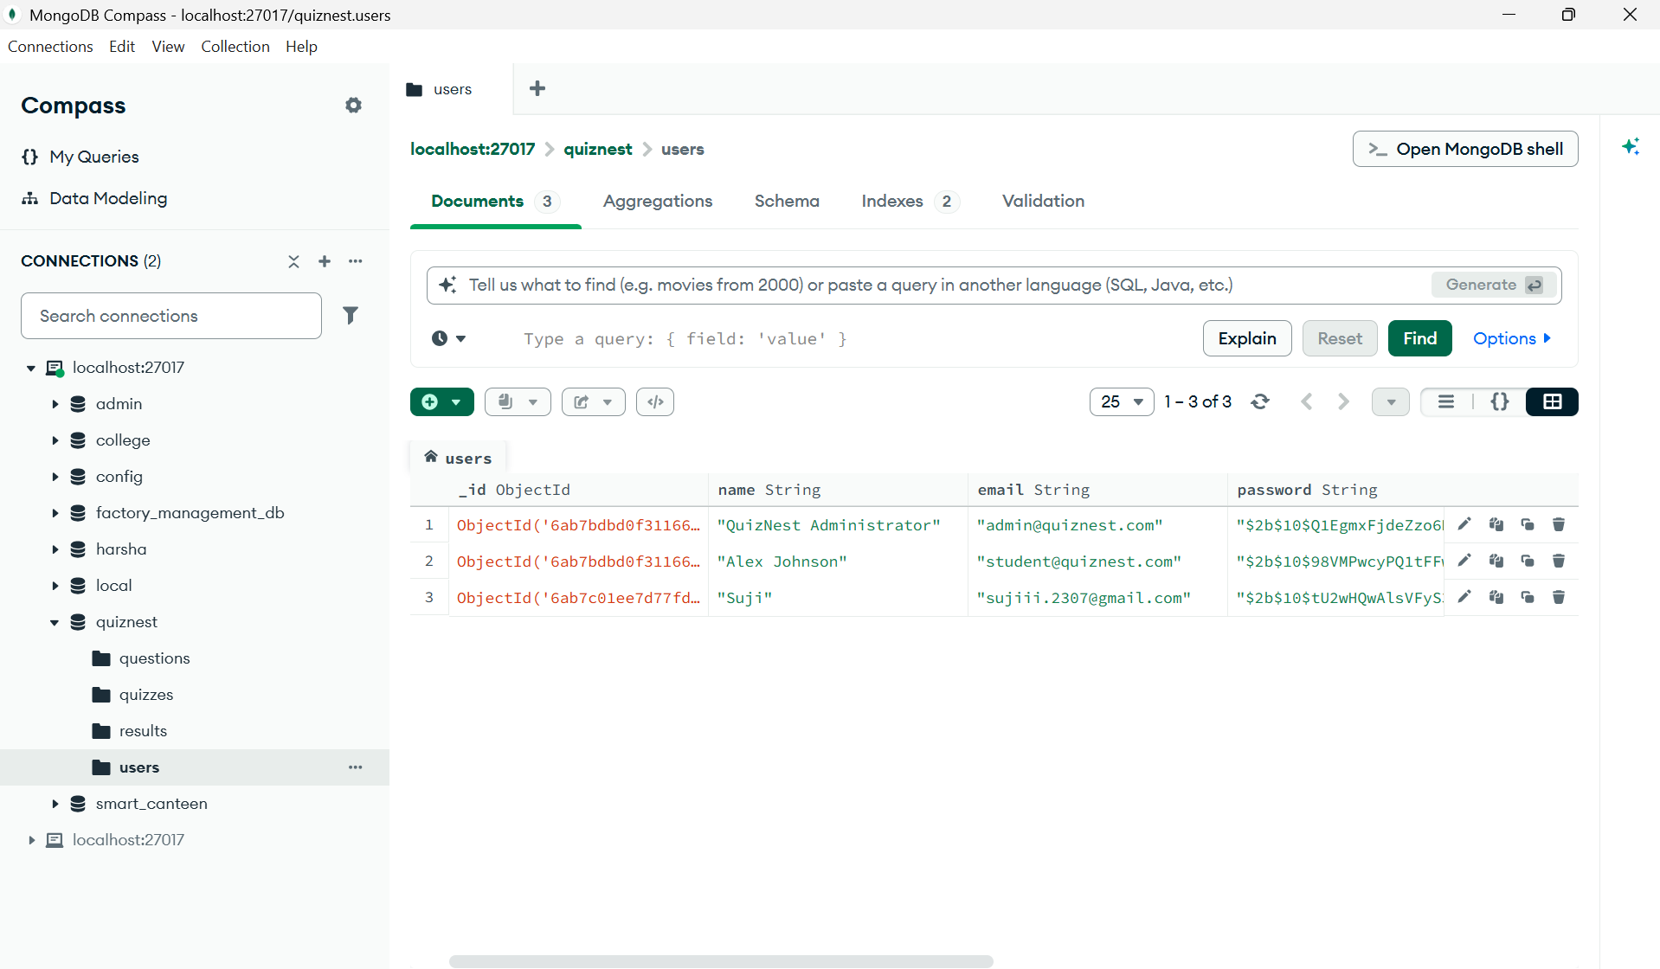
Figure 3.8 MongoDB User Records

Github Link:https://github.com/sujithamanikandan2007/QuizNest
CHAPTER 4

CONCLUSION

QuizNest – Online Quiz System has been successfully developed as a MERN stack-based web application to simplify online quiz participation and management. The application provides a centralized platform where students can register and log in securely, browse quizzes, attend tests, view results, and track their performance. Administrators can manage quizzes, questions, student records, and results efficiently through a dedicated dashboard. The system uses React.js to develop an interactive user interface, Node.js and Express.js to handle backend operations, and MongoDB to store and manage data. JWT authentication and bcryptjs password hashing help protect user accounts, while role-based access control ensures secure access to different functionalities. Automatic evaluation and detailed result reports make the assessment process faster and more accurate. This project reduces the difficulties associated with manual quiz management and provides an organized digital solution for conducting assessments. It helps students evaluate their knowledge and monitor their progress while allowing administrators to manage quiz activities efficiently. The simple and responsive interface makes the application convenient for both students and administrators. In conclusion, QuizNest provides an effective solution for online quiz management and student performance tracking. In the future, the system can be enhanced by adding timed quizzes, randomized questions, leaderboards, certificates, email notifications, and advanced performance analytics. These improvements could make the application more interactive and provide a better online assessment experience.

REFERENCES
- Wang, T.-H., “Web-based Quiz-Game-Like Formative Assessment,” Computers & Education, 2008.
- Subramanian, V., Pro MERN Stack, Apress, 2019.
- Sravani, C. Et al., “Constructing a Study Buddy Using MERN Stack,” Engineering Proceedings, 2024.
- Bhat, N. Et al., “MERN Stack Unveiled,” Journal of Propulsion Technology, 2023.
- Kaur, S. And Bala, R., “MERN Stack in Web Application Development,” IJARCCE, 2026.
- Varshini, V. J. Et al., “Quiz and Assessment Application Using MERN,” 2024.
- Parmar, Y. Et al., “Web-Based Student Management System Using MERN Stack,” IRE Journals, 2026.
- Labba, S. T. Et al., “Web Application Development Using MERN Stack,” IJCRT, 2023.
- Raj, H. Et al., “AI-Based Smart Quiz System Using MERN,” TEJAS Journal, 2026.
- “E-Assessment as a Self-Test Quiz Tool,” Procedia Social and Behavioral Sciences, 2012.

