WEEK 3 INTERNSHIP TASK
Unsupervised Learning and Clustering Analysis
Mall Customer Segmentation using K-Means

Dataset Source | Kaggle – Mall Customer Segmentation
Dataset Used | Mall_Customers.csv
Tools | Python, Pandas, Matplotlib, Scikit-learn
Analysis Type | Unsupervised learning, K-Means clustering, customer segmentation
Prepared as a Week 3 internship submission

1. Executive Summary
This report documents an unsupervised learning workflow for customer segmentation using the Kaggle Mall Customer Segmentation dataset. The analysis focuses on identifying groups of customers with similar annual income and spending-score characteristics using the K-Means clustering algorithm.
The workflow begins with dataset loading and exploratory analysis, followed by standardization of the two clustering features. Candidate cluster counts from K=2 through K=10 are evaluated using K-Means inertia and silhouette score. Based on the elbow pattern and the strong silhouette result, K=5 is used for the final segmentation. The resulting clusters are visualized and summarized using cluster counts, average age, income, spending score, a relative profile heatmap, and an age-versus-spending plot.
For the supplied 200-record dataset, the final K=5 model produces an inertia of 65.6 and a silhouette score of 0.555. These results are generated directly from the provided CSV file and the stated random_state=42 and n_init=10 settings.

2. Objectives
- Load and inspect the Mall Customer Segmentation dataset using Python.
- Explore annual income and spending-score distributions before clustering.
- Standardize the numerical clustering features so that they contribute comparably to distance calculations.
- Evaluate candidate values of K using the Elbow Method and Silhouette Score.
- Apply K-Means clustering with five clusters.
- Interpret the resulting customer groups using descriptive statistics and visualizations.
- Generate reproducible figures and CSV outputs for reporting and further analysis.

3. Dataset Selection and Source

3.1 Dataset Overview
The selected dataset is the commonly used Mall Customer Segmentation dataset available through Kaggle. It contains customer-level demographic and spending information. The analysis uses CustomerID, Age, Annual Income (k$), and Spending Score (1-100). The clustering model uses Annual Income and Spending Score as its two input features.

3.2 Why This Dataset Was Selected
- It is suitable for demonstrating unsupervised learning and customer segmentation.
- The dataset contains numerical features that can be directly visualized in two dimensions.
- The relationship between income and spending score provides an intuitive basis for interpreting clusters.
- The dataset is small enough to inspect and visualize while still producing distinct customer groups.
- The resulting segments can be discussed in a practical business-analysis context.

3.3 Data Dictionary
Column | Meaning | Type
CustomerID | Unique customer identifier | Integer
Gender | Customer gender | Categorical
Age | Customer age | Integer
Annual Income (k$) | Annual income in thousands of dollars | Numeric
Spending Score (1-100) | Customer spending score assigned by the dataset | Numeric

4. Data Acquisition
The analysis reads the downloaded Mall Customer Segmentation CSV file using Pandas. The original file is kept unchanged so that the analysis remains reproducible.
- Download Mall_Customers.csv from the selected Kaggle dataset.
- Place Mall_Customers.csv in the same project directory as the Python script.
- Run the script after installing Pandas, NumPy, Matplotlib, and scikit-learn.
- Keep the original dataset unchanged and store generated figures and output tables separately.
import pandas as pd
# Load dataset
df = pd.read_csv("Mall_Customers.csv")
print(df.head())

5. Python Environment and Libraries
import pandas as pd
import matplotlib.pyplot as plt
from sklearn.preprocessing import StandardScaler
from sklearn.cluster import KMeans
from sklearn.metrics import silhouette_score
Pandas is used for loading, manipulating, grouping, and exporting tabular data. Matplotlib is used to create the required visualizations. StandardScaler standardizes the clustering variables, while KMeans performs the clustering and silhouette_score evaluates the separation and compactness of the candidate and final cluster solutions.

6. Exploratory Data Analysis
Before clustering, the distributions of annual income and spending score were reviewed. These plots help establish the range and concentration of observations and provide an initial understanding of the variables used for segmentation.
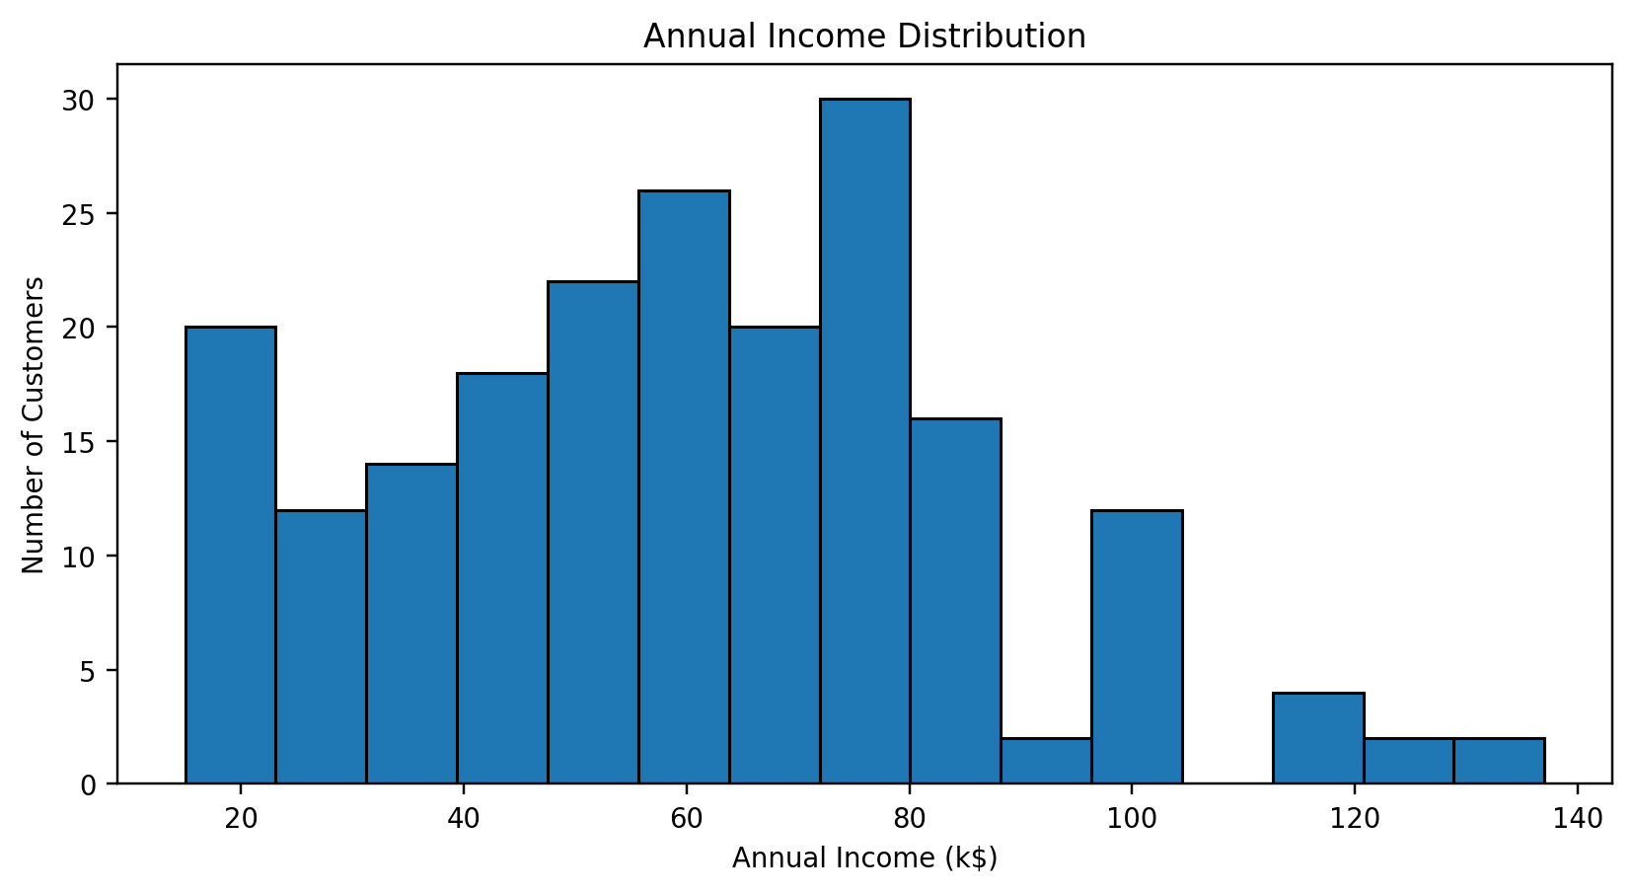
Figure 1. Distribution of annual income.
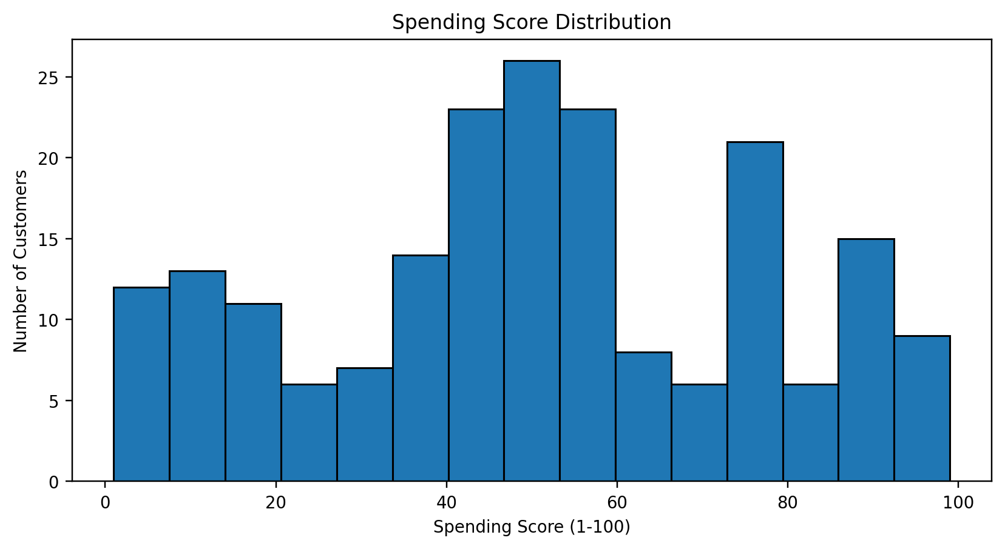
Figure 2. Distribution of spending score.
The annual-income histogram shows customers spread across a broad range of income levels, while the spending-score histogram covers the full 1-100 scale with noticeable concentration in several ranges. These differences make the two variables useful for customer grouping.

7. Choosing the Number of Clusters
Candidate values of K from 2 to 10 were tested. For each K, K-Means was fitted to the standardized features and both inertia and silhouette score were recorded.
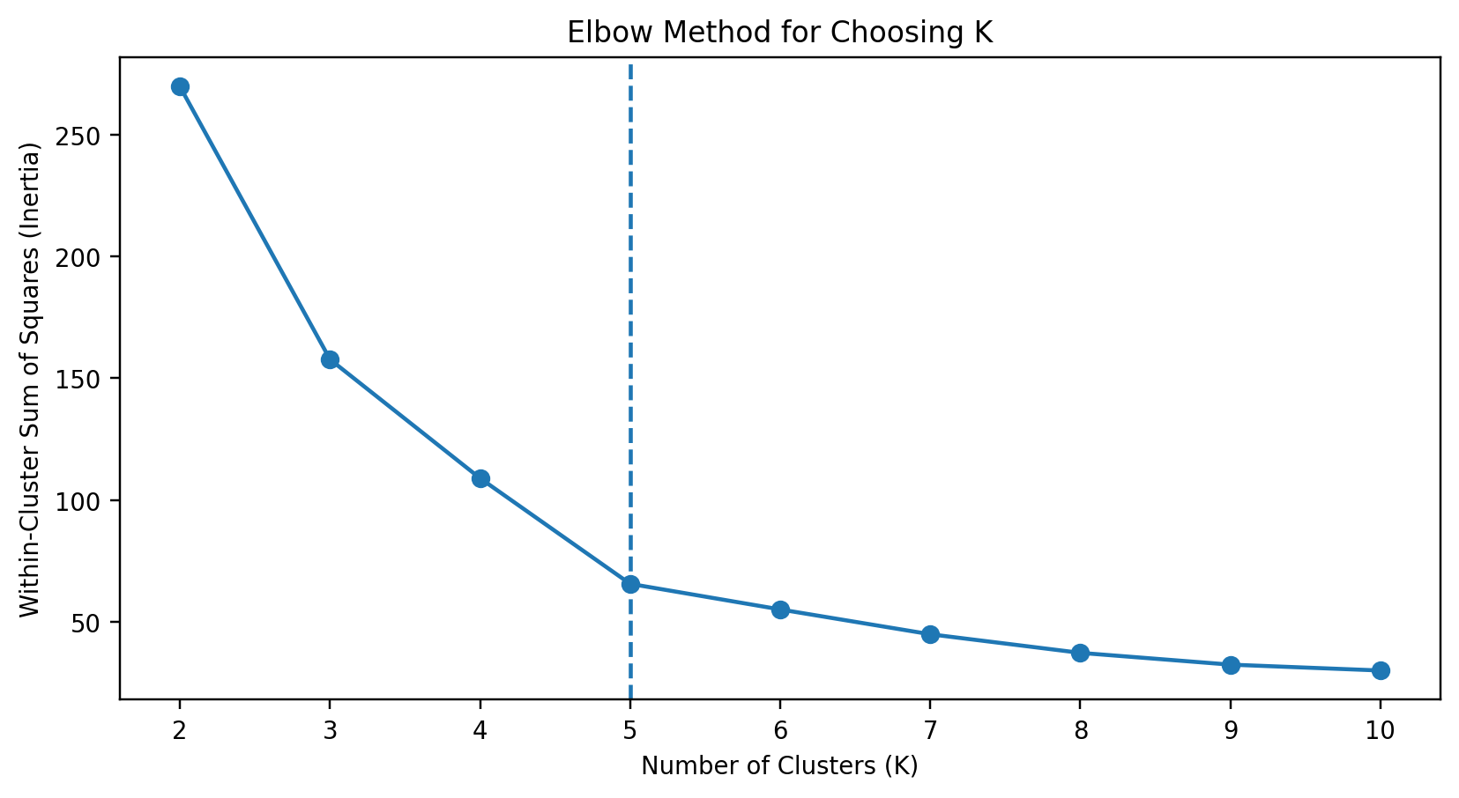
Figure 3. Elbow Method using K-Means inertia.
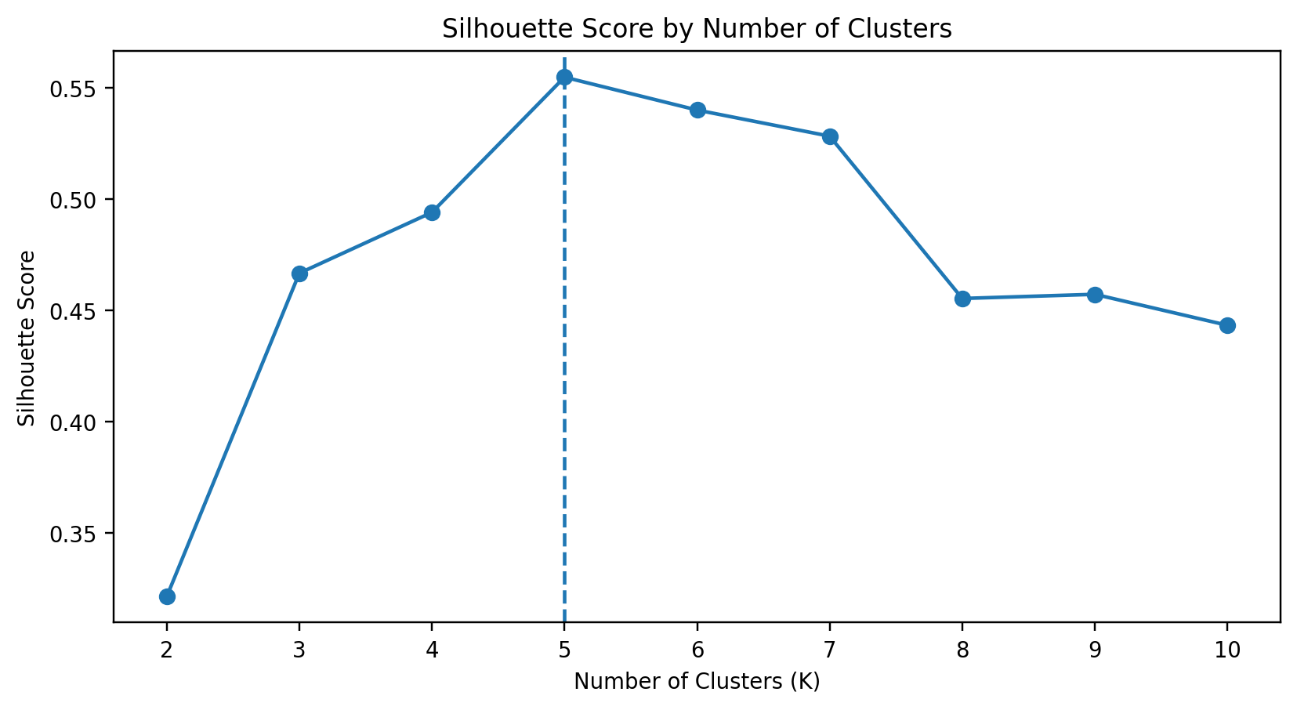
Figure 4. Silhouette Score across candidate K values.
The inertia curve decreases substantially as K increases, with the rate of improvement becoming smaller after approximately K=5. The silhouette score reaches 0.555 at K=5, which is the highest value among the candidate K values evaluated in this run. Therefore, K=5 is selected for the final segmentation.
K | Inertia | Silhouette
2 | 269.7 | 0.321
3 | 157.7 | 0.467
4 | 108.9 | 0.494
5 | 65.6 | 0.555
6 | 55.1 | 0.540
7 | 44.9 | 0.528
8 | 37.2 | 0.455
9 | 32.4 | 0.457
10 | 30.0 | 0.443

8. K-Means Clustering
The final K-Means model uses five clusters, random_state=42, and n_init=10. The two selected features are standardized before fitting so that their numerical scales do not disproportionately affect the distance calculations used by K-Means.
scaler = StandardScaler()
X_scaled = scaler.fit_transform(X)
kmeans = KMeans(
n_clusters=5,
random_state=42,
n_init=10
)
df["Cluster"] = kmeans.fit_predict(X_scaled)
The final model has an inertia of 65.6 and a silhouette score of 0.555. Cluster labels are numerical identifiers generated by K-Means and do not inherently represent business meanings. Meaningful segment names are assigned afterward using the cluster centers.

9. Results and Visualizations
The final K=5 model separates customers according to their income and spending-score characteristics. The cluster-center markers are plotted in the original income-spending space so the resulting groups can be interpreted more easily.
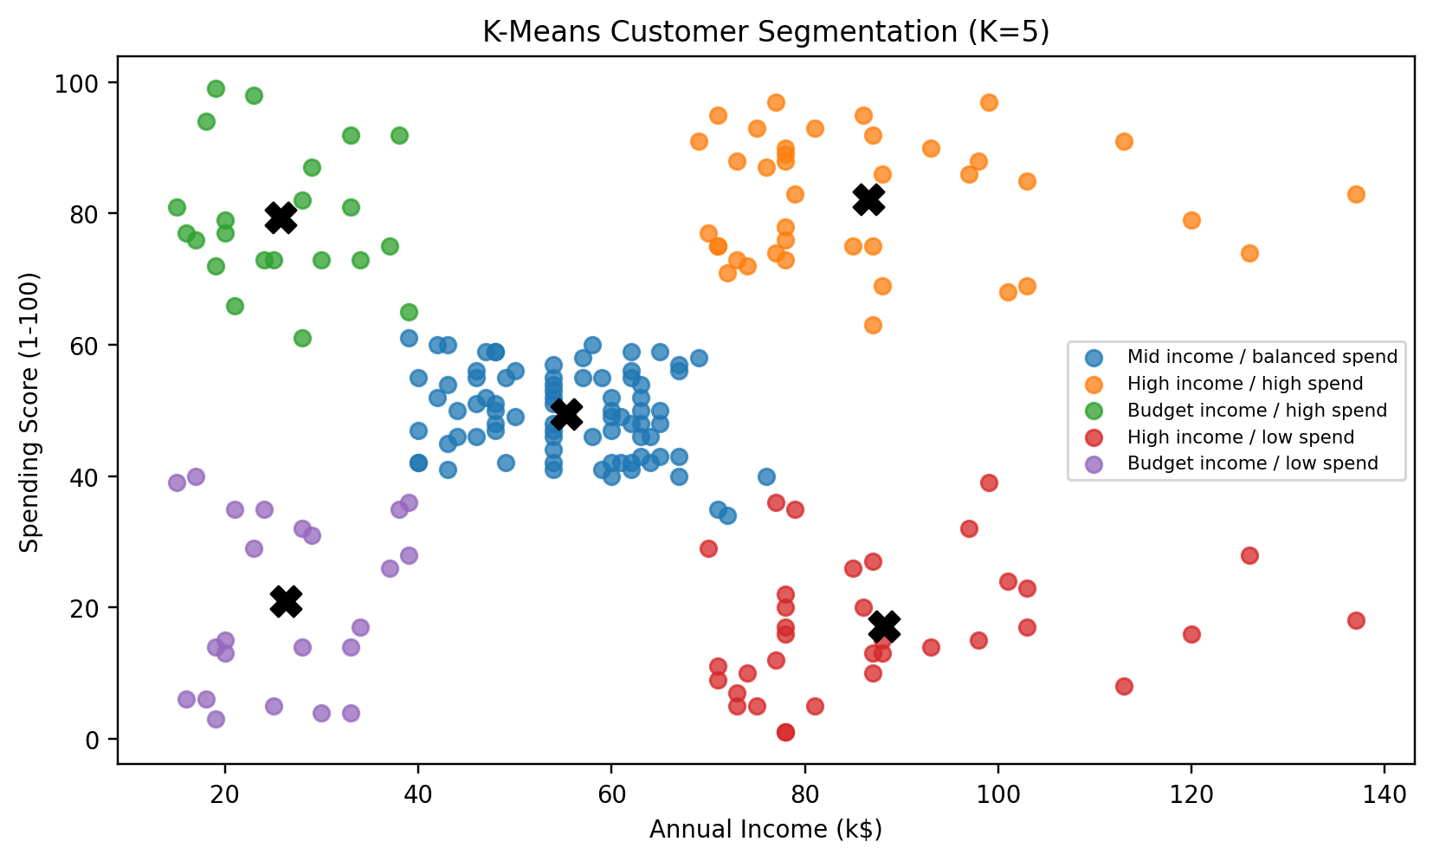
Figure 5. Customer clusters and centroid locations.
The customer groups are interpreted as Budget income / high spend, Budget income / low spend, Mid income / balanced spend, High income / high spend, and High income / low spend. These names are descriptive labels derived from the cluster-center values and should not be interpreted as categories contained in the original dataset.
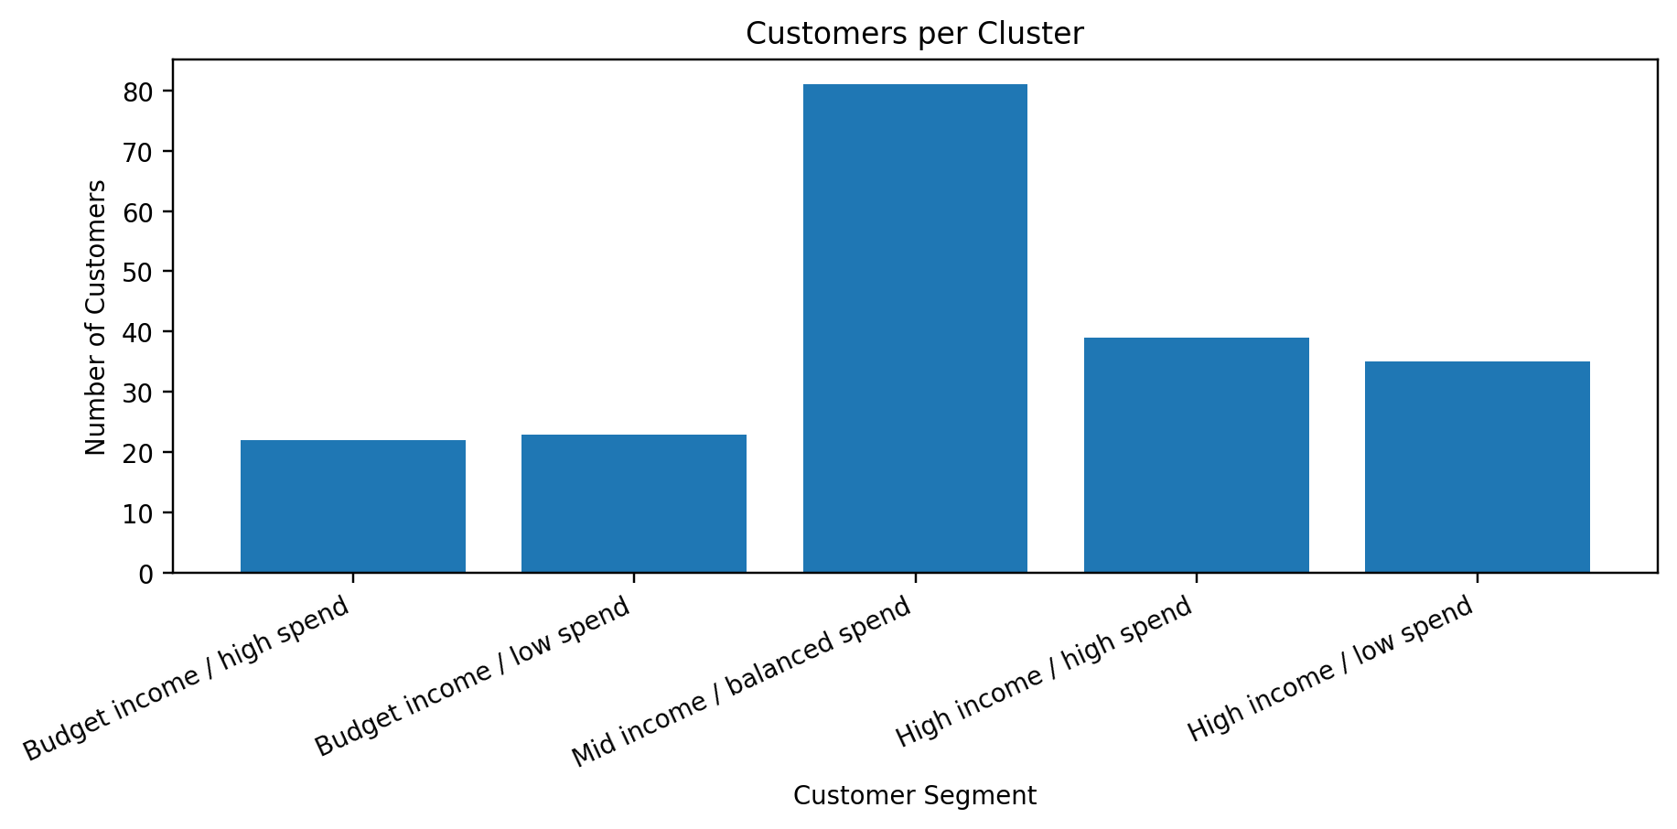
Figure 6. Number of customers in each cluster.
Segment | Customers | Avg Age | Avg Income (k$) | Avg Spending
Budget income / high spend | 22 | 25.3 | 25.7 | 79.4
Budget income / low spend | 23 | 45.2 | 26.3 | 20.9
Mid income / balanced spend | 81 | 42.7 | 55.3 | 49.5
High income / high spend | 39 | 32.7 | 86.5 | 82.1
High income / low spend | 35 | 41.1 | 88.2 | 17.1

10. Cluster Profile Comparison
The cluster profile summarizes each segment using the number of customers and the average age, annual income, and spending score. A standardized profile comparison is also used to show whether a segment is above or below the overall cluster-average level for each metric.
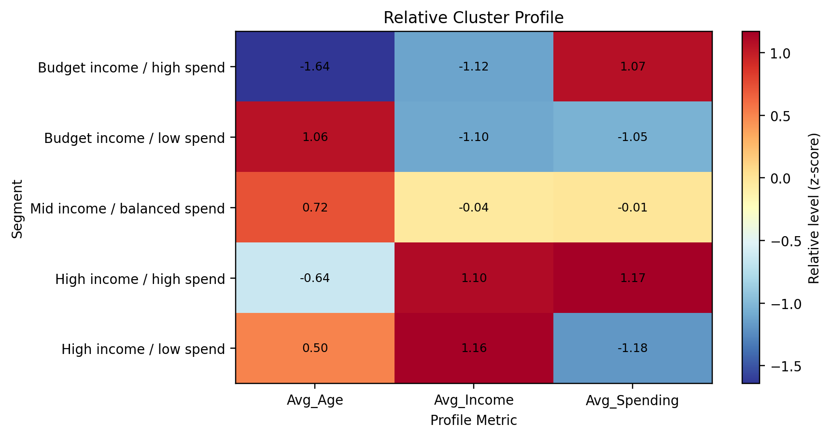
Figure 7. Standardized cluster profile comparison.
Positive heatmap values indicate above-average levels relative to the five cluster means, while negative values indicate below-average levels. The heatmap is a comparative visualization rather than a replacement for the original measurements in the profile table.

11. Age and Spending Score Analysis
An additional scatter plot compares age and spending score while preserving the cluster membership. This provides a second perspective on how spending behavior varies across age ranges within the identified segments.
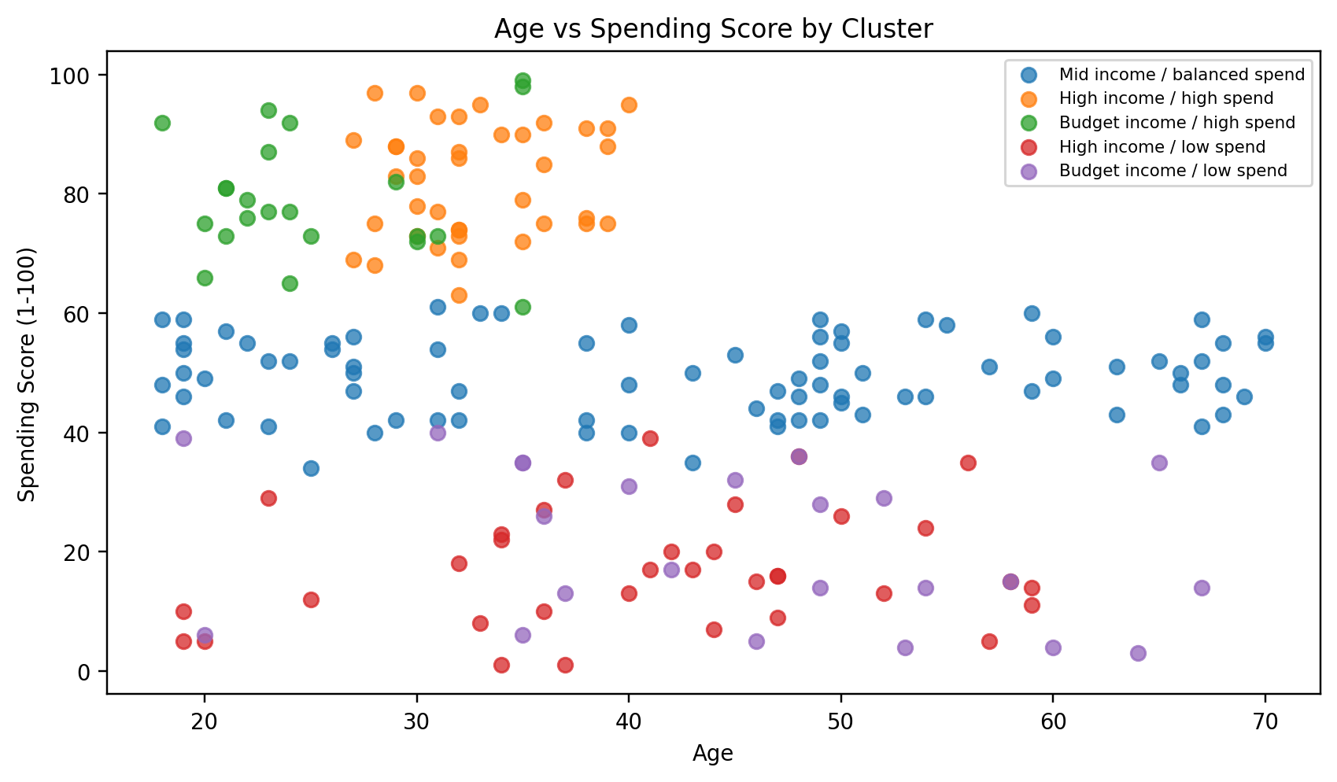
Figure 8. Age and spending score viewed by cluster.

12. Business and Research Implications
- Customer segmentation can help organize customers into groups with similar income and spending characteristics.
- High-income/high-spending customers can be studied separately from high-income/low-spending customers for differentiated analysis.
- Budget-income groups with different spending behavior demonstrate that income alone does not completely describe customer behavior.
- The segmentation can support exploratory marketing analysis, campaign grouping, customer profiling, and hypothesis generation.
- The analysis is descriptive; it does not establish causal relationships between income, age, and spending.

13. Challenges and Solutions
Challenge | Why it matters | Solution
Choosing K | Different K values produce different partitions. | Compared inertia and silhouette score for K=2 through K=10.
Different feature scales | Distance-based clustering can be affected by scale. | Standardized income and spending score with StandardScaler.
Interpreting numeric cluster labels | K-Means labels have no inherent business meaning. | Assigned descriptive segment names from cluster-center characteristics.
Reproducibility | K-Means can vary if initialization changes. | Used random_state=42 and n_init=10.
Visual interpretation | Tables alone can hide group separation. | Generated scatter plots, distributions, cluster counts, and a profile heatmap.

14. Specific Week 3 Outcomes
- Applied an unsupervised learning workflow using K-Means clustering.
- Used StandardScaler to prepare features for distance-based clustering.
- Compared candidate cluster counts using inertia and silhouette score.
- Selected and fitted a five-cluster K-Means solution.
- Generated customer segmentation visualizations and cluster-profile statistics.
- Exported clustered customer records and cluster profile results as CSV files.
- Developed practical understanding of how clustering can be used for customer segmentation.

15. Limitations
- Only annual income and spending score are used as clustering features; adding other variables could produce different segments.
- K-Means assumes compact, roughly spherical clusters and uses distance-based assignments.
- The choice of K is partly analytical and interpretive, even though K=5 has the highest silhouette score in this run.
- The dataset is relatively small and is intended primarily for educational and exploratory analysis.
- The resulting segments should be validated against real business outcomes before operational use.

16. Conclusion
This Week 3 project demonstrates a complete unsupervised learning workflow for Mall Customer Segmentation. The process includes exploratory visualization, feature standardization, candidate-K evaluation, K-Means clustering, cluster interpretation, and output generation. The supplied dataset produced a five-cluster solution with a silhouette score of 0.555. The analysis provides a reproducible foundation for understanding customer groups based on annual income and spending behavior.

Appendix A – Complete Python Script
The following code is the complete version used for the Week 3 analysis. It does not use the os module; the visualizations and outputs folders should already exist in the project directory.
import pandas as pd
import matplotlib.pyplot as plt
from sklearn.preprocessing import StandardScaler
from sklearn.cluster import KMeans
from sklearn.metrics import silhouette_score
# ==========================================
# 1. LOAD DATASET AND BASIC INSPECTION
# ==========================================
df = pd.read_csv("Mall_Customers.csv")
print(df.head())
print(“\n”)
print(df.shape)
print(“\n”)
print(df.info())
print(“\n”)
features = [
"Annual Income (k$)",
"Spending Score (1-100)"
]
X = df[features]
# ==========================================
# 2. STANDARDIZE FEATURES
# ==========================================
scaler = StandardScaler()
X_scaled = scaler.fit_transform(X)
# ==========================================
# 3. ANNUAL INCOME DISTRIBUTION
# ==========================================
plt.figure(figsize=(8, 4.5))
plt.hist(
df["Annual Income (k$)"],
bins=15,
edgecolor="black"
)
plt.title("Annual Income Distribution")
plt.xlabel("Annual Income (k$)")
plt.ylabel("Number of Customers")
plt.tight_layout()
plt.show()
# ==========================================
# 4. SPENDING SCORE DISTRIBUTION
# ==========================================
plt.figure(figsize=(8, 4.5))
plt.hist(
df["Spending Score (1-100)"],
bins=15,
edgecolor="black"
)
plt.title("Spending Score Distribution")
plt.xlabel("Spending Score (1-100)")
plt.ylabel("Number of Customers")
plt.tight_layout()
plt.show()
# ==========================================
# 5. ELBOW METHOD & SILHOUETTE SCORE
# ==========================================
k_values = range(2, 11)
inertias = []
silhouette_scores = []
for k in k_values:
model = KMeans(
n_clusters=k,
random_state=42,
n_init=10
)
labels = model.fit_predict(X_scaled)
inertias.append(model.inertia_)
silhouette_scores.append(
silhouette_score(
X_scaled,
labels
)
)
# ==========================================
# 6. ELBOW METHOD
# ==========================================
plt.figure(figsize=(8, 4.5))
plt.plot(
list(k_values),
inertias,
marker="o"
)
plt.axvline(
x=5,
linestyle="--",
label="Selected K = 5"
)
plt.title("Elbow Method for Choosing K")
plt.xlabel("Number of Clusters (K)")
plt.ylabel("Within-Cluster Sum of Squares (Inertia)")
plt.xticks(list(k_values))
plt.legend()
plt.tight_layout()
plt.show()
# ==========================================
# 7. SILHOUETTE SCORE
# ==========================================
plt.figure(figsize=(8, 4.5))
plt.plot(
list(k_values),
silhouette_scores,
marker="o"
)
plt.axvline(
x=5,
linestyle="--",
label="Selected K = 5"
)
plt.title("Silhouette Score by Number of Clusters")
plt.xlabel("Number of Clusters (K)")
plt.ylabel("Silhouette Score")
plt.xticks(list(k_values))
plt.legend()
plt.tight_layout()
plt.show()
# ==========================================
# 8. EVALUATION TABLE
# ==========================================
evaluation = pd.DataFrame({
"K": list(k_values),
"Inertia": inertias,
"Silhouette": silhouette_scores
})
print("\nClustering Evaluation:")
print(
evaluation.round(3).to_string(index=False)
)
# ==========================================
# 9. FINAL K-MEANS MODEL
# ==========================================
kmeans = KMeans(
n_clusters=5,
random_state=42,
n_init=10
)
df["Cluster"] = kmeans.fit_predict(X_scaled)
# Final silhouette score
final_silhouette = silhouette_score(
X_scaled,
df["Cluster"]
)
print("\nFinal K-Means Results")
print("Number of clusters:", 5)
print(
"Silhouette Score:",
round(final_silhouette, 3)
)
print(
"Inertia:",
round(kmeans.inertia_, 2)
)
# ==========================================
# 10. CLUSTER CENTERS
# ==========================================
centers = scaler.inverse_transform(
kmeans.cluster_centers_
)
centers_df = pd.DataFrame(
centers,
columns=features
)
# ==========================================
# 11. CREATE MEANINGFUL CLUSTER NAMES
# ==========================================
income_order = centers_df.sort_values(
"Annual Income (k$)"
).index.tolist()
budget_clusters = income_order[:2]
middle_cluster = income_order[2]
high_income_clusters = income_order[3:]
budget_high_spend = max(
budget_clusters,
key=lambda c:
centers_df.loc[
c,
"Spending Score (1-100)"
]
)
budget_low_spend = min(
budget_clusters,
key=lambda c:
centers_df.loc[
c,
"Spending Score (1-100)"
]
)
high_income_high_spend = max(
high_income_clusters,
key=lambda c:
centers_df.loc[
c,
"Spending Score (1-100)"
]
)
high_income_low_spend = min(
high_income_clusters,
key=lambda c:
centers_df.loc[
c,
"Spending Score (1-100)"
]
)
cluster_names = {
budget_high_spend:
"Budget income / high spend",
budget_low_spend:
"Budget income / low spend",
middle_cluster:
"Mid income / balanced spend",
high_income_high_spend:
"High income / high spend",
high_income_low_spend:
"High income / low spend"
}
df["Segment"] = df["Cluster"].map(
cluster_names
)
segment_order = [
"Budget income / high spend",
"Budget income / low spend",
"Mid income / balanced spend",
"High income / high spend",
"High income / low spend"
]
# ==========================================
# 12. CUSTOMER CLUSTER VISUALIZATION
# ==========================================
plt.figure(figsize=(8, 5))
for cluster in sorted(
df["Cluster"].unique()
):
subset = df[
df["Cluster"] == cluster
]
plt.scatter(
subset["Annual Income (k$)"],
subset["Spending Score (1-100)"],
label=cluster_names[cluster],
alpha=0.75
)
# Plot cluster centers
for cluster_id, center in centers_df.iterrows():
plt.scatter(
center["Annual Income (k$)"],
center["Spending Score (1-100)"],
marker="X",
s=130,
color="black"
)
plt.title(
"K-Means Customer Segmentation (K=5)"
)
plt.xlabel("Annual Income (k$)")
plt.ylabel(
"Spending Score (1-100)"
)
plt.legend(fontsize=7)
plt.tight_layout()
plt.show()
# ==========================================
# 13. CUSTOMERS PER CLUSTER
# ==========================================
cluster_counts = (
df["Segment"]
.value_counts()
.reindex(
segment_order,
fill_value=0
)
)
plt.figure(figsize=(9, 4.5))
plt.bar(
cluster_counts.index,
cluster_counts.values
)
plt.title("Customers per Cluster")
plt.xlabel("Customer Segment")
plt.ylabel("Number of Customers")
plt.xticks(
rotation=25,
ha="right"
)
plt.tight_layout()
plt.show()
# ==========================================
# 14. CLUSTER PROFILE TABLE
# ==========================================
profiles = (
df.groupby("Segment")
.agg(
Customers=("CustomerID", "count"),
Avg_Age=("Age", "mean"),
Avg_Income=(
"Annual Income (k$)",
"mean"
),
Avg_Spending=(
"Spending Score (1-100)",
"mean"
)
)
.reindex(segment_order)
)
print("\nCustomer Cluster Profiles:")
print(
profiles.round(1)
.to_string()
)
profiles.to_csv(
"outputs/cluster_profiles.csv"
)
# ==========================================
# 15. SAVE CLUSTERED DATA
# ==========================================
df.to_csv(
"outputs/clustered_customers.csv",
index=False
)
# ==========================================
# 16. RELATIVE CLUSTER PROFILE HEATMAP
# ==========================================
profile_metrics = profiles[
[
"Avg_Age",
"Avg_Income",
"Avg_Spending"
]
]
profile_std = (
profile_metrics -
profile_metrics.mean()
) / profile_metrics.std(ddof=0)
plt.figure(figsize=(8, 4.5))
image = plt.imshow(
profile_std.values,
cmap="RdYlBu_r",
aspect="auto"
)
plt.colorbar(
image,
label="Relative level (z-score)"
)
plt.xticks(
range(3),
[
"Avg_Age",
"Avg_Income",
"Avg_Spending"
]
)
plt.yticks(
range(len(segment_order)),
segment_order
)
# Display values inside heatmap
for i in range(
profile_std.shape[0]
):
for j in range(
profile_std.shape[1]
):
plt.text(
j,
i,
f"{profile_std.iloc[i, j]:.2f}",
ha="center",
va="center"
)
plt.title(
"Relative Cluster Profile"
)
plt.xlabel("Profile Metric")
plt.ylabel("Segment")
plt.tight_layout()
plt.show()
# ==========================================
# 17. AGE VS SPENDING SCORE
# ==========================================
plt.figure(figsize=(8, 5))
for cluster in sorted(
df["Cluster"].unique()
):
subset = df[
df["Cluster"] == cluster
]
plt.scatter(
subset["Age"],
subset["Spending Score (1-100)"],
label=cluster_names[cluster],
alpha=0.75
)
plt.title(
"Age vs Spending Score by Cluster"
)
plt.xlabel("Age")
plt.ylabel(
"Spending Score (1-100)"
)
plt.legend(fontsize=7)
plt.tight_layout()
plt.show()
print("\nAll analysis completed successfully.")

Appendix B – Suggested Folder Structure
Week3_Mail_Clustering/
│
├── Mail_Customers.csv
├── Mail_Seg_Week3.ipynb
├── cluster_profiles.csv
├── clustered_customers.csv
├── Charts/
│ ├── Mail_customers_loaded.png
│ ├── Annual_income_distribution.png
│ ├── Spending_score_distribution.png
│ ├── Elbow_method.png
│ ├── Silhouette_score_graph.png
│ ├── KMeans_customer_segmentation.png
│ ├── Customers_by_cluster.png
│ ├── Cluster_profile_heatmap.png
│ └── Avg_spending_score_by_cluster.png
└── Week3_report.docx

