Supplement: Evidence of traumatic brain injury in muskoxen (*Ovibos moschatus*). Code for heatmaps and linegraphs

Nicole Ackermans

10/19/2021

# Packages

library(ggplot2)  
library(readxl)  
library(plotly)  
library(ggpubr)  
library(viridis)

# Heatmaps

# Muskox 1 / MO1 / Generic 0191

## Read in data

NTCs <- read_excel("NA_BHP_Supp_211022.xlsx", sheet=3)  
neuropils <- read_excel("NA_BHP_Supp_211022.xlsx", sheet=4)  
neurons <- read_excel("NA_BHP_Supp_211022.xlsx", sheet=5)

## Heat Map 1

Muskox1_heatmap <- ggplot(neuropils, aes(x=x, y=y))+  
 stat_density_2d(aes(fill=..level..), geom="polygon")+  
 scale_fill_viridis_c(option = "viridis", alpha=0.7)+   
 geom_point(data=NTCs, color="black", size=2, alpha=0.5)+  
 geom_point(data=neurons, shape=23, colour="pink", fill="pink", size=2, alpha=0.8)+   
 labs(title="A")+  
 theme_void()  
  
Muskox1_heatmap

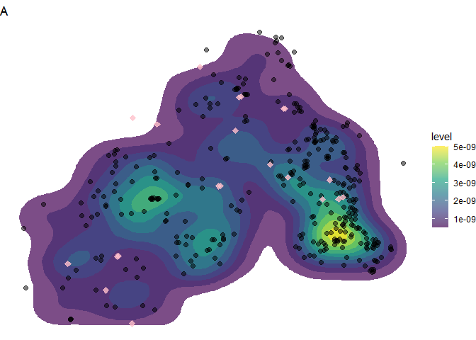

# Muskox 2 / MO2 / Generic 0194

## Read in data

NTCs <- read_excel("NA_BHP_Supp_211022.xlsx", sheet=6)  
neuropils <- read_excel("NA_BHP_Supp_211022.xlsx", sheet=7)  
neurons <- read_excel("NA_BHP_Supp_211022.xlsx", sheet=8)

## Heat Map 2

Muskox2_heatmap <- ggplot(neuropils, aes(x=x, y=y))+  
 stat_density_2d(aes(fill=..level..), geom="polygon", bins=20)+  
 scale_fill_viridis_c(option = "viridis", alpha=0.7)+   
 geom_point(data=NTCs, color="black", size=1, alpha=0.5)+  
 geom_point(data=neurons, shape=23, colour="pink", fill="pink", size=2, alpha=0.8)+   
 labs(title="B")+  
 theme_void()  
  
Muskox2_heatmap

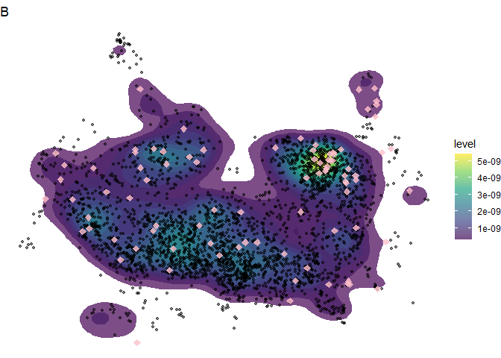

# Muskox 3 / MO3 / Generic 0193

## Read in data

NTCs <- read_excel("NA_BHP_Supp_211022.xlsx", sheet=9)  
neuropils <- read_excel("NA_BHP_Supp_211022.xlsx", sheet=10)  
neurons <- read_excel("NA_BHP_Supp_211022.xlsx", sheet=11)

## Heat map 3

Muskox3_heatmap <- ggplot(neuropils, aes(x=x, y=y))+  
 stat_density_2d(aes(fill=..level..), geom="polygon")+  
 scale_fill_viridis_c(option = "viridis", alpha=0.7)+   
 geom_point(data=NTCs, color="black", size=2, alpha=0.5)+  
 geom_point(data=neurons, shape=23, colour="pink", fill="pink", size=2, alpha=0.8)+   
 labs(title="C")+  
 theme_void()  
Muskox3_heatmap

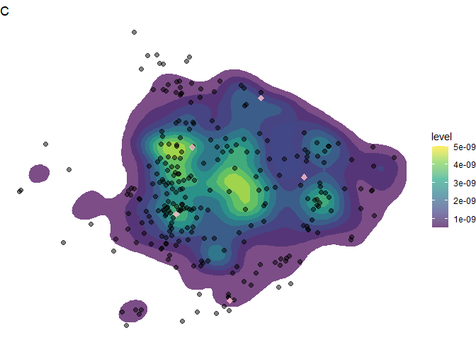 # all three together

AllHeatmaps<-ggarrange(Muskox1_heatmap, Muskox2_heatmap, Muskox3_heatmap, nrow=3,  
 common.legend = TRUE, legend="right")  
  
AllHeatmaps

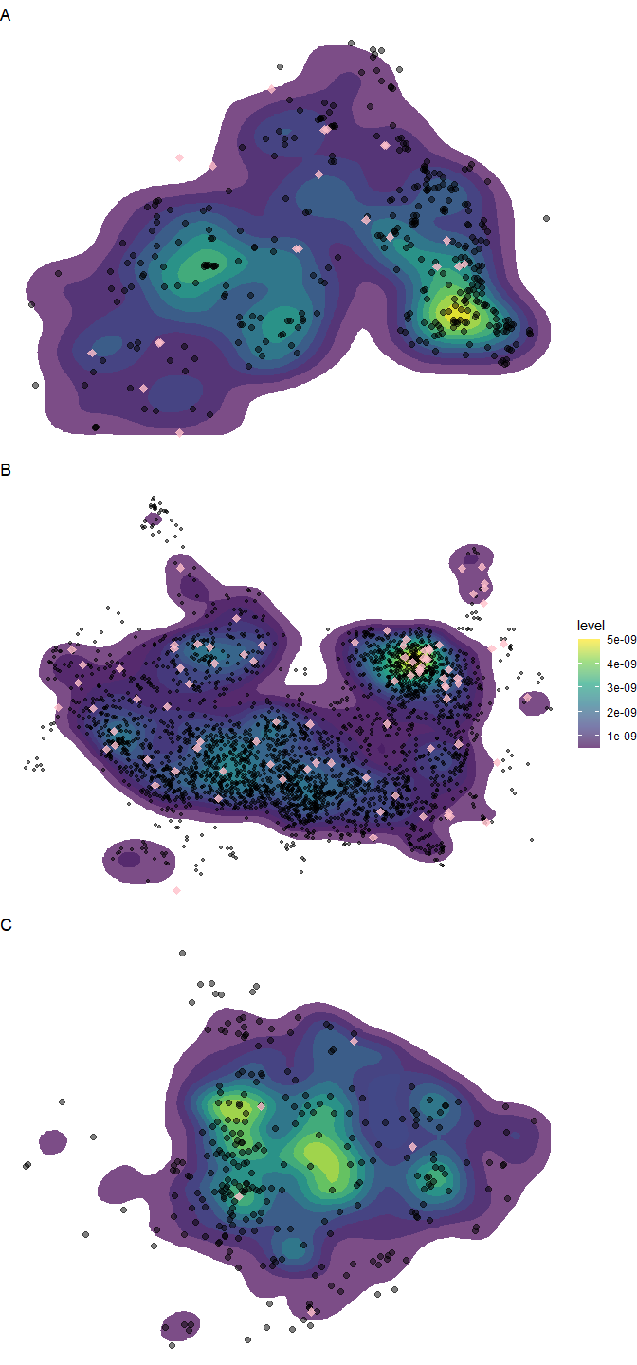

# Linegraphs

## Read in Data

AllData <- read_excel("NA_BHP_Supp_211022.xlsx", sheet=2)

## make characters non numerical

AllData$Individual<-as.character(AllData$Individual)  
AllData$layer<-as.character(AllData$layer)

## Subset

NTCsub <- subset(AllData, marker=="NTC" & layer=="all")  
Neuropilsub <- subset(AllData, marker=="neuropil" & layer=="all")  
Neuronsub <- subset(AllData, marker=="neuron" & layer=="all")

### Marker count per layer per Individual

sub_NTC <- subset(AllData, marker=="NTC")  
sub_Neuropil <- subset(AllData, marker=="neuropil")  
sub_Neuron <- subset(AllData, marker=="neuron")

## Make line graphs

## 3 Individuals NTC

p1 <- ggplot(data=sub_NTC, aes(x=layer, y=count, group=Individual, colour=Individual)) +   
 geom_line()+ geom_point()+ scale_color_manual(values=viridis(3))+  
 labs(title="B",x=element_blank(), y=element_blank())+  
 theme(  
 plot.title = element_text(size=11, hjust=0.5),  
 panel.border = element_blank(),   
 panel.grid.major = element_blank(),  
 panel.grid.minor = element_blank(),  
 panel.background = element_blank(),  
 axis.line = element_blank(),  
 axis.text=element_text(size=7),  
 legend.position="none") +  
 geom_path(size=1)+  
 scale_x_discrete(limits=c("I","II","III","IV-VI","WM"))  
  
p1

## Warning: Removed 3 row(s) containing missing values (geom_path).

## Warning: Removed 3 rows containing missing values (geom_point).

## Warning: Removed 3 row(s) containing missing values (geom_path).

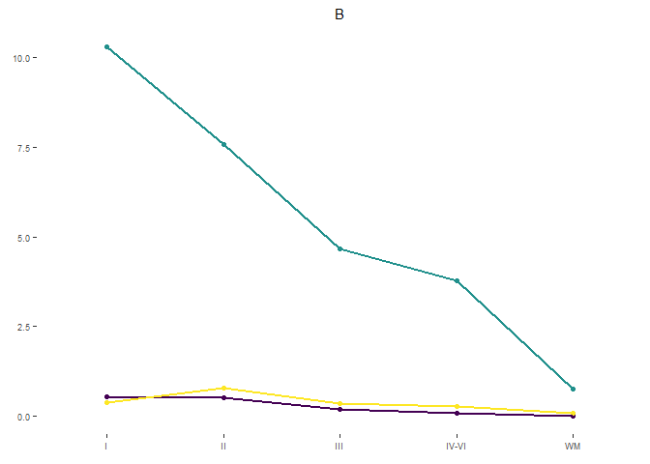

### 3 Individuals Neuropil

p2 <- ggplot(data=sub_Neuropil, aes(x=layer, y=count, group=Individual, colour=Individual)) +   
 geom_line()+ geom_point()+ scale_color_manual(values=viridis(3))+  
 labs(title="A",x=element_blank(), y=element_blank())+  
 theme(  
 plot.title = element_text(size=11, hjust=0.5),  
 panel.border = element_blank(),   
 panel.grid.major = element_blank(),  
 panel.grid.minor = element_blank(),  
 panel.background = element_blank(),  
 axis.line = element_blank(),  
 axis.text=element_text(size=7),  
 legend.position="none") +  
 geom_path(size=1)+  
 scale_x_discrete(limits=c("I","II","III","IV-VI","WM"))  
  
p2

## Warning: Removed 3 row(s) containing missing values (geom_path).

## Warning: Removed 3 rows containing missing values (geom_point).

## Warning: Removed 3 row(s) containing missing values (geom_path).

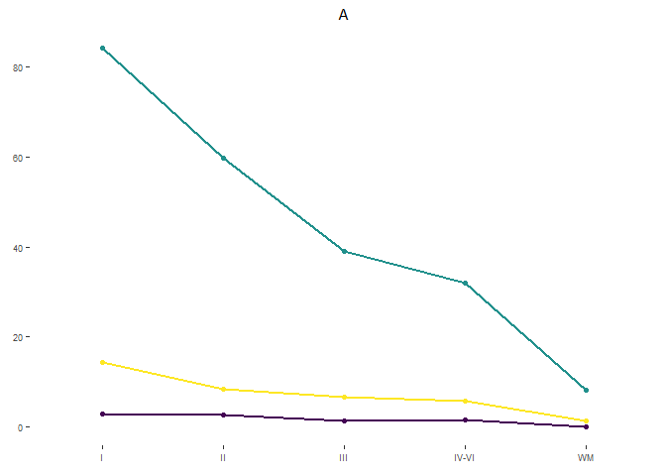

### 3 Individuals Neuron

p3 <- ggplot(data=sub_Neuron, aes(x=layer, y=count, group=Individual, colour=Individual)) +   
 geom_line() + geom_point()+ scale_color_manual(values=viridis(3))+  
 labs(title="C",x="Brain layers", y=element_blank())+  
 theme(  
 plot.title = element_text(size=11, hjust=0.5),  
 panel.border = element_blank(),   
 panel.grid.major = element_blank(),  
 panel.grid.minor = element_blank(),  
 panel.background = element_blank(),  
 axis.line = element_blank(),  
 axis.title.x = element_text(size=8),  
 axis.text=element_text(size=7)) +  
 geom_path(size=1)+  
 scale_x_discrete(limits=c("I","II","III","IV-VI","WM"))  
  
p3

## Warning: Removed 3 row(s) containing missing values (geom_path).

## Warning: Removed 3 rows containing missing values (geom_point).

## Warning: Removed 3 row(s) containing missing values (geom_path).

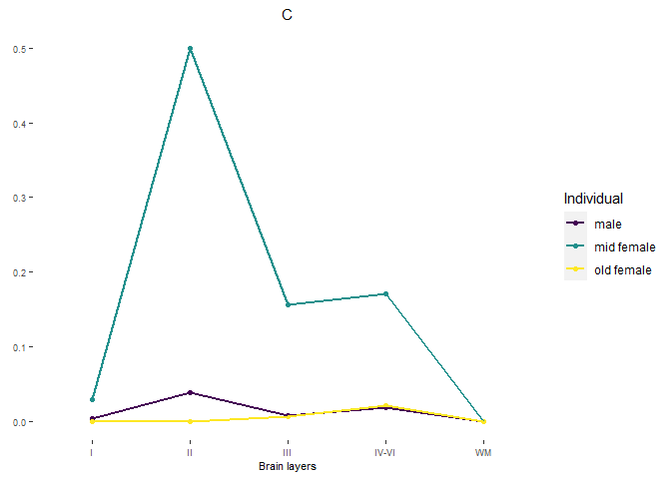

##arrange on page

all3<-ggarrange(p2, p1, p3, nrow=3, common.legend = TRUE, legend="right")

all3<-annotate_figure(all3, left=text_grob("Estimated population / volume "~(mm^3),rot = 90))  
  
all3

