TA Recruitment System
User Manual

1. Overview
The TA Recruitment System is a browser-based application for managing Teaching Assistant recruitment at BUPT International School. It provides separated portals for applicants (TAs), module organisers (MOs), and administrators, while using a lightweight Java server and JSON-based persistence.
This manual explains how end users interact with the delivered system, using the structure of the original illustrated manual and aligning each feature description with the current codebase in `Test_Version_02`.

2. System Access
Role | Portal URL | Purpose
TA | http://localhost:8080/TA/index.html | Browse jobs, apply, manage profile, track results
MO | http://localhost:8080/MO/index.html | Publish jobs, review applicants, use matching tools
Admin | http://localhost:8080/admin/index.html | Oversee operations, manage users, export data
Default demonstration accounts are seeded on first run. The administrator account is `admin / admin123`. Seeded TA and MO accounts use password `123456` unless changed in the running environment.

3. Core Functional Scope
- TA functions: registration, authentication, vacancy browsing, application submission, CV upload, AI-assisted matching, profile management, and notifications.
- MO functions: authentication, job publishing, applicant review, timetable-aware recruitment decisions, AI-assisted comparison, and communications.
- Admin functions: dashboards, job oversight, workload control, user and role management, password reset processing, notifications, data export, and audit logging.

4. TA Portal
This section follows the typical applicant journey from sign-in to submission tracking and profile maintenance.

4.1 Sign In
Open the TA portal and sign in with a seeded student account or a registered account. The TA portal is intended for applicants who browse vacancies, submit applications, and track outcomes.
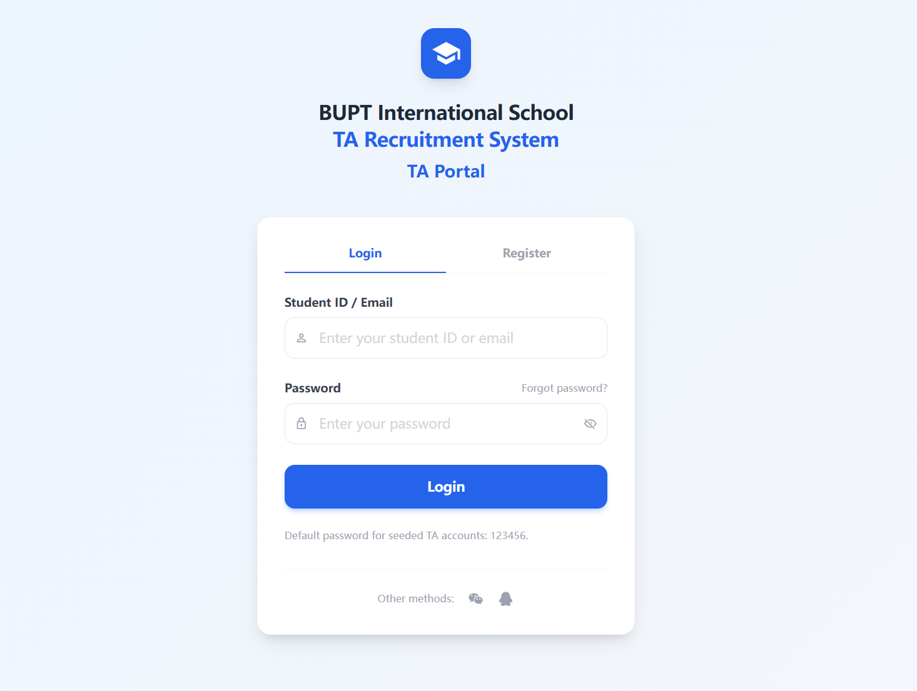
Figure: Sign In

4.2 Register a New TA Account
New applicants can create an account directly from the TA login page. Registration captures the core identity information required for later applications.
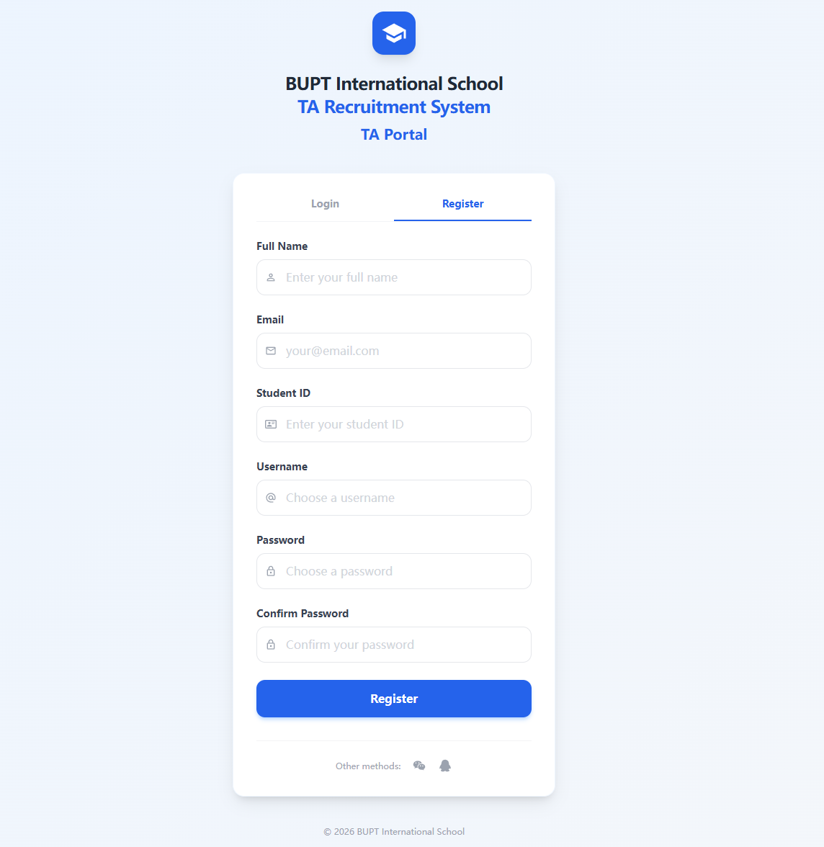
Figure: Register a New TA Account

4.3 TA Home Dashboard
After login, the dashboard provides a concise overview of the recruitment status, quick access to open jobs, and recent personal activity.
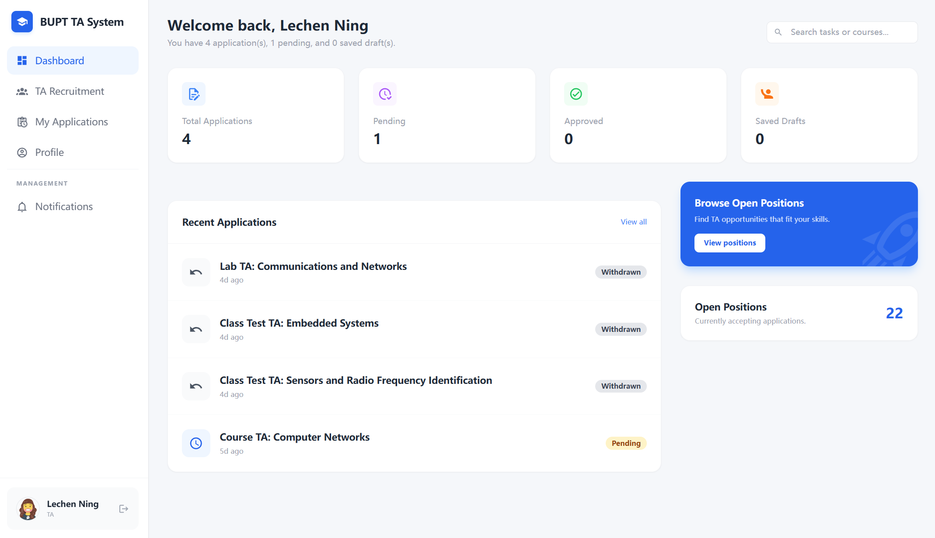
Figure: TA Home Dashboard

4.4 Status Summary Cards
The dashboard highlights application counts by status so applicants can quickly understand whether submissions are pending, approved, rejected, or withdrawn.
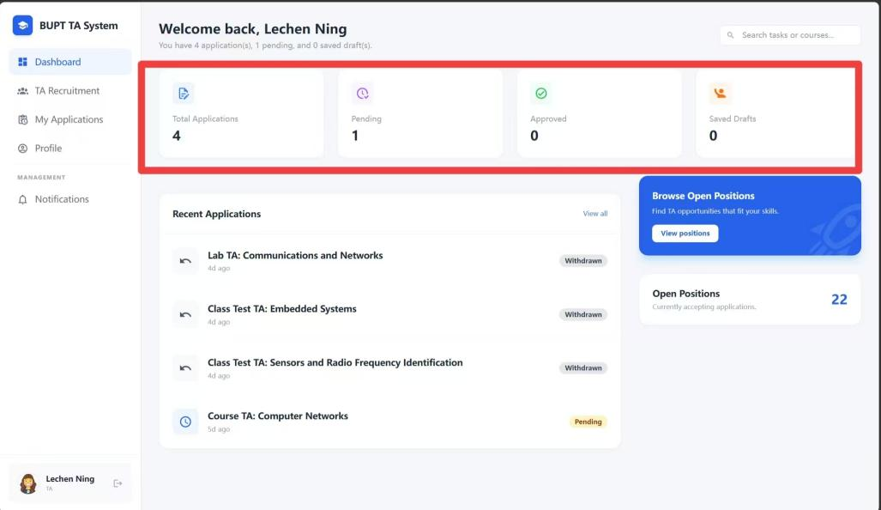
Figure: Status Summary Cards

4.5 Recent Applications
The recent applications panel shows the latest submissions and acts as a shortcut for checking progress without reopening each job posting manually.
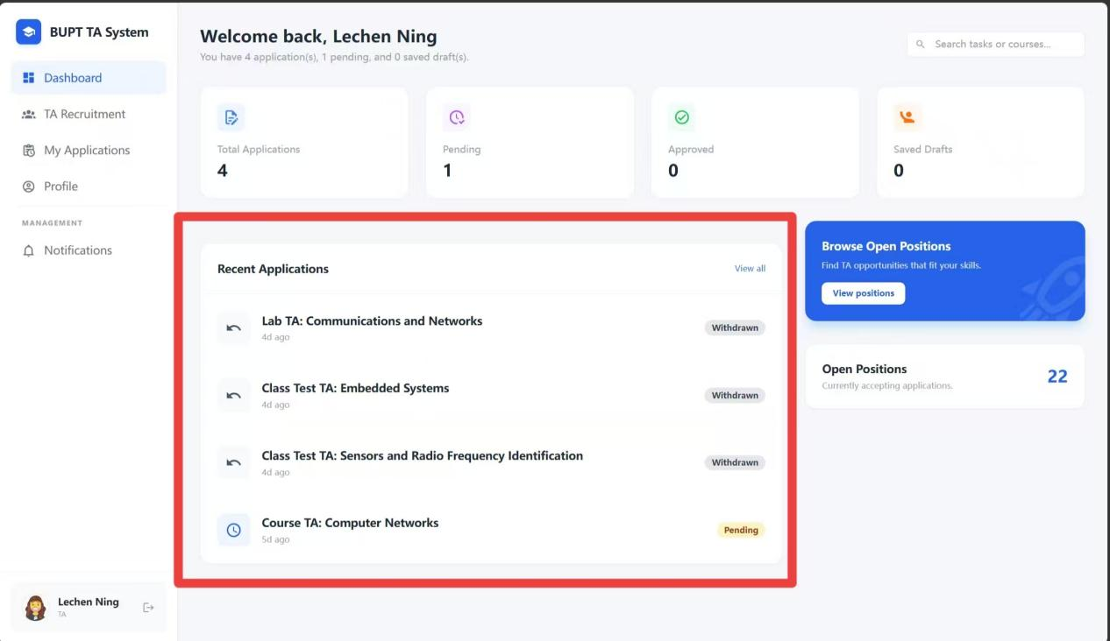
Figure: Recent Applications

4.6 Browse Available Jobs
Applicants can open the job list and examine current vacancies published by module organisers.
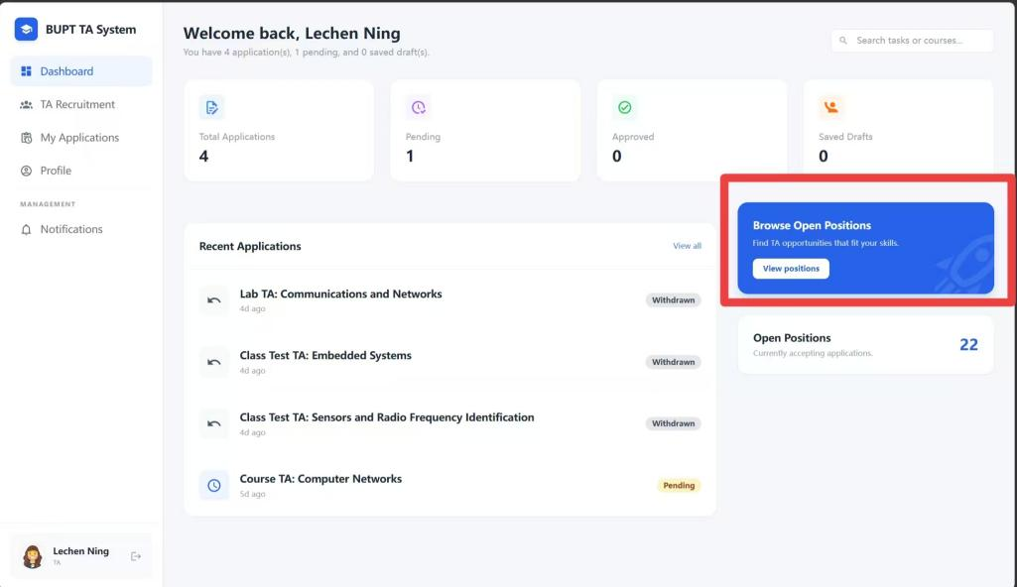
Figure: Browse Available Jobs

4.7 Open a Job Record
Each job entry includes a dedicated view action for reading the vacancy details in full.
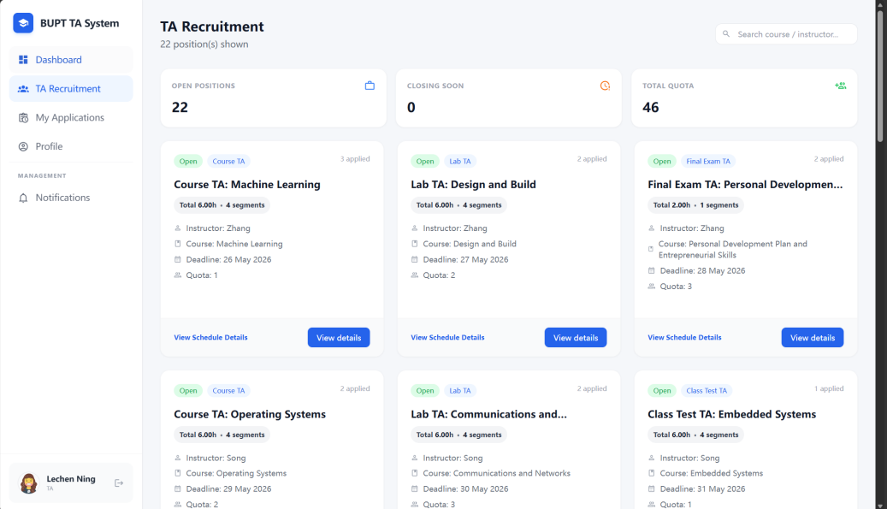
Figure: Open a Job Record

4.8 Review Job Details
The job details page presents teaching duties, requirements, recruitment deadlines, and scheduling information before the applicant proceeds.
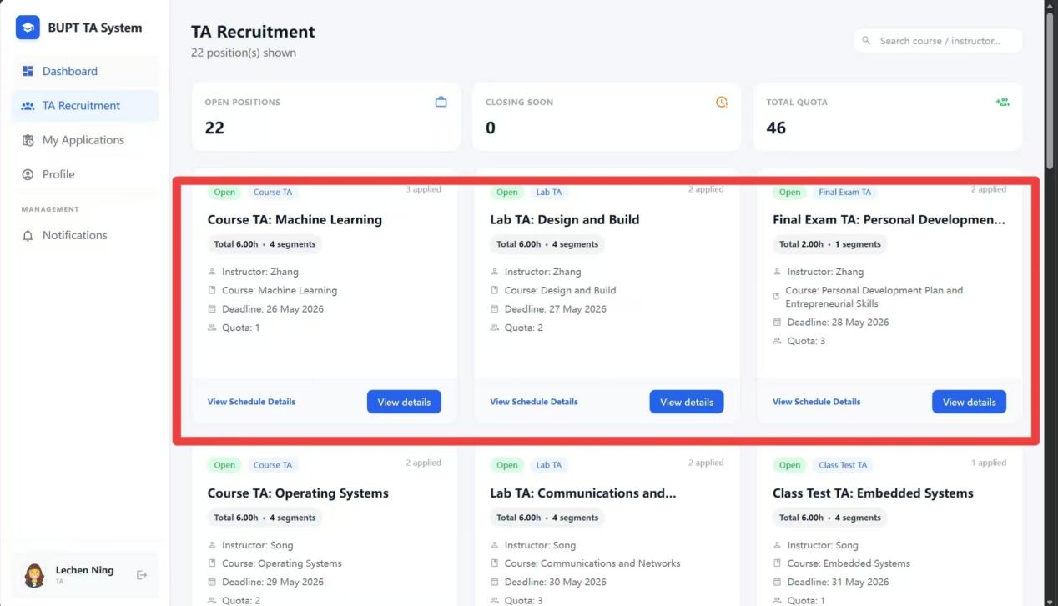
Figure: Review Job Details

4.9 Check the Schedule Information
Applicants can inspect the timetable-related details to confirm availability before applying.
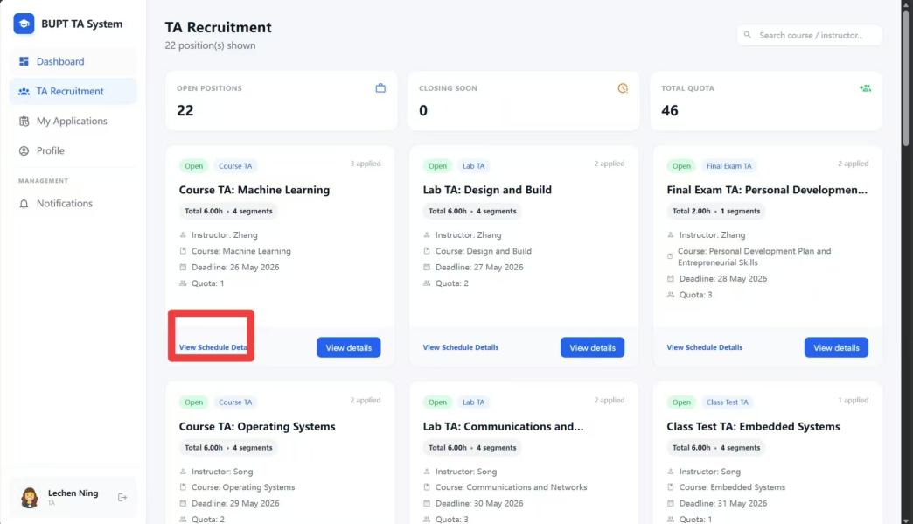
Figure: Check the Schedule Information
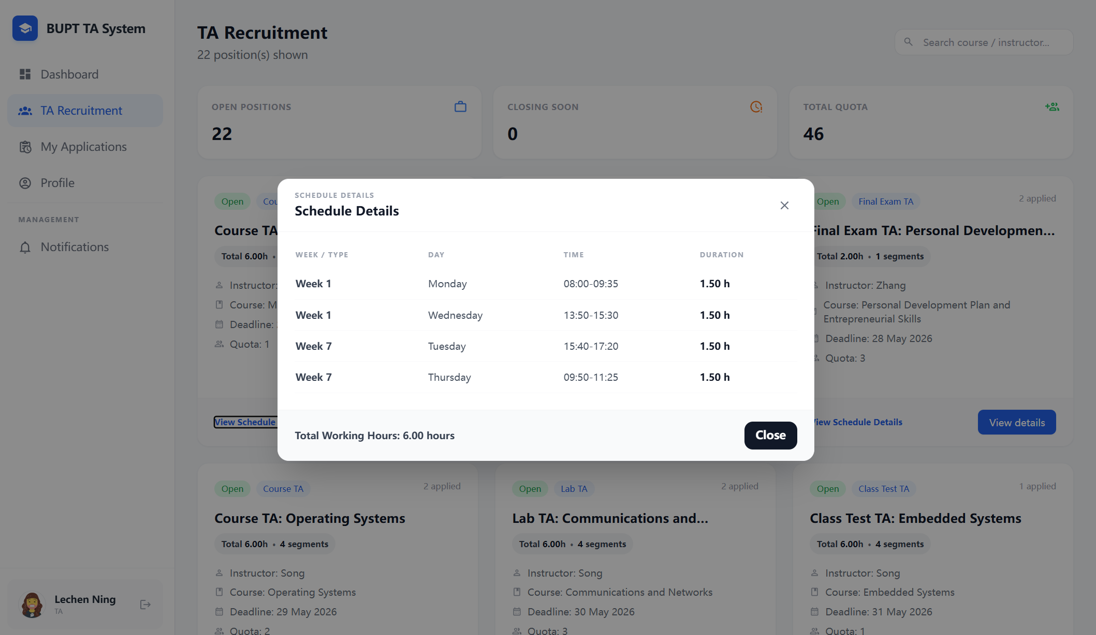
Figure: Check the Schedule Information

4.10 Open the Application Form
The View and Apply actions lead to the application page where the applicant prepares a submission.
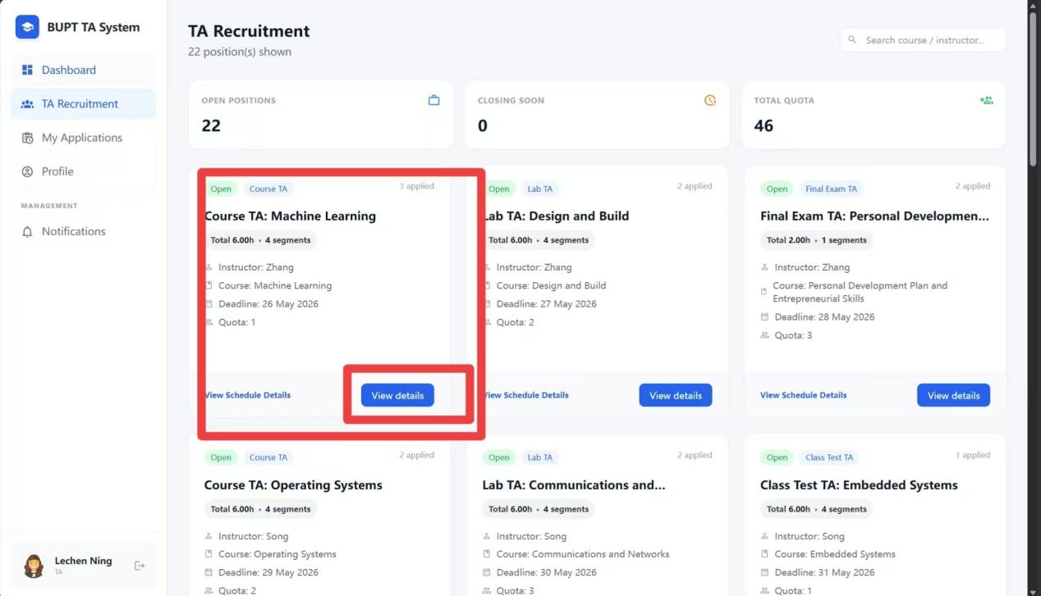
Figure: Open the Application Form
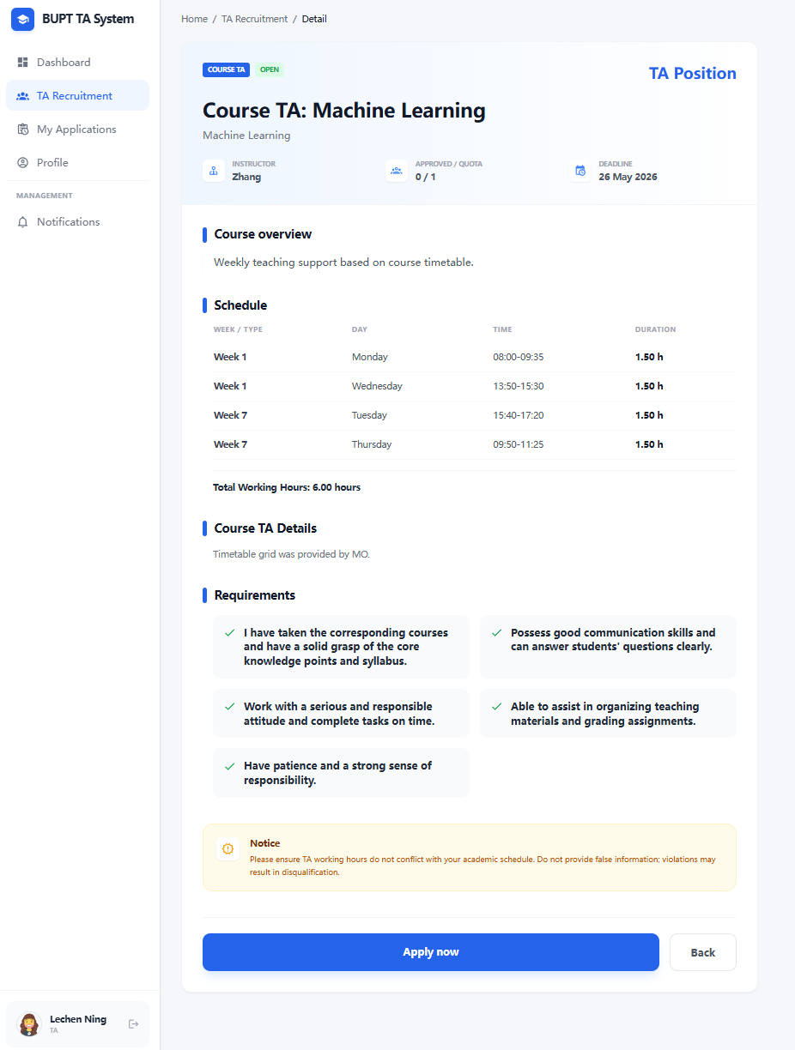
Figure: Open the Application Form

4.11 Start an Application
The application form supports structured submission of personal information and supporting details.
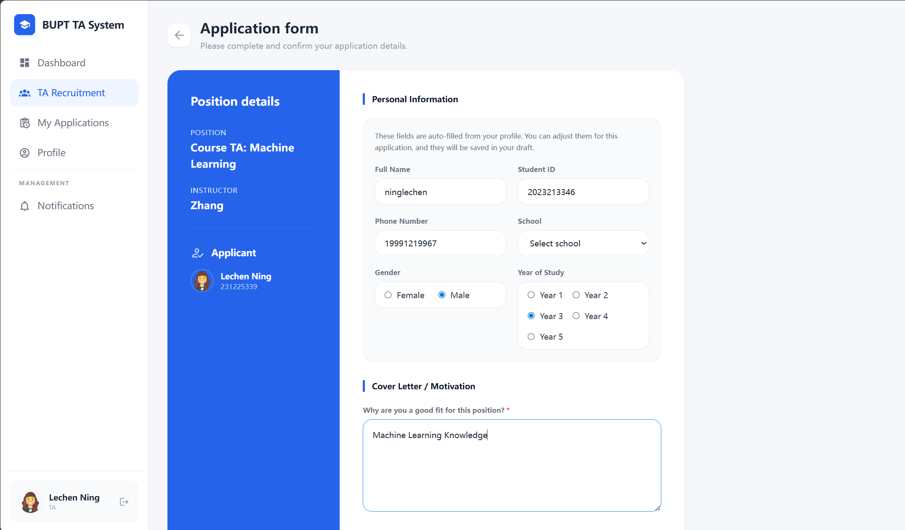
Figure: Start an Application

4.12 Optional AI Matching
The TA portal includes an optional AI matching workflow to support applicant decision-making before submission.

4.13 Choose a Model
Applicants can select the AI model configuration used for matching analysis.
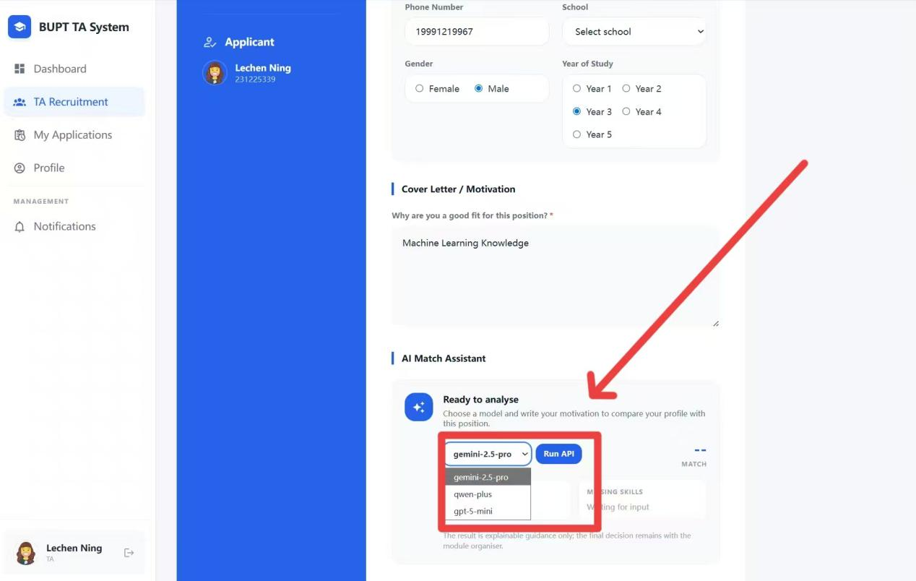
Figure: Choose a Model

4.14 Run the Matching Request
A dedicated action triggers the AI-assisted analysis based on the available profile and job information.
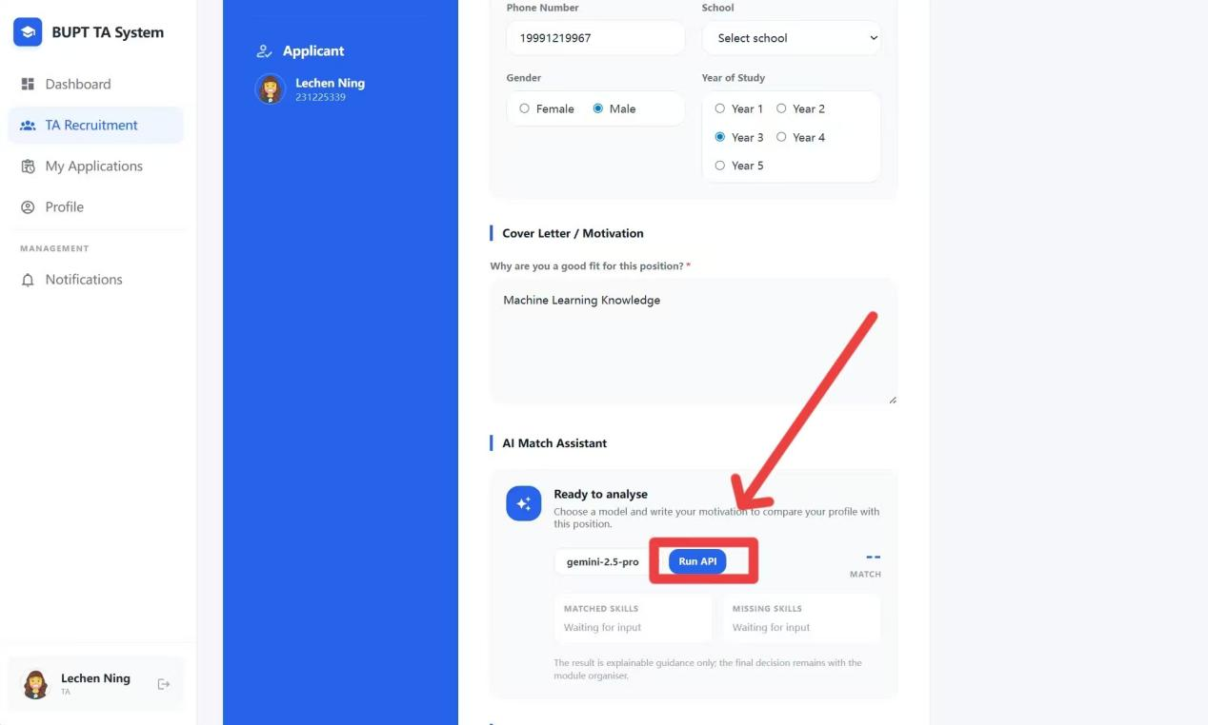
Figure: Run the Matching Request

4.15 Set Priority
The applicant can indicate a preferred priority level to help organize the submission.
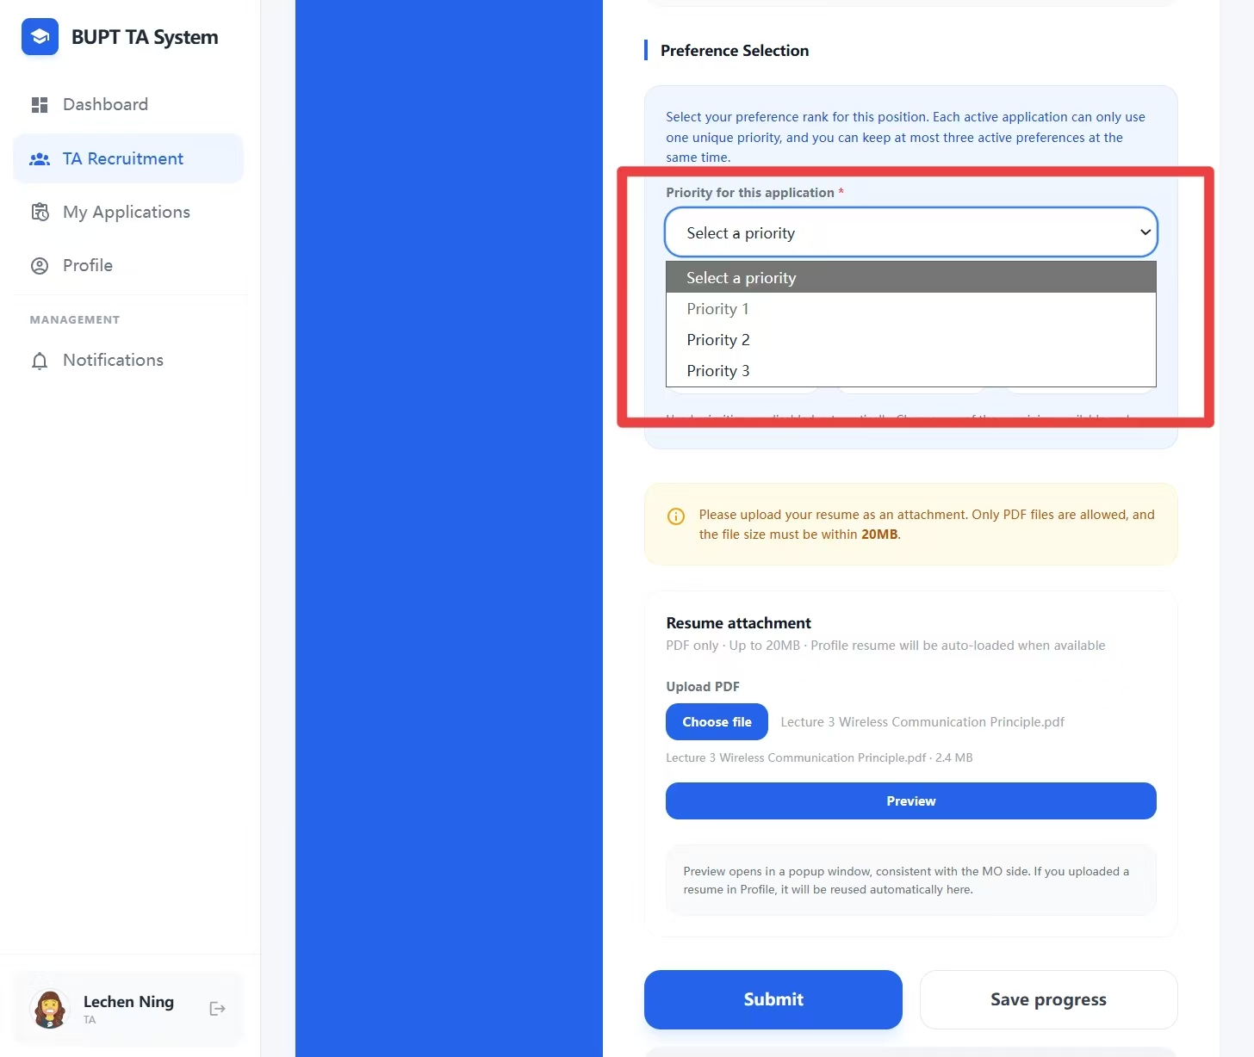
Figure: Set Priority

4.16 Attach a CV
A CV or related supporting document can be selected and uploaded as part of the application package.
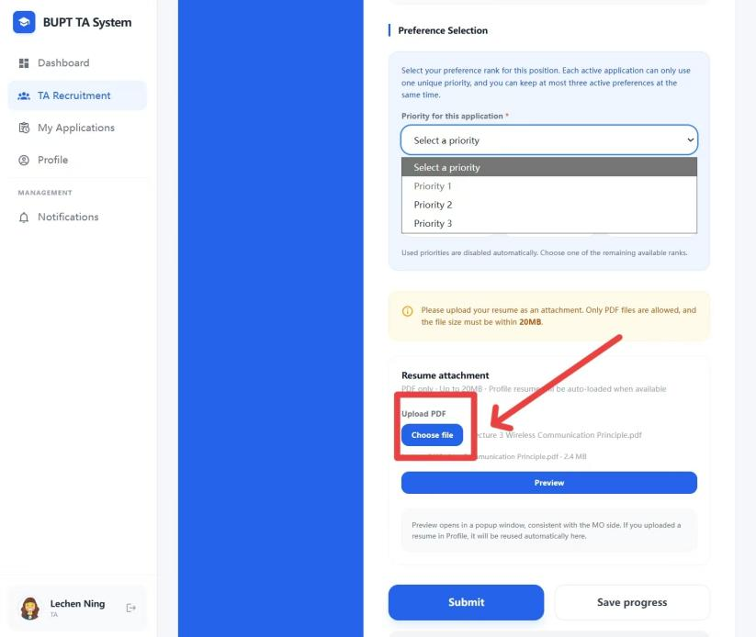
Figure: Attach a CV

4.17 Submit the Application
Once all required fields are complete, the applicant submits the application for review by the module organiser.
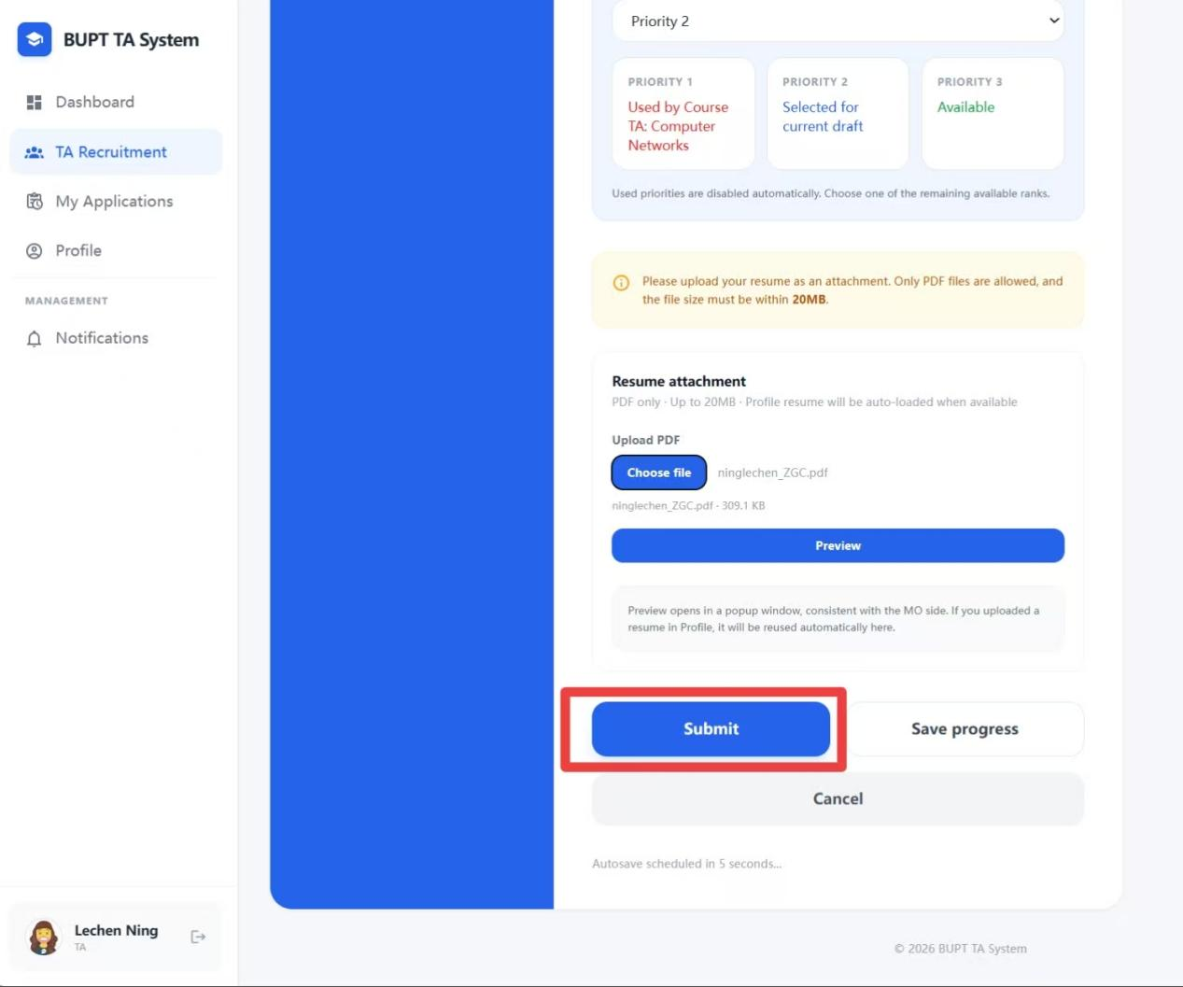
Figure: Submit the Application

4.18 Track or Withdraw a Submission
Submitted applications remain visible in the TA portal, and the user can review their state or withdraw them when the workflow permits.
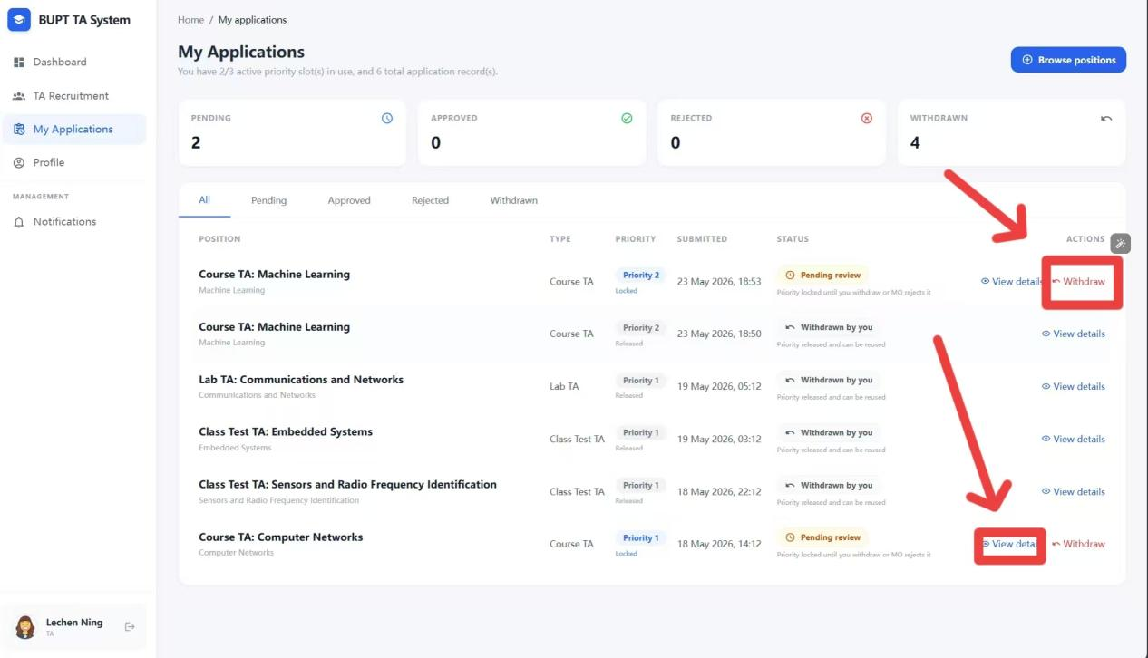
Figure: Track or Withdraw a Submission

4.19 Change Password
The profile area includes password maintenance for routine account security updates.
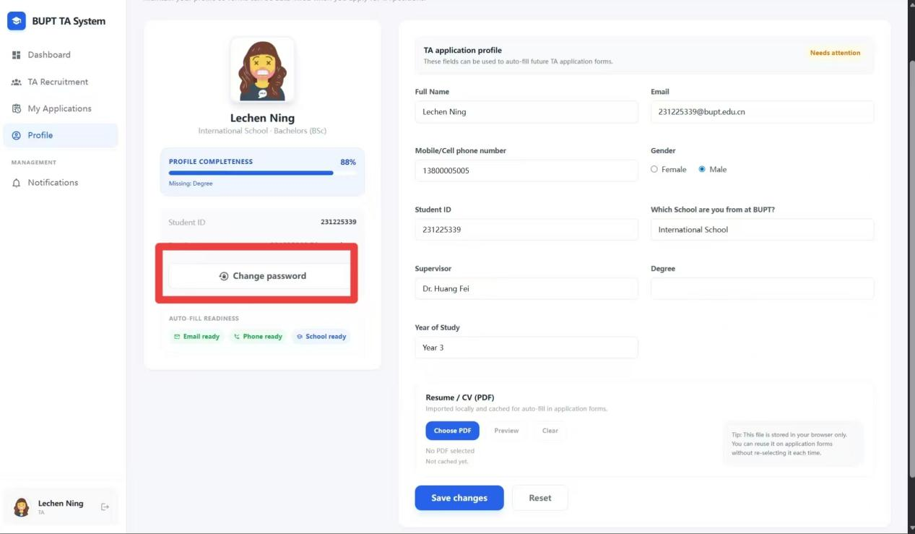
Figure: Change Password
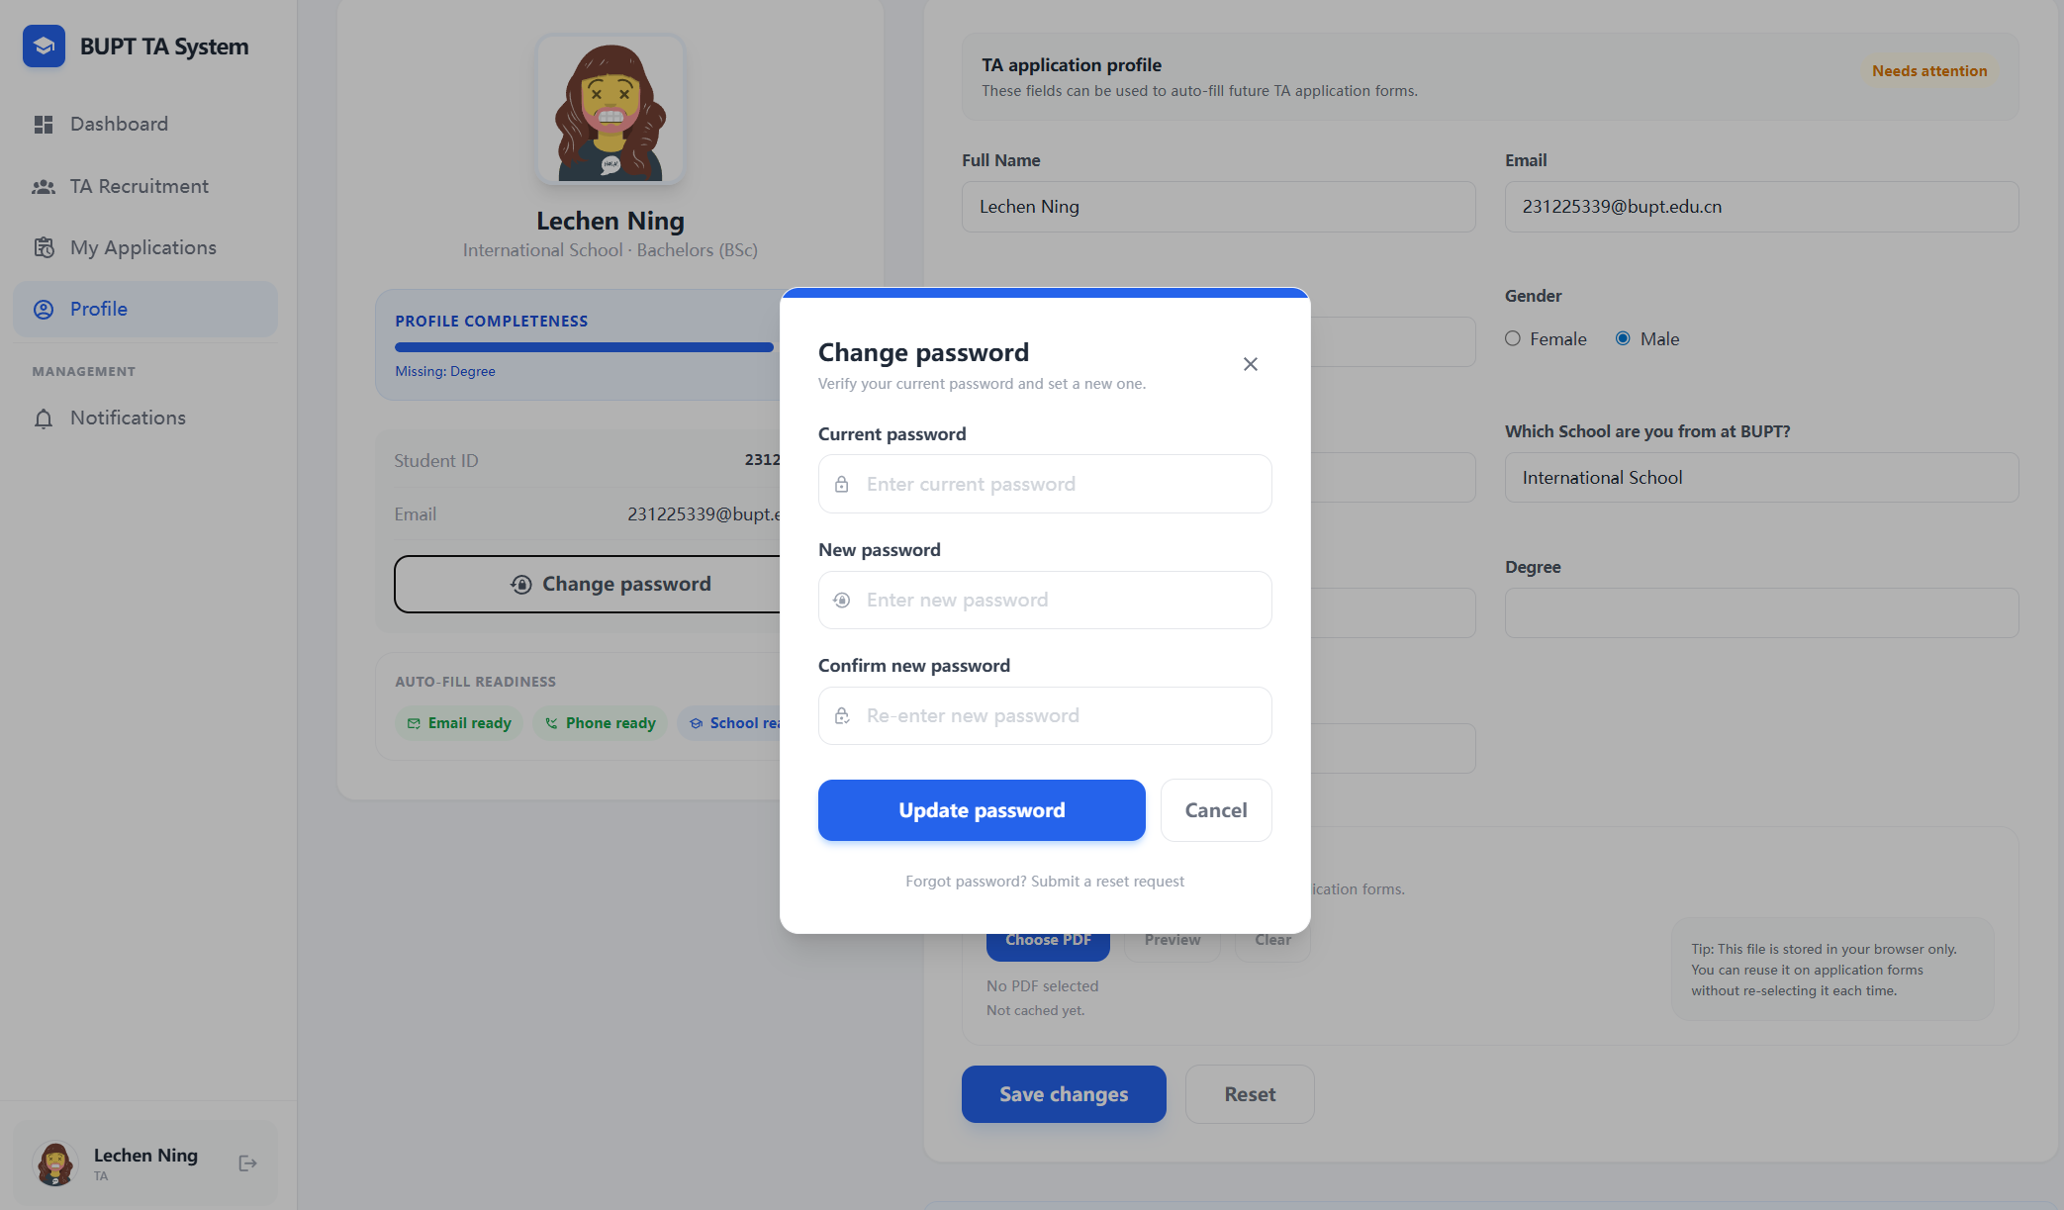
Figure: Change Password

4.20 Update Profile and Save CV Information
Applicants can revise personal details and keep profile information aligned with their latest CV.
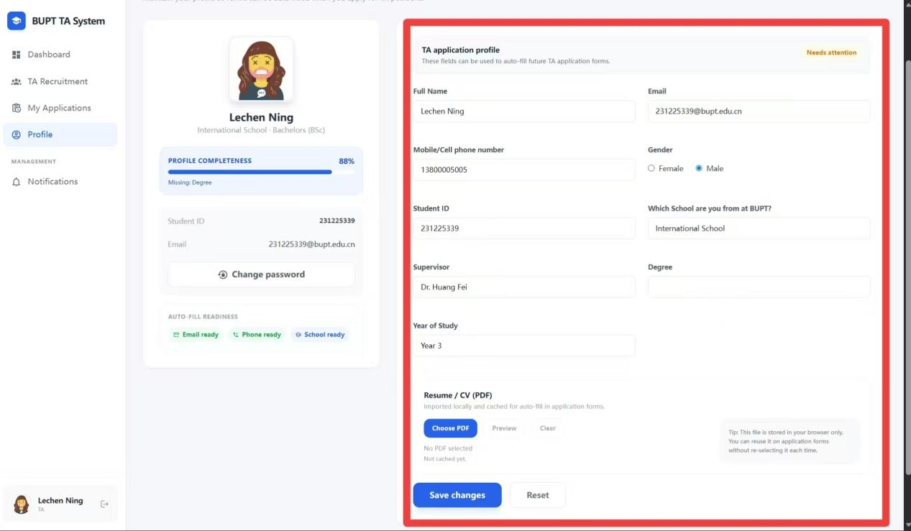
Figure: Update Profile and Save CV Information

4.21 Receive Notifications
System messages and recruitment updates are delivered through the portal notification area.
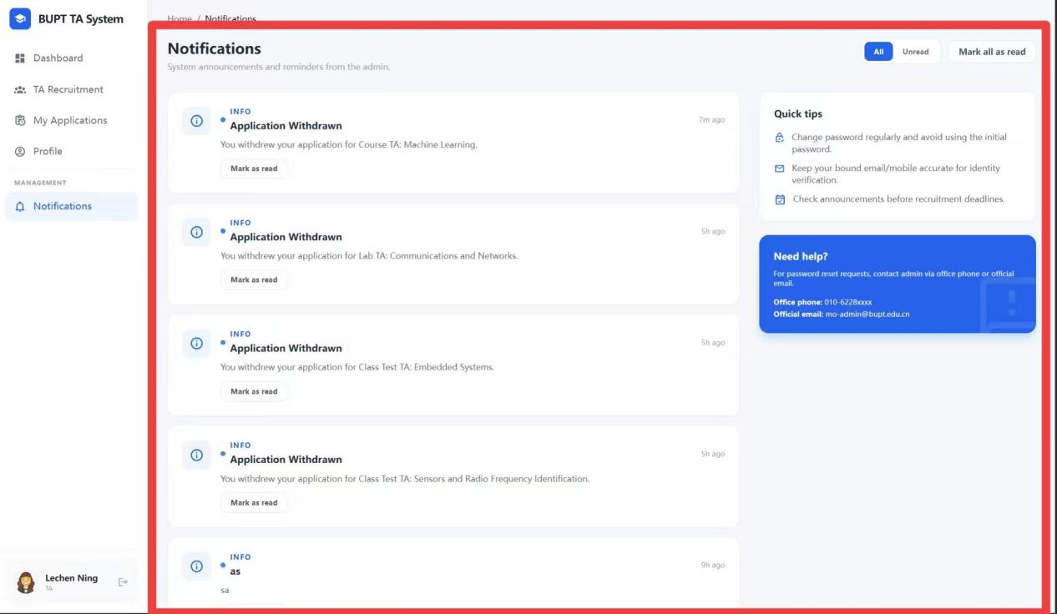
Figure: Receive Notifications

5. MO Portal
This section describes the organiser-facing workflow for vacancy creation, applicant review, AI-assisted comparison, and communication.

5.1 Sign In
Module organisers access their portal through a dedicated login page separated from TA and Admin functions.
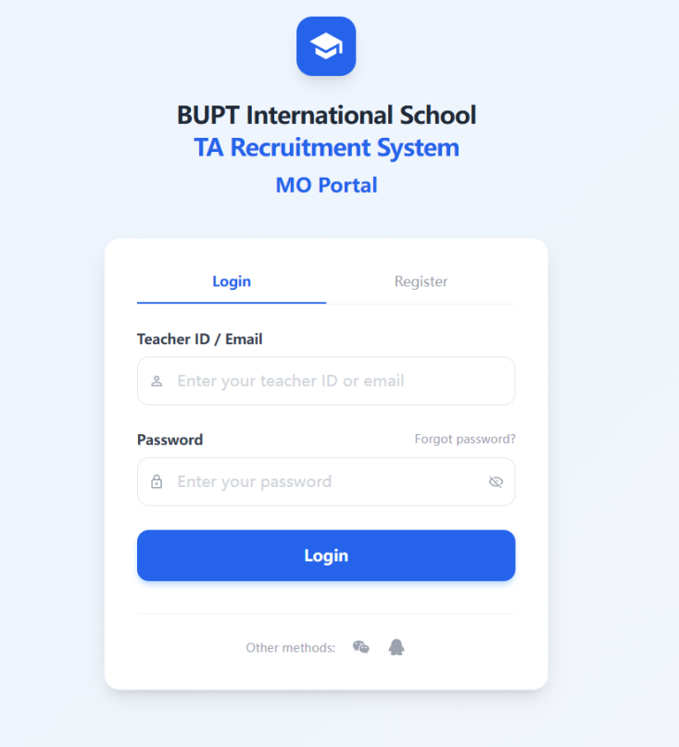
Figure: Sign In

5.2 Register a New MO Account
If self-registration is enabled for the environment, module organisers can create an account from the MO login page.
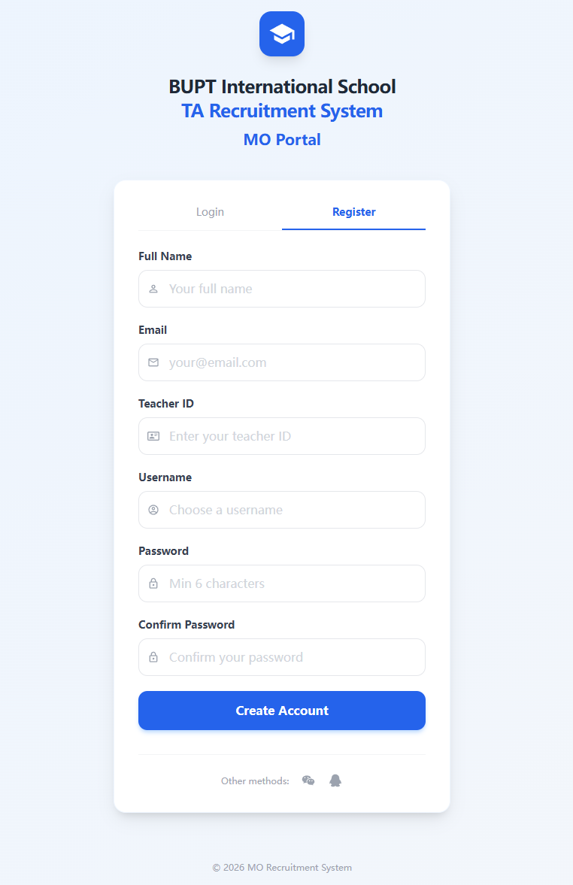
Figure: Register a New MO Account

5.3 Create a Job Posting
The posting workflow lets an MO define a vacancy with module context, responsibilities, deadlines, and supporting constraints.
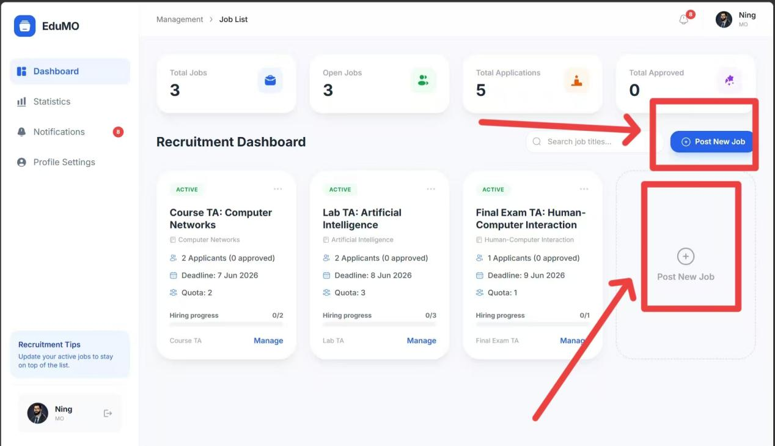
Figure: Create a Job Posting

5.4 Select the Job Type
Different recruitment categories can be chosen to describe the vacancy accurately.
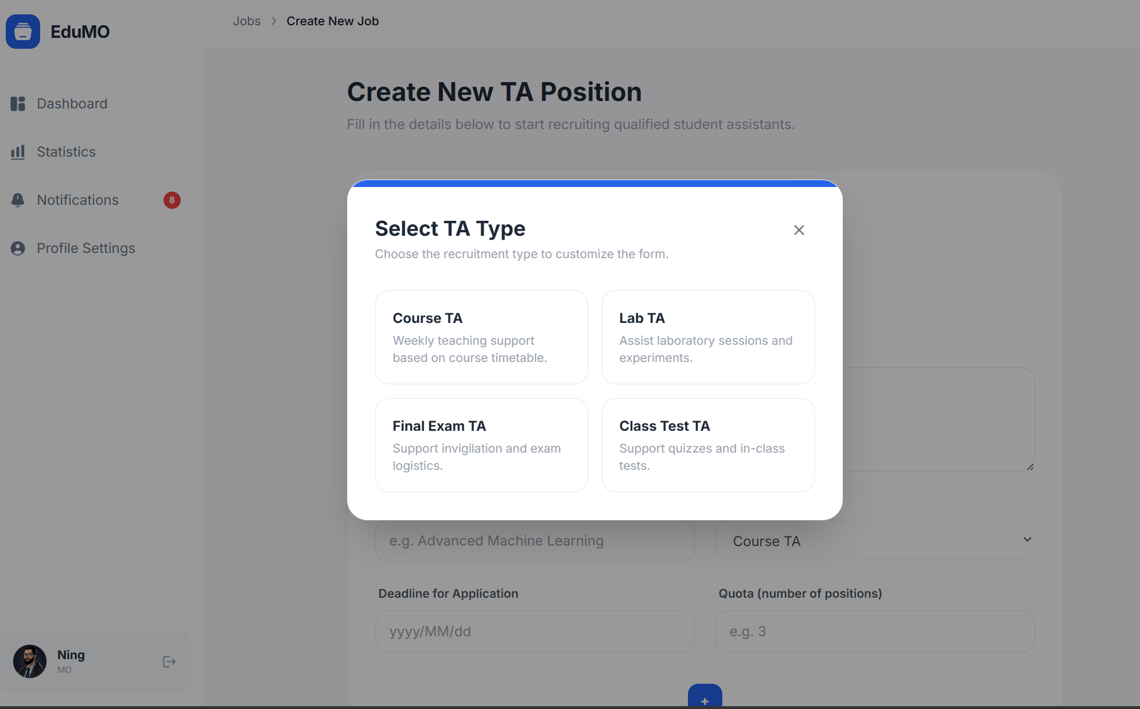
Figure: Select the Job Type

5.5 Set the Application Deadline
The organiser specifies the deadline so that late submissions can be controlled consistently.
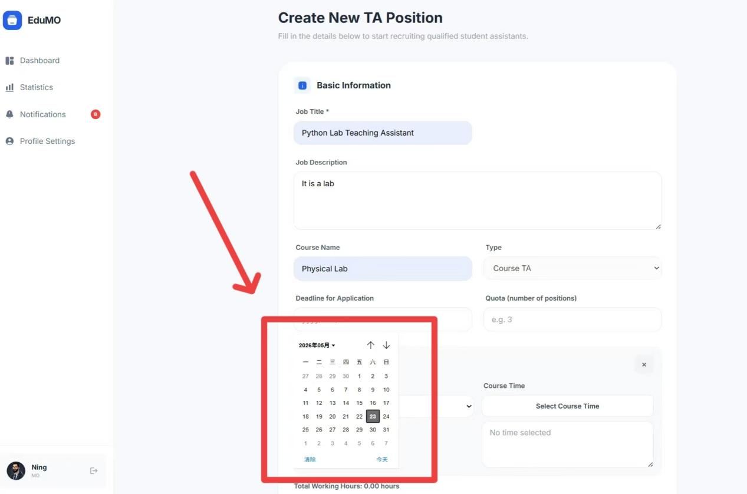
Figure: Set the Application Deadline

5.6 Set the Working Date
The posting form records the expected work date or period associated with the position.
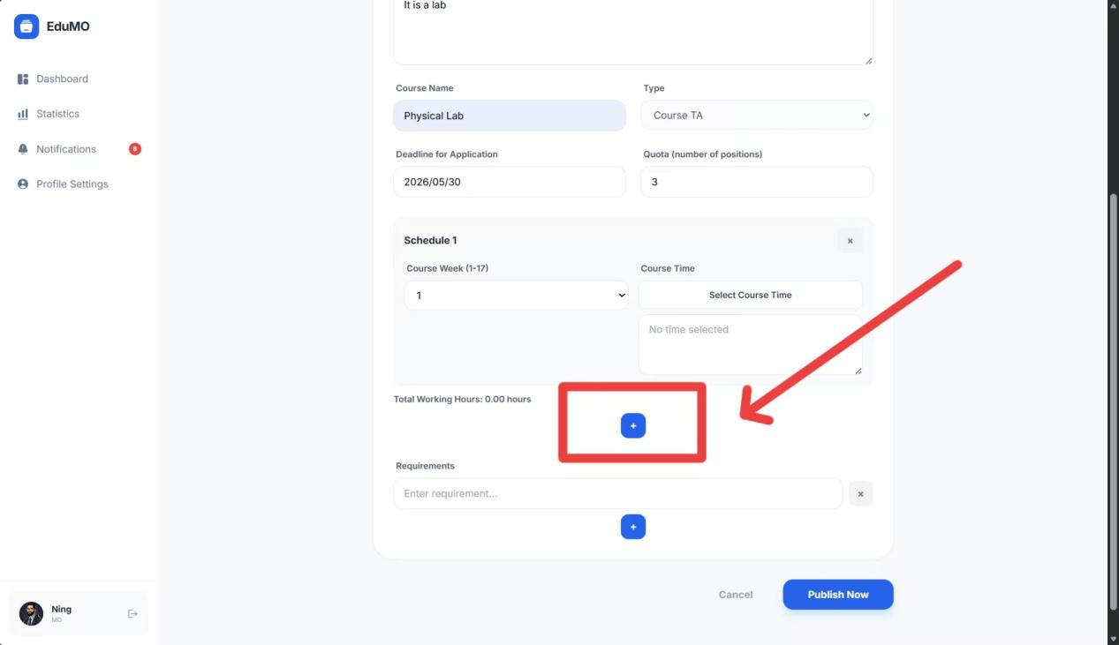
Figure: Set the Working Date

5.7 Use the BUPT Timetable Reference
The workflow incorporates schedule awareness so organisers can align requirements with the institutional timetable.
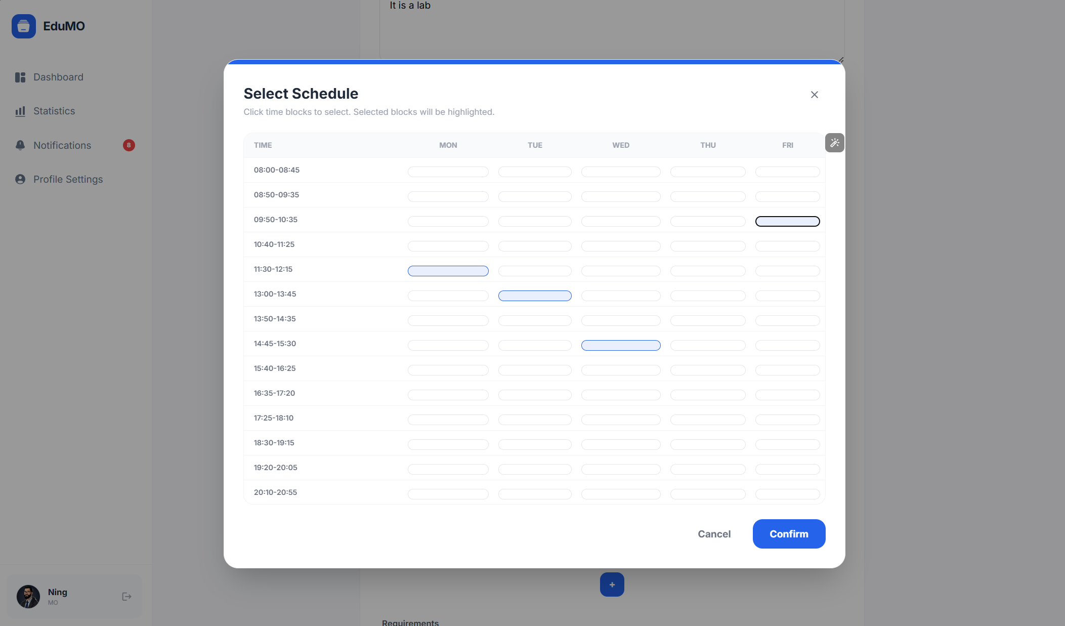
Figure: Use the BUPT Timetable Reference

5.8 Add Requirements
Requirement fields make it possible to document eligibility rules, skills, and preferred experience for the role.
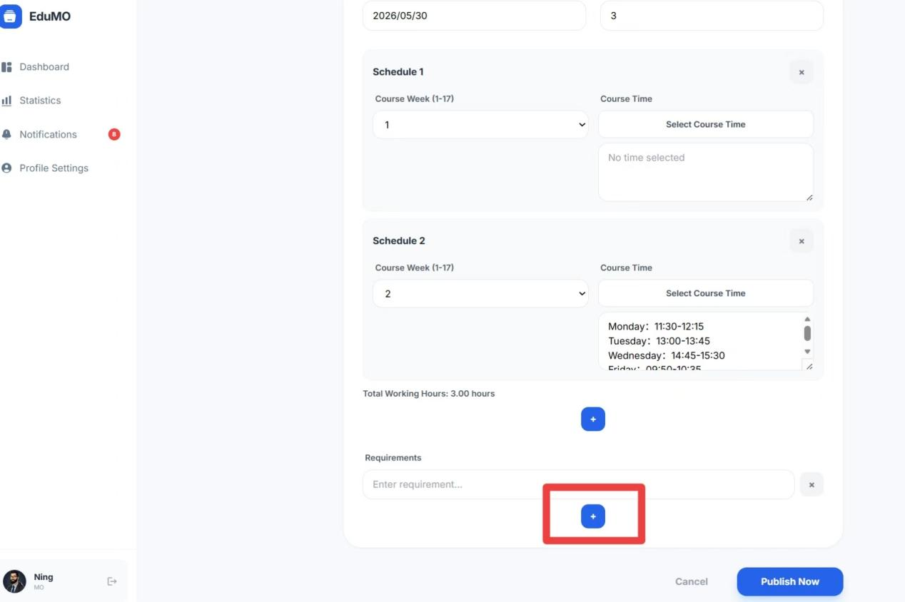
Figure: Add Requirements

5.9 Use Templates or Custom Text
The system supports both predefined requirement content and custom free-text additions.
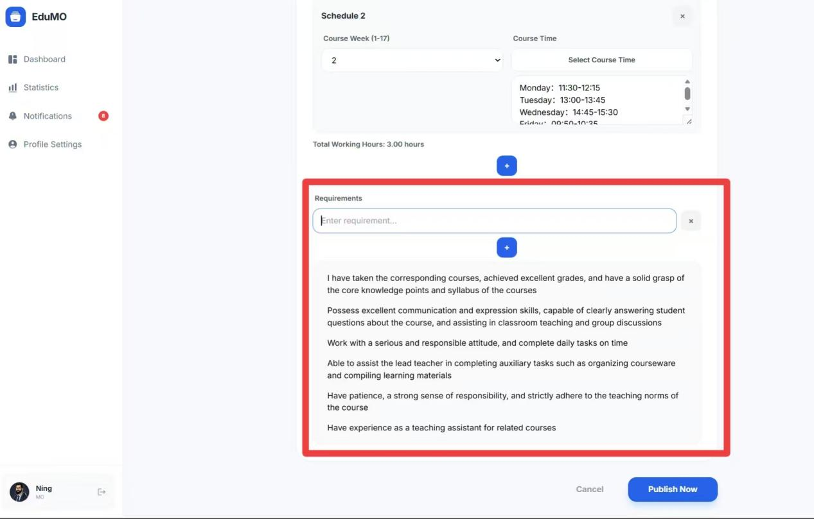
Figure: Use Templates or Custom Text

5.10 Manage Existing Jobs
Published jobs remain editable and reviewable from the job management area.
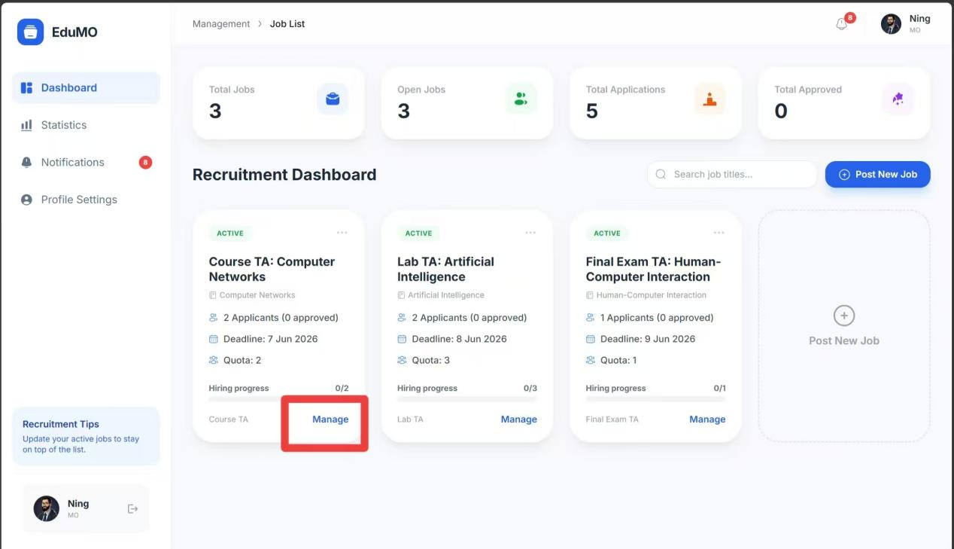
Figure: Manage Existing Jobs

5.11 View Applicants
The MO can open a posting and inspect the list of applicants associated with that vacancy.
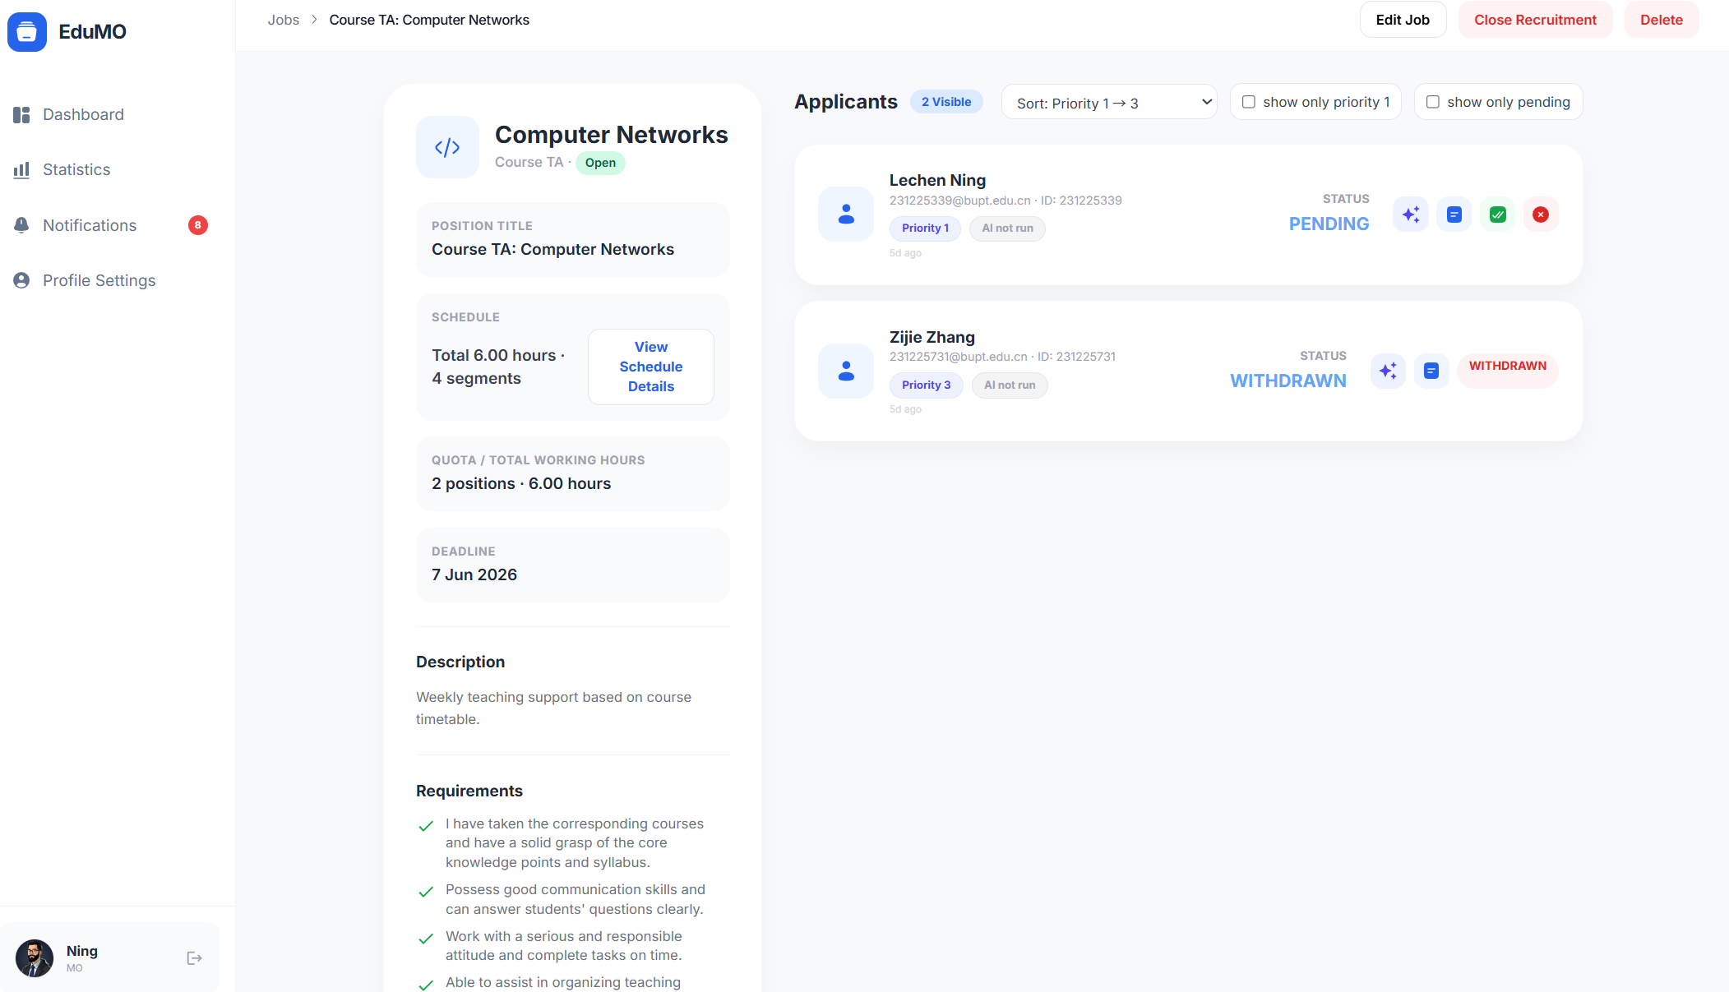
Figure: View Applicants
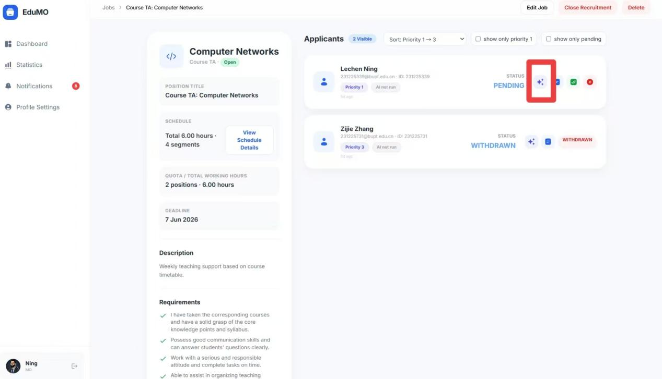
Figure: View Applicants

5.12 Use the AI Matching Tool
The portal provides an AI-assisted analysis tool to help compare applicants against the job requirements.
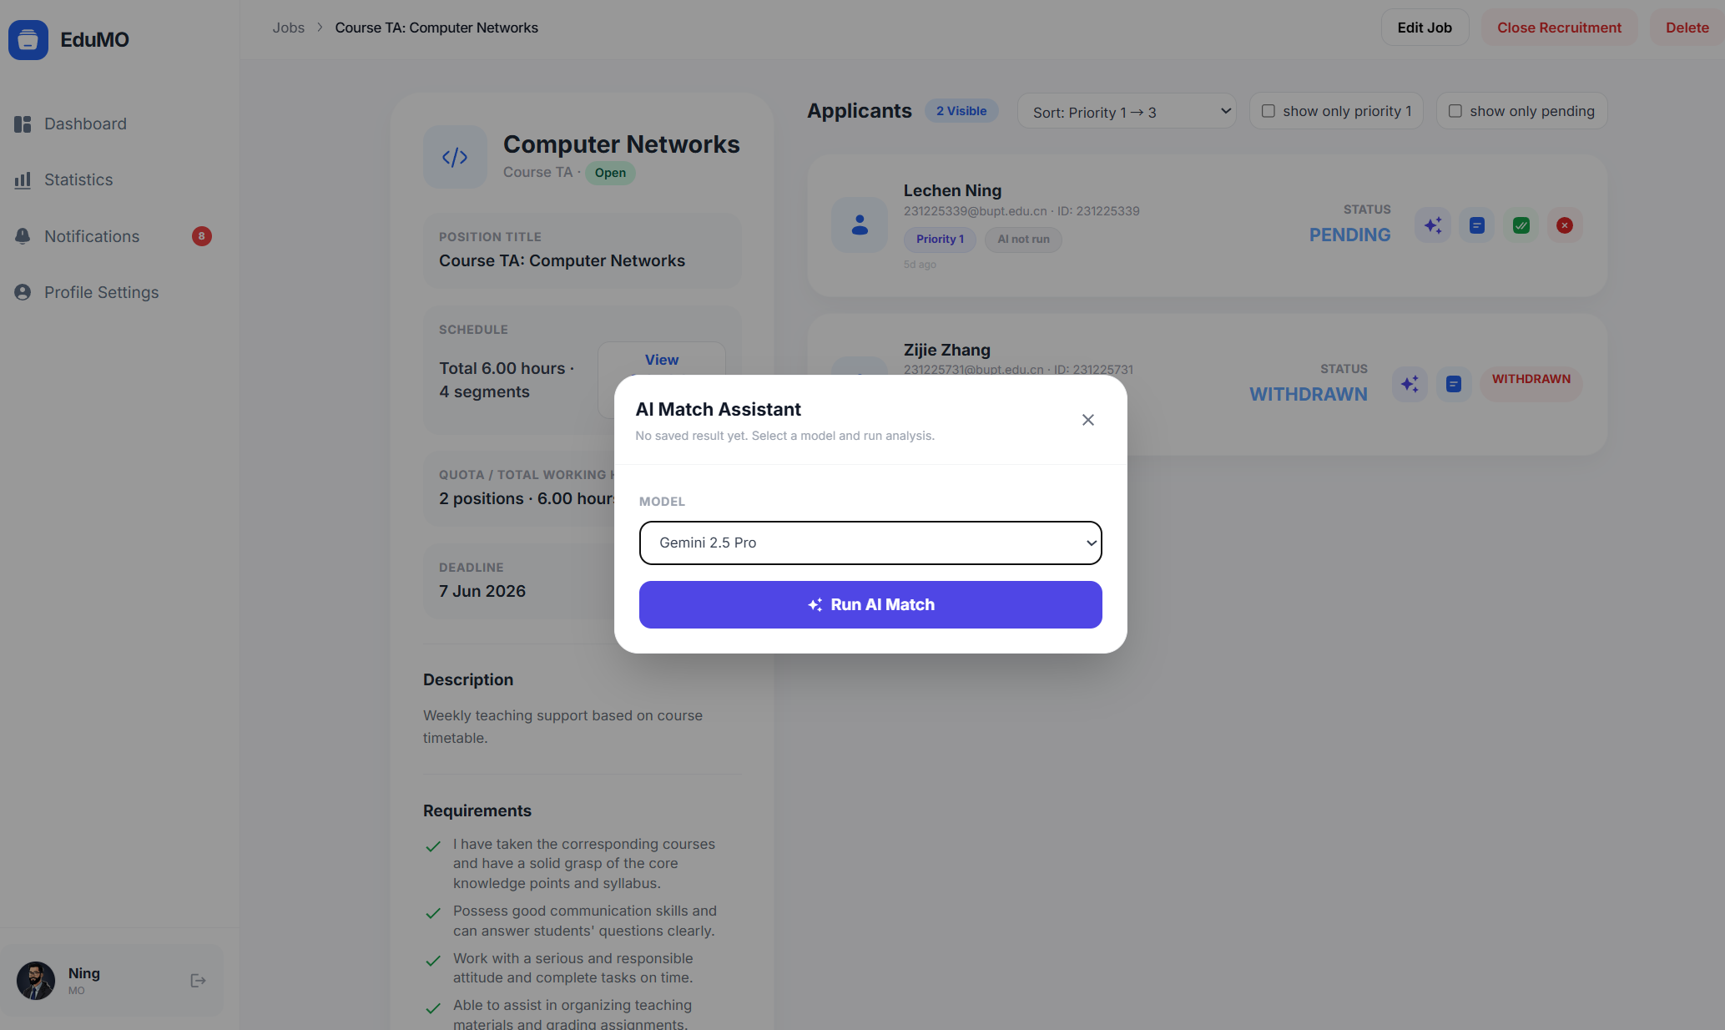
Figure: Use the AI Matching Tool
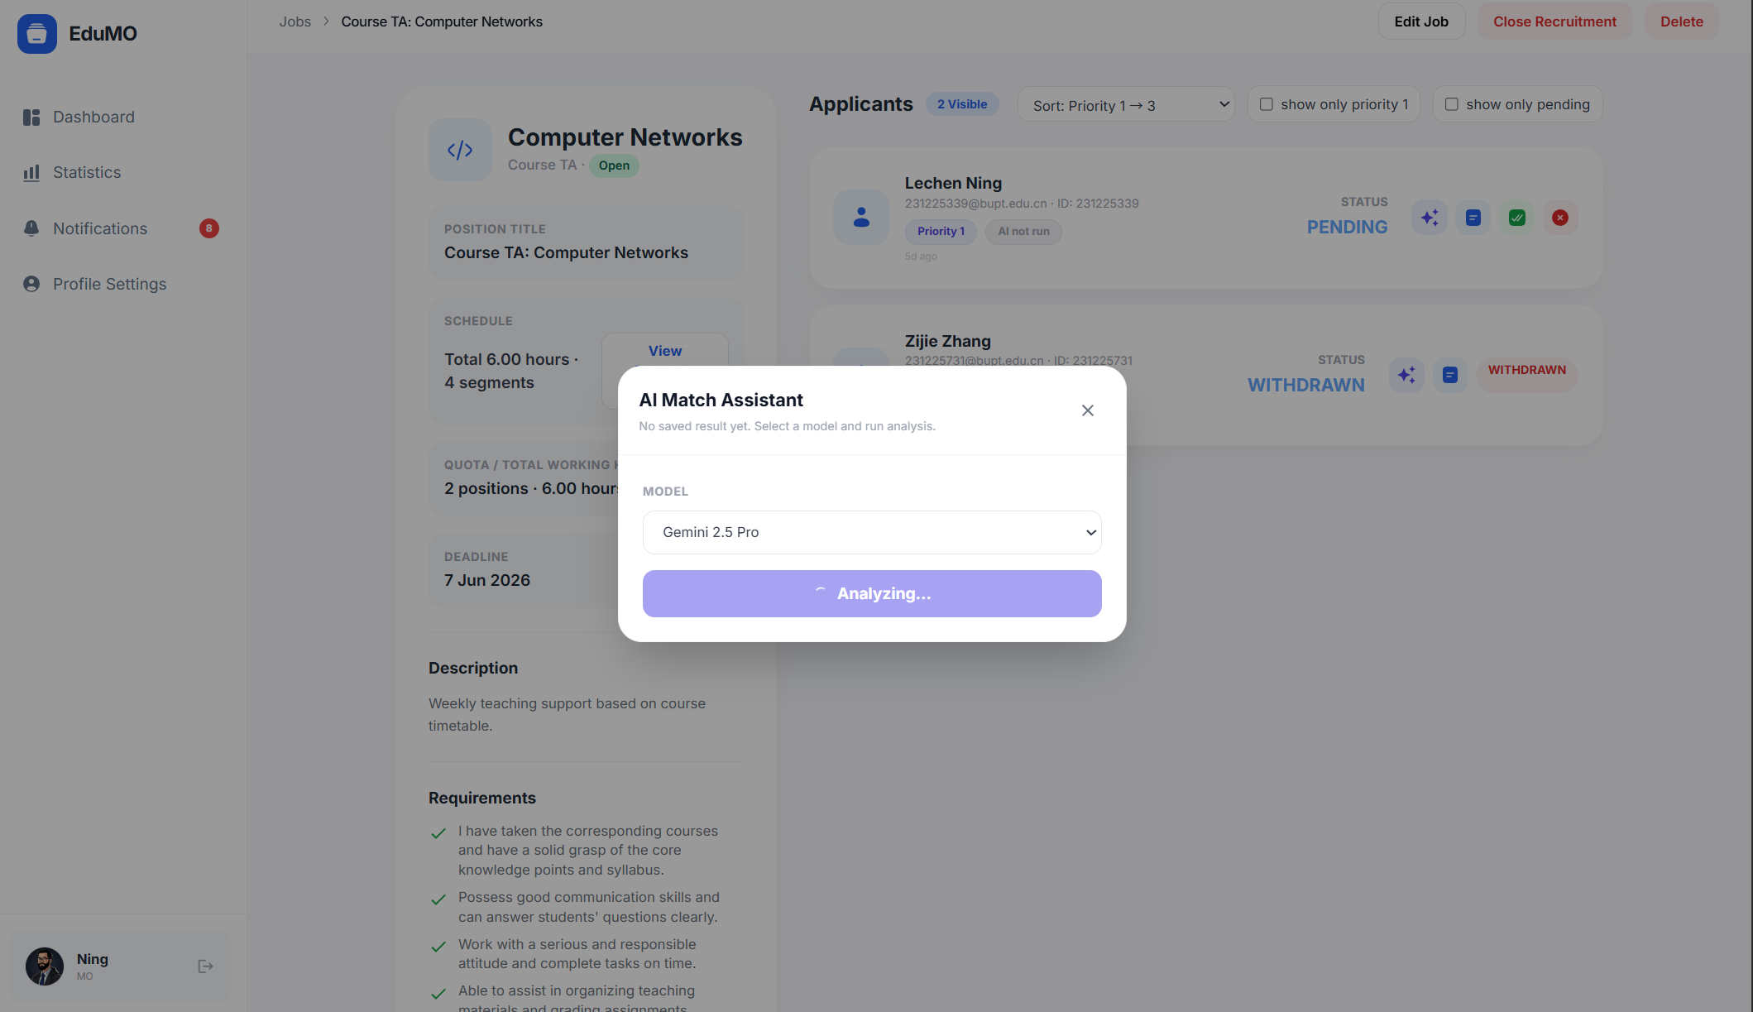
Figure: Use the AI Matching Tool

5.13 Read Matching Results
The matching result view summarizes the comparative analysis for the organiser.
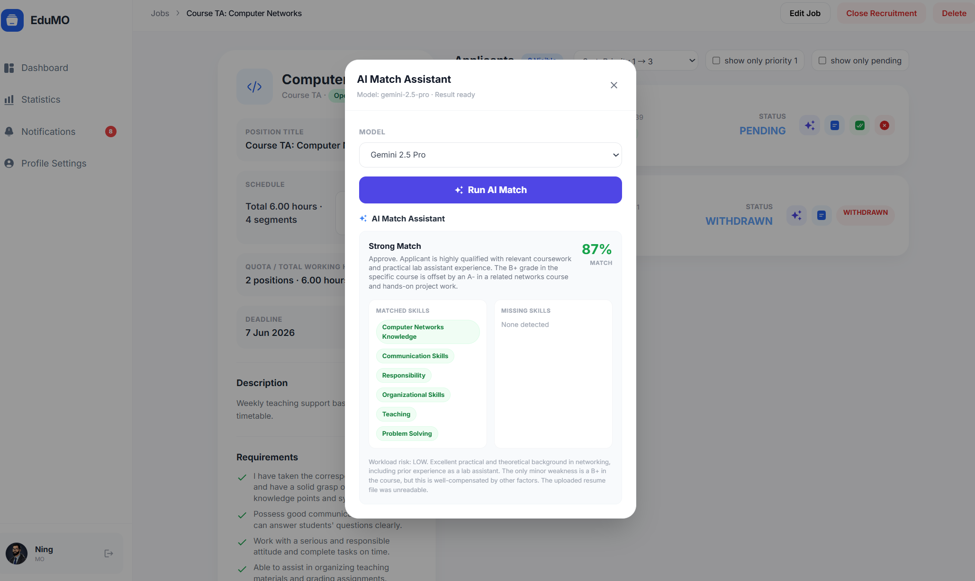
Figure: Read Matching Results

5.14 Keep the Analysis Record
Generated analysis remains available in the system so the organiser can revisit prior evaluation output.
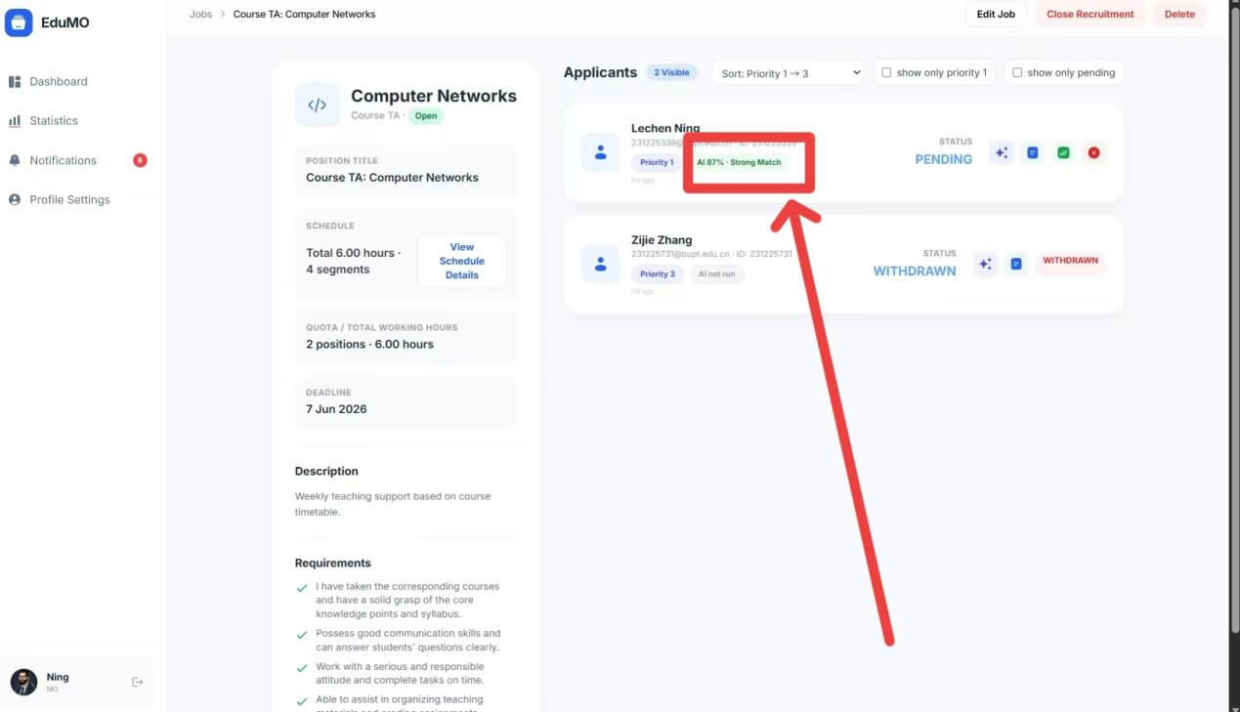
Figure: Keep the Analysis Record

5.15 Open Full Applicant Details
A detail view exposes more complete application information for final decision-making.
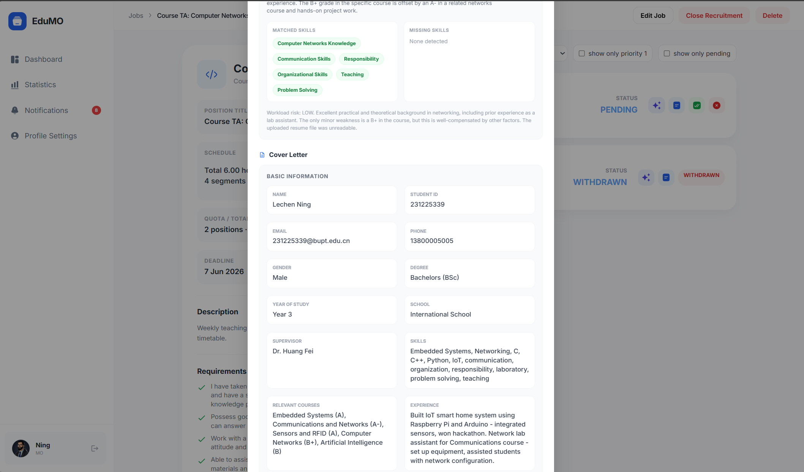
Figure: Open Full Applicant Details

5.16 Inspect Course Time Details
Timetable-related detail pages help organisers evaluate schedule conflicts or alignment.
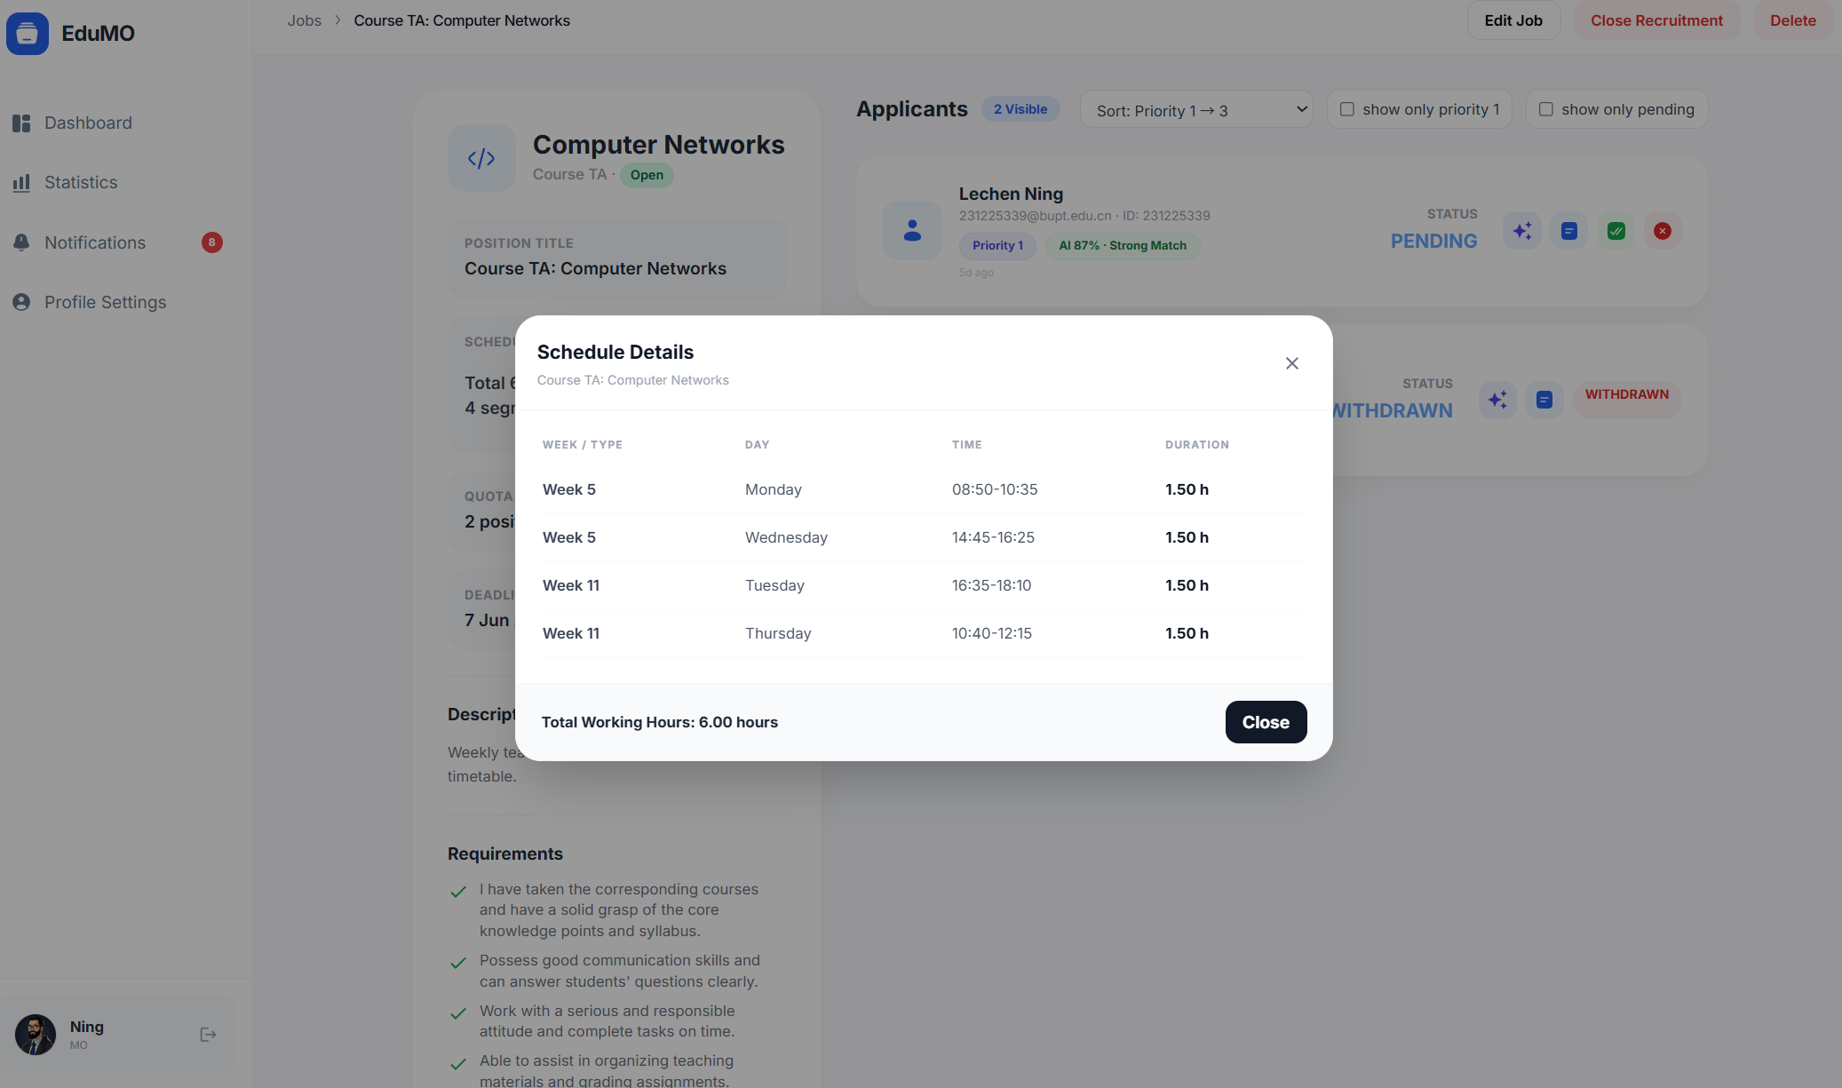
Figure: Inspect Course Time Details

5.17 View Statistics
The MO portal includes statistics pages for job and application monitoring.
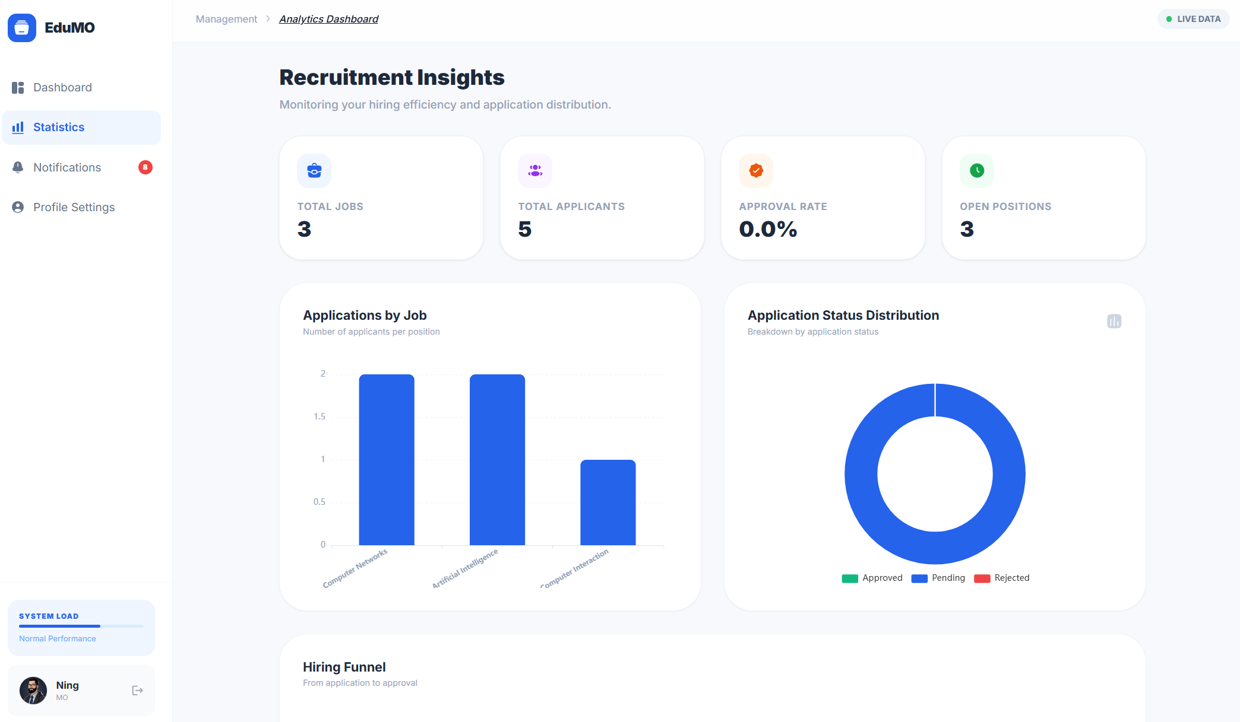
Figure: View Statistics
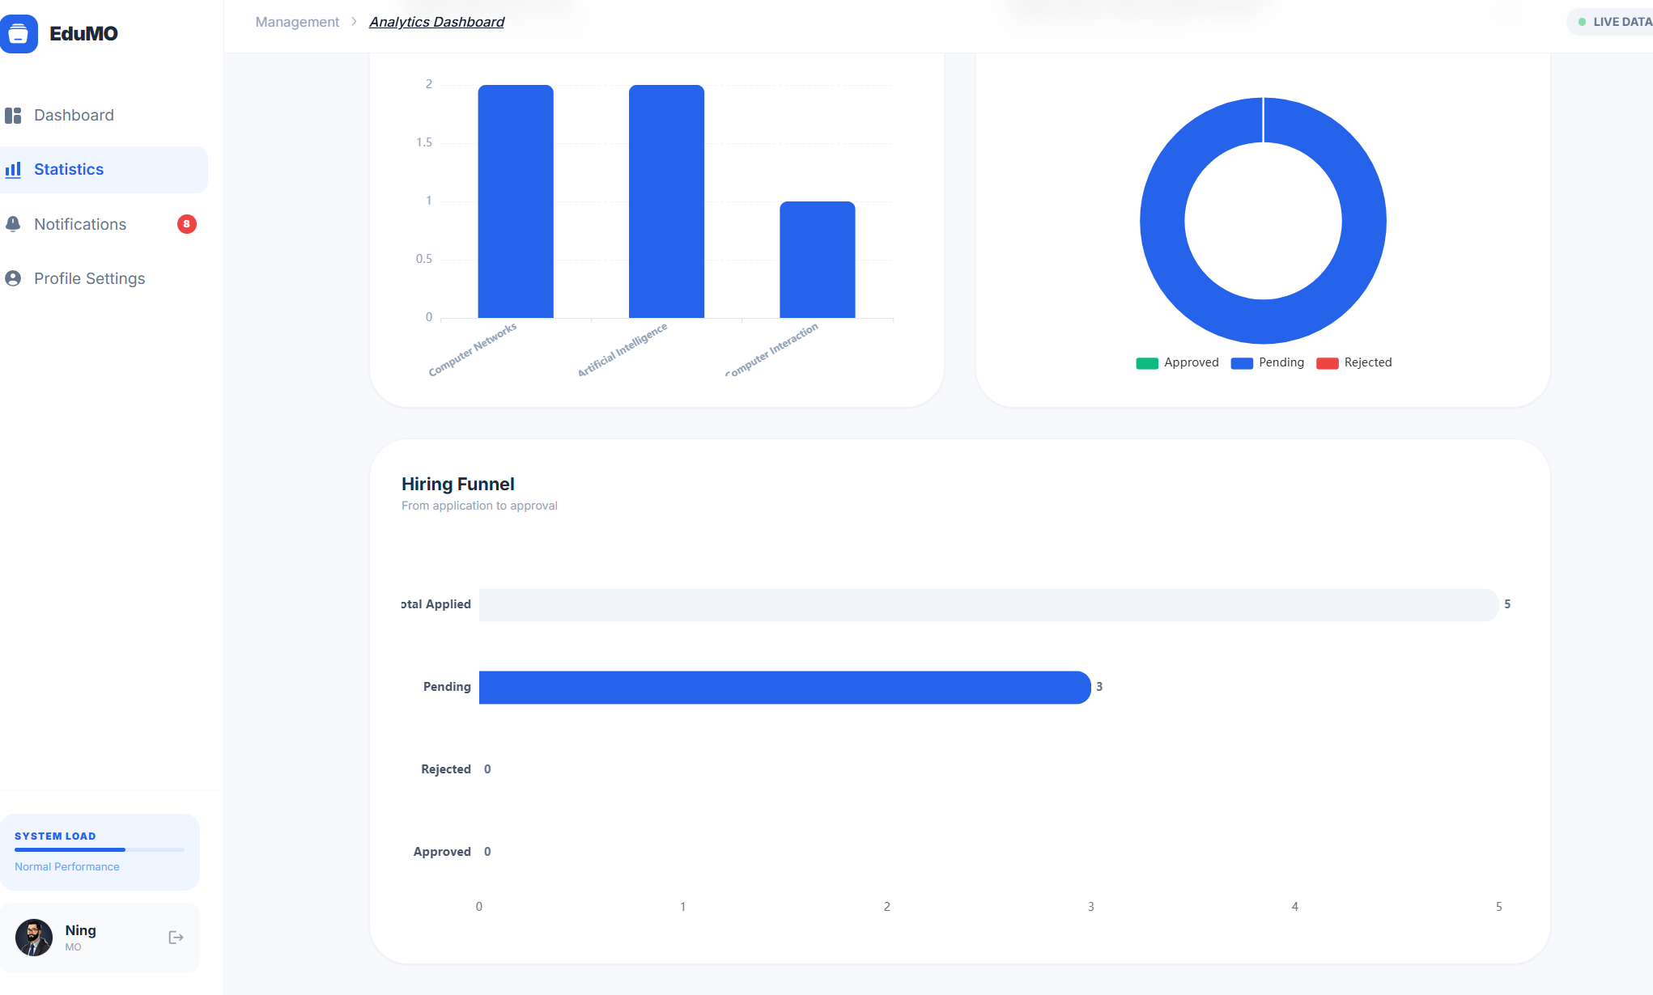
Figure: View Statistics

5.18 Read Messages
Incoming system messages and updates are accessible from the organiser interface.
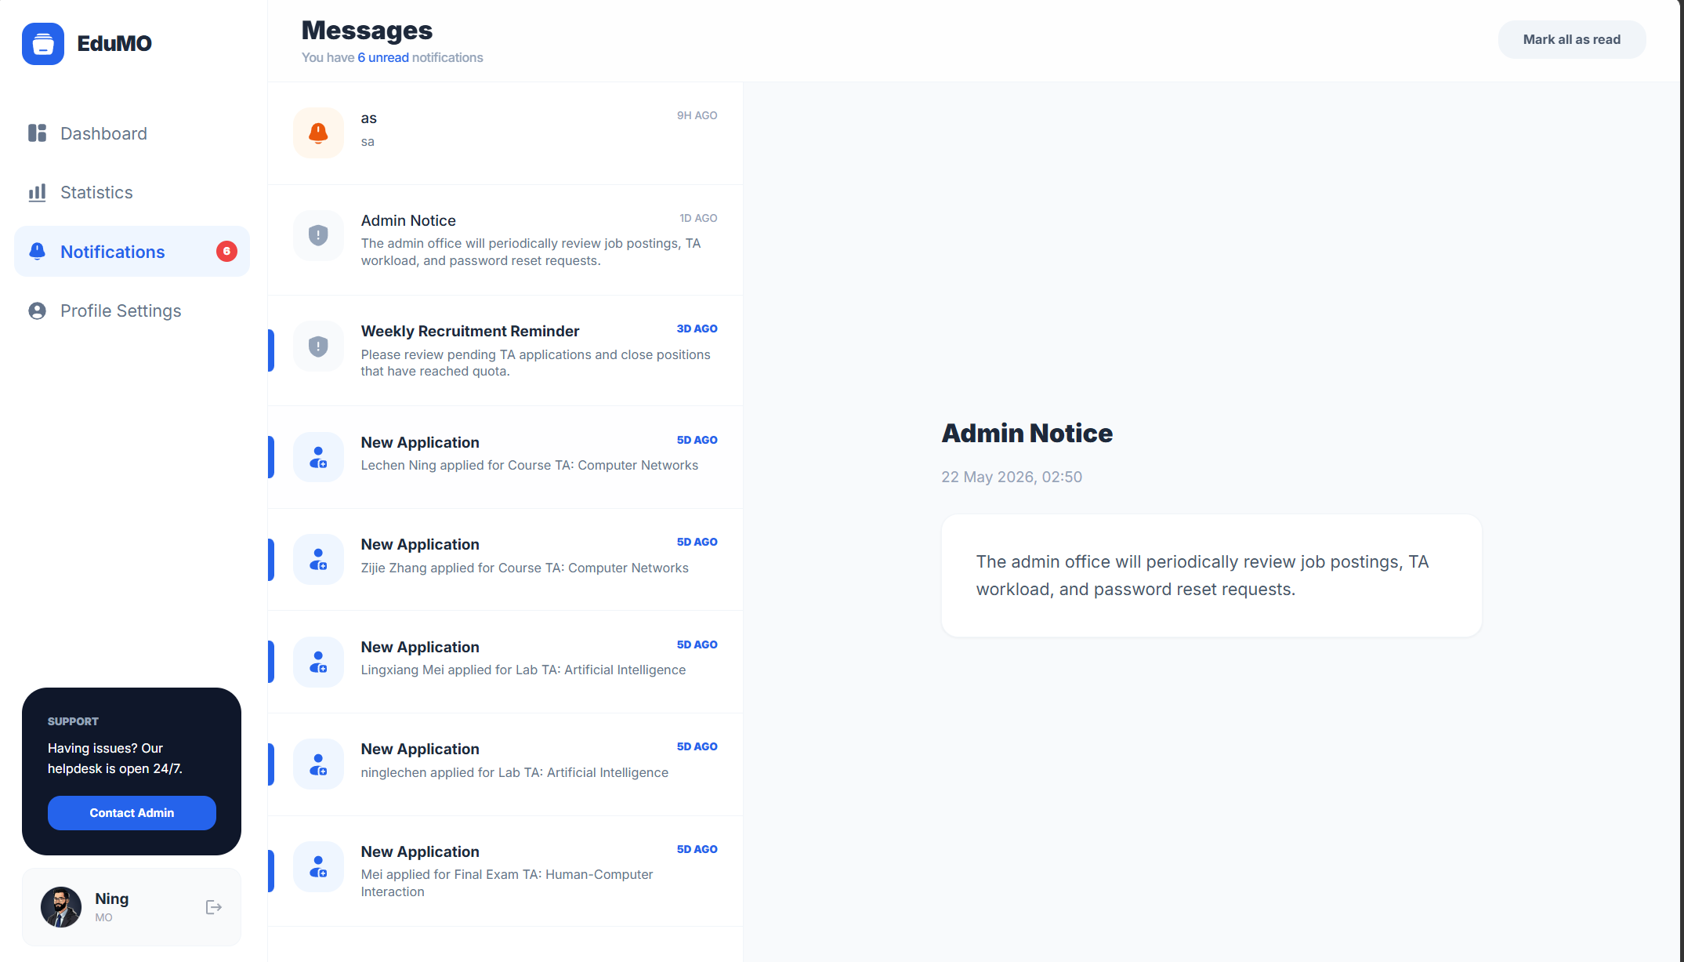
Figure: Read Messages

5.19 Contact the Administrator
The organiser can initiate communication with the administrator from the portal when support is required.
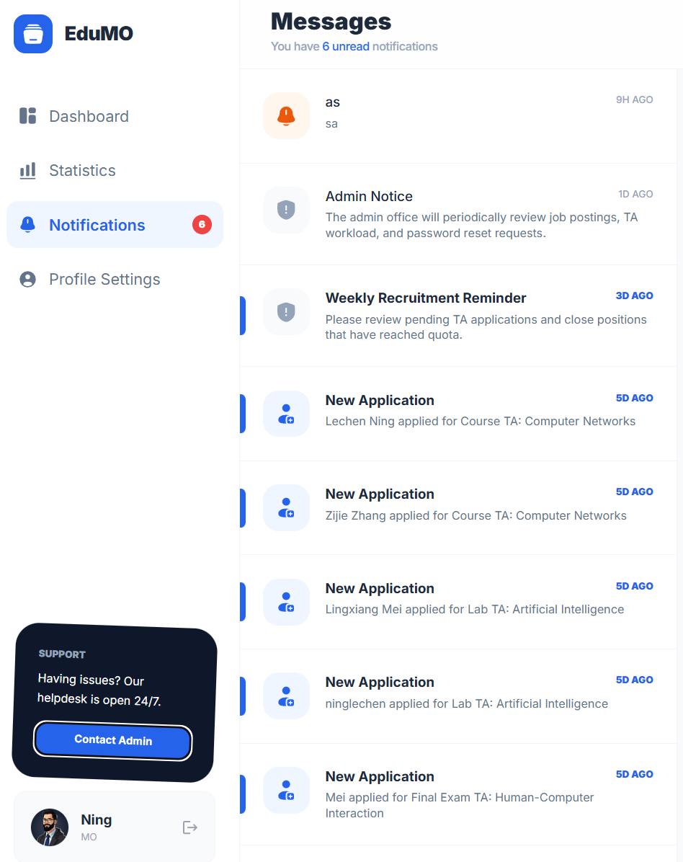
Figure: Contact the Administrator

5.20 Open Outlook
An email shortcut launches the external mail client for direct communication.
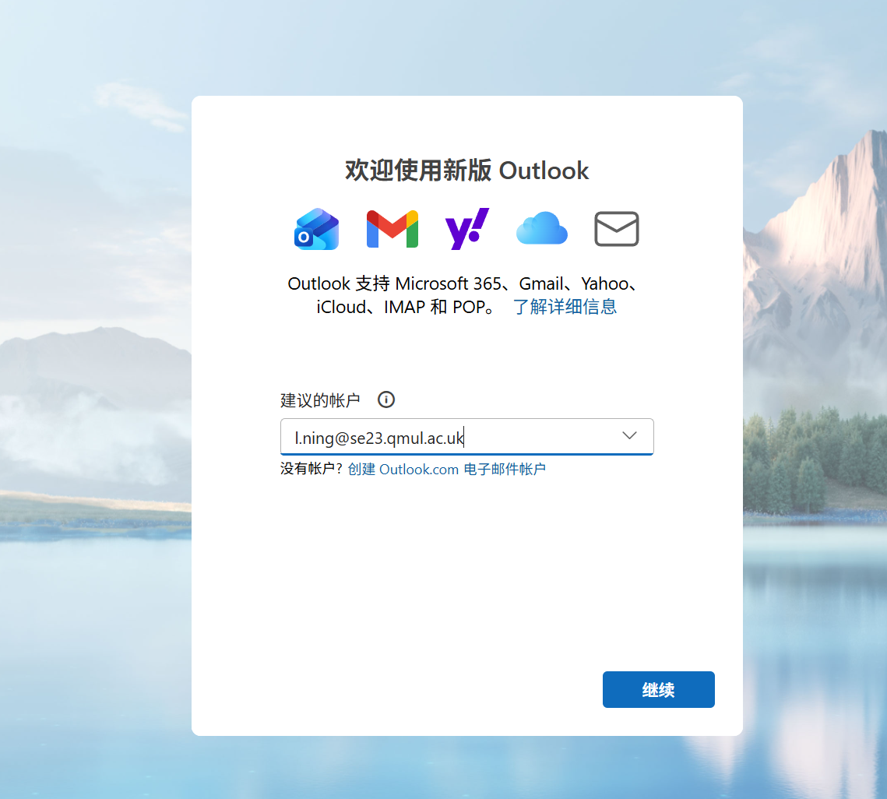
Figure: Open Outlook

5.21 Profile and Password Management
The organiser can maintain account details and update the account password.
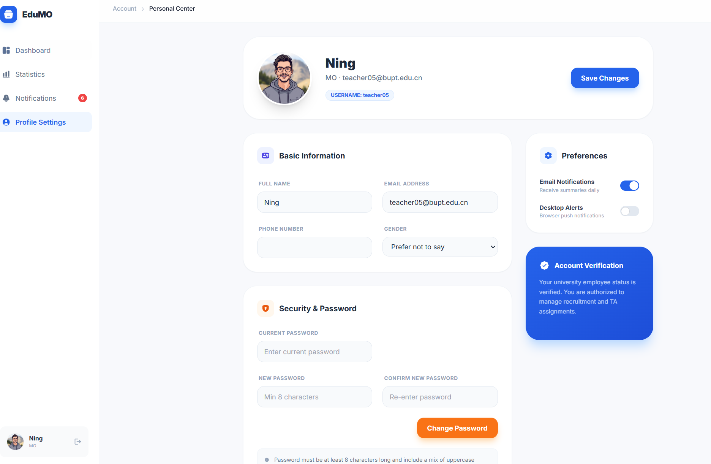
Figure: Profile and Password Management
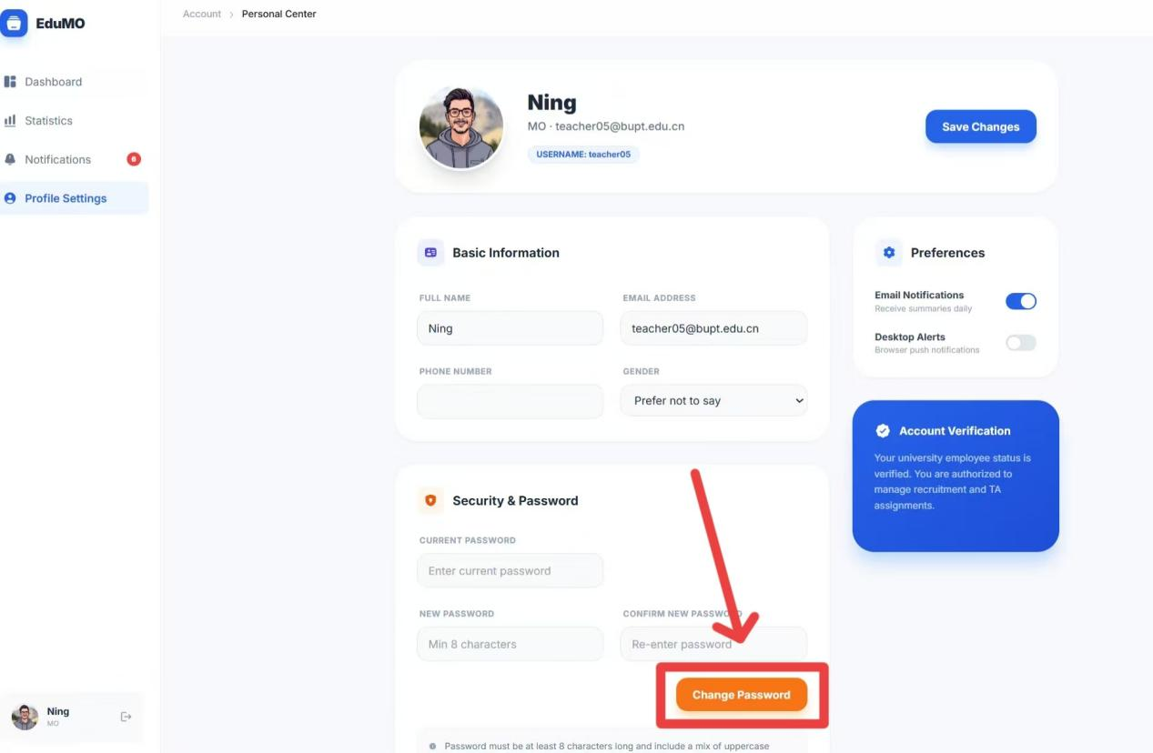
Figure: Profile and Password Management

6. Admin Portal
This section documents administrative oversight, operational control, and governance functions available in the system.

6.1 Sign In
Administrators use a dedicated admin portal for oversight, configuration, and data operations.
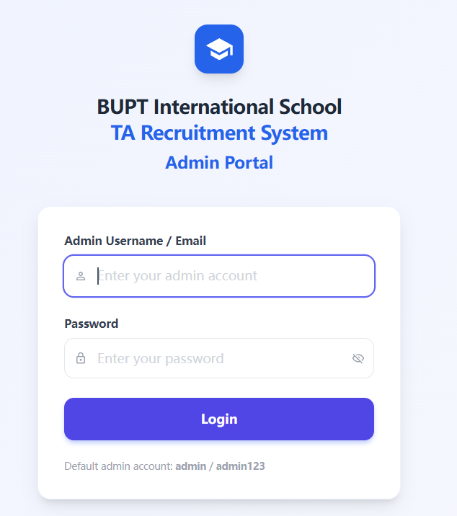
Figure: Sign In
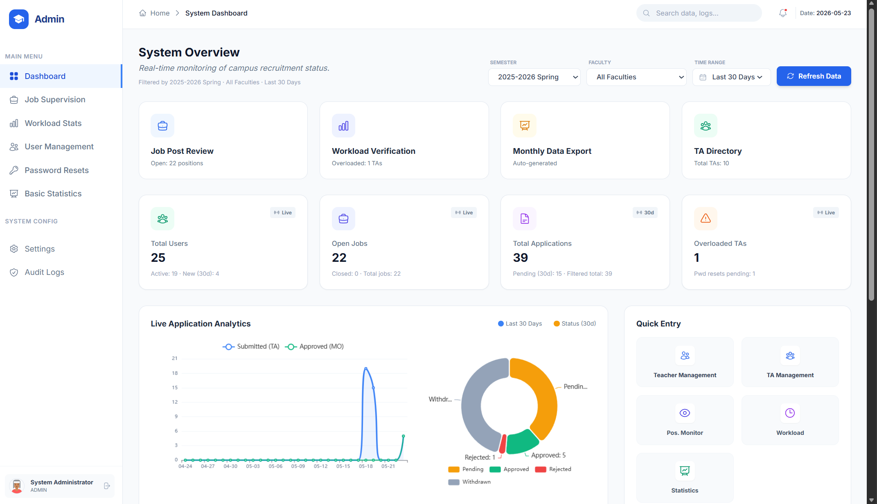
Figure: Sign In

6.2 Quick Navigation
The admin home page provides direct entry points to the main management modules.
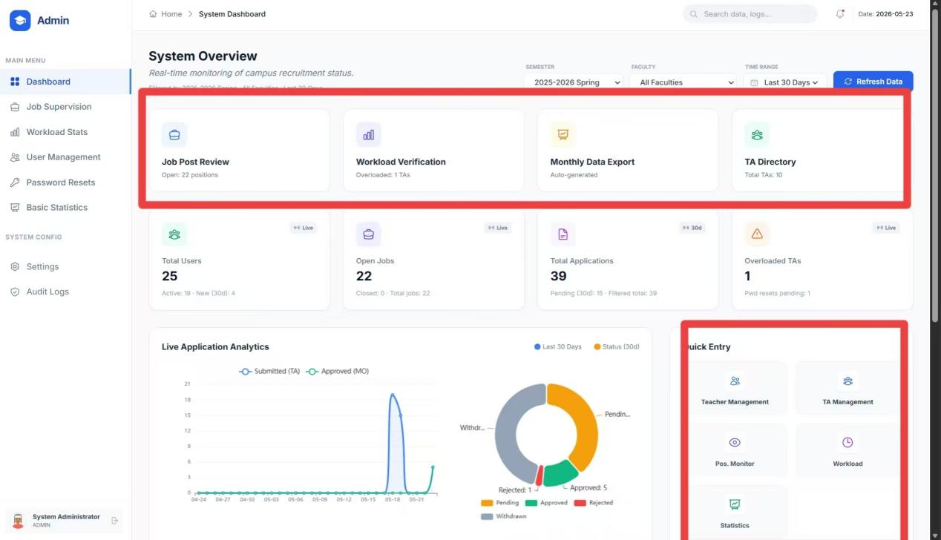
Figure: Quick Navigation

6.3 Statistics Dashboard
The dashboard aggregates operational indicators across the recruitment system.
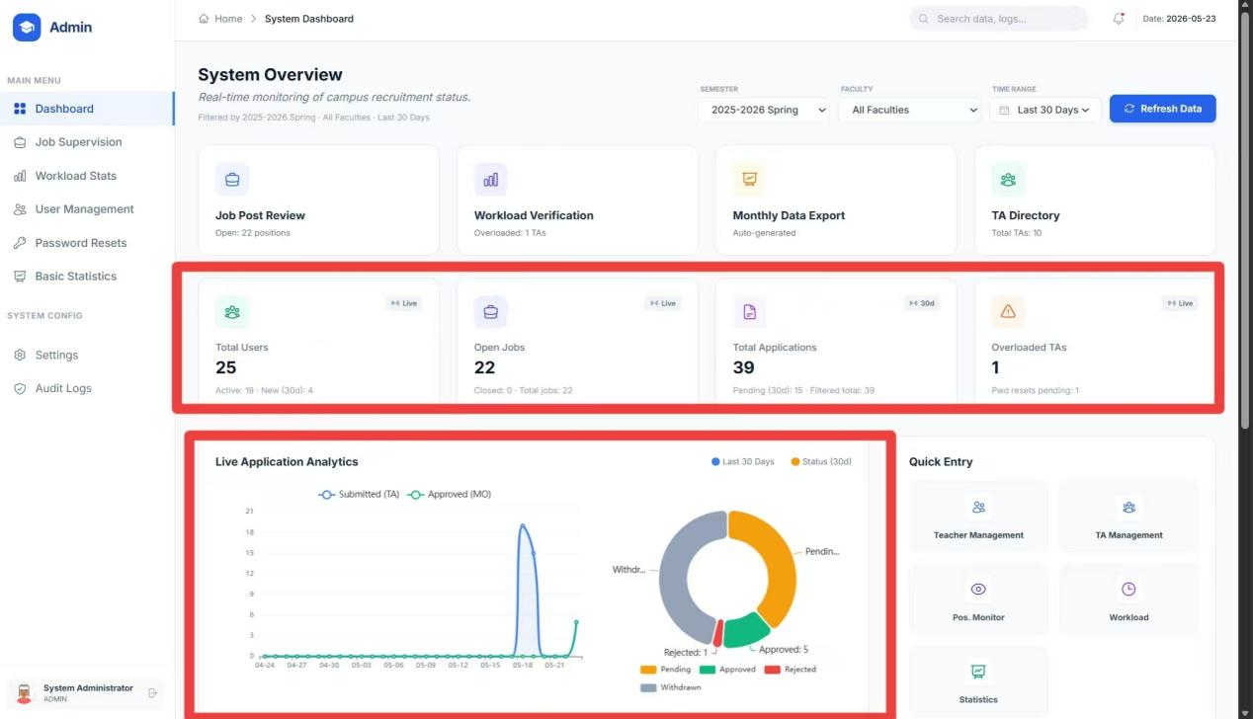
Figure: Statistics Dashboard

6.4 Apply Filters
Administrative views provide filters so the data shown can be narrowed to the relevant subset.
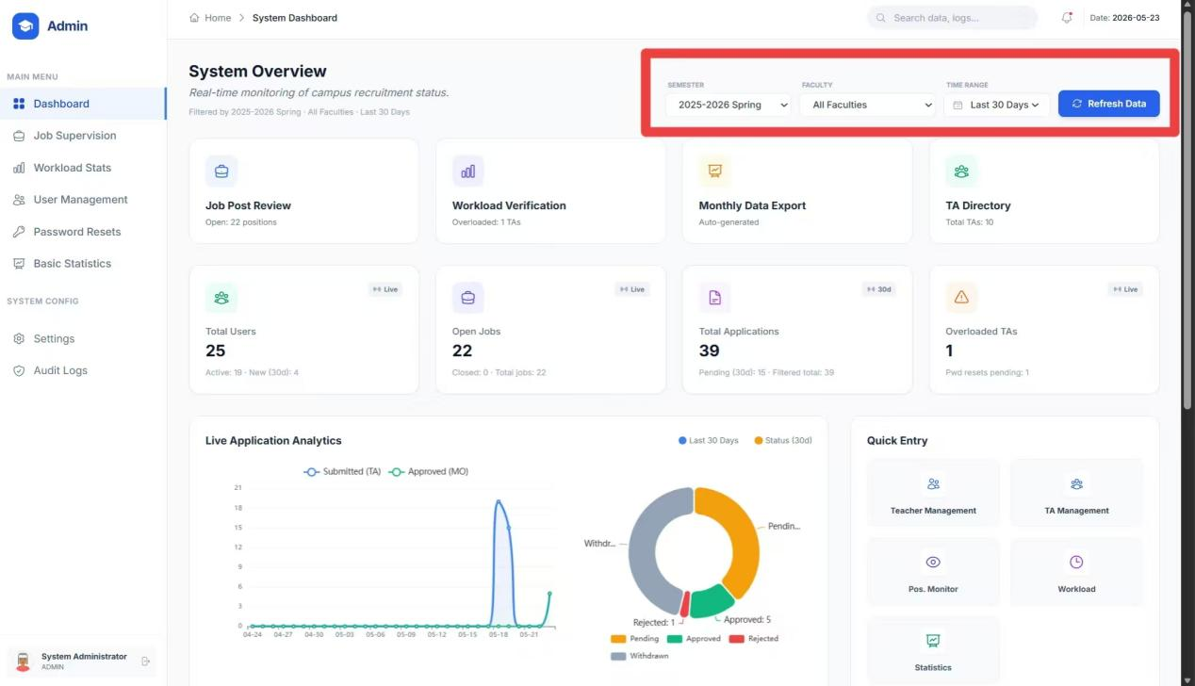
Figure: Apply Filters

6.5 Example: Last 7 Days
Time-based filtering helps isolate recent activity for quick operational review.
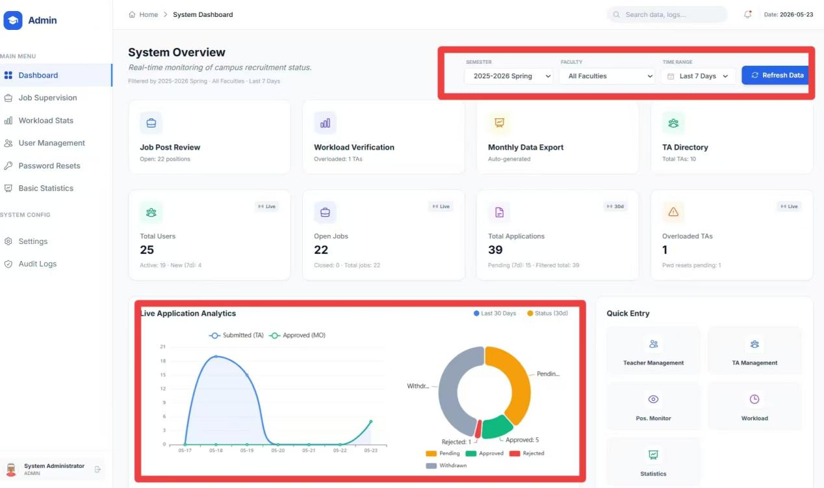
Figure: Example: Last 7 Days

6.6 Password Reset Alerts
Pending password reset requests are surfaced prominently for timely handling.
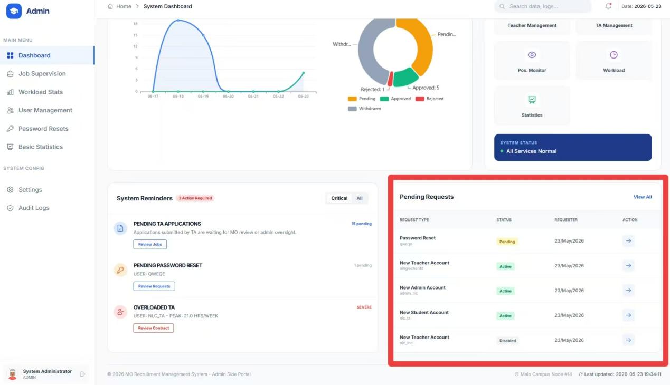
Figure: Password Reset Alerts

6.7 System Notifications
Platform-wide notices and alerts are visible from the admin portal.
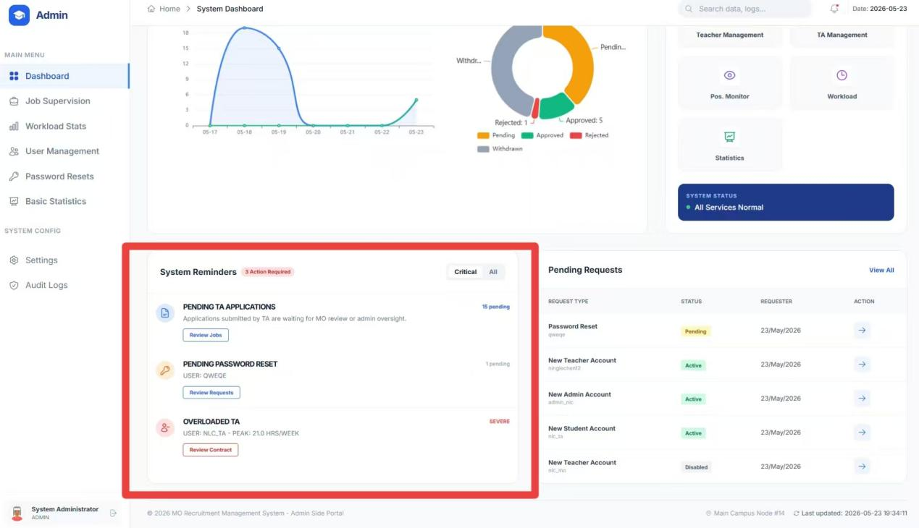
Figure: System Notifications

6.8 Review Job Postings
Administrators can inspect job records across the system for governance and quality control.
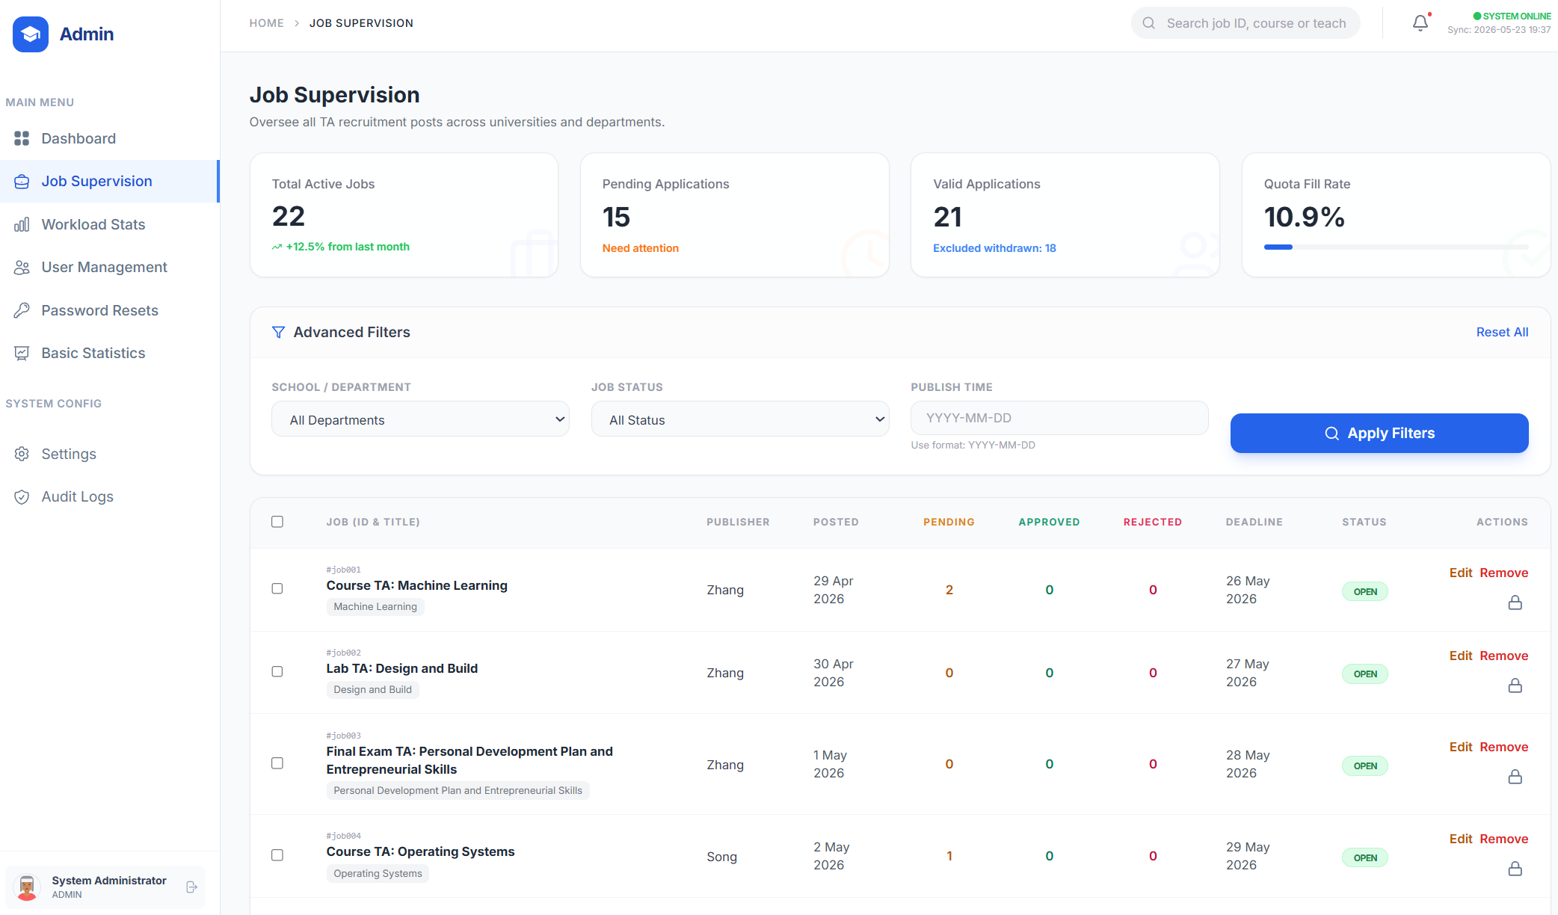
Figure: Review Job Postings

6.9 Filter Job Records
The job management page supports additional filtering to focus on specific postings or states.
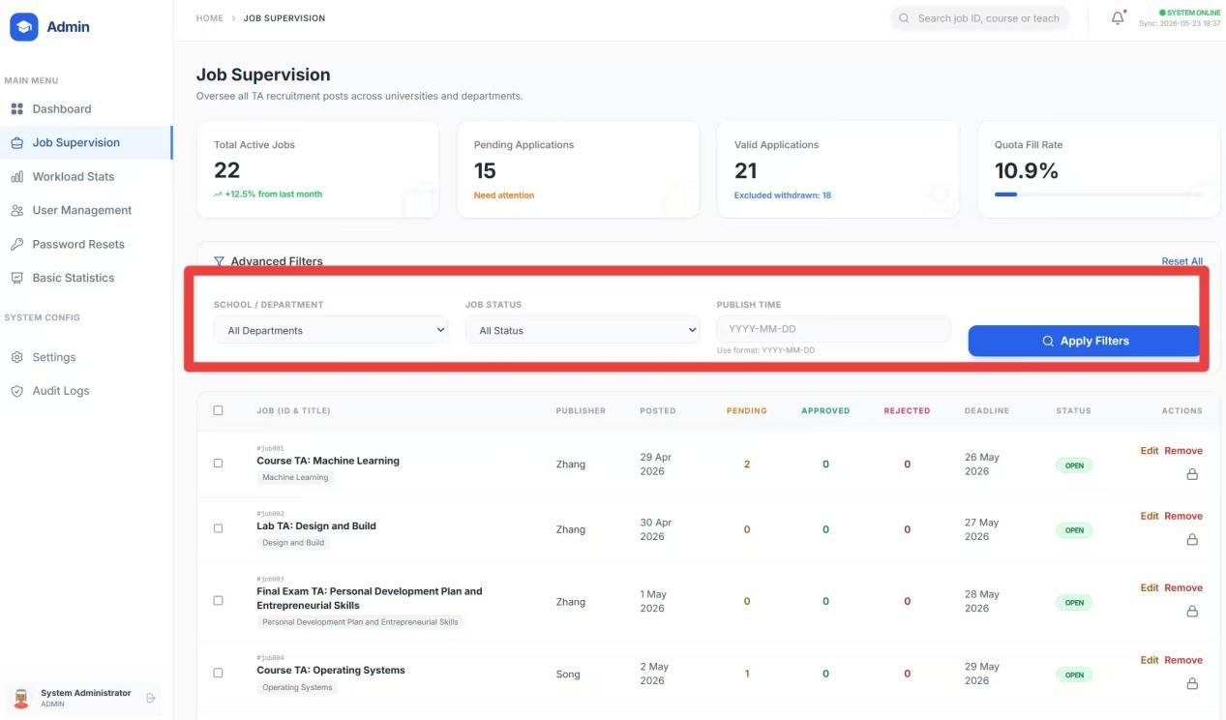
Figure: Filter Job Records

6.10 Read Summary Statistics
Contextual statistics provide operational insight while the administrator reviews records.
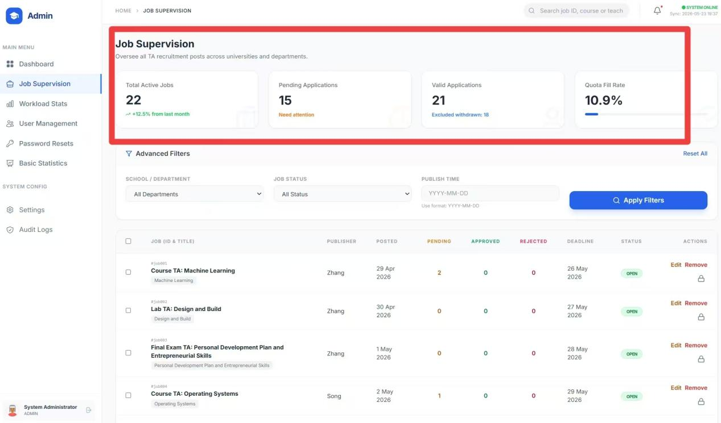
Figure: Read Summary Statistics

6.11 Open Full Job Details
Detailed views expose the complete record for a selected vacancy.
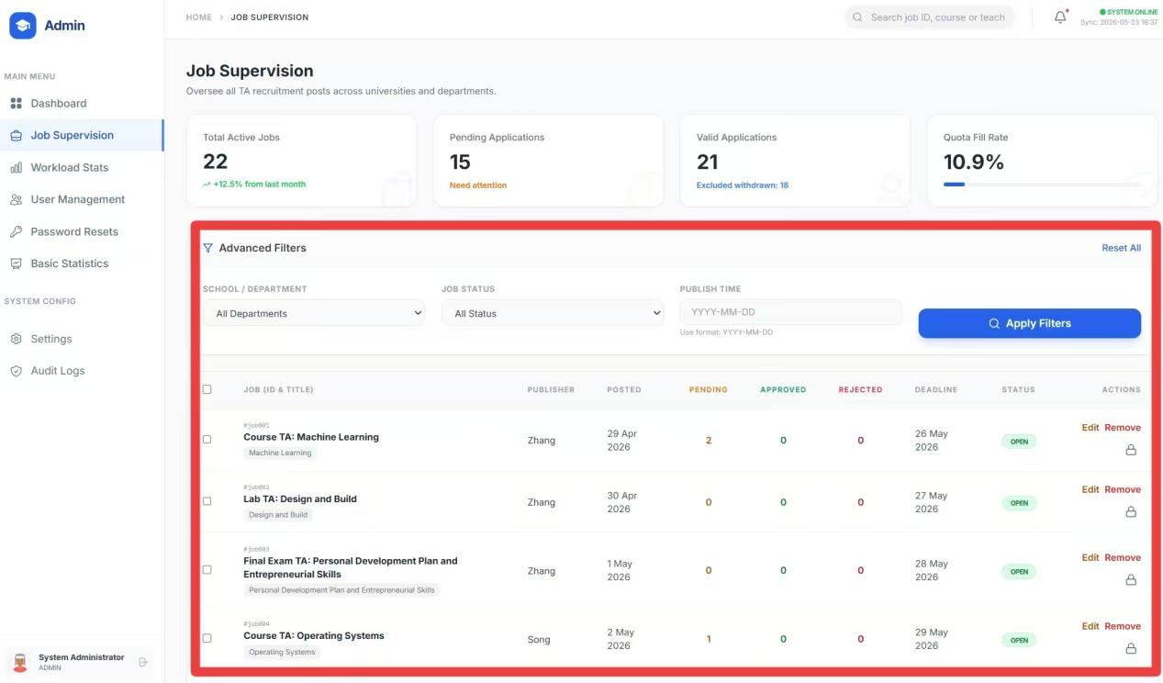
Figure: Open Full Job Details

6.12 Edit or Delete Records
Administrative controls support correction and removal of records where policy permits.
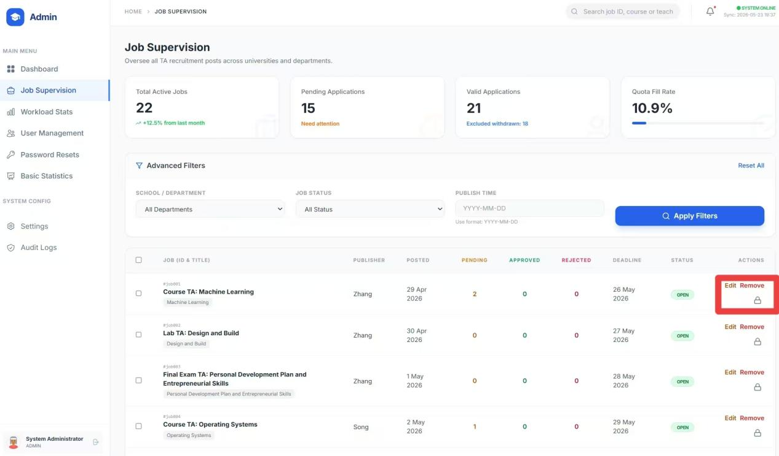
Figure: Edit or Delete Records

6.13 Modify Job Information
Selected job fields can be edited directly from the admin interface.
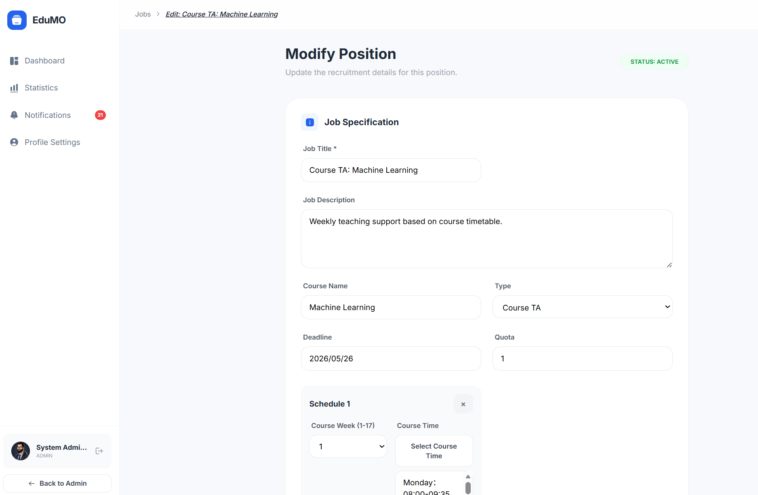
Figure: Modify Job Information

6.14 Control Workload
Workload control pages help identify whether weekly TA hours exceed the configured threshold.
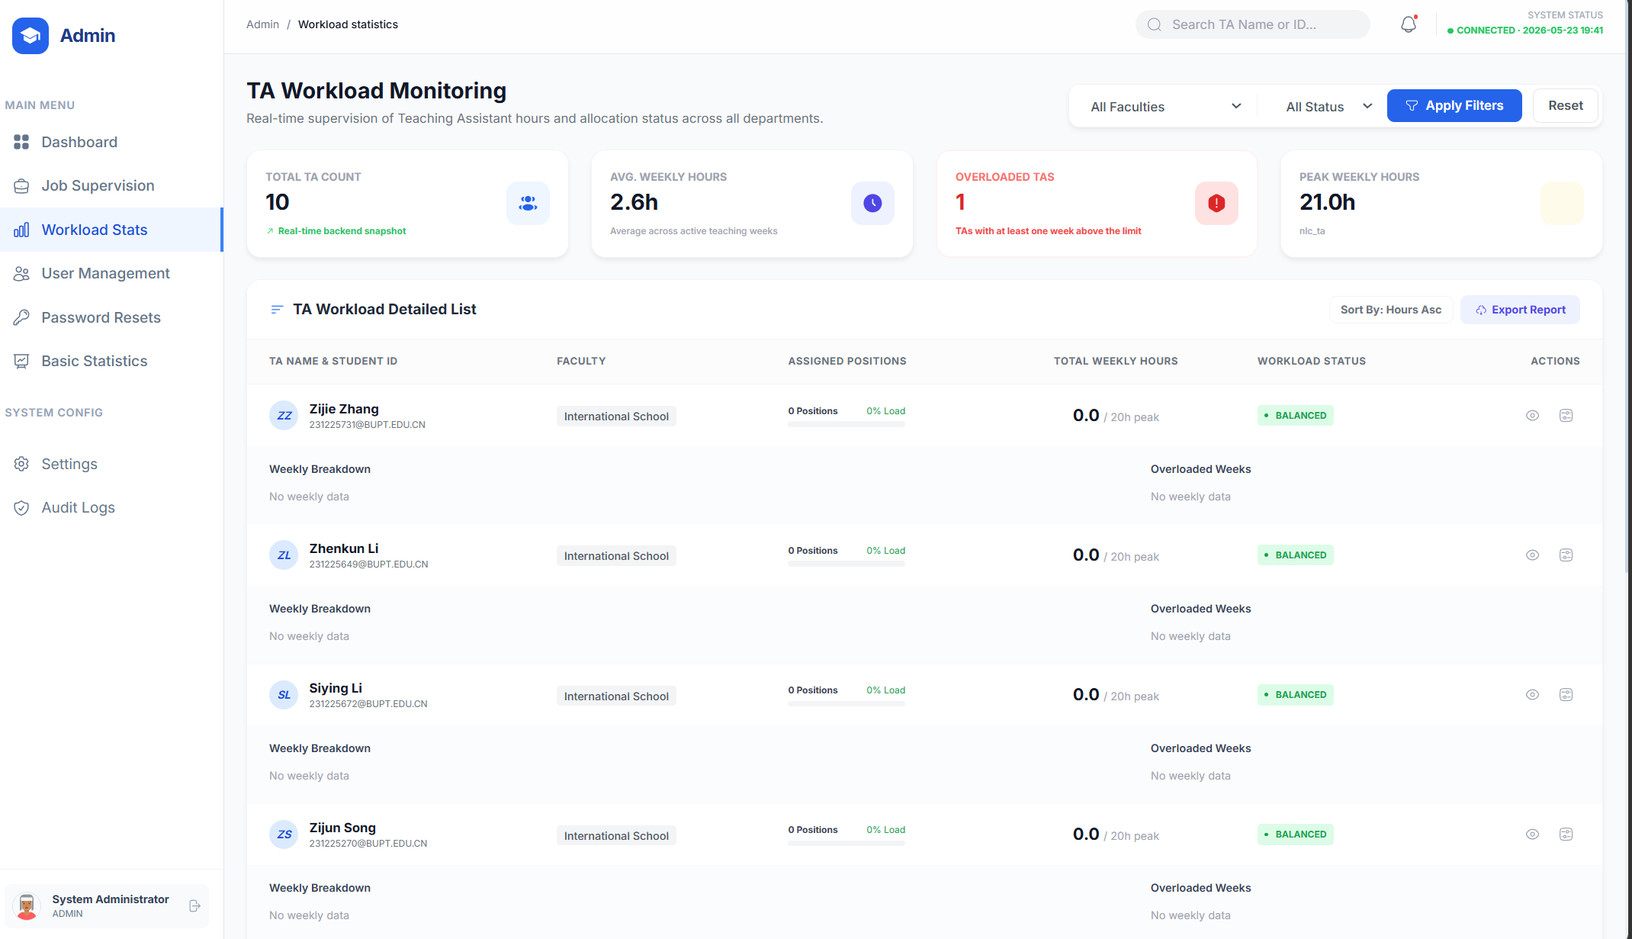
Figure: Control Workload

6.15 Review Overload Cases and Metrics
The statistics view highlights excessive workload situations and related counts.
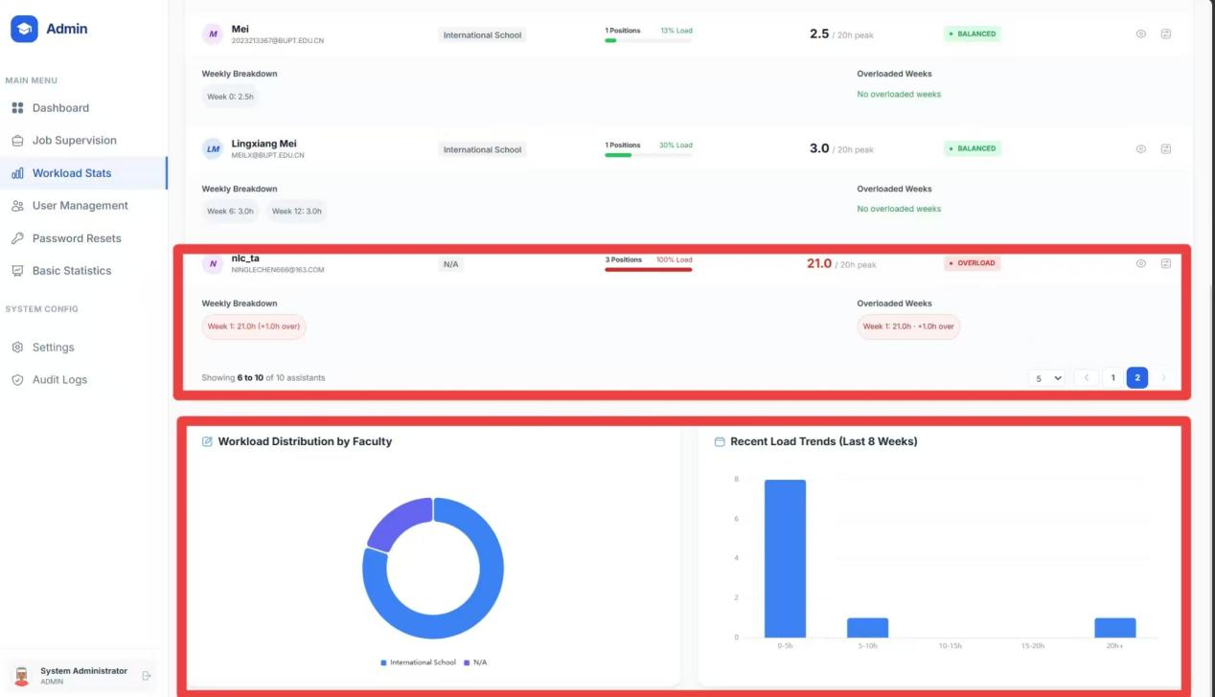
Figure: Review Overload Cases and Metrics

6.16 User Management
Administrators can manage the user base centrally, including inspection of user records and account lifecycle operations.

6.17 Change Roles, Deactivate Users, View Details, Create Users
The user management screen supports role changes, deactivation, record inspection, and manual account creation.
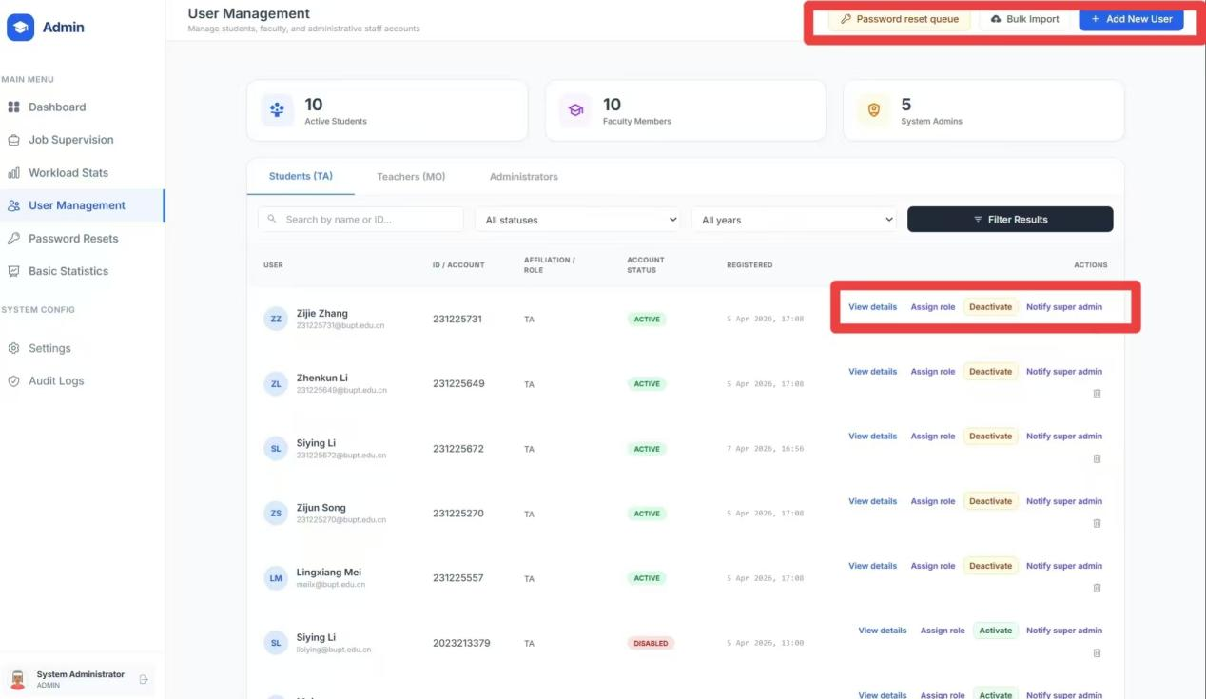
Figure: Change Roles, Deactivate Users, View Details, Create Users

6.18 Different Role Types
The interface distinguishes multiple role categories for fine-grained administration.
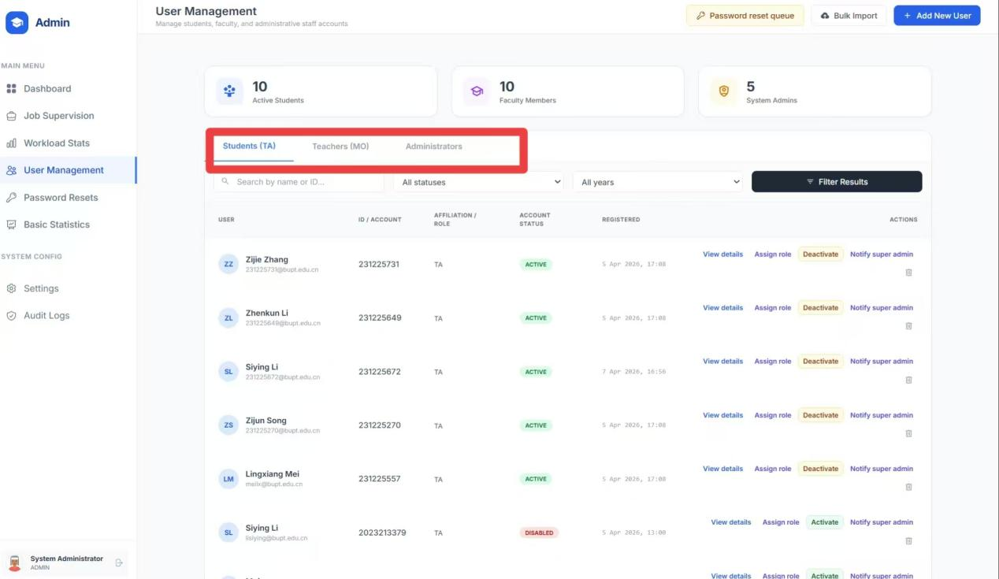
Figure: Different Role Types

6.19 Sub-Administrator Support
The system allows delegated administration through sub-admin roles.
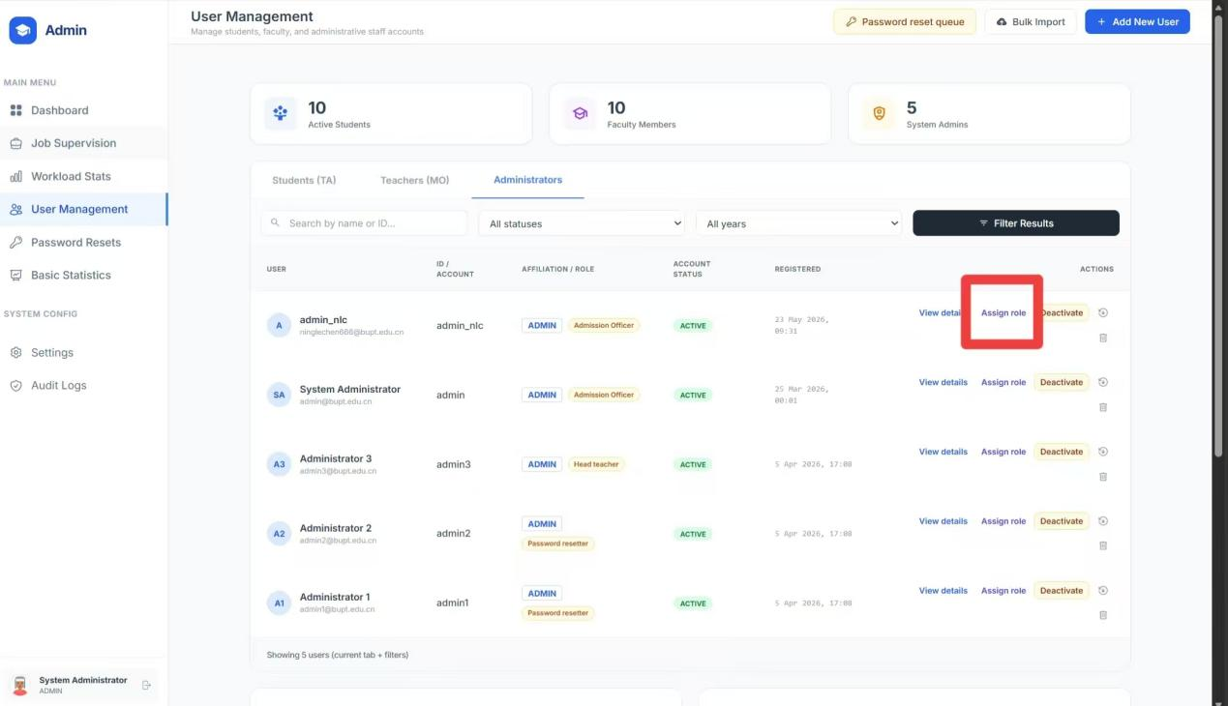
Figure: Sub-Administrator Support

6.20 Role Labels for Sub-Admins
Sub-administrator accounts can be tagged with role labels to reflect scope or responsibility.
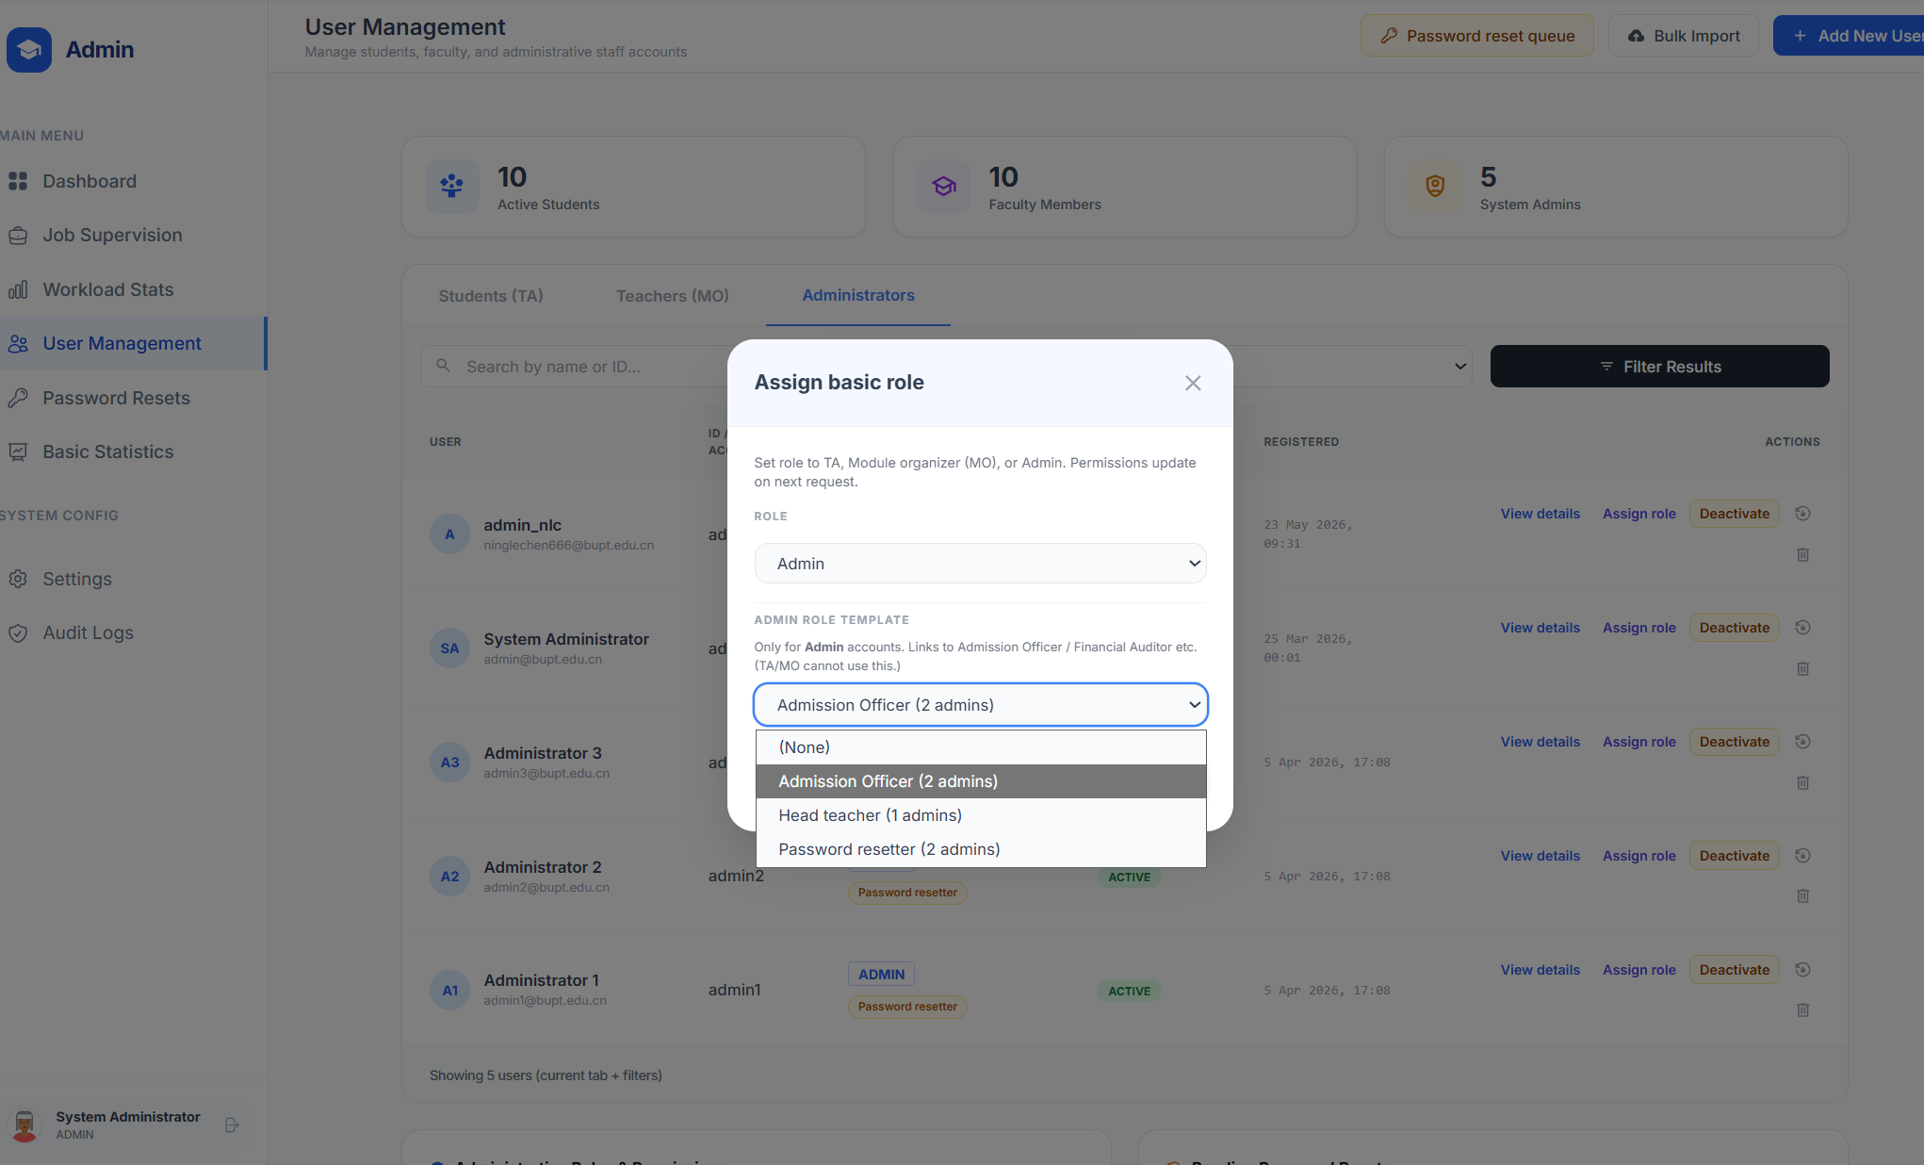
Figure: Role Labels for Sub-Admins

6.21 Define Sub-Admin Permissions
Additional configuration controls appear below the role label area for delegated authority management.
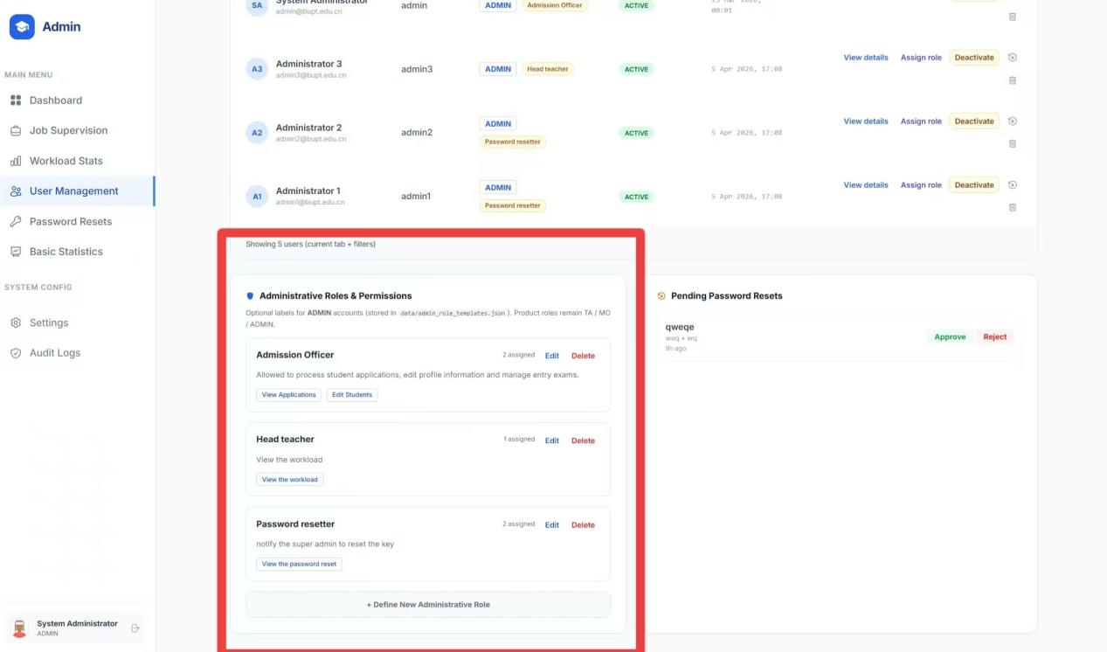
Figure: Define Sub-Admin Permissions
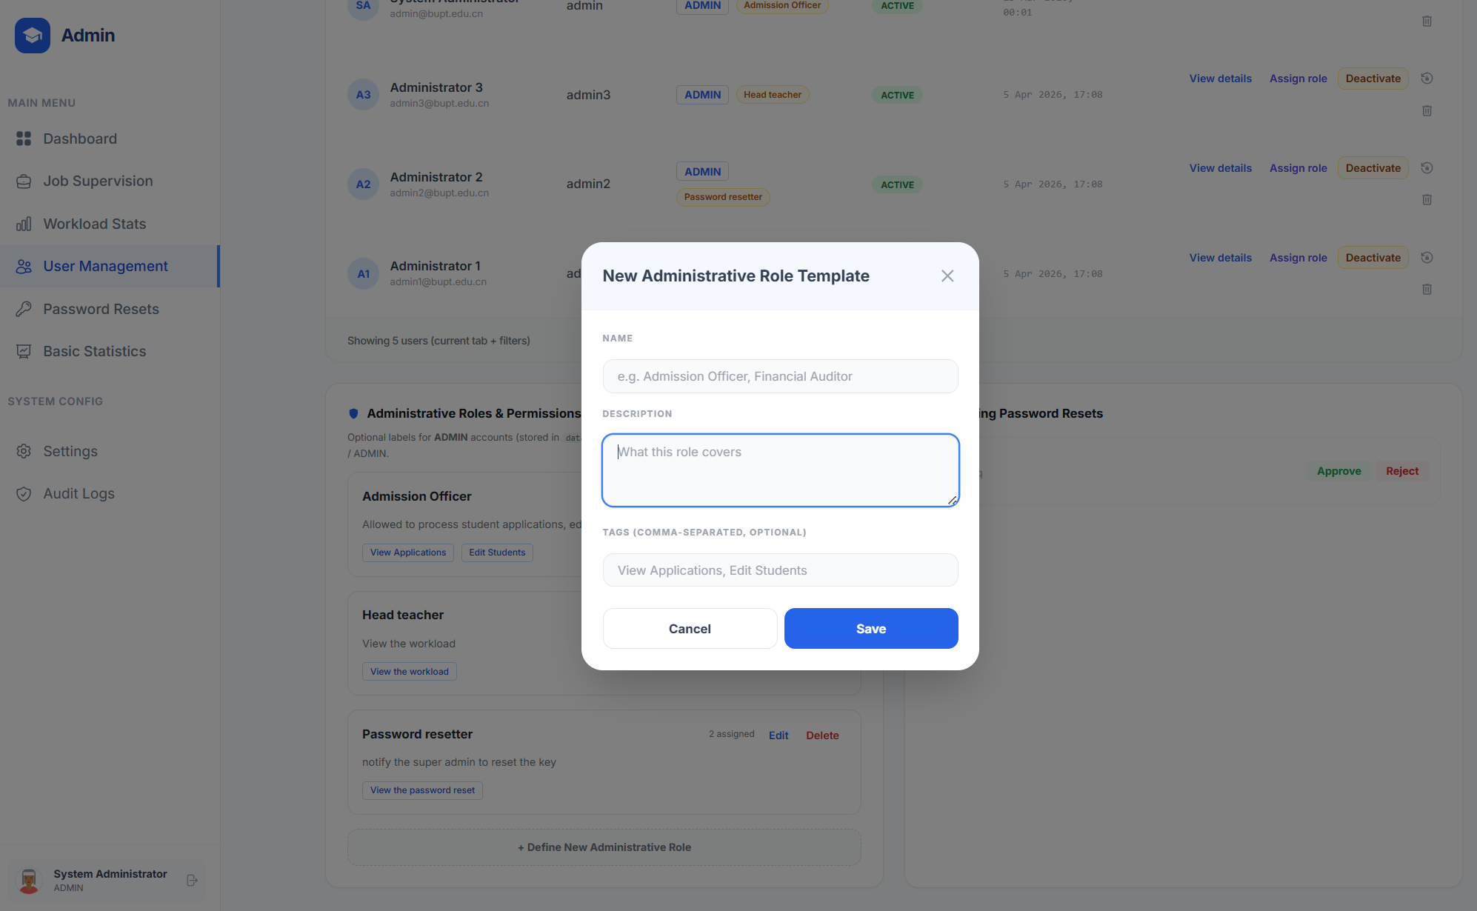
Figure: Define Sub-Admin Permissions

6.22 Password Reset Review Page
The dedicated review page supports approval or rejection of reset requests.
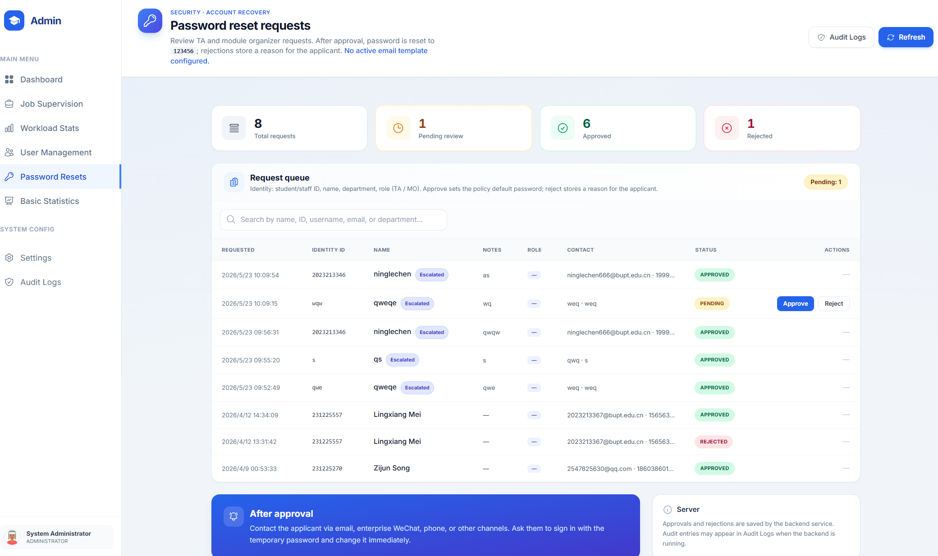
Figure: Password Reset Review Page

6.23 Forgot Password Flow
Users who forget their password can submit a reset request that enters the admin review queue.
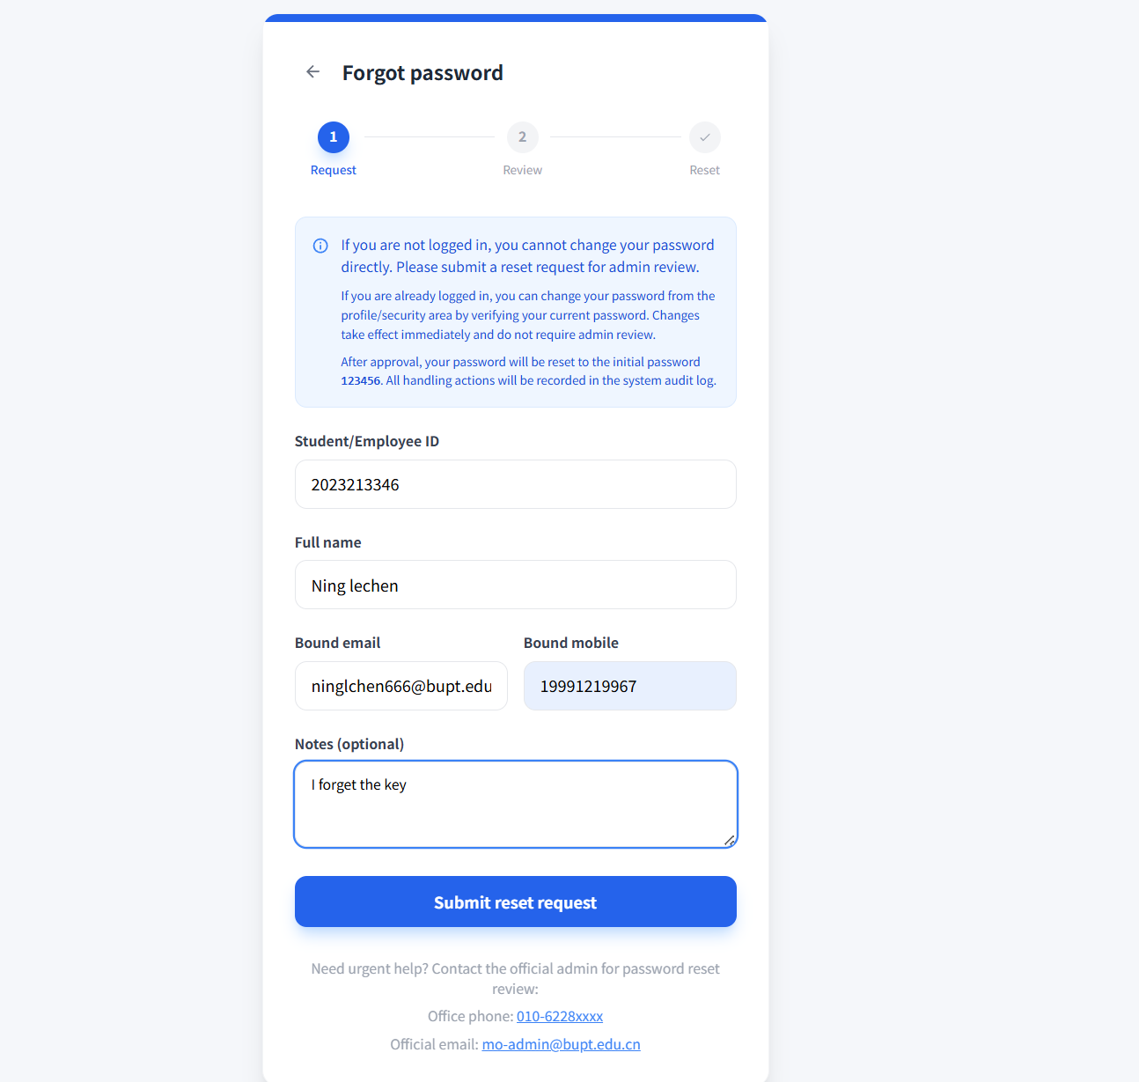
Figure: Forgot Password Flow
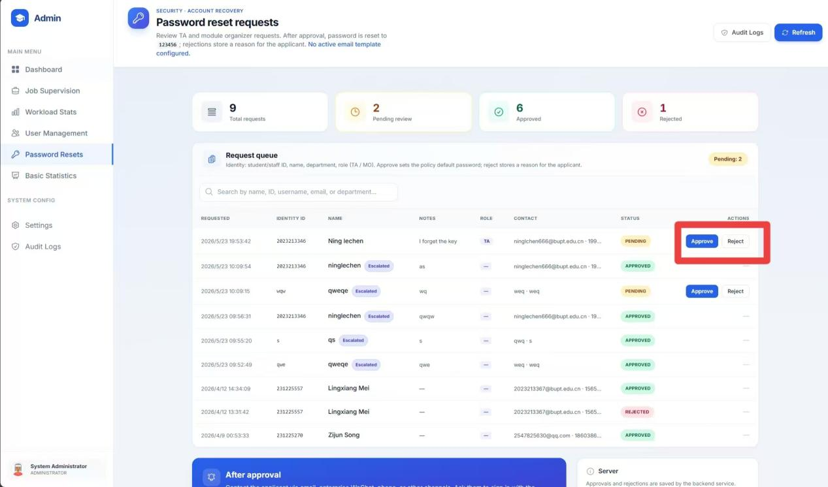
Figure: Forgot Password Flow
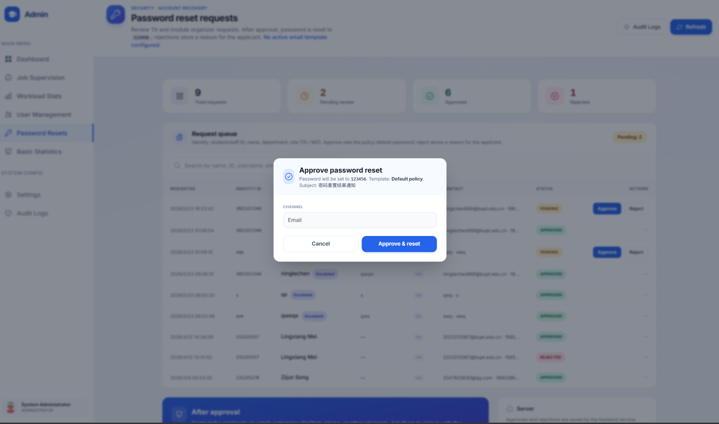
Figure: Forgot Password Flow
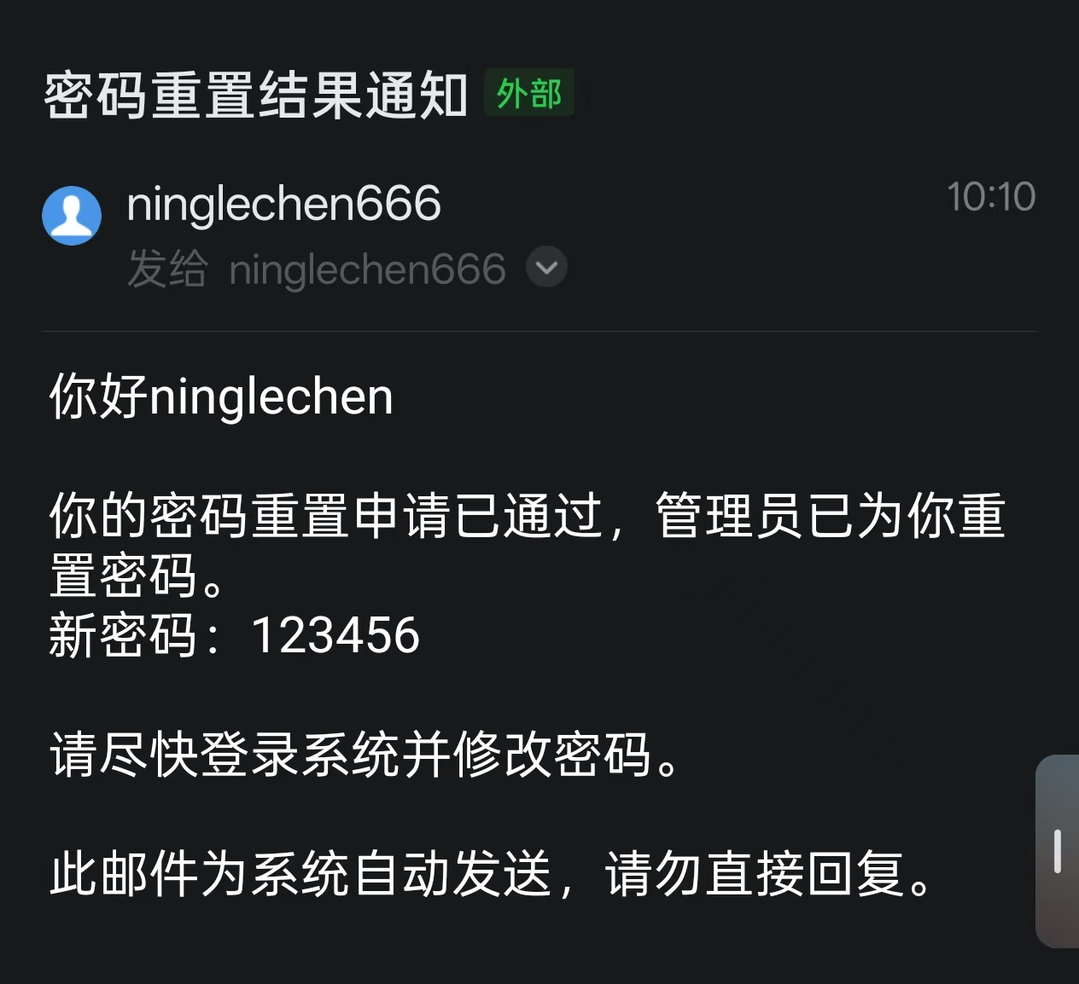
Figure: Forgot Password Flow

6.24 Operational Reports and Metrics
Administrative report pages summarize a wide range of system activity indicators.
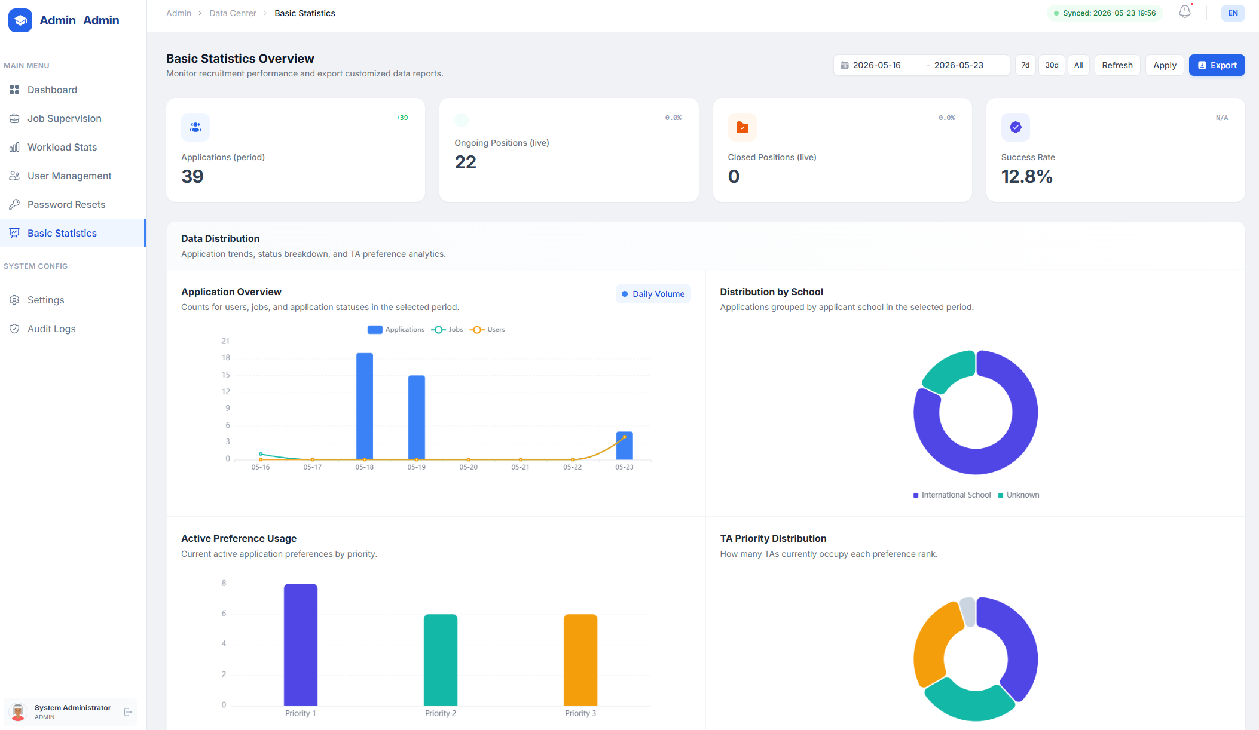
Figure: Operational Reports and Metrics
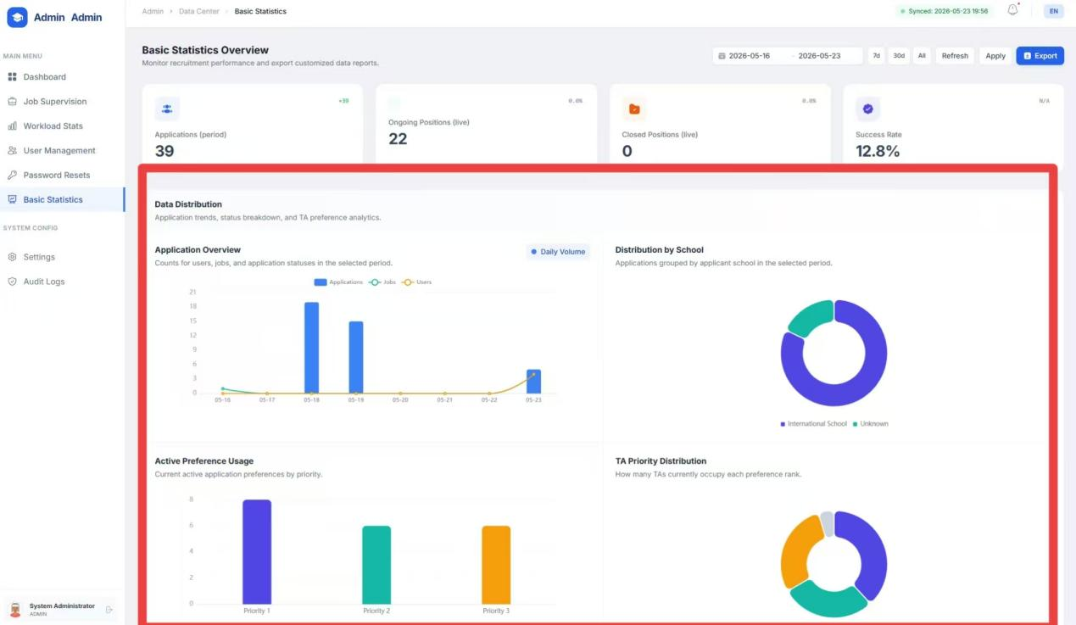
Figure: Operational Reports and Metrics

6.25 Filter and Export
Many admin-facing reports can be filtered and exported for evidence, audit, or sharing.
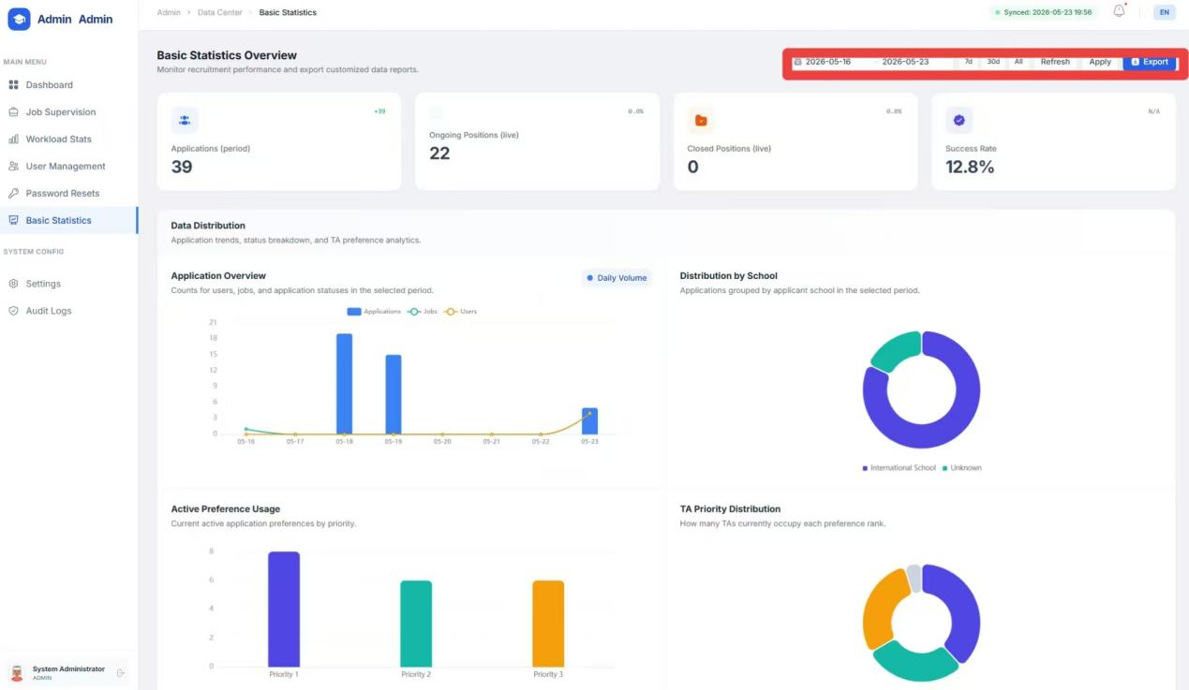
Figure: Filter and Export

6.26 Download Data
Data export functions provide downloadable output for offline review.
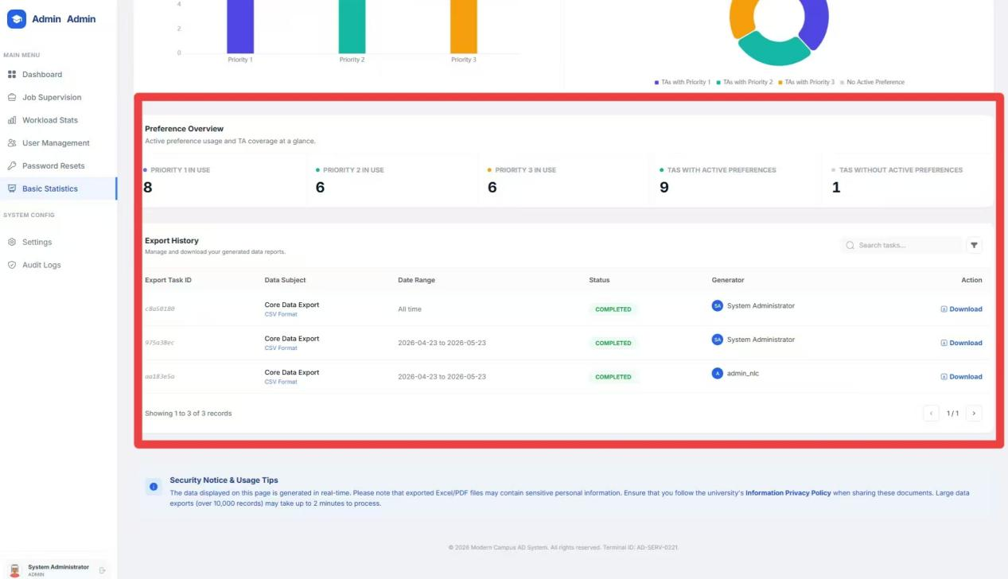
Figure: Download Data

6.27 Broadcast Notifications
Administrators can send announcements to users in bulk through the notification module.
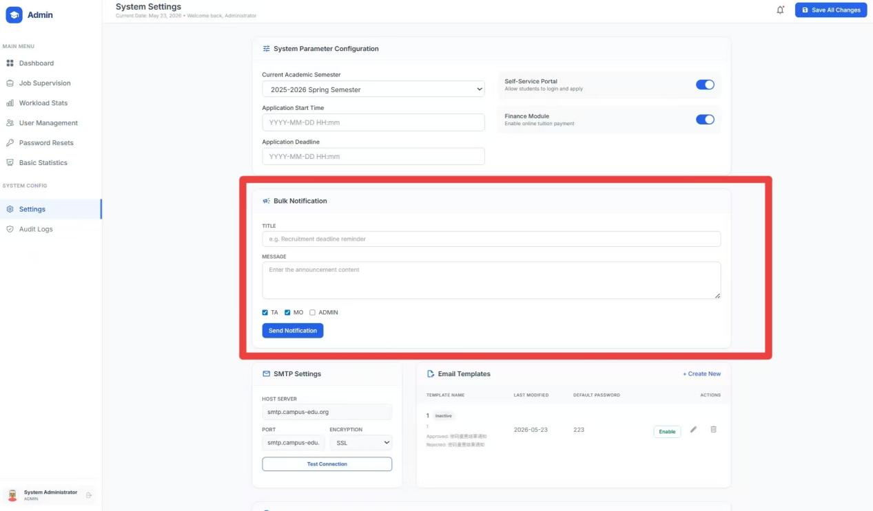
Figure: Broadcast Notifications

6.28 Password Reset Defaults and Settings
The system settings area includes reset-password policy and the configurable default reset password.
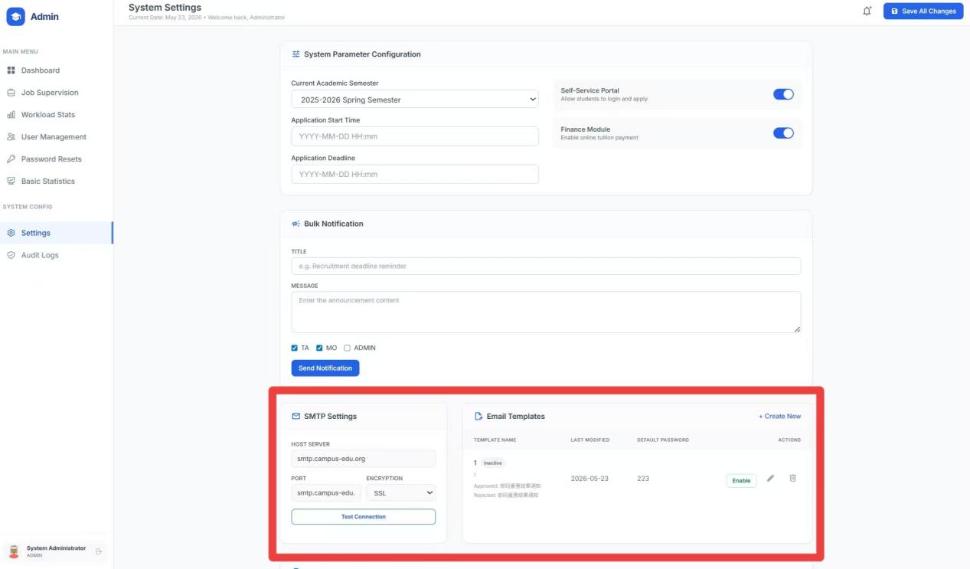
Figure: Password Reset Defaults and Settings

6.29 Manage and Download Data Files
Administrative data management supports controlled download of system data artifacts.
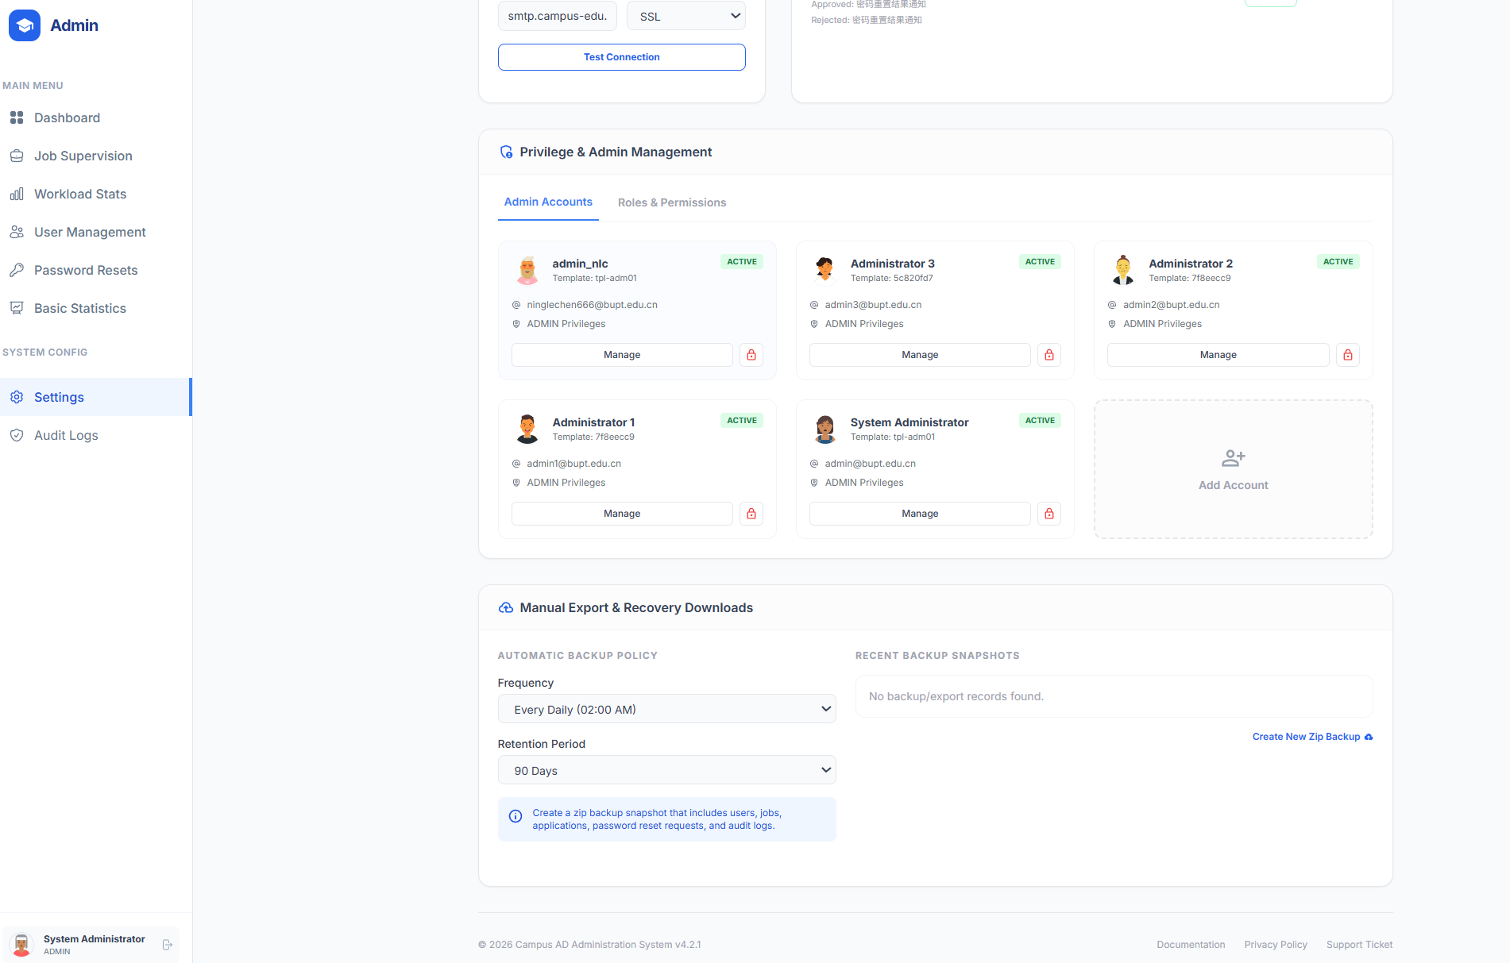
Figure: Manage and Download Data Files

6.30 Audit Logs
Audit log pages preserve operational traces and also support download for governance and coursework evidence.
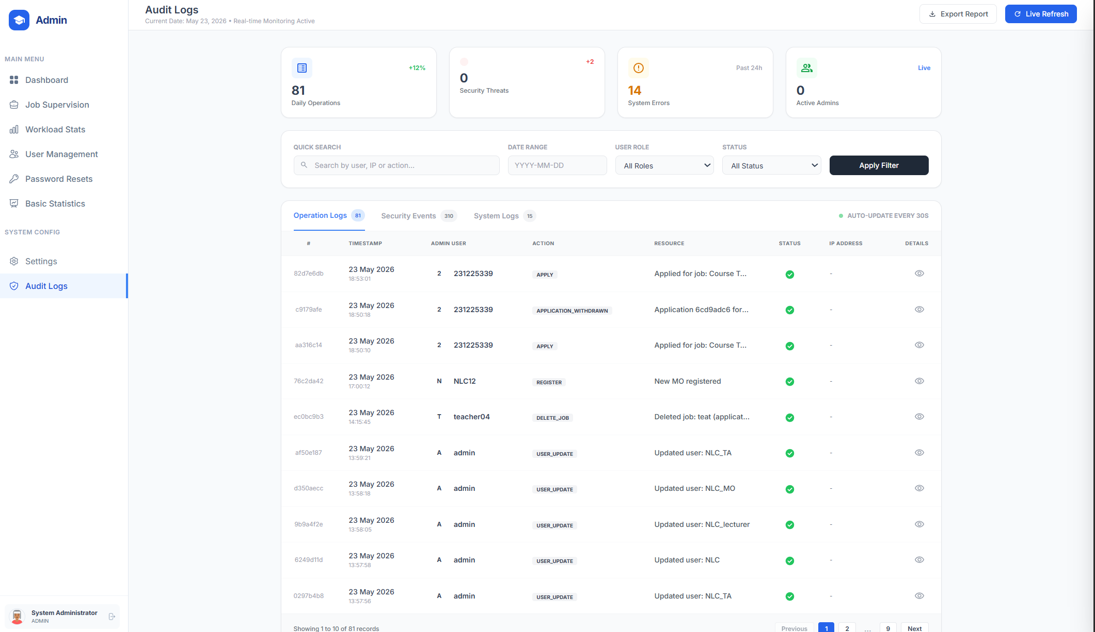
Figure: Audit Logs

7. Operating Notes
- Run the project from the root folder so the server can resolve the `data/` and `uploads/` directories correctly.
- The delivered implementation uses Java 11+ and JSON files instead of a database.
- Administrative settings such as workload thresholds, recruitment windows, and password reset defaults are maintained through the Admin portal or `data/settings.json`.
- Password reset email is optional and depends on SMTP settings being configured.
- The application is intended to be opened in a modern browser such as Chrome, Edge, or Firefox.

8. Recommended End-to-End Workflow
- An MO creates a job posting and publishes the vacancy with dates, requirements, and timetable-aware details.
- A TA logs in, reviews the vacancy, optionally uses the AI matching assistant, uploads a CV, and submits the application.
- The MO inspects applicants, compares them with AI support if needed, and makes a selection decision.
- The Admin monitors workload, user activity, password reset requests, notifications, exports, and audit evidence.

