Title page
Title: “Understanding climate change impacts on habitat complementation and disassociation for mobile species”
Authors: Nicholas L. James¹, Graeme S. Cumming¹
Affiliations: ¹College of Science and Engineering, James Cook University, Townsville, Queensland, 4811, Australia
Corresponding author: Nicholas L. James
Corresponding author email: nlj987@gmail.com
Preprint servers: N/A
Classification: Biological Sciences - Ecology
Keywords: Breeding Strategy, Coral Reefs, Foraging Efficiency, Oceanographic Processes, Resource Predictability, Site Fidelity

Abstract
Climate change poses a significant threat to mobile organisms by impacting the proximity of important resources to one another. As ‘complementary’ terrestrial and aquatic habitats are pulled apart by environmental change, animals will have to adjust their behaviours to successfully track their fundamental niches. We show how a growing mismatch between nesting, roosting, and foraging sites has already pushed individuals in a breeding tropical seabird population to extend their foraging range by an order of magnitude in poor years, with direct negative consequences for juveniles. Our findings highlight the need to explicitly consider habitat complementation in conservation initiatives and planning.

Significance statement

Main text
As Earth’s ecosystems undergo increasingly rapid change due to global heating, the survival of many animal populations will depend on their ability to track suitable habitat. Suitable habitats are defined as those that provide access to a full range of critical resources (e.g., for food, shelter, and reproduction). Habitats that contain all essential resources within an accessible distance of each other exhibit habitat complementation (1–3). Although it has been recognised that climate change may impact habitat complementation(4), most studies of climate change impacts have focused on access to single resources or habitats and few have documented the potential for climate-driven separation of complementary resources. This latter phenomenon, which we term ‘habitat disassociation’, has received little direct academic attention in the literature on species responses to climate change. We thus have limited knowledge of how habitat complementation may change in a warming planet, or of how different organisms will respond to habitat disassociation.
Organisms that rely on particular static features of their local environment, such as caves or islands, seem particularly vulnerable to habitat disassociation. For example, bats that hibernate in caves in cold climates are vulnerable to the loss of adjacent wetlands that they depend on for winter foraging habitat(5); and many wetland species require complementary habitats in the wetland-adjacent matrix(2). Well-documented empirical examples are urgently needed to illustrate both the range of contexts in which habitat disassociation may occur, and the potential for novel adaptive behaviours in response.
In this manuscript we present a novel and previously undocumented example of how climate change may reduce habitat complementation for seabirds by disassociation of breeding, roosting and foraging locations. We collected telemetry data for Black Noddies (Anous minutus) at one of the largest breeding colonies of this species, on Heron Island in the Southern Great Barrier Reef, across four breeding seasons. We also collected additional data on Black Noddy breeding success and offspring mortality. Black Noddies forage on small pelagic fish, which they carry in their crops to feed their young. They breed colonially on wooded islands, where they build leaf nests in suitable trees. Prey fish abundance near the ocean’s surface appears to be reduced by warmer water. In years where fish abundance is lower, Black Noddies must fly further to locate schools of suitably sized fish.
We had previously observed some inter-annual variance in food availability to breeding Black Noddies at Heron Island, with good years and bad years. In 2022, however, environmental conditions appear to have led to a severe reduction in local food abundance, decoupling breeding locations from foraging locations. Black Noddies with chicks responded to this decline by foraging further, as might be expected. What we did not expect was that the distances they moved increased by an order of magnitude further than any previously documented foraging trip (Fig. 2). This sudden scale-jump in foraging behaviour appears to have been associated with the use of one of the nearest well-treed northern islands, Bushy Islet, as an overnight roosting location during long foraging trips. Thus, the unusual environmental conditions reduced the complementarity of breeding, foraging and roosting sites, resulting in a novel and seemingly counter-intuitive response.

The claim that foraging success was low in 2022 is strongly supported by data from Black Noddy chicks that we measured at regular intervals (Table 1). In 2019 and 2022, the two seasons with greater foraging distances from the colony, mortality was 54-64%. From 2021 to 2022, mortality in chicks from tracked parents increased from 0.3% to 54% and mortality in control nests increased from 0 to 38%, coinciding with a magnitude increase in foraging distances. We also found that chick condition (weight at the same stage of development) was significantly lower in 2022 than in 2021 (Fig. 3). We confirmed that the extracted residuals grouped by year were significantly different with a t-test (t = -32.009, df = 404.35, p <0.001) with a mean positive value for 2021 (points below trend line) and negative for 2022.
As one of the first tracking studies on Black Noddies, our findings imply that seabird populations on the GBR may already be subject to changes in oceanographic and/or trophic processes that alter seasonal peaks in prey populations, posing a threat to their persistence. Prey availability for Black Noddies varies with ocean temperatures and bathymetry(6). These variables interact with oceanographic processes that directly influence regional upwellings, which in turn promote primary production and aggregations of seabird prey. For surface feeding species such as noddies, a deep thermocline puts prey out of reach. Although we could not establish a direct link to environmental covariates, emerging evidence suggests that the world’s oceans may be shifting to an El Niño oscillation and hence that some precursor of change in ocean dynamics may have impacted Black Noddy prey(7).
It is also noteworthy that these tropical birds of the southern oceans went further north, rather than further south, to find both prey and suitable roosting locations. Discussions around tropicalisation of the world’s ecosystems often assume that tropical species will migrate towards the poles to avoid warmer conditions(8). These assumptions typically ignore the need for complementary habitats; even for fish, cooler water is not necessarily accompanied by suitable breeding or sheltering habitat.
Climate driven habitat disassociation deserves considerably more attention in research on climate change and its impacts on population and community ecology. Access to resources within a landscape is context specific, being primarily driven by habitat spatial arrangement and composition(1) relative to the traits of organisms (e.g., mobility and resource needs)(9). Studies in behavioural plasticity typically consider how novel behaviour influences the capacity of populations to overcome changes in resource availability and environmental cues(10–12), but not the role of access to complementary habitats. Our research unites these areas of study by showing how adaptive capacity can also be affected if obligatory access to specific static resources excludes habitat beyond the movement capacity of individuals. Disparate range and phenological shifts within communities(13, 14) will further increase the chances of habitat disassociation in populations using static resources. Consideration of these concepts together, as demonstrated in this study, suggests new and exciting avenues for understanding and responding to the impacts of climate change on biodiversity.

Acknowledgements
This research was supported by the ARC Centre of Excellence for Coral Reef Studies and James Cook University. We are grateful to Bradley Congdon for his intellectual contributions to this study. We also thank Bradley Congdon, Emma Carmichael and Penn Lloyd for their assistance with field work on Heron Island.

References
1. J. B. Dunning, B. J. Danielson, H. R. Pulliam, Ecological Processes That Affect Populations in Complex Landscapes. Oikos 65, 169 (1992).
2. S. E. Pope, L. Fahrig, H. G. Merriam, Landscape Complementation and Metapopulation Effects on Leopard Frog Populations (2023) https:/doi.org/10.1890/0012-9658(2000)081[2498:LCAMEO]2.0.CO;2.
3. J. Colding, “Ecological land-use complementation” for building resilience in urban ecosystems. Landscape and Urban Planning 81, 46–55 (2007).
4. K. B. Heinle, et al., Influence of water temperature and biotic interactions on the distribution of westslope cutthroat trout ( Oncorhynchus Clarkii Lewisi ) in a population stronghold under climate change. Canadian Journal of Fisheries and Aquatic Sciences 78, 444–456 (2021).
5. M. Mas, et al., Winter bat activity: The role of wetlands as food and drinking reservoirs under climate change. Science of The Total Environment 828, 154403 (2022).
6. C. A. Devney, M. J. Caley, B. C. Congdon, Plasticity of noddy parents and offspring to sea-surface temperature anomalies. PLOS ONE 5, e11891 (2010).
7. C. A. Devney, M. Short, B. C. Congdon, Sensitivity of tropical seabirds to El Niño precursors. Ecology 90, 1175–1183 (2009).
8. A. Vergés, et al., Tropicalisation of temperate reefs: Implications for ecosystem functions and management actions. Functional Ecology 33, 1000–1013 (2019).
9. R. Gaigher, J. S. Pryke, M. J. Samways, Habitat complementarity and butterfly traits are essential considerations when mitigating the effects of exotic plantation forestry. Biodiversity and Conservation 30, 4089–4109 (2021).
10. S. Ducatez, D. Sol, F. Sayol, L. Lefebvre, Behavioural plasticity is associated with reduced extinction risk in birds. Nature Ecology & Evolution 4, 788–793 (2020).
11. O. J. Schmitz, B. T. Barton, Climate change effects on behavioral and physiological ecology of predatorprey interactions: Implications for conservation biological control. Biological Control 75, 87–96 (2014).
12. S. Bonamour, L.-M. Chevin, A. Charmantier, C. Teplitsky, Phenotypic plasticity in response to climate change: The importance of cue variation. Philosophical Transactions of the Royal Society B: Biological Sciences 374, 20180178 (2019).
13. K. A. Marske, H. C. Lanier, C. D. Siler, A. H. Rowe, L. R. Stein, Integrating biogeography and behavioral ecology to rapidly address biodiversity loss. Proceedings of the National Academy of Sciences 120, e2110866120 (2023).
14. S. J. Thackeray, et al., Trophic level asynchrony in rates of phenological change for marine, freshwater and terrestrial environments: PHENOLOGICAL CHANGE ACROSS MAJOR ENVIRONMENTS. Global Change Biology 16, 3304–3313 (2010).
15. B. C. Congdon, Brood Enlargement and Post-natal Development in the Black Noddy Anous Minutus. Emu - Austral Ornithology 90, 241–247 (1990).

Figures
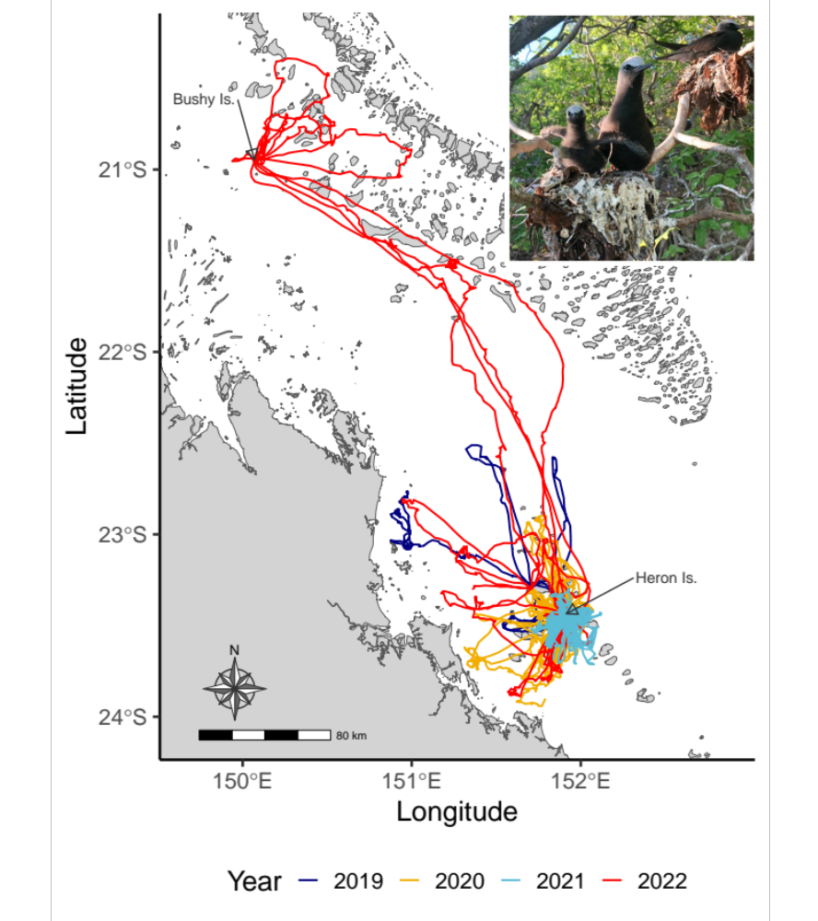
Fig. 1. Foraging tracks of chick-rearing Black Noddies (Anous minutus) from years 2019 to 2022 during their December breeding season.
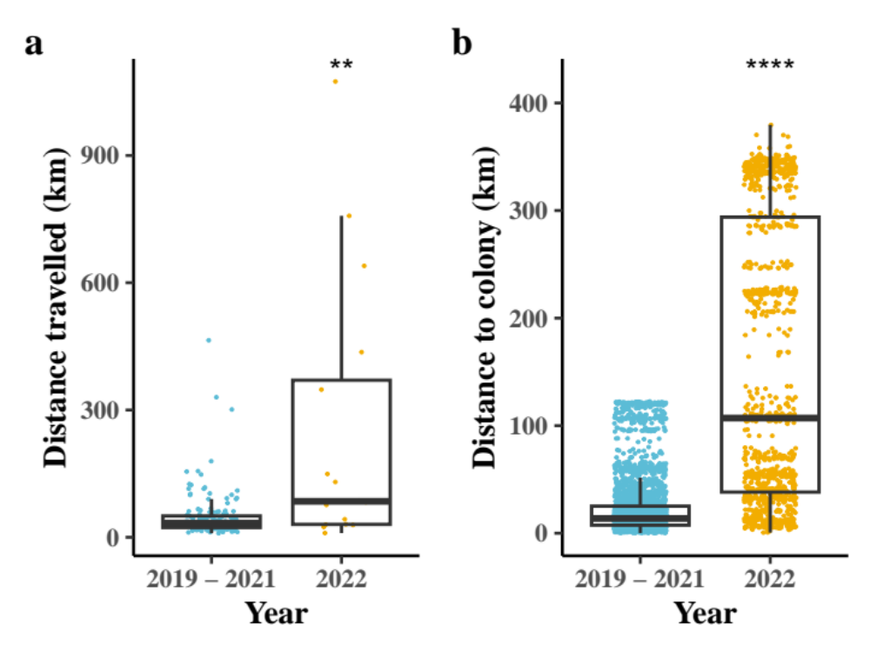
Fig. 2. Foraging and total distances travelled. a, Foraging distances a. per foraging trip (distance travelled while away from the breeding colony) and b, foraging distance from the colony during breeding season for Black Noddies (Anous minutus) from the Heron Island colony, 2019 to 2022. Asterisks indicate results from a Wilcoxon’s test indicating significantly different foraging patterns in 2022 compared to the reference years 2019-2021.
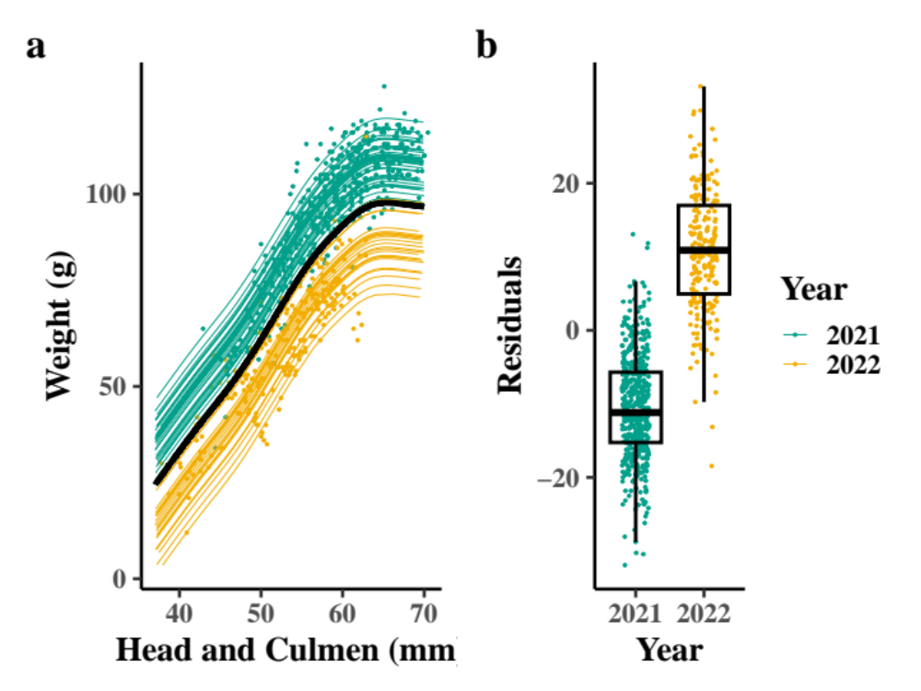
Fig. 3. Changes in Black Noddy chick condition per year. a, Prediction plot for the GAMM model of chick weights at measured head and culmen lengths for each year. Points represent observed data. Black line indicates the predicted trend without inter-annual or inter-individual variance. b, Residuals taken from the GAMM per year. The distribution of residuals was found to be significantly different (t = -32.009, df = 404.35, p <0.001).

Online Methods Section
We used GPS telemetry and regular measurements of chick body mass and other morphological features to investigate the relationship between the distances that breeding adults travelled and their breeding success (chick condition and mortality). Comparisons were made between breeding seasons across four different years.
To collect data on foraging behaviour we fitted GPS tracking devices to foraging Black Noddies that were actively provisioning offspring in the Heron Island colony in the southern Great Barrier Reef. Trackers (Lotek PinPoint50 gps device, <3g) were attached to hand caught individuals (Table 1). We programmed GPS trackers to record locations every 10 minutes with a mean deployment time of 62.27 +/- 11.89 hours. Each individual was fitted with a GPS logger only once; all tagged birds were banded and could subsequently be individually identified. After four days or more the tracker was retrieved by recapture of the individual to download data. Chicks provisioned by a tracked adult were weighed and measured for tarsus, culmen and head lengths. The same data were also collected for control nests where no adults were tracked or handled in 2021 and 2022 (Table 1). Chick mortality was recorded where a chick was found dead at the nest or was no longer present on the nest during daily observations.
Table 1. Tracking and chick mortality data. Summary of data collected for each nest with a GPS tracked parent or control on Heron Island from 2019 to 2022. Chick mortality values are given separately for both chicks of birds carrying GPS trackers and chicks from control nests, respectively.
Year | Trackers retrieved | Trackers deployed | Control nests | Chick Mortality
2019 | 4 | 11 | 0 | 7/*
2020 | 20 | 31 | 0 | 9/*
2021 | 21 | 30 | 10 | 1/0
2022 | 7 | 13 | 16 | 7/6
Totals | 52 | 85 | 26
*Indicates where data was not collected.
To investigate the changes in foraging behaviour we identified foraging locations with a Hidden Markov Model. Given distance travelled from breeding colony is a well known proxy for energy expenditure, we calculated the total trip distance (between visits to the colony) and distance to each foraging location from the colony (Heron Island). We then used a Wilcox test to detect changes in foraging distances from the colony per year.
We used a Generalised Additive Mixed Model (GAMM) to model chick weight against the combined length of head and culmen measurements for each chick in 2021 and 2022 (6, 15). Head and culmen was used as a fixed effect while year and individual were used as random effects to account of pseudoreplication and variance occurring in chick weights between the years. We then extracted the residuals from the fitted model and compared them between years to determine if a significant difference in weight could be detected for the same head and culmen measurements indicating arrested growth.

