3 page multi-page PDF with images

One evening, Māui and his brothers were making a hāngi for their evening meal. They had just finished heating the stones when the sun went down and it quickly became too dark to see. Māui was annoyed with having to eat his food in the dark. He stood in the light of the fire and addressed his people.
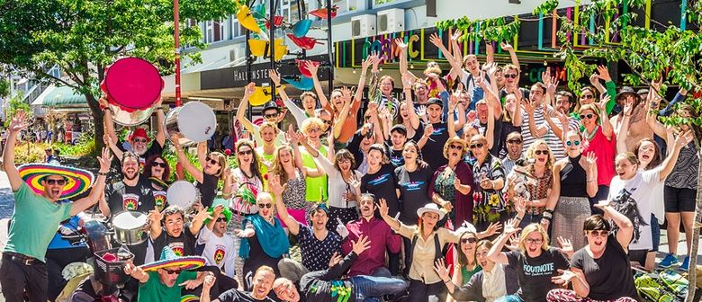
"Every day we have to rush to do our chores and gather our food before the sun sets. Why should we be slaves to the sun? I will catch the sun before it rises, and teach it to travel slowly across the sky!" But one of the brothers was quick to criticise, not believing Māui could possibly do such a thing. "It would be impossible to catch the sun, he's much bigger than any bird you've ever caught!" "The heat and flames would surely burn you to death," said another. "I think he's got sunstroke," another added, and they all laughed.

When they had quietened down, Māui took the sacred jawbone of his ancestor from his belt and waved it in the air. "I have achieved many things that were thought impossible – gaining fire from Mahuika, catching the greatest fish in the world, descending to the underworld, and many more. With this magic jawbone, gifted by Murirangawhenua, and with your help, I will succeed in conquering the sun!". The majority of the people agreed that Māui had achieved many great feats, they decided to help Māui in his quest.

The next day Māui and his whānau collected a huge amount of flax, Māui then taught them how to make flax ropes, a skill he learnt when he was in the underworld. They made square shaped ropes, tuamaka, flat ropes, paharahara, and twisted the flax to make round ropes. After five days the ropes were completed and Māui said a special karakia over them. "Taura nui, taura roa, taura kaha, taura toa, taura here i a Tamanuiterā, whakamaua kia mau kia ita!".

During the night, Māui and his brothers hoisted the ropes and travelled towards the east to where the sun first rises. They hid under trees and bushes during the day, so the sun wouldn't see them approaching. They collected water in calabashes as they travelled, which Māui said was necessary for their task ahead.

On the twelfth night Māui and his brothers arrived at the edge of a huge, red-hot pit, dug deep into the ground. Inside the pit Tamanuiterā, the sun, was sleeping. The brothers were silent, terrified at what might happen if he awoke. Māui immediately ordered his brothers to build four huts around the edges of the pit to hide their long ropes. In front of the huts they used water to soften the clay and build a wall to shelter them. Māui and his brothers then spread their flax ropes into a noose, only just finishing before dawn, when the sun was due to wake. "When Tamanuiterā rises and his head and shoulders are in the noose I will call for you to pull tight on the ropes," Māui instructed his brothers.

Second page of three-page PDF

One of the brothers became worried and wanted to run while he still had time."Why are we doing this?" he asked another. "It's madness!" "We'll be burnt alive, if we run now we might escape with our lives!" The two brothers tried to sneak away but Māui caught sight of them through the corner of his eye. "If you run now the sun will see you when he rises from his pit. You will be the first ones to die. There is no turning back!"

The brothers had no time to answer. The sun had begun to wake and was rising from the pit. They quickly ran back to their huts grabbed hold of their ropes and hid behind the wall of clay, trembling as they waited for Māui's orders. Māui hid and watched.

Tamanuiterā slowly emerged from the deep pit, not knowing that a trap was set for him. His head went through the noose and then his shoulders. Māui suddenly jumped from his hut and yelled to his brothers, "Pull on the ropes, now!" At first the brothers were too scared to come out. Māui yelled again, "Quickly, before it's too late, and we are scorched to death!". Just then the sun peered down to the edges of the pit and saw Māui standing before him. Tamanuiterā was furious. He hurled a ball of fire towards Māui, but Māui ducked, holding tightly to his rope and once more chanting his karakia: "Taura nui, taura roa, taura kaha, taura toa, taura here i a Tamanuiterā, whakamaua kia mau kia ita!".
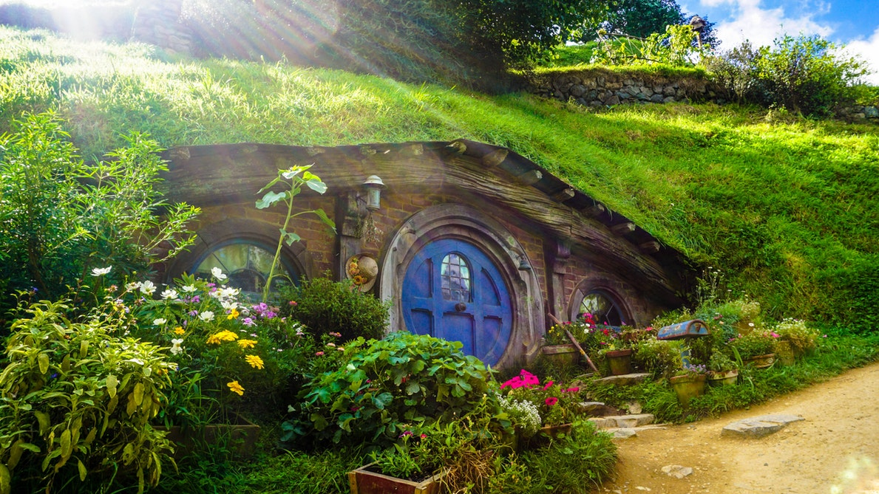
The brothers jumped from their hiding places, grabbing their ropes just before Tamanuiterā could free himself from the noose. "Aaaarrrhhh!" the sun roared in anger. Māui fought off the intense heat and moved to the edge of the pit. He raised his magic jawbone above his head and brought it down hard on the sun. The magic forces from the jawbone flashed like a bolt of lightening. "Why are you doing this to me?" Cried Tamanuiterā."

From now on you will travel slowly across the sky, never again will the length of our day be dictated by you," Māui replied. Tamanuiterā tried to struggle free, but again, Māui showed him the power of his magic jawbone. And Tamanuiterā finally gave up the fight. Māui instructed his brothers to let go of their ropes. Tamanuiterā travelled slowly up into the sky, tired and beaten.

Third page of three-page PDF

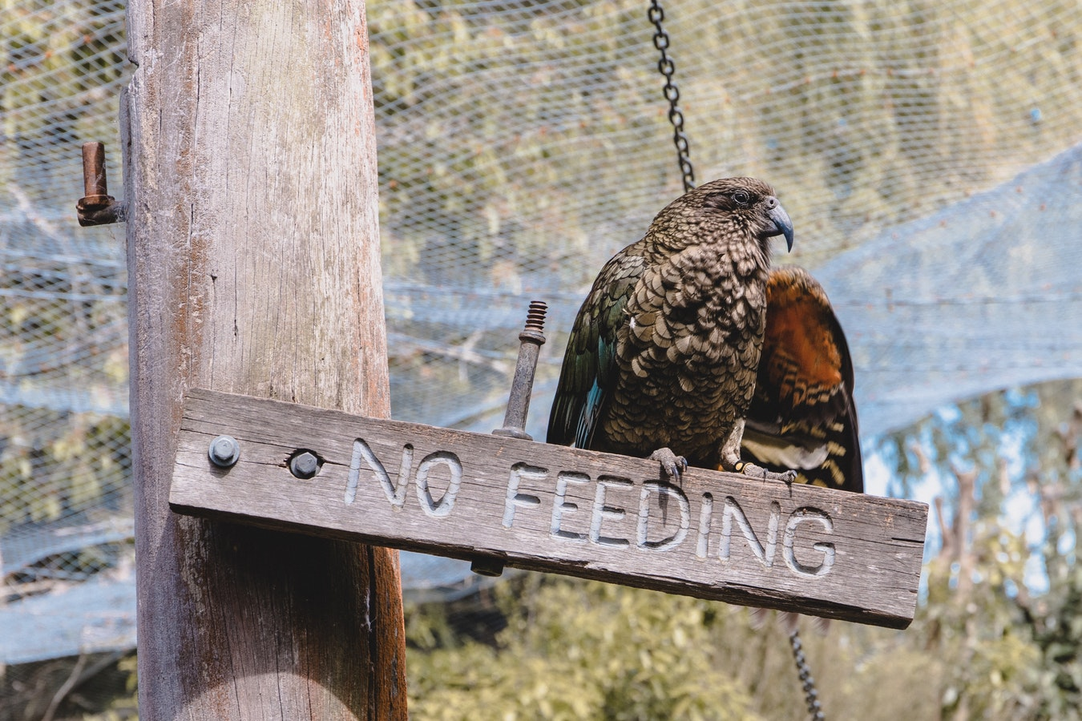
The days became longer for Māui and his people, giving them plenty of time to fish, gather food and do their chores. Māui's power and ability could never be questioned again, he had succeeded in taming the sun. From that day until this, Tamanuiterā has always travelled slowly across the sky. And this is the story of how Māui slowed the sun.

