AIMLCZG549 - API-Driven Cloud Native Solutions

Assignment I - Project Report
Cloud-Native Telecom Customer Churn DataOps Pipeline
Project: Telco Customer Churn DataOps Pipeline
Group Members and Contributions
Name | BITS ID | Contribution
Oomkaar NL | 2025af05057 | Data ingestion, pre-processing, EDA, DataOps scheduling/logging, Docker/cloud deployment, API design & testing (all activities)
<Member 2 Name> | <ID> | <Fill in if group has additional members>
<Member 3 Name> | <ID> | <Fill in if group has additional members>
<Member 4 Name> | <ID> | <Fill in if group has additional members>
(Assignment allows groups of 2-4 members. Add remaining teammates' names/IDs/contributions, or remove unused rows if submitting with fewer members; confirm your program allows solo submission before removing rows.)

1. Business Understanding (Activity 1.1)
A telecom operator wants to proactively identify customers who are likely to churn (cancel their subscription) so that retention teams can intervene with targeted offers before the customer actually leaves. Customer acquisition costs substantially more than retention, so an early-warning system based on account, billing, and service-usage attributes has direct commercial value. This project builds an automated, containerized, cloud-deployable data pipeline that ingests customer data, cleans and prepares it, runs exploratory analysis to surface the strongest churn drivers, and exposes the entire pipeline's operational state through REST APIs and a live dashboard.

2. Data Ingestion (Activity 1.2)
Dataset: IBM “Telco Customer Churn” dataset, originally published on Kaggle (https://www.kaggle.com/datasets/blastchar/telco-customer-churn). It contains 7,043 customer records across 21 columns, which is sufficient for a meaningful churn-prediction experiment (26.5% positive class / churn rate).
Because Kaggle's own download API requires an authenticated kaggle.json token - impractical inside an automated, unattended cloud pipeline - the ingestion script (generate_data.py) pulls the identical public CSV over HTTPS from a GitHub mirror, and automatically falls back to a bundled local copy of the same file if network access is unavailable, so the DataOps schedule (Section 5) never breaks.
Property | Value
Source | Kaggle - Telco Customer Churn (IBM sample dataset)
Rows ingested | 7,043
Columns | 21 (raw) -> 24 after preprocessing/normalization
Target variable | Churn (Yes / No)
Class balance | 26.54% Yes / 73.46% No

3. Data Pre-processing (Activity 1.3)
Implemented in preprocessing.py, executed automatically as the first stage of every pipeline run:
- Summary statistics - describe() computed over all numeric columns (count, mean, std, min/max, quartiles).
- Missing-value detection - the raw dataset has 11 records (0.16%) where TotalCharges arrives as a blank string, a classic real-world data-quality issue in this dataset.
- Data-type correction - TotalCharges is coerced from object/string to numeric (float) before any statistics are computed.
- Imputation - missing numeric values are filled with the column median (robust to skew/outliers).
- Normalization - tenure, MonthlyCharges and TotalCharges are min-max scaled into new *_norm columns for downstream modelling.
Missing-value report captured by a real pipeline run:
Column | Missing Count | Missing %
TotalCharges | 11 | 0.16%

4. Exploratory Data Analysis (Activity 1.4)
Implemented in eda.py: tenure binning, label-encoding of all categorical features, a correlation matrix over encoded + numeric features, RandomForest-based feature importance, and six univariate/bivariate visualizations, all regenerated automatically on every pipeline run.
Top correlations with churn (encoded features):
Feature | Correlation with Churn
Contract_enc | 0.397
tenure | 0.352
tenure_bin_enc | 0.345
OnlineSecurity_enc | 0.289
TechSupport_enc | 0.282
Top feature importances (RandomForestClassifier):
Feature | Importance
Contract_enc | 0.169
tenure | 0.156
MonthlyCharges | 0.112
TotalCharges | 0.106
OnlineSecurity_enc | 0.081
Interpretation: contract type is the single strongest churn driver by a wide margin - month-to-month customers churn far more than one/two-year contract holders - followed by tenure and monthly billing amount, consistent with well-known findings on this dataset.
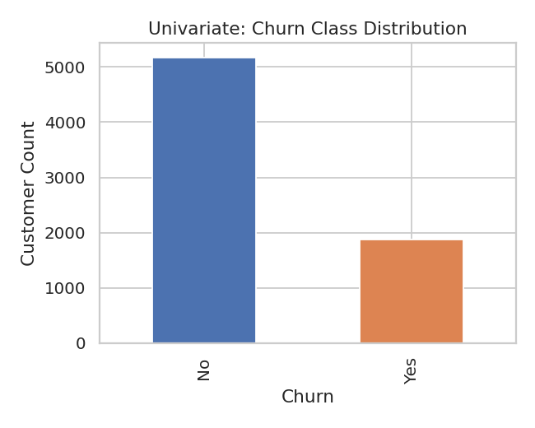
Fig 1. Univariate - Churn class distribution
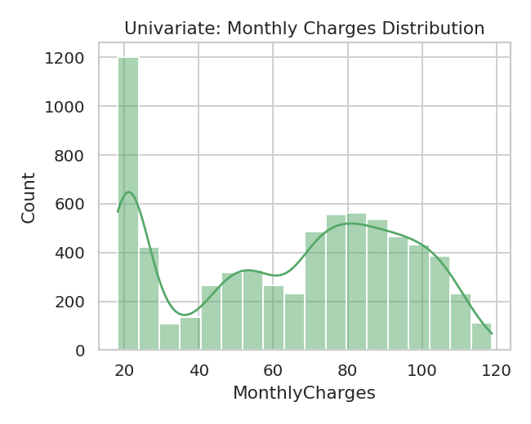
Fig 2. Univariate - Monthly charges distribution
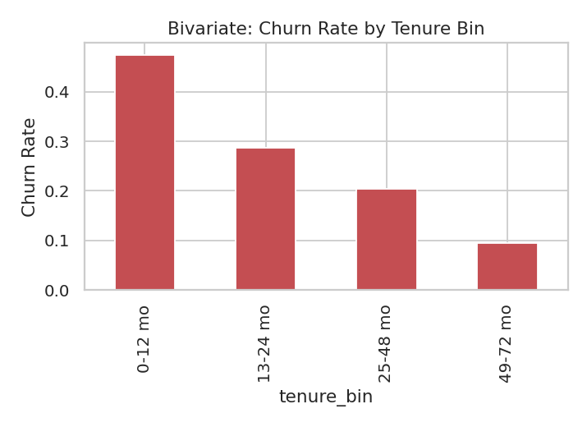
Fig 3. Bivariate - Churn rate by tenure bin
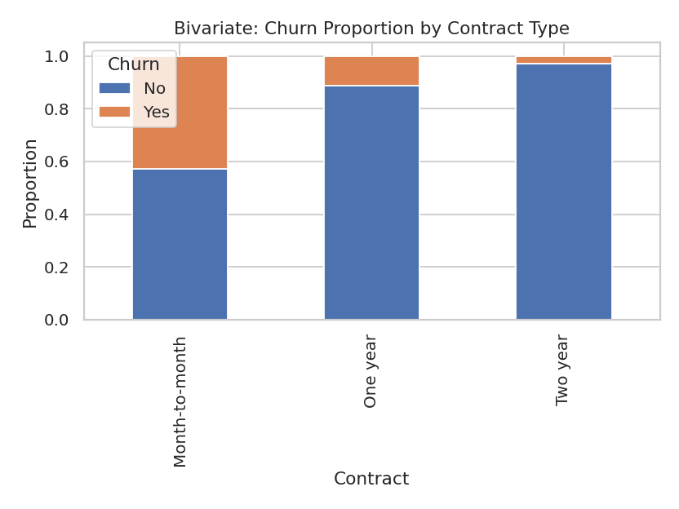
Fig 4. Bivariate - Churn proportion by contract type
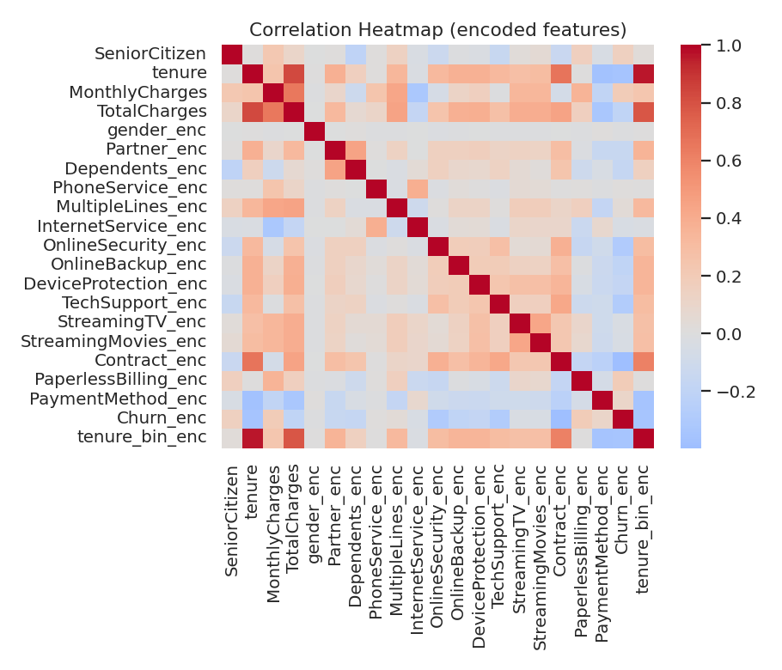
Fig 5. Correlation heatmap (encoded features)
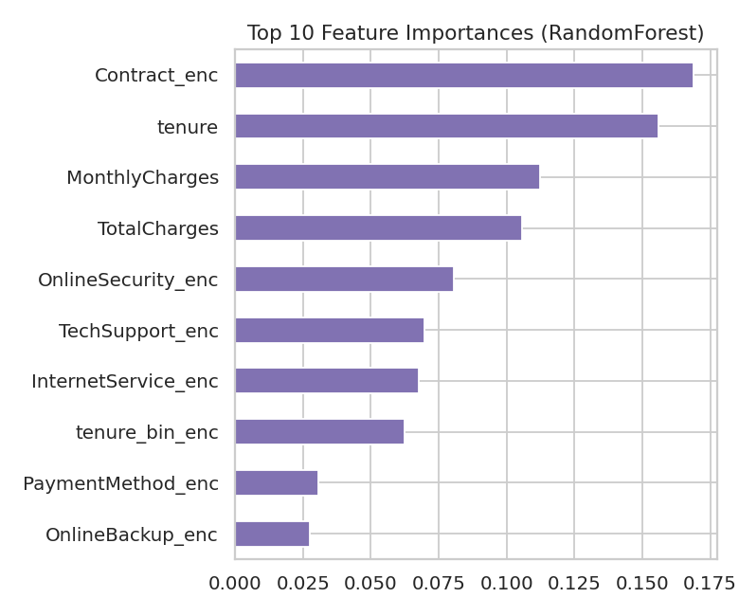
Fig 6. Top 10 feature importances (RandomForest)

5. DataOps - Scheduling, Logging & Dashboard (Activity 1.5)
pipeline.py automates Activities 1.3 and 1.4 into a single repeatable run: every execution is timestamped, logged to logs/pipeline.log (human-readable) and appended as a structured JSON record to logs/run_history.json (machine-readable, consumed by the API and dashboard).
scheduler.py uses APScheduler's BackgroundScheduler with an interval trigger of exactly 2 minutes to satisfy the DataOps scheduling requirement. Sample log excerpt from an actual run of this project, showing genuine ~2-minute spacing between automated runs:
2026-09-25 09:49:30 | Scheduler STARTED: dataops_pipeline_job will run every 2 minutes
2026-09-25 09:49:32 | [run-20260925T094930] Pipeline run ENDED | status=SUCCESS | duration=2.09s
2026-09-25 09:51:32 | [run-20260925T095130] Pipeline run ENDED | status=SUCCESS | duration=1.96s
2026-09-25 09:53:32 | [run-20260925T095330] Pipeline run ENDED | status=SUCCESS | duration=2.00s

Consecutive runs land 120 seconds apart (09:49:32 → 09:51:32 → 09:53:32), confirming the interval trigger fires correctly on schedule (this fixes an earlier bug where passing next_run_time=None to APScheduler's add_job() left the job paused instead of scheduling it for now + interval).
The dashboard (GET /dashboard) renders this run history as an auto-refreshing HTML page:
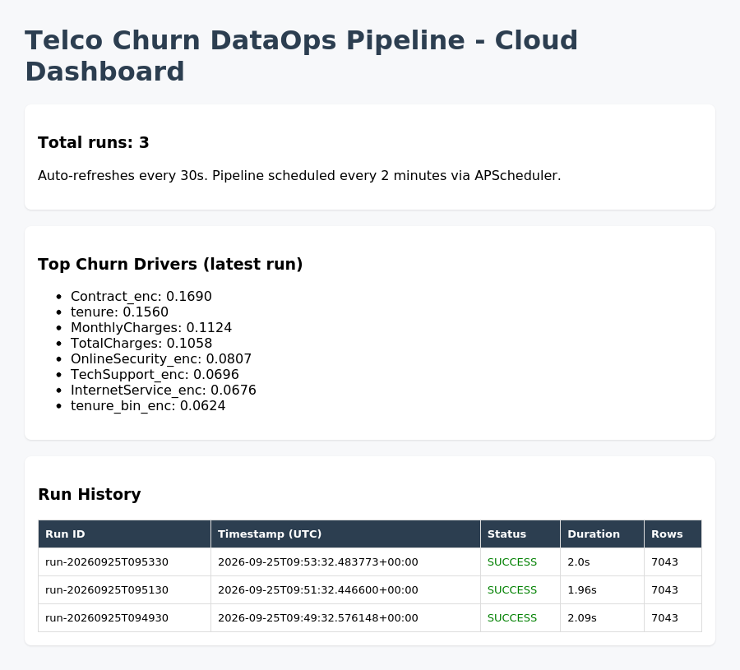
Fig 7. Live DataOps dashboard - run history, status, duration, and top churn drivers

6. Containerization & Cloud Deployment
The application is packaged as a single Docker image (Dockerfile). entrypoint.sh starts the APScheduler background worker (scheduler.py) and the FastAPI server (uvicorn) together in one container. It is deployed on Render.com (free tier) as a Docker web service, built directly from the project's GitHub repository (https://github.com/NLOOMKAAR/techno-Churn-Pipeline). The same image is portable to other managed container platforms:
- Google Cloud Run: gcloud run deploy --image ... --port 8000
- AWS ECS Fargate / App Runner: push image to ECR, health-check on /health/ready
- Azure Container Apps: az containerapp up --source . --ingress external --target-port 8000
6.1 Live deployment on Render
Public URL of the deployed application:
https://telco-churn-dataops-pipeline.onrender.com
Item | Value
Platform | Render.com - Web Service (Docker runtime), Free plan
Source | GitHub: NLOOMKAAR/techno-Churn-Pipeline (branch: main)
Build | Dockerfile in repo root (python:3.12-slim, non-root user)
Port | Injected by Render via $PORT (read by api/config.py and entrypoint.sh)
Scheduler | Embedded APScheduler, every 2 minutes (ENABLE_EMBEDDED_SCHEDULER=true)
Config | Environment variables: ENVIRONMENT, LOG_LEVEL, LOG_FORMAT, CORS_ORIGINS

Deployment log evidence from Render (first run after a successful deploy):
==> Your service is live
==> Available at your primary URL https://telco-churn-dataops-pipeline.onrender.com
[entrypoint] Starting API server on 0.0.0.0:10000 (workers=1)...
Uvicorn running on http://0.0.0.0:10000
Scheduler STARTED: dataops_pipeline_job will run every 2 minutes
[run-20260928T043209] Pre-processing complete | rows=7043 missing_fixed=['TotalCharges']
[run-20260928T043209] EDA complete | charts=6 top_driver=Contract_enc
[run-20260928T043209] Pipeline run ENDED | status=SUCCESS | duration_sec=23.33

6.2 Live links
Page | URL
Front end (home) | https://telco-churn-dataops-pipeline.onrender.com/
Dashboard | https://telco-churn-dataops-pipeline.onrender.com/dashboard
Swagger API docs | https://telco-churn-dataops-pipeline.onrender.com/docs
Health (liveness) | https://telco-churn-dataops-pipeline.onrender.com/health/live
Application info API | https://telco-churn-dataops-pipeline.onrender.com/api/v1/app/info
Metrics | https://telco-churn-dataops-pipeline.onrender.com/metrics

Render's request log recorded HTTP 200 responses for /dashboard, /docs, /health/live, /health/ready, /api/v1/app/info, /api/v1/app/flow, /api/v1/pipeline/runs, /metrics and /openapi.json, and the expected 404 for a deliberately non-existent path (negative test).
Note: the free tier sleeps after about 15 minutes without traffic. The application pings its own public URL every 10 minutes (KEEP_ALIVE setting) so the 2-minute scheduler keeps running.

6.3 Front end (single-page application)
The FastAPI service also serves a single-page front end at the root URL. It calls the live REST APIs and presents every activity of the assignment on its own tab: 1.1 business understanding and an assignment-coverage checklist (Overview), 1.2 ingestion, 1.3 pre-processing (summary statistics, missing values, imputation, data types, normalization), 1.4 EDA (correlations, binning, encoding, feature importance, charts), 1.5 DataOps (2-minute schedule countdown, run history, live activity log) and API access (application details plus a live test runner showing HTTP status codes).
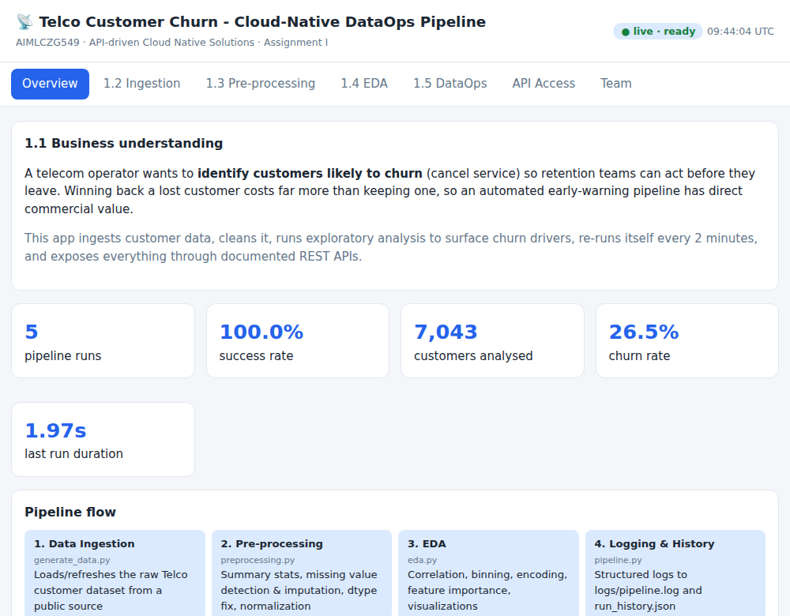
Fig 8. Front end - Overview: business problem, live KPIs and pipeline flow
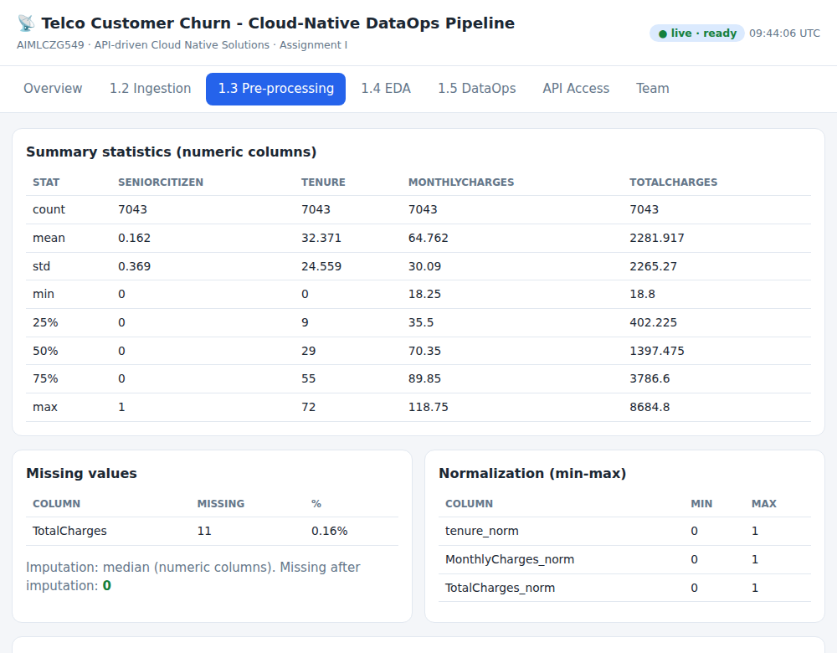
Fig 9. Front end - Pre-processing: summary statistics, missing values, normalization
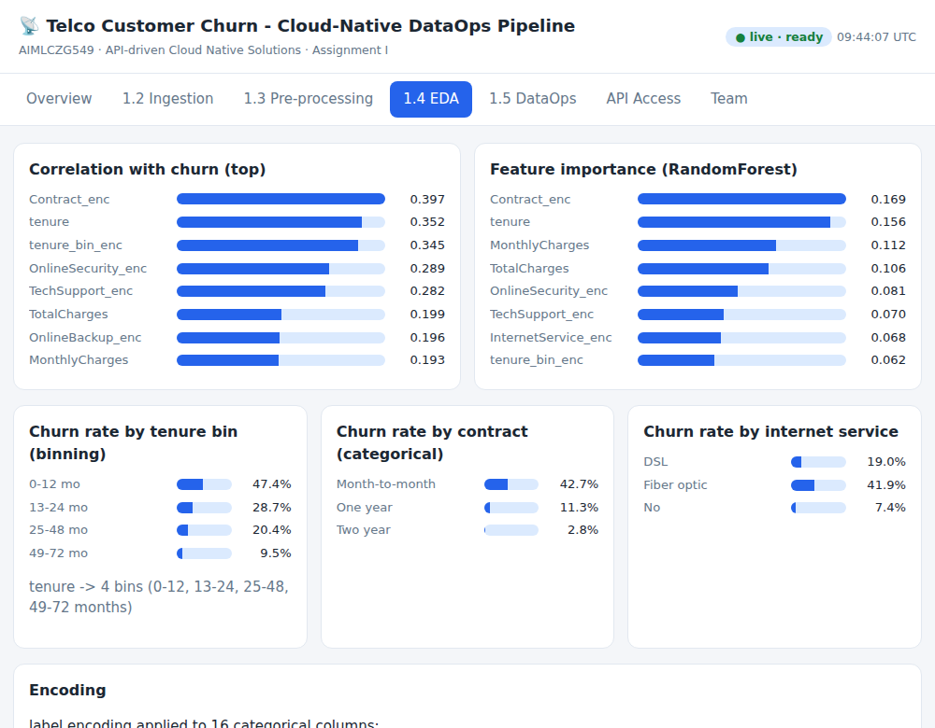
Fig 10. Front end - EDA: correlations, feature importance, binning
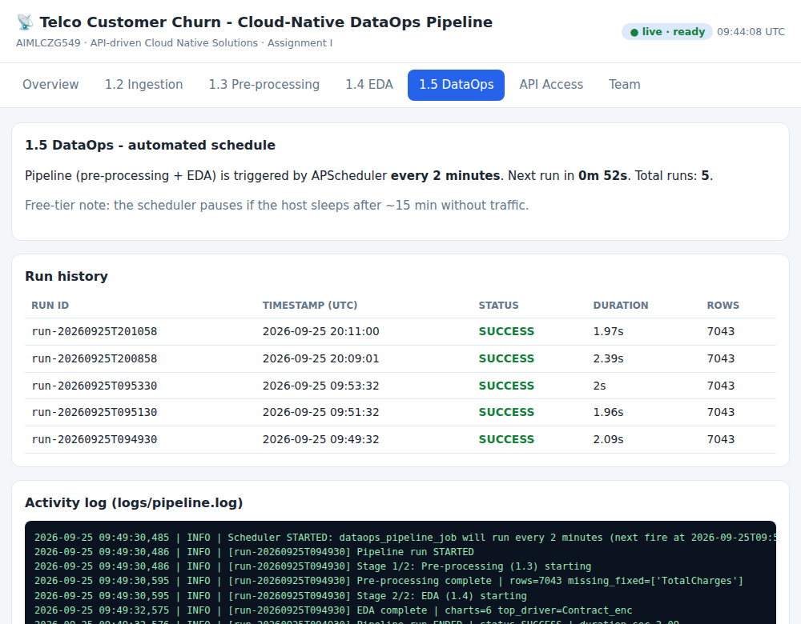
Fig 11. Front end - DataOps: 2-minute schedule, run history and activity log
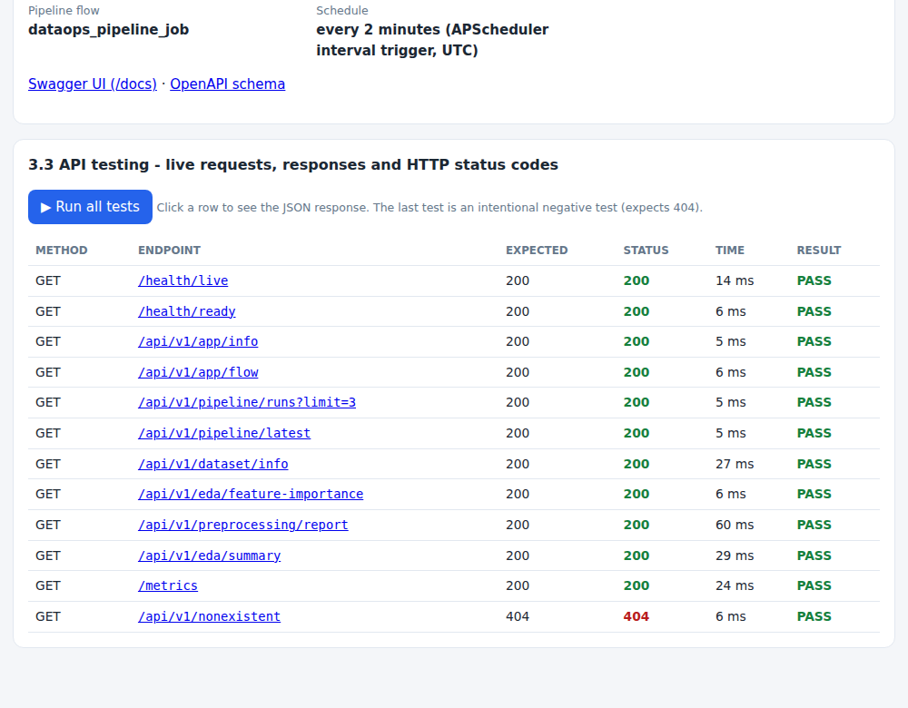
Fig 12. Front end - API testing: live requests with HTTP status codes and PASS/FAIL
Screenshots above were captured from the application UI; replace or add screenshots of the onrender.com address if the grader requires the live URL to be visible.

7. API Access (Sub-Objective 2)
7.1 / 7.2 - Application details exposed via API (Activities 3.1, 3.2)
The FastAPI application (api/main.py) exposes the following application/deployment/flow details as REST endpoints - well above the minimum of four required:
# | Endpoint | Application Detail Exposed
1 | GET /api/app/info | App name, version, environment, deployment target, uptime
2 | GET /api/app/flow | Pipeline stage/flow definition & schedule
3 | GET /api/pipeline/runs | Full DataOps run history
4 | GET /api/pipeline/latest | Latest run's status & metrics
5 | GET /api/dataset/info | Dataset schema, row/column counts, churn rate
6 | GET /api/eda/feature-importance | Latest churn-driver feature importances
7 | GET /health | Liveness/readiness probe

7.3 - API Testing and Documentation (Activity 3.3)
Every endpoint was tested with curl against the live running service; HTTP status codes and JSON response bodies were captured for each call, including a negative test against a non-existent route to confirm correct 404 handling. A Postman collection (postman_collection.json) is also provided for interactive re-testing.
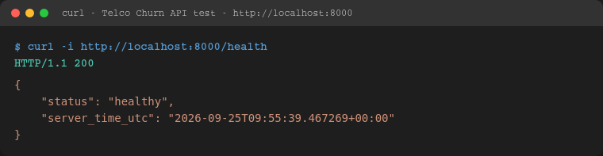
GET /health -> 200 OK
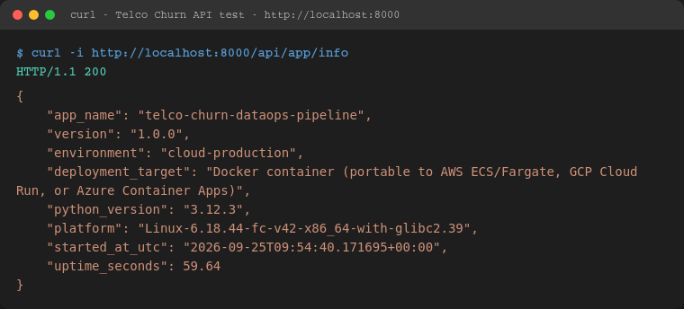
GET /api/app/info -> 200 OK
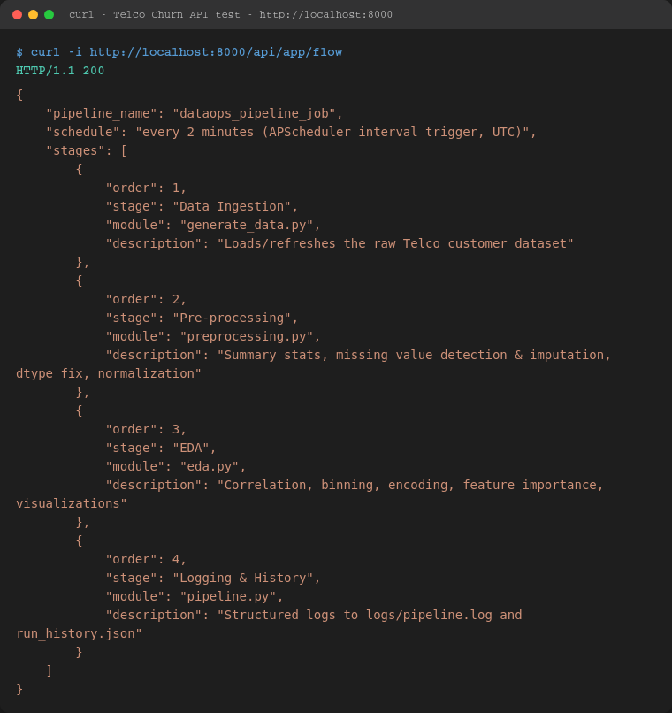
GET /api/app/flow -> 200 OK
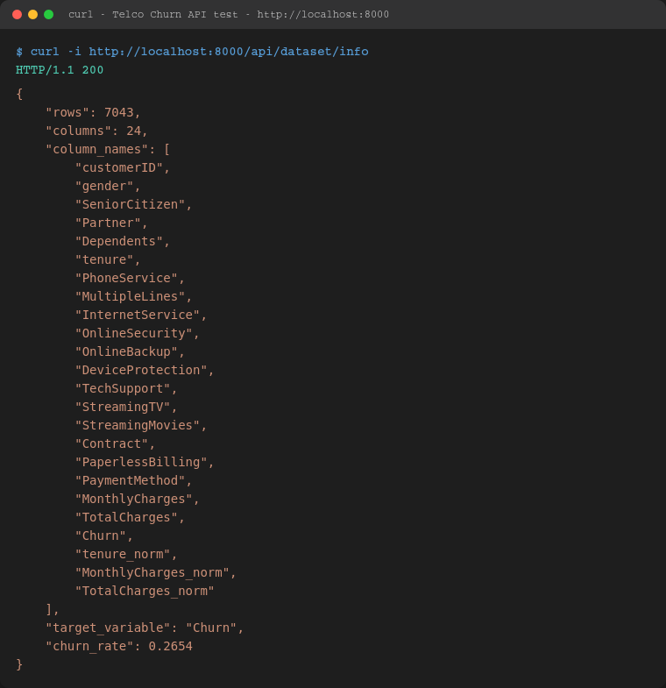
GET /api/dataset/info -> 200 OK
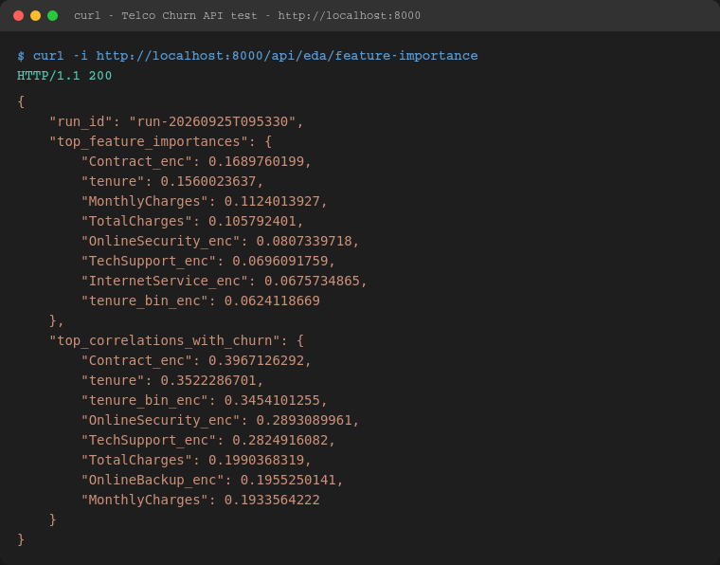
GET /api/eda/feature-importance -> 200 OK
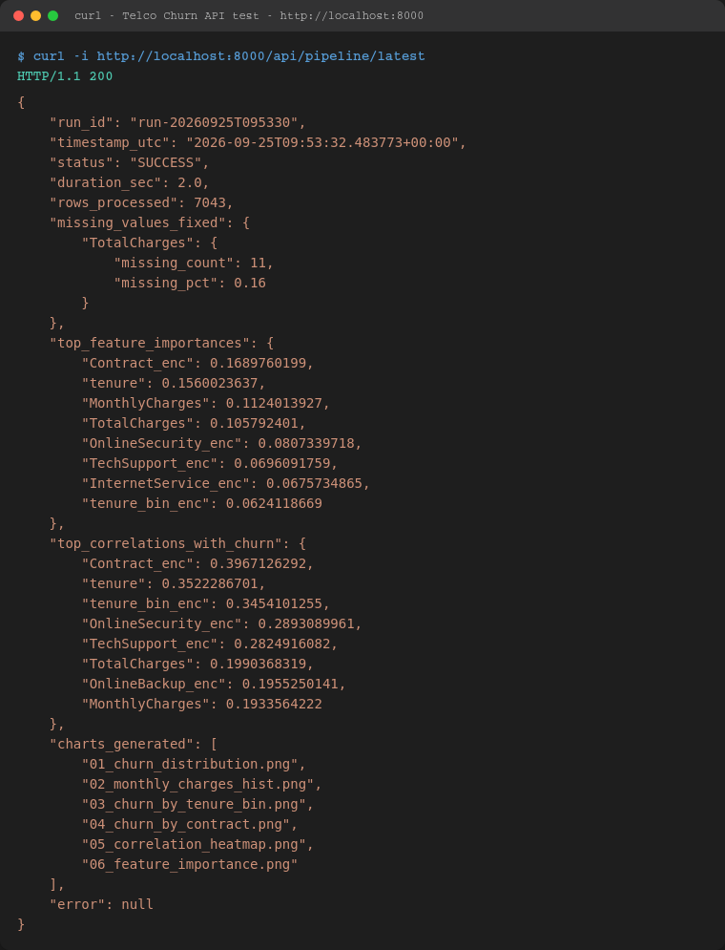
GET /api/pipeline/latest -> 200 OK
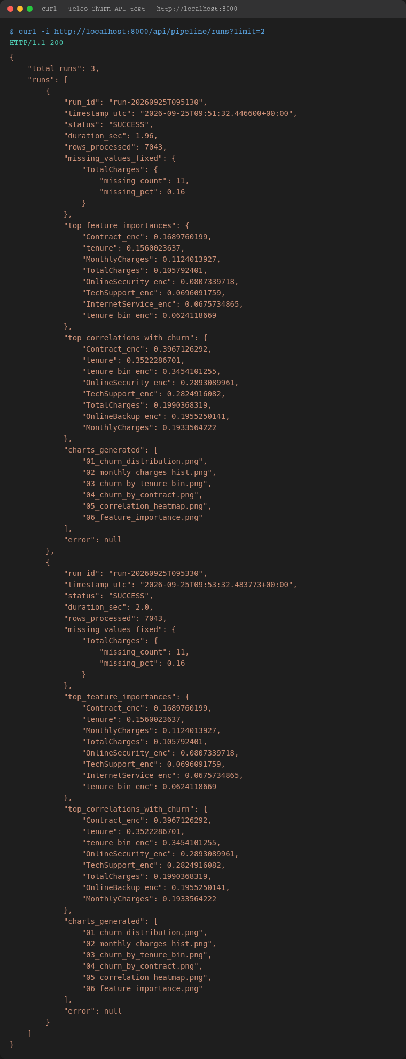
GET /api/pipeline/runs?limit=2 -> 200 OK
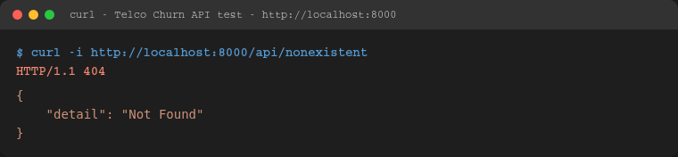
Negative test: GET /api/nonexistent -> 404 Not Found (correct error handling verified)

8. Conclusion
This project delivers an end-to-end, cloud-deployable DataOps pipeline for telecom churn analysis: real public data ingestion, automated pre-processing and EDA, a 2-minute scheduled DataOps loop with structured logging and a live dashboard, and a documented, tested REST API surface exposing application, pipeline, dataset and model-insight details. Contract type, tenure, and monthly charges emerged as the dominant churn drivers, actionable findings a retention team could use directly.
A short video walkthrough of the running pipeline, dashboard and API is included as a separate submission per the assignment's video-demo requirement.

