# Assignment 3, Task 1: NQueens problem

Group 11: Shakhrom Rustamov, Henrietta Helberg

1. We’ve completely refactored Task1 solution as discussed and made the matrix size dynamic(N Queens on NxN grid) .   
     
   Please set ***number_of_queens*** parameter (int) to size N you want to run the experiment. Ex: ***int number_of_queens <- 8;***It is interesting to note that in our laptop, experiments with Queen size with 4, 8, 10 worked quite fast. As it gets to 20, it takes a minute to complete. The logs show the progress as it goes through the cycles.   
   When it finishes, we print in the log as:   
   “All queens are placed according to rules!”
2. Results for different Grid Size:  
     
   a) N = 4  
   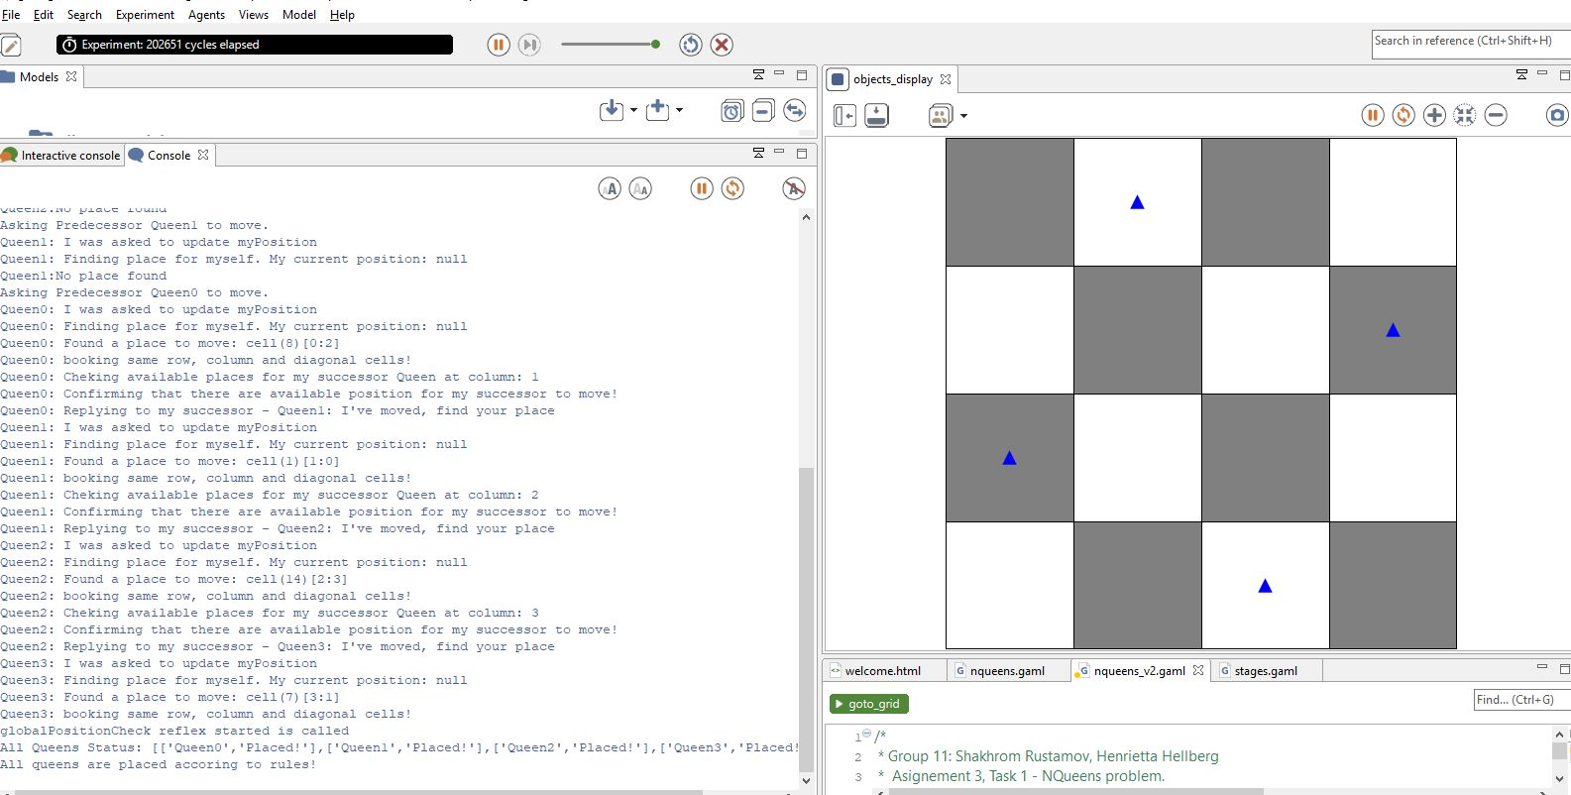
3. b) N =8  
   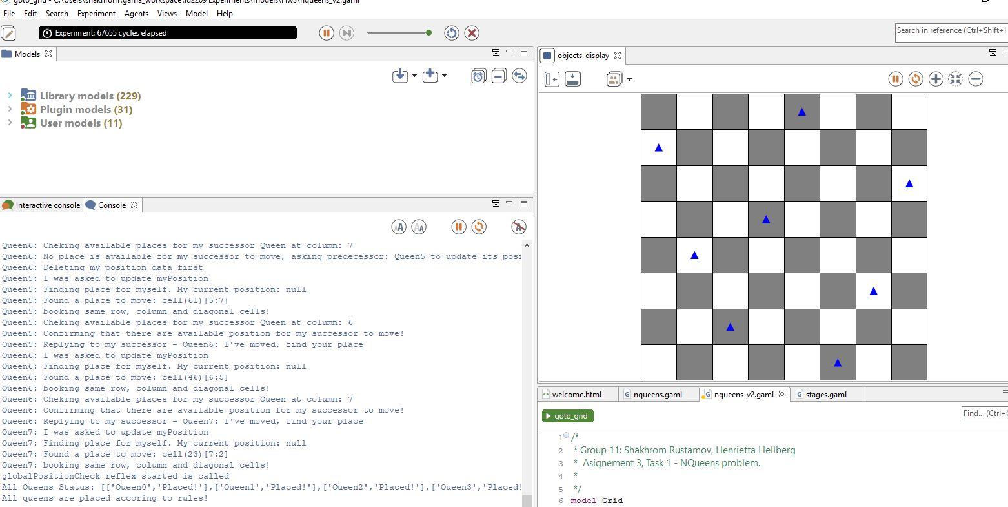  
     
   c) N = 20  
     
   