AMS Deployment:

1. Create the DB using the Sql scripts. All scripts are available in “\AMS_Database_Import_1.0” location.
2. Host the API application in IIS. Published code is available in ‘\Published_API’ location.
3. Change the connection string as per your DB credential in API config file ‘\Published_API\Web.config’.
4. Need to change the IP/Server name for ‘baseAppUrl’ variable in ‘Published_UI\main.a09474dd9a020432a3dc.js’ file and it should be the hosted API IP/Server name.

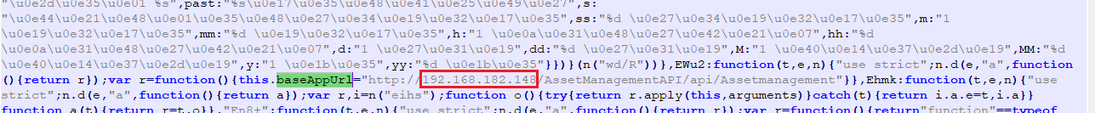

1. Host the UI in IIS. Published source code is available in ‘\Published_UI’ location.
   1. Create the web application.

