**Project Initiation Document**

**“Mapping the Via Appia in 3D”** *Path finding project NL eScience Center / SPINlab VU Amsterdam*

**1. Project definition**

This path finding application aims to develop an integrated set of generic tools which enables researchers to generate a 4D Geographic Information System (4D GIS) in which highly detailed features can be spatially stored, visualized and analyzed. Its field of application is monumental archaeology for which the NWO funded project “Mapping the Via Appia” serves as use case. The project aims to generate an evaluation of different software and newly developed tools necessary for archaeologists and other disciplines to develop a 4D GIS system.

A highly detailed 4D GIS in which archaeological objects are spatially stored and to which attribute information can be linked enables archaeologists to analyse complex archaeological sites like the Via Appia. Capabilities on querying large datasets in a 3D environment and the possibilities to conduct 3D spatial analysis like visibility and shadow analysis, provides insights for a better understanding on how the monuments were positioned in antiquity, thus reconstructing how the archaeological site looked like and –even more important– contribute to reconstruct how the archaeological site functioned. Besides the objects in 3D the project would benefit a lot from functionality which enables the researchers to align historical images as viewing windows in 3D, making it 4D (time). Especially in Rome archaeological sites have been painted and photographed a lot, forming a valuable source of information for archaeological research.

To develop the 4D GIS three steps have been identified (De Hond, 2013). The first one is to get from the physical reality to a virtual 3D representation. For capturing the current state of the archaeological site, the SPINlab has already obtained 3D data of the Via Appia. Massive point clouds (.LAS) of the research area have been generated by making use of Fugro’s DRIVE-MAP service, and meshes (.OBJ) and point clouds (.LAS) of the individual archaeological objects have been generated using Autodesk 123D Catch. The second step is to identify and define objects within the 3D environment. The third challenge is to enrich these 3D objects with attributive information and 4D GIS functionality.

The aims of the project are to first provide a thorough evaluation of existing software and tools to process the data and include functionality described above. Second, based on this evaluation, the project will integrate existing tools and develop necessary tools that generated functionality that allows the archaeologists to work with their data in a 3D interface.

**2. Work packages (WPs)**

The project is subdivided in 4 work packages. The first work package contains preparatory works: the user requirements of the 4D GIS are being defined and existing tools evaluated; a work schedule will be approved in a board meeting. Work packages two and three will develop the required tools and web-based solutions. In the fourth work package, the results of the project are being disseminated and future directions will be defined.

**Work package 1 – Preparation**

This first work package (WP1) evaluates the archaeologist’s user requirements and produces a conceptual design of the intended end product with clear descriptions of its functionalities. Second, it provides a thorough evaluation of existing software and tools, indicating which tool could be re-used in this project and identifying gaps where new tools should be developed. A board meeting will be organised to approve a work schedule.

|  |  |  |  |  |
| --- | --- | --- | --- | --- |
| **Deliverable / Task** | **Description** | **Who** | **When?** | **Estimate working days** |
| **1.1 User requirements** | An evaluation of the intended end product, with a clear description of its functionalities and purposes. | Rens / Maurice | Week 6 | 2 (SPINlab) |
| **1.2 Evaluation of existing tools** | A report on available tools and previous research in the field of 4D GIS. | Rens / Maurice | Week 6 | 2 (SPINlab) |
| **1.3 Documentation MPC** | Provide the project team with documentation on the activities, results and prospects of the Massive Point Cloud project, and report on the usability for the Mapping the Via Appia in 3D project. | Oscar | 17 March | 1 (eScience) |
| **1.4 SQL dump of archeodatabase & footprints** | Provide an SQL dump of the database in which the archaeological data will be stored and of the shapefiles that contain the footprints of the monuments | Rens / Maurice | 1 april | 2 (SPINlab) |
| **1.5 Board meeting** | Organise a meeting with the advisory board and the user group to assess PID, inform about the proceedings and prospects of the project, and to develop the network. | Rens / Maurice | 24-28 March | 1 (SPINlab) |

*Milestone 1 Board meeting and approval of work schedule.*

**Work package 2 – Database loading and alignment**

The second work package (WP2) is focussed on getting the basic dataset functional: the point clouds and other data must be loaded into databases, and a tool must be created to align the two types of point clouds.

|  |  |  |  |  |
| --- | --- | --- | --- | --- |
| **Deliverable / Task** | **Description** | **Who** | **When?** | **Estimate working days** |
| **2.0 Starting data set** | Provide the engineers with sufficient data: drive-map point cloud, image-based point clouds & images, reconstruction models, and footprints. | Rens | 28 March | 3 (SPINlab) |
| **2.1 Database integration** | Loading the required data (drive-map point cloud, image-based point clouds, and footprints) into a PostGIS database, using Oscar’s manual. | Engineers  Rens | 18 April | 5 (SPINlab)  5 (eScience) |
| **2.2. Manual alignment tool** | Develop a standalone tool to manually align image-based point clouds of individual sites and reconstruction models of monuments (OBJ/Collada) to the drive-map point cloud.  NB: (semi-)automatic alignment is optional, when resources are still available near the end of the project. | Maarten | 9 May | 10 (eScience) |
| **2.3 Documentation** | Documentation of all tasks in WP2. | Engineers  Rens | 16 May | 1 (eScience)  2 (SPINlab) |

*Milestone 2 Alignment of point clouds and reconstruction models*

**Work package 3 – Tools and solutions**

Work package 3 (WP3) is responsible for the development of the generic 4D GIS functionalities and web-based user solutions. Based upon the results of WP1 and the outcome of WP3.1, either existing tools can be re-used or used as a basis for new tools, or new tools can be developed from scratch.

**NB:** Right after the completion of WP2, we will make an **evaluation of the planning of WP3**. The remaining time schedule is open for refinements and changes at this point.

|  |  |  |  |  |
| --- | --- | --- | --- | --- |
| **Deliverable / Task** | **Description** | **Who** | **When?** | **Estimate working days** |
| **3.1 Analysis & choice of Bentley, ESRI, QGIS** | Analyse (SWOT) and choose a program that will be the base and interface of the 4D GIS. Important criteria will be:   * Minimum license costs * Presence of or extensibility for required tools (see 3.2, 3.3, 3.4) * Database connectivity * 3D visualisation capabilities   Most likely candidates are Bentley Map, ESRI ArcScene and QuantumGIS. | Rens  Engineers | 23 May | 2 (SPINlab)  3 (eScience) |
| **3.2 Segmentation functionality** | Functionality to define segments of point clouds of sites as objects. (Each site will exist of at least one object.) | Engineer  Rens | 6 June | 10 (eScience)  5 (SPINlab) |
| **3.3 Archeodatabase query functionality** | Workflow to extract the attribute data from the archeodatabase and assign it to the sites and objects, and functionality to query the dataset. | Engineers  Rens | 20 June | 5 (eScience)  5 (SPINlab) |
| **3.4 User requirements for web-based solution** | Specification of the user requirements for web-based access to the system | Engineers  Rens | 4 July | 2 (SPINlab)  2 (eScience) |
| **3.5 Web-based solutions** | Web-based solution with server operation on the net. eInfrastructure and web-client (webviewer like CityEngine WebViewer?) for the archaeologists (users), to make the 4D GIS run smoothly on the archaeologists normal PCs and laptops and to enable them to perform queries and view their results in 3D in a user friendly and non-computer specialist way | Engineers  Rens | 18 July  Re-evaluation upon starting of WP3 | 10 (eScience) |
| **3.5 OPTIONAL: historical pictures tool** | Tool to import historical pictures into the 3D environment and to attach the corresponding point of view. This task is optional and can be done when resources are still available near the end of the project. | Maarten  Rens | Optional upon available resources. | 10 (eScience)  5 (SPINlab) |
| **3.6 Documentation WP3** | Documentation of all tasks in WP3. | Engineers  Rens | 18 July | 3 (eScience)  2 (SPINlab) |

*Milestone 3 Integrated set of 4D GIS tools and web-based solutions*

**Work package 4 – Publication and dissemination**

Work package 4 (WP4) ensures the scientific dissemination and release of tools for public and private companies. The integration of the tools into the eScience Technology Platform (eSTeP) will make the developed tools available for many research domains, thus enabling other fields of research to fully profit from this project’s results. Furthermore, this work package explores possibilities for future collaborations.

|  |  |  |  |  |
| --- | --- | --- | --- | --- |
| **Deliverable / Task** | **Description** | **Who** | **When?** | **Estimate working days** |
| **Publication final products** | Scientific dissemination of the final results and end products of this project. Contributions to several networks. | Rens  Maurice  Engineers | 22 August | 3 (eScience)  20 (SPINlab) |
| **Release of tools WP2 and WP3** | Software release of tools developed during the project as part of eStep | Engineers | 22 august | 5 (eScience) |
| **Strategic document** | Document in which future directions are presented. | Rens  Engineers | 22 August | 3 (eScience)  3 (SPINlab) |

*Milestone 4 Scientific article and dissemination tools*

NB: The division of working days, as described in the tables above, has 61 days for SPINlab and 71 days for eScience Center. This leaves 5 spare days for eScience Center (0.4 x 1680h/year = 672h = 84 days, of which appr. 8 have been used so far), which could either be used to work on the optional WP3.5 (Historical pictures tool), or to spent more time on other tasks if needed.

**3. Organisational structure**

The project consists of 5 teams with defined roles and responsibilities.

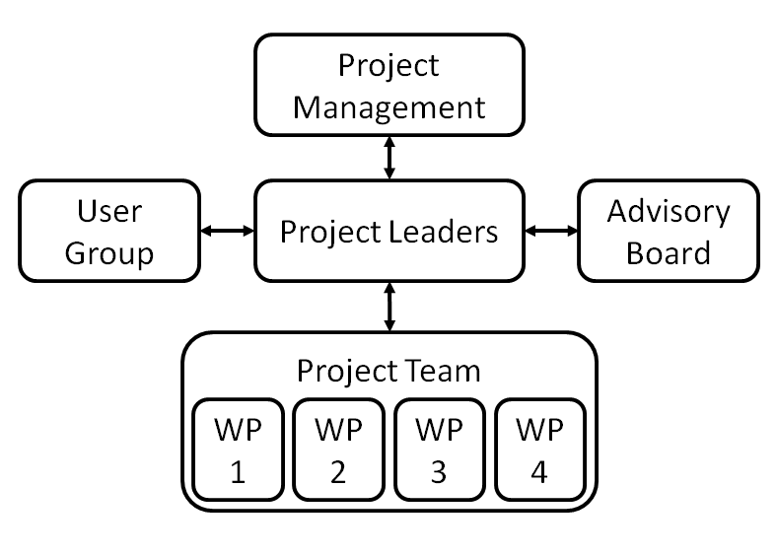

**Project management**

Are being updated by the project leaders on a regular basis and have the right to intervene in the project if necessary.

*Rob van Nieuwpoort (MT / CTO NLeSC)  
Henk Scholten (VU, professor in Spatial Informatics)*

**Project leaders**

Have the responsibility to steer the project team and update all participants in the project. Specific progress control regarding milestones and deliverables. Assessment and evaluation of work packages. Development of proactive measures against potential threads and bottlenecks.

*Maurice de Kleijn (VU), Eduardo Dias (VU), Milena Ivanova (NLeSC)*

**Project team**

Will generate deliverables defined in this document.

*Oscar Martinez Rubi (NLeSC)  
Maarten van Meersbergen (NLeSC)  
Stefan Verhoeven (NLeSC)  
Rens de Hond (VU)  
Simeon Nedkov (VU)  
Eduardo Dias (VU)  
Maurice de Kleijn (VU)*

**Advisory board**

Are updated on a regular basis and are invited to give input for the project. This will be done by the project leaders who will organize meetings and send project updates.

*Henk Scholten (VU)  
Rob van Nieuwpoort (NLeSC)  
Stephan Mols (RU, project leader Mapping the Via Appia)  
Peter van Oosterom (TUD)  
Ron Rozema (Fugro director)  
Jeremia Pelgrom (KNIR)*

**User group**

Are invited to test the generated tools and give input on the functionality.

*Stephan Mols (RU)  
Maurice de Kleijn (VU)  
Martin Kodde (Fugro)  
Azarakhsh Rafiee (VU)  
Patricia Lulof (UvA)*

**Signature for Approval**

Dr. Milena Ivanova (NLeSC) Prof. dr. H.J. Scholten (SPINlab)

……………….. ………………..

M.T.M. de Kleijn MA (SPINlab) Dr. Eduardo Dias (SPINlab)

……………….. ………………..