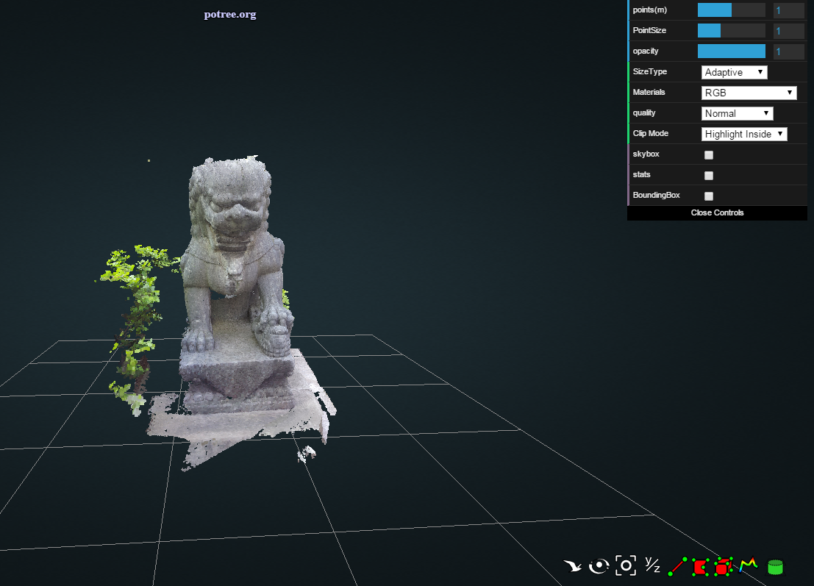

bird keep as is

rotate keep as is

center keep as is

y/z remove

line keep - extend with adding the numbers up

- add functionality to show angle in degrees

- add functionality to measure on xyz axis; snap on the xy or z axis.

area keep as is (including angles)

cube keep - add the measurements (length of xyz axis)

height profile keep as is

clip volume keep as is

