November 13, 2020

**DEPARTMENT OF MICROBIOLOGY AND IMMUNOLOGY**

1520A MEDICAL SCIENCE RESEARCH BUILDING I

ANN ARBOR, MICHIGAN 48109-0620

PHONE: (734) 763-3531

FAX: (734) 764-3562



Dear Dr. Casadevall,

My colleagues and I are happy to submit our manuscript, **Clearance of *Clostridioides difficile* colonization is associated with antibiotic-specific bacterial changes,** for your consideration at *mBio*. This work demonstrates that the gut microbiota of mice can be altered such that different communities are rendered susceptible and then vary in their ability to clear the *C. difficile* infection. We think this is an important contribution because it further highlights that *C. difficile* is using multiple mechanisms to colonize the gut and that the community is also using multiple mechanisms to clear the infection.

The manuscript has also been submitted to bioRxiv as a preprint.

Sincerely,

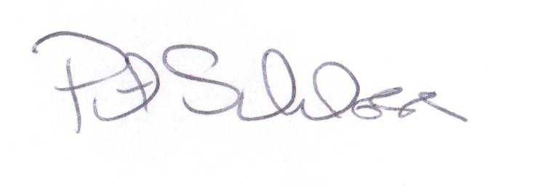

Patrick D. Schloss, PhD

Professor