**Microbiota predict *Clostridium difficile* severity in germ-free mice colonized with human feces**

Kaitlin J Flynn*, Nicholas Lesniak*, Alyxandria M. Schubert, Hamide Sinani, anyone-else-ERIN-people?, maybe-Ingrid Bergin?, Patrick D. Schloss

**Abstract**

*Clostridium difficile* causes diarrheal disease when it successfully colonizes a dysbiotic gut microbial community. Current mouse models to study *C. difficile* infection (CDI) rely on pre-treatment with antibiotics to disrupt the mouse microbiome prior to *C. difficile* inoculation. This is an effective model for many studies but does not allow for analysis of human-associated microbial community members that modulate *C. difficile* colonization and expansion. To study human-associated microbes in the context of CDI, we inoculated germ-free C57BL/6 mice with one of 16 human fecal samples from diarrheal or healthy donors and challenged with *C. difficile* 14 days later. Five unique donor-mice combinations resulted in severe CDI while the remaining 11 only experienced mild disease. Both healthy and diarrheal donors were susceptible to colonization and severe symptoms of CDI. To determine if specific microbes were associated with disease severity outcomes, we built a classification Random Forest machine learning model based on relative abundance data of the communities on day zero. The model identified a number of bacterial populations associated with the development of severe CDI, including *Bacilliales*, *Ruminococcaceae*, *Ruminococcus, Staphylococcus, Streptococcus* and *Bacteriodetes.* Additionally, a regression model accurately predicted colonization levels of *C. difficile* at one to ten days post-infection. This model explained 99% of the variance in the number of CFU isolated from mouse stool. Members of *Lachnospiraceae, Parabacteroides, Bacteroidales, Bacteroidetes, Porphyromonadaceae* and unclassified *Bacteria* were predictive of future *C. difficile* colonization levels. Finally, challenging these mice with different strains of *C. difficile* revealed that susceptible human-associated microbial communities were prone to severe disease independent of strain type. Taken together these results suggest that human-associated microbial communities can be recapitulated in germ-free mice and used to characterize dynamics of CDI. Because both healthy and diarrheal patients were susceptible to severe CDI, machine-learning models are useful to identify bacterial populations that allow colonization and contribute to the development of *C. difficile* associated disease in humans.

**(Importance?)**

**Introduction**

*Clostridium difficile* is an opportunistic pathogen of the human lower gastrointestinal tract. Disruption of the native microbial community of the gut by antibiotics is the most common risk factor for development of *C. difficile* infection (CDI) (1). *C. difficile* is a spore-forming bacteria and can persist on abiotic surfaces and is not readily killed by ethanol-based hand-sanitizers, putting hospital patients particularly at risk. Indeed, ~12% of hospital acquired infections in the United States are due to *C. difficile* and result in up to 15,000 deaths annually (2).

Murine models to study CDI typically rely on treating conventionally-raised mice with antibiotics either in drinking water or by injection to induce susceptibility (3, 4). This model provides a convenient way to study *C. difficile* pathogenesis and virulence factors. Numerous microbiome studies have been performed using this model to determine the antibiotic classes (5), starting microbial community (6) and metabolites (7) that impact development and severity of CDI. While informative, these studies are somewhat removed from human disease because they only examine mouse-associated microbial communities.

Gnotobiotic or germ-free mouse models have been used for a range of studies of CDI, including assessment of species-specific interactions between *C. difficile* and competing microbial community members (8), analysis of nutrient restriction (9), *in vivo* transcriptomics of *C. difficile* and examination of host immune response to CDI (10). Further, CDI therapeutics such as antibiotics and fecal microbiota transplants have been tested extensively in a gnotobiotic-piglet or piglet-to-gnotobiotic-mouse model of disease (11), (12). Pigs have a longer digestive tract with components more similar to humans than mice and are typically infected by strains typical in human infection (13). However, the murine and porcine microbiomes typically do not resemble those of the human gut.

The power of the gnotobiotic models to study CDI has been further realized by first inoculating germ-free mice and piglets with human stool microbes. In one study, germ-free piglets were acutely colonized with human feces for one week and then treated with tigecycline. After challenge with *C. difficile* none of the antibiotic-treated piglets succumbed to infection, while some of the untreated human-colonized pigs did (11). Further, germ-free mice colonized with human feces were bred over several generations to create a cohort of mice with identical human-derived microbiomes (14). These mice were subsequently treated with a five-antibiotic cocktail to induce dysbiosis and then were successfully colonized by *C. difficile* (14*)*. While informative, these studies were limited in their use of only one human donor as input inoculum. In order to best understand the impact of *C. difficile* pathogenesis on human disease, we must have a laboratory model that allows for study of a variety of human-derived microbiomes.

To test the impact of individual human microbiomes on CDI, we colonized germ-free mice with 16 different human stool donors. We then characterized human-associated microbiome response to *C. difficile* challenge. Additionally, the use of machine-learning models allowed us to build a predictive model that classified “at-risk” microbiomes prior to infection with *C. difficile*. These findings show that human-associated microbiomes can be at risk for CDI even in the absence of antibiotics and that study of mice colonized with human feces provides a range of clinical outcomes.

**Results**

**Germ-free mice inoculated with human feces as model for *C. difficile* infection.** To generate mice with human-derived microbiomes, we inoculated one cage of gnotobiotic C57/BL6 mice with one of 16 different human fecal donors. Five donors were patients that had diarrhea that was not attributable to *C. difficile* infection while 11 donors were healthy at time of donation. As a positive control, the final donor was a patient that was colonized with virulent *C. difficile*. After inoculation with human stool, mice were allowed to equilibrate for 14 days. Prior to infection, stool samples were taken from each mouse to establish baseline. Then, the *C. difficile* strain isolated from the positive control patient’s sample (strain 430) was used to infect each mouse with 100 spores. Mice were monitored for weight loss and clinical signs of disease. Fecal samples were taken to enumerate *C. difficile* CFU and for microbiome analysis every day for up to 10 days post-infection (Fig 1A). To ensure that the donors we selected represented a diverse array of human microbiomes, we sequenced the 16S rRNA genes from donor fecal inocula. Ordination of the distances between donor communities showed that the donors each had distinctly different communities, independent of whether the sample came from a sick or healthy person (Fig 1B). Likewise, the starting microbial communities of the mice on day 0 were characterizing by sequencing of fecal pellets DNA prior to infection. Ordination of all of the mouse communities on day 0 shows that mice were similar to each other within each cage and donor, but distinct from other donors (Fig 1C). This result confirmed that human-associated microbes were able to colonize gnotobiotic mice and provide distinct initial communities to test *C. difficile* dynamics.

***C. difficile* infection in mice with human-derived microbiota cause a range of outcomes.** *C. difficile* colonization was monitored by daily plating of stool pellets for *C. difficile* CFU. Nearly all of the mice were colonized to 10^5 – 10^7 CFU by one day post-infection and remained colonized at that level until the end of the experiment (Fig 2A). As one indicator of disease, mouse weights were taken each day post-infection and weight-loss was monitored alongside clinical signs of disease. When mice were judged to be too ill to continue they were humanely euthanized. Overall, disease phenotypes fell into two classes. Mice that became severely ill and lost 20% or more of their starting body weight within one to two days post-infection were classified as “severe” whereas mice that were colonized with *C. difficile* but did not show signs of disease or severe weight loss were considered to have “mild” disease (Fig 2A, 2B). Interestingly, *C. difficile* was able to cause severe disease in both mice that had been colonized with healthy stool and those colonized with diarrheal stool, suggesting susceptibility to CDI is dependent on the composition of the starting microbiome and not associated with donor clinical metadata.

**Results to be written**

1. Microbes present in the gut prior to infection are predictive of *C. difficile* CFU and severity
   1. Figure 3: Random forest to predict CFU, predictive OTUs
   2. Figure 4: Random Forest predicts CDI severity, predictive OTUs
2. Propensity for severe CDI is community-dependent and strain-independent
   1. Figure 5: Infection of mice with different *C. difficile* strains.

**Discussion**

* Restate results,
* caveats about mouse weights
* No donors were colonization resistant, discuss donor differences
* Discuss prediction methods and outcomes
* Discuss potential mechanisms for interesting OTUs
* Discuss different strain results
* Future work blah blah

**Methods**

* Mice ULAM number
* Donor stool ERIN IRB shit
* Bacteria/plating
* Sequencing
* Data analysis, code availability
* Machine learning models

**Acknowledgments**

Lab, sequencing core, Jhansi  
**Figures**

**Figure 1: Germ-free mice inoculated with human feces as a model for *C. difficile* infection**

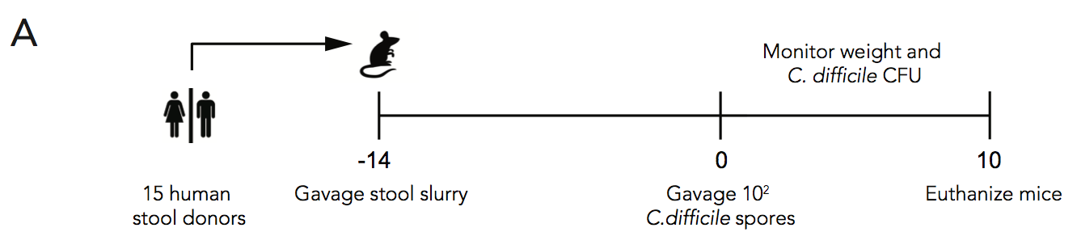 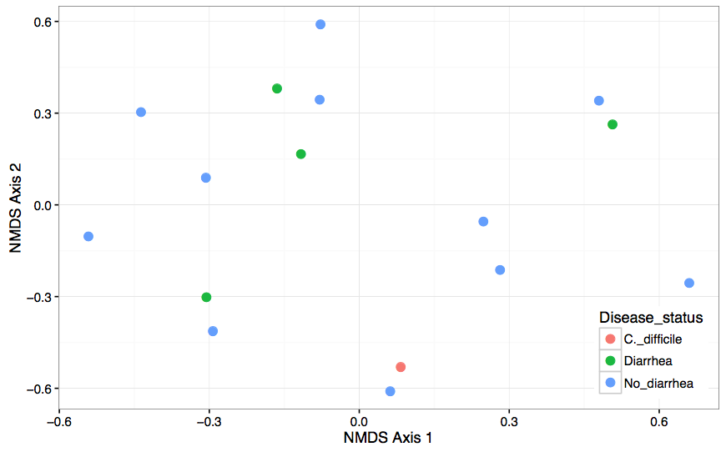

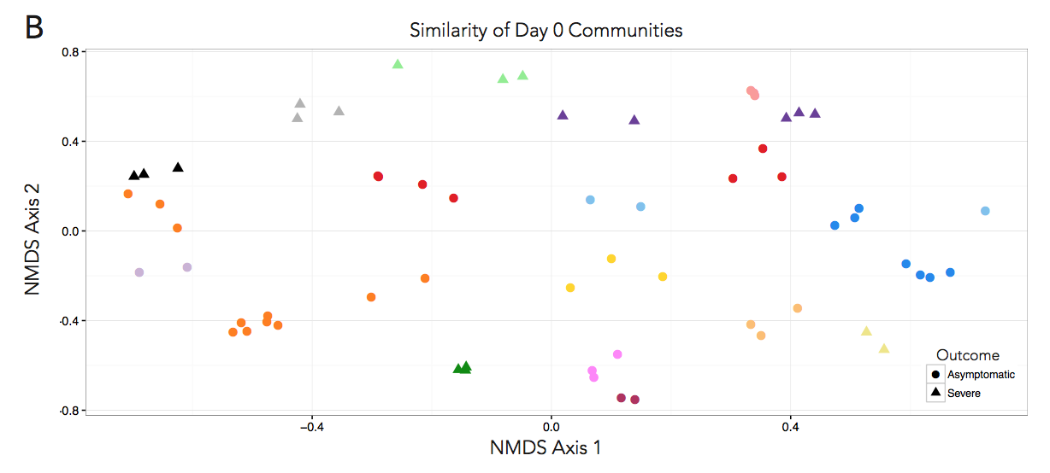

Figure 1. Germ-free mice inoculated with human feces as a model for *C. difficile* infection. A) Stool was collected from 16 healthy, diarrheal and CDI patients and inoculated into 3-4 germ-free mice per donor by oral gavage. After allowing the community to stabilize for 14 days, mice were orally gavaged with 100 spores of *C. difficile* strain 431. Weight and stool CFU was monitored for up to 10 days post infection. B) NMDS ordination of donor stool communities prior to inoculating mice. Each point represents one donor and donors are colored by clinical diagnosis. C) NDMS ordination of the stool communities on day 0. Each symbol represents one mouse and is colored by donor. Circles represent mice that survived the 10 days of infection and triangles represent those who suffered severe disease.

Figure to dos:  
A) Consider making this timeline a bit more streamlined/using R like Jenior’s timelines look

B) Do ADONIS to show no differences or mantel test, report value on figure or in text?

C) Do mantel test for correlation of distances between severe/mild. Change legend to be mild/severe. Decide if colors are distinguishable enough (I think they are)

**Figure 2. *C. difficile* infection dynamics**

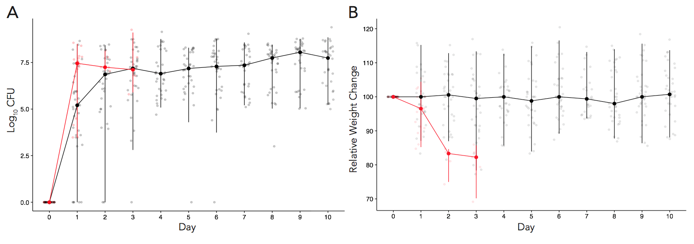

Figure 2. *C. difficile* infection dynamics. A) *C. difficile* CFU was enumerated by plating of mouse stool pellets daily. Each point represents a mouse and the lines represent the mean of mice in each cage and error bars are interquartile ranges. Red lines and points correspond to mice that succumbed to severe disease, black lines and points correspond to mice that had mild or no disease. B) Mouse weights were recorded daily percent weight loss calculated for each mouse. Data presented as the mean of mice in each cage. Mice that succumbed to severe infection typically lost a significant amount of weight by day 1 or 2 post infection. Red lines correspond to severely ill mice, black to mice with mild disease.

Figure to dos:

A + B) Decide if these are the final values/error we want to represent, add back mild/severe legend

**Figure 3. Microbial community on day 0 predicts future *C. difficile* CFU**

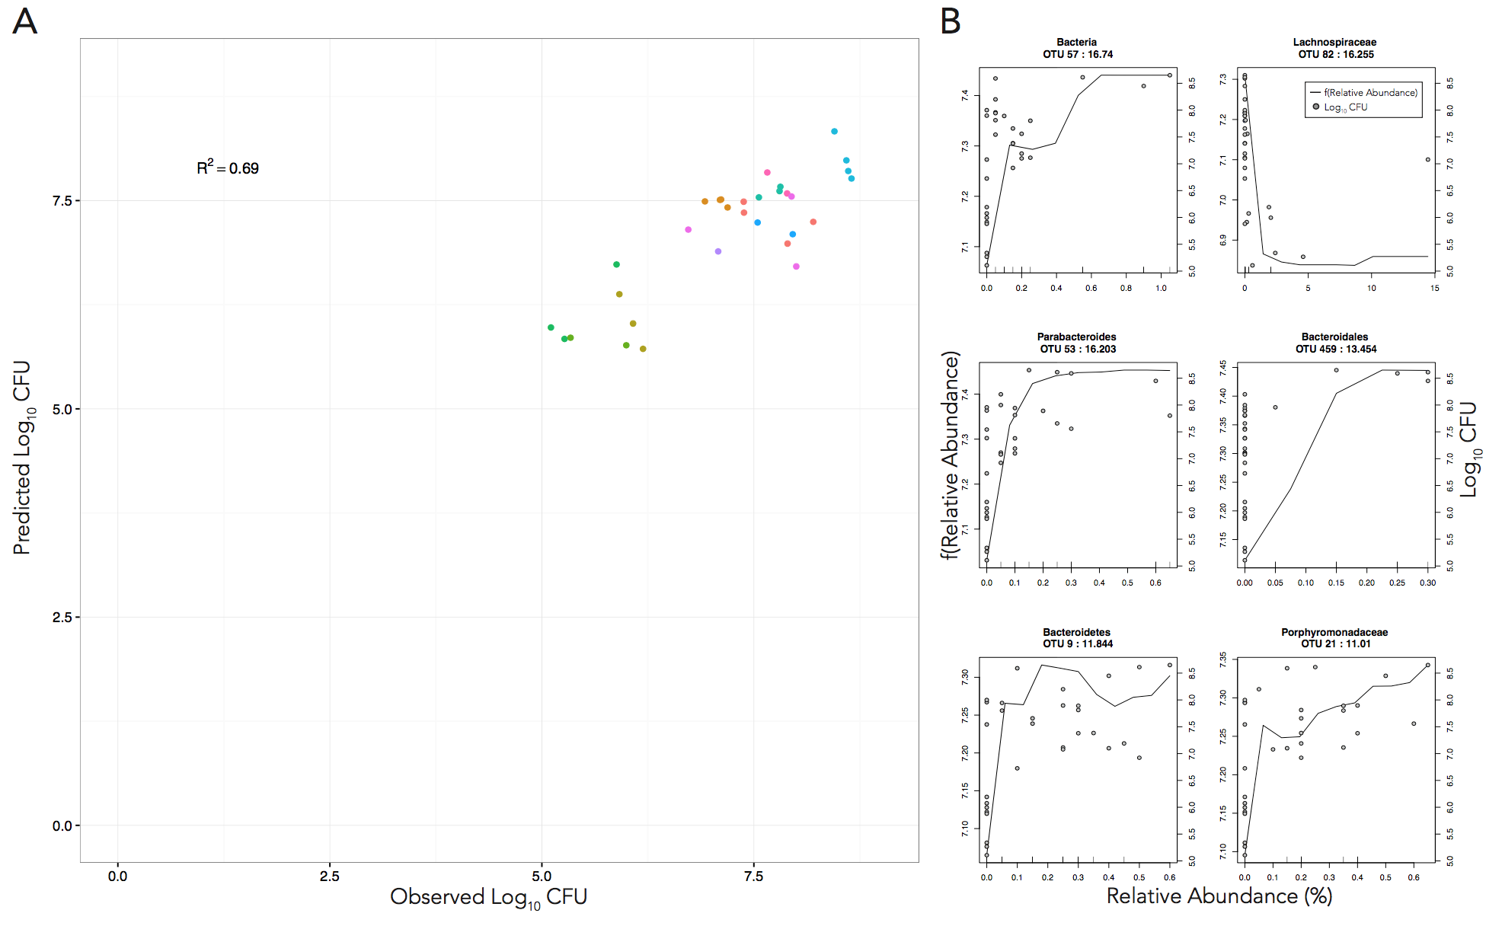

Figure 3. Random Forest prediction of *C. difficile* colonization level. A) Day 0 microbial community members above 1% relative abundance were used to predict median log10 CFU of *C. difficile* after colonization. OTUs were chosen such that they were not predictive of cage or donor. Each point is a mouse colored by cage. B) Partial dependency plots of the top six predictive OTUs. Line displats the partial dependence of log10 CFU on the relative abundance of each predictive OUT. Each median log10 CFU is plotted against its relative abundance for each predictive OTU.

Figure to-dos

A) make points bigger, probably entire plot can be smaller

B)New partial dependency representation/graph style? Nick

**Figure 4. Random forest predicts CDI severity from day 0 microbiome.**

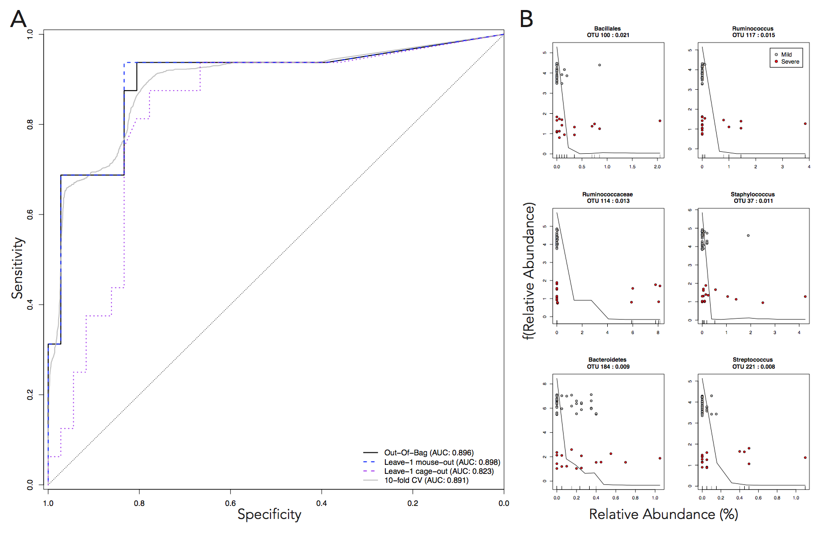

Figure 4. Random Forest prediction of CDI severity. Day 0 microbial community members above 1% relative abundance were used to predict disease severity. OTUs were chosen such that they were not predictive of cage or donor. Predictive classification tested via 10-fold (gray), leave-one-cage-out (purple dashed) or leave-one-mouse-out (blue dashed) models are displayed in A). B) Partial dependency plots of most predictive OTUs. Line displays the partial dependence of log10 CFU on OTU relative abundance. Points are the OTU relative abundance of each mouse colored by outcome (red, severe, black, mild).

Figure to –dos

A) decide on final models to present

B) new partial dependency plots/format, Nick?

**Figure 5. Propensity for severe CDI is community-dependent**

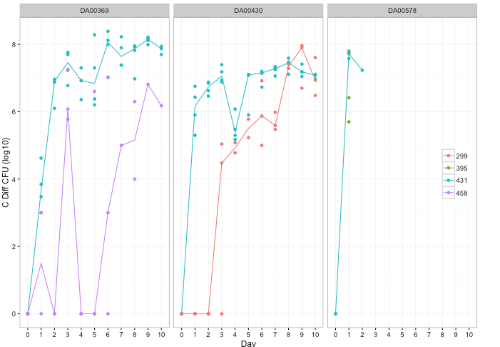

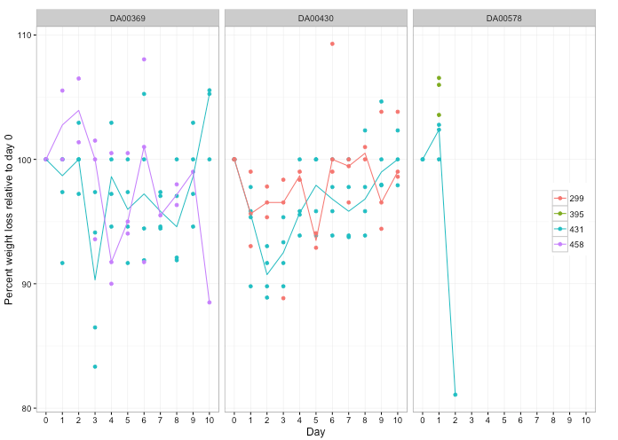

Figure 5. Infection of mice with different *C. difficile* strains. 3 strains of *C. difficile* were used to infect mice colonized with susceptible (DA00578) or resistant (DA00369, DA00430) human donor stool. A) *C. difficile* stool CFU was enumerated over 10 days. B) Percent weight loss was calculated each day for each mouse. In both plots, each mouse is a point and lines represent the mean of each cage.

Figure to-dos:

* + 1. decide how we want to label donors (numbers aren’t really used elsewhere)
    2. Need to add lines for green points in DA00578 plots

**Supplement**

**Table S1: Mouse day 0 communities by donor genera (avg + stdev of cage)**

**Citations**

1. Britton RA, Young VB. Interaction between the intestinal microbiota and host in Clostridium difficile colonization resistance. Trends in microbiology. 2012;20(7):313-9. doi: 10.1016/j.tim.2012.04.001. PubMed PMID: 22595318; PubMed Central PMCID: PMC3408078.

2. Lessa FC, Winston LG, McDonald LC, Emerging Infections Program CdST. Burden of Clostridium difficile infection in the United States. N Engl J Med. 2015;372(24):2369-70. doi: 10.1056/NEJMc1505190. PubMed PMID: 26061850.

3. Buffie CG, Jarchum I, Equinda M, Lipuma L, Gobourne A, Viale A, et al. Profound alterations of intestinal microbiota following a single dose of clindamycin results in sustained susceptibility to Clostridium difficile-induced colitis. Infection and immunity. 2012;80(1):62-73. doi: 10.1128/IAI.05496-11. PubMed PMID: 22006564; PubMed Central PMCID: PMC3255689.

4. Theriot CM, Koumpouras CC, Carlson PE, Bergin, II, Aronoff DM, Young VB. Cefoperazone-treated mice as an experimental platform to assess differential virulence of Clostridium difficile strains. Gut microbes. 2011;2(6):326-34. doi: 10.4161/gmic.19142. PubMed PMID: 22198617; PubMed Central PMCID: PMC3337121.

5. Schubert AM, Sinani H, Schloss PD. Antibiotic-Induced Alterations of the Murine Gut Microbiota and Subsequent Effects on Colonization Resistance against Clostridium difficile. mBio. 2015;6(4):e00974. doi: 10.1128/mBio.00974-15. PubMed PMID: 26173701; PubMed Central PMCID: PMC4502226.

6. Reeves AE, Theriot CM, Bergin IL, Huffnagle GB, Schloss PD, Young VB. The interplay between microbiome dynamics and pathogen dynamics in a murine model of Clostridium difficile Infection. Gut microbes. 2011;2(3):145-58. PubMed PMID: 21804357; PubMed Central PMCID: PMC3225775.

7. Theriot CM, Young VB. Microbial and metabolic interactions between the gastrointestinal tract and Clostridium difficile infection. Gut microbes. 2014;5(1):86-95. doi: 10.4161/gmic.27131. PubMed PMID: 24335555; PubMed Central PMCID: PMC4049944.

8. Reeves AE, Koenigsknecht MJ, Bergin IL, Young VB. Suppression of Clostridium difficile in the gastrointestinal tracts of germfree mice inoculated with a murine isolate from the family Lachnospiraceae. Infection and immunity. 2012;80(11):3786-94. doi: 10.1128/IAI.00647-12. PubMed PMID: 22890996; PubMed Central PMCID: PMC3486043.

9. Ng KM, Ferreyra JA, Higginbottom SK, Lynch JB, Kashyap PC, Gopinath S, et al. Microbiota-liberated host sugars facilitate post-antibiotic expansion of enteric pathogens. Nature. 2013;502(7469):96-9. doi: 10.1038/nature12503. PubMed PMID: 23995682; PubMed Central PMCID: PMC3825626.

10. Pawlowski SW, Calabrese G, Kolling GL, Platts-Mills J, Freire R, AlcantaraWarren C, et al. Murine model of Clostridium difficile infection with aged gnotobiotic C57BL/6 mice and a BI/NAP1 strain. The Journal of infectious diseases. 2010;202(11):1708-12. doi: 10.1086/657086. PubMed PMID: 20977342; PubMed Central PMCID: PMC3057484.

11. Kim HB, Zhang Q, Sun X, Beamer G, Wang Y, Tzipori S. Beneficial effect of oral tigecycline treatment on Clostridium difficile infection in gnotobiotic piglets. Antimicrobial agents and chemotherapy. 2014;58(12):7560-4. doi: 10.1128/AAC.03447-14. PubMed PMID: 25267665; PubMed Central PMCID: PMC4249528.

12. Diao H, Yan HL, Xiao Y, Yu B, Yu J, He J, et al. Intestinal microbiota could transfer host Gut characteristics from pigs to mice. BMC microbiology. 2016;16(1):238. doi: 10.1186/s12866-016-0851-z. PubMed PMID: 27729007.

13. Steele J, Feng H, Parry N, Tzipori S. Piglet models of acute or chronic Clostridium difficile illness. The Journal of infectious diseases. 2010;201(3):428-34. doi: 10.1086/649799. PubMed PMID: 20039803; PubMed Central PMCID: PMC2804769.

14. Collins J, Auchtung JM, Schaefer L, Eaton KA, Britton RA. Humanized microbiota mice as a model of recurrent Clostridium difficile disease. Microbiome. 2015;3:35. doi: 10.1186/s40168-015-0097-2. PubMed PMID: 26289776; PubMed Central PMCID: PMC4546040.