# The gut microbiota potentiates *Clostridiodes difficile* infection severity.

**Running title:** Microbiota potentiates *Clostridioides difficile* infection severity

Nicholas A. Lesniak, Alyxandria M. Schubert, Kaitlyn Flynn, Hamide Sinani, Kathyrn A. Eaton, Ingrid L. Bergin, Patrick D. Schloss

To whom correspondence should be addressed: [pschloss@umich.edu](mailto:pschloss@umich.edu)  
1. Department of Microbiology and Immunology, University of Michigan, Ann Arbor, MI  
2. Unit for Laboratory Animal Medicine, University of Michigan, Ann Arbor, MI

## Abstract

*Clostridioides difficile* infection (CDI) has become more common and severe in the last few decades. Patient age, white blood cell count, creatinine levels as well as *C. difficile* ribotype and the presence of toxin genes have been associated with disease severity. However, current models of CDI disease severity that incorporate these factors are not robust enough to be broadly applied. Interactions between *C. difficile* and the gut environment, including the resident microbiota, are thought to be determinants of CDI incidence and severity. Indeed, antibiotic perturbation of the gut microbiota is a risk factor for CDI. Bacteria in the gut can impair *C. difficile* colonization through bile acid metabolism, nutrient consumption and bacteriocin production. However, it is unclear if the gut bacteria affect CDI disease severity. Here we demonstrate that gut bacterial communities contribute to disease severity variation. We derived diverse gut communities by colonizing germ-free mice with human fecal communities. Each community was infected with *C. difficile* which resulted in range of disease severities. The severity grouped by the human fecal community they received. Generally, facultative anaerobes with pathogenic potential, such as Escherichia, Helicobacter and Klebsiella, were associated with more severe disease. Bacterial groups associated with dietary fiber degradation, such as Coprobacillus, were associated with reduced disease severity. Lastly, we showed communities that resulted in either low or high histopathologic scores or severe disease had the same outcome when infected with a different *C. difficile* isolate.

## Importance

Clostridioides difficile infection (CDI) can be asymptomatic, or range in severity from mild diarrhea to severe outcomes of recurrent infections and even death. Models that predict severity and guide treatment decisions are based on clinical factors and *C. difficile* capabilities. The gut microbiome plays a role in protecting against CDI, though has not been investigated for its effect on CDI disease severity. We demonstrate that variation in the microbiome of mice colonized with human feces was sufficient to result in a range of disease severities. The results reveal groups of bacteria associated with both severe and more mild *C. difficile* infections. Gut bacterial community data from patients with CDI could improve our ability to identify patients more at risk for severe disease and improve interventions which treat the gut bacteria to reduce host damage.

## Introduction

*C. difficile* was first identified in 1931 in a healthy fecal community [CITATION]. Following the introduction of broad-spectrum antibiotics in the late 1970s, *C. difficile* was identified as the cause of antibiotic-associated psuedomembranous colitis [CITATION]. By the early 2000s, it was apparent that *C. difficile* infections (*CDI)* were increasing in incidence and severity [CITATION]. Disease severity can range from asymptomatic to mild diarrhea to toxic megacolon and death. Severity has been associated with characteristics of *C. difficile* ribotypes. Over time more pathogenic ribotypes have emerged, such as ribotype 027 in the early 2000s. The presence of the genes for Toxin A/B or fluoroquinolon resistence has been associated with more severe disease [CITATION]. Binary toxin, while alone insufficient to cause damage on it own, when in the presence of Toxin A/B has been associated with increased virulence [CITATION]. Mutations in tcd C, the negative regulator of of toxin transcription, also increased the virulence of *C. difficile* [CITATION]. In addition to the pathogenic potential of the infecting strain, the response by the host also affects the disease severity. Delayed or reduced production of antibodies IgG and IgA can result in more severe disease [CITATION]. Increased neutrophil inflitration can lead to worse outcomes [CITATION]. In addition to the immune response, increased density of the toxin receptor on the host cells can increase the severity of the infection [CITATION]. While there is a thorough understanding of some of the mechanisms that contribute to CDI incidence and disease severity, our understanding is far from complete, and there still lacks effective tools to predict and treat severe disease.

Models have been developed to identify patients at risk for severe CDI (1). These models use clinical data, such as patient age, white blood cell count, serum albumin levels, and creatinine levels, to predict disease severity[citations for models]. A recent multi-center external validation of several of these models demonstrated a decline in performance and high false positivity rate (3). Thus, there seems to be a missing factor contributing to disease severity.

Missing from these models are the roles of gut bacteria which also interact with *C. difficile* during infection. The indigenous bacteria of a healthy intestinal community provide a protective barrier preventing *C. difficile* from infecting the gut. A range of mechanisms can disrupt this barrier, incuding antibiotic use, medications, or dietary changes, and lead to increased susceptibility for CDI. Once established, the gut bacteria can either promote or inhibit *C. difficile* through producing molecules or modifying the environment [Abbas2020]. Bile acids metabolized by the gut bacteria can inhibit *C. difficile* growth and affect toxin production (5). Bacteria in the gut also can compete more directly with *C. difficile* through antibiotic production or nutrient consumption (7). The primary treatment for CDI is a course of antibiotics. For patients who become reinfected and demonstrate recalitrance to antibiotics, a fecal microbiota transplantion often is sufficient to restore the gut community and eliminate *C. difficile*. While there have been many studies to investigate the interaction between the gut bacteria and *C. difficile* during the infection, it has not been demostrated the bacterial community can modulate the disease severity of CDI. Recently, Tomkovich et al. showed the variation in the bacterial communities between mice from different colonies and vendors was sufficient to cause differences in the temporal dynamics of the *C. difficile* infection (9). Since the gut bacteria interact with *C. difficile* throughout the infection and community difference resulted in different colonization dynamics, we hypothesized that the gut bacteria contribute to the variation in CDI disease severity. Here, we colonized germ-free C57BL/6 mice with human fecal communities to test if the variablity in the gut bacteria can produce and explain variation in the disease severity caused by a single *C. difficile* isolate.

## Results

**Germ-free mice colonized with human fecal commmunities have diverse and unique community structures.** Based on our previous observation that mice with variation in their microbiota showed differences in colonization of *C. difficile* (9), we sought to explore the effect communties with greater variation had on *C. difficile* challenge. To produce communities with greater variation than mouse colonies with their indigenous communties, we used human fecal communities to establish a microbial community in the intestine of germ-free mice. We inoculated a cage of germ-free C57BL/6 mice (2-4 mice per cage) with homogenized feces from one of 15 different human donors via oral gavage. The fecal community was allowed to colonize and stabilize for two weeks post inoculation [CITATION?]. We then surveyed the bacterial members of the gut communities by sequencing the V4 region of the 16S rRNA gene extracted from fecal pellets (Figure 1A). The bacterial communities from each mouse grouped more closely to those communities from mice that received the same human fecal donor community than to either their respective donor community or any mice who received stool from a different donor (Figure 1B). Most of the communities were primairily composed of populations of *Clostridia*, *Bacteroidia*, *Erysipelotrichia*, *Bacilli*, and *Gammaproteobacteria*. However, each group of mice harbored unique combination of class abunadances in their gut bacterial communities. *Any alpha? compare to murine variation? Number of unique otus?*

***C. difficile* is able to colonize mice without perturbation.** Our goal was to test the effect of the variation in the microbiota on *C. difficile* infection. A typical mouse model of CDI requires pretreatment with antibiotics such as clindamycin to become susceptible to *C. difficile* colonization [CITATION]. However, we wanted to avoid modifying the communties with an antibiotic to maintain their community structures and differences. Since these communties came from human donors which may have become susceptible through their own exposures, we decided to test if *C. difficile* was able to colonize these communities without any perturbation. After two weeks post incoluation with human fecal communities, the mice were then challenged with 10^**4?** *C. difficile* ribotype 027 isolate 431 spores (**Add schematic?**) (10). The mice were followed for 10 days post challenge and their stool was collected and plated for *C. difficile* CFU to detect colonization level. We hypothesized that *C. difficile* would most likely be able to colonize the mice with communities that came from donors which had a history of antibiotic use, one of the primary risk factors for developing CDI (TABLE, CITATION). Suprisingly, communities from all donors were colonized (Figure 2). Only two mice were able to resist *C. difficile* colonization and both recieved their community from the same donor. The remaining mice demonstrated susceptibility to *C. difficile* colonization without the need for any perturbation.

**Infection severity varies by initial community structure.** After challenging the mice with *C. difficile*, we looked at the effect of the community variation on the outcome from the *C. difficile* infection. We followed the mice for signs of disease as well as *C. difficile* colonization and toxin production for 10 days post challenge. Some mice were not initally colonized on the day after *C. difficile* challenge but became colonized with a few days post challenge (**SUPP FIG?**). A subset of mice, all that received their community from one of 6 donors, suffered from severe disease, which became highly colonized one day post challenge and moribund within 3 days post challenge. The remaining mice, except for one cage, maintained *C. difficile* colonization through the end of the experiment (Figure 2). At day 10, or an earlier humane endpoint, mice were euthanized and cecal tissue was collected and scored for histological signs of disease and fecal pellets were assayed for C. difficile toxin activity. (Figure 3). Overall, there was greater toxin activity detected in the stool of the moribund mice (*P* = 0.003). However, when looking at each group of mice, we saw there was a range in toxin activity for both the mice with non-severe disease and severe disease (Figure 3A). Some donor groups that maintained colonization without severe disease had comparably high toxin acitivity to those mice with severe disease. Paradoxically, some mice with severe disease did not have toxin activity detected in their stool. This discordance between toxin activity and disease severity has been previously described (11). Next we examined the cecal tissue for histopathological damage. For mice with severe disease, we observed high levels of epithelial damage, tissue edema and inflammation (Figure SXXXX), similar to previously reported histopathologic findings for *C. difficile* ribotype 027 (13). As observed with toxin activity, the mice with severe disease had higher histopathologic scores than the mice with non-severe disease (*P* = 3.0e-9). However, unlike the toxin activity, all moribund mice had consistently high histopathologic scores. The mice which maintained persistent population size, we saw a range in tissue damage from no signs of disease to nearly the same level as the mice with severe disease, which grouped by community donor. Together, the toxin activity, histopathologic score, and moribundity showed variation across the donors but were largely consistent within each group of mice recieving the same human donor fecal community.

**Populations of the microbial communities explain variation in CDI disease severity.** Since the disease charateristics grouped by human donor fecal community, we next investigated specific bacterial taxa could explain the variation in disease severity. To this end, fecal pellets were collected prior to *C. difficile* challenge (I’m guessing…), and bacterial community members were surveyed using 16S rRNA gene sequencing. Linear discriminant analysis (LDA) effect size (LEfSe) was used to determine bacterial genera that are most likely to explain the differences observed in our measurements of CDI severity. We split the mice into groups by severity level based on their if they became moribund (severe), or if their clinical score was above 5 (moderate) or below 5 (mild). This analysis revealed 20 genera that were significantly different by the disease severity (Figure 4A). Bacterial genera *Turicibacter*, *Streptococcus*, *Staphylococcus*, *Pseudomonas*, *Phocaeicola*, *Parabacteroides*, *Bacteroides*, and *Escherichia/Shigella* were detected at higher levels in the mice that developed severe disease. Populations of *Anaerotignum*, *Coprobacillus*, *Enterocloster*, and *Murimonas* were increased in the mice that would experience mild disease. There were many genera that did not have a correlation of relative abundance and disease severity, such as *Monoglobus* and *Hungatella*, but were decreased or increased, respectively in the group of mice that would develop moderate disease (compared to…?). To understand these cases better we used LEfSe to identify the genera most likely to explain the observed differences in toxin activity (Figure 4B). Many genera were associated with toxin production as we would expect from their association with severe disease, such as populations of *Escherichia/Shigella* and *Bacteroides*. Likewise, there were genera such as *Anaerotignum*, *Enterocloster*, and *Murimonas* that exhibited greater relative abundance in communities from mice that had mild disease and no toxin activity. Overall, communities without genera that demonstrate a linear trend between relative abundance and disease severity can be better understood by their association with toxin production. Populations of *Hungatella* were increased in the group with moderate disease but not with the production of toxin. Lastly, we used LEfSe to identify genera in the endpoint bacterial communities and histopathologic score (Figure 4C). Bacteroides relative abundance in both the initial and endpoint communities correlated positively with histopathologic score. *Klebsiella* and *Prevotellaceae* were positively correlated with clinical score and were increased in the group that produced toxin. Our analyses have revealed bacterial taxa that are associated with three different measures of CDI severity in our model: clinical score, toxin production (activity?), and histopathological score.

We next wanted to understand how the populations in the context of each other lead to the different disease severities. We trained random forest models with the intital bacterial community relative abundance data at each taxonomic rank to predict toxin production, severe disease or final histopathologic score. Overall for predicting toxin production, microbial populations aggregated by their phylum level classificiation performed as well as models using lower taxonomic ranks (AUROC = 0.83, Figure S2). ~~In the initial community,~~ Collectively, members of *Verrucomicrobia*, *Campilobacterota* and *Proteobacteria* contributed the most to the correct prediction of toxin production (Figure 5A). *C. difficile* was more likely to produce toxin when the initial community had smaller populations of *Verrucomicrobia* and *Campilobacterota* and had larger popluations of *Proteobacteria*. Next, we assessed the ability of the community to predict severe disease. Class rank classification was sufficient to predict if the mouse would succumb to the infection before the end of the experiment (AUROC = 0.91, Figure S2). Bacterial taxa belonging to *Bacilli*, *Firmicutes*, and *Erysipelotrichia* contributed the most to the correct prediction. Larger populations of *Bacilli* and *Firmicutes* and reduced populations of *Erysipelotrichia* were more likely to result in moribundity (Figure 5B). The only other class that was decreased in moribund mice was *Clostridia.* Lastly, the relative abundances of genera were able to predict if the mice would have a histopathologic score above or below the median score (median histopathologic score = 5, AUROC = 0.99, Figure S2). There were no genera with a significantly greater effect on the model performance than any others, indicating the model is reliant on many genera for the correct prediction. The model used some of the genera identified in the LEfSe analysis, such as *Coprobacillus*, *Anaerostipes*, and *Hungatella*. Communities with greater abundances of *Hungatella*, *Eggerthella*, *Bifidobacterium*, *Duncaniella* and *Neisseria* were more likely to have high histopathologic scores.

**Disease severity consistent by donor community across strains/isolates.** We used a single *C. difficile* isolate, ribotype 027 isolate 431 to characterize the range of disease severity and the features of the bacterial community associated with severity (10). We next wanted to test if the effect of the community on CDI severity would apply to other *C. difficile* isolates. To facilitate this analysis, we selected a subset of the donor fecal samples based on their associated mouse transplant communities that fit the following criteria: one community we would expect to result in a low clinical score (< 5), a high clinical score (> 5), and one with a high clinical score which becomes moribund. Additionally, we selected the subset of donors based on the relative abundance patterns of *Sellimonas* and *Anaerotignum* (higher abundance in mice with a low clinical score), *Lachnospiracea* (lower abundance in moribund mice), *Hungatella* and *Eisenbergiella* (higher abundance in moderate mice and lower in moribund mice), Clostridium sensu stricto (higher in moribund mice by both LEfSe analysis and RF model) and *Enterocloster* (lower in moribund mice and a negative linear trend with disease severity by LEfSe analysis) (Figure S3). With this set of human fecal communities selected, we inoculated mice via oral gavage of the human fecal slurry and allowed two weeks for the a community to establish. We then challenged the mice with a different *C. difficile* (10). The disease severity for this set of experiments closely matched that in our first set of experiments with *C. difficile* isolate 431 (Figure 6).

## Discussion

This is essentially just me thinking out loud, feel free to delete…I was getting carried away.

Paragraph 1

Historically, predictive models of CDI severity have been limited to the use of clinical metrics, C. difficile genetic backgrounds, enzymatic activity and toxin production. Given the importance of the resident gut microbiota in mediating colonization resistance to CDI, we designed an experiment that enabled us to test human-relevant microbiota mediation of CDI severity. Importantly, our design excluded the use of antibiotics that are typical of murine models to facilitate the establishment of CDI (why is this important? Maintain relevance to those gut microbes found in humans?). In doing so, we demonstrate that human fecal material transplanted into germ-free mice can establish microbial communities that, following challenge with C. difficile, result in divergent outcomes with respect to infection severity. Our results allowed us to develop a predictive model of CDI severity that leverages information about bacterial microbiota membership ……Significance of using a model like this? Advantages in a clinical setting? Who do the current models miss?

Then…work backwards, providing analysis about what it all means.

Paragraph 2: What did the models tell us about CDI severity, and did they do a good job? Better than existing? Worse than existing?

Paragraph 3: How did the models agree/disagree with the single organism experiments, Do these match up with other pubished results in the literature? Did they make sense, or were there some new associations that hadn’t been made before.

Paragraph 4: Are the results robust to any old C. diff? Strain level similarities and differences (leaving C.diff strain to the last is good, because it gives a segue into suggesting that, for example, microbiota can be combined with current predictive information such as C. diff strain to improve current models)…..and carry that on to concluding sentences: (1) Drawbacks of the work. (2) successes of the work. (3) Potential for the future use of microbiota in CDI severity models.

Challenging mice colonized with different human fecal communities with a single *C. difficile* isolate allowed us to identify the effect of microbiome variation on *C. difficile* infection disease severity. Our LEfSe analyses and random forest models revealed the relationships between the bacterial community members and the degree of disease severity. We used the relative abundance patterns of community members with strong associations with disease severity to select communities to test if the observed disease severity is conserved when other *C. difficile* isolates are used. The disease outcome from the *C. difficile* challenge with the new isolate matched the expected disease severities. Overall, these results have demonstrated that the bacterial community is capable of modulating the disease severity of *C. difficile* infection.

CDI severity can range from no symptoms, mild symptoms such as diarrhea, or severe symptoms such as toxic megacolon or death. Physicians use prediction tools to identify patients most at risk of developing a severe infection using white blood cell counts, serum albumin level, or serum creatine level (14). Those levels are being driven by the activities in the intestine (17). Research into the drivers of this variation have revealed factors that make *C. difficile* more virulent. Strains are categorized for their virulence by the presence and production toxin A and toxin B and the prevelance in outbreaks, such as ribotype 027 and 078 (18). However, other studies have shown that virulence is not necessarily linked with toxin production **???** or the strain **???**. Furthermore, there is variation in the genome, growth rate, sporulation, germination, and toxin production in different isolates of a strain (10). This variation may help explain why severe CDI prediction tools often miss identifying many patients with CDI that will develop severe disease (1). Therefore, it is necessary to gain a full understanding of all factors contributing to disease variation to improve our ability to predict severity.

The state of the intestinal bacterial community determines the ability of *C. difficile* to colonize, persist and even cause recurrent infections [citations]. *C. difficile* is unable to colonize an unperturbed healthy gut community and is only able to entry after a perturbation (24). Once colonized, the different communities lead to different metabolic responses and dynamics of the *C. difficile* population (25). The gut bacteria metabolize primary bile acids into secondary bile acids (27). The concentration of these bile acids affect the germination, growth, toxin production and biofilm formation (5). Members of the bacterial community also affect other metabolites *C. difficile* utilizes. *Bacteroides thetaiotaomicron* produce sialidases which release sialic acid from the mucosa for *C. difficile* to utilize (31). The nutrient environemt affects toxin production (33). Thus, many of the actions of the gut bacteria modulate *C. difficile* in ways that would affect the disease severity driven by CDI.

The gut community has not been demostrated to modulate CDI disease severity. Myriad studies have explored the relationship between the microbiome and CDI but none have ventured into the variation of disease severity due to the microbiome. Most CDI studies employ either an *in vitro* or *in vivo* model using a homogenous bacterial community. Collins et al used multiple human communities to colonize mice, however the communities were pooled prior to gavaging into germ-free mice (34), resulting in a single community. Studies examining difference in disease often use different *C. difficile* strains or ribotypes in mice with similar microbiota as a proxy for variation in disease, such as strain 630 for non-severe and ribotype 027 for severe (18). There has been studies demonstrating variation in severity, but through tapering antibiotic dosage (26) or by reducing the amount of cells or spores used for the challenge (22). Our group has recently been uncovering how variation in the microbiome affects CDI but have been limited to *C. difficile* colonization (26).

With our recent observations that the initial community affects the ability of *C. difficile* to persist in an environment and the existing research describing the myriad ways the microbiome interacts with *C. difficile*, we hypothesized that the microbiome directly and indirectly modulates CDI disease severity. Our data demostrate gut bacterial relative abundances associate with variation in toxin production, histopathologic scoring of the cecum and severe disease. This anaylsis has revealed populations of *Akkermansia*, *Anaerostipes*, *Coprobacillus*, *Enterocloster*, *Lactonifactor*, and *Monoglobus* were more abundant in the microbiome of mice which little to no disease was detected. These genera providing a protective role are supported by previous studies. *Coprobacillus*, *Lactonifactor*, and *Monoglobus* have been shown to be involved in dietary fiber fermentation and associated with healthy communities (37). *Anaerostipes* and *Coprobacillus* produce short chain fatty acids which also have been associated with healthy communities (41). Furthermore, *Coprobacillus*, which is abundant in mice with low histopathologic scores but rare in all other mice, has been shwon to contain putative type I lantibiotic gene cluster and inhibit *C. difficile* colonization (44). *Akkermansia* and *Enterocloster* were also idenitified as more abundant in mice which had a low clinical disease but have contridictory supporting evidence in the current literature. In our data, *Akkermansia* is most abundant in the mice with least disease but there were some mice with severe disease which had increased populations of *Akkermansia*. This could be attributed to either a more protective mucus layer had developed in the mice with little disease and *Akkermansia* is inhibiting colonization (46) or *Akkermansia* could be crossfeeding *C. difficile* or exposing a niche via its mucus consumption (48). Similarly with *Enterocloster*, in our data this genus was more abundant and associated with low histopathologic scores. It has been associated with healthy populations and has been used to mono-colonize germ-free mice to reduce the ability of *C. difficile* to colonize (51). However, *Enterocloster* has mostly been indentified in infections that result in disease (53). These data demostrate a population of bacteria has the potential to be either protective or harmful. The disease outcome is not likely based on the abundance of a single population of bacteria rather the result of the interactions of many populations.

The groups of bacteria that were associated with either a higher histopathologic score or severe disease are members of the indigenous gut community that also have been associated with disease. These are often referred to as opportunitic pathogens, however based on the the results reported in this study it is more appropriate to apply the damage-response framework for microbial pathogenesis (55). The disease is not driven by a single entity, rather it is an emergent property of the responses of the host immune system, infecting microbe, and the microbes of the indigenous community. Many of the populations with pathgenic potential that associated with worse outcomes are also facultative anaerobes. *Enterococcus*, *Klebsiella*, *Shigella/Escherichia*, *Staphylococcus*, and *Streptococcus* have been shown to expand their population with antibiotic use (57) and are commonly detected in CDI cases (60). In addition to these populations, another set of bacteria, populations of *Eggerthella*, *Prevotellaceae* and *Helicobacter*, associated with worse outcomes have also been associated with intestinal inflammation (64). Recently, *Helicobacter hepaticus* has been demostrated to be sufficient to cause susceptibility to CDI in IL-10^(-/-) B57BL/6 mice (67). In our experiments, when *Helicobacter* was present, the mouse resulted in either severe disease or a high histopathologic score. While we did not use IL-10^(-/-) mice, it is possible the bacterial communtity or host response are similarly modified by *Helicobacter* allowing *C. difficile* infection and resulting in host damage. However, the populations identified other than *Helicobacter* are not as clear with their relationship between their relative abundance and the resulting disease severity.

The damage-response framework for pathogenesis helps to understand how bacterial populations identified in this study potentiate CDI disease severity through the varied interactions with the host and *C. difficile*. In this set of experiments, we use the same host, C57BL/6 mice, the same infecting microbe, *C. difficile* ribotype 027 isolate 431, with different gut bacterial communities. The members of those communities were often present in multiple levels of disease severity. Thus, it is not merely, the presence of the bacteria but their activity in response to the other microbes and host which determine their effect on host damage. Additionally, while we are using the same host and infecting microbe, they too are reacting to the specific members of the bacterial community. Disease severity is driven by the cummulative effect of the host immune response and the activity of the gut bacteria and *C. difficile*. *C. difficile* can be driving host damage through the production of toxin. The gut microbiota could be contributing to the host damage through the balance of metabolic and competitive activities, such as bacteriocin production or mucin degradation. Low levels of mucin degradation can provide nutrients to other community members producing a diverse non-damaging community []. However, if mucin degradation becomes too great it reduces the protective function of the mucin layer and exposes the epithelial cells []. This over-harvesting contributes to the host damage due to other members producing toxin. Thus disease is a balance of many activities of the community. Host damage is the emergent property of numerous damage-response curves, one for host immune response, one for *C. difficile* activity and another for microbiome community activity, each of which are a composite curve of the individual activities from each group, such as antibody production, neutrophil infiltration, toxin production, sporulation, fiber and mucin degradation. Therefore, while we have identified populations of interest, it is likely targeting one specifically will reduce disease severity.

Many studies have investigated individual activities contributing to CDI. Here we have shown myraid bacterial groups and their relative abundances associate with variation in CDI disease severity. We must continue to explore how the host, microbiota, and *C. difficile* interactions result in severe disease. We can reduce the risk of severity with a better understanding of which interactions, whether be driven by specific community functions or groups of bacteria, reduce the host damage. Approaching this problem from a damage-response framework allows us to experiment with modifying subsets of activities to reduce overall host damage. Our current clinical treatment targets an individual group in this tripartite system. Most commonly, CDI is treated with an antibiotic to eliminate *C. difficile*. Alternatively, another treatment uses antibodies to neutralize *C. difficile* toxins. These treatments are only addressing a single entity of the system, leaving the potential for the others to maintain responses that maintain host damage. However, we can continue this research to elucidate treatments that drive all three entities towards reduced host damage. When a patient is diagnosed with CDI, the gut community composition, in addition to the traditionally obtained information, may improve our severity prediction and appropriate treatment. Treating the microbiome may contribute to reduced severity. From our results, promoting fiber metabolizing bacteria and reducing facultative anerobes could bolster the efficacy of current CDI treatments, reducing disease severities.

## Materials and Methods

**Animal care.** 5. 64 mice, 33F and 31M, ages 6-13 weeks old, 3-4 mice/group (except 2 for C/DA00581 and MOUT/DA10093) each run once except for DA00581 which was run 4 times because we observed colonization resistance in one of the experiments 15 human fecal samples, selected to create a subset list with diverse responses to health questionaire

***C. difficile* challenge.** M.

**Sample collection.** F.

**DNA sequencing.** T.

**Sequence curation.** S.

**Statistical analysis and modeling.** D.

**Code availability.** Scripts necessary to reproduce our analysis and this paper are available in an online repository (<https://github.com/SchlossLab/Lesniak_XXXX>).

**Sequence data accession number.** All 16S rRNA gene sequence data and associated metadata are available through the Sequence Read Archive via accession XXXX.

## Acknowledgements

This work was supported by several grants from the National Institutes for Health R01GM099514, U19AI090871, U01AI12455, and P30DK034933. Additionally, NAL was supported by the Molecular Mechanisms of Microbial Pathogenesis training grant (NIH T32 AI007528). The funding agencies had no role in study design, data collection and analysis, decision to publish, or preparation of the manuscript.

## References

1. **Dieterle MG**, **Putler R**, **Perry DA**, **Menon A**, **Abernathy-Close L**, **Perlman NS**, **Penkevich A**, **Standke A**, **Keidan M**, **Vendrov KC**, **Bergin IL**, **Young VB**, **Rao K**. 2020. Systemic inflammatory mediators are effective biomarkers for predicting adverse outcomes in clostridioides difficile infection. mBio **11**. doi:[10.1128/mbio.00180-20](https://doi.org/10.1128/mbio.00180-20).

2. **Butt E**, **Foster JA**, **Keedwell E**, **Bell JE**, **Titball RW**, **Bhangu A**, **Michell SL**, **Sheridan R**. 2013. Derivation and validation of a simple, accurate and robust prediction rule for risk of mortality in patients with clostridium difficile infection. BMC Infectious Diseases **13**. doi:[10.1186/1471-2334-13-316](https://doi.org/10.1186/1471-2334-13-316).

3. **Perry DA**, **Shirley D**, **Micic D**, **Patel CP**, **Putler R**, **Menon A**, **Young VB**, **Rao K**. 2021. External validation and comparison of clostridioides difficile severity scoring systems. Clinical Infectious Diseases. doi:[10.1093/cid/ciab737](https://doi.org/10.1093/cid/ciab737).

4. **Beurden YH van**, **Hensgens MPM**, **Dekkers OM**, **Cessie SL**, **Mulder CJJ**, **Vandenbroucke-Grauls CMJE**. 2017. External validation of three prediction tools for patients at risk of a complicated course of clostridium difficile infection: Disappointing in an outbreak setting. Infection Control & Hospital Epidemiology **38**:897–905. doi:[10.1017/ice.2017.89](https://doi.org/10.1017/ice.2017.89).

5. **Sorg JA**, **Sonenshein AL**. 2008. Bile salts and glycine as cogerminants for clostridium difficile spores. Journal of Bacteriology **190**:2505–2512. doi:[10.1128/jb.01765-07](https://doi.org/10.1128/jb.01765-07).

6. **Thanissery R**, **Winston JA**, **Theriot CM**. 2017. Inhibition of spore germination, growth, and toxin activity of clinically relevant c. difficile strains by gut microbiota derived secondary bile acids. Anaerobe **45**:86–100. doi:[10.1016/j.anaerobe.2017.03.004](https://doi.org/10.1016/j.anaerobe.2017.03.004).

7. **Aguirre AM**, **Yalcinkaya N**, **Wu Q**, **Swennes A**, **Tessier ME**, **Roberts P**, **Miyajima F**, **Savidge T**, **Sorg JA**. 2021. Bile acid-independent protection against clostridioides difficile infection **17**:e1010015. doi:[10.1371/journal.ppat.1010015](https://doi.org/10.1371/journal.ppat.1010015).

8. **Kang JD**, **Myers CJ**, **Harris SC**, **Kakiyama G**, **Lee I-K**, **Yun B-S**, **Matsuzaki K**, **Furukawa M**, **Min H-K**, **Bajaj JS**, **Zhou H**, **Hylemon PB**. 2019. Bile acid 7-dehydroxylating gut bacteria secrete antibiotics that inhibit clostridium difficile: Role of secondary bile acids **26**:27–34.e4. doi:[10.1016/j.chembiol.2018.10.003](https://doi.org/10.1016/j.chembiol.2018.10.003).

9. **Tomkovich S**, **Stough JMA**, **Bishop L**, **Schloss PD**. 2020. The initial gut microbiota and response to antibiotic perturbation influence clostridioides difficile clearance in mice. mSphere **5**. doi:[10.1128/msphere.00869-20](https://doi.org/10.1128/msphere.00869-20).

10. **Carlson PE**, **Walk ST**, **Bourgis AET**, **Liu MW**, **Kopliku F**, **Lo E**, **Young VB**, **Aronoff DM**, **Hanna PC**. 2013. The relationship between phenotype, ribotype, and clinical disease in human clostridium difficile isolates. Anaerobe **24**:109–116. doi:[10.1016/j.anaerobe.2013.04.003](https://doi.org/10.1016/j.anaerobe.2013.04.003).

11. 2006. Correlation of disease severity with fecal toxin levels in patients with clostridium difficile -associated diarrhea and distribution of PCR ribotypes and toxin yields in vitro of corresponding isolates. Journal of Clinical Microbiology **44**:353–358. doi:[10.1128/jcm.44.2.353-358.2006](https://doi.org/10.1128/jcm.44.2.353-358.2006).

12. **Vitucci JC**, **Pulse M**, **Tabor-Simecka L**, **Simecka J**. 2020. Epidemic ribotypes of clostridium (now clostridioides) difficile are likely to be more virulent than non-epidemic ribotypes in animal models. BMC Microbiology **20**. doi:[10.1186/s12866-020-1710-5](https://doi.org/10.1186/s12866-020-1710-5).

13. **Cowardin CA**, **Buonomo EL**, **Saleh MM**, **Wilson MG**, **Burgess SL**, **Kuehne SA**, **Schwan C**, **Eichhoff AM**, **Koch-Nolte F**, **Lyras D**, **Aktories K**, **Minton NP**, **Petri WA**. 2016. The binary toxin CDT enhances clostridium difficile virulence by suppressing protective colonic eosinophilia. Nature Microbiology **1**. doi:[10.1038/nmicrobiol.2016.108](https://doi.org/10.1038/nmicrobiol.2016.108).

14. **Lungulescu OA**, **Cao W**, **Gatskevich E**, **Tlhabano L**, **Stratidis JG**. 2011. CSI: A severity index for clostridium difficile infection at the time of admission. Journal of Hospital Infection **79**:151–154. doi:[10.1016/j.jhin.2011.04.017](https://doi.org/10.1016/j.jhin.2011.04.017).

15. **McDonald LC**, **Gerding DN**, **Johnson S**, **Bakken JS**, **Carroll KC**, **Coffin SE**, **Dubberke ER**, **Garey KW**, **Gould CV**, **Kelly C**, **Loo V**, **Sammons JS**, **Sandora TJ**, **Wilcox MH**. 2018. Clinical practice guidelines for clostridium difficile infection in adults and children: 2017 update by the infectious diseases society of america (IDSA) and society for healthcare epidemiology of america (SHEA). Clinical Infectious Diseases **66**:e1–e48. doi:[10.1093/cid/cix1085](https://doi.org/10.1093/cid/cix1085).

16. **Zar FA**, **Bakkanagari SR**, **Moorthi KMLST**, **Davis MB**. 2007. A comparison of vancomycin and metronidazole for the treatment of clostridium difficile-associated diarrhea, stratified by disease severity. Clinical Infectious Diseases **45**:302–307. doi:[10.1086/519265](https://doi.org/10.1086/519265).

17. **Masi A di**, **Leboffe L**, **Polticelli F**, **Tonon F**, **Zennaro C**, **Caterino M**, **Stano P**, **Fischer S**, **Hägele M**, **Müller M**, **Kleger A**, **Papatheodorou P**, **Nocca G**, **Arcovito A**, **Gori A**, **Ruoppolo M**, **Barth H**, **Petrosillo N**, **Ascenzi P**, **Bella SD**. 2018. Human serum albumin is an essential component of the host defense mechanism against clostridium difficile intoxication. The Journal of Infectious Diseases **218**:1424–1435. doi:[10.1093/infdis/jiy338](https://doi.org/10.1093/infdis/jiy338).

18. **Abernathy-Close L**, **Dieterle MG**, **Vendrov KC**, **Bergin IL**, **Rao K**, **Young VB**. 2020. Aging dampens the intestinal innate immune response during severe clostridioides difficile infection and is associated with altered cytokine levels and granulocyte mobilization. Infection and Immunity **88**. doi:[10.1128/iai.00960-19](https://doi.org/10.1128/iai.00960-19).

19. **Theriot CM**, **Koumpouras CC**, **Carlson PE**, **Bergin II**, **Aronoff DM**, **Young VB**. 2011. Cefoperazone-treated mice as an experimental platform to assess differential virulence ofClostridium difficilestrains. Gut Microbes **2**:326–334. doi:[10.4161/gmic.19142](https://doi.org/10.4161/gmic.19142).

20. **Goorhuis A**, **Bakker D**, **Corver J**, **Debast SB**, **Harmanus C**, **Notermans DW**, **Bergwerff AA**, **Dekker FW**, **Kuijper EJ**. 2008. Emergence ofClostridium difficileInfection due to a new hypervirulent strain, polymerase chain reaction ribotype 078. Clinical Infectious Diseases **47**:1162–1170. doi:[10.1086/592257](https://doi.org/10.1086/592257).

21. **OConnor JR**, **Johnson S**, **Gerding DN**. 2009. Clostridium difficile infection caused by the epidemic BI/NAP1/027 strain. Gastroenterology **136**:1913–1924. doi:[10.1053/j.gastro.2009.02.073](https://doi.org/10.1053/j.gastro.2009.02.073).

22. **Chen X**, **Katchar K**, **Goldsmith JD**, **Nanthakumar N**, **Cheknis A**, **Gerding DN**, **Kelly CP**. 2008. A mouse model of clostridium difficileAssociated disease. Gastroenterology **135**:1984–1992. doi:[10.1053/j.gastro.2008.09.002](https://doi.org/10.1053/j.gastro.2008.09.002).

23. **He M**, **Sebaihia M**, **Lawley TD**, **Stabler RA**, **Dawson LF**, **Martin MJ**, **Holt KE**, **Seth-Smith HMB**, **Quail MA**, **Rance R**, **Brooks K**, **Churcher C**, **Harris D**, **Bentley SD**, **Burrows C**, **Clark L**, **Corton C**, **Murray V**, **Rose G**, **Thurston S**, **Tonder A van**, **Walker D**, **Wren BW**, **Dougan G**, **Parkhill J**. 2010. Evolutionary dynamics of clostridium difficile over short and long time scales. Proceedings of the National Academy of Sciences **107**:7527–7532. doi:[10.1073/pnas.0914322107](https://doi.org/10.1073/pnas.0914322107).

24. **Schubert AM**, **Sinani H**, **Schloss PD**. 2015. Antibiotic-induced alterations of the murine gut microbiota and subsequent effects on colonization resistance against clostridium difficile. mBio **6**. doi:[10.1128/mbio.00974-15](https://doi.org/10.1128/mbio.00974-15).

25. **Jenior ML**, **Leslie JL**, **Young VB**, **Schloss PD**. 2017. Clostridium difficile colonizes alternative nutrient niches during infection across distinct murine gut microbiomes. mSystems **2**. doi:[10.1128/msystems.00063-17](https://doi.org/10.1128/msystems.00063-17).

26. **Lesniak NA**, **Schubert AM**, **Sinani H**, **Schloss PD**. 2021. Clearance of clostridioides difficile colonization is associated with antibiotic-specific bacterial changes. mSphere **6**. doi:[10.1128/msphere.01238-20](https://doi.org/10.1128/msphere.01238-20).

27. **Staley C**, **Weingarden AR**, **Khoruts A**, **Sadowsky MJ**. 2016. Interaction of gut microbiota with bile acid metabolism and its influence on disease states. Applied Microbiology and Biotechnology **101**:47–64. doi:[10.1007/s00253-016-8006-6](https://doi.org/10.1007/s00253-016-8006-6).

28. **Long SL**, **Gahan CGM**, **Joyce SA**. 2017. Interactions between gut bacteria and bile in health and disease. Molecular Aspects of Medicine **56**:54–65. doi:[10.1016/j.mam.2017.06.002](https://doi.org/10.1016/j.mam.2017.06.002).

29. **Sorg JA**, **Sonenshein AL**. 2010. Inhibiting the initiation of clostridium difficile spore germination using analogs of chenodeoxycholic acid, a bile acid. Journal of Bacteriology **192**:4983–4990. doi:[10.1128/jb.00610-10](https://doi.org/10.1128/jb.00610-10).

30. **Dubois T**, **Tremblay YDN**, **Hamiot A**, **Martin-Verstraete I**, **Deschamps J**, **Monot M**, **Briandet R**, **Dupuy B**. 2019. A microbiota-generated bile salt induces biofilm formation in clostridium difficile. npj Biofilms and Microbiomes **5**. doi:[10.1038/s41522-019-0087-4](https://doi.org/10.1038/s41522-019-0087-4).

31. **Ng KM**, **Ferreyra JA**, **Higginbottom SK**, **Lynch JB**, **Kashyap PC**, **Gopinath S**, **Naidu N**, **Choudhury B**, **Weimer BC**, **Monack DM**, **Sonnenburg JL**. 2013. Microbiota-liberated host sugars facilitate post-antibiotic expansion of enteric pathogens. Nature **502**:96–99. doi:[10.1038/nature12503](https://doi.org/10.1038/nature12503).

32. **Ferreyra JA**, **Wu KJ**, **Hryckowian AJ**, **Bouley DM**, **Weimer BC**, **Sonnenburg JL**. 2014. Gut microbiota-produced succinate promotes c. difficile infection after antibiotic treatment or motility disturbance. Cell Host & Microbe **16**:770–777. doi:[10.1016/j.chom.2014.11.003](https://doi.org/10.1016/j.chom.2014.11.003).

33. **Martin-Verstraete I**, **Peltier J**, **Dupuy B**. 2016. The regulatory networks that control clostridium difficile toxin synthesis. Toxins **8**:153. doi:[10.3390/toxins8050153](https://doi.org/10.3390/toxins8050153).

34. **Collins J**, **Auchtung JM**, **Schaefer L**, **Eaton KA**, **Britton RA**. 2015. Humanized microbiota mice as a model of recurrent clostridium difficile disease. Microbiome **3**. doi:[10.1186/s40168-015-0097-2](https://doi.org/10.1186/s40168-015-0097-2).

35. **Lawley TD**, **Clare S**, **Walker AW**, **Stares MD**, **Connor TR**, **Raisen C**, **Goulding D**, **Rad R**, **Schreiber F**, **Brandt C**, **Deakin LJ**, **Pickard DJ**, **Duncan SH**, **Flint HJ**, **Clark TG**, **Parkhill J**, **Dougan G**. 2012. Targeted restoration of the intestinal microbiota with a simple, defined bacteriotherapy resolves relapsing clostridium difficile disease in mice. PLoS Pathogens **8**:e1002995. doi:[10.1371/journal.ppat.1002995](https://doi.org/10.1371/journal.ppat.1002995).

36. **Reeves AE**, **Theriot CM**, **Bergin IL**, **Huffnagle GB**, **Schloss PD**, **Young VB**. 2011. The interplay between microbiome dynamics and pathogen dynamics in a murine model ofClostridium difficileInfection. Gut Microbes **2**:145–158. doi:[10.4161/gmic.2.3.16333](https://doi.org/10.4161/gmic.2.3.16333).

37. **Mabrok HB**, **Klopfleisch R**, **Ghanem KZ**, **Clavel T**, **Blaut M**, **Loh G**. 2011. Lignan transformation by gut bacteria lowers tumor burden in a gnotobiotic rat model of breast cancer. Carcinogenesis **33**:203–208. doi:[10.1093/carcin/bgr256](https://doi.org/10.1093/carcin/bgr256).

38. **Kim CC**, **Healey GR**, **Kelly WJ**, **Patchett ML**, **Jordens Z**, **Tannock GW**, **Sims IM**, **Bell TJ**, **Hedderley D**, **Henrissat B**, **Rosendale DI**. 2019. Genomic insights from monoglobus pectinilyticus: A pectin-degrading specialist bacterium in the human colon. The ISME Journal **13**:1437–1456. doi:[10.1038/s41396-019-0363-6](https://doi.org/10.1038/s41396-019-0363-6).

39. **Prado SBR do**, **Minguzzi BT**, **Hoffmann C**, **Fabi JP**. 2021. Modulation of human gut microbiota by dietary fibers from unripe and ripe papayas: Distinct polysaccharide degradation using a colonic in vitro fermentation model. Food Chemistry **348**:129071. doi:[10.1016/j.foodchem.2021.129071](https://doi.org/10.1016/j.foodchem.2021.129071).

40. **Muthuramalingam K**, **Singh V**, **Choi C**, **Choi SI**, **Kim YM**, **Unno T**, **Cho M**. 2019. Dietary intervention using (1, 3)/(1, 6)--glucan, a fungus-derived soluble prebiotic ameliorates high-fat diet-induced metabolic distress and alters beneficially the gut microbiota in mice model. European Journal of Nutrition **59**:2617–2629. doi:[10.1007/s00394-019-02110-5](https://doi.org/10.1007/s00394-019-02110-5).

41. **Han S-H**, **Yi J**, **Kim J-H**, **Lee S**, **Moon H-W**. 2019. Composition of gut microbiota in patients with toxigenic clostridioides (clostridium) difficile: Comparison between subgroups according to clinical criteria and toxin gene load. PLOS ONE **14**:e0212626. doi:[10.1371/journal.pone.0212626](https://doi.org/10.1371/journal.pone.0212626).

42. **Duncan SH**, **Louis P**, **Flint HJ**. 2004. Lactate-utilizing bacteria, isolated from human feces, that produce butyrate as a major fermentation product. Applied and Environmental Microbiology **70**:5810–5817. doi:[10.1128/aem.70.10.5810-5817.2004](https://doi.org/10.1128/aem.70.10.5810-5817.2004).

43. **Ye J**, **Lv L**, **Wu W**, **Li Y**, **Shi D**, **Fang D**, **Guo F**, **Jiang H**, **Yan R**, **Ye W**, **Li L**. 2018. Butyrate protects mice against methionineCholine-deficient diet-induced non-alcoholic steatohepatitis by improving gut barrier function, attenuating inflammation and reducing endotoxin levels. Frontiers in Microbiology **9**. doi:[10.3389/fmicb.2018.01967](https://doi.org/10.3389/fmicb.2018.01967).

44. **Walsh CJ**, **Guinane CM**, **Toole PWO**, **Cotter PD**. 2017. A profile hidden markov model to investigate the distribution and frequency of LanB-encoding lantibiotic modification genes in the human oral and gut microbiome. PeerJ **5**:e3254. doi:[10.7717/peerj.3254](https://doi.org/10.7717/peerj.3254).

45. **Sandiford SK**. 2018. Current developments in lantibiotic discovery for treatingClostridium difficileinfection. Expert Opinion on Drug Discovery **14**:71–79. doi:[10.1080/17460441.2019.1549032](https://doi.org/10.1080/17460441.2019.1549032).

46. **Stein RR**, **Bucci V**, **Toussaint NC**, **Buffie CG**, **Rätsch G**, **Pamer EG**, **Sander C**, **Xavier JB**. 2013. Ecological modeling from time-series inference: Insight into dynamics and stability of intestinal microbiota. PLoS Computational Biology **9**:e1003388. doi:[10.1371/journal.pcbi.1003388](https://doi.org/10.1371/journal.pcbi.1003388).

47. **Nakashima T**, **Fujii K**, **Seki T**, **Aoyama M**, **Azuma A**, **Kawasome H**. 2021. Novel gut microbiota modulator, which markedly increases akkermansia muciniphila occupancy, ameliorates experimental colitis in rats. Digestive Diseases and Sciences. doi:[10.1007/s10620-021-07131-x](https://doi.org/10.1007/s10620-021-07131-x).

48. **Geerlings S**, **Kostopoulos I**, **Vos W de**, **Belzer C**. 2018. Akkermansia muciniphila in the human gastrointestinal tract: When, where, and how? Microorganisms **6**:75. doi:[10.3390/microorganisms6030075](https://doi.org/10.3390/microorganisms6030075).

49. **Deng H**, **Yang S**, **Zhang Y**, **Qian K**, **Zhang Z**, **Liu Y**, **Wang Y**, **Bai Y**, **Fan H**, **Zhao X**, **Zhi F**. 2018. Bacteroides fragilis prevents clostridium difficile infection in a mouse model by restoring gut barrier and microbiome regulation. Frontiers in Microbiology **9**. doi:[10.3389/fmicb.2018.02976](https://doi.org/10.3389/fmicb.2018.02976).

50. **Engevik MA**, **Engevik AC**, **Engevik KA**, **Auchtung JM**, **Chang-Graham AL**, **Ruan W**, **Luna RA**, **Hyser JM**, **Spinler JK**, **Versalovic J**. 2020. Mucin-degrading microbes release monosaccharides that chemoattract clostridioides difficile and facilitate colonization of the human intestinal mucus layer. ACS Infectious Diseases **7**:1126–1142. doi:[10.1021/acsinfecdis.0c00634](https://doi.org/10.1021/acsinfecdis.0c00634).

51. **Reeves AE**, **Koenigsknecht MJ**, **Bergin IL**, **Young VB**. 2012. Suppression of clostridium difficile in the gastrointestinal tracts of germfree mice inoculated with a murine isolate from the family lachnospiraceae. Infection and Immunity **80**:3786–3794. doi:[10.1128/iai.00647-12](https://doi.org/10.1128/iai.00647-12).

52. **Ma L**, **Keng J**, **Cheng M**, **Pan H**, **Feng B**, **Hu Y**, **Feng T**, **Yang F**. 2021. Gut microbiome and serum metabolome alterations associated with isolated dystonia. mSphere **6**. doi:[10.1128/msphere.00283-21](https://doi.org/10.1128/msphere.00283-21).

53. **Haas KN**, **Blanchard JL**. 2020. Reclassification of the clostridium clostridioforme and clostridium sphenoides clades as enterocloster gen. Nov. And lacrimispora gen. Nov., including reclassification of 15 taxa. International Journal of Systematic and Evolutionary Microbiology **70**:23–34. doi:[10.1099/ijsem.0.003698](https://doi.org/10.1099/ijsem.0.003698).

54. **Finegold SM**, **Song Y**, **Liu C**, **Hecht DW**, **Summanen P**, **Könönen E**, **Allen SD**. 2005. Clostridium clostridioforme: A mixture of three clinically important species. European Journal of Clinical Microbiology & Infectious Diseases **24**:319–324. doi:[10.1007/s10096-005-1334-6](https://doi.org/10.1007/s10096-005-1334-6).

55. **Pirofski L-a**, **Casadevall A**. 2008. The damage-response framework of microbial pathogenesis and infectious diseases, pp. 135–146. *In*. Springer New York.

56. **Casadevall A**, **Pirofski L-a**. 2014. What is a host? Incorporating the microbiota into the damage-response framework: TABLE 1 **83**:2–7. doi:[10.1128/iai.02627-14](https://doi.org/10.1128/iai.02627-14).

57. **VanInsberghe D**, **Elsherbini JA**, **Varian B**, **Poutahidis T**, **Erdman S**, **Polz MF**. 2020. Diarrhoeal events can trigger long-term clostridium difficile colonization with recurrent blooms **5**:642–650. doi:[10.1038/s41564-020-0668-2](https://doi.org/10.1038/s41564-020-0668-2).

58. **Garza-González E**, **Mendoza-Olazarán S**, **Morfin-Otero R**, **Ramı́rez-Fontes A**, **Rodrı́guez-Zulueta P**, **Flores-Treviño S**, **Bocanegra-Ibarias P**, **Maldonado-Garza H**, **Camacho-Ortiz A**. 2019. Intestinal microbiome changes in fecal microbiota transplant (FMT) vs. FMT enriched with lactobacillus in the treatment of recurrent clostridioides difficile infection **2019**:1–7. doi:[10.1155/2019/4549298](https://doi.org/10.1155/2019/4549298).

59. **Schubert AM**, **Rogers MAM**, **Ring C**, **Mogle J**, **Petrosino JP**, **Young VB**, **Aronoff DM**, **Schloss PD**. 2014. Microbiome data distinguish patients with clostridium difficile infection and non-c. Difficile-associated diarrhea from healthy controls **5**. doi:[10.1128/mbio.01021-14](https://doi.org/10.1128/mbio.01021-14).

60. **Shafiq M**, **Alturkmani H**, **Zafar Y**, **Mittal V**, **Lodhi H**, **Ullah W**, **Brewer J**. 2020. Effects of co-infection on the clinical outcomes of clostridium difficile infection **12**. doi:[10.1186/s13099-020-00348-7](https://doi.org/10.1186/s13099-020-00348-7).

61. **Keith JW**, **Dong Q**, **Sorbara MT**, **Becattini S**, **Sia JK**, **Gjonbalaj M**, **Seok R**, **Leiner IM**, **Littmann ER**, **Pamer EG**. 2020. Impact of antibiotic-resistant bacteria on immune activation and clostridioides difficile infection in the mouse intestine **88**. doi:[10.1128/iai.00362-19](https://doi.org/10.1128/iai.00362-19).

62. **Zackular JP**, **Moore JL**, **Jordan AT**, **Juttukonda LJ**, **Noto MJ**, **Nicholson MR**, **Crews JD**, **Semler MW**, **Zhang Y**, **Ware LB**, **Washington MK**, **Chazin WJ**, **Caprioli RM**, **Skaar EP**. 2016. Dietary zinc alters the microbiota and decreases resistance to clostridium difficile infection **22**:1330–1334. doi:[10.1038/nm.4174](https://doi.org/10.1038/nm.4174).

63. **Berkell M**, **Mohamed Mysara**, **Xavier BB**, **Werkhoven CH van**, **Monsieurs P**, **Lammens C**, **Ducher A**, **Vehreschild MJGT**, **Goossens H**, **Gunzburg J de**, **Bonten MJM**, **Malhotra-Kumar S**. 2021. Microbiota-based markers predictive of development of clostridioides difficile infection **12**. doi:[10.1038/s41467-021-22302-0](https://doi.org/10.1038/s41467-021-22302-0).

64. **Gardiner BJ**, **Tai AY**, **Kotsanas D**, **Francis MJ**, **Roberts SA**, **Ballard SA**, **Junckerstorff RK**, **Korman TM**. 2014. Clinical and microbiological characteristics of eggerthella lenta bacteremia **53**:626–635. doi:[10.1128/jcm.02926-14](https://doi.org/10.1128/jcm.02926-14).

65. **Iljazovic A**, **Roy U**, **Gálvez EJC**, **Lesker TR**, **Zhao B**, **Gronow A**, **Amend L**, **Will SE**, **Hofmann JD**, **Pils MC**, **Schmidt-Hohagen K**, **Neumann-Schaal M**, **Strowig T**. 2020. Perturbation of the gut microbiome by prevotella spp. Enhances host susceptibility to mucosal inflammation **14**:113–124. doi:[10.1038/s41385-020-0296-4](https://doi.org/10.1038/s41385-020-0296-4).

66. **Nagalingam NA**, **Robinson CJ**, **Bergin IL**, **Eaton KA**, **Huffnagle GB**, **Young VB**. 2013. The effects of intestinal microbial community structure on disease manifestation in IL-10-/- mice infected with helicobacter hepaticus **1**. doi:[10.1186/2049-2618-1-15](https://doi.org/10.1186/2049-2618-1-15).

67. **Abernathy-Close L**, **Barron MR**, **George JM**, **Dieterle MG**, **Vendrov KC**, **Bergin IL**, **Young VB**. 2021. Intestinal inflammation and altered gut microbiota associated with inflammatory bowel disease render mice susceptible to clostridioides difficile colonization and infection. doi:[10.1128/mbio.02733-20](https://doi.org/10.1128/mbio.02733-20).

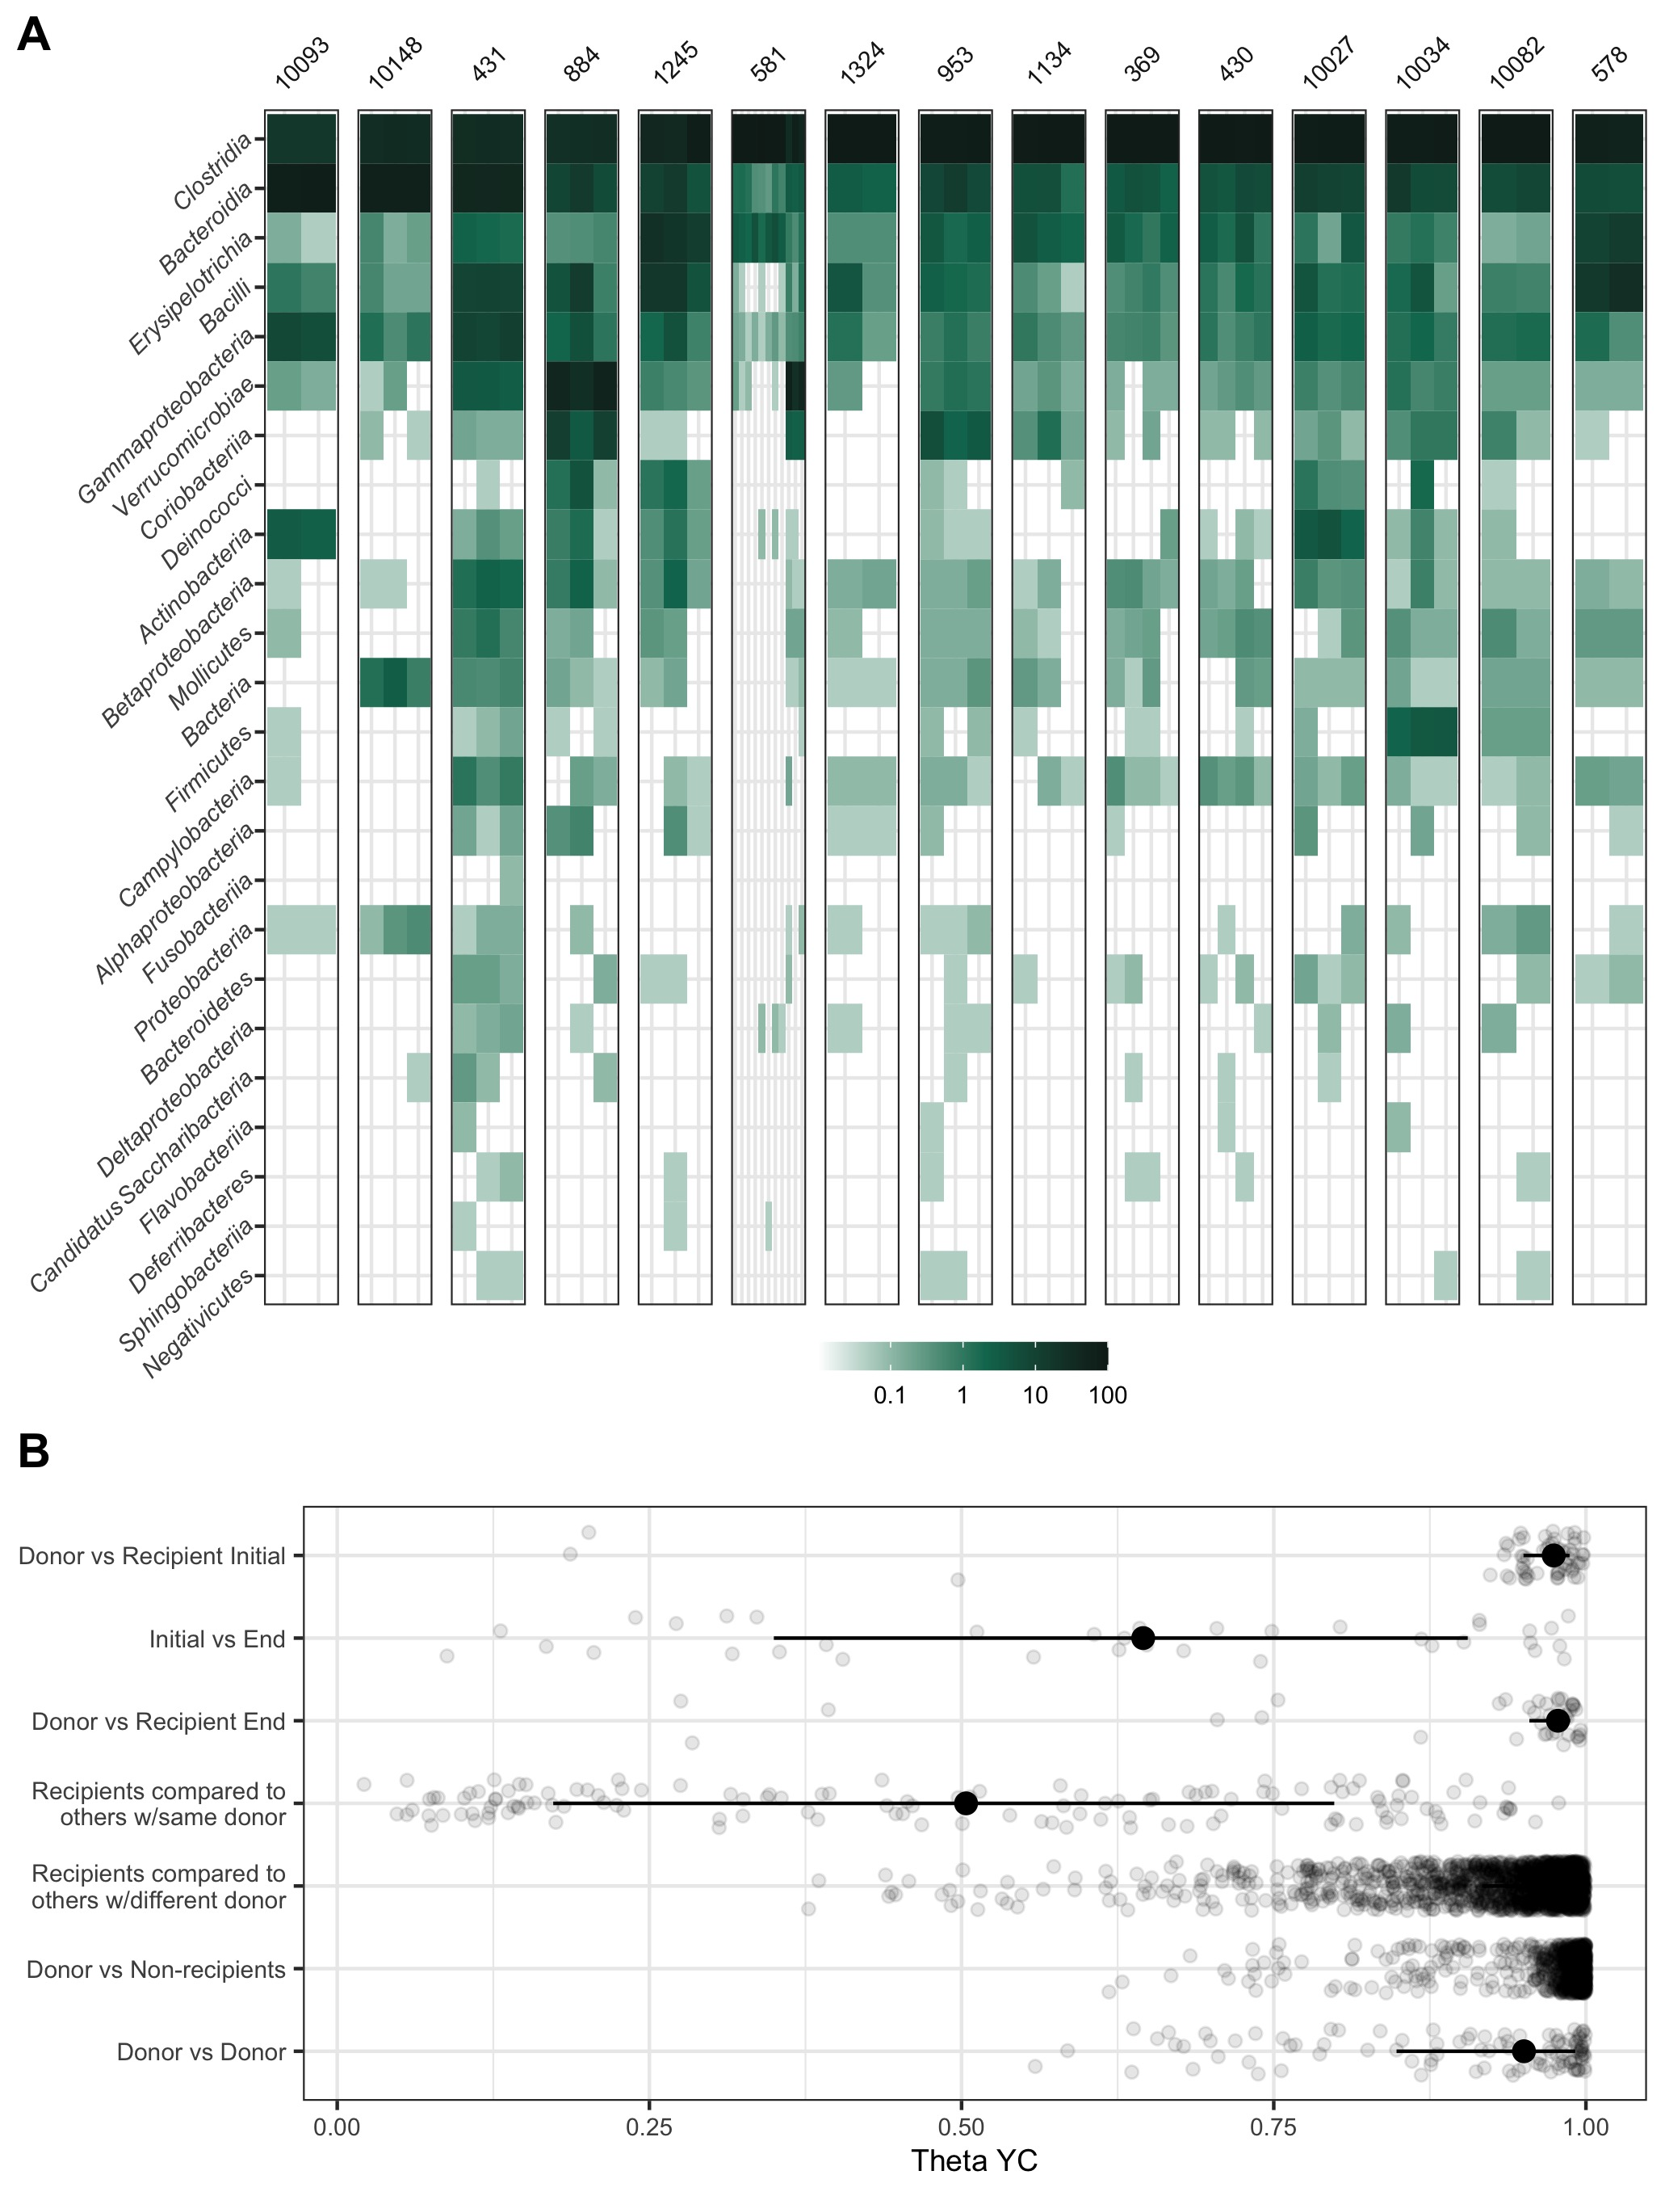

**Figure 1. R.** (A-C).

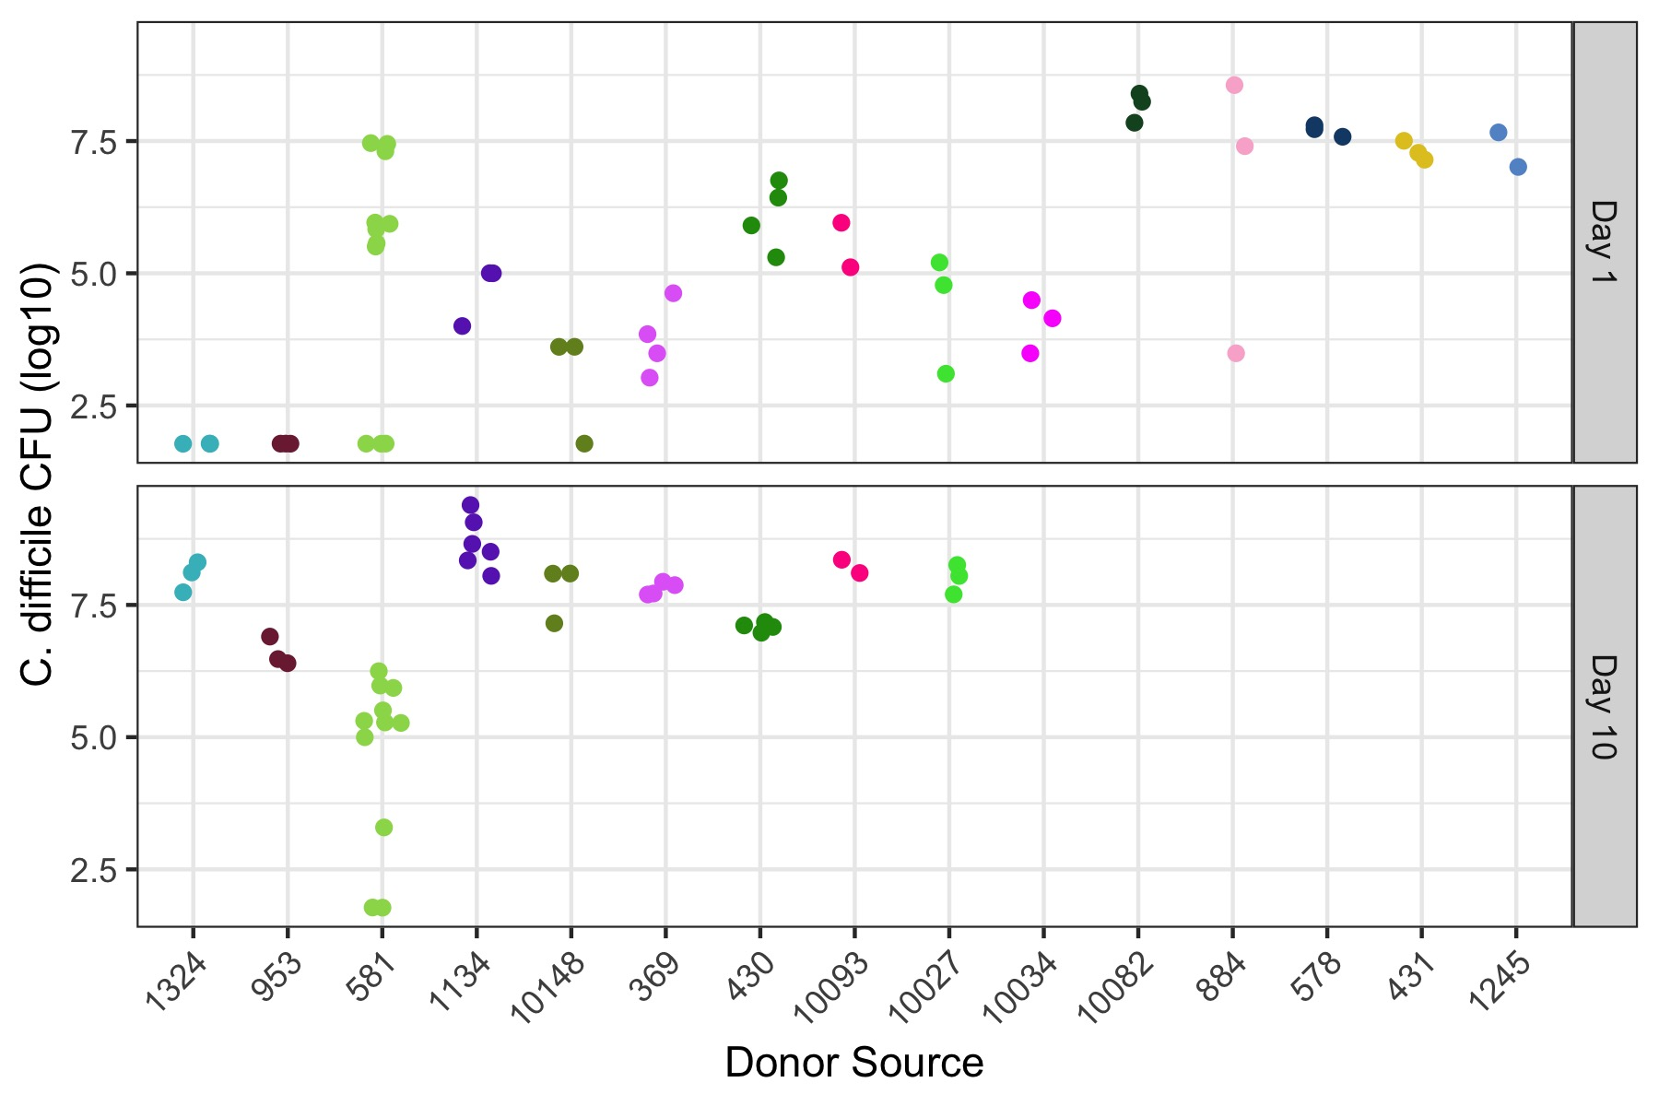

**Figure 2. M.** F.

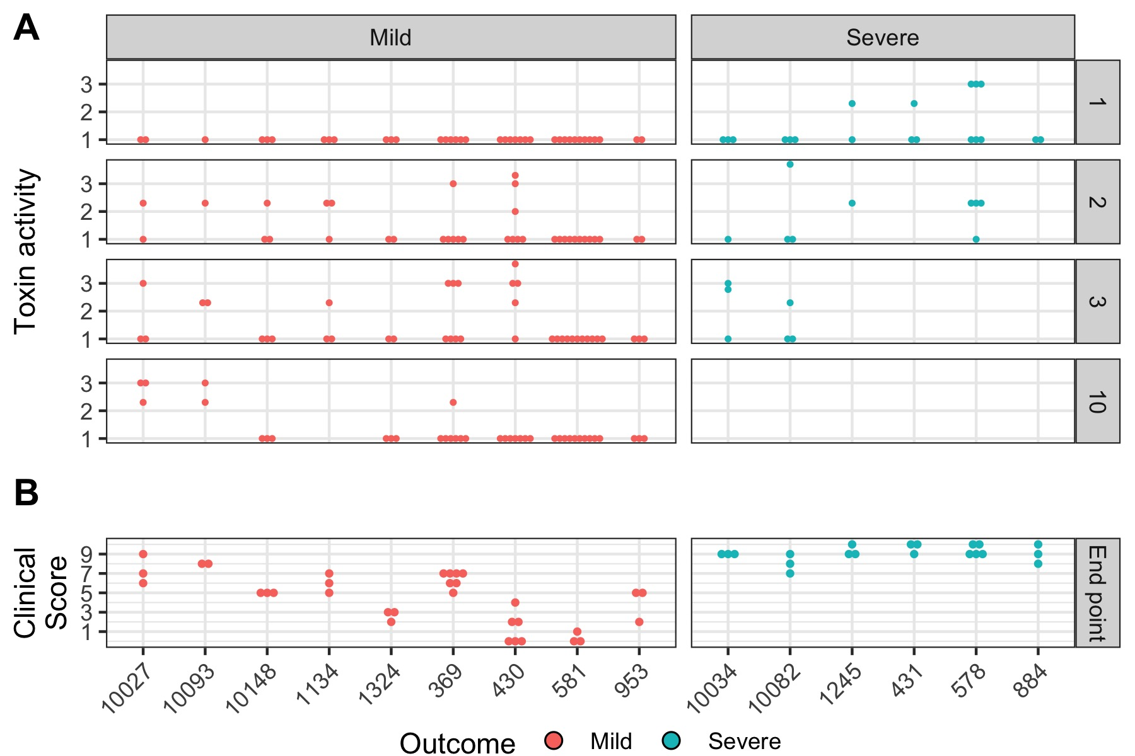

**Figure 3. O.** F.

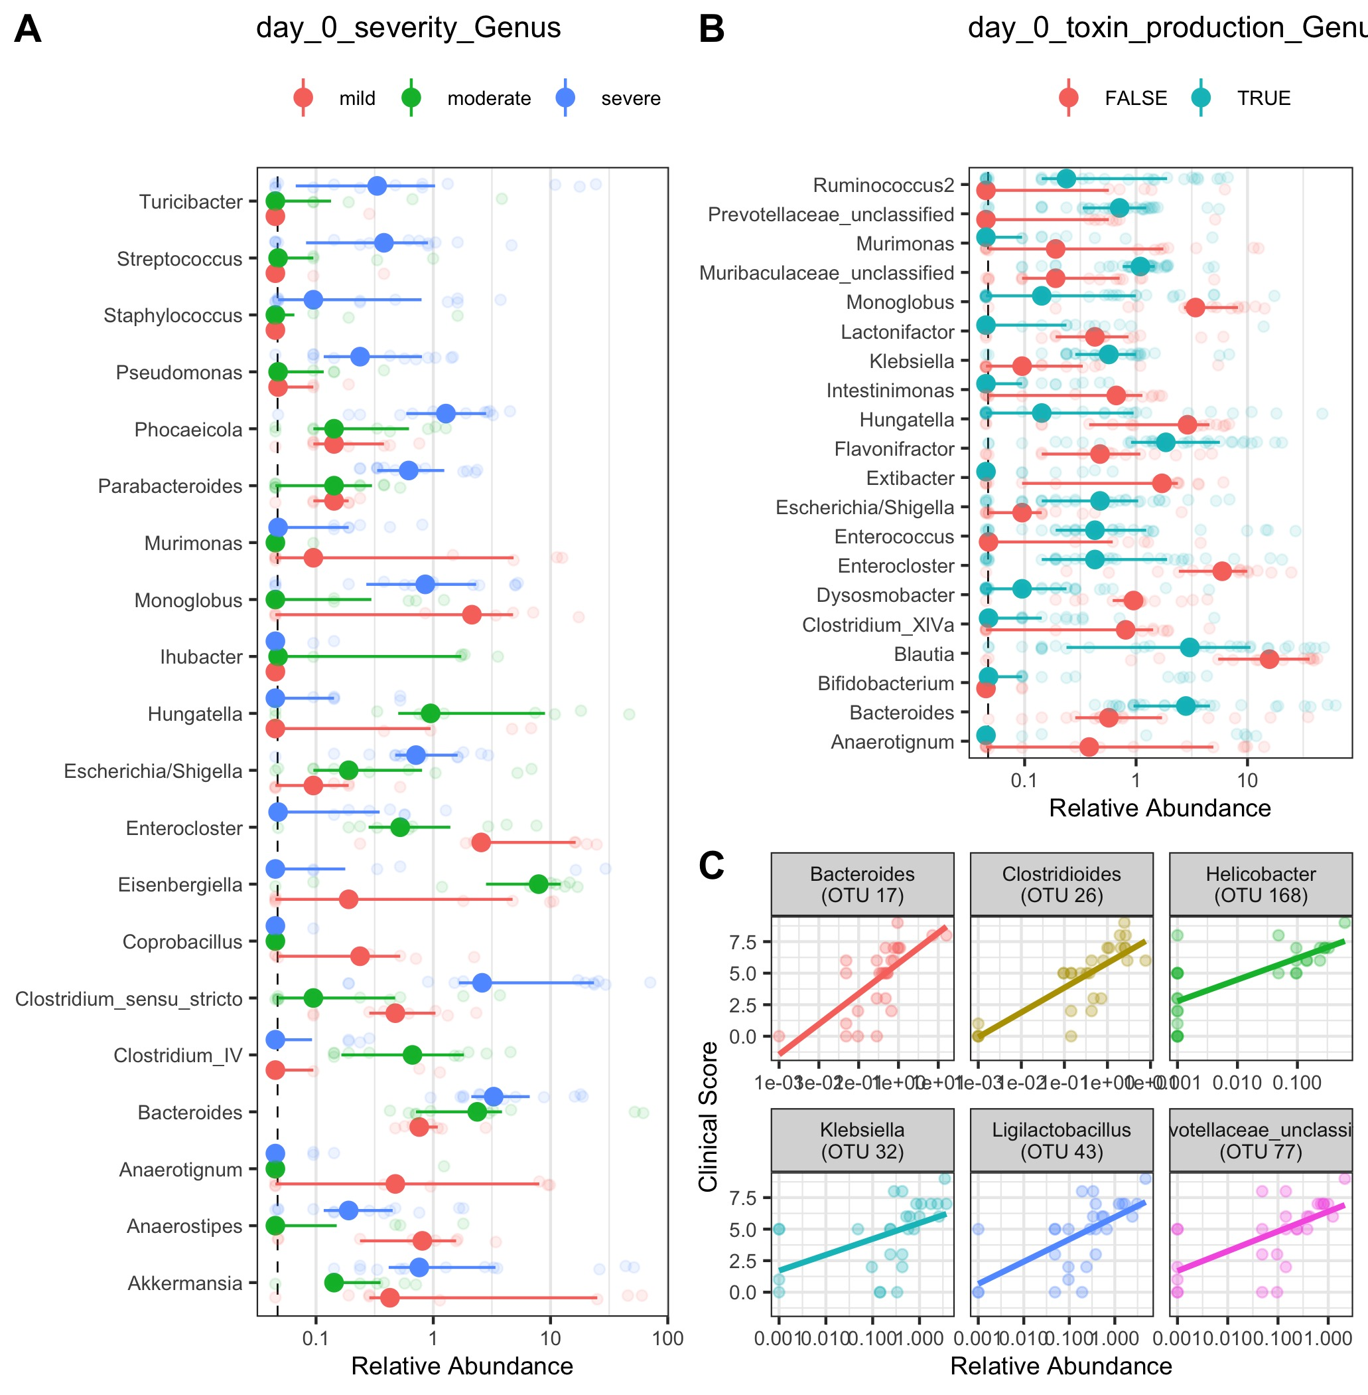

**Figure 4. E.** A.

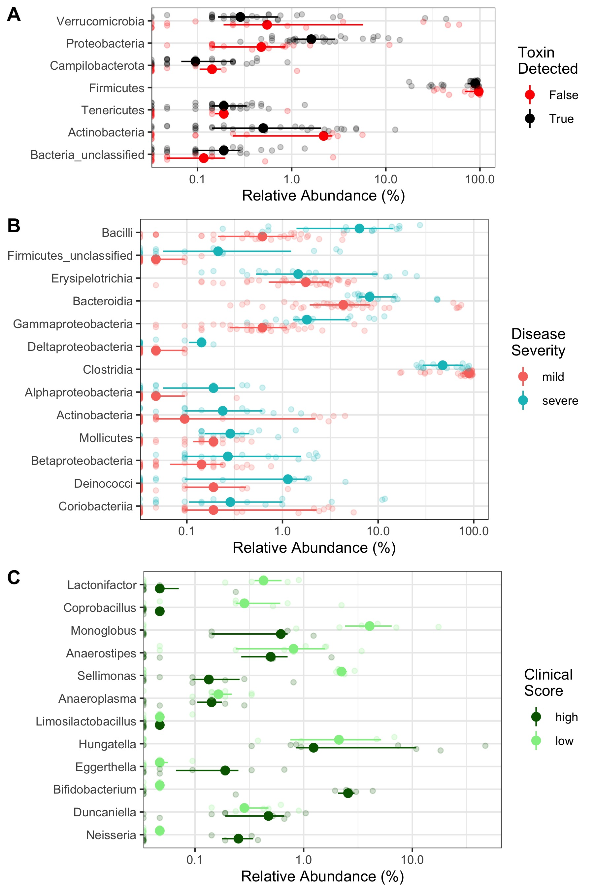

**Figure 5. D.** (A) L

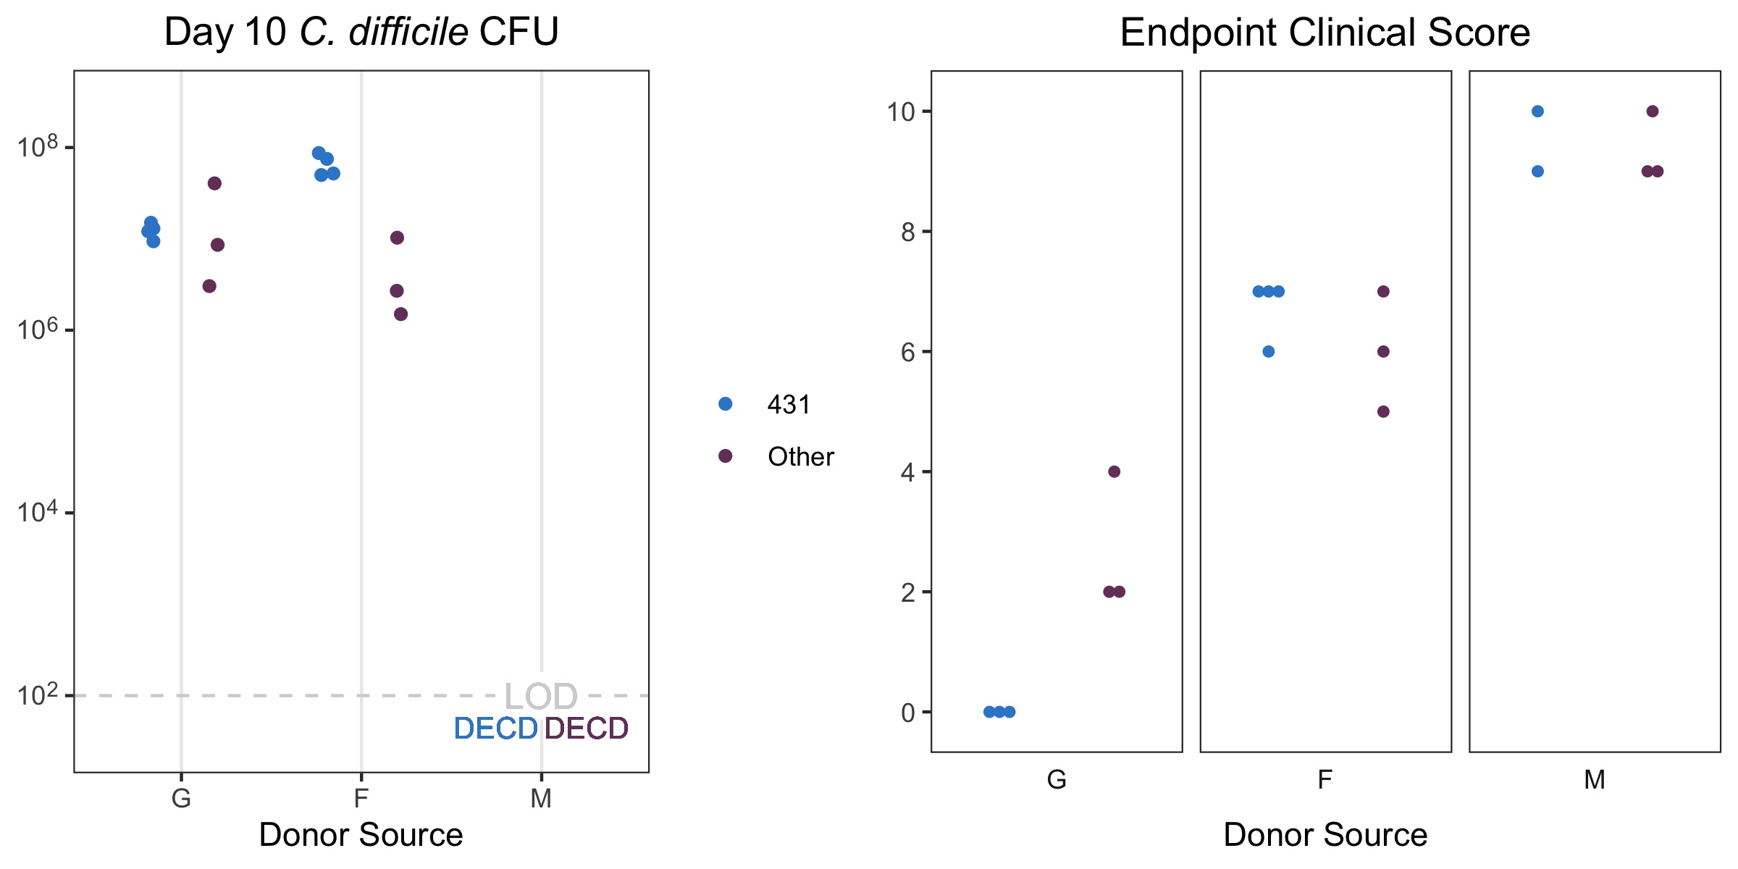

**Figure 6. D.** (A) L

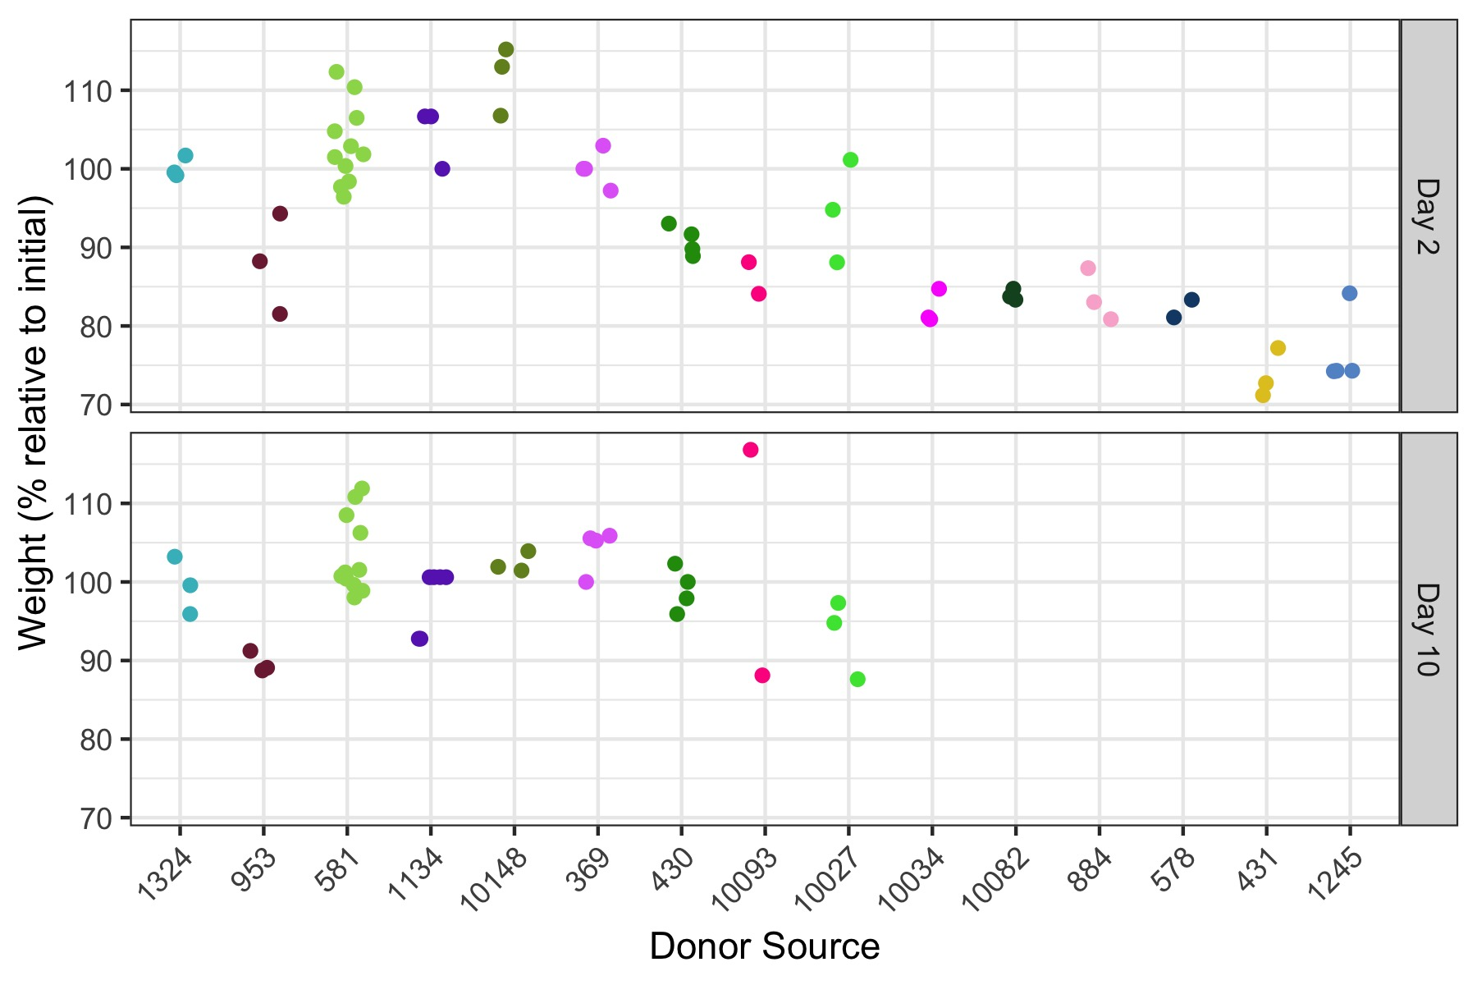

**Figure S1. D.** (A) L

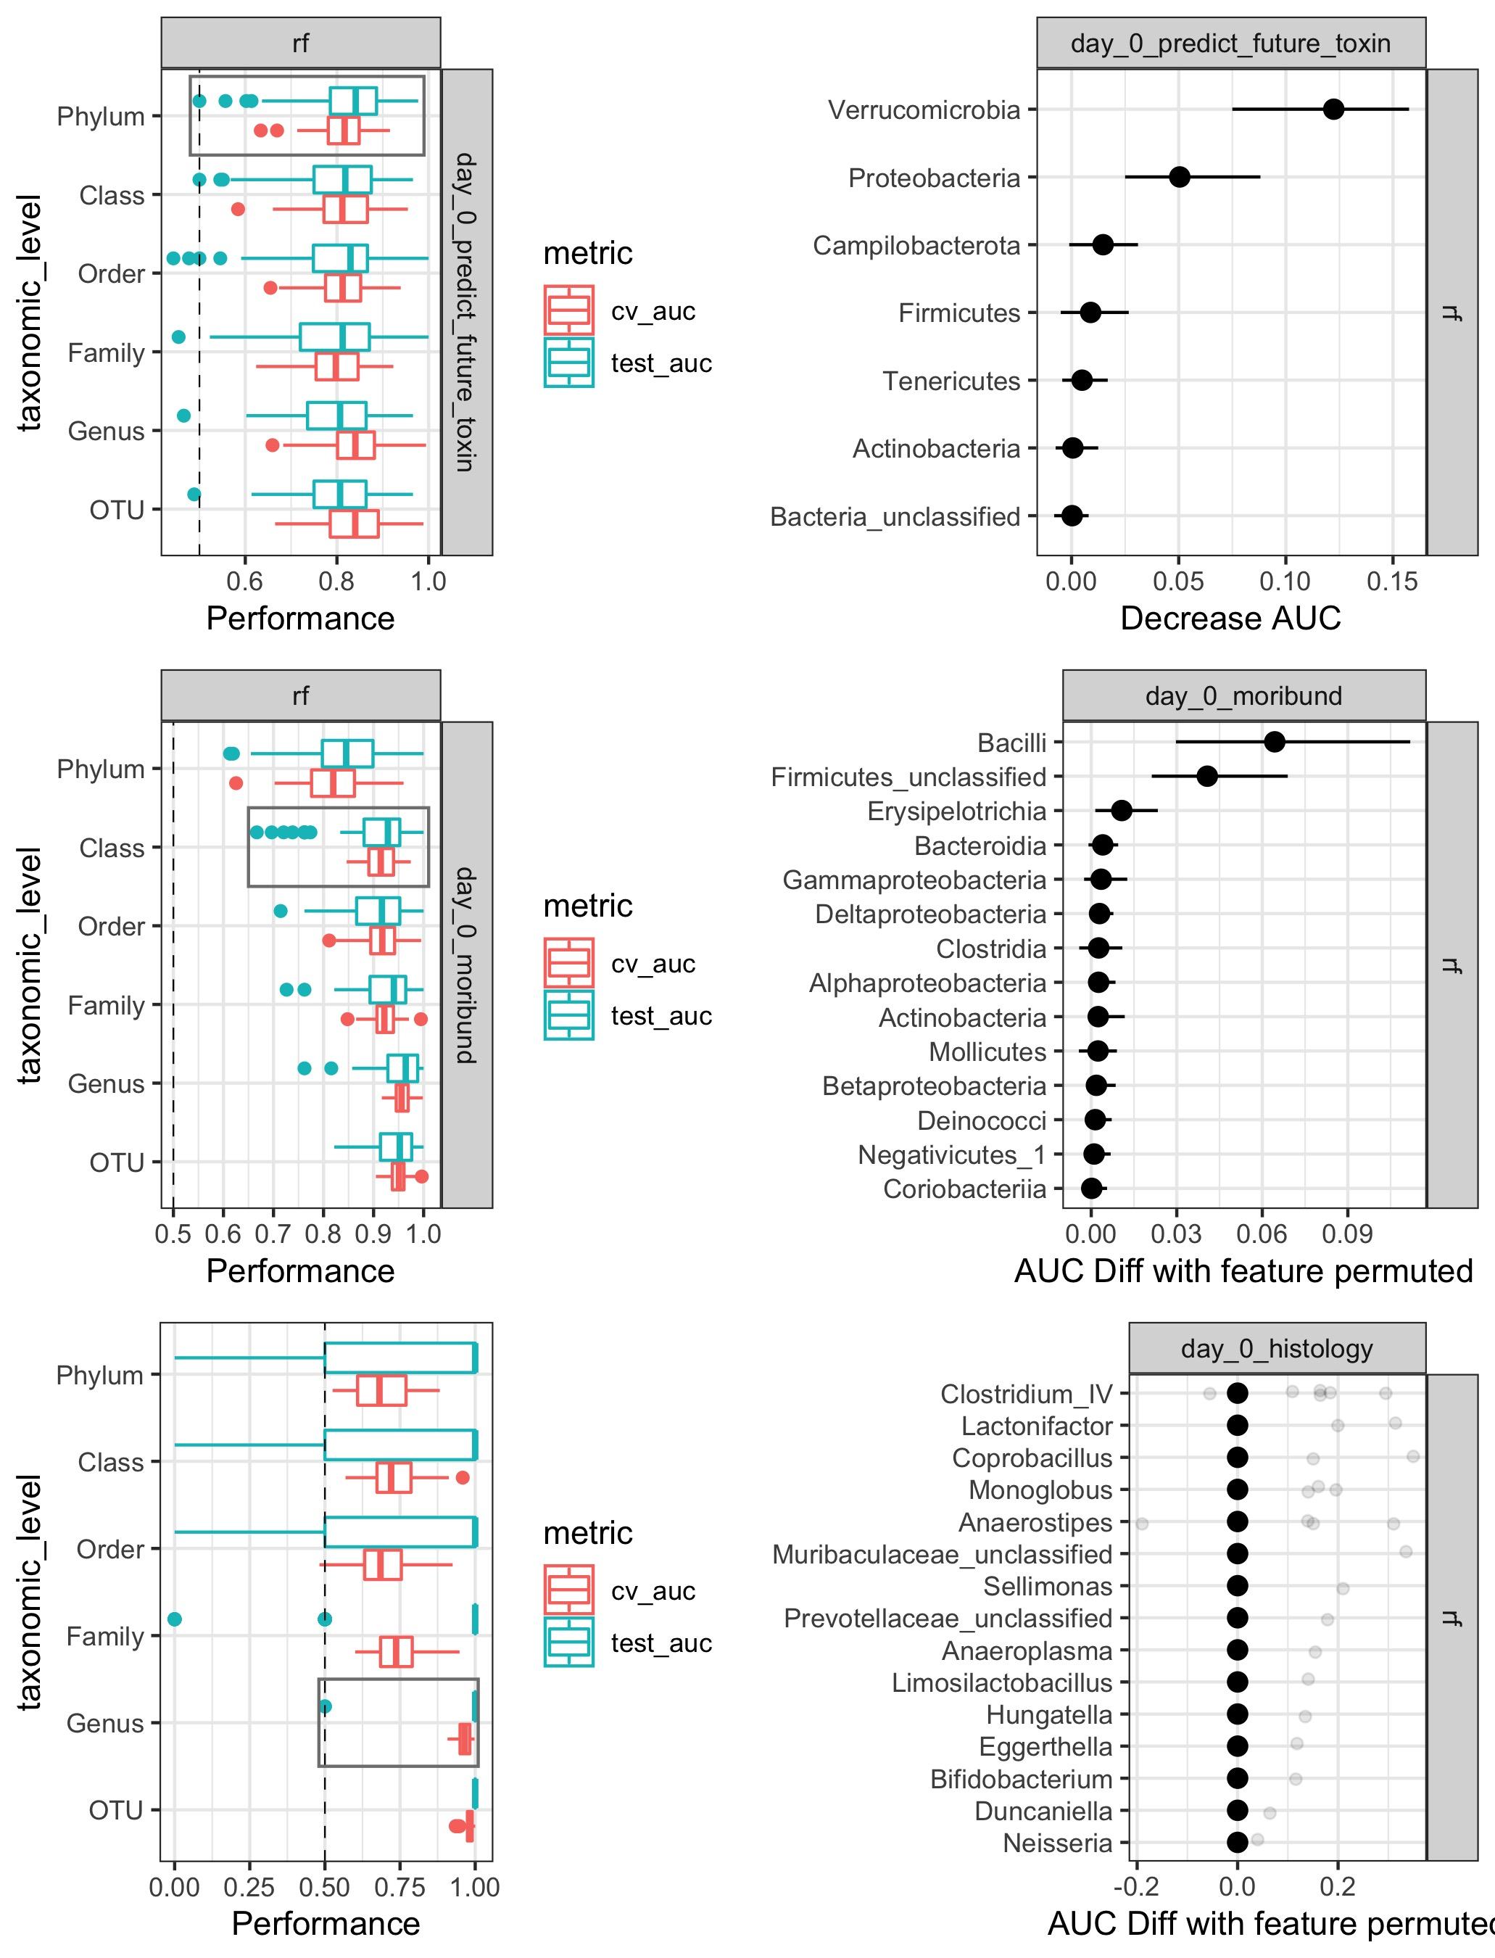

**Figure S2. D.** (A) L

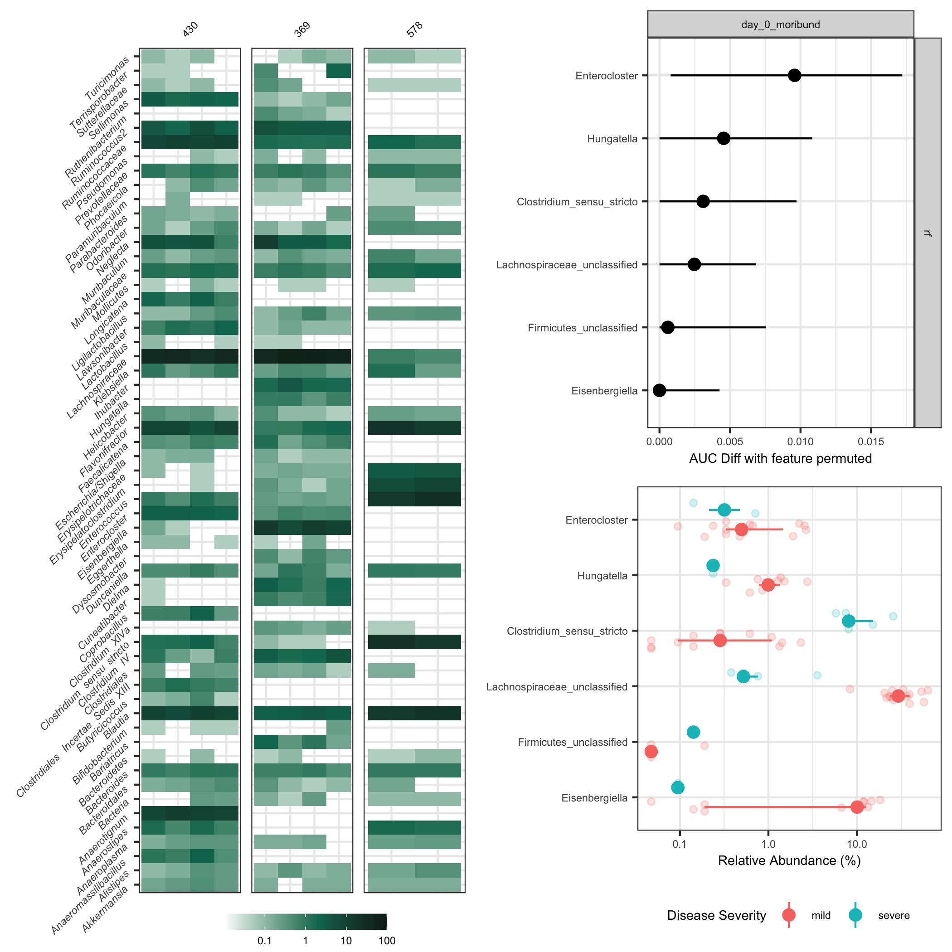

**Figure S3. D.** (A) L

**Table 1. D.** (A) L

samples_used <- readxl::read_xlsx(‘data/raw/humanGF_ids.xlsx’) %>% pull(human_source) %>% unique donor_data <- readxl::read_xlsx(‘data/raw/MIMARKS_cdclinical.xlsx’) %>% filter(sample_id %in% samples_used) %>% select(sample_id, biome, age, gender, “antibiotics >3mo”, protonpump, antacid, Healthworker, historyCdiff, Surgery6mos, Vegetarian, weight, disease_stat)

**Table 2. D.** (A) L

read.csv(here(‘data/raw/Hanna_in_vitro_data_plus_germination.txt’)) %>% rownames_to_column(‘isolate’) %>% filter(isolate %in% c(‘DA00299’, ‘DA00395’, ‘DA00458’, ‘DA00431’))