|  |  |
| --- | --- |
| **Student Name:** | **Natthaphon Chaimongkhon** |
| **Student ID:** | **J222144** |
| **Task Title:** | **Portfolio Task – Part 2** |

# GitHub Repository Interaction:

## Fork project to create branch and add feature:

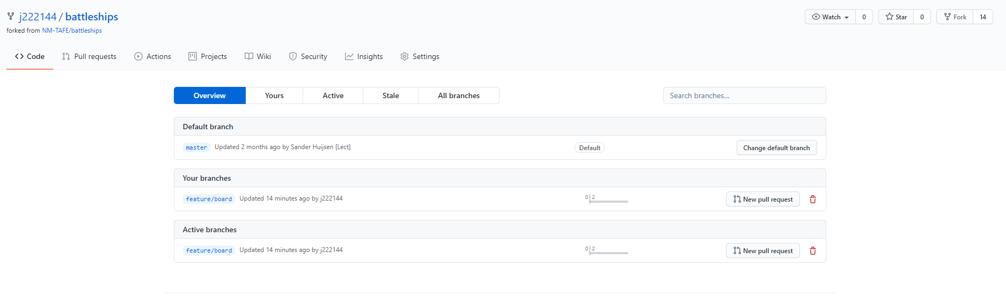

## Issues Interaction:

