Task: |  | 3
Task Title: |  | Portfolio
Task Code: |  | AT2 POR-Task-3

Assessment type (☒):
☐ | Questioning (Oral/Written) |  | ☒ | Portfolio
☐ | Practical Demonstration |  | ☐ | Project
☐ | 3rd Party Report |  | ☐ | Other – Please Specify
The base requirements this assessment task include:
- Web server, Python interpreter and database server
- IDE or editor for developing Python programs (only PyCharm supported by the college)
- Raspberry Pi with SenseHat
- Access to Office 365 & Microsoft Word
- Report Template (Portfolio: Part 3 Document Template) as supplied

Use of some of these items may not occur in this part of the assessment task.

Assessment Due
This assessment is due on the following date:
- Week 14 17:00 (5:00PM) on the day of the scheduled lecture.
Refer to Blackboard for the most accurate dates, which may alter due to unforeseen circumstances.
We also will endeavour to update these document(s) at the same time.

Instructions
Follow the steps listed in this assessment item. Please note that additional information may be given.
Submission of the documentation, code, and associated items is at the end of each part of the portfolio.
Each part of the portfolio has a deadline for submission.
It is advantageous to you to attempt to meet the deadline provided.

Important
If you are using a different configuration of tools and equipment for this assessment item, then assistance in this and subsequent parts of the portfolio to ensure the systems work correctly will be limited.

Scenario / background
In this Portfolio Task, we’re going to have a closer look at the four pillars of OO:
- Abstraction
- Polymorphism
- Inheritance
- Encapsulation

General Instructions
We provide a document template for your answers.
Save the file as:
- XXX-IoT-Port-Part-3.docx
Replacing the XXX with your initials.
For example, Adrian Gould would use AG-IoT-Port-Part-3.docx for his submitted filename.
Upload any code as a PyCharm project in a zip-file. Remove the virtual environment (venv or .venv) from the zip-file before uploading it to Blackboard. Include your .git file with your submission. Your .git file must point to an origin on GitHub.

Answering Questions
When a step includes a question, you must attempt to answer it.
There is a minimum and maximum number of words to use for each answer.
If a step has more than one question, these maxima and minima are a total for all the questions in that specific step.
All answers must be in complete sentences unless indicated.

Sources of Information
In industry, it is good practice to keep track of where information was obtained. This is especially true if it is a written document, or even code.
If you answer any questions using information from web sites, please include the site name and URL (Web site address) after the answer. Likewise, include the title and author for books and magazine articles. For example:
- RS Electronics Ltd: https://au.rs-online.com/
- Slack API Documentation, Users List Method: https://api.slack.com/methods/users.list
If you use ChatGPT (or any other AI) to help you answer the questions, you must reference the chat as a conversation (e.g. 2023, Conversation with ChatGPT) . Copying/pasting from ChatGPT or any other LLM without attribution is plagiarism. Your answer must be in your own words to be accepted. If you use ChatGPT to proof your answer, include “Proofed by ChatGPT” with your answer. Your lecturer may ask follow up questions to validate your understanding.

Code Storage
The initial source code for this project is available on GitHub. You must fork the repository and provide evidence of using Git. See for details:
https://github.com/NM-TAFE/civ-ipriot-smiley/blob/main/README.md
This space left intentionally blank.

STEP | Task to perform | Words  Min/Max
00 | Create Evidence Document  Make sure you have followed the instructions on creating the answer document, as given in the General Instructions.  Familiarise yourself with the content and document your progress in this assessment.  Make sure that you complete the title page of the document.  At any stage during this assignment, you may consult the stakeholder(s) or their representative(s).
 | This space left intentionally blank.
01 | Download the “Smileys” project  You can download the Smileys project from GitHub using the provided link. .  After cloning, the directory structure should look something like this:  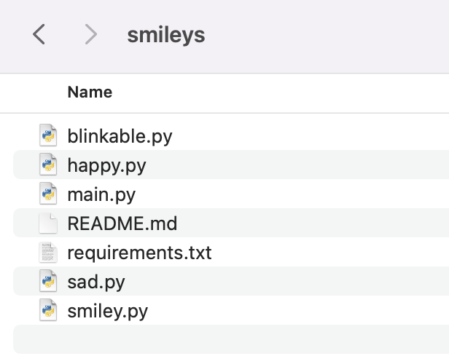  The main.py script is the entry point for the project. You should be able to run the script on your Raspberry Pi by typing python3 main.py in a terminal. Make sure to cd into your project directory (this means Change Directory).  You may ignore the requirements.txt for now. The file README.md contains a brief description of what the project is about. It is good practice to add a README to any project you create.  Take a screenshot of the result of the following two commands and put it in the answer document ($ is the prompt; don’t type that):  $ ls  $ python3 main.py | n/a
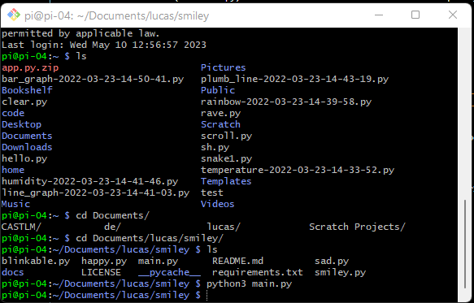
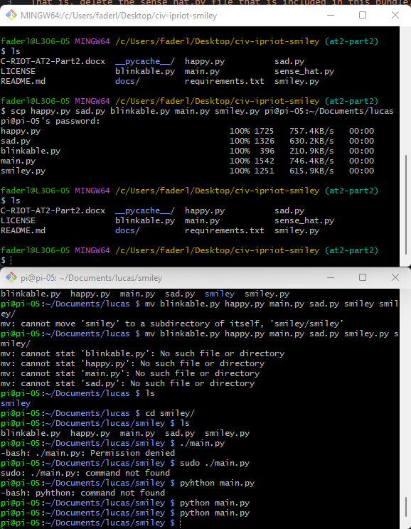

02 | Find the classes  The project contains a few classes. Some are “base classes” (sometimes called super classes) and some are “subclasses”, which are derived from the base classes.  Answer the following questions:  - How many classes can you identify in the project?  A. five classes  - In your own words, describe how ‘abstraction’ is visible in this project  B. abstract base class, ABC. This creates a class with an outline of the design without implementation. It has an abstract method called blink that need to be implement.  - Describe which of these classes are subclasses and which are base (or super) classes.  Happy and Sad are sub-class of Smiley, which is the super class.  binkable is also a superclass for happy  - What is the name of the process of deriving from base classes?  Inheritance | n/a
 | This space left intentionally blank.
03 | Not all classes are the same  Investigate the classes Happy and Sad.  Notice the similarities and the difference. Be careful, what may look like a similarity may actually contain a subtle but important difference.  In your own words, describe:  - The commonalities between Happy and Sad  - The differences between Happy and Sad  - Is there anything that stands out as a difference?  Happy and Sad are mostly the same but the names. Happy inherits from Blinkable. Happy also has a blink method implement. | n/a
 | This space left intentionally blank.
04 | Where’s the Sense(Hat) in that?  You will have noticed by now that the project uses the SenseHat to display the smileys on the display.  Yet, in main.py there is no mention of any SenseHat at all.  Answer the following questions:  - Where is SenseHat used (in which class)?  SenseHat is used in the Smiley class and is initialised in the __init__() method  - Which functionalities of SenseHat are used?  Low_light and set_pixels  - What is the process of storing and potentially hiding objects in classes called?  Encapsulation  - Draw a simple Class Diagram that shows the class SenseHat and the containing class (the answer from a.). Make sure to use the correct relationship and multiplicities.  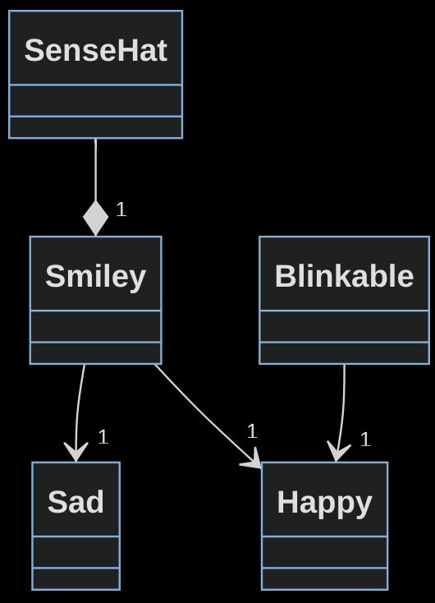 | n/a
05 | Sad smileys can’t blink (or can they?)  Unlike the Happy smiley, the current implementation of the Sad smiley does not have the ability to blink.  Investigate the Happy smiley to see how blinking has been implemented by looking at the method blink(), which takes in one argument. The argument determines how long the blink lasts.  You will now add the ability to blink to the Sad smiley.  Follow the instructions (and answer any questions):  - In your own words, how does the blink()method make the smiley blink?  The blink() uses the draw_eyes method. When False is passed to the draw_eyes() will change the value to yellow at the coordination in eyes attribute then it uses the show method to update the LEDs. It will delay, after that will pass True to the draw_eyes() which will change the value to blank at the eyes attribute coordination. then it uses the show method to update the LEDs.  - Create a new method called blink in the Sad class and ensure you use the same prototype (prototype = name + arguments):  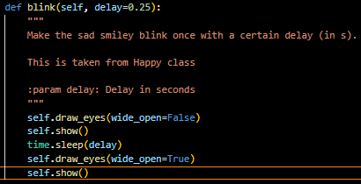  - Implement the code that makes the smiley blink. You may use the implementation from Happy as guidance.  - Test the code on your Raspberry Pi and watch the sad smiley blink its eyes. (You may have to adjust the main.py script for this.)
 | 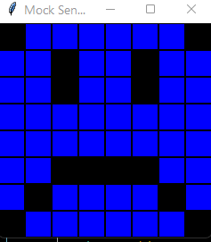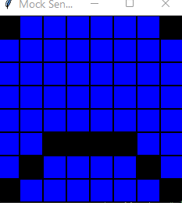
06 | If it walks like a duck…  If you followed the instructions in the previous question closely, you didn’t use the class Blinkable to make Sad blink. (If you did, that’s fine. In that case, however, you should assume you did not when answering the following questions.)You did not have to use Blinkable to allow the Sad smiley to blink. Answer the following questions:  - What kind of class is Blinkable? Look at its super class for a hint  it is an abstract base class.  - Any class that uses Blinkable is said to “implement” it. What is another (generic) name for a class like Blinkable, which may be implemented by other classes?  An interface  - What is the answer from the previous question an example of? Choose from: Abstraction, Polymorphism, Inheritance, and .  Polymorphism  Inheritance  - Why were you able to use it like the one defined in Happy, yet without using Blinkable?  Blinkable has interface ‘blink’ in it that must be defined by inheriting classes. If it dosen’t have this an interface can be defined or not.  - Regarding the answer to d., what is this called and why does it work in Python but not in some other languages, like C#? (A hint is in the title of this question.)  duck typing  Python doesn't check it’s inputs and if it can perform the tasks asked of it on them it will. C# the type must be declared, and that type must be used
 | This space left intentionally blank.
07 | Does a smiley have to be yellow?  You don’t have to answer the above question, because obviously it doesn’t. But keep reading.  Smileys that do not feel too well are often green, while angry smileys are usually red or orange.  The current implementation only allows for yellow smileys, though. That means we’re a bit limited as to what emotions we can express with our SenseHat Smileys.  Answer the following questions:  - Which colours are defined and where?  In Smiley there is white, green, red, yellow and blank defined as constantans.  - What is the name of the type of variables that hold the colours?  They are constant tuples  - Where are the colour variables actually used?  They are using red green blue RGB  - What would be an easy, albeit rather naive, way to change the colour of the smileys, for example, to green?  Change Y = self.YELLOW  To Y = self.GREEN  in the Smiley __init__
 | This space left intentionally blank.
08 | Flexible colours – Step 1  Changing the colour of the smileys once is easy. But it’s not very flexible, is it?  To allow for smileys to have different colours, we best not hardcode any values in any class, which you discovered in question 7c.  Some classes have a built-in assumption about the colour that is used. Let’s remove that assumption one step at a time.  Follow these instructions:  - Added an instance method called complexion to the class Smiley. You can make it return self.YELLOW.  (Technically speaking, smileys don’t have a complexion as they have no skin, but it sounds a bit nicer than just “colour”.)  - Update the subclasses that use the colour variable directly to, instead, use the new method complexion.  - Which of the four pillars of OO have we used here: Abstraction, Polymorphism, Inheritance, or Encapsulation? (If you feel more than one applies, pick the one that applies best.)  Encapsulation  - Check that the new code works correctly. It should still just show a yellow smiley…
 | This space left intentionally blank.
09 | Flexible colours – Step 2  The subclasses no longer make any assumptions about the colour (complexion) of the smiley. Instead, it simply “asks” the superclass by calling the new method we defined.  While that still does not provide the flexibility we crave, it will make it easier to provide this flexibility.  We will now update the base class to allow flexible colours.  Follow these instructions:  - Add a default argument to the magic method __init__() of the Smiley class and call it complexion. Assign YELLOW to it. (Yes, this is allowed.)  - Create a new instance variable called my_complexion and assign complexion to it.  - Why do we need to call this instance variable my_complexion and can’t just use complexion? (You may refer to Question 8.)  Needs to be put into the right scope so the instance can use it.  - Also assign complexion to Y. (Okay, not the best name, but because the scope is so small, we’ll allow it for now.)  - Finally, update the method complexion and have it return self.my_complexion.  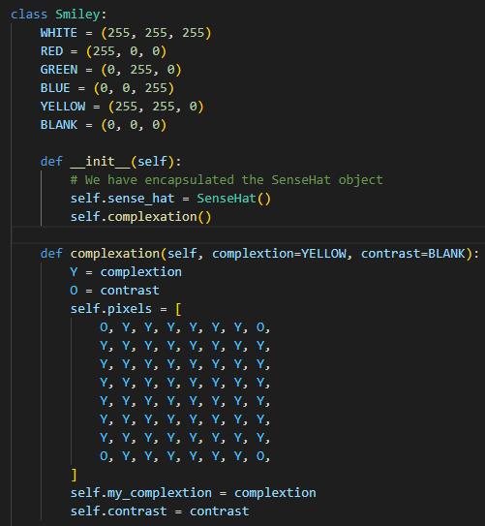  - Run the program and see that it still just creates a yellow smiley…
 | This space left intentionally blank.
10 | Flexible colours – Step 3  We have updated our code to allow for smileys to have different colours. The colours that are provided for us are Yellow, Green, Red, and Blue.  Let’s update the sad smiley to be Blue. (See what we did there?)  Follow these instructions:  - Locate the initialiser method of the class Sad and within it the call to its super class’s initialiser method.  - Change the call as follows:  super().__init__(complexion=self.BLUE)  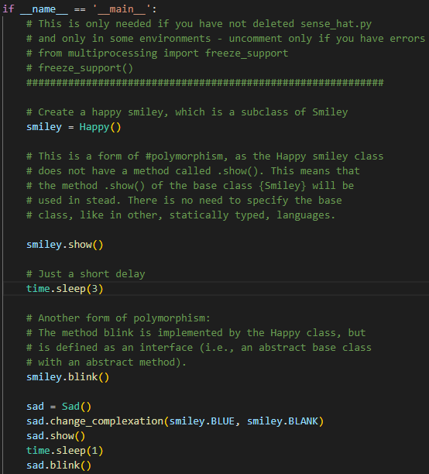  I have made a method so im my main I can change colour  - Run code to show that the sad smiley is now blue.  - Run code to show that the happy smiley is still yellow.  - In your own words, describe how you would create a new angry smiley that has a Red complexion and angry looking eyes. (You don’t have to write this code, but you may do this as an exercise.)  would inherit from smiley and blinkable with the class name angry. Change it colour to red and alter the eyes so they furry. Change pixel 10 to 9 and 18 to 19.
 | This space left intentionally blank.

Submission of Portfolio Work
To submit the portfolio, do the following:
- Save the document with your answers as a MS Word file (.docx).
- Save the code that you have produced or changes in a zip-file. Make sure to remove any virtual environment (.venv) and project directories (.idea) from the zip-file before uploading.
- Open Blackboard, and locate the AT2 Portfolio Task 3 assessment
- Open the assessment and upload the original word-processed document and the zip-file.
- Click submit.

Whilst there is no need to use any other word processing software as you have access to Office 365 for free as a student, if you use Apple Pages, or Open Office, we will then require you to upload the original file AND a PDF version.

Appendix A: Code Style Guidelines
Your code will follow the PEP 8 standard.
Readability Counts
- Zen of Python
Explicit is better than implicit.
- Zen of Python

Other code standards available in the Presentation, “Python Coding Standards for North Metropolitan TAFE”.

