**PROJECT REPORT**

1. **INTRODUCTION**

**1.1 Overview**

**Project Name: Implementing CRM for Result tracking of a candidate with internal marks.**

Administrator should be able to create all base data including Semester, Candidate, Course and Lecturer. Lecturer should have the ability to create Internal Results ,Dean, who is one of the Lecturer, should be the only one with ability to update Internal Results, Re-evaluation Can be initialised by Candidate for all Internal Results. Now only dean can update the marks after re- evaluation.

**1.2 Purpose**

It is used to track Candidate Result.

**2. Problem Definition & Design Thinking**

**2.1 Empathy Map**

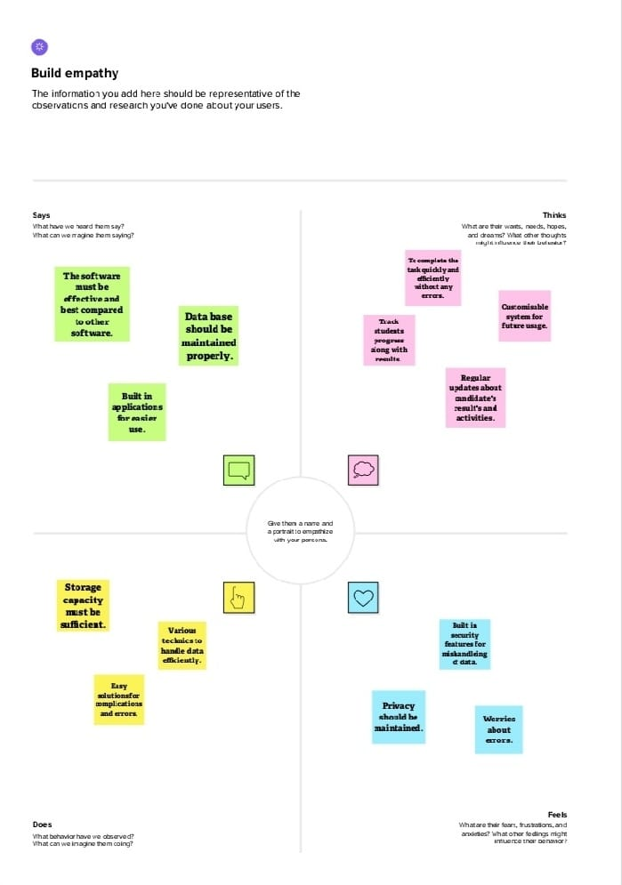

**2.2 Ideation & Brainstorming Map 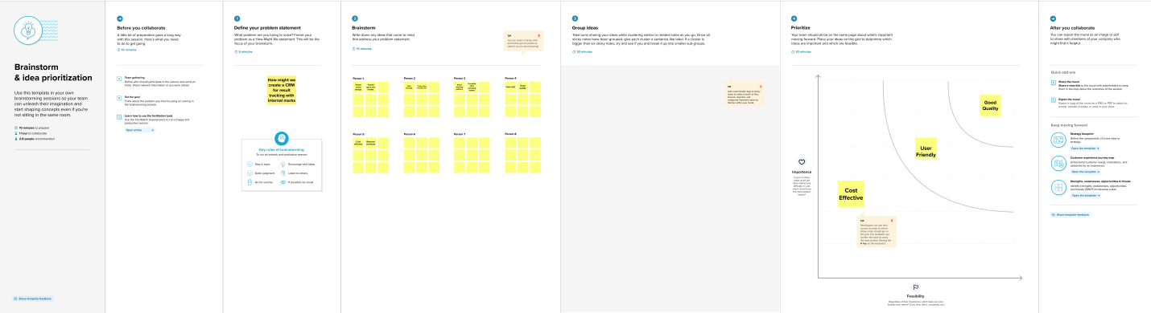 3. RESULT 3.1 Data Model:**

|  |  |
| --- | --- |
| **Object Name** | **Fields in the object** |
| **Object 1** | |  |  | | --- | --- | | Field Label | Data Type | | Semester Name | Text | |
| **Object 2** | |  |  | | --- | --- | | Field Label | Data Type | | Candidate Name | Text | | Candidate Id | Text | | Semester Name | Text | |

**3.2 Activity & Screenshot**

Milestone 1: Creating Developer Account, Go to developers.salesforce.com/ click on signup. On the signup form, enter the details. After signing up, go to your inbox of mail and activate your account and click on the verify account. After the verification again go to salesforce.com and login, then enter the username and password that you have created. After login homepage which you will see.

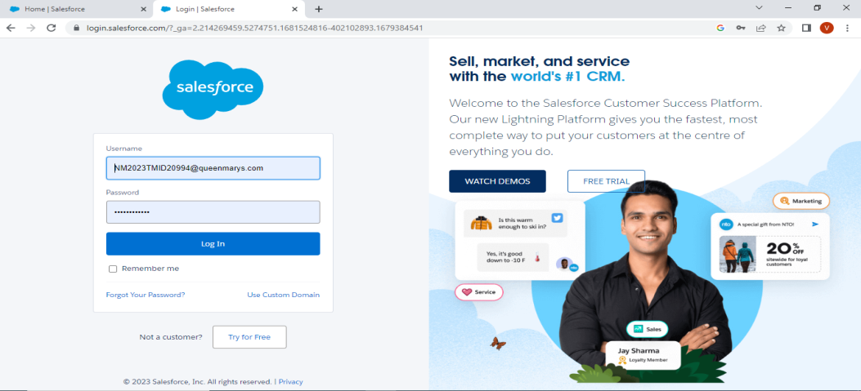 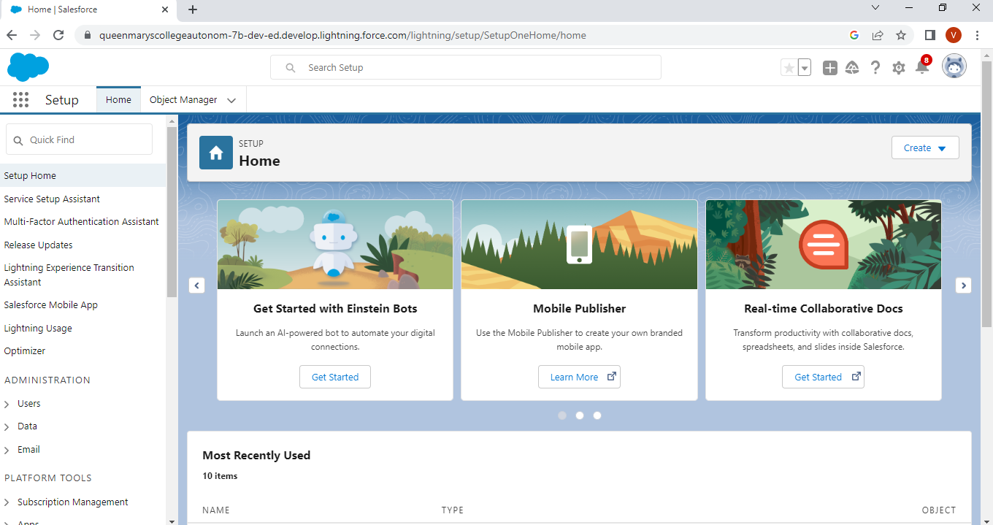

**Milestone 2: Creation of Objects and Fields**

Salesforce objects are database tables that permit you to store data that is specific to an organization. Standard objects are the kind of objects that are provided by salesforce.com such as users, contracts, reports, dashboards, etc., Relationships are created by creating custom relationship fields on an object. This is done so that when users view records, they can also see and access related data.

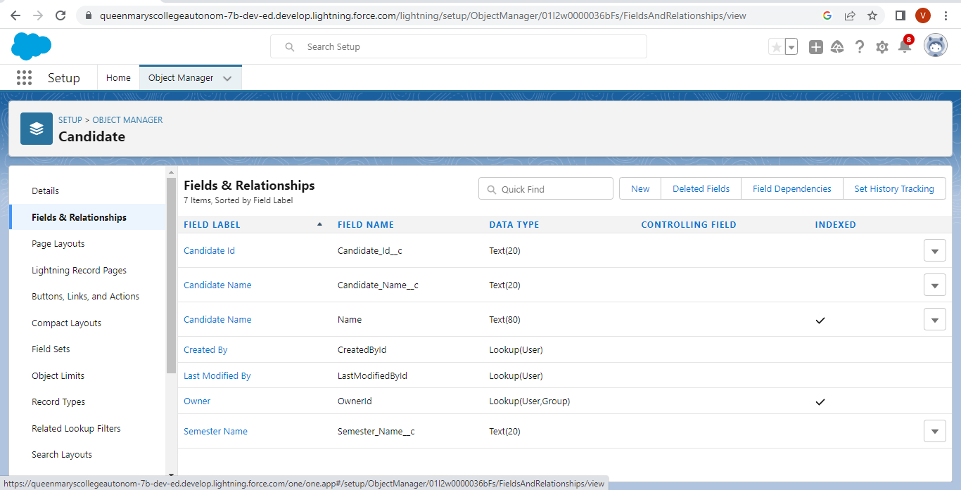

**Milestone 3: Creation of Candidate Internal Result Card :**

Apps in Salesforce are a group of tabs that help the application function by working together as a unit. It has a name, a logo, and a particular set of tabs. The simplest app usually has just two tabs.

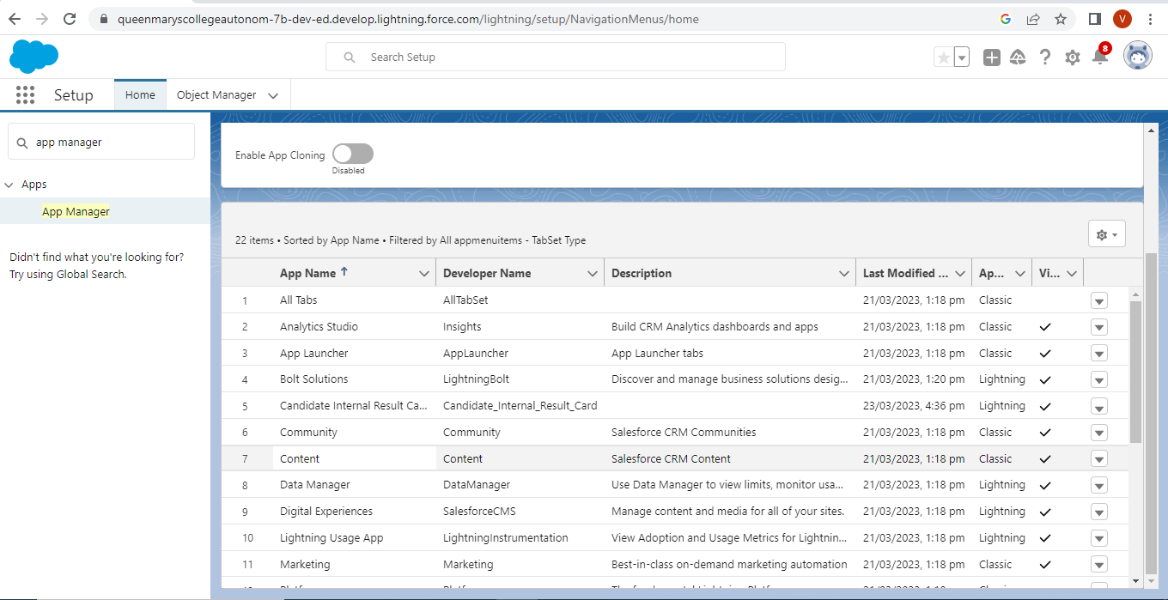

**Milestone-4: Creating a Users**

A user is anyone who logs in to Salesforce. Users are employees at your company, such as sales reps, managers, and IT specialists, who need access to the company's records. Every user in Salesforce has a user account.

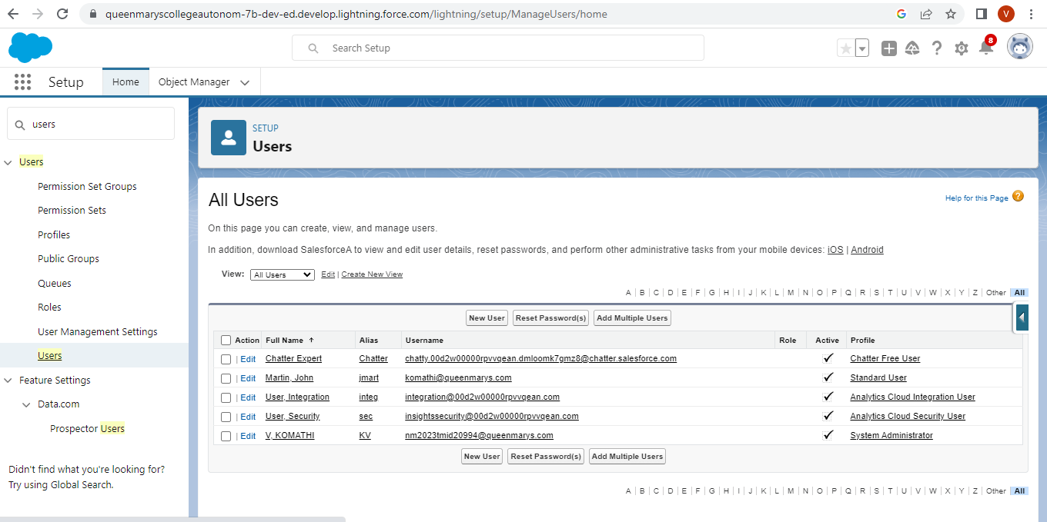

**Milestone 5: Reports**

A report is a list of records that meet the criteria you define. It's displayed in Salesforce in rows and columns, and can be filtered, grouped, or displayed in a graphical chart. Every report is stored in a folder. Folders can be public, hidden, or shared, and can be set to read-only or read/write.

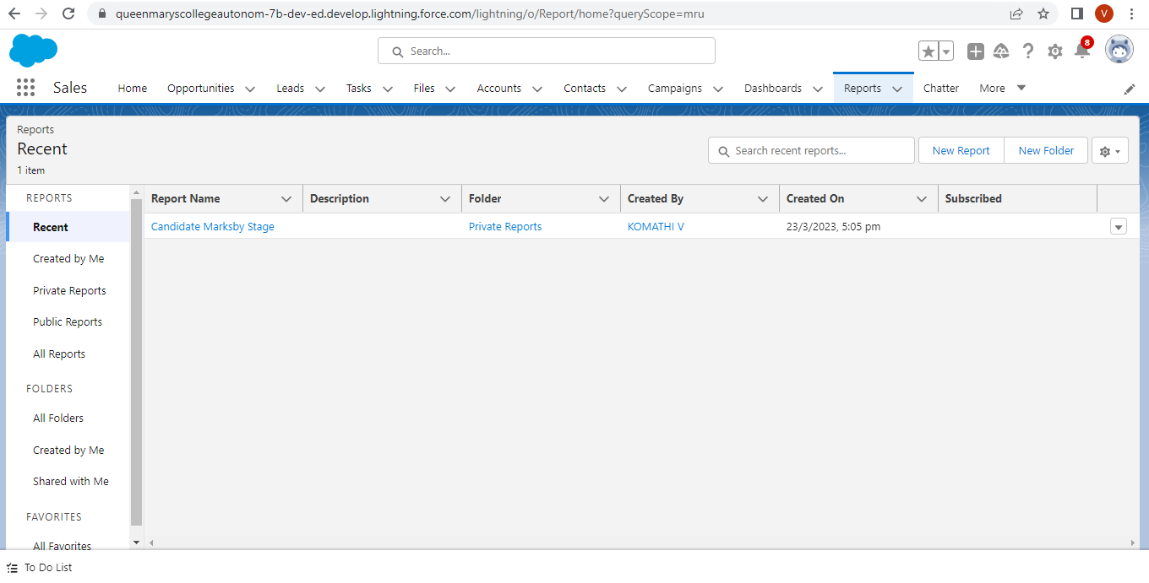

**Milestone-6: Dashboard**

Dashboards let you curate data from reports using charts, tables, and metrics. If your colleagues need more information, then they're able to view your dashboard's data-supplying reports. Dashboard filters make it easy for users to apply different data perspectives to a single dashboard.

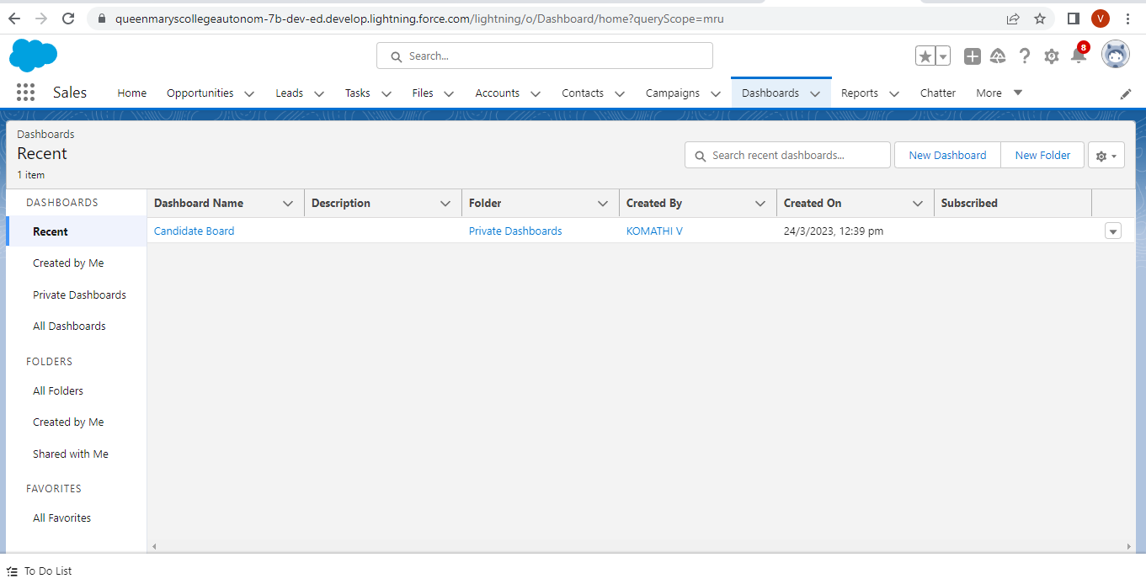

**4.**  **Trailhead Profile Public URL :**

Team Leader : https://trailblazer.me/id/viibscmathematics5211

Team Member 1 : https://trailblazer.me/id/viibscmathematics5210

Team Member 2 : https://trailblazer.me/id/viibscmathematics5209

Team member 3 : https://trailblazer.me/id/viibscmathematics5205

Team member 4 : https://trailblazer.me/id/jjeevi13

**5. ADVANTAGES AND DISADVANTAGES:**

**Advantages:**

* Smart tracking platform to save time and data management burden.
* Reduced work load.

**Disadvantages:**

* Proper data management.
* It is costly.

**6. APPLICATIONS:**

* It is used in Universities, Schools and Colleges

**7. CONCLUSION:**

We created a developer account, then Custom objects and field for the objects. Next, we create Candidate Internal result card app. Then, creating a user and finally we create a report and dashboard.

**8 FUTURE SCOPE:**

Detailed project manual along with solutions of frequently asked questions can be implemented.