Strsming_Logistics_order_tracking

Developed a pipeline which generates mock data with the help of python script and publishes them to pub/sub topic in GCP and ingests these records to Bigquery.

Tech Stacks used

1.GCP pub/sub

2.cloud function

3.Bigquery

Steps :-

1. Developed python script which generates mock data and publishes it to pub/sub topic “topic_order”
2. “gcloud auth application-default login” command to be used to login into the account using command prompt to publish messages.
3. Scripted cloud function which is triggered as soon as message is published in the pub/sub.
4. This cloud function the ingests records to bigquery

Bigquery create tale command

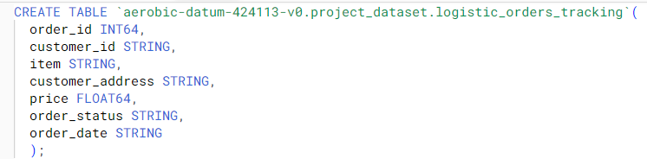

Snippet of messages published

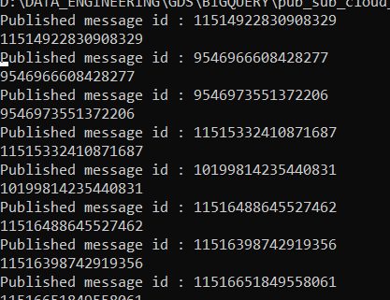

Records ingested to bigquery table

