

TASK
Exploratory Data Analysis on the Automobile Data Set



Introduction
This Exploratory Data Analysis will analyse the automobile dataset. Throughout this EDA, I will explain the methods, visualisations and assumptions based on this data.

The initial analysis of the dataset, using the info() method, show that it is relatively large with 26 columns describing the various aspects of an automobile. There are 205 entries in total, consisting of int64, float64 and objects datatypes, therefore the dataset can be described as numerical and categorical. The describe method was also applied to show the statistical values of the numerical columns.

DATA CLEANING

The first step used in the data cleaning process was to remove any duplicate rows. After applying the drop_duplicates(), the same number of entries (205) demonstrating that there were no instances of duplicated data.

Although there doesn’t initially appear to be any NaN values, there are ‘?’ symbols, which were discovered after using the head () method, which were used illustrating missing values which are most likely MNAR. In order to begin with missing data imputation for the whole dataset, the ‘?’ symbols would have to be replaced with NaN markers. Once these symbols were replaced, the isnull (). sum () method was applied and showed that there were 41 missing values in the ‘normalized-losses’ column, 2 missing values in the ‘num-of-doors’, horsepower’ ‘peak-rpm’ columns, and 4 missing values in the ‘bore’, ‘stroke’ and ‘price’ columns. In order to proceed with the EDA, these values will have to be filled. The strategy used for the missing data in all columns, except the ‘num-of-doors’, was imputation using the mean method. From the info () method, we know that these columns have an object datatype, but they are presented as floats and integers in the dataset. As a result of this, the data was converted to a numeric form using pd.numeric(), the mean was calculated, and the missing values filled their mean equivalents. For the ‘num-of-doors’ column, the approach used was to count the values already present and identify the max of this count. Once it had been established that ‘four’ was the result of the values_count.idx_max() method, the result was then used to fill the missing data. As a final step, a scatterplot below is used to visualise any outliers, the ‘price’ column has the highest proportion, the EDA will keep these outliers as they can be described as true.

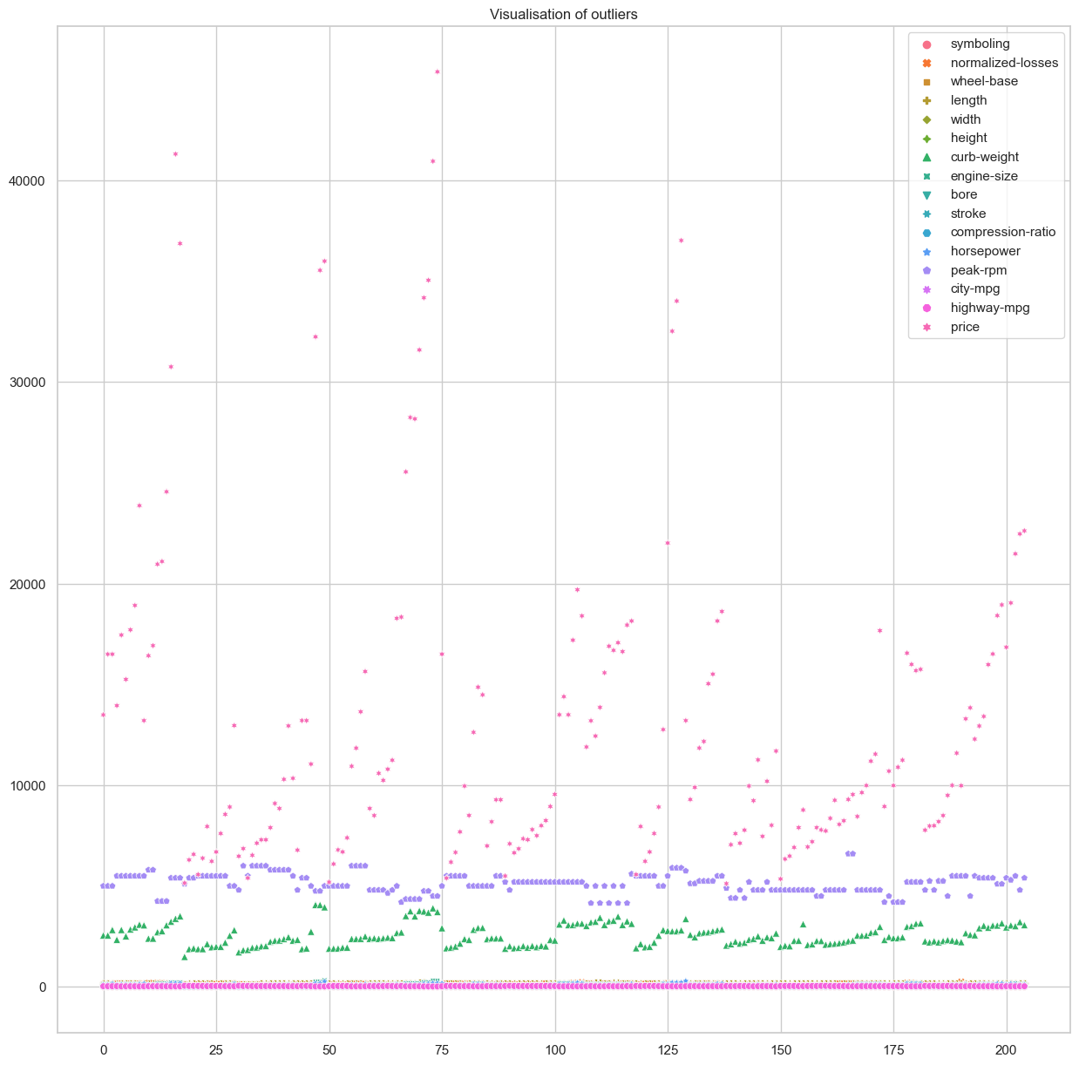

Once the data cleaning methods had been applied and it was confirmed that there was no missing data, the EDA continued by visualising and exploring the dataset.

MISSING DATA

As described above.

DATA STORIES AND VISUALISATIONS
The focus of this EDA is to show how the various features associated with an automobile, as described in the dataset, has an impact on price and popularity of make .
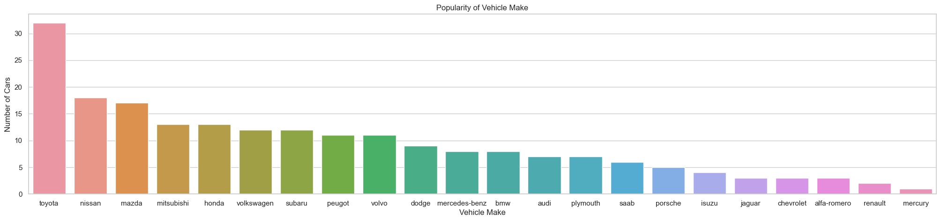

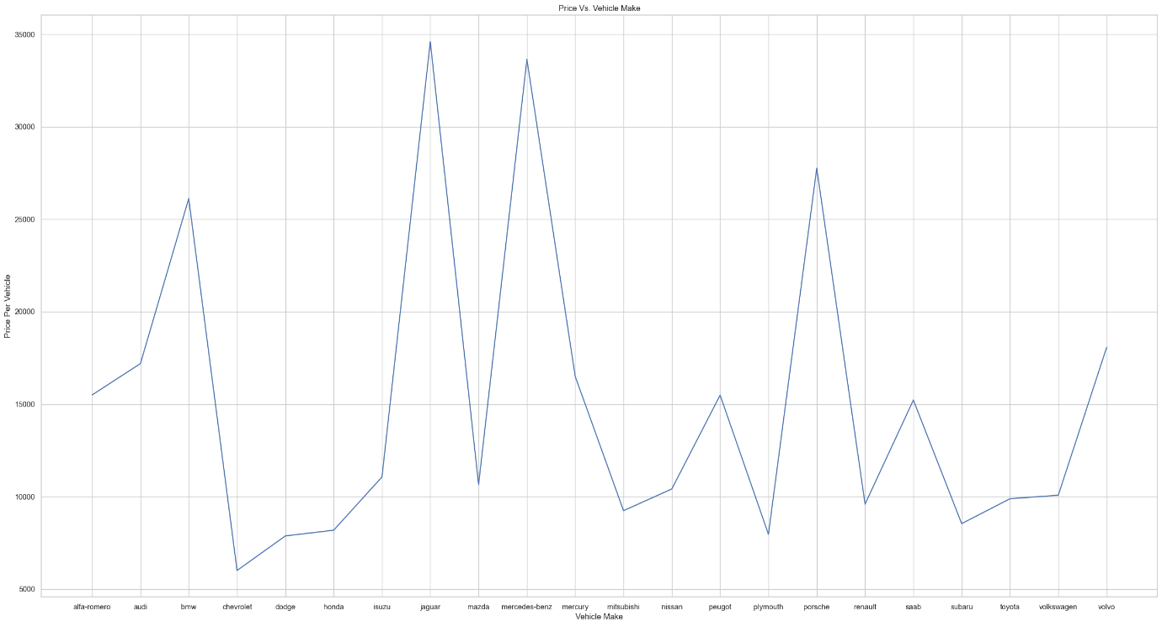
The first graph, a barplot, depicts the total number of vehicles by their make. The results show that Toyota, at 32 counts, is the most popular car make and mercury is least popular in the dataset.

An explanation for the popularity of the Toyota could be explained by it’s a lower price, in fact the most frequent car makes to appear have a lower price than the least frequent car makes (see lineplot). However, there is an anomaly to this assumption as the Chevrolet is the least expensive in the dataset, yet it less popular than other of the cheaper makes. This line plot and bar plot visualisations suggests that the popularity of cars is heavily influenced by its price range.

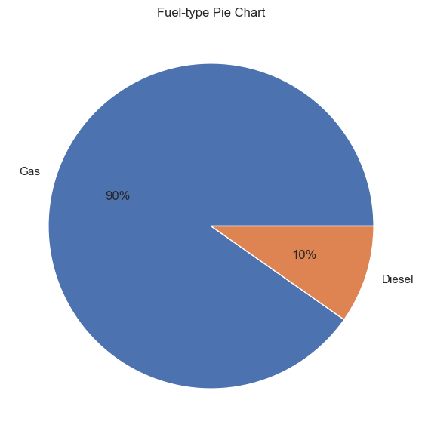

There is a significant difference between the fuel-types in this dataset, this is explored by a pie chart. Around 90% of the vehicles have a gas fuel type, with only 10% having a diesel fuel type. This disparity can be explained by the price of gas being less expensive, see below barplot. Contrarily, the Volkswagen, Toyota, Nissan and Mercedes-Benz diesel examples are cheaper than their gas counterparts.
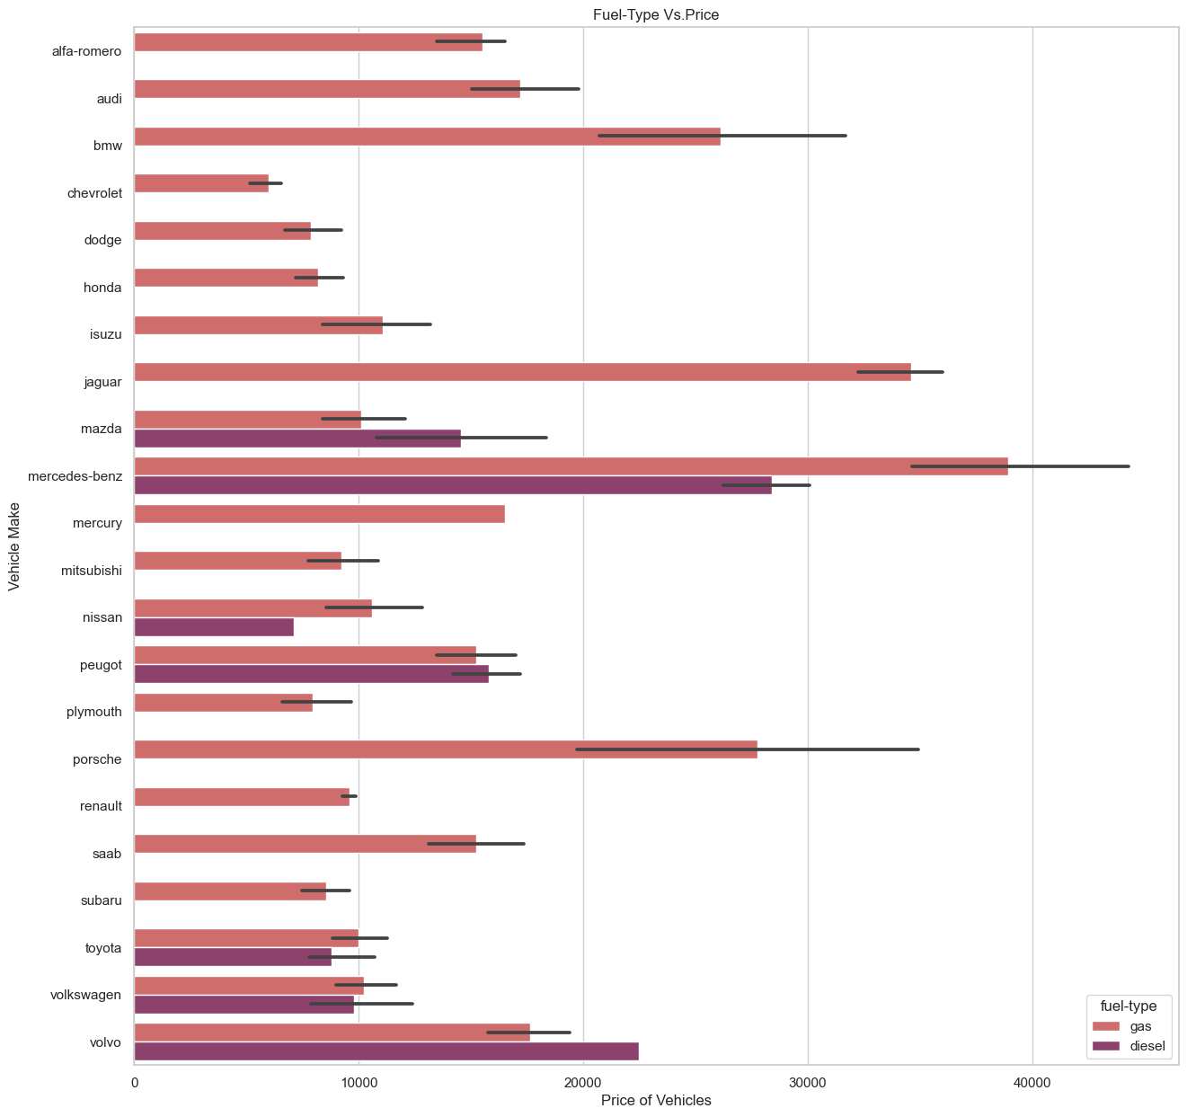

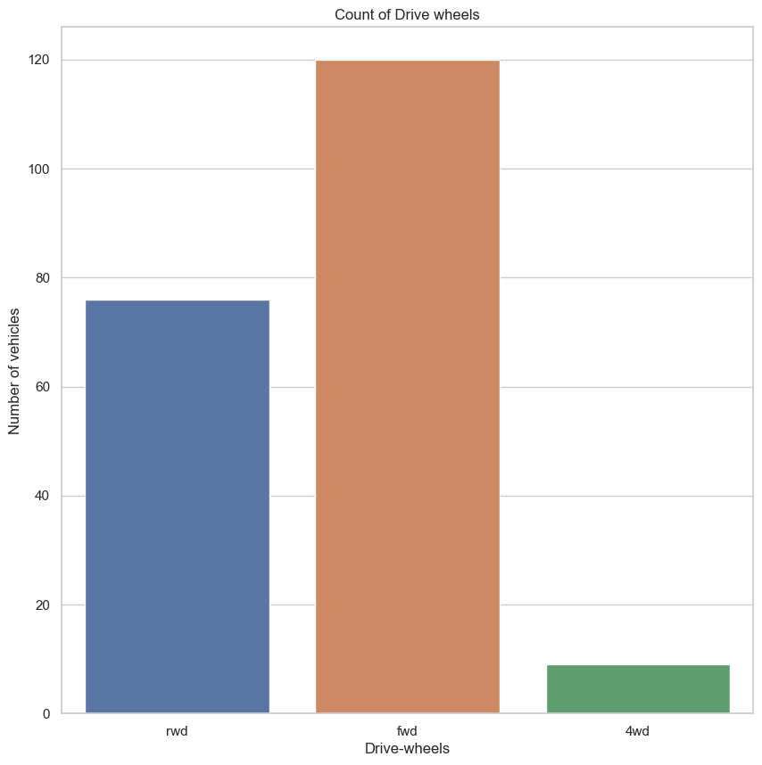

In terms of drive-wheels, the fwd wheel is much preferred to the rwd or 4wd drive as you can tell from the above countplot. More than half of the car examples are fwd and they always all placed in the lower half of the price range (under or around 10,000). The rwd cars are representative of all the most expensive cars in the dataset, as shown in the replot.
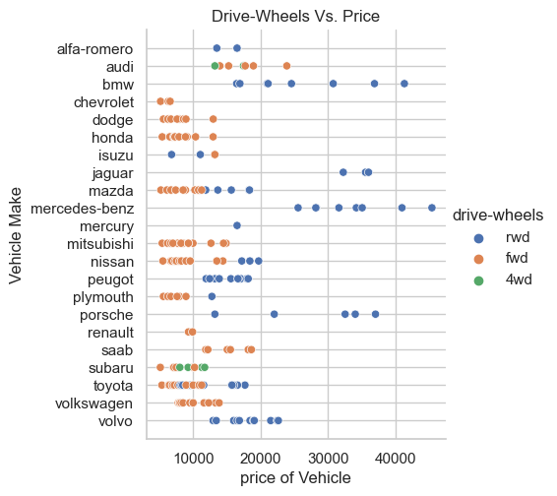

The body style is also an important factor to consider and will be explored through the below barplot. The sedan is the most frequent body style in the dataset at 46.83 %, followed by hatchback at 34.14%. Surprisingly, the sedan is more expensive in this case, an explanation for this could be that a sedan has more room to accommodate passengers than a hatchback making it a more family friendly option. Out of 22 different vehicle makes, only 3% convertibles and 4% hardtops appear in this dataset. This is presumably due to them having the highest price ranges and only being suitable for certain lifestyles.
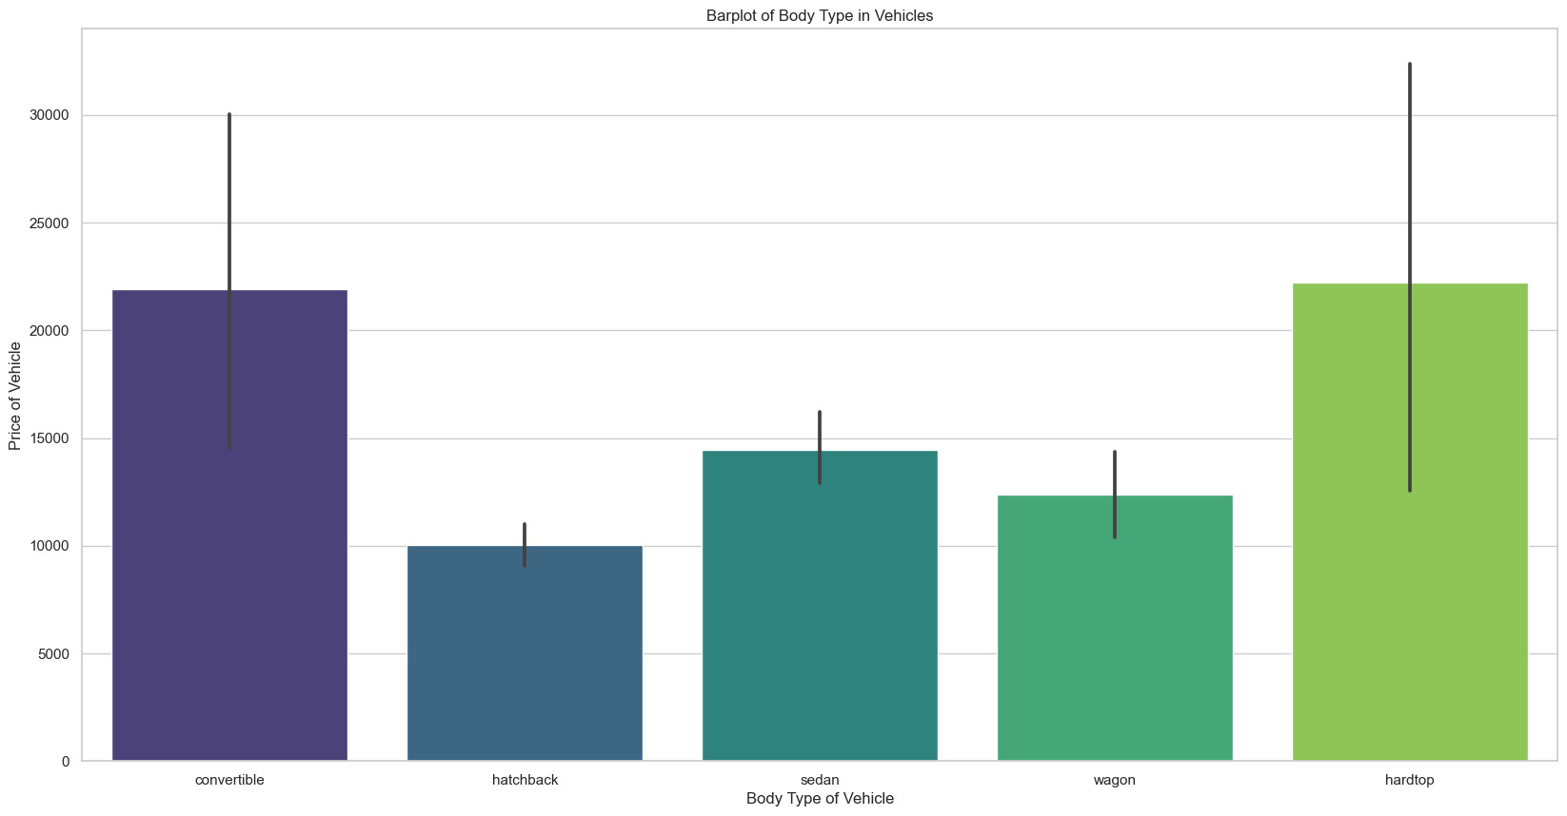

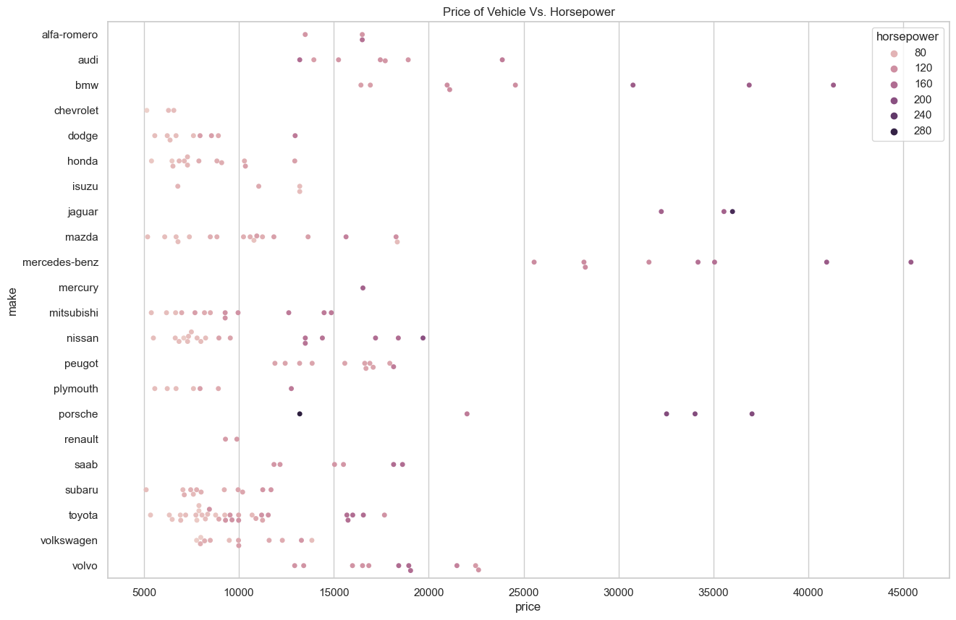

The horsepower of the cars also supports this theory, see above swarmplot. Most of the cars are grouped in the 90-160 horsepower range and have a lower price range. There would be little need to have an extremely expensive, fast and powerful car (240-280 horsepower) such as a Porsche for everyday use. The number of doors on the cars are split into two and four. The four door cars are more expensive due to them being more spacious, this would suit a family lifestyle. The Toyota and Nissan four-door makes have a lower price than the 2-door example.

The Mercury, Alfa-Romero, some of least popular, only has a 2-door make and the Renault 2-door example is more expensive than the 4-door one.

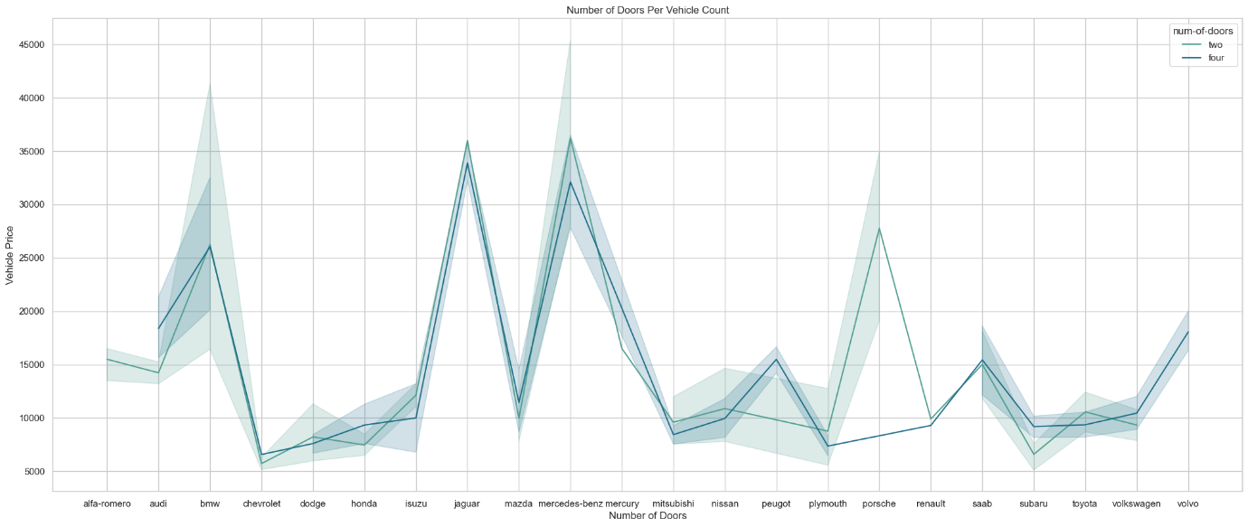

The histplot below shows a cluster of vehicles having a smaller engine size, most notably at size 100, and a lower price range than bigger engines sizes-over 200. The benefits of having a smaller engine size are that these vehicles are more fuel-cost effective and less powerful. Lastly, the aspiration variable is measured using a catplot, see below. The std aspiration is most popular, this will be due to the engine sizes being on the smaller size and the fact they are a cheaper option than turbo.

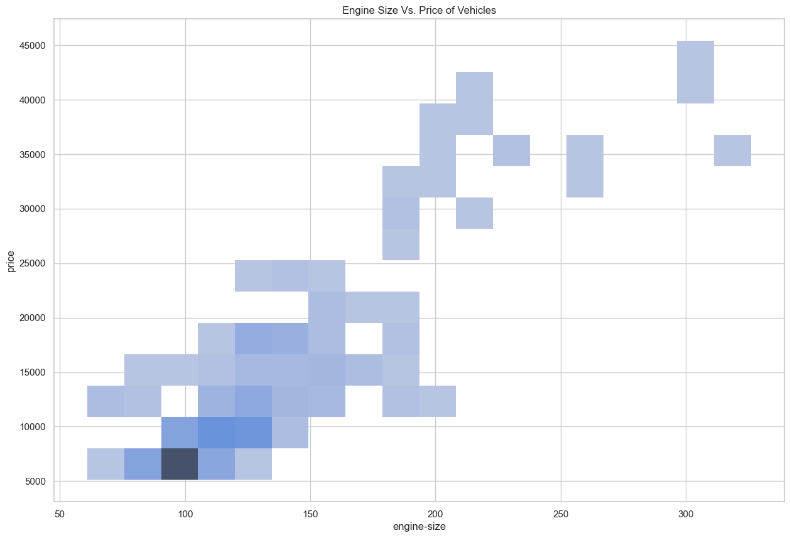

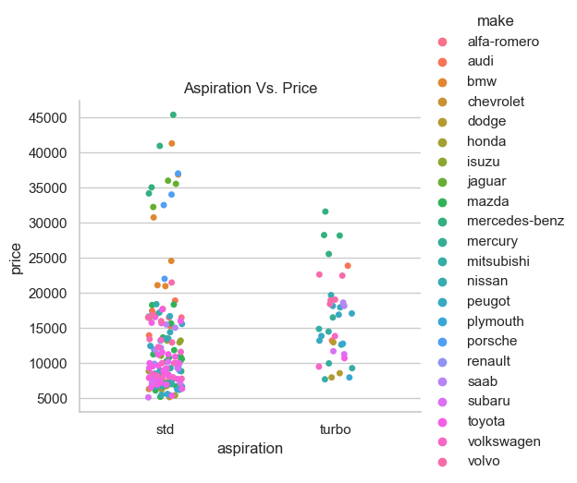

In conclusion, the popularity of the cars in the dataset is primarily based on price, most specifically the lower the price of a car, the more popular it will be. Yet there are other factors that only come into play such as family-friendly designs and efficient fuel consumption.

THIS REPORT WAS WRITTEN BY : Naomi Bouch

