* File 1 – Customers: there’s a list of customers, channel code, market segment code and brand group code.  
  the number of customers to 1K.
* Mapping Catalogues: this file shows which catalogue should be applied based on customer’s channel, market segment and brand group combination. Note that the channel, market segment and brand group have French descriptions here instead of the codes.
* To map codes with descriptions there’re two auxiliary files:  
  - Marketing segmentation values for channel and market segment  
  - Brand Group  
  These files will help you to match the 1st two files between each other.

Task 1 (mandatory). To define which catalogue should be applied to which customer based on its channel, market segment and brand group.

Task 2 (optional). To present the result in a Power BI dashboard.

For the 1st task let me bring you one example.

1. We take customer 1, which has channel DL, Market Segment M100 and Brand Group



1. We see in the auxiliary files that:  
   Channel DL = Concessionaire

  
Market Segment M100 = Marine (Commerciale)

  
Brand Group LD = Honda Marine

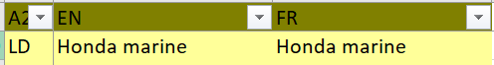

1. We go to the Mapping Catalogues files and see that the combination of Concessionaire + Marine (Commerciale) + Honda Marine gives us Catalogue E  
   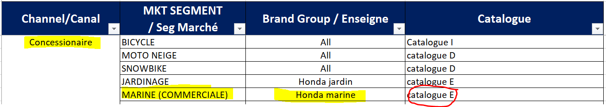
2. So it means that customer 1 should be assigned to catalogue E.

