1.First Demo Execution in console andwe write Simple JS Functionand see Output and lets take its Screen shot.

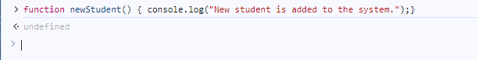

2. The function runs and execute the codes contain within the function and print to the console the following and its screenshot



3. let’s pass an argument to the function. First, clear the console window – click the browser refresh button, enter the following codes and then press enter or return key and after execution its output:

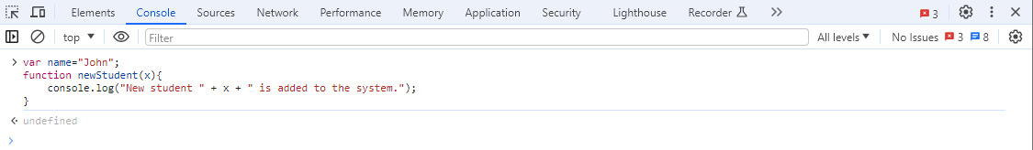

4. We will now call the function by entering the function name along with an argument (the variable) to be passed to it and then hit enter or return key. The concatenate message will be printed to the console and its Output can be seen in Screenshot

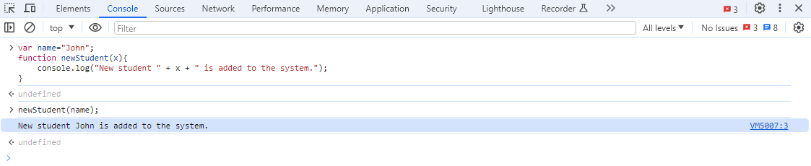

5. we will look at conditional statements. The if-else or if-elseifelse statements are examples of this decision making process. We will create a variable that contains a value or data to be used as part of the decision making and the output is seen in below screen shot

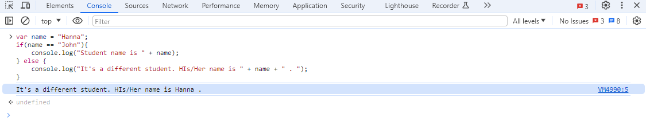

6. Change the value of the name variable from Hanna to John. Then hit the enter or return key. This time the statement evaluates the condition to true. As a result, the first message will be printed to the console for output you an see below screenshot:

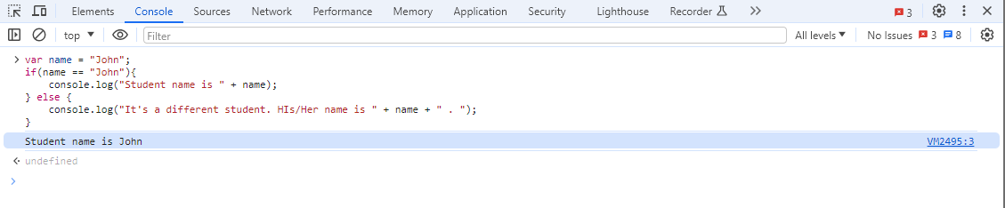

7. let’s practice an if-elseif-else statement. Return to your console window and clear the codes. In this demo, we are constructing a multiple elseif statement to see how it works. Enter the following codes.

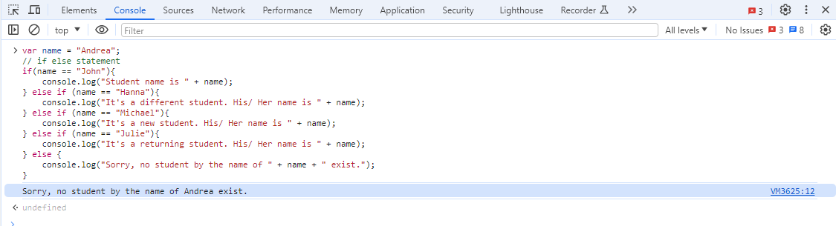

8. we’ll practice an if-else statement that test more than one condition at the same time. The first example uses the and (&&) to evaluate to a true statement. Enter the following on a cleared console:

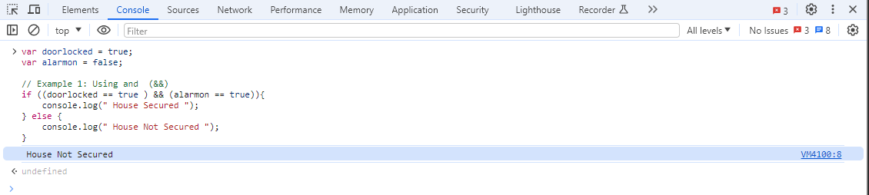

9. The second example uses the or (||) to evaluate to a true statement. Enter the following on a cleared console:

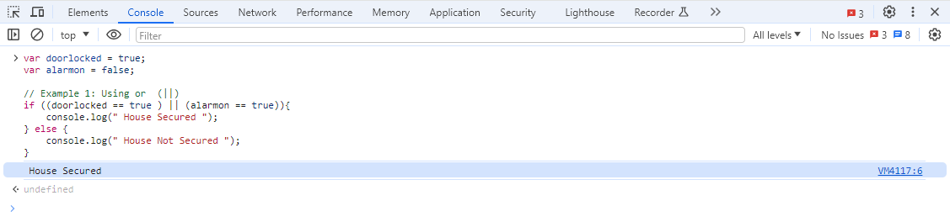

10. What if the values of both variables are reversed?

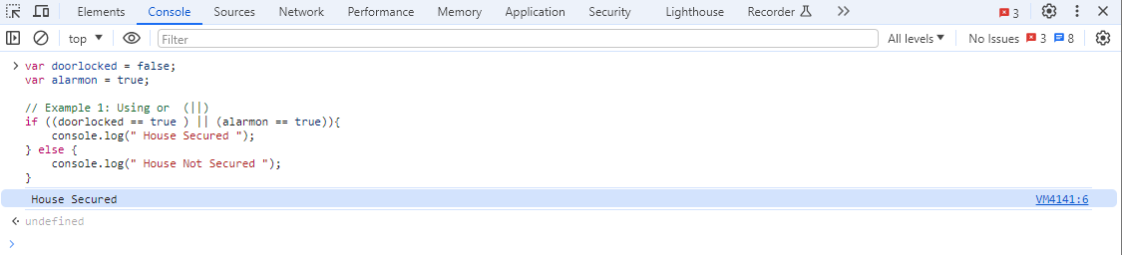

11. The final demo is the switch statement. Switch works similarly to the if-elseif-else statement. Return to your console, clear all codes and enter the following:

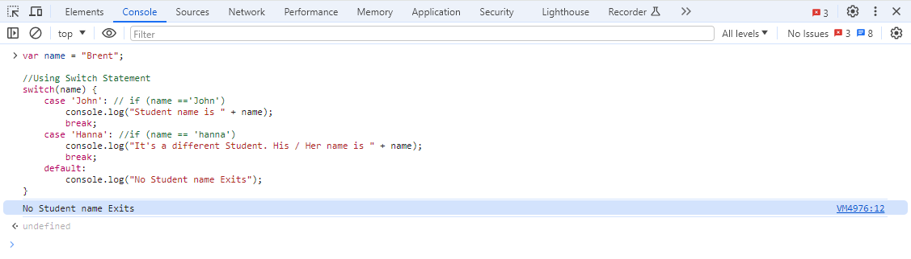

**Day2 Output_Screenshots**

1.