### Next Meeting: November 28, 2022. 11:00 - 1:00 CST / 12:00-2 pm Eastern Standard Time

* Christmas party!

### November 14, 2022. 11:00 - 1:00 CST / 12:00-2 pm Eastern Standard Time

* **Orientation, Project Management approach (**5 min) -Joy
  + Agenda access From Google Calendar… see PEM_HEB and update ALL
  + Or Access at Google Drive[Notes - Habitat Ecology Bi-Weekly Meeting](https://docs.google.com/document/u/0/d/1qGvndeFGDzoM2J2cgOo8-GZmbIdy85X5cSJ3BB164Uo/edit)
  + Tip

Star Link

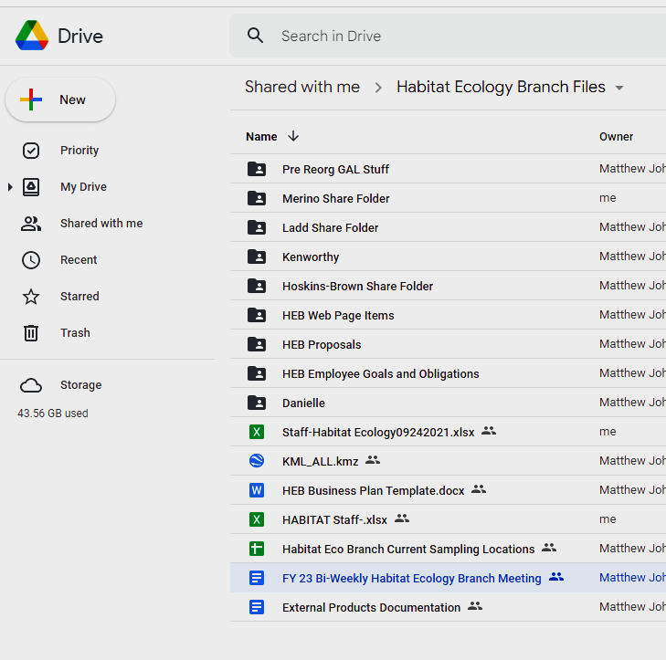

**Use high level folders like this for STARS!**

see Starred on GDrive

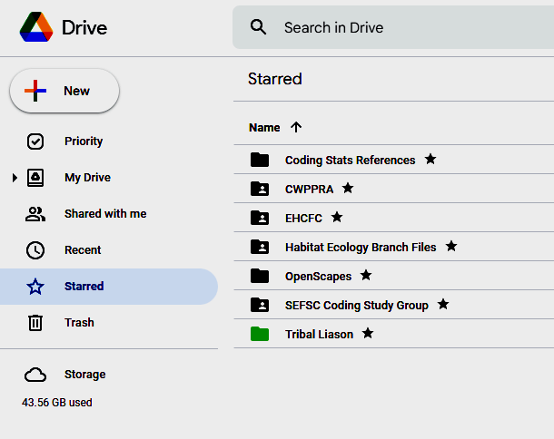

* **OperationsUpdates** (15 min) -MWJ
  + PAWS- Performance Plans
  + SEBAS status
  + Budget
  + Annual Branch Strategies of Business Plan Development

-Open Discussion

* **Project Funding Status** (2 min) - MWJ
  + MARFIN LOI - 8 submitted. Excellent group work
  + [MARFIN](https://drive.google.com/drive/folders/1l-8Jt9lc2MvZmFU6t7NyXT6WiDi-HkNa?usp=share_link) Applications : HEB had 4 of 8 submitted

-Assessing range, estuarine habitat use, and interspecific c**ompetition** between two juvenile, gray and lane snapper *Jennifer Doerr, Joan Browder,Jen Leo, Lauren LaMonica, John Everhart*

-Identifying resilient acroporid populations in St. Croix: Determining **genotypic distributions** and connectivity in the U.S. Virgin Islands *Jennifer Doerr, Hannah Nylander-Asplin …RonHill*

*-*Identification of Critical Habitat for Penaeid Shrimp Using **Stable Isotopes** *Dionne Hoskins-*

*Brown, Joan Browder, Jennifer Doerr*

-Evaluation of the fishery impacts of **dredging** on shallow mud bottoms *Joy Merino*, *Dionne Hoskins-Brown, Jennifer Doerr, Joshua Goldston*

* + MARFIN Reply expected …
  + MSA -Pre Proposals : 2 submitted

- Snapper Expansion *Doerr, Everhard, LaMonica*

- Habitat Transition *Doerr*

* + MSA - Full Proposals…? due…
  + Catch Share Program RFP
  + HCD
  + Aquaculture FY23 Internal Competition

-Understanding the far-field impacts of offshore pen culture on fish and fishermen in the Gulf of Mexico. *Matt Johnson with Dauphin Island Sea Lab (DISL), U of S. Alabama*

-Identifying the linkages between salt marsh and **black mangrove** estuarine habitats and habitat-specific density and abundance of fishery species across the Gulf of Mexico *Jennifer Doerr collaborating with James Nelson ULL*

* **Project Funding PROCESS** (10 min) - Open Discussion
* Staff add updates here….

Of note…[National Marine Ecosystem Status Website](https://ecowatch.noaa.gov/home)

* In Progress~~Coral - Mark~~

| ***Project*** | ***Status*** | ***Related files*** | ***Notes*** |
| --- | --- | --- | --- |
| *Meeting Notes* | *Lord help me!* |  | * *~~to this~~* |
| *Pathway* | *so-so* | [Merino Openscapes Pathway](https://docs.google.com/spreadsheets/u/0/d/1ISDwJGmY0qk_n8AaiIoUdK8NDAnnTfwBPD_nrN3tqrM/edit) |  |
| *HEB Calendar* | *ok* | [nmfs.sefsc.pem.habitat@noaa.gov](mailto:nmfs.sefsc.pem.habitat@noaa.gov) |  |

* Openscapes Progress and [Philosophy](https://www.nature.com/articles/d41586-019-03335-4) -Joy

*Tip of the day:* Google Drive Change folder colors. Select folder, right click, only YOU see color change.

### November 1, 2022. 11:00 - 1:00 CST / 12:00-2 pm Eastern Standard Time

* **Halloween Updates presentation**: Matt provided updates via presentation here.
* ~~Joy to send GSA vehicle licenses~~
* ~~Dionne to share article with Joy~~
* Mark shared [a cheap tech option for cameras](https://www.sciencedirect.com/science/article/pii/S2468067219300537), Coral Cam. This is the [logic board for $40](https://www.ecologisconsulting.com/products/p/coralcam-v3-pcb)
* Openscapes - team work options Hannah uses Asana, Dionne: slack too busy,
* Coral field work status
* Many out later this week -
  + update calendars, for Holidays All!.ALL

*Tip of the day: Use Google Stars to find files.*

### STAFF, TASKS, and PROJECTS Inventory

| ***Project*** | ***Status*** | ***Related files*** | ***Notes*** |
| --- | --- | --- | --- |
| *Meeting Notes* | *Needs Review* |  |  |
| *Pathway* | *so-so* | [Merino Openscapes Pathway](https://docs.google.com/spreadsheets/u/0/d/1ISDwJGmY0qk_n8AaiIoUdK8NDAnnTfwBPD_nrN3tqrM/edit) |  |
| *HEB Calendar* | *ok* | [nmfs.sefsc.pem.habitat@noaa.gov](mailto:nmfs.sefsc.pem.habitat@noaa.gov) |  |

| ***TEAMS*** | ***Needs*** | ***associates*** | ***Notes*** |
| --- | --- | --- | --- |
| *Coral* [Mark Ladd - NOAA Federal](mailto:mark.ladd@noaa.gov) | *ok* | [Kathryn Grazioso - NOAA Affiliate](mailto:kathryn.grazioso@noaa.gov)[Sophia Ippolito - NOAA Affiliate](mailto:sophia.ippolito@noaa.gov)[Allan Bright - NOAA Affiliate](mailto:allan.bright@noaa.gov)[Dylan Orcutt - NOAA Affiliate](mailto:dylan.orcutt@noaa.gov) | [*Bi-Weekly Meeting Fridays*](https://www.google.com/url?q=https://docs.google.com/document/d/1GqqB_0iXUCi0ZSZVKjihk7XSappP53eWe1CqK0q0MW4/edit?usp%3Dsharing&sa=D&source=calendar&ust=1668025728053995&usg=AOvVaw3AHC3-c7LZR8LwtqYp__f9) |
| *ROSES* | *ok* | [Matthew Johnson - NOAA Federal](mailto:matthew.johnson@noaa.gov)[Jennifer Doerr - NOAA Federal](mailto:jennifer.doerr@noaa.gov)[Jennifer Leo - NOAA Federal](mailto:jennifer.leo@noaa.gov)[Joan Browder - NOAA Federal](mailto:joan.browder@noaa.gov) |  |
| *GulfCoast,* [Jennifer Doerr - NOAA Federal](mailto:jennifer.doerr@noaa.gov) | *so-so* | [Hannah Nylander-Asplin - NOAA Affiliate](mailto:hannah.nylander-asplin@noaa.gov) | [*Southeast Climate Team*](https://docs.google.com/document/d/1iuGyvNfZW7gTqdnhA30W2KqQn2tUUHkZY80bPup2TEA/edit) *(SERAP*  *AOML-Climate Fisheries Initiative Project*  *ESA* |
|  | *ok* |  |  |
| *Snapper*  [Joan Browder - NOAA Federal](mailto:joan.browder@noaa.gov) | *SOS* | [John Everhart - NOAA Affiliate](mailto:john.everhart@noaa.gov)  [Nathan LaSpina - NOAA Affiliate](mailto:nathan.laspina@noaa.gov)  [Joshua Goldston - NOAA Affiliate](mailto:joshua.goldston@noaa.gov) | *Periodic Scientists Conference Call Lake Okeechobee/Estuaries*  *Biscayne Bay Science Coordination*  *BBSEER WaterQualitySubTeam*  *RECOVER Regional+ Executive+SWFL Team*  *NSP Strategic Plan Steering Committee* |
| *Leo* | *ok* | [Jan Lara - NOAA Affiliate](mailto:jan.lara@noaa.gov) | *SERO Education and Outreach?*  *SEFSC Outreach*  *YNAB?*  *Complexity Explorer?*  [*Southeast Climate Team*](https://docs.google.com/document/d/1iuGyvNfZW7gTqdnhA30W2KqQn2tUUHkZY80bPup2TEA/edit) *(SERAP* |
| [Dionne Hoskins-Brown - NOAA Federal](mailto:Dionne.Hoskins-Brown@noaa.gov) | *ok* |  |  |

### CONTACTS to KNOW or KEEP

| **SE HCD Partnerships with:** | **subgroup** | **HCD Rep:** |  | **HEB collaborator:** |
| --- | --- | --- | --- | --- |
| **NOAA Coral Reef Conservation Program** |  |  |  | [Matthew Johnson - NOAA Federal](mailto:matthew.johnson@noaa.gov) |
| **SE Aquatic Resource Partnership (SARP)** | *SARP Steering Committee* |  |  |  |
|  | *SARP Science and Data Subcommittees* |  |  |  |
| **National Estuary Program (NEP)s** | *Galveston Bay Estuary Program* |  |  | [Jennifer Leo - NOAA Federal](mailto:jennifer.leo@noaa.gov) |
|  | *Barataria Terrebonne* |  |  |  |
|  | *Tampa Bay* |  |  |  |
|  | *Sarasota Bay* |  |  |  |
|  | *Charlotte Harbor* |  |  |  |