# Attendance

Entity Relationship Diagram(ERD)

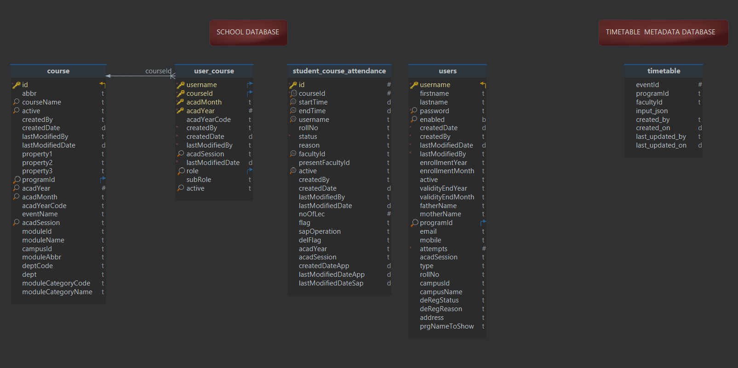

## Tables:

1. Master Tables: users, user_course, course from school database
2. Attendance Table: timetable from timetable_metadata database and student_course_attendence from School database.

## Diagram:

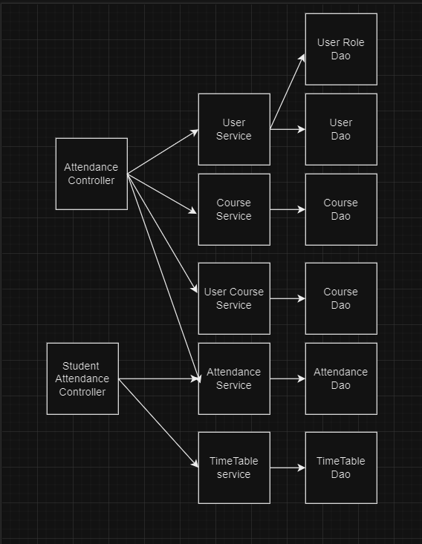

## Data Flow:

1. **Data Transmission**:
   * Daily attendance data is transmitted from the SAP system to our system.
   * The data is stored in the timetable_metadata database, specifically in the timetable table on the MySQL server.
2. **Faculty Access**:
   * Faculty members access the system to view their attendance slots.
   * The application retrieves relevant data by combining information from three tables:
     + **Timetable Table**: Provides the schedule.
     + **Course Table**: Contains details about the courses being taught.
     + **Usercourse Table**: Holds information about student enrollments in these courses.
3. **Attendance Marking**:
   * By default, all students are marked as present.
   * Faculty members can mark any student as absent using a toggle feature.
4. **Data Storage**:
   * Once attendance is recorded, the data is stored in the student_course_attendance table.
   * This table is used to retrieve attendance data for viewing and editing purposes.
5. **Faculty Updates**:
   * Faculty can easily access and update attendance records, ensuring accurate and up-to-date information.
6. **Student Access**:
   * Attendance data received from SAP is stored in both a MySQL database and a text format.
   * Students can retrieve and view their attendance records accurately.