6/25/2021

Max Adams

NMIT

Exploring and Describing the Technology Edge of Web Technology

WEB701

# Why Use Vue?

What are the benefits of using Vue.js as a web framework going forwards?

Vue.js is a relatively new and developer friendly web framework created by Evan You. Evan You worked for Google on various Angular.js projects and Vue.js was the result of Evan liking many of the features that Angular.js has to offer, but he wanted to make it far more lightweight and easier to use. Vue.js has a far shallower learning curve than Anuglar.js and compiles and executes its functions far more quickly due to how light weight it is, especially in comparison. Vue.js also implements a method called “tree shaking”. This method allows the user to only import the parts of the library that you need for your application. This even further reduces the impact on both the physical system it is being hosted on, and the overall network performance of the app. Vue.js uses a diffing algorithm to boost the performance of its rendering.

The downside of Vue.js when compared to Angular.js is that there are less people that know how to use it, its library of tools, prebuilt features, online resources, and support are not as extensive, and it may not handle extremely large and extensive web applications as well.

These reasons may seem to stack up in Angular.js’ favour, however, I believe that Vue.js handles exceptionally well and is growing extremely fast in the web framework world. Its usability and lightweight design make it perfect for smaller, reliable websites that do not require the clunky, yet extremely extensive tools that Angular.js provides. I am not the only one that believes this either.

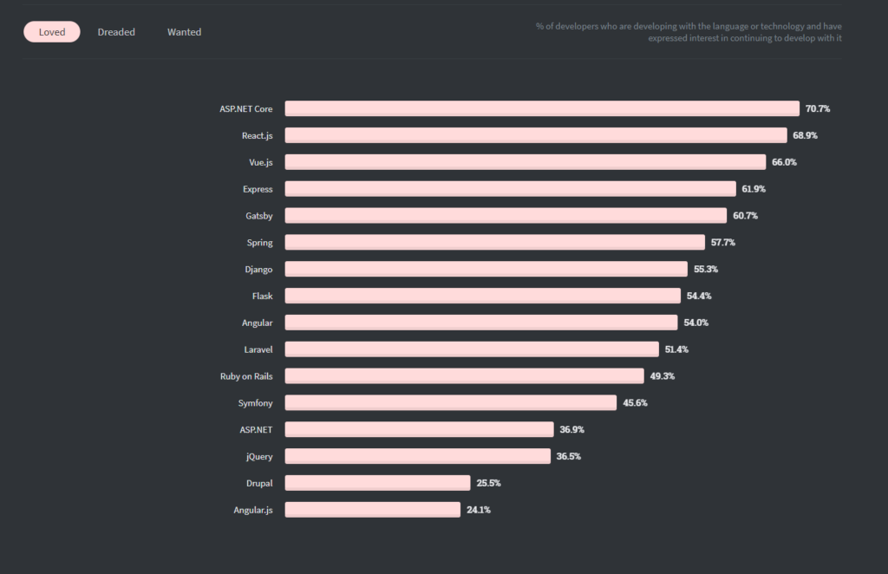

According to this chart obtained from (10 Most Popular Web Frameworks to Use in 2021 | Monocubed, n.d.), Vue.js is the third most popular web framework for web developers. Far more popular than Angular and just shy of being the most popular. The reason for this popularity is in that it is easy to use, and extremely lightweight which makes rolling out websites to most clients easy and their apps will be run and render extremely quickly. It is no wonder its popularity has recently skyrocketed.

# My Implementation

I used multiple Vue.js components for the creation of my web app. One online resource that I found very helpful was <https://mdbootstrap.com/docs/vue/> (“Vue Bootstrap with Material Design - Powerful and Free UI KIT,” n.d.). This website has thousands of templates and tutorials for many different web frameworks and fortunately, it has many for Vue. It incorporates Bootstrap which is a CSS framework that I am very familiar with and produces many clean and user friendly components. The one that I chose to use was the carousel found [here](https://mdbootstrap.com/docs/vue/advanced/carousel/). The main issue that I found with Vue was getting the css to work properly so I admittedly did not fully implement that in this component. However, the carousel still works and other than the css was extremely easy to implement and alter to suit the website I created.

Another Vue component I utilized was the router-link. This system is an extremely efficient and sensible way to handle changing pages while retaining user information. This in conjunction with a token service (that I will discuss later) made what has traditionally been an extremely tedious task for me, quite easy to achieve.

For this web application [Bezkoder](https://bezkoder.com/) has been extremely helpful (bezkoder, n.d.). His tutorials on both Vue.js and Angular.js were informative and easy to follow and resulted in a website that already met a large amount of the criteria for this assessment. For this Vue project a store was utilized that handled keeping the state of the user and the site as well as send requests through the services to the API and back. The best Vue components that I used were a combination of Form, Field and Error Message (from [vee-validate](https://vee-validate.logaretm.com/v4/) (VeeValidate, n.d.)) and yup. Following information from [this website](https://vee-validate.logaretm.com/v4/guide/components/validation) (Validation, n.d.), this method of implementing forms with validation is second to none that I have tried. While setting it up takes a little while, it was impressive how intuitive, easy and well formatted this approach is. Look at this code:

(From Register.Vue in HelpingFamiliesNelson - Vue)

It is the cleanest and easiest to alter form validation that I have come across and it made adding new fields with new validations extremely easy and straightforward. Something that can seem difficult at times.

In general, using Vue was a breeze when compared to Angular. I had issues with Angular not submitting forms then submitting them twice, but Vue had no such issue and handled a lot of the error checking by itself. The layout of the .vue files using <template>, <script> and <style scoped> was intuitive and having everything on the same page for a web application as small as this one was useful. I can understand for a bigger application this being too much for one page though as this could result in code being difficult to find.

# Conclusion

To conclude; Vue.js is a viable web framework due in large part to its user-friendly approach to developing websites and its lightweight nature. I would recommend Vue.js as a framework for anyone starting out developing, or full time developing for small to medium businesses. Vue is a tool that is being used a lot right now, and will continue to be used a lot in the future making it a great choice for a framework to master as there is plenty of scope for job possibilities using this framework.

# References:

10 Most Popular Web Frameworks to Use in 2021 | Monocubed. (n.d.). Retrieved June 26, 2021, from <https://www.monocubed.com/10-most-popular-web-frameworks/>

Vue Bootstrap with Material Design—Powerful and free UI KIT. (n.d.). Material Design for Bootstrap. Retrieved June 26, 2021, from <https://mdbootstrap.com/docs/vue/>

bezkoder. (n.d.). BezKoder—Mobile & Web App Development Tutorials. BezKoder. Retrieved June 26, 2021, from <https://bezkoder.com/>

VeeValidate. (n.d.). Retrieved June 26, 2021, from <https://vee-validate.logaretm.com/v4/>

Validation. (n.d.). Retrieved June 26, 2021, from <https://vee-validate.logaretm.com/v4/guide/components/validation>