At first, Install Visual Studio Community 2015

1. Install OCULUS RIFT
2. Put OCULUS SDK in OS(C:)
3. Install Zed_SDK
4. Put SDL2 and EigenDIR in OS(C:)
5. Install Boost Pre-Built Binaries (boost_1_66_0-msvc-14.0-64)

Install cmake Windows Gui (cmake-3.13.5-win64-x64)

Open zed_oculus\build\ZED_Stereo_Passthrough in Visual Studio.

In Solution Explorer window

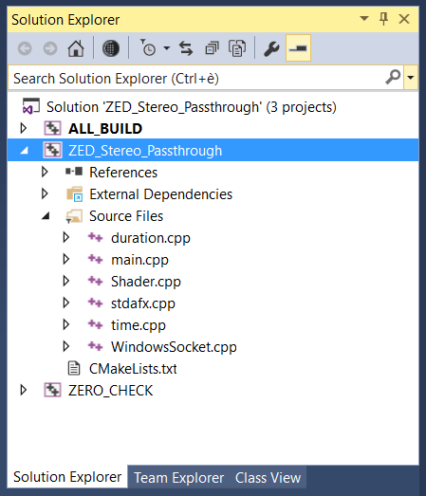

click the right mouse button on ZED_Stereo_Passthrough and choose “Properties”.

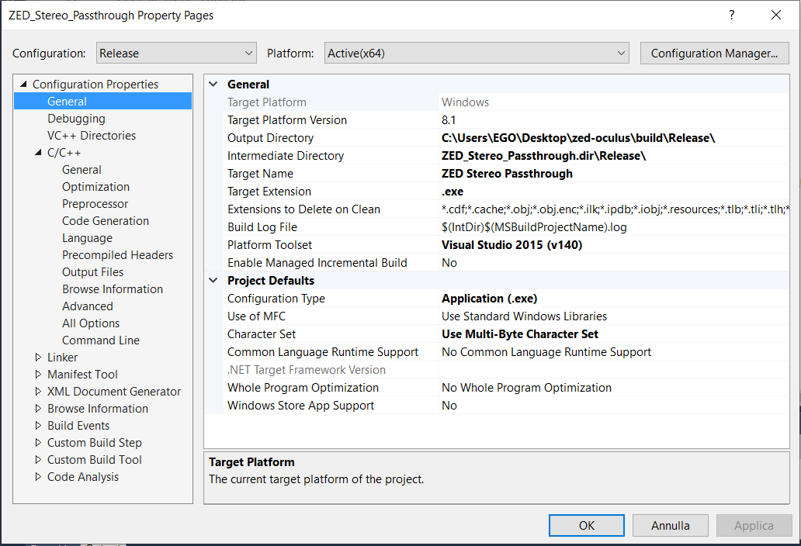

In the new windows, click on C/C++ >Optimization and disable the optimization:

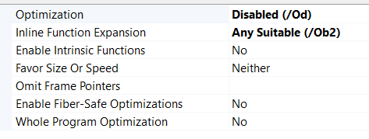

Then, in C/C++ > General clik on Additional Include directories and, compared the open windows with the one reported below, add the missing directories. 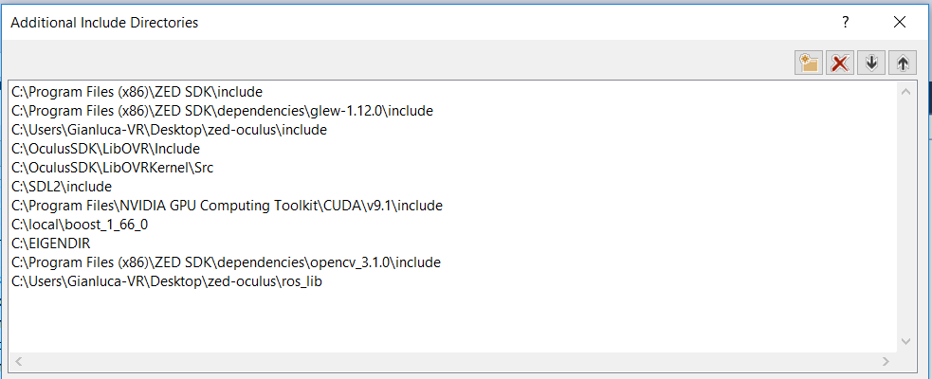

In Linker > General clik on Additional library directories and, compared the open windows with the one reported below, add the missing directories.

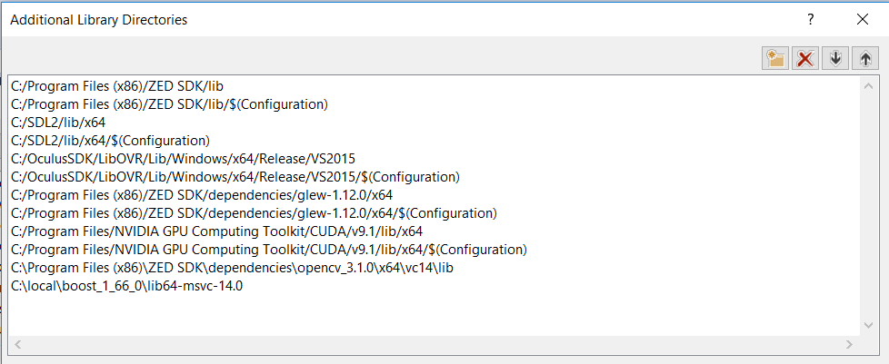

At the end, Linker > Input clik on Additional Dependencies and, compared the open windows with the one reported below, add the missing dependencies.

