**Expt. # 01**

**Name of Expt**: Verification of Ohm’s law

**Aim of the experiment:**

Verification of Ohm’s law by showing that the voltage to current ratio is constant.

To determine the resistance of an unknown resistor by plotting a graph for potential difference (V) versus current (I).

**Apparatus required**:

A power supply (Voltage source or Battery).

An ammeter (mA) to measure current.

A voltmeter (V) to measure Voltage.

A rheostat to control and adjust the current through the circuit.

**Materials required**: Connecting wire, unknown resistors etc.

**Brief theory**:

**Ohm**'s **law** states that for a constant temperature, the current passing through a conductor (or a resistor) is directly proportional to potential difference applied across it.

Mathematically, **I $∝$ V**

i.e. **V** = **I R**; or, **V**= **I** × **R** ; where V is the voltage, I is the current and R is the constant of proportionality known as resistance of the conductor and measured in Ohms (Ω).

Resistance(R) is inversely proportional to current (I) i.e. **R** = **V**/**I** and **I** = **V**/**R**

The circuit diagram to verify ohm's law is shown below. A voltmeter across a resistor is connected in parallel. An ammeter to measure current in the circuit is connected in series. A variable resistor is connected as shown, changing the resistance would alter potential drop across the resistor which would affect the amount of current through it.

**A** is the ammeter to measure current (note that ammeter should always connected in series with the load through which the current is flowing).

**V** is the voltmeter to measure voltage or potential difference (note that voltmeter should always be connected in parallel with the load across which the voltage is developed).

**R** is the unknown resistor whose value is to be determined.

**B** is the power supply or battery.

**Rh** is rheostat or potentiometer.

**K** is key acts as a switch to make the circuit close or open.

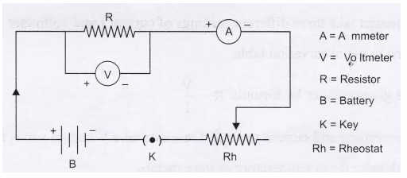

**Procedures:**

1. Connect the circuit as per the circuit diagram shown. Check the polarity or direction of the ammeter and voltmeter connection.
2. For our case the rheostat and key are not used so the –ve terminal of the ammeter is directly connected to the –ve terminal of the variable power supply.
3. Vary the power supply from zero, in steps of 1 volt and note down the readings of ammeter and voltmeter in the table for 5 or 6 steps.
4. Calculate the value of resistor for each step’s reading.
5. Draw the graph, with suitable scale of voltage (V) versus current (I) and compute the resistance using R = ΔV/ΔI between two points of the V-I curve as shown in figure 2.

**Observation table:**

|  |  |  |  |  |
| --- | --- | --- | --- | --- |
| **Sl no.** | **Voltage (V)** | **Current (I)** | **Resistance (Ω)** | **Comments** |
| **1.** |  |  |  |  |
| **2.** |  |  |  |  |
| **3.** |  |  |  |  |
| **4.** |  |  |  |  |
| **5.** |  |  |  |  |

So, we can see that in each observation the voltage to current ratio is almost the same. Thus, the voltage across the conductor (unknown resistor) is proportional to the current through passing through it. Hence Ohm’s law is verified.

Now we got the calculated value of the resistance of the wire is R = 100 Ω.

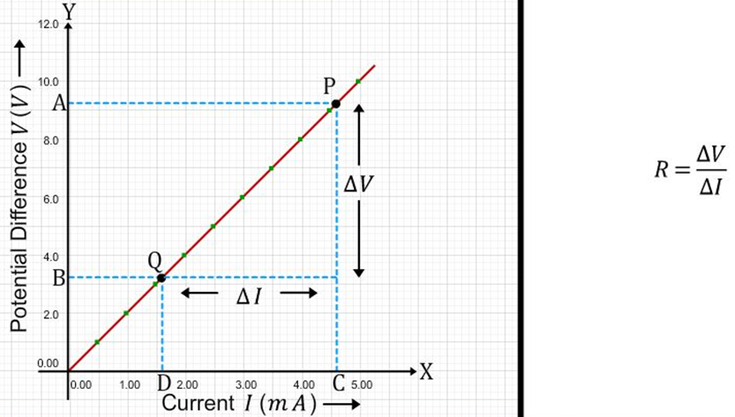

We also need to verify the experimental value of R = *Δ*V/*Δ*I from the I-V graph to confirm again.

Note that the slope (m = tan θ = perp/base) of the I-V graph gives the resistance of the unknown resistor.

Now, suppose from the graph, the change in current, ∆I = CD = 0.01 amp corresponding to change in voltage, ∆V = AB = 1.0 volt

Thus, the resistance from the graph, R = ∆V/∆I = 1.0/0.01 = 100 ohm.

**Calculation of resistivity of the wire with 1 Ω resistance:**

If length of the wire is, L = 50 cm = 0.5 m,

Radius of the wire, r = 0.25 mm = 0.25 × 10-3 m

So, the cross-section area of the wire,

A = πr2 = 3.14 × (0.25×10-3)2 = 0.196 × 10-6 m2

Thus from the expression R = ρL/A, we get the resistivity of the material of the wire is, ρ = (1 × 0.196 ×10-6)/0.5

or, ρ = 0.392 × 10-6 = 3.92 ×10-7 ohm-m

Thus the resistivity of the material of the wire is 3.92 ×10-7 ohm-m.

**Prerequisites:**

* **Charge:** There are two charges in nature i.e., positive and negative. The negative charge is due to **electron**. Its value is 1.602 x 10-19 C. It is measured in Coulombs.
* **Coulomb:** One Coulomb is the amount of charge present on 6.25 x 1018 electrons.
* **Electric Current:** It is the rate of flow of charge through a conductor. If a net charge Q flows across any cross-section of conductor in time t, then the current I, through the cross-section is  
  **I = Q/t**; the unit of current is Ampere.
* **One Ampere:** One Ampere is constituted by the flow of one coulomb of charge per second.  
  **1 A =1 C/1s**
* It is measured by an instrument called **ammeter** which is always connected in **series** in a circuit.
* **Potential difference** in an electric circuit carrying current is the work done to move a unit charge from one point to the other and measured by an instrument called **voltmeter** which is always connected in **parallel** with the circuit. So,
* **V**= **W/Q** = **Work done/Charge**. The SI unit of potential difference (PD) is volt (V).
* **One Volt:** When 1 joule of work is done to move a charge of 1 Coulomb from one point to the other in a circuit then the potential difference is of 1 volt.  
  **1Volt = 1 Joule /1 Coulomb**
* **e.m.f.:** Electro motive force is the force which disturbs the equilibrium of free electrons flowing in the metal wire. The source of e.m.f. like cell or battery can develop a potential difference across the ends of the wire and the electrons can flow through the wire. EMF is the PD across the terminal of a battery when there is no load connected across it.
* **Cell:** A cell is a device which produces potential difference in the wire and supplies the electrons to flow through the closed circuit.
* **Battery:** is a combination of two or more cells.

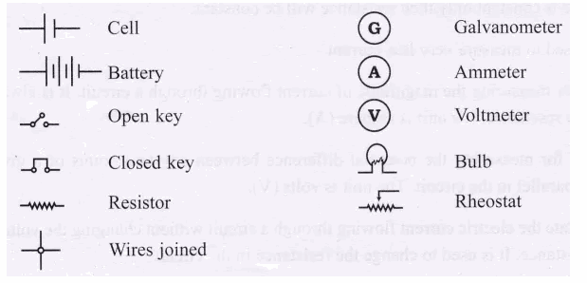

* **Resistor:** It is a passive electronic component which offers restriction to the flow of current through it. Its unit is Ohm (Ω).
* **Resistance:** When the electrons flow through a wire conductor, they collide with the atoms of the wire, due to this collision the speed of electrons flowing gets disturbed and they also lose the energy in the form of heat energy. This obstruction or restriction for the flow of electrons is called resistance.

Each and every wire that may be a very good conductor of electricity will certainly offer some resistance to the flow of electrons.

* **Factors affecting resistance:**  
  (a) If the wire is long then the collision of electrons flowing through the wire will be more and hence it will offer more resistance. But if the wire is thick the collisions would be less and the resistance offer would be less. Hence, the resistance of the wire depends on the thickness, length material and the temperature of the wire.  
  (b) If the wire is made up of same material and is thick the resistance will be less as compared the long wire of the same material at the constant temperature.  
  (c) This law is not valid for semiconductors like diode, thermistor, diode, filament of lamp, light dependent resistor, LED etc. Therefore, all semiconductors are called non-ohmic materials.
* **Validity of Ohm’s Law:** Ohm’s law is valid only under the condition when temperature is kept constant. This is reasonable because when temperature is constant only then resistance will be constant.
* **Galvanometer:** It is an instrument used to measure very low current.
* **Ammeter:** It is an instrument used for measuring the magnitude of current flowing through a circuit. It is always connected in series, it offers very low resistance. Its unit is ampere (A).
* **Voltmeter:** It is an instrument used for measuring the potential difference or voltage between any two points of a given circuit. It is always connected in parallel with the circuit. The unit is volts (V).
* **Rheostat:** A component used to regulate the electric current flowing through a circuit without changing the voltage is called Rheostat. It is a variable resistance. It is used to change the resistance in the circuit hence the current.
* **Ohm’s Law:** The potential difference, V across the ends of a given metallic wire in an electric circuit is directly proportional to the current flowing through it, provided its temperature is the same. This is Ohm’s law. V ∝ I; or, **V** = **I** × **R**, (where R = a constant for the given metallic wire). The SI unit of resistance is Ohm (Ω).
* **One Ohm:** If the potential difference across the ends of a conductor is 1 volt and the current flowing through it is 1 ampere, then the resistance of the conductor R is 1 ohm.

**1 Ohm = $\frac{1 Volt }{1 Ampere}$**

**To calculate the least count of an analog ammeter or voltmeter:**

**A**. If in the ammeter, there are 50 divisions from 0 to 100 mA then each division indicates 2 mA.  
To calculate the least count of ammeter,   
Range of ammeter = AR and number of small divisions in ammeter = AS  
Therefore the least count of ammeter *= $\frac{AR}{AS}$*

= 100 mA / 50 division = 2 mA / division.

**B**. If in a voltmeter there are 50 small divisions from 0 to 50 V then each small division represents 1 V.   
To calculate the least count of voltmeter,  
Range of voltmeter = VR and the number of divisions in voltmeter = VD

Therefore least count of voltmeter = $\frac{VR}{VD}$   = 50 V/50 division = 1 Volt/division..