**Question 1**

INNER JOIN: Orders with Customer and Product Names Question List all orders along with the customer name and product name. Expected Output Columns: • OrderID, OrderDate, CustomerName, ProductName, Quantity

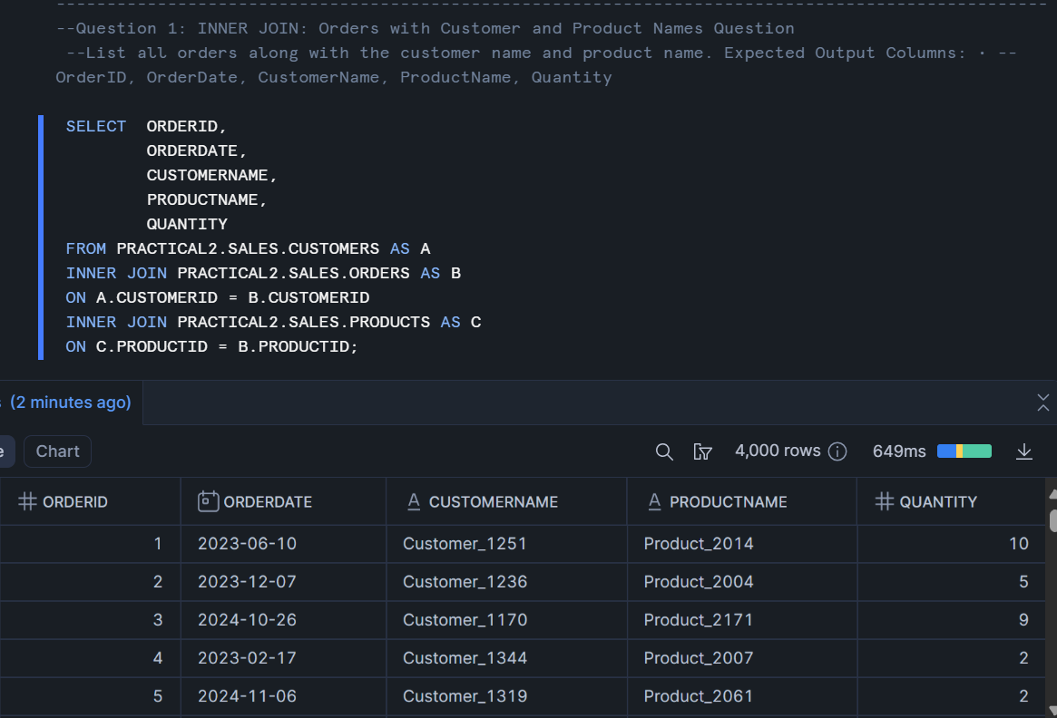

**Question 2.**

INNER JOIN: Customers Who Placed Orders Question: Which customers have placed at least one order? Expected Output Columns: • CustomerID, CustomerName, Country, OrderID, OrderDate

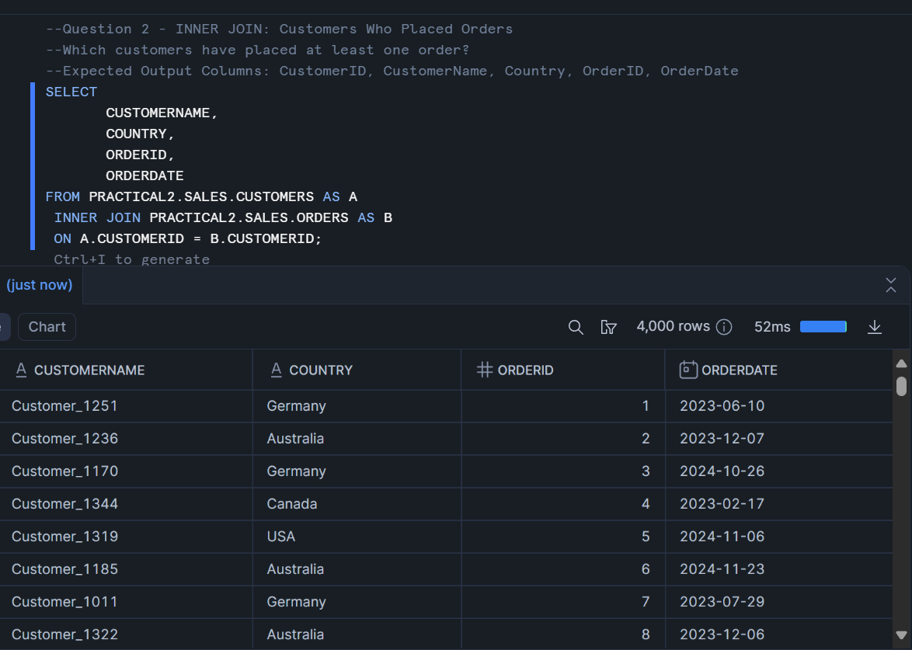

**Question 3**

LEFT JOIN: All Customers and Their Orders

List all customers and any orders they might have placed. Include customers who have not placed any orders. Expected Output Columns: • CustomerID, CustomerName, Country, OrderID, OrderDate, ProductID, Quantity

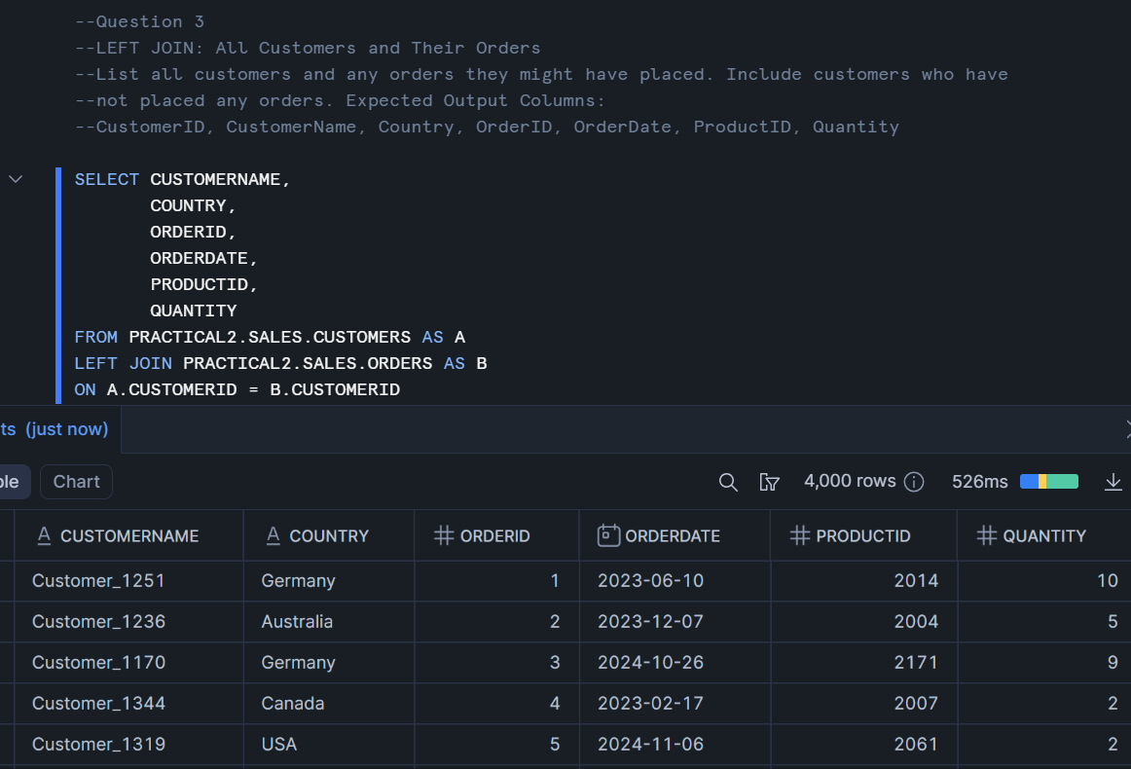

**Question 4**

LEFT JOIN: Product Order Count Question: List all products and how many times each was ordered (if any). Expected Output Columns: • ProductID, ProductName, TotalOrders (TotalOrders is the count of how many times the product appears in orders)

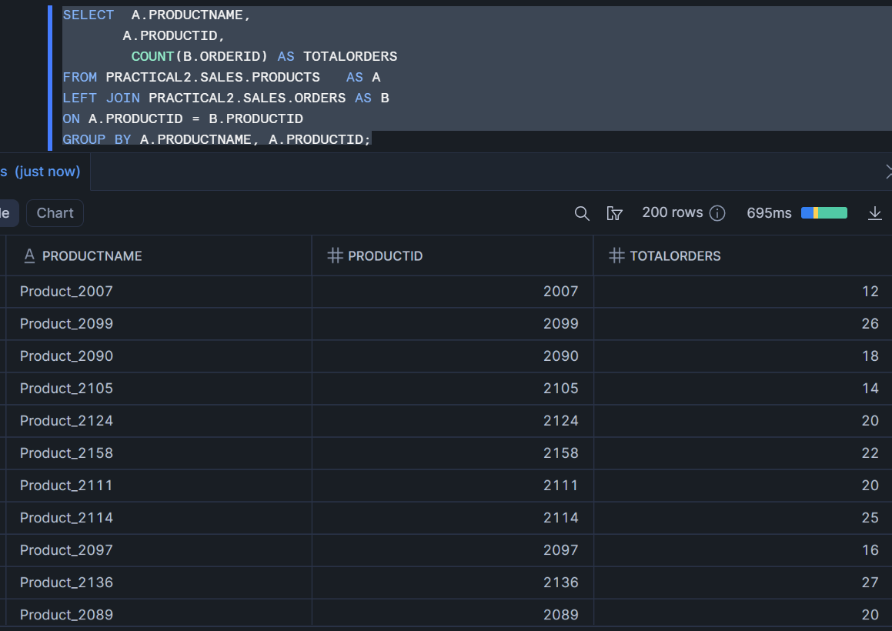

**Question 5**

**Question 6: RIGHT JOIN: Customer Info with Orders (Include All Customers)**

--Which customers have made orders, and include customers even if they have never

--placed an order.

--Expected Output Columns:

--CustomerID, CustomerName, Country, OrderID, OrderDate, ProductID, Quantity

**Question 7: FULL OUTER JOIN: All Customers and All Orders**

List all customers and orders, showing NULLs where customers have not ordered or where orders have no customer info. Expected Output Columns: • CustomerID, CustomerName, Country, OrderID, OrderDate, ProductID, Quantity

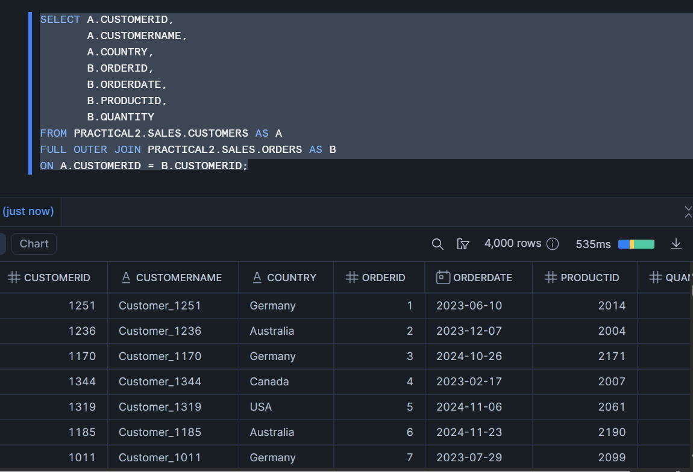

**Question 8. FULL OUTER JOIN: All Products and Orders**

List all products and orders, showing NULLs where products were never ordered or orders are missing product info. Expected Output Columns: • ProductID, ProductName, Price, OrderID, OrderDate, CustomerID, Quantity

