Name: Nonkululeko Mokansi

Task: Practical 3

Question 1

Question 2

Question 3

Question 4

Question 5

Question 6

Question 7

Question 8

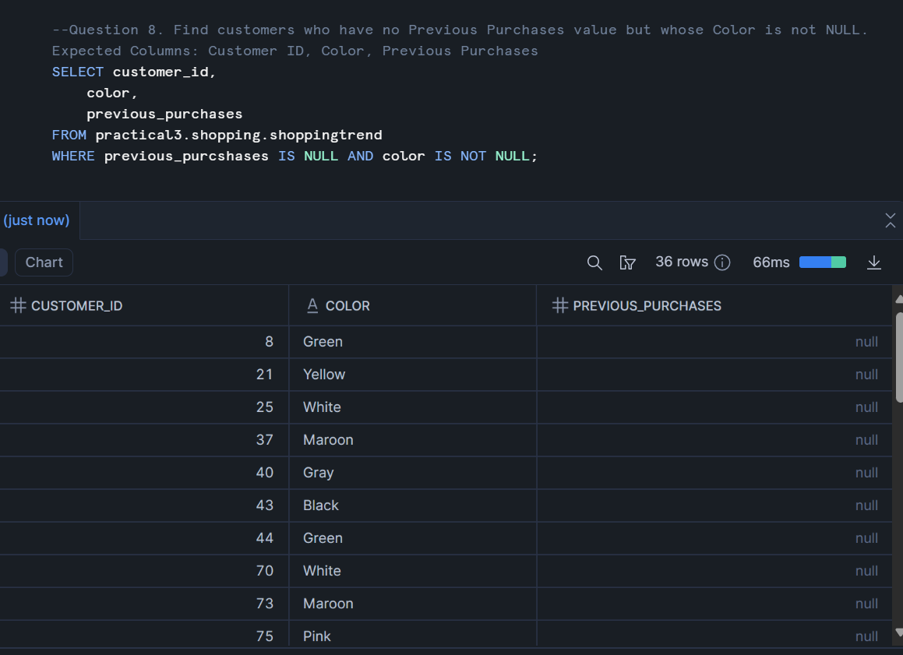

Question 9

Question 10.

Question 11.

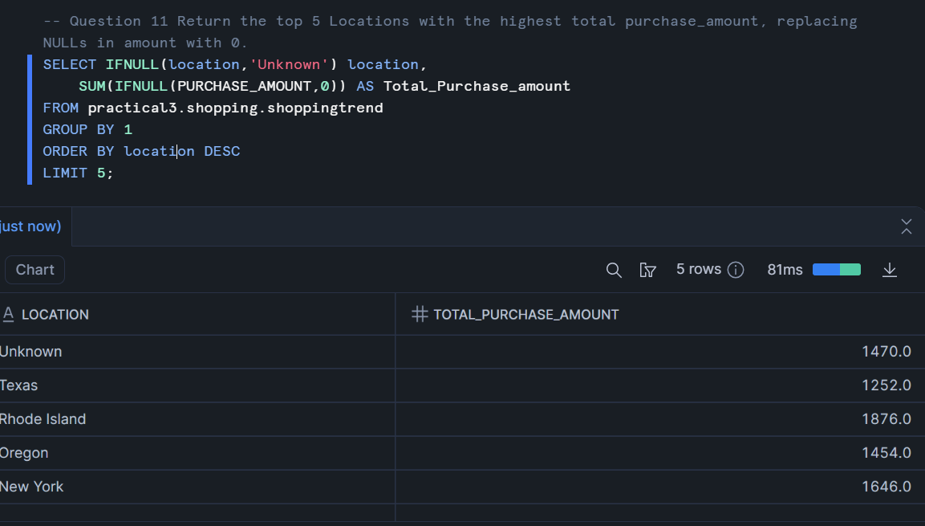

Question 12.

Question 13.

Question 14.

Question 15.

Question 16.

Question 17.

Question 18.

Question 19.

Question 20.

