English
Task Book
VCE Practice Examination – XX XX XX 2026

- Reading time is 15 minutes: 9.00am to 9.15am
- Writing time is 3 hours: 9 .15 am to 12.15 pm
Approved materials
- An English and/or bilingual printed dictionary
Materials supplied
- Task Book of 20 pages
- Answer Book
Instructions
- Write your responses in English.
- Follow all instructions on your Answer Book.
- You may keep this Task Book.
Students are not permitted to bring mobile phones and/or any unauthorised electronic devices into the examination room.

Contents pages
Section A (1 question, 20 marks) 3-8
Section B (1 question, 20 marks) 9-13
Section C (1 question, 20 marks) 15-17
Assessment criteria 18
'V'

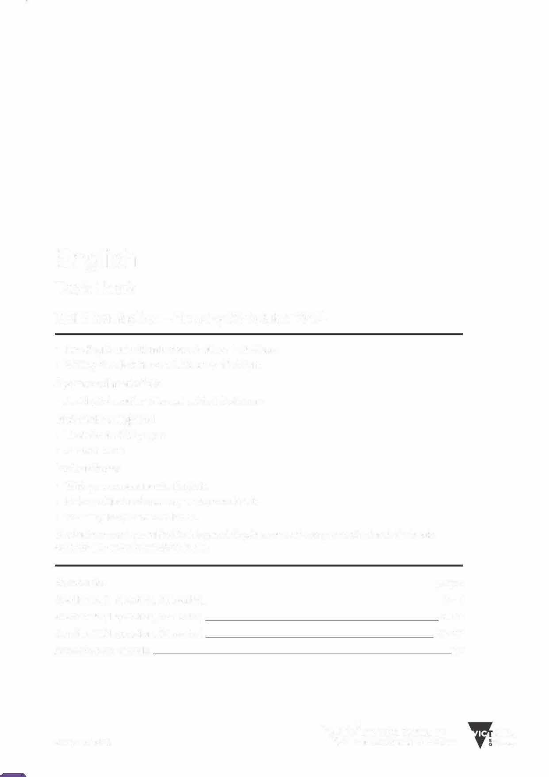

© 2026

to

This page is blank.

Section A - Analytical response to a text

Instructions
  - You must write an analytical response to a selected text on one of the topics (either i or ii) provided for that text.
  - Your response should engage with the ideas, concerns and values raised by the topic and be supported by close reference to the text.
  - If your selected text is a collection of poetry or short stories, you may write on several poems or stories, or on at least two in close detail. In the Answer Book, indicate which text you have chosen to write on and whether you have chosen to answer i or ii.
  - Refer to the assessment criteria on page 18.
  - Section A is worth one-third of the total marks for the examination.

Text list
- Sunset Boulevard
directed by Billy Wilder

- Rainbow’s End
by Jane Harrison

- Rainbow’s End by Jane Harrison
  - {A10}
  - {A11}
.

OR

2. Sunset Boulevard directed by Billy Wilder
- {A7}
- {A8}

End of Section A

Section B - Creating a text

Instructions
    - In this section, you must create one written text (not including song, poetry or verse).
    - In your text, you must include meaningful connections with ideas drawn from
      - one of the Frameworks of Ideas
      - the title provided for your selected Framework of Ideas
      - at least one piece of stimulus material provided for your selected Framework of Ideas.
    - You must develop your text with a clear purpose, incorporating at least one of the following: to explain, to express, to reflect, to argue.
    - You must write an effective and cohesive text that demonstrates fluency through your selection of vocabulary, text structure(s) and language features.
    - Refer to the assessment criteria on page 18.
    - Section B is worth one-third of the total marks for the examination.

Framework 3: Writing about personal journeys
- Write a text that explores ideas about personal journeys.
- You must use the title provided.
- You must use at least one of the following stimuli.

Title: {G9}

Stimulus 1
{G11}

Stimulus 2



Stimulus 3
{G15}

End of Section B

This page is blank.

Section C - Analysis of argument and language

Instructions
  - In this section, you are required to analyse the use of argument(s) and language to persuade an intended audience to share the point of view expressed in a persuasive text.
  - Read the background information on this page and the material on pages 16 and 17, and write an analytical response to the task below.
  - For the purposes of this task, the term 'language' refers to written and spoken language, and 'visuals' refers to images and graphics.
  - Refer to the assessment criteria on page 18.
  - Section C is worth one-third of the total marks for the examination.

Task
Write an analysis of the ways in which arguments, written and spoken language, and visuals are used in the material on the following pages to try to persuade the intended audience to share the point of view presented.







End of examination questions

Assessment criteria

Section A will be assessed against the following criteria:
- knowledge and understanding of the text, its structure, and the ideas, concerns and values it explores
- development of a coherent analysis in response to the topic
- use of evidence from the text to support the analysis
- use of fluent expression through appropriate use of vocabulary and conventions of Standard Australian English

Section B will be assessed against the following criteria:
- use of relevant idea(s) drawn from one Framework of Ideas, the title provided and at least one piece of stimulus material
- creation of a cohesive text that connects to a clear purpose(s) and incorporates an appropriate voice
- use of suitable text structure(s) and language features to create a text
- use of fluent expression, including the appropriate use of vocabulary

Section C will be assessed against the following criteria:
- understanding of contention, argument(s), and point of view
- analysis of the ways in which written and spoken language and visuals are used to present an argument(s) and to persuade an intended audience
- use of evidence from the text to support the analysis
- use of fluent expression through appropriate use of vocabulary and conventions of Standard Australian English

© South Oakleigh College 2026

