GIT INSTALLATION PROCESS

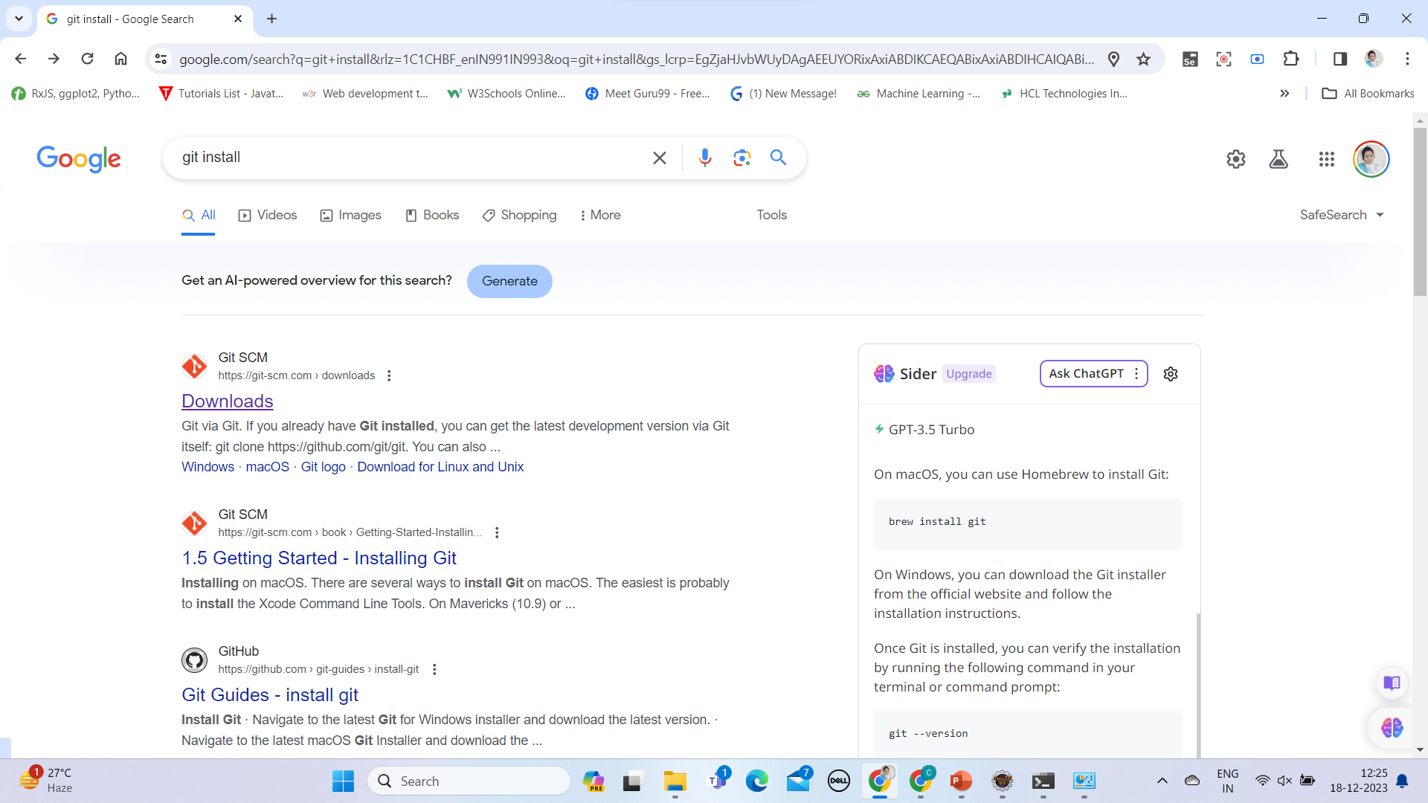

Link:- <https://git-scm.com/downloads>

Click on download for windows 2.43.0 version latest version

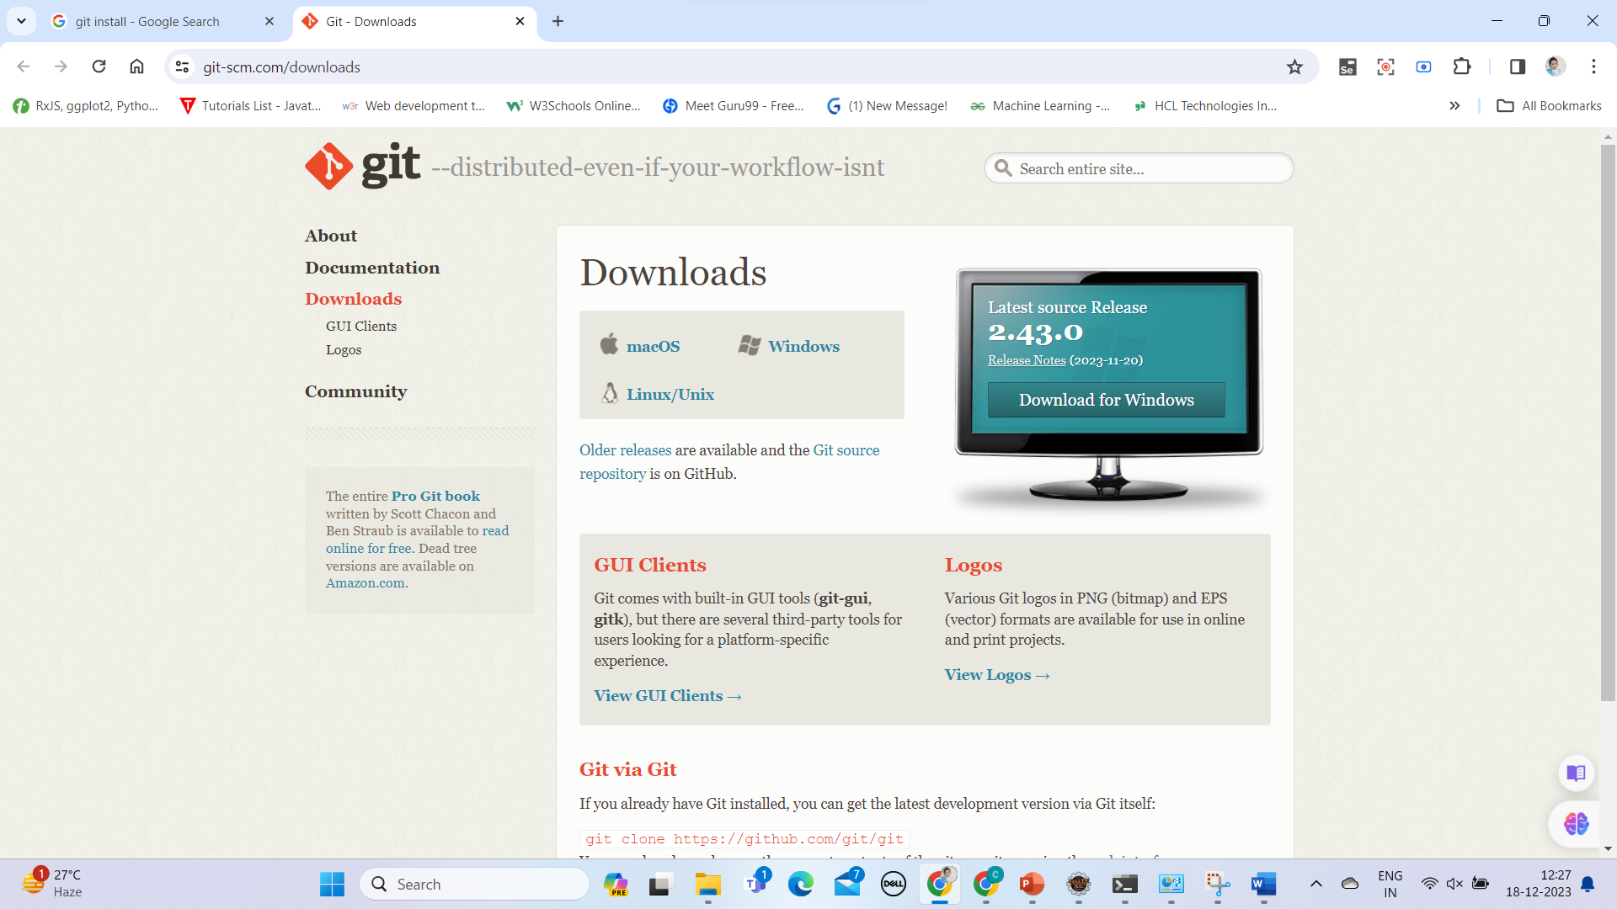

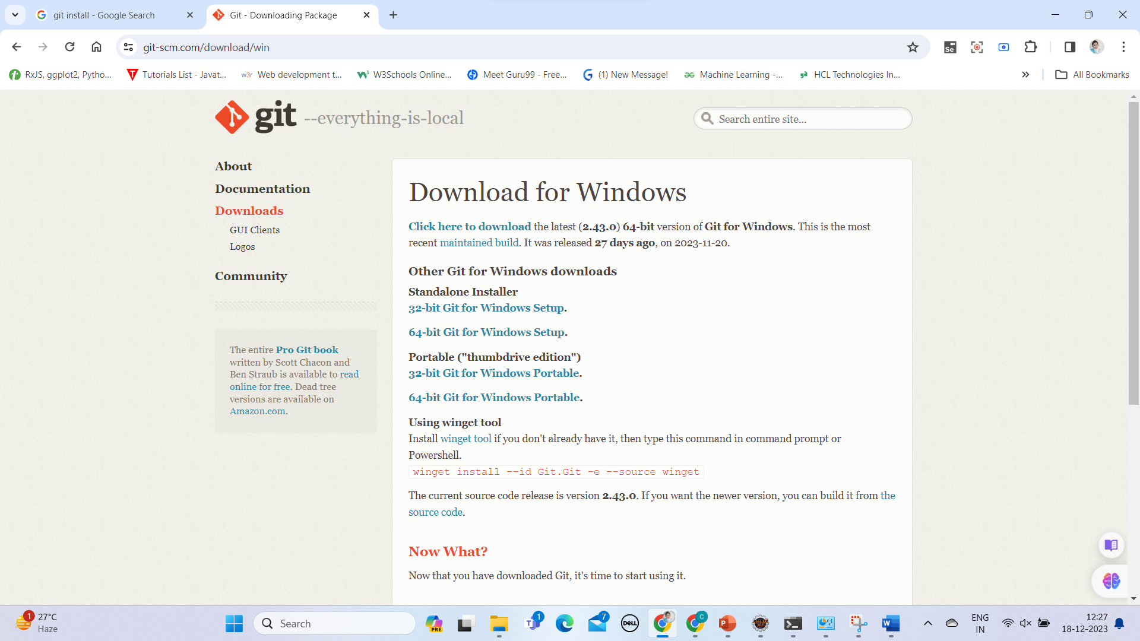



*Click here to download* the latest version

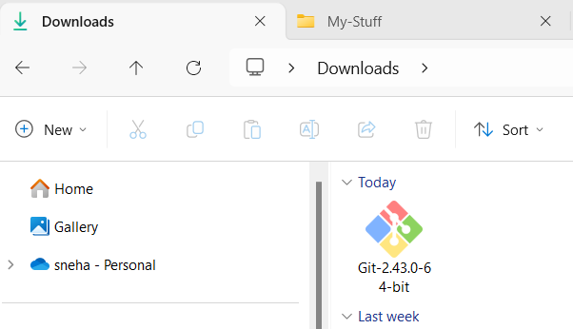

This is what you see after download

Double Click on downloaded file

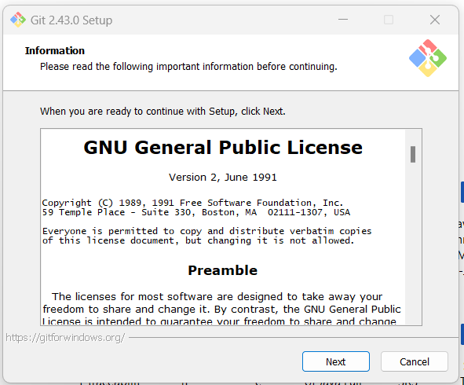

Click on next

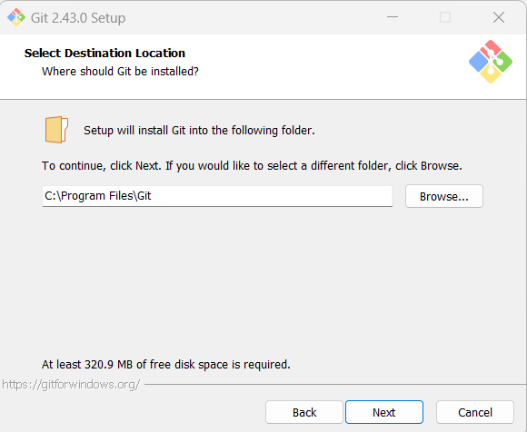

Click on next

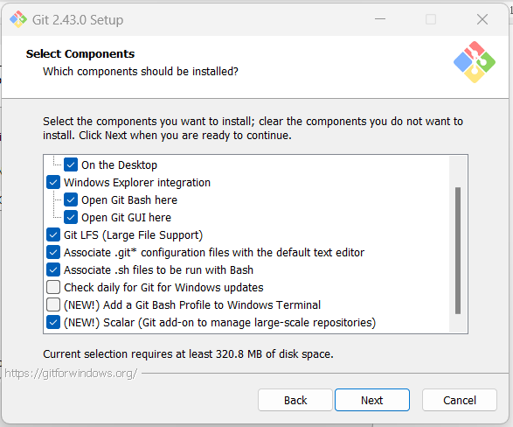

Select as in above picture and click on next

Click on next

Click on next

Click on next

Click on next

Click on next

Click on next

Click on next

Click on next

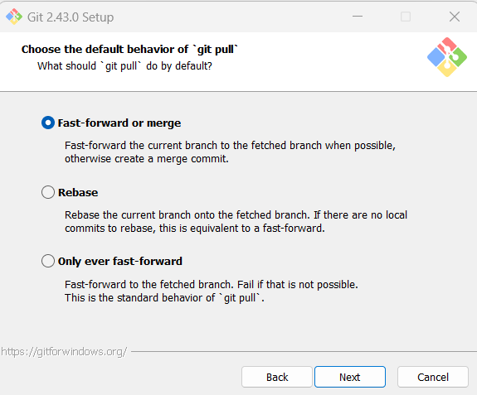

Click on next

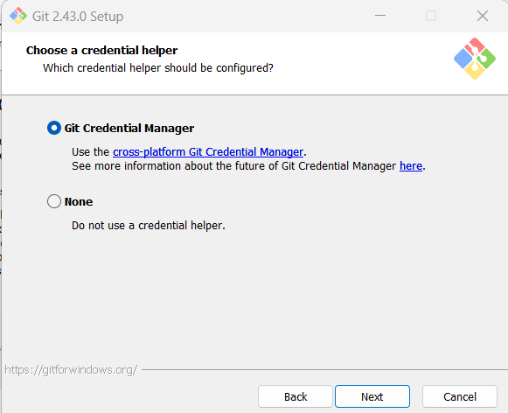

Click on next

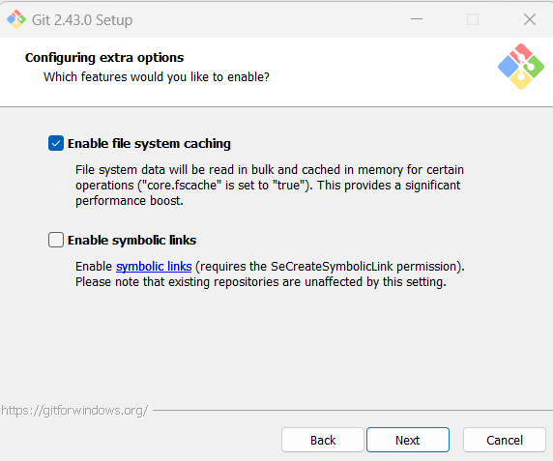

Click on next

Click on install

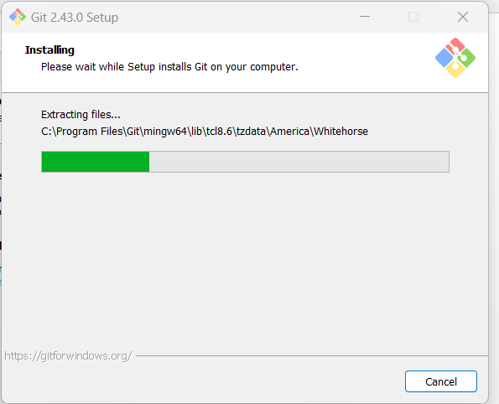

Its installing

Check the above mentioned and click on next

This will open on browser. please close it after opened

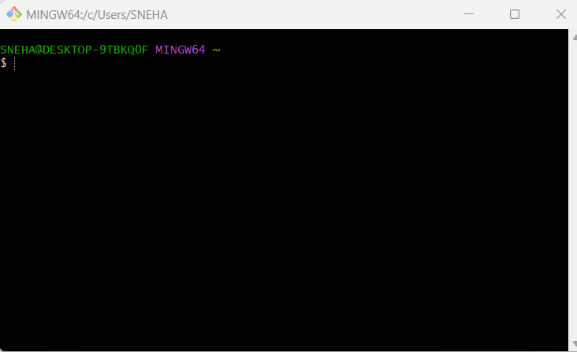

This is GIT Bash

Now Check in terminal as

Git - -version

You have to see version of the git you installed

**Congratulations!!! For Successful Installation**