DeActivation
Concept Sketch v1 – Punishment of the Gods

2) Vision Statement:

2.1) Game Log:
Running Platformer that is endless, with obstacles, such as boxes and rocks that the player has to evade, while running away from a giant boss.

2.2) Gameplay Synopsis:
Uniqueness:
Boss that constantly chases the player narrows the running ground for the player.
Mechanics:
The player is able to move side to side (left and right) and jump up while running.
Setting:
Grassy, plains area set in Greek Age time period.
Look and Feel:
Dark, shadowy (gloomy) look, with shimmering brightness that cascades along the path the player travels through. Character is afraid to be caught by the giant boss that follows him throughout the game. The character trips and falls throughout the game, but remains at a consistent speed.

3) Audience, Platform, and Marketing:

3.1) Target Audience:
Game meant to entertain the user for a short period of time. Age meant to range from 5 and above. No specific gender. Game meant to be played throughout the world (everywhere).

3.2) Platform:
Played on PC and as a phone app, because it's a game meant to be played in the user's spare time. Meant to be “on the go” type game.

5) Gameplay:

5.1) Overview:
The player constantly moves right, while dodging and jumping over obstacles. If the player hits an obstacle, the player slows down and gets closer to being captured by the Giant Boss chasing them.

5.2) Gameplay description:
The overview of the gameplay continues until the player gets captured by the giant boss, in which leads to the end of the game. Gameplay is based on scoring points by collecting specific objects to add points to the user's final score. The distance the player traveled before getting caught by the giant boss will also count towards the user's final score.

5.3) Controls:
5.3.2) Rules:
Game objects are walls, boxes, rocks, tokens, the player, and the giant boss. The walls limit the character's movement. Boxes and rocks provide a hindrance to the player in trying to escape the giant boss, by slowing the player's movement. The tokens will be placed randomly throughout the players movement of the map to add to the player's final score. The player is the character the user controls. The giant boss is the main villain the user is trying to avoid and run away from.

5.3.3) Scoring/winning conditions:
Distance provides a way of gaining points consistently of 1 dragma (coin) per meter traveled in the game. Tokens provide 25 dragma to the player's final score at the end of the game (after being caught by the giant boss). The game only ends when the player is finally caught by the giant boss, meaning the player can never wins (Damn the Gods).

5.5) Levels:
3-D flat, grounded level that has Ancient Greek ruins and mountains in the background. Has a cloudy sky, with light shining from the clouds.

5.6) Flowchart:

6) Game Characters:

6.1) Character Design:
The main character will be a small, masculine figure that has a bright, white light that shines from him. The figure himself will be a very dark (almost a shadowy) character, but he will have a light that shines around him. A good looking male in his early thirties, he's actually a former angel that's about 30,000 years old (still a fairly young angel). Very similar to the image bellow:
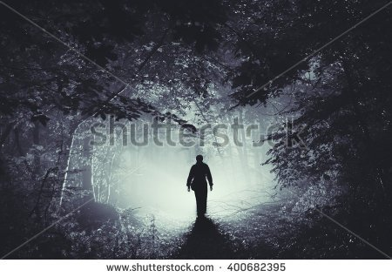

The main villain will be a giant, golem character that will be chasing the main character the whole game. The golem will be a rock type character, with the movement similar that of a gorilla. Bellow is a similar depiction of what the giant boss will look like as well as what the main character will look like. The depiction also has an accurate scale between the giant boss and the main character:
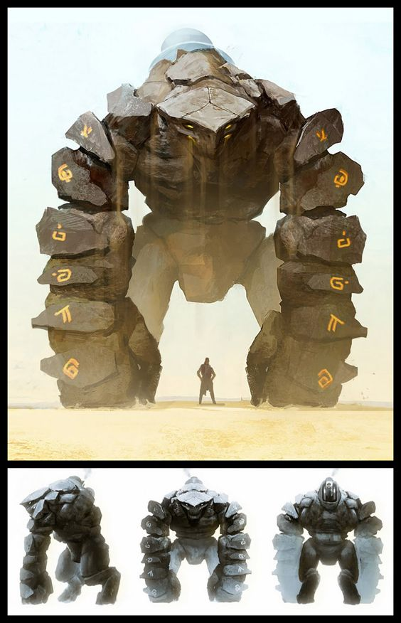

6.2) Types:
6.2.1) PCs (player characters):
Steve Rogers - A male, angel character, who is a conniving, mischievous angel (unlike the other angels), who does not like to follow orders or play by the rules (he makes his own rules). By angering the Gods for his poor behavior, he's stripped of his wings by the Gods and sent down to Earth as a human to forever run from the giant golem that constantly lingers behind him til the end of his days.

6.2.2) NPCs (nonplayer characters):
Baragnock - A giant, golem character, who is sent by the Gods to terrorize and hunt down Steve
Rogers for the rest of his days. He's made out of rock, dirt, and lava. He's brought to life by the Gods for one purpose, chase and capture Steve Rogers. He's very aggressive and with a short temper, he's a deadly creature to run into (especially since we also has a giant sword).

8) The Game World:

8.1) Overview:
The map will be a 3-D and linear, where the character can only move right or left and can jump or dodge obstacles in his path. The map will be limited with two wall barriers (one in the front of the map, one in the back of the map) to limit the movement of the player. There will be obstacles in the players way that will appear at random to slow the player down. The background will be mixed of ancient ruins, tall mountains, and a cloudy sky with sunlight shining from the clouds.

8.2) Key Locations:
The setting will be from Ancient Greek times, so ruined colosseums, temples, and other giant structures will appear in the background as the player advances forward.

8.3 & 8.4) Travel and Mapping:scenery
The mapping will be linear, where the character will only be able to travel forwards (right) and backwards (left).

8.5) Scale:
Since this game is an endless runner, the scale of the map could range from very short to very large depending on how far the user is able to travel before getting caught by the Giant Boss (Baragnock).

8.6) Physical Objects:
Rocks and boxes will appear at random to slow down the main character (Steve Rogers). Boxes will be able to be broken through at the cost of a one second slow down time. Rocks will be able to be jumped over. However, if the user fails to jump over the rock, their character will trip over the rock and cause a three second slow down time. All objects will be able to be dodged. Throughout the game, the Giant Boss (Baragnock) will be able to swing his sword, where the user will either have to dodge or jump over Baragnock's attack. If hit by the sword attack, the player will be stunned for three seconds
(unable to move completely). A shadow will signify when Baragnock will swing his sword and in what direction he will be swinging his sword.

8.7) Weather Conditions:
The weather will alwasceneryys be cloudy, with specks of sunlight appearing through the clouds as the player advances forward in the game.

8.8) Day and Night:
Since there will always be sunlight peering through the clouds, this game will always be occurring during the day time.

8.9) Time:
The time of day will be unknown, but the game will always be during the day time.

8.10) Physics:
The player will be able to move forward (right), backward (left), upward (up), and downward (down). The character will be able to jump over object (possibly space bar or built-in jump button) and dodge objects and attacks from the Giant Boss (possibly 'D' button on keyboard or built-in dodge button). A player remains at a constant speed, unless they are hit by an object or an attack from the Giant Boss. The player's speed slows down based on what object they hit. The player will unable to move if they are hit by the Giant Boss's attack.

8.11) Society/culture:
Since this game takes place during Ancient Greek times, the society and culture will be based on Greek mythology and the Greek Gods.

9) Media List:

9.1) Interface Assets:
We will use blender to create characters and the appearance. We will use Unity for texture packs based on the game's outer appearance and background look.

9.2) Environments:
Rough, grassy terrain for ground to walk on, white, marble wall to set the boundaries for the game, Ancient Greek colosseums and large, grassy mountains for the background of the environment, as well as cloudy skies with light shining down to the ground to set the mood of the game.

9.3) Characters:
Character designs will be imported through Blender and edited to match the character requirements in Unity. This will give us a sense of free form and leeway when it comes to the design of our characters. Basically, our characters will not just be cheap knockoffs of already existing characters, but new and unique characters that fit the design we would like them to be.

9.4) Animations:
We will be using Blender to add the different action animations. This will include (but not limited to) the main character movements for when he's running, forcefully slowed down, moving up, down, left, or right, the actions he makes when he's jumping or dodging objects, when he's paralyzed and can't move, and when he has been caught by the giant boss. Other animations will include the pace of which the objects (boxes and rocks) travel towards the player as they are running as well as the different movements of the giant boss. The giant boss movements will include (but not limited to) his movement speed (which will be quite slow at first, then will get faster as the user progresses through the game) as well as his different attacking actions (two types of swinging actions his sword, vertical and horizontal swings) and the animation he makes when he captures the main character. We will also include cloud movement as well as changing of scenery so the player will no through the background movement alone that they get the feel of their character is moving and progressing forward.

9.5) Music and Sound Effects:
We will do a mixture of playing our own music as well as using music editors (such as FL Studios) to create the music for the game. We will then import the music into Unity and make the adjustments of the the music will be played that fit the requirements of Unity. As for the sounds, we will personally record the sounds made in the game and edit those sounds using a music editor (probably FL Studios). Finally, we will import these sounds into Unity and adjust the times these sounds will be made that will fit the requirements Unity sees fit.

