*CS 301*

*Chapter 7/9/10*

*Assignment 3.*

*100 points.*

*Thomas crow*

*11/17/2023*

*1 (7.9). (5 points each, total 30 points)*

*Assume the following rules of associativity and precedence for*

*expressions:*

*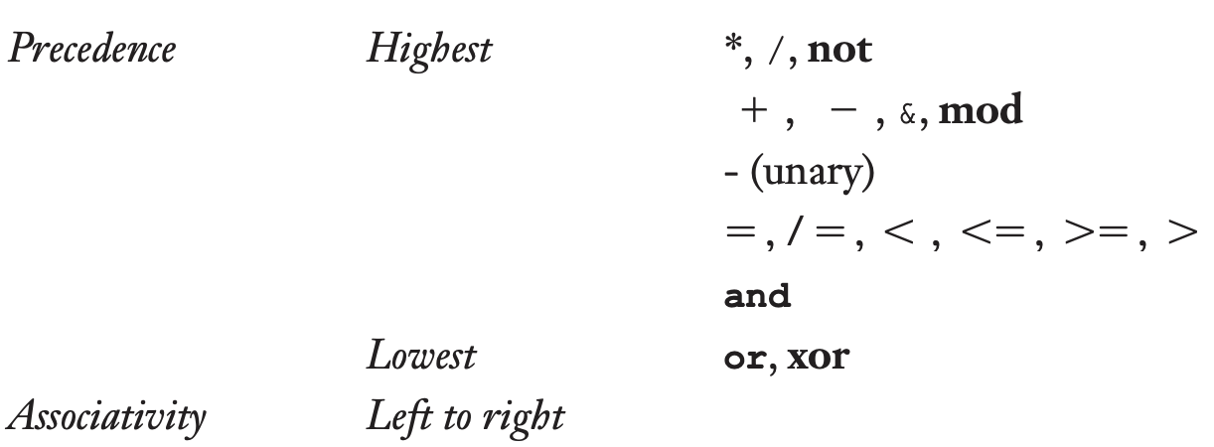*

*Show the order of evaluation of the following expressions by*

*parenthesizing all subexpressions and placing a superscript on the*

*right parenthesis to indicate order. For example, for the expression*

*a + b \* c +d*

*the order of evaluation would be represented as ((a + (b \* c)1)2 + d)3*

*a. (((a \* b)1 – 1)2 + c)3*

*b. (((a \* (b - 1)1)2 / c)3 mod d)4*

*c. (((a - b)1 / c)6 & ((((d \* e)3 / a)4 – 3)5)2)7*

*d. (-a or ((c = d)1 and e)2)3*

*e. (((a > b)1 xor c)3 or (d <= 17)2)4*

*f. (–(a + b)1)2*

*2. (7.13) (10 points each, 20 points total)*

*Let the function fun be defined as*

*int fun(int\*k) {*

*\*k += 4;*

*return3 \* (\*k) - 1;*

*}*

*Suppose fun is used in a program as follows:*

*void main() {*

*int i = 10, j = 10, sum1, sum2;*

*sum1 = (i / 2) + fun(&i);*

*sum2 = fun(&j) + (j / 2);*

*}*

*What are the values of sum1 and sum2*

*a. operands in the expressions are evaluated left to right?*

*b. operands in the expressions are evaluated right to left?*

*A) sum1 = 46, sum2 = 48  
B) sum1= 48, sum2 = 46*

*3. (7.19) (10 points each, total 20 points)*

*Consider the following C program:*

*int fun(int \*i) {*

*\*i += 5;*

*return 4;*

*}*

*void main() {*

*int x = 3;*

*x = x + fun(&x);*

*}*

*What is the value of x after the assignment statement in main,*

*assuming:*

*a. operands are evaluated left to right.*

*X=7*

*b. operands are evaluated right to left.*

*X=12*

*4. (9.7) (5 points each, total 15 points)*

*Consider the following program written in C syntax:*

*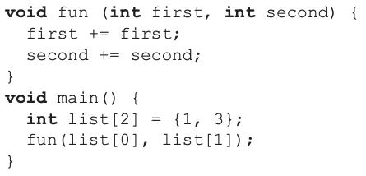*

*For each of the following parameter-passing methods, what are the*

*values of the list array after execution?*

*a. Passed by value*

*b. Passed by reference*

*c. Passed by value-result*

a) {1,3}  
b) {2,6}  
c) {1,3}

*5. (10.1) Show the stack with all activation record instances (like*

*Figure 10.9 on the textbokk), including static and dynamic chains,*

*when execution reaches position 1 in the following skeletal program.*

*Assume bigsub is at level 1. (15 points)*

*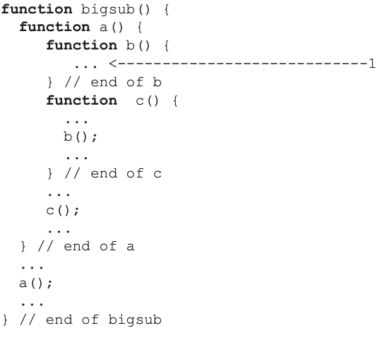*

*You can write your answers by hand, scan them, and upload them to Canvas as a single PDF*

*file.*

*Please make sure your writing is clear and well organized.*

*There are no late submissions.*